**UI/UX Advanced Product Report**

-CMGTwitch (E-Lecture manager) -

-Ana-Maria Ilea-

-474817-

Contents

1. Solution’s Stylesheet 3

2. Hi-Fi Prototype 4

2.1. User functionality 4

2.2. URL of the prototype 4

3. User journey of the Hi-Fi prototype (Optional for Excellent) 5

4. Unity/Web Application 6

4.1. Implemented interface (Max. 3 sentences) 6

4.2. Implemented user journey (Optional for Excellent; Max. 1 sentence.) 6

4.3. URL of the prototype 6

5. Content that needs crediting 7

6. Student-generated content (Optional for Excellent) 8

# Solution’s Stylesheet

-Provide the stylesheet for your solution (examples <https://dribbble.com/tags/stylesheet>).-

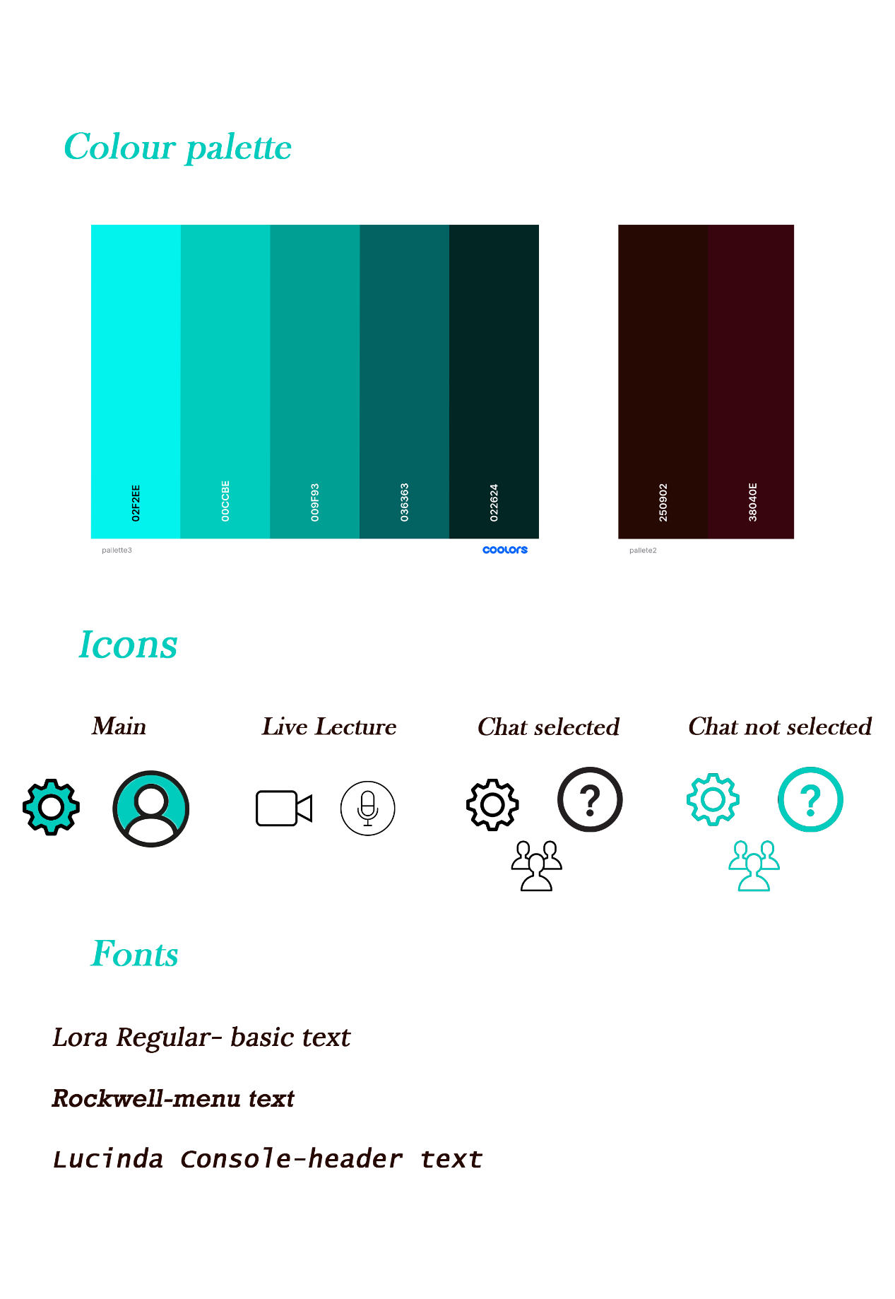

# Hi-Fi Prototype

## User functionality

-Make a list with the 3 most important tasks the user can carry out in your prototype.-

* The user can view the timestamps in the Week one recorded lecture in the software architecture course
* The user can search for the rigging course and enroll.
* The user can send a message marked as a question in the Live lecture in the 3D Rendering course

## URL of the prototype

-Provide the shareable public URL to your prototype. Make sure it is accessible before submitting. In case of A/B testing with the prototype, add both URLs.-

**Version A:**

* <https://invis.io/QAZZJRBZUFW>

**Version B:**

* <https://invis.io/M6ZZJRKBCE3>

# User journey of the Hi-Fi prototype (Optional for Excellent)

-Fill in the template with the required information.-

|  |  |
| --- | --- |
| Persona | *University student, during online education* |
| Scenario | *The student has missed one of the Software Architecture Lecture and wants to watch the recording and see what topics have been discussed.* |
| Goals & Expectations | *The user’s goal is to find the lecture they are looking for and expects to find the timestamps with the topics discussed.* |

|  |  |  |  |
| --- | --- | --- | --- |
| Phase 1  Going to the courses page | Phase 2  *Select the year and the course* | Phase 3  Find and select the right lecture | Phase 4  *Play the lecture, click on description and look at the timestamps and topics* |
| User actions:  -Start the application  -Tap on the courses button | User actions:  -Select year 2  -Select the Software Architecture course | User actions:  -Scroll to find the lecture  -possibly filter the lectures to show only the recorded lecture  -Select the lecture | User actions:  -Click play on the lecture  -Click on description  -Check the timestamps |
| User Thoughts:  -I missed the live lecture  -I want to watch the recording | User Thoughts:  -I need to select year 2 first. My current courses should be displayed when I go to the courses page.  -The lectures are displayed in a list and the courses are displayed in a grid with icons | User Thoughts:  -There are no recent lectures so I can find the recent recording  -I need to filter the lectures if I want to find the lecture fast | User Thoughts:  -The topics and timestamps are not displayed at all times  -The chat and the description aren’t shown at the same time |
| Opportunities: *(potential improvements for the user)* | Opportunities: *Change how the courses are shown to a list layout, to match how the lectures are displayed* | Opportunities: *Add recent lectures to the courses page* | Opportunities: *Change the layout of the chat and the description so that the user has all the information available* |

# Unity/Web Application

## Implemented interface (Max. 3 sentences)

-State the interface (screen) that you have implemented, and explain its functionality.-

The interface has the following screens: the courses page, the explore page, the software architecture course page. With the application the user can navigate through the pages and search in the explore bar for “UI UX”, “Software Architecture” and “Rigging”(With this spelling). The buttons are highlighted when the mouse is hovering over them and scrolling is done by clicking and dragging(like a mobile/tablet application).

## Implemented user journey (Optional for Excellent; Max. 1 sentence.)

-If you implemented the necessary interfaces for the user to carry out one complete task, describe the task here.-

The user can navigate through the courses page, choose the Software Architecture and check the timestamps in the Week-one Lecture.

## URL of the prototype

-Provide the shareable public URL to your application. Make sure it is accessible before submitting.-

-In case of A/B testing with the application, add both URLs (**Optional for Excellent**).-

**Version A:**

* <https://anamariailea.itch.io/cmgtwitch-application>

**Version B (Optional for Excellent):**

* …

# Content that needs crediting

-List of free assets (code, icons, fonts, etc.) that were not made by you, and a link to the source of these assets.-

|  |  |  |
| --- | --- | --- |
| **Asset** | **Location** | **Source** |
| All icons | … | <https://www.iconfinder.com/> |

# Student-generated content (Optional for Excellent)

-List of assets (code, icons, fonts, etc.) that were made by you.-

|  |  |
| --- | --- |
| **Asset** | **Location** |
| … | … |