**UI/UX Advanced Evaluation Report**

-CMGTwitch (E-Lecture manager) -

-Ana-Maria Ilea-

-474817-

Contents

1. Usability testing protocol 3

1.1. Procedure 3

1.2. User tasks 3

1.3. Measurements 3

2. Usability testing results 4

2.1. Individual Results 4

2.2. Actions points 5

3. Unmoderated A/B testing protocol 6

3.1. A/B conditions (Max. 2 sentences) 6

3.2. Hypothesis (Max. 1 sentence) 6

3.3. Variables 6

3.4. User tasks 7

3.5. Survey 7

4. Unmoderated A/B testing results 7

4.1. Survey raw data 7

4.2. Processed results 7

4.2.1. Box plots (Optional for Good) 8

4.2.2. Conclusion (Max. 5 sentences) 8

4.3. Future work (Optional for Good) 9

4.4. Reflection (Optional for Excellent; Max 3 sentences) 9

# Usability testing protocol

## Procedure

-Step-by-step procedure that you will follow for your test.-

1. Share the link to the prototype
2. Ask the user to share their screen
3. Introduction of the prototype
4. Start task 1
5. Start task 2
6. Start task 3
7. Post task 1 talk
8. Post task 2 talk
9. Post task 3 talk

## User tasks

-State the actions you will ask the user to perform with your prototype. More tasks will allow you to get more feedback on your prototype. Copy-paste the table as necessary.-

|  |  |
| --- | --- |
| **Task 1** | Use timestamps in the recorded lecture for 3dRendering |
| **Success criteria** | The user jumped to a part of the video in the recorded lecture |

|  |  |
| --- | --- |
| **Task 2** | Filter the chat in the upcoming lecture |
| **Success criteria** | The chat is filtered to questions only in the live lecture page |

|  |  |
| --- | --- |
| **Task 3** | Go to the courses page and use the dropdown menus to see the 3D Rendering course |
| **Success criteria** | The dropdown menus will Year 2 and 3dRendering, and the specific lectures will be shown |

## Measurements

-List what type of data you will collect, and how, from the tester before, during or after the test-

|  |  |
| --- | --- |
| **Metric** | **Process** |
| Time | How long it talks to complete the tasks |
| Number of errors | How many errors were made while doing the task |
| Level of frustration | How frustrated the user is while doing the tasks |

# Usability testing results

## Individual Results

-Makes notes of the usability tests and fill in the feedback grid for each participant. You need at least 3 testers.-

|  |  |
| --- | --- |
| Tester 1 – Tabea Hasz van 475830 | … |
| Likes   * Layout is clear * The colors are nice * The filters are useful | Criticisms   * The buttons is too small * “News” isn’t a good word for that page * The text is too small |
| Questions   * What is the platform for the app? * Did I skip to the timestamp? | Ideas   * Differentiate the courses through colors * Make the text and buttons bigger and more visible * Make the live lecture more visible by adding a red dot or icon |
| **Summary:** The button and text were too small and was hard to read and click for the user. The tasks were completed quickly and were a couple of errors. There was some confusion with the timestamp task. | |

|  |  |
| --- | --- |
| Tester 2 - Maikel Lucas 485985 | … |
| Likes   * The timestamps * The filters/dropdown menus | Criticisms   * The clock area, text and buttons are too small * “News” is not a good title * Some options were vague * There were spelling mistakes |
| Questions   * What are the downloads? * What happens when you press the account icon? | Ideas   * Have a sort options for engineers/artists/designers * Have sort options for topics * Add AM and PM for any time mention |
| **Summary:** The user had trouble reading the text. Some of the options, like “see lecture page” were vague. | |

|  |  |
| --- | --- |
| Tester 3 - Alejandro Moreno | … |
| Likes   * The chat is ok * The timestamps | Criticisms   * The type of recording is easy to miss * There is a lot of empty space * The news title is not good |
| Questions   * Am I on the right page (task 3)? * What does the filters button do? | Ideas   * Add title for specific course * Color code the courses * Move the chat and make the video bigger in the lectures * Make subsections to structure the information |
| **Summary:** The user had trouble with navigation. There was a lot of empty space and the text was hard to read. Some parts of the text were easy to miss. | |

## Actions points

-Summarize the outcome of the usability testing in terms of improvements that need to be made to the prototype. Be specific about the improvements that the prototype will undergo and add a screenshot of the relevant Lo-Fi prototype section so the teacher can see the usability problem.-

* The news title is not specific. It needs to be replaced to Home or Announcements



* The layout of the pages has a lot of empty space. It needs to be redesigned. The new design will be a grid made out of squares.
* It was difficult to tell which code is which. I will associate different colors to courses to make them more obvious

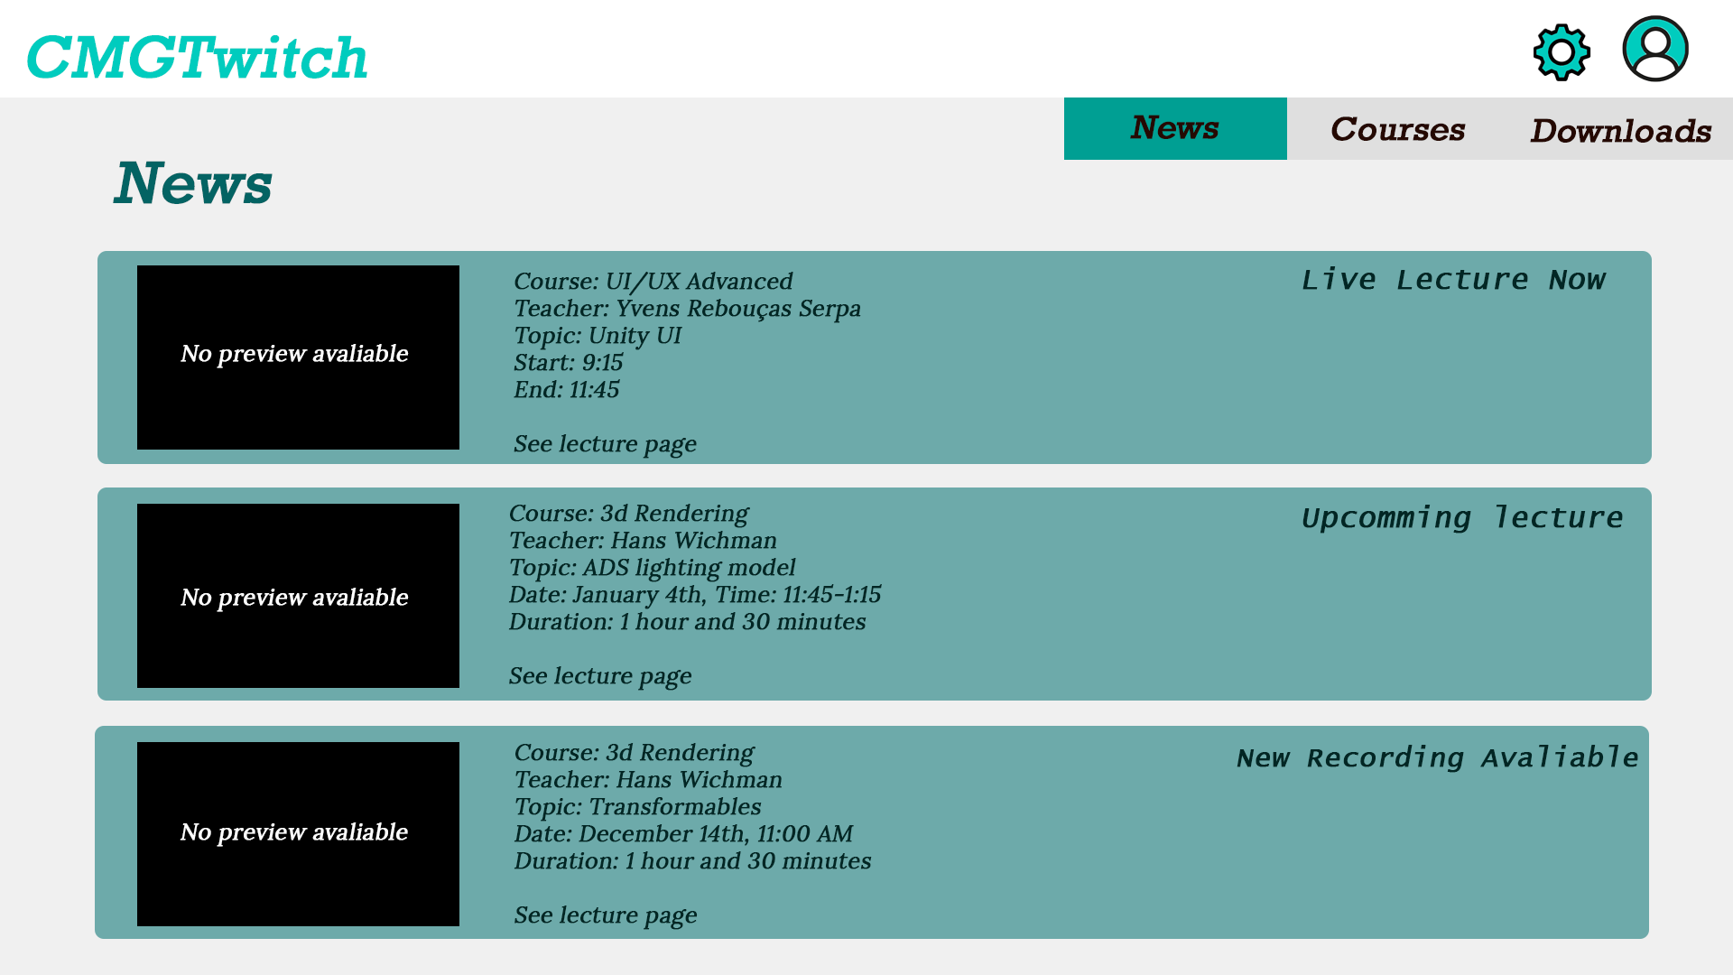

* The information describing the lectures was hard to read. I need to rewrite it, make it bigger and more noticeable
* The type of the lectures was easy to miss. I will change the position and the style to make it more noticeable. I will also make subsections in different pages to make different types of lecture more noticeable.

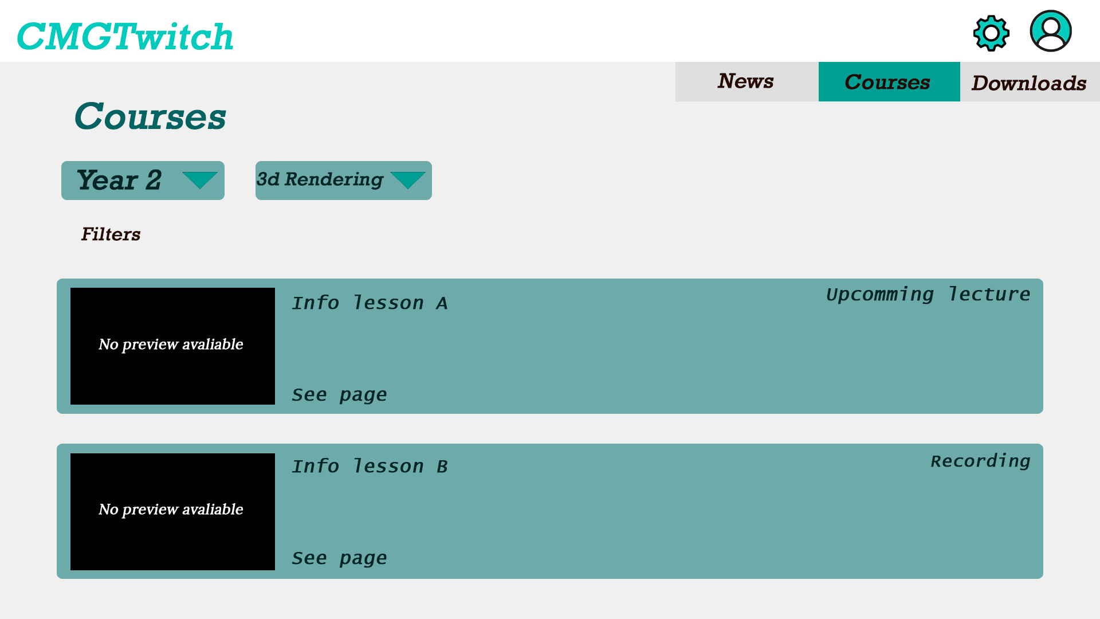

# Unmoderated A/B testing protocol

## A/B conditions (Max. 2 sentences)

-Explain the difference between the two versions of your prototype/application. Make sure there is only one thing you are changing so your experimental results are valid.-

In version A the user selects both the year and the course from 2 different dropdown menus, in order to access the lectures from the selected course. In version B each year has its own button; when the user selects a year a list of courses appears, each having its own button which when pressed takes the user to the main page of the course where all the lectures are shown.

## Hypothesis (Max. 1 sentence)

-State what you believe will change, in terms of user behavior, between conditions A and B.-

Because the navigation is more laid-out, it would be easier and more intuitive for a user to find the course and lecture that they seek using version B.

## Variables

-List the aspect of the experiment that you are controlling and changing (independent variable – there should only be one), what is affected by that change (dependent variables), and what aspects you have no control over but could affect the results (confounding variables).-

|  |  |
| --- | --- |
| **Independent variable** | The navigation Layout for finding courses and lectures |
| **Dependent variable(s)** | * Intuitively factor for navigation * Ease of use * Time to complete the tasks |
| **Confounding variable(s)** | * Screen resolution/size * User expectations and experience |

## User tasks

-State the actions you will ask the user to perform with your prototype/application. Copy-paste the table as necessary.-

|  |  |
| --- | --- |
| **Task 1** | Find the Week One Recorded Lecture in the Software Architecture Course |
| **Success criteria** | Click on the Week one lecture in the Software Architecture course. |

|  |  |
| --- | --- |
| **Task 2** | Find The live lecture in the UI/UX Course |
| **Success criteria** | Click on the live lecture in the UI/UX course |

## Survey

-Fill in the URL of your survey and the questions you asked your testers. You need at least 4 questions and they should be relevant to your test (should allow you to validate your hypothesis).-

|  |  |
| --- | --- |
| **URL** | https://forms.gle/UyGyvw2L3EGEB9wKA |
| **Type of answer** | **Question** |
| Multiple Choice | 1. Which version did you test? |
| Linear Scale 1-5 | 2. Rate the difficulty of finding the Week One Recorded Lecture in the Software Architecture Course |
| Linear Scale 1-5 | 3. How intuitive was it to find the lectures for UI/UX? |
| Linear Scale 1-5 | 4. How fast were you able to find the UI/UX course lectures? |
| Linear Scale 1-5 | 5. Rate the layout for the courses page. |
| Open | 6. Do you have any recommendations to improve this solution? |

# Unmoderated A/B testing results

## Survey raw data

-Copy-paste the raw data (results) of your survey. These are usually obtained as a table of answers per respondent. Demographic information does not need to be reported here or in the following sections.-

|  |  |  |  |  |  |  |
| --- | --- | --- | --- | --- | --- | --- |
| Timestamp | Which version did you test? | Rate the difficulty of finding the Week One Recorded Lecture in the Software Architecture Course | How intuitive was it to find the lectures for UI/UX? | How fast were you able to find the UI/UX course lectures? | Rate the layout for the courses page. | Do you have any recommendations to improve this solution? |
| 1/21/2021 15:34:10 | Version A | 2 | 5 | 5 | 4 |  |
| 1/21/2021 15:35:39 | Version B | 1 | 5 | 5 | 5 |  |
| 1/21/2021 17:33:44 | Version B | 1 | 4 | 5 | 4 | The only thing that sticked out to me was that the recent courses were pretty big and centered, although I would expected the courses of this year to immediatly being shown to me once I enter the course tab. |
| 1/21/2021 17:38:17 | Version A | 1 | 4 | 5 | 4 | I prefered the year overview from version B, it felt a bit more intuitive to me! |
| 1/22/2021 11:50:38 | Version A | 5 | 1 | 3 | 1 | It's very irritating that in the My Courses page you can't actually click on the courses in that page, you have to use the drop down feature to filter for courses. It's also irritating that that My Courses page seems to contain both Courses in general and specific content from within that course. It should be an overview of all the courses and to get to a content within a course like a lecture or recording you need to click the course then navigate to the content from within that course page |
| 1/22/2021 11:52:48 | Version B | 5 | 1 | 2 | 1 | The same problems as with Solution A: The Announcements page has the courses you need for the tasks but you can't click them, the My Course page has the courses you need but for some reason you have to click on "Year 2" first, then suddenly the entire layout is different using Icons instead of a List format and only then you can actually select the course you're looking for. |
| 1/24/2021 13:11:37 | Version B | 1 | 4 | 4 | 3 |  |
| 1/24/2021 13:15:49 | Version A | 1 | 5 | 5 | 5 |  |
| 1/25/2021 12:07:30 | Version A | 2 | 4 | 4 | 4 | I'm guessing that it's just the way the prototype is set up, but it would be nice to be able to access some lectures and recordings from the homepage. Aside from that, cool idea! |
| 1/25/2021 12:10:26 | Version B | 2 | 4 | 4 | 4 | Same as for solution A, having access to recordings and lectures from the homepage (which probably is just the way the prototype is set up now). Really liked the solution! |
| 1/25/2021 13:19:07 | Version B | 2 | 4 | 4 | 4 |  |
| 1/25/2021 13:20:41 | Version A | 2 | 1 | 1 | 3 |  |

## Processed results

-Fill in the table with the results of your descriptive statistical analysis of the raw data from your survey. You can choose a different way of presenting your data if the table does not provide a good structure but make sure you show, per question and per condition, the required information.-

|  |  |  |  |
| --- | --- | --- | --- |
| **Question 2 –** Linear Scale 1-5 | | | |
| **Condition A** | | **Condition B** | |
| **Number of testers** | 6 | **Number of testers** | 6 |
| **Mean** | 2.16 | **Mean** | 2 |
| **Median** | 2 | **Median** | 1.5 |
| **Standard deviation** | 1.4719601 | **Standard deviation** | 1.5491933 |

|  |  |  |  |
| --- | --- | --- | --- |
| **Question 3 –** Linear Scale 1-5 | | | |
| **Condition A** | | **Condition B** | |
| **Number of testers** | 6 | **Number of testers** | 6 |
| **Mean** | 3.33 | **Mean** | 3.66 |
| **Median** | 4 | **Median** | 4 |
| **Standard deviation** | 1.8618987 | **Standard deviation** | 1.3662601 |

|  |  |  |  |
| --- | --- | --- | --- |
| **Question 4 –** Linear Scale 1-5 | | | |
| **Condition A** | | **Condition B** | |
| **Number of testers** | 6 | **Number of testers** | 6 |
| **Mean** | 3.83 | **Mean** | 4 |
| **Median** | 4.5 | **Median** | 4 |
| **Standard deviation** | 1.602082 | **Standard deviation** | 1.0954451 |

|  |  |  |  |
| --- | --- | --- | --- |
| **Question 5 –** Linear Scale 1-5 | | | |
| **Condition A** | | **Condition B** | |
| **Number of testers** | 6 | **Number of testers** | 6 |
| **Mean** | 3.5 | **Mean** | 3.5 |
| **Median** | 4 | **Median** | 4 |
| **Standard deviation** | 1.3784049 | **Standard deviation** | 1.3784049 |

## Box plots (Optional for Good)

-Draw a box plot to better understand the results from the A/B testing.-

Question 2

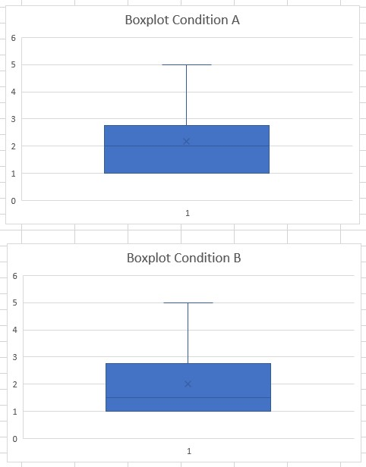

Question 3

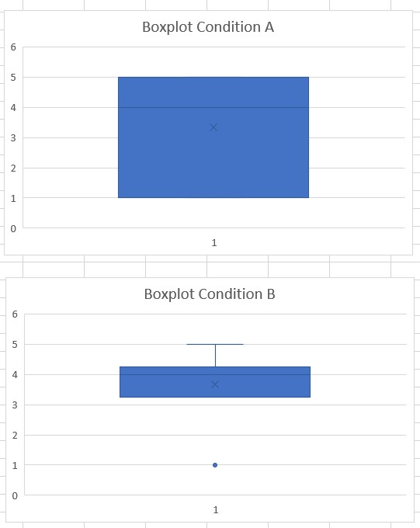

Question 4

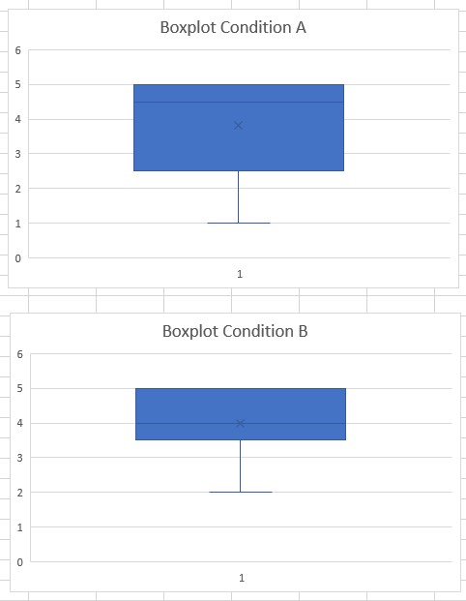

Question 5

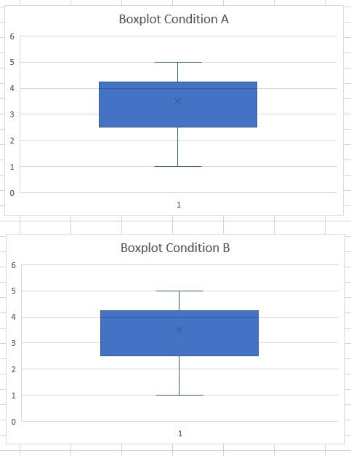

## Conclusion (Max. 5 sentences)

-Discuss if your hypothesis was validated or not using the results of your A/B testing.-

Based on the date collected the hypothesis seems to be correct. Version B seems to be more intuitive and easier to understand than version A. The results of the A/B test and the recommendations from question 6 show that it was faster and easier for the users to navigate with version B.

## Future work (Optional for Good)

-List a set of recommendations for future work for your prototype/application based on the results of your A/B testing.-

* Change the way in which the courses are displayed to a list-like layout in order to match the way in which the lectures are displayed
* Show the courses of the user’s current year when going to the courses page

## Reflection (Optional for Excellent; Max. 3 sentences)

-Discuss what went well and what didn’t during the entire A/B testing process. Also, list the things that you would do, or wouldn’t do, differently in the future (think about future modules or projects).-

I think the A/B test was a good way of finding out which design was better. The whole process was great. One thing that didn’t go so well was related to the expectation and UX of one of the testers – the A/B test was about the navigation of the courses page so all pf the tasks started from there while the user was inclined to do the tasks another way (going to the announcement page to click on the live lecture)

**Dos**

* Come up with multiple designs and test them in order to see which is the best one
* Come up with good questions for the tests/surveys

**Don’ts**

* Plan the usability test if the part of the prototype that needs to be tested isn’t fully functional
* Make a single survey, make one for every version instead, this way it will be easier to