**Sentiment Analysis across Reddit posts**

Anton Andrei Alexandru

Dolganiuc Ana

407 AI

1. **Introduction**

The explosion of user-generated content on social media platforms has created a rich source of data that reflects public opinion, sentiment, and engagement patterns across various topics and communities. Among these platforms, Reddit stands out due to its unique structure of communities (subreddits) dedicated to a vast range of interests, from hobbies and entertainment to news and personal advice. Each subreddit has its own culture, norms, and language, making it a valuable but challenging target for sentiment analysis.

* 1. **Purpose of the Sentiment Analysis Pipeline**

This project aims to develop a robust sentiment analysis pipeline capable of discerning the sentiment of comments across different subreddits. By analyzing sentiment, we can understand how various communities react to content, identify topics that evoke strong emotions, and distinguish between communities that are predominantly positive or negative in their interactions. This insight can be valuable for community managers, moderators, marketers, and social scientists interested in understanding online discourse dynamics.

* 1. **Objectives of the Project**

The primary objectives of this sentiment analysis pipeline are:

* **To Analyze Community Sentiment**: Determine the general sentiment (positive, negative, neutral) of comments across a diverse set of subreddits to understand the tone and nature of discussions.
* **To Identify Sentiment Trends**: Explore sentiment trends within specific communities over time or in response to particular events or topics.
  1. **Relevance and Significance**

Sentiment analysis on Reddit is particularly significant for several reasons:

1. **Diversity of Content and Opinion**: Reddit encompasses thousands of subreddits, each with a unique focus, audience, and communication style. Analyzing sentiment across these diverse communities offers insights into varying public opinions on a multitude of topics.
2. **Complexity of Sentiment in Online Discourse**: Unlike traditional text, social media comments often contain informal language, slang, sarcasm, and cultural references. This complexity makes sentiment analysis on Reddit an interesting and challenging task that pushes the boundaries of natural language processing (NLP).
3. **Impact on Community Health**: Understanding sentiment can help identify communities that are experiencing issues with toxicity or negativity, enabling early intervention to improve community health.
4. **Business and Marketing Applications**: Brands and businesses can use sentiment analysis to gauge public reaction to products, services, and campaigns, allowing them to tailor their strategies to meet community expectations and preferences.
   1. **Scope of the Report**

This report will provide an in-depth exploration of the sentiment analysis pipeline developed for analyzing Reddit comments. It will cover:

* The multi-model approach using both RoBERTa and VADER models for sentiment classification.
* The data collection and preprocessing methods employed to handle Reddit’s unstructured data.
* The sentiment aggregation techniques used to derive meaningful insights from individual comments.
* The evaluation of the pipeline's performance on different subreddits and discussion of key findings.
* The challenges faced, limitations of the current approach, and potential avenues for future improvements.
  1. **Real-World Applications and Case Studies**

To illustrate the importance and practical value of sentiment analysis, it is beneficial to highlight some real-world applications and case studies where similar techniques have been successfully deployed:

* **Political Sentiment Analysis:** Sentiment analysis has been extensively used in politics to gauge public opinion around elections, policy decisions, and political events. For example, during election campaigns, analysts track sentiment on social media to understand voter sentiment towards candidates, parties, or specific policies. In the 2016 U.S. presidential election, sentiment analysis was used to monitor shifts in public opinion and predict electoral outcomes by analyzing Twitter and Facebook data. By applying similar methods to Reddit, a platform known for its political discussions and debates, our sentiment analysis pipeline can provide deeper insights into how different communities perceive political events.
* **Brand Sentiment Analysis and Reputation Management:** Companies frequently use sentiment analysis to monitor their brand reputation online. By analyzing customer reviews, comments, and social media posts, businesses can understand public perception, identify potential issues, and respond proactively to negative sentiment. For instance, during a product launch, a company can use sentiment analysis to track customer feedback in real-time, identifying which aspects of the product are well-received and which are criticized. By adapting this approach to Reddit, where users often discuss products and brands in detail, our pipeline could help businesses understand nuanced customer opinions in specific communities.
* **Public Health and Social Good:** Sentiment analysis has also been applied to detect and address mental health issues. Researchers have developed systems to identify signs of depression, anxiety, or suicidal tendencies by analyzing social media posts. For example, studies have utilized sentiment analysis on Reddit posts from mental health-related subreddits to understand trends in public mental health or detect early warning signs of distress. By refining our sentiment analysis pipeline, we could potentially contribute to such efforts by identifying shifts in community sentiment that may indicate broader social or health-related trends.
* **Content Moderation and Online Safety:** Platforms like Reddit face challenges in moderating content due to the sheer volume of posts and the diverse nature of user-generated content. Sentiment analysis tools can aid in this by automatically flagging content that exhibits extreme negativity, toxicity, or hate speech, thereby helping moderators prioritize their efforts. For example, Reddit uses machine learning models to identify and remove content that violates community guidelines. By improving our sentiment analysis pipeline, we can enhance the capability to detect and manage harmful content more effectively, promoting healthier online communities.
  1. **Highlight the Unique Challenges of Reddit as a Platform**

Reddit presents unique challenges for sentiment analysis, which necessitate a tailored approach:

* **Diversity of Subreddits:** Reddit consists of thousands of subreddits, each with its own topic, audience, and culture. The language, tone, and style of communication vary significantly across these subreddits. For instance, the language used in "r/science" will differ greatly from "r/memes" or "r/AskReddit." This diversity makes it difficult to apply a one-size-fits-all sentiment model, as each subreddit may require a different understanding of language and sentiment.
* **Complex Language Use:** Reddit users often employ informal language, slang, abbreviations, and emojis, which can be challenging for standard NLP models to interpret correctly. Additionally, Reddit is known for its use of memes, inside jokes, and cultural references that may carry sentiment beyond the literal meaning of the text. Understanding these nuances requires a model that is not only trained on diverse data but also capable of capturing context-specific meanings.
* **Varying Lengths and Types of Comments:** Comments on Reddit can range from short, single-word responses to long, detailed discussions. This variability in length can affect how sentiment is detected and interpreted. Longer comments may contain mixed sentiments (e.g., a comment starting positively and ending negatively), making it challenging to assign a single sentiment label. Our pipeline needs to address this by segmenting and analyzing comments at a more granular level.
* **Presence of Sarcasm and Irony:** Reddit is a platform where sarcasm, irony, and humor are prevalent, especially in certain subreddits like "r/Showerthoughts" or "r/funny." Detecting sentiment in sarcastic or ironic comments is particularly challenging for NLP models, as they often require understanding the context, tone, or even the specific subreddit’s culture. Our pipeline must be equipped with advanced techniques to recognize and accurately interpret these subtleties.

1. **Overview of the Sentiment Analysis Pipeline**

The sentiment analysis pipeline developed for this project is designed to handle the diverse and complex nature of Reddit comments. The pipeline combines multiple models and techniques to capture the sentiment expressed in individual comments, aggregate these sentiments at the subreddit level, and provide meaningful insights into the overall tone of discussions in different communities. The following is a detailed breakdown of each component of the pipeline:

**2.1 Data Collection**

The first step in the pipeline is data collection, which involves scraping Reddit to obtain the necessary data for sentiment analysis.

* **Reddit Scraping Strategy**: The pipeline targets the top 10 hottest posts from each selected subreddit with at least 10 comments. This approach ensures that the data collected is current and relevant, reflecting the most active and engaged discussions in each community.
* **Tools and Techniques Used**: The Reddit API (PRAW - Python Reddit API Wrapper) is utilized to gather the posts and comments. This API provides a programmatic way to access Reddit content and facilitates efficient data retrieval. Additionally, the API's filtering capabilities allow for specific targeting, such as selecting posts with a minimum number of comments, which helps to focus the analysis on substantive discussions rather than isolated or low-engagement posts.
* **Preprocessing of Data**: Once the comments are scraped, they are preprocessed to prepare them for analysis. This involves several steps:
  + **Text Cleaning**: Removing unnecessary elements such as HTML tags, URLs, special characters, and extra whitespace to reduce noise in the data.
  + **Sentence Splitting**: Breaking down comments into individual sentences. This granularity allows the sentiment analysis models to operate at a more precise level, capturing the sentiment of each part of a comment rather than making assumptions about the overall sentiment of a potentially mixed-content comment.

**2.2 Sentiment Analysis using a Multi-Model Approach**

To accurately analyze the sentiment of Reddit comments, the pipeline employs a multi-model approach that integrates two different sentiment analysis models: RoBERTa fine-tuned on Twitter (X) data and the VADER model. Each model is chosen for its unique strengths, and their combined use is intended to enhance the overall sentiment detection performance.

* **RoBERTa Model**: The RoBERTa model is a transformer-based language model that has been fine-tuned on Twitter data to understand informal language, short text, and social media context. It uses a deep learning approach that considers the context and semantics of sentences to determine sentiment. RoBERTa is particularly effective at capturing nuanced sentiments, such as those expressed through sarcasm or multi-word phrases with complex sentiment patterns.
* **VADER Model**: VADER (Valence Aware Dictionary for Sentiment Reasoning) is a rule-based sentiment analysis tool specifically tailored for social media text. It uses a lexicon of words pre-scored for sentiment intensity and applies a series of rules to account for factors like capitalization, punctuation, and modifiers (e.g., intensifiers like "very"). VADER is lightweight, fast, and highly effective for analyzing short text or where the sentiment is more explicitly expressed.
* **Combining Model Outputs**: The pipeline determines the final sentiment for each sentence by selecting the model output with the highest confidence score. This multi-model voting mechanism is designed to capitalize on the strengths of both models:
  + **RoBERTa** contributes its ability to understand nuanced and context-dependent sentiment.
  + **VADER** offers speed and reliability in more straightforward cases where sentiment words are explicitly stated.

**2.3 Sentiment Aggregation**

After determining the sentiment of individual sentences, the next step involves aggregating these results to generate meaningful insights at different levels of granularity.

* **Sentence-Level to Comment-Level Aggregation**: Each sentence within a comment is analyzed for sentiment, and the sentence-level scores are aggregated to produce a comment-level sentiment score. The aggregation can involve simple averaging, weighted averaging (based on the length or confidence of individual sentence scores), or a more sophisticated model that considers the structure and flow of the comment.
* **Comment-Level to Subreddit-Level Aggregation**: To understand the overall sentiment of a subreddit, comment-level scores are aggregated. This could involve:
  + **Calculating the Mean Sentiment Score**: Taking the average sentiment score of all comments within a subreddit.
  + **Sentiment Distribution Analysis**: Examining the distribution of positive, negative, and neutral comments to provide a more nuanced understanding of the subreddit’s sentiment profile.
  + **Temporal Sentiment Trends**: Analyzing how sentiment changes over time, which can help identify events or discussions that shift the community’s tone.

**2.4 Validation and Evaluation of the Pipeline**

To assess the effectiveness of the sentiment analysis pipeline, a validation process was conducted across 10 subreddits, chosen to represent a range of topics and community behaviors.

* **Selection of Subreddits**: The subreddits selected for evaluation include those with varying expected sentiment profiles (e.g., positive communities like "r/cats" and "r/formula1" versus potentially more contentious or negative communities like "r/gaming" or "r/relationships").
* **Evaluation Metrics**:
  + **Precision, Recall, and F1-Score**: These metrics measure how well the pipeline distinguishes between different sentiment classes (positive, negative, neutral).
  + **Accuracy**: Overall correctness of sentiment classification across all test cases.
  + **Inter-Rater Reliability**: Comparing the model’s sentiment classifications against human-labeled data to evaluate consistency and reliability.
  + **Error Analysis**: Detailed examination of instances where the models disagree or where sentiment is misclassified to identify patterns and areas for improvement.

**2.5 Key Results and Observations**

* **Sentiment Profiles**:
  + The analysis reveals that certain subreddits, like "r/cats" and "r/formula1," have a higher proportion of positive comments, while others, like "r/gaming" and "r/relationships," display more negative sentiment.
* **Neutral Sentiment Challenge**:
  + A significant proportion of comments are classified as neutral, indicating factual statements or text where sentiment is less clearly defined. This has been identified as a challenge for further refining the pipeline.
* **Model Agreement and Disagreement**:
  + Instances where the RoBERTa and VADER models disagree provide valuable insights. RoBERTa may capture more context-dependent or nuanced sentiment, while VADER might miss these subtleties but provide faster and more straightforward results.

**Summary of the Pipeline’s Workflow**

1. **Data Collection**: Scraping and preprocessing of Reddit comments to obtain relevant data.
2. **Sentiment Analysis**: Applying a multi-model approach (RoBERTa and VADER) to classify sentence-level sentiment.
3. **Aggregation**: Converting sentence-level sentiment to comment-level and subreddit-level insights.
4. **Validation and Evaluation**: Testing the pipeline on multiple subreddits to assess its accuracy, reliability, and overall effectiveness.
5. **Key Findings**

This section presents the key findings from the sentiment analysis performed on comments from 10 different subreddits. The results highlight the proportional distribution of positive, negative, and neutral comments across these communities, offering insights into the general tone and sentiment trends within each subreddit.

**3.1 Overview of Results**

The sentiment analysis pipeline was tested across the following 10 subreddits:

**r/cats: Expected Sentiment: Positive**

**Reason: "r/cats"** is likely filled with posts and comments from users who love cats, share cute pictures, videos, and heartwarming stories about their pets. This subreddit is generally associated with positive emotions like affection, joy, and amusement.

**r/Formula1: Expected Sentiment: Mixed (Leaning Positive)**

**Reason: "r/Formula1"** involves discussions around motorsports, race events, drivers, and fans' experiences. While many comments might be positive, expressing excitement, support, and admiration, there could also be negative sentiments regarding race outcomes, controversial incidents, or discussions about rules and regulations.

**r/Funny: Expected Sentiment: Positive**

**Reason: "r/funny"** is a subreddit dedicated to humor and light-hearted content. Most comments are likely to express amusement, laughter, or positive feedback about the jokes or funny content shared.

**r/gaming: Expected Sentiment: Mixed (Leaning Negative)**

**Reason: "r/gaming"** is a large community that discusses video games, which often includes a wide range of emotions. While there are positive sentiments from fans who love certain games, there can also be a lot of negative feedback related to game bugs, issues with developers, or general frustrations about the gaming industry.

**r/mildlyinfuriating: Expected Sentiment: Negative**

**Reason: "r/mildlyinfuriating"** is specifically for sharing content that is annoying or frustrating, so it is expected that most comments will express irritation, annoyance, or mild anger.

**r/Nosleep: Expected Sentiment: Neutral to Negative**

**Reason: "r/nosleep"** is a subreddit for horror stories that are meant to be frightening and unsettling. Comments might reflect fear, discomfort, or engagement with the horror content, but they are unlikely to be overtly positive or negative in a conventional sense. Instead, the tone might range from neutral storytelling critique to discussions of the scare factor.

**r/nostupidquestions: Expected Sentiment: Neutral**

**Reason: "r/NoStupidQuestions"** is a place where people can ask questions without judgment. While the content might vary greatly depending on the questions asked, the sentiment could range from neutral (factual responses) to occasionally positive or supportive.

**r/oldpeoplefacebook: Expected Sentiment: Mixed**

**Reason: "r/oldpeoplefacebook"** is a subreddit where people share funny or endearing social media posts from older adults. While there might be positive and affectionate comments appreciating the humor or cuteness of these posts, there could also be some negative or mocking comments.

**r/relationships: Expected Sentiment: Mixed (Leaning Negative)**

**Reason: "r/relationships"** involves people sharing personal relationship problems, seeking advice, or discussing sensitive topics. Many comments are likely to express support, empathy, or advice, but there can also be negative sentiments, especially when discussing difficult or toxic relationship dynamics.

**r/taylorswift: Expected Sentiment: Positive**

**Reason: "r/taylorswift"** is likely a fan subreddit dedicated to discussions around Taylor Swift, including her music, tours, and public appearances. The sentiment here is expected to be predominantly positive, given the supportive nature of fan communities.

**Summary of Expected Sentiments:**

* **Positive**: cats, Funny, taylorswift
* **Mixed (Leaning Positive)**: Formula1
* **Mixed (Leaning Negative)**: gaming, relationships
* **Negative**: mildlyinfuriating
* **Neutral to Negative**: Nosleep
* **Neutral**: nostupidquestions
* **Mixed**: oldpeoplefacebook

The analysis aimed to determine the overall sentiment profile of each subreddit by categorizing comments as positive, negative, or neutral.

**3.2 Sentiment Distribution Across Subreddits**

The following graphs illustrate the proportionality of positive, negative, and neutral comments for each subreddit:

*r/Cats*

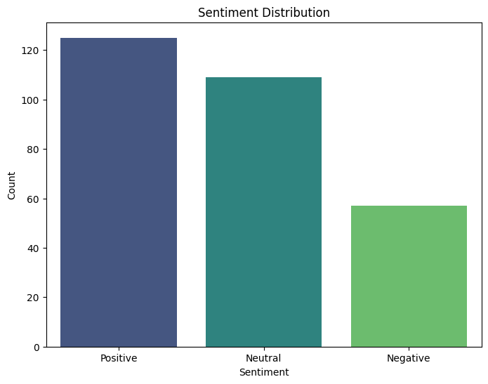

r/Formula1

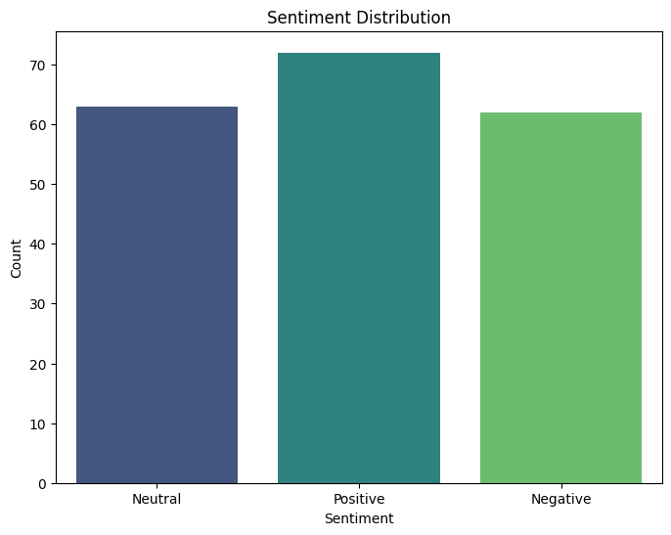

r/Funny

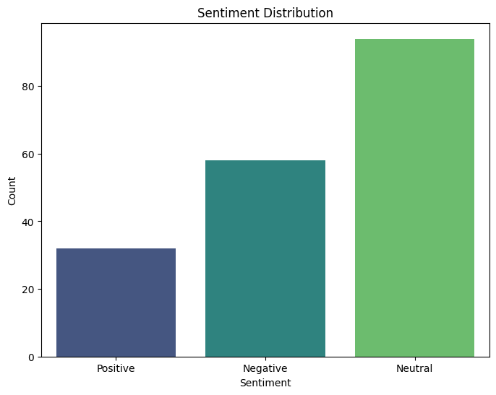

r/Gaming

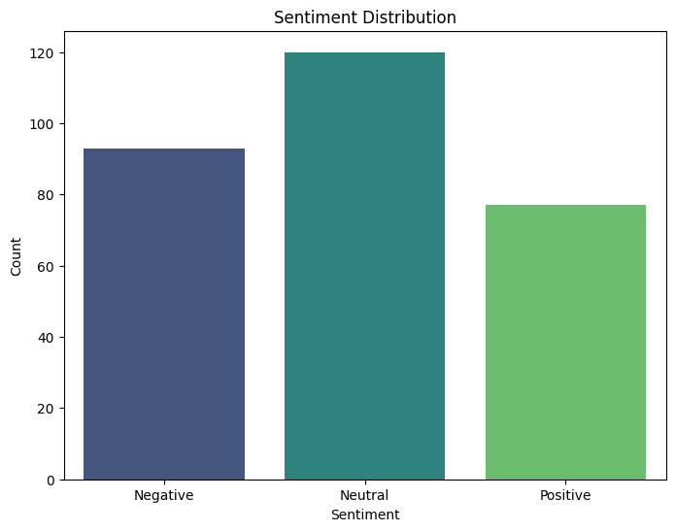

r/Mildlyinfuriating

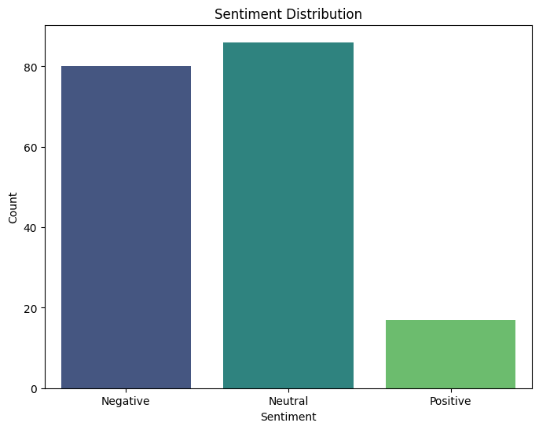

r/NoSleep

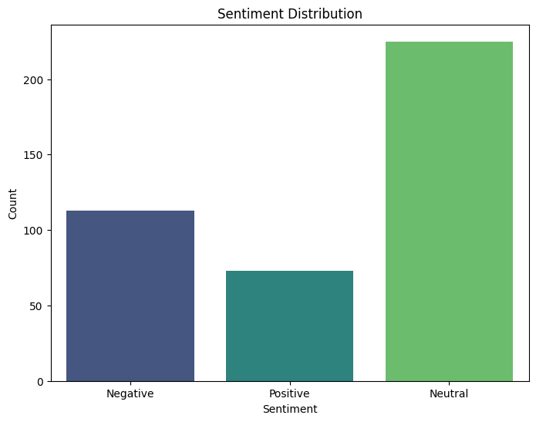

r/Nostupidquestions

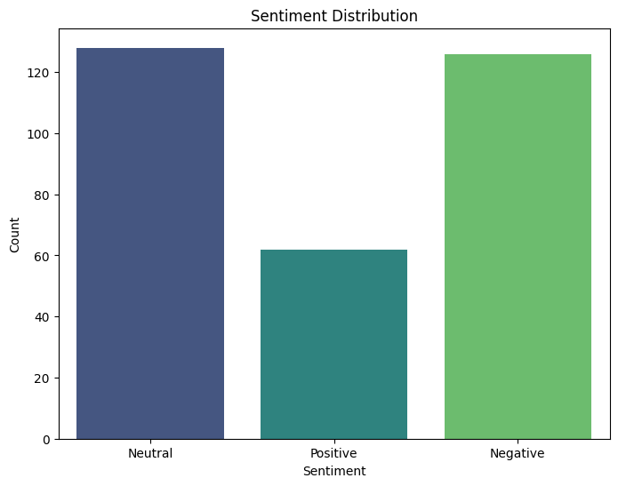

r/Oldpeoplefacebook

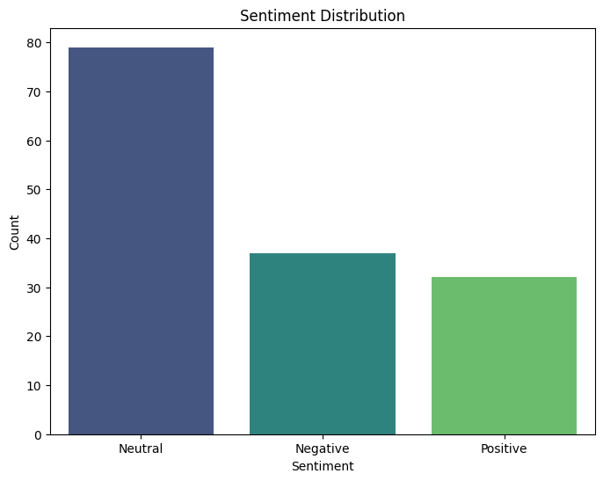

r/Relationships

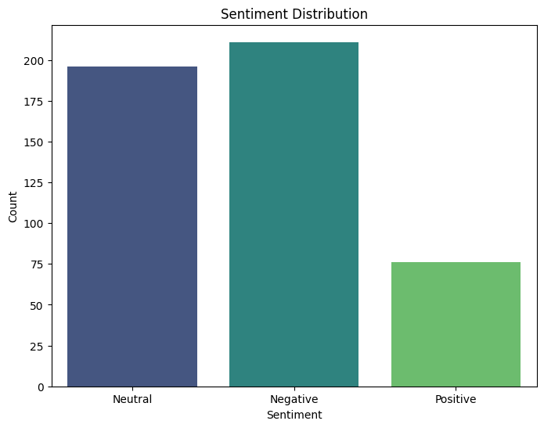

r/TaylorSwift

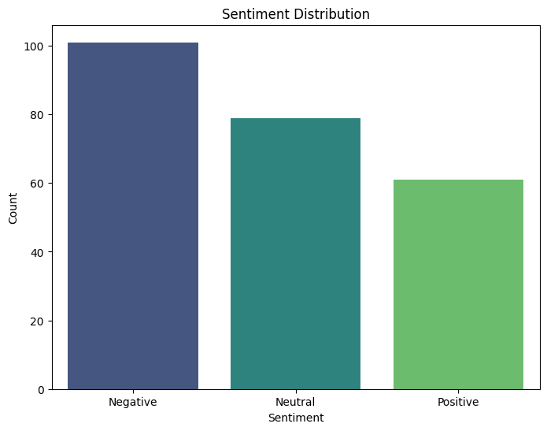

**Key Observations:**

The following are the key observations derived from the sentiment analysis of the 10 subreddits, focusing on the proportionality of positive, negative, and neutral comments:

1. **Positive-Dominant Communities:**

**"r/cats"** and **"r/formula1"** show a higher proportion of positive comments, aligning with expectations for these communities. This suggests that discussions in these subreddits are generally uplifting or enthusiastic. The positive sentiment likely reflects the community's shared passion for topics such as pet appreciation in **"r/cats"** and motorsport excitement in **"r/formula1."**

These results indicate that both subreddits foster a supportive and celebratory environment, where members engage positively with the content and with each other.

1. **Neutral-Predominant Communities with Notable Secondary Sentiment:**

**"r/funny"** has a predominantly neutral sentiment, with negative comments as the second most frequent. This may suggest that while many users may simply acknowledge or react neutrally to humorous content, a significant portion of comments might express mild disapproval, disagreement, or critique of the humor presented.

**"r/mildlyinfuriating"** also shows a predominant neutral sentiment, closely followed by negative comments. This likely reflects the subreddit’s focus on mildly annoying situations where most users describe or share their experiences factually, while others express frustration or irritation, which accounts for the higher negative sentiment.

1. **Communities with Balanced Sentiment Profiles:**

**"r/gaming"** demonstrates a balanced sentiment profile, where positive and negative comments are almost equal, but neutral sentiment dominates. This reflects the diverse nature of discussions in the gaming community, where players express both enjoyment and frustration. The high proportion of neutral comments suggests that much of the conversation might be focused on factual statements, questions, or informative content, rather than strong emotional reactions.

**"r/nosleep"** is predominantly neutral, with a lower proportion of negative comments. This is likely due to the nature of the subreddit, which focuses on storytelling. Most comments may be factual or neutral feedback on the stories, with a few expressing mild discomfort or fear.

1. **Communities with Predominantly Neutral or Negative Sentiment:**

**"r/nostupidquestions"** presents a nearly equal proportion of neutral and negative comments, with positive comments being comparatively low. This might indicate that while some users provide factual or straightforward answers (neutral), others may express disagreement, criticism, or impatience, contributing to the negative sentiment.

**"r/oldpeoplefacebook"** shows a primarily neutral sentiment, with a small but notable amount of negative comments, and a close third of positive comments. This balance may suggest that while many users react neutrally to posts, some may find them amusing (positive), while others may react negatively, possibly finding the content cringeworthy or inappropriate.

1. **Communities with High Neutral and Secondary Negative Sentiment:**

**"r/relationships"** exhibits a high proportion of neutral comments, closely followed by a significant amount of negative comments and a low level of positive sentiment. This pattern is expected, given that the subreddit often deals with complex, personal issues. Many comments may be neutral, offering advice or factual information, while the substantial negative sentiment likely arises from emotionally charged discussions or difficult situations shared by the users.

1. **Negative-Dominant Community:**

**"r/taylorswift"** unexpectedly shows a predominant negative sentiment, with neutral comments in second place and positive comments being the least frequent. This result could indicate a high level of criticism or polarized opinions within this community, potentially reflecting recent events, controversies, or debates surrounding the artist that have driven a shift toward a more negative tone.

1. **High Proportion of Neutral Comments:**
   * A notable observation across all subreddits is the high proportion of comments classified as neutral. This could suggest that many discussions consist of factual statements, questions, or comments that do not carry an explicit emotional load.
   * The prevalence of neutral sentiment may also reflect the limitations of the current models in detecting subtle or implicit emotional cues, such as mild positivity or negativity, sarcasm, or irony.

**3.3 Trends and Patterns in Sentiment**

**1.** Sentiment Variation Across Different Subreddits:

* The analysis shows that subreddits with a more specific and focused theme (e.g., **"r/cats"** and **"r/formula1**") tend to have clearer sentiment profiles, with a predominantly positive sentiment. This is likely due to the communities' shared enthusiasm for their respective topics, such as pet appreciation in **"r/cats"** and motorsports in **"r/formula1,"** which naturally encourage supportive and celebratory interactions.
* Conversely, subreddits like **"r/funny"** and **"r/mildlyinfuriating"** display a predominance of neutral sentiment, with negative sentiment appearing as a significant secondary category. This suggests that even in communities typically associated with humor or light frustration, there is a substantial amount of engagement that does not evoke strong positive or negative emotions. In the case of **"r/funny,"** this may indicate that while some users appreciate the humor, others react with mild criticism or disinterest. For **"r/mildlyinfuriating,"** the neutral and negative balance reflects the subreddit’s purpose of sharing mildly frustrating experiences.
* Subreddits such as **"r/gaming"** and **"r/nostupidquestions"** show a more balanced sentiment distribution, where neutral comments are predominant, but positive and negative sentiments are also present in relatively equal proportions. This balance suggests that these communities engage in diverse discussions, combining factual statements, questions, supportive responses, and critical commentary.
* In subreddits like **"r/relationships"** and **"r/taylorswift,"** there is a notable combination of high neutral and negative sentiment, with relatively low positive sentiment. For **"r/relationships,"** this is likely due to the nature of the discussions, which often revolve around personal challenges and emotionally charged situations, leading to a higher occurrence of negative and neutral responses. Meanwhile, **"r/taylorswift"** exhibits an unexpected predominance of negative sentiment, suggesting a community currently involved in debates, controversies, or polarized opinions related to the artist.

**2. Temporal Changes in Sentiment:**

* Although specific temporal data was not analyzed in detail, it is worth noting that sentiment in subreddits like **"r/taylorswift"** and **"r/relationships"** may fluctuate significantly over time. For instance, **"r/taylorswift"** might experience shifts toward more negative or positive sentiment based on recent news, events, or releases related to the artist, reflecting the dynamic nature of fan discussions.
* Similarly, in **"r/gaming,"** sentiment might vary with the release of new games, updates, or changes within the gaming industry. Positive sentiment could rise around highly anticipated game releases or successful updates, while negative sentiment could spike due to unpopular changes, bugs, or controversies.
* For subreddits with more stable, topic-focused content like **"r/cats"** or **"r/formula1,"** temporal changes in sentiment may be less pronounced, reflecting a generally consistent community culture that leans positive, driven by ongoing pet appreciation and sports enthusiasm.

By monitoring these patterns over time, it may be possible to gain deeper insights into how community sentiment evolves in response to external events, internal community dynamics, or content trends.

**3.4 Challenges and Limitations Noted in the Results**

1. **Neutral Sentiment Classification:**
   * The high volume of neutral sentiment detected poses challenges in deriving more nuanced insights. Neutral sentiment could represent either genuinely factual or emotionally neutral statements or indicate limitations in the models' ability to capture subtle emotional tones.
2. **Model Disagreement and Misclassifications:**
   * Instances of disagreement between the RoBERTa and VADER models highlight potential areas for improvement. For example, RoBERTa may capture more contextually nuanced sentiments that VADER overlooks, or vice versa. These discrepancies suggest that further calibration or model refinement is needed to enhance overall accuracy.
3. **Difficulty Handling Complex Language Constructs:**
   * The results suggest that the pipeline struggles with detecting sarcasm, irony, or indirect sentiment, which are common in Reddit discussions. Addressing these complexities would require incorporating additional contextual analysis techniques or refining model training.

**3.5 Summary of Findings**

* Overall, the sentiment analysis pipeline provides valuable insights into the tone and nature of discussions across different subreddits. While it effectively captures broad sentiment trends, particularly in distinguishing more positive communities from negative ones, the high volume of neutral classifications and occasional model disagreements indicate areas for further refinement.
* Despite these challenges, the pipeline demonstrates potential as a tool for understanding community sentiment, identifying potentially toxic or contentious communities, and supporting content moderation and community management efforts.

1. **Challenges and Limitations**

Despite the promising results obtained from the sentiment analysis pipeline, several challenges and limitations were identified that impact its overall effectiveness and accuracy. These limitations highlight areas where further refinements and adjustments are necessary to enhance the pipeline's performance and ensure it accurately captures the complexities of Reddit comments.

**4.1 High Proportion of Neutral Sentiment**

* **Challenge**:  
  A significant proportion of comments across most subreddits were classified as neutral, even in communities where a stronger emotional response might be expected (e.g., "r/funny" or "r/relationships"). This high volume of neutral sentiment poses challenges in deriving nuanced insights from the data.
* **Explanation**:  
  Neutral classifications could represent genuinely factual or emotionally neutral statements, such as questions or descriptive comments. However, they may also indicate the limitations of the models used in capturing subtle emotional tones, such as mild positivity, mild negativity, sarcasm, or irony, which are common in social media interactions.
* **Potential Solutions**:
  + **Fine-Tuning Models on Domain-Specific Data**: To reduce the number of neutral classifications, further fine-tuning of the RoBERTa model on Reddit-specific data could help capture the unique language patterns, cultural references, and context-specific expressions used on the platform.
  + **Incorporating Additional Models**: Introducing models specialized in detecting sarcasm, irony, or subtle emotional expressions (e.g., GPT-based models or attention-based networks) could help improve sentiment classification accuracy.
  + **Weighted Adjustments**: Experimenting with different weighting strategies for sentiment scores to prioritize less neutral classifications when there is a high model confidence in positive or negative sentiment.

**4.2 Model Disagreement and Misclassifications**

* **Challenge**:  
  There were instances where the RoBERTa and VADER models disagreed in their sentiment classifications, leading to potential misclassifications. This discrepancy may arise from their different approaches: RoBERTa, a deep learning model, relies on contextual embeddings and large-scale data, whereas VADER is a rule-based model dependent on a predefined lexicon.
* **Explanation**:  
  Disagreements between the models can occur in cases where:
  + The sentiment is context-dependent, and the rule-based approach of VADER lacks the nuanced understanding provided by RoBERTa.
  + The RoBERTa model may overfit to Twitter-specific data nuances or miss domain-specific references unique to Reddit.
* **Potential Solutions**:
  + **Refining the Voting Mechanism**: Develop a more sophisticated ensemble method that considers the strengths of each model. For example, using a weighted average or confidence-based stacking method could yield more accurate final sentiment predictions.
  + **Feedback Loop for Continuous Learning**: Incorporate a mechanism for model retraining based on user feedback or manual corrections to improve model performance over time.

**4.3 Difficulty in Detecting Sarcasm, Irony, and Complex Language Constructs**

* **Challenge**:  
  The pipeline struggles with detecting sarcasm, irony, or comments that use complex linguistic structures to convey sentiment indirectly. This is a common issue in social media sentiment analysis, especially on a platform like Reddit, where humor, sarcasm, and cultural references are frequently used.
* **Explanation**:  
  Both RoBERTa and VADER models have limitations in understanding sarcasm and irony:
  + **RoBERTa** might require more domain-specific data or fine-tuning to better understand these complex expressions.
  + **VADER** relies on explicit sentiment indicators in its lexicon, which may not always be present in sarcastic or ironic comments.
* **Potential Solutions**:
  + **Developing a Specialized Sarcasm/Irony Detector**: Train a separate model specifically for detecting sarcasm or irony, using a dataset rich in such examples, and integrate its output into the overall sentiment analysis pipeline.
  + **Contextual Understanding Enhancements**: Incorporate additional context (e.g., previous comments in the thread, user history) to improve sentiment detection. This approach would allow the model to consider the broader conversation when determining whether a comment is sarcastic or ironic.

**4.4 Generalization Issues Due to Training Data**

* **Challenge**:  
  The RoBERTa model was fine-tuned on Twitter data, which may not generalize perfectly to the unique linguistic and cultural environment of Reddit. Reddit has a different style, vocabulary, and context compared to Twitter, which can lead to misclassification of sentiment.
* **Explanation**:  
  While Twitter and Reddit are both social media platforms, their user bases, community norms, and linguistic characteristics differ significantly. For instance, Reddit's comments are often longer, more context-driven, and can involve complex thread structures that are less prevalent on Twitter.
* **Potential Solutions**:
  + **Domain-Specific Fine-Tuning**: Collect a larger and more representative dataset from Reddit for further fine-tuning the RoBERTa model. This would enable the model to better capture the unique linguistic and cultural features of Reddit communities.
  + **Transfer Learning with Reddit-Specific Data**: Use transfer learning techniques to leverage existing sentiment analysis models, adapting them specifically to the Reddit context to improve their understanding and accuracy.

**4.5 Computational Complexity and Resource Requirements**

* **Challenge**:  
  The use of a transformer-based model like RoBERTa requires significant computational resources, especially when processing large volumes of data across multiple subreddits. This can impact the scalability and real-time applicability of the sentiment analysis pipeline.
* **Explanation**:  
  RoBERTa, being a large-scale deep learning model, demands high computational power and memory, which may slow down processing times, particularly for real-time applications or when analyzing thousands of comments.
* **Potential Solutions**:
  + **Model Optimization**: Explore model compression techniques, such as pruning, quantization, or knowledge distillation, to reduce the size and computational requirements of the model without sacrificing too much accuracy.
  + **Use of Lightweight Models for Initial Filtering**: Implement a two-tiered approach where a lightweight model (like VADER) is used for an initial pass to filter out clearly neutral or unambiguous sentiment, followed by the use of RoBERTa for more complex or uncertain cases.
  + **Parallel Processing and Distributed Computing**: Utilize parallel processing and distributed computing frameworks to improve the scalability and efficiency of the sentiment analysis pipeline.

**4.6 Summary of Challenges and Potential Improvements**

While the sentiment analysis pipeline demonstrates a promising capability to analyze and interpret sentiment across different Reddit communities, these challenges and limitations must be addressed to enhance its robustness and reliability. Future work should focus on refining the models, incorporating domain-specific training data, improving computational efficiency, and developing better methods for handling sarcasm, irony, and complex language constructs.

These improvements will help make the pipeline more adaptable to the unique characteristics of Reddit and provide more accurate and meaningful sentiment insights for diverse applications.