1. Set your Phrase username and password in “credentials.txt”. They will be used to log onto Phrase so make sure you use the correct case and spelling.

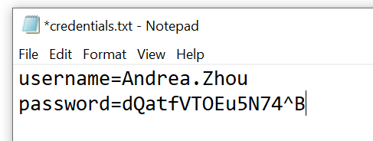

1. Set the base url in “baseurl.txt”, in general there should only be 2 options, “https://cloud9.memsource.com”, or “https://cloud.memsource.com”

Note that there shouldn’t be extra “/” by the end of the base url, or the tool will fail to run.

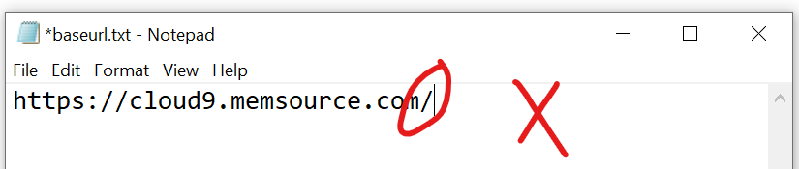

1. Run “main.py” on command line. (you should first go to where main.py is located)

It has 3 parameters: “format” to specify in which format you want the downloaded bilingual files to be, e.g. MXLF, XLIFF, DOCX, if no value is given, then it will be set to “MXLF”; “target” to determine where to put the downloaded files, if no value is given, then it will be set to “C:”; and “id” should be the project’s id on Phrase, this value is required, and if not given the tool will fail to run.

For example, the final command can be:

main.py --format=XLIFF --target=C:\Users\AnZhou\Downloads --id=Y0K7MFt1qdz9eAPQHfZbB1

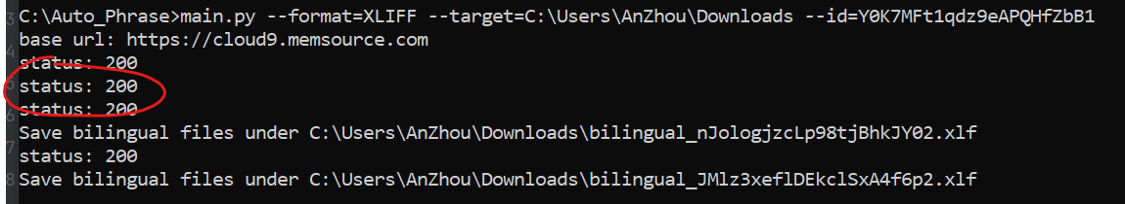

The tool will return “status: 200” if it successfully connects to Phrase and finds the project. If the server is down or project id is wrong, it will return other status codes such as 504 or 404.