**Planning and design**

**General ethos**

The website is meant to be informative in a semi formal, catchy way and to give to its visitors an insight about my course and the modules I am studying in the first year and also some information about me.

The design aims to be user-friendly but also modern and neat, inspired by the <https://trentwalton.com/> website. The menu is easy to use, all the pages having suggestive titles which anticipate their content. The design is consistent and the pages are linked in a logical way. The mobile first approach was documented from <https://developers.google.com/search/mobile-sites> .

It has an eye-catching and sleek color palette, a combination of viridian green and telemagenta over a dark background that creates heightened visual interest and draws the viewer in at first glance. <https://www.awwwards.com/sites/history-of-icons> was an inspiration for the color palette.

**Figure 1. The color palette of the site**

**Site map**

Figure 2. The site map including all the pages

The structure of the site is simple, including a home page and 5 other pages, each of them having a clear purpose in the website. The modules, contact and accessibility page can be accessed from the menu on the home page. The quiz and data visualization pages can only be accessed from the modules page because their content is based on the information provided by this page. This way, the information is structured in a logical way, easy for the users to find.

**Legal issues**

This site contains general information about my degree and the modules I am studying. The modules’ descriptions will be inspired from their official descriptions on the University of Sheffield website <https://www.sheffield.ac.uk/undergraduate/courses/2021/artificial-intelligence-and-computer-science-year-industry-bsc#modules> , but I am going to write them in my own words. However, I am going to provide a link to the official descriptions, so the users can easily go and look them up for more details. In addition, I will include in the brief description on the home page a link to the University of Sheffield website and mention it as a primary source of inspiration.

The images I am going to use will be either my own or taken from the university website. In the latter case, I will include a link to the original picture on the university website under each picture on my site. I think this is the best thing to do, considering it is a university-related project and I will only its official website as the source of my images. Any other pictures taken from the Internet will be copyright free.

**Design mock-ups**

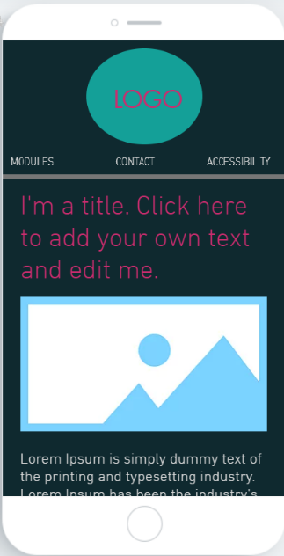

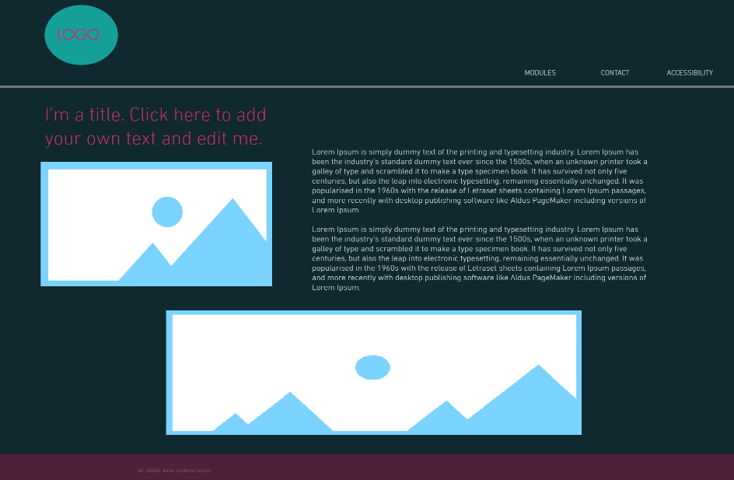

**Figure 3. Home page desktop and mobile mock-up**

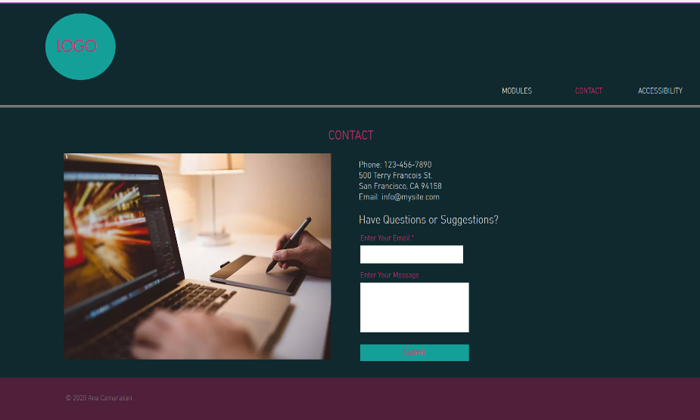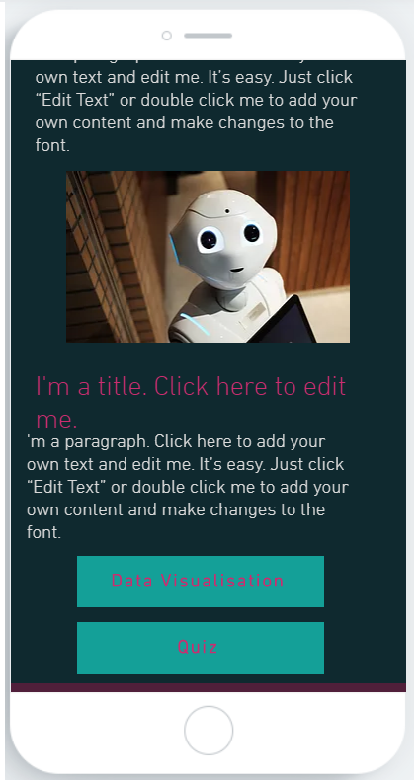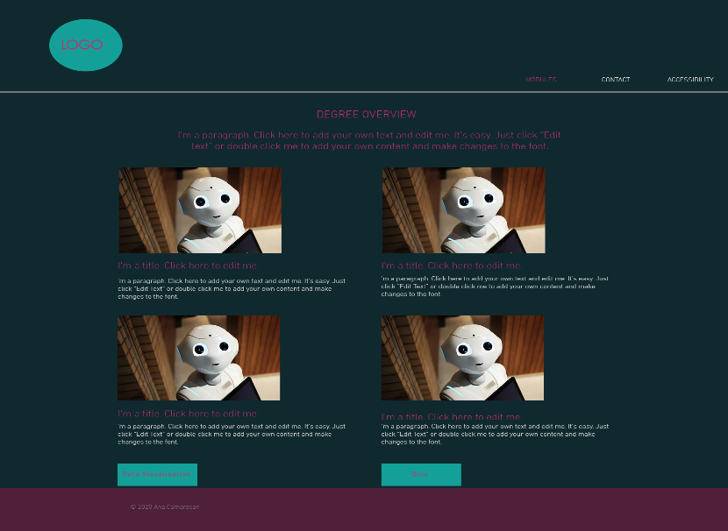

**Figure 4. Modules page desktop and mobile mock-up**

**Figure 2. Home page desktop and mobile mock-up**

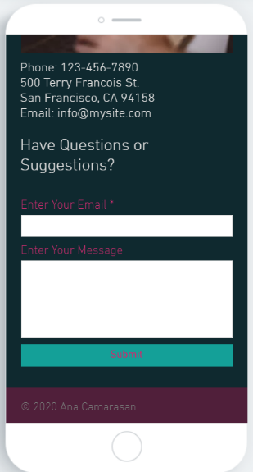

**Figure 5. Contact page desktop and mobile mock-up**

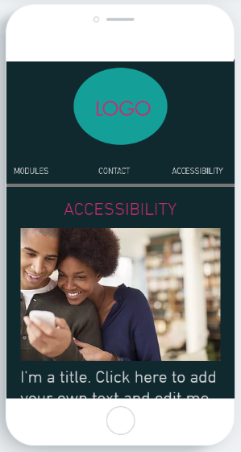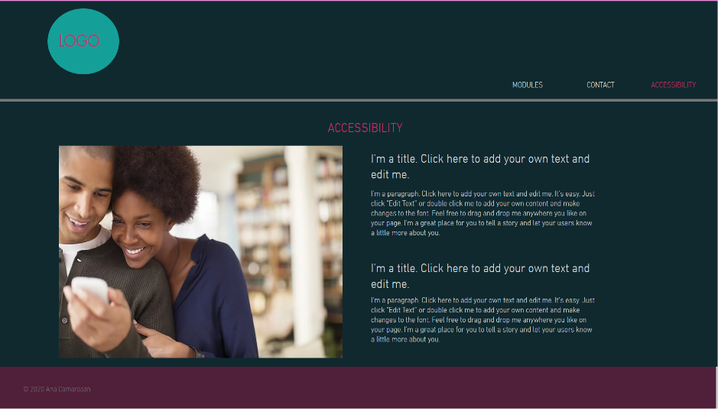

**Figure 6. Accessibility page desktop and mobile mock-up**

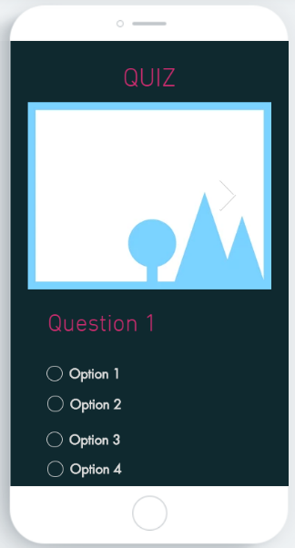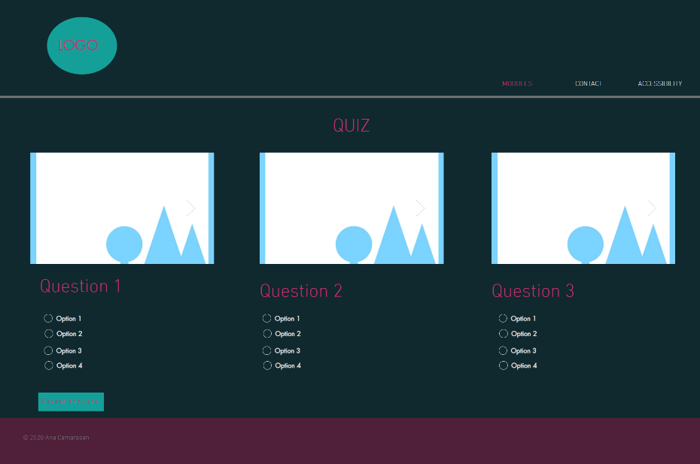

**Figure 7. Quiz page desktop and mobile mock-up**

The design I chose is an efficient one, everything being displayed in a logical order, the website being easy to use. The design is adapted for both desktop and mobile versions as illustrated in the figures above. The website is developed by using Mobile First Responsive Web Design. The design is adapting to increasing screens, the first tweakpoint being when the width is equal or greater than 425px and the navbar containing the menu floats to right. The major breakpoint is when the screen width is equal or greater than 768px when the content is displayed in a different way, the text that was displayed under the pictures floating to right and being positioned next to them.

**Menu System**

The menu system I chose was inspired by the <https://trentwalton.com/> website. The menu is displayed on the top corner of all the pages, as shown in the design mock-ups above, so the navigation between the pages easier, as the user does not need to return to the home page before accessing another one. The menu contains the modules, contact and accessibility pages. The home page can be accessed by the logo on the top left corner and the quiz and data visualization pages can only be accessed from the modules page. On the mobile version, the logo is displayed at the top of every page and the menu is right under it. The menu is displayed all the time on the top of the page with all its contents, a dropdown list being unnecessary because of the small number of pages.

**Accessibility**

* The website does not have much content due to its small number of pages so there are not many accessibility issues that can be addressed, but there still exist some.
* The font-size of all the elements is big enough so even the users with sight deficiencies can read it without struggle.
* There is contrast between the text color and the background color, the text content being readable for all users.
* All the images provide an alternative text for the users who access the site using text-to-speech tools.

**Canvas and JavaScript demo**

This page’s design will be similar to the other ones. The canvas will be adapted to the size of the screen so the data can be easy visualized. There will be 6 buttons. 3 of them will switch between visualizations and the other 3 between color scales. They will be placed under the canvas. All color scales will be in contrast with background color so the whole page will be readable, as stated in the accessibility section. The page will also feature a table which will display the data visualized with canvas.

The data that will be visualized will be the time spent on coursework, watching Netflix and exercising, respectively in three different ways: a bar chart, a pie chart and a doughnut chart.