**Ministerul Educaţiei și Cercetării al Republicii Moldova Universitatea Tehnică a Moldovei**

**Facultatea Calculatoare, Informatică și Microelectronică**

Laboratory work 4:

Dynamic programming

Elaborated:

st. gr. FAF-221 Calugareanu Ana

Verified:

asist. univ. Fiștic Cristofor

prof. univ. Andrievschi-Bagrin Veronica

Chişinău – 2024

**Objective:**

Study and analyze different graph traversing algorithms.

**Tasks:**

1. To study the dynamic programming method of designing algorithms.
2. To implement in a programming language algorithms Dijkstra and Floyd–Warshall using dynamic programming.
3. Do empirical analysis of these algorithms for a sparse graph and for a dense graph.
4. Increase the number of nodes in graphs and analyze how this influences the algorithms. Make a graphical presentation of the data obtained

Theoretical Notes:

Empirical analysis provides an alternative approach to understanding the efficiency of algorithms when mathematical complexity analysis is impractical or insufficient. This method proves beneficial in various scenarios:

1. Initial Insights: It offers preliminary insights into an algorithm's complexity class, aiding in the understanding of its efficiency characteristics.
2. Comparative Analysis: It facilitates the comparison of multiple algorithms tackling the same problem, allowing for informed decisions regarding efficiency.
3. Implementation Comparison: Empirical analysis enables the comparison of different implementations of the same algorithm, providing insights into which may perform better in practice.
4. Hardware-specific Evaluation: It helps in assessing an algorithm's efficiency on a particular computing platform, taking into account hardware constraints and capabilities.

The empirical analysis of an algorithm typically involves the following steps:

Establishing Analysis Goals: Clearly define the objectives and scope of the analysis.

1. Choosing Efficiency Metrics: Select appropriate metrics, such as the number of operations executed or the execution time, based on the analysis goals.
2. Defining Input Data Properties: Determine the characteristics of the input data relevant to the analysis, including data size or specific attributes.
3. Implementation: Develop the algorithm in a programming language, ensuring it accurately reflects the intended logic.
4. Generating Input Data Sets: Create multiple sets of input data to cover a range of scenarios and edge cases.
5. Execution and Data Collection: Execute the program for each input data set, recording relevant performance metrics.
6. Data Analysis: Analyze the collected data, either by computing synthetic quantities like mean and standard deviation or by plotting graphs to visualize the relationship between problem size and efficiency metrics.
7. The choice of efficiency measure depends on the analysis's objectives. For instance, if assessing complexity class or verifying theoretical estimates, counting the number of operations may be suitable. Conversely, if evaluating algorithm implementation behavior, measuring execution time becomes more relevant.

8. Post-execution, recorded results undergo analysis. This involves computing statistical measures or plotting graphs to visualize the algorithm's performance characteristics in terms of problem size and efficiency metrics. Such analyses aid in making informed decisions regarding algorithm selection and optimization strategies.

**Introduction:**

Dijkstra's Algorithm:

Dijkstra's algorithm, named after Dutch computer scientist Edsger W. Dijkstra, is a widely used algorithm for finding the shortest paths between nodes in a graph, particularly for graphs with non-negative edge weights. It is commonly employed in various applications such as network routing protocols and GPS navigation systems.

The algorithm works by iteratively selecting the node with the smallest tentative distance from a set of unvisited nodes and updating the distances to its neighbors accordingly. It maintains a priority queue or a min heap to efficiently select the next node to visit.

Dijkstra's algorithm guarantees the shortest path from a single source node to all other nodes in the graph. However, it does not handle negative edge weights and requires non-negative weights for its correctness.

Time Complexity: O(V^2) with adjacency matrix representation and O((V + E)logV) with adjacency list representation, where V is the number of vertices and E is the number of edges in the graph.

Space Complexity: O(V) for storing distances and predecessors.

Floyd-Warshall Algorithm:

The Floyd-Warshall algorithm is a dynamic programming-based algorithm used to find the shortest paths between all pairs of vertices in a weighted graph, including graphs with negative edge weights (but with no negative cycles). It was developed independently by Bernard Roy in 1959 and later by Stephen Warshall in 1962.

The algorithm works by iteratively considering all pairs of vertices as intermediate vertices and updating the shortest path distances between them. It maintains a two-dimensional array to store the shortest distances between all pairs of vertices.

Floyd-Warshall algorithm provides a convenient way to find the shortest paths between all pairs of vertices in a graph, making it suitable for applications such as network topology analysis and traffic routing.

Time Complexity: O(V^3), where V is the number of vertices in the graph.

Space Complexity: O(V^2) for storing the distance matrix.

## **Comparison Metric:**

The comparison metric for this laboratory work will be considered the time of execution of each algorithm (T(n))

## **Input Format:**

As input, each algorithm will receive 8 series of numbers of nodes 4, 8, 16, 32, 64, 128, 256, ,512.

Next, using this numbers of nodes, it will be generated randomly graphs with that amount of nodes.

**Implementation**

All algorithms will be implemented in their naïve form in python an analyzed empirically based on the time required for their completion. While the general trend of the results may be similar to other experimental observations, the particular efficiency in rapport with input will vary depending on memory of the device used.

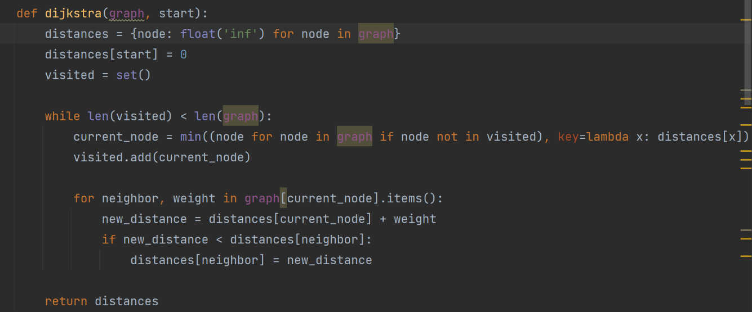Dijkstra Algorithm:

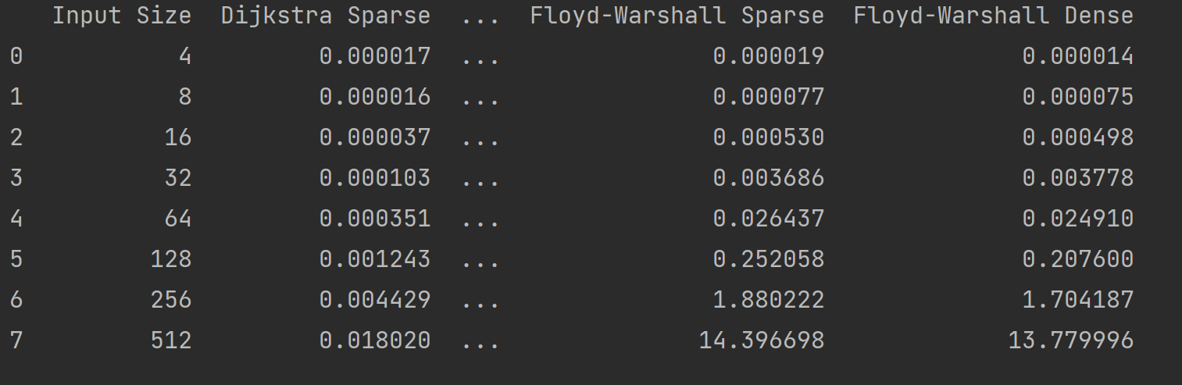

**Figure 1. Time table for algorithms**

As observed in the table, Dijkstra algorithm is faster than Floyd-Warshall in all cases. For a small number of nodes, either the graph is sparse of dense, the algorithms are executed almost in the same time. But as the number of nodes increase, the time also increase considerably for Floyd-Warshall.

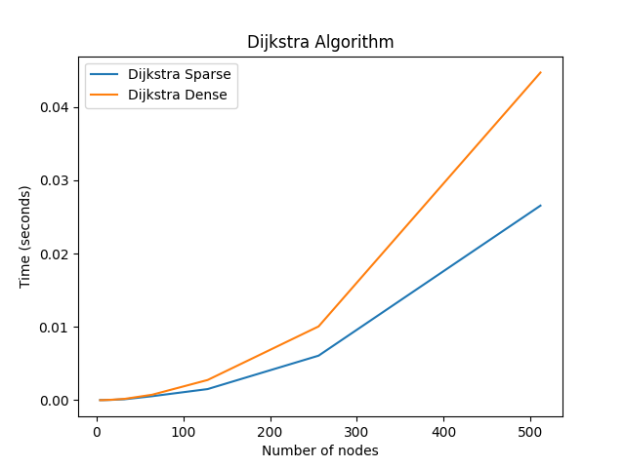**Figure 2. Graph for Dijkstra algorithm**

Floyd-Warshall:

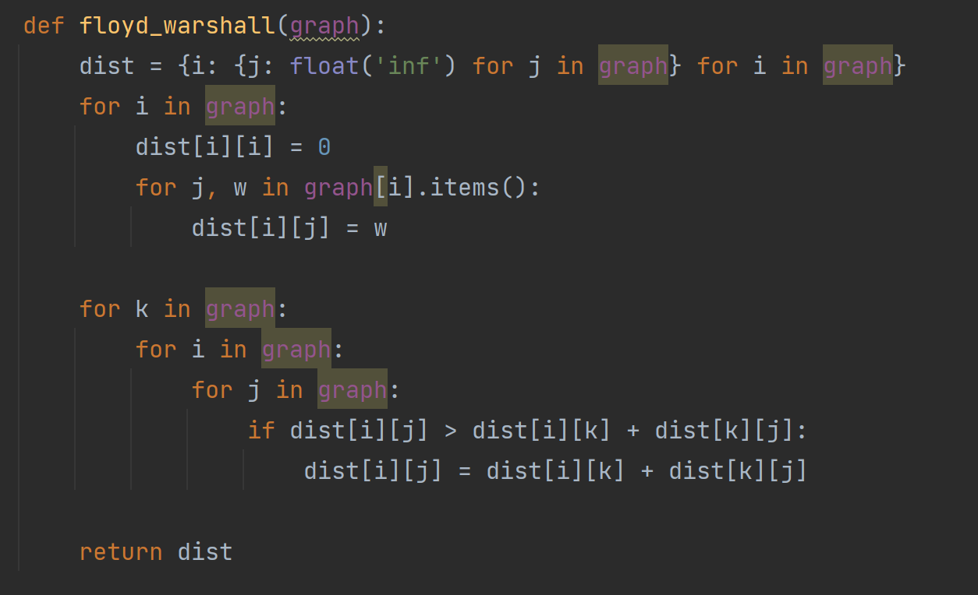

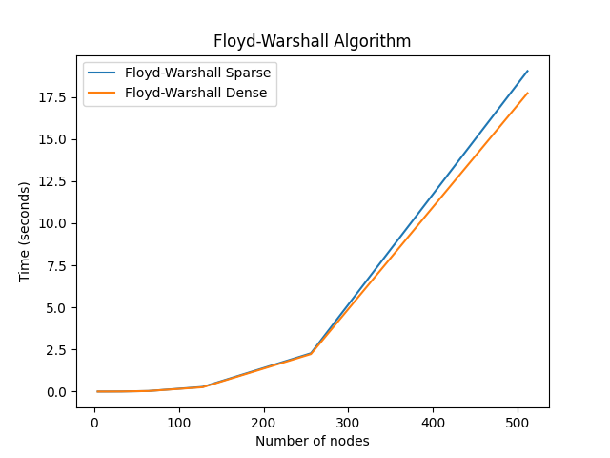

**Conclusion**

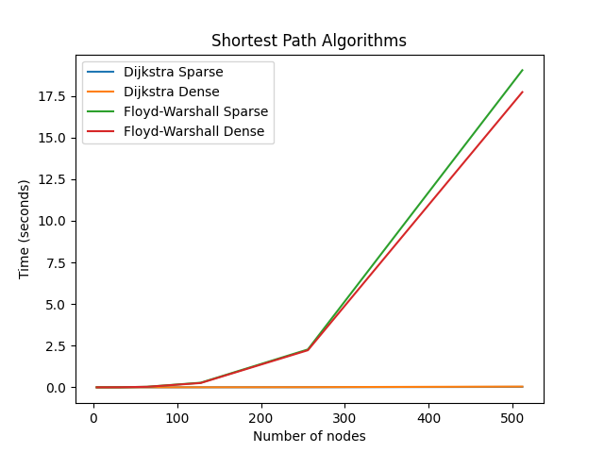

Dijkstra's algorithm is well-suited for finding the shortest paths from a single source node to all other nodes in graphs where all edge weights are non-negative. It uses a greedy approach that prioritizes the least cumulative distance to unvisited nodes, which can be efficiently implemented using priority queues. On the other hand, Floyd-Warshall algorithm takes a dynamic programming approach to calculate the shortest paths between every pair of vertices in a graph, regardless of edge weights, provided there are no negative cycles. This makes Floyd-Warshall particularly useful in applications that require comprehensive path analysis across all node pairs. Dijkstra’s algorithm often has a more favorable computational complexity, especially in sparse graphs, where it can perform significantly faster than Floyd-Warshall's cubic time complexity.

However, the efficiency of Dijkstra’s algorithm is highly dependent on the data structures used in its implementation. Floyd-Warshall’s strength lies in its straightforwardness and lack of special requirements regarding the graph's edge weights, offering a uniform solution for both positive and negative weights. This versatility makes it indispensable for more complex graph scenarios where negative weights are present. While Dijkstra's algorithm is generally faster for most single-source problems, Floyd-Warshall remains unbeatable for ensuring all-pairs connectivity analysis in more intricate graph structures. The choice between Dijkstra's and Floyd-Warshall should be guided by the specific requirements of the problem, including graph size, density, and edge weight conditions. Both algorithms have their place in computational graph theory, each addressing different needs efficiently. In practice, understanding the nature of the graph and the specific requirements of the application will guide the selection of the most appropriate algorithm. For instance, in real-world network analysis or routing problems where edge weights are typically non-negative, Dijkstra's might be the preferred choice. Conversely, for theoretical studies or simulations involving potentially negative weights, Floyd-Warshall offers a more reliable option. Each algorithm's design reflects a strategic compromise between computational complexity and applicability across various graph conditions, highlighting the importance of context in algorithm selection.