Manual QA Test for candidates

**Question 1**

How would you test an ATM? Please write the top tests you would run, and how you will perform them.

The first thing to do is to ask for documentation and certificates, find out which operating system is installed on the ATM, the availability of credit cards and data for testing.

Modern ATMs are computer terminals that combine a variety of equipment.

The minimum required for any ATM is a control computer- a card reader, a pin pad keyboard that serves to enter a PIN code and payment amounts. Also, a device that issues and accepts banknotes, a receipt printer, as well as a set of sensors that monitor the correct operation of ATM subsystems. What are the main operations performed by ATM :

* Transfer funds between linked bank accounts.
* Receive account balance.
* Prints recent transactions list.
* Change your pin.
* Deposit your cash.
* Prepaid mobile recharge.
* Bill payments.
* Cash withdrawal.

The main types of Testing ATM, in my opinion, this is:

* **GUI Testing**—ATM Design, logo
* **Interface Testing**—navigation panel, menu bar, language selection bar, start page. How accurately the interface meets the user's expectations, how fully and efficiently it provides information, how quickly and easily operations are performed, is also the attractiveness of the interface.
* **Accessibility Testing**—accessibility for people with disabilities. Also, to all people in certain conditions, such as noisy or dark. Should be taking an account things such : height of the ATM, large font, voice accompaniment, backlight, contrast ratio, braille font etc.
* **Usability Testing—**the ability to quickly and efficiently perform basic banking operations such as: checking the card balance, depositing cash, transferring money by card number, withdrawing cash, attaching a check, changing a PIN code, printing, SMS message about the completed operation at the ATM. All these operations should be tested by the user, the convenience of performing operations.
* **Globalization Testing**: Internationalization Testing and Localization Testing
* **Performance Testing**: Stress Testing and Load Testing
* **Security Testing** (user data protection)
* **Compatibility Testing** (for example, if I can log in using my phone or smartwatch)
* **Recovery Testing**
* **Functional Testing** (basic banking operations)
* **Tests on positivity** (Positive Testing, Negative Testing)
* **API**

Requirements:

ATM Enabled and working.

ATM connected to the banking network.

ATM has banknotes.

ATM dispenses banknotes.

ATM accepts cards.

ATM has a language choice function.

ATM's security system is working.

Keyboard for entering the PIN code works.

ATM asks for a PIN code.

Returns the card if the PIN code is entered incorrectly three times.

ATM gives out money.

ATM has an SOS function.

ATM issues the card after withdrawing the money.

ATM has other additional functions.

Examples of test cases:

Test case balance request on the ATM screen

1. Make sure that the ATM is working, the main page is displayed.

2. Insert the card. A window appears on the screen with a request to enter a PIN code.

3. If the card is inserted on the wrong side, a warning message will appear on the screen.

4. After entering the code correctly, a menu window appears on the screen with a list of suggested actions. Find and select: Withdraw, then Request a balance.

5. Select the display method on the screen or on the receipt.

6. Select on the screen.

7. Confirm the operation.

8. Check the information on the ATM screen.

Test cases cash withdrawal with incorrect PIN code

1. Insert the card

2. Enter the wrong PIN code.

3. Enter the wrong PIN code again.

4. Enter the wrong PIN code for the 3rd time.

5. The card is blocked. (the ATM writes that the PIN code is entered incorrectly, the card is blocked, contact the support service with the phone numbers)

**Question 2**

Choose a known app you using on your phone and describe three things you don’t like. How would you describe them? Are they bags? Flaw in the design? What should be the desired behavior?

For example, I use the Pango Application. The App works well, but there are some issues.

1. There is no automatic shutdown if you forgot to log in to the application and close the parking time.Parking for 10 minutes, we can pay for the whole day, this is an important feature in the application - to make an automatic shutdown when the car starts moving.

2. The application does not support foreign languages.

3. As a user, I don't like the design of the application, boring and unattractive. I would do GUI Testing of this application. GUI testing evaluates design elements such as layout, colors, fonts, font sizes, labels, text boxes, text formatting, captions, buttons, lists, icons, links and content. I would increase the font, add more attractive graphics elements, and add options for content.

**Question 3**

The following table contains made-up data. Please write SQL queries to answer the questions under the table.

Customer table:

| ID | Name | Occupation | Country |
| --- | --- | --- | --- |
| 1 | John Doe | Personal Assistant | England |
| 2 | Jane Doe | VP R&D | Germany |
| 3 | Larry Page | entrepreneur | USA |
| 4 | Michael Jordan | Athlete | USA |
| 5 | Justin Trudeau | Prime Minister | Canada |

* Write a query that returns the names of customer that live in the US. What would be the output.

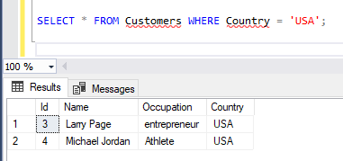

* Write a query that returns the Countries that exist in the table. What would be the output?

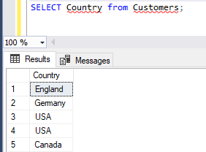

* Write a query that states the number of customers in each Country. What would be the output?

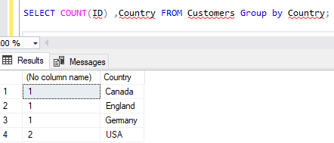

**Question 4 - Bonus**

How would you test an API? Please provide a very high level description of the types of tests you will perform.

API (Application Programming Interface) - The API is, first of all, an interface. An interface that allows developers to use ready-made blocks to build an application, it is a code that allows to applications to exchange data from the server or it can be used as an intermediary between microservices.

API Testing helps to make sure that the program fulfills its goal and will be able to interact correctly with other programs.

The API works on 3 levels:

Application: These are applications that you use on your smartphone, or software.

Programming: Programmers use APIs to write code.

Interface: How you interact with the application.

There are also tools for working with API, for example, Postman is an API tool that allows the tester to send requests to services and work with their responses. You can use it to test the backend and make sure that it works correctly.

I don't have enough knowledge and experience in API yet. I understand that the API is a ready-made code in the form of a library or service. If we take, for example, the Twitter API, then the interface of this service can give us information about the user's tweets, his readers and those who read him, and so on. I hope to study API more deeply in practice.