1. Select \* from Customers order by City desc, ID asc;
2. Update Employees set Birhday = null where Birthday not like ‘%2003’;
3. Select Count (EmployeeID) from Employees where Photo is not null;
4. Update Products set Price = Price \* 1.13 where Category= 'Ice Cream' and

ProductName! ='Magnum' and Price >10 and Supplier='Vitman';

1. Products left join Orders.
2. Select \* from Customers where Country<>'Spain' and City in

('Barcelona', 'Madrid', 'Valencia', 'Malaga') Order by Age desc limit 3;

1. Select Distinct Category as "2021 Categories" from Products;
2. Search for Last names and numbers of orders “number of orders” for employees fulfilling orders and grouping responses by last name for those who have made more than 10 orders.
3. With this command, a table was created.

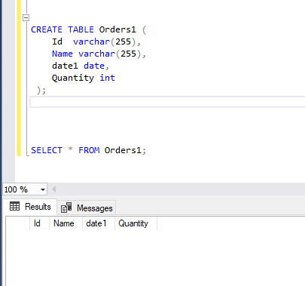

1. Select C.CustomersID, C.CustomerName, Count(O.OrderID) as NumOrders from Customers as Cleft join Orders as O on C.CustomersID = O.CustomerID group by NumOrders Order by NumOrders;