Supplemental Materials for

A Machine Learning Platform for Genotype-specific Cardiotoxicity Risk Prediction Using Patient-Derived iPSC-CMs

Short title: Integration of Disease-Specific iPSC-CM and Machine Learning for Cardiotoxicity Prediction

Yun-Gwi Park^{a,1}, Na Kyeong Park^{b,1}, Youngsun Lee^{c,d,1}, Muhammad Adnan Pramudito^{e,1}, Yeo-Jin Son^{f}, Hyeyeon Park^{c,d}, Ali Ikhsanul Qauli^{e,g}, Seong Woo Choi^{h}, Kiwon Ban^{i}, Jong-il Choi^{j}, Soon-Jung Park^{b,}*, Hun-Jun Park^{k,}*, Ki Moo Lim^{e,g,l,}*, Soo Kyung Koo^{c,d,}*, Jung-Hyun Kim^{c,d,m,}*, Sung-Hwan Moon^{a,}*

* Correspondence to Sung-Hwan Moon (moonsh@cau.ac.kr)

Detailed Methods

Generation and maintenance of iPSC lines
Following initial reprogramming described in the main text, human peripheral blood mononuclear cells were maintained in StemSpan™ SFEM II medium (STEMCELL Technologies, Vancouver, BC, Canada) and reprogrammed to iPSCs using a CytoTune™-iPS 2.0 Sendai Reprogramming Kit (Thermo Fisher Scientific, Waltham, MA, USA), according to the manufacturers’ instructions. The reprogrammed hiPSCs were maintained on Vitronectin-coated plates in TeSR™-E8™ medium (STEMCELL Technologies) at 37 °C in a humidified atmosphere with 5% CO₂. Cells were detached using 0.5 mM EDTA and placed in vitronectin-coated plates with a medium containing 10 μM Y-27632 at a 1:5 ratio. The culture medium was replenished daily (1-3). Two normal hiPSC cell lines (CMC-hiPSC-011 and PB01-EiPS21) and all patient-derived hiPSC lines were provided by the Korea Stem Cell Bank and maintained using the same method as one hiPSC cell line (TnR-hiPS-4F) generated in a previous study (4).

Cardiomyocyte differentiation
The hiPSCs were differentiated into CMs as previously reported (4-6). Briefly, hiPSCs were seeded onto hESC-qualified Matrigel-coated cell culture dishes at 35,000 cells/cm². Y-27632 (10 μM) was added 24 h after the first passage. The medium was changed daily, and hiPSCs were allowed to grow in StemMACS™ iPS-Brew XF for 4 d until 90% confluence. On day 0, to initiate CM induction, the cells were treated with 6 μM of CHIR99021 in cardiomyocyte differentiation medium (CDM) composed of RPMI 1640 (Thermo Fisher Scientific), 500 μg/mL human albumin, and 213 μg/mL L-ascorbic acid-2-phosphate. After 48 h, the medium was changed to CDM containing 2 μM Wnt-C59 (Wnt inhibitor) for another 48 h. On day 5, the medium was replaced with CDM and refreshed every 2 d. Spontaneously, contracting cells began to appear on days 8–10, at which point the medium was replaced every 2 d with Advanced MEM (Thermo Fisher Scientific) containing 100 ng/mL 3,3′,5-triiodo-L-thyronine (Sigma-Aldrich, St. Louis, MO, USA), 1 μM dexamethasone (STEMCELL Technologies), and 2 mM GlutaMAX Supplement (Thermo Fisher Scientific). From days 10 to 15, the medium was replaced with RPMI 1640 medium without glucose and with sodium DL-lactate solution to metabolically select and purify the CMs. Live images were captured using a Tie100 microscope (Nikon, Tokyo, Japan).

Immunofluorescence
Human iPSC-CMs were plated onto gelatin-coated glass dishes and cultured for 5 d, fixed with 4% paraformaldehyde for 20 min at 4 °C, permeabilized with 0.1% Triton X-100 for 10 min at room temperature, and blocked with 0.03% Triton X-100 containing 10% normal goat serum for 30 min at room temperature. Subsequently, the cells were stained with antibodies against TNNT2 (1:500, Abcam, Cambridge, UK) and sarcomeric-α-actinin (SA-Actinin; 1:200, Sigma-Aldrich) diluted in 0.03% Triton X-100 and incubated at 4 °C overnight. The cells were washed three times for 10 min with 0.03% Triton X-100 and incubated with Goat anti-Rabbit IgG (H+L) Cross-Adsorbed Secondary Antibody, Alexa Fluor™ 594 (Thermo Fisher Scientific), Goat anti-Mouse IgG (H+L) Cross-Adsorbed Secondary Antibody, and Alexa Fluor 488 (Thermo Fisher Scientific) antibodies for 1 h at room temperature. The cells were washed four times before counterstaining the nuclei with DAPI staining solution. All images were acquired using a Ti2 fluorescence microscope (Nikon).

Action potential (AP) recording and analysis
The APs of hiPSC-derived cardiomyocytes (hiPSC-CMs) were recorded using a conventional whole-cell current-clamp configuration (Molecular Devices, San Jose, CA, USA). The intracellular pipette solution consisted of 120 mM K-aspartate, 25 mM KCl, 5 mM NaCl, 10 mM HEPES, 0.1 mM EGTA, 1 mM MgCl₂, and 3 mM Mg-ATP (pH 7.25, adjusted with KOH). The extracellular bath solution comprised 145 mM NaCl, 5.4 mM KCl, 1.8 mM CaCl₂, 1 mM MgCl₂, 5 mM glucose, and 10 mM HEPES (pH 7.4, adjusted with NaOH). Patch-clamp recordings were performed on spontaneously beating cardiomyocytes at day 15 post-differentiation under standard conditions to ensure consistent cellular maturity. The APs were recorded and analyzed using Clampex and Clampfit 11 (Molecular Devices). AP parameters were measured to characterize electrophysiological properties, including the maximum diastolic potential, membrane potential at maximum relaxation, and the total change in membrane potential during an AP cycle (Fig. S2A). The APs were classified into ventricular-, atrial-, and nodal-like types based on the following parameters: Ventricular-like: amplitude ≥100 mV; maximum upstroke velocity (V_{max}) ≥10 V/s; APD₈₀ ≥200 ms; APD₂₀₋₃₀/APD₇₀₋₈₀ ratio ≥2.5. Atrial-like: V_{max} ≥10 V/s; APD₈₀ ≤200 ms; APD₂₀₋₃₀/APD₇₀₋₈₀ ratio ≤2.5. Nodal-like: amplitude ≤100 mV; V_{max} ≤10 V/s (Fig. S2B) (7-9). Quantitative analysis of APD₈₀, amplitude, and other AP characteristics was performed to assess cell type distribution and validate the electrophysiological features of each cardiomyocyte subtype.

Microelectrode array (MEA)
Electrophysiological responses to pharmacological agents were assessed by culturing hiPSC-CMs on 96-well MEA plates and recording field potentials using the Maestro Pro platform (Axion BioSystems). Changes in field potential parameters were compared via two independent 5-min recordings between 30 min of drug exposure. Each well was assigned a single concentration, with three or more replicates. The drugs were prepared at a final concentration of 10× [10% (v/v)] in culture medium and added to the wells. The MEA experimental protocol was adapted from previous studies (5, 10). The names and concentrations of the drugs are listed in Table S3. Drug concentrations were selected based on a previous study by Blinova et al (11). Data were analyzed using the Cardiac Analysis Tool (Axion BioSystems).

Data selection and augmentation
Data selection and augmentation were performed to ensure the integrity and relevance of the data to the research objectives. In four samples of normal cells, three samples of LQTS, and two samples of BrS, we assessed the responses to the induction of 28 drugs across four different concentrations, each corresponding to a percentage change in the biomarker field potential duration (FPD), FPD corrected using the Fridericia correction (FPDc) (12), beating period (BP), and amplitude. This information provides crucial insights into drug-induced changes in cellular behavior. Drug potency was classified into two risk categories, high and low/no torsades de pointes (TdP) risk, as previously described (13). We selected drug concentrations based on logarithmic values of 10^{–2} to 10¹ (Fig. S3A). This covers the therapeutic range in which drugs typically show meaningful pharmacological effects without toxicity and ensures that the data accurately represent the most likely cell responses in a clinical setting. Moreover, lower concentrations may not show significant effect and higher concentrations may be impractical. Following data selection, data augmentation was performed by averaging the biomarkers across the four different drug concentrations (Fig. S3B). Here, it is essential that the combined samples come from the same cell type and are treated with the same drug to ensure consistency in the comparisons. This approach enriched our dataset with nuances that could be missed under single concentrations, allowing for a more thorough and accurate analysis of drug effects on cardiomyocyte stem cells.

ML algorithms and grid search for optimal prediction
We developed an artificial neural network (ANN) model using the Keras framework to enhance the accuracy of data classification (Fig. 6B) (14). We initially determined the number of input features and output units based on the previously processed data using four input features (FPD, FPDc, beat period, and amplitude) and two output units, representing the high and no/low TdP risk categories. The ANN architecture was designed with two flexible hidden layers adaptable to varying numbers of units (Fig. 6B) (14). The optimal hyperparameters were selected through a grid search, where we established a broad parameter grid that included various configurations for the hidden layer units as well as the optimizer function (15). We set the hidden layer units to 4, 5, 6, 7, 8, 12, 16, and 32; and for optimizer functions, we selected Adam, RMSprop, and Nadam. Using the K-fold cross-validation approach, we ensured that the model not only performed best on the training data but also exhibited strong generalization when tested on previously unseen data. This optimization process was run in parallel to enhance computational efficiency, using accuracy as the primary evaluation metric. After determining the best hyperparameters using a grid search, the optimized ANN model was trained. The use of callbacks, such as “ModelCheckpoint” and “CSVLogger,” allowed us to closely monitor the training process, save the model at specified intervals, and log the training progress for further analysis.
We utilized a Random Forest (RF) classification model with a grid search approach to enhance predictive accuracy (Fig. 6C) (16). We first defined the number of features from a previously processed dataset. Five-fold cross-validation was conducted with consistent seed checking and setting (14). Unlike the ANN model, which requires defining functions such as those in Keras, the RF model was directly initialized with default parameters and seed settings. The hyperparameter grid search included the number of estimators (n_estimators), maximum tree depth (max_depth), and minimum number of samples per leaf (min_samples_leaf) and was run using “GridSearchCV”; parallelization was performed to search for the parameter combinations yielding the best accuracy score (17). This systematic approach ensured that the RF model was optimally tuned for recognizing patterns in the data and providing robust predictions. After completing the grid search, the best parameters were used to train the model using five-fold cross-validation, and the best-performing fold model was saved. In each fold, the RF model was trained using a data split in which 80% was allocated to the training set and 20% to the validation set. The accuracy results from each fold elucidate the model's performance across different data splits. The trained model was saved for evaluation using the testing data. This approach not only reinforces the reliability of the model but also confirms its robustness to both known and new data, promoting its real-world practicality.
We applied XGBoost, a machine learning algorithm based on gradient boosting, to address the classification problems (Fig. 6D) (18). We first set up a five-fold stratified cross-validation method (StratifiedKFold) ensuring that each fold contained a similar proportion of samples for each class. This approach ensures the representation of all classes across different validation sets, which is crucial for achieving unbiased model performance. The grid of hyperparameters for the XGBoost model included the number of estimators (n_estimators), maximum tree depth (max_depth), learning rate (learning_rate), minimum child weight (min_child_weight), subsample, and “colsample_bytree.” By strategically adjusting these parameters, we aimed to determine the optimal model settings for robustly classifying and predicting outcomes based on the training data. The XGBoost model was initialized with specific settings to prevent warnings during training and utilized “GridSearchCV” on the predetermined hyperparameters. The model was executed with parallelization (“n_jobs=1”), and estimated accuracy as the evaluation metric. The results from the grid search provided the optimal hyperparameters, which were displayed in the output. With the optimized hyperparameters, training was performed with five-fold cross-validation and the best-trained model was saved. We repeated the training for each fold of cross-validation to measure the accuracy of the model on the test set. The final trained model was evaluated using the testing data, ensuring that the model not only performs well on the training data but is generalizable to new unknown datasets.

ML testing mechanism and performance evaluation
We implemented various testing scenarios to evaluate the effectiveness of the model in predicting cell responses to drugs (19). We adopted a structured training and testing approach with clear data division, using 11 drugs for training and 15 drugs for testing within each cell group (normal, LQTS, and BrS) as shown in Fig. 6A. Additionally, we conducted cross-condition testing, in which the model was trained with drugs from one cell type and tested with drugs from another cell type to assess the model’s flexibility.
To predict responses to unknown drugs, our model was trained with known drugs and tested to predict responses to four novel drug candidates across cell types. We also implemented focused condition testing using a subset of drugs from normal cells for training and specific subsets from LQTS or BrS cells for testing to predict the risk of TdP.
Model performance was evaluated by compiling 10,000 test sets (Fig. 7A), each containing 15 samples that included four MEA biomarkers representing information from the 15 drugs tested. Each set was then evaluated using the classification model, generating performance metrics (Equations 1, 2, 3, 4 and 5) over a total of 10,000 runs (20). Model performance was summarized as the median and 95% confidence intervals. Moreover, we individually tested each drug sample to determine the probabilities of different TdP risk levels. Through this approach, we aimed to comprehensively evaluate drug potential based on variations in the associated cellular responses.

$Accuracy=\frac{TP+TN}{TP+TN+FP+FN}$ Equation 1
$Sensitivity=\frac{TP}{TP+FN}$ Equation 2
$Specificity=\frac{TN}{TN+FP}$ Equation 3
$LR+=\frac{Sensitivity}{1-Specificity}$ Equation 4
$LR-=\frac{1-Sensitivity}{Specificity}$ Equation 5

The metrics used to assess system performance were designed to consider the high- and low/no-risk classifications for TdP. The accuracy measurement (Equation 1) indicates how often the model correctly identifies both risk conditions, calculated as the ratio of correct predictions (both positive and negative) to the total number of predictions (21). The sensitivity, or true-positive rate (Equation 2) assesses the model's ability to correctly identify drugs with a high TdP risk, minimizing the risk of overlooking high-risk patients (21). The specificity, or true-negative rate (Equation 3) indicates how accurately the model can recognize drugs with low or no TdP risk, which is crucial for avoiding side effects and promoting disease management. The positive likelihood ratio (LR⁺; Equation 4) indicates the likelihood of a positive test for drugs with a high TdP risk compared to those with a low risk (20, 21). Conversely, the negative likelihood ratio (LR–, Equation 5) indicates the likelihood of a negative test for low-risk drugs compared to high-risk drugs. These ratios inform the interpretation of drug sensitivity and specificity metrics and elaborate on the diagnostic performance of the model under different clinical conditions.

Supplementary figure legend

Figure S1: Beating morphology of human-induced pluripotent stem cell-derived cardiomyocytes (hiPSC-CMs)
Brightfield images of hiPSC-CMs from normal individuals (CMC-011, PB01, and TnR-4F), and patients with LQTS (DPHCi01, DPHCi08, DPHKi20, and DPHCi02) and BrS DPHCi15, DPHKi09, DPHKi08, and DPHKi11). Scale bar: 500 μm.
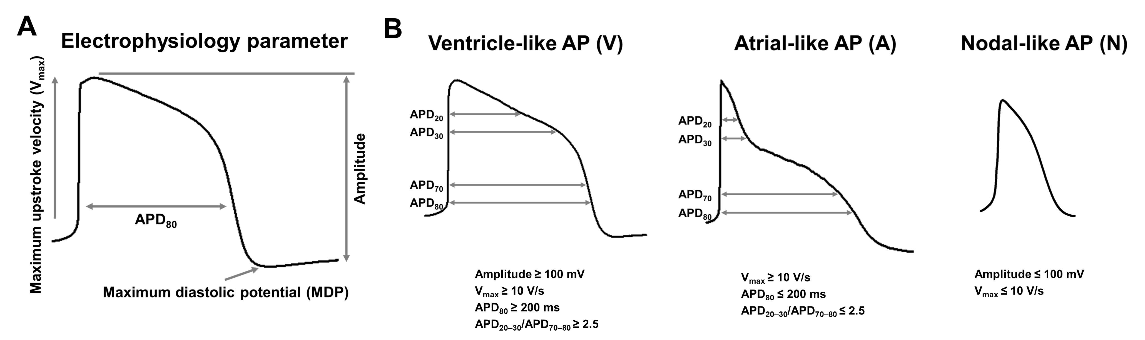
Figure S2: Electrophysiological characterization and classification of hiPSC-CM action potentials (APs)
(A) Key electrophysiological parameters used to assess APs, including maximum upstroke velocity (Vmax), maximum diastolic potential (MDP), amplitude, and action potential duration at 80% repolarization (APD80).
(B) Classification of cardiomyocyte subtypes based on AP criteria: ventricular-like APs (amplitude ≥100 mV, Vmax ≥10 V/s, APD80 ≥200 ms, APD20-30/APD70-80 ratio ≥2.5); atrial-like APs (Vmax ≥10 V/s, APD80 ≤200 ms, APD20-30/APD70-80 ratio ≤2.5); and nodal-like APs (amplitude ≤100 mV, Vmax ≤10 V/s). These parameters provide a comprehensive basis for categorizing cardiomyocyte electrophysiological phenotypes.

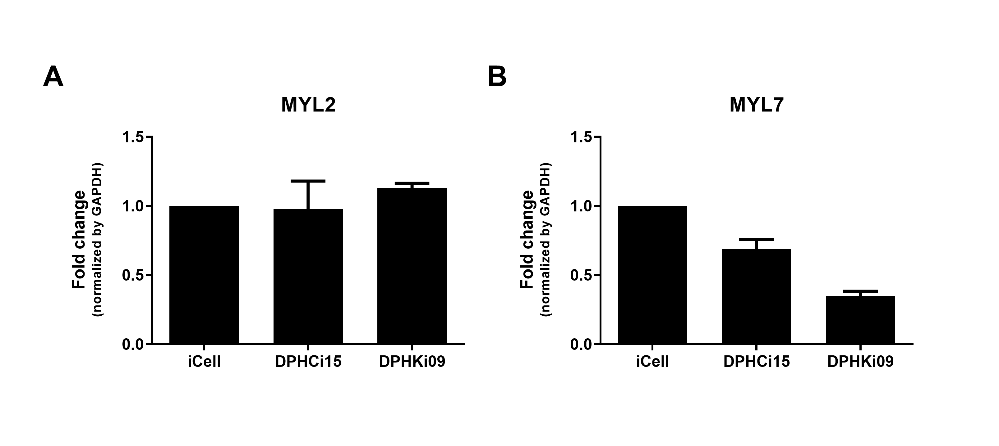
Figure S3: Confirmation of ventricular- and atrial- differentiation potential in BrS cell lines. Expression levels of ventricular- and atrial-CM-specific genes, MYL2 (A) and MYL7 (B) in DPHCi15 and DPHKi09, relative to global control iCell CMs. Data represents mean ± SD. *p < 0.05 compared with iCell cardiomyocytes; n = 3. Student’s t-test was used for statistical analyses. MYL2; Myosin Light Chain 2, MYL7; Myosin Light Chain 7

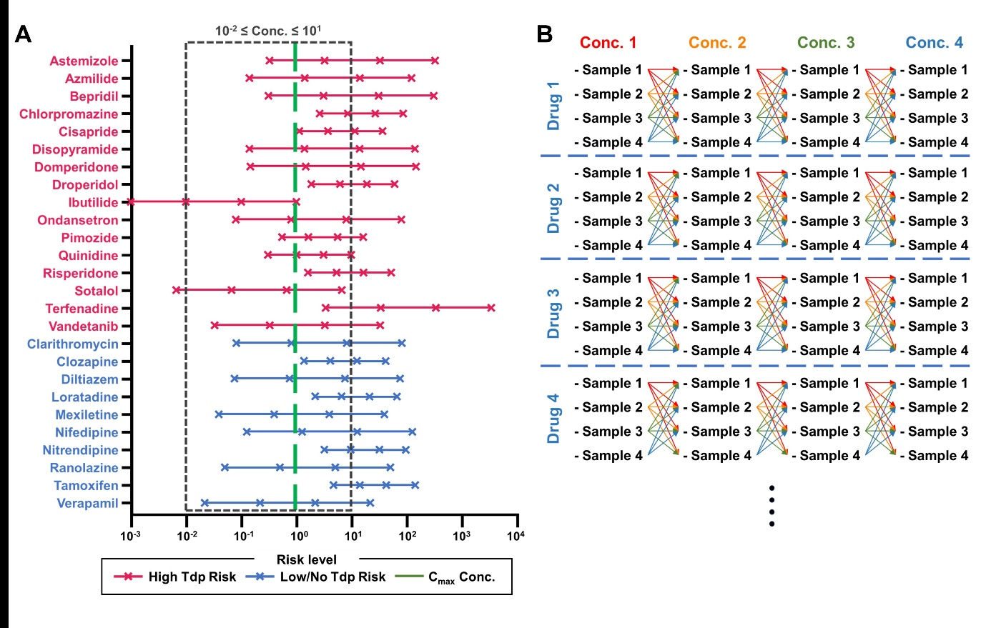

Figure S4: Drug concentration range and data augmentation strategy for machine learning analysis
(A) Drug concentration ranges used for microelectrode array (MEA) analysis and TdP risk classification. Drugs were categorized as high TdP risk (red) or low/no TdP risk (blue) based on clinical and experimental reports. The concentration range of 10⁻² to 10-folds C_{max} (dashed box) represents the clinically relevant range used for analysis. Each drug's maximum plasma concentration (C_{max}, green line) was used as a reference for selecting meaningful concentrations, minimizing effects from sub-therapeutic or toxic doses.
(B) Data augmentation strategy applied to MEA data. Each drug was tested across four concentrations (Conc. 1 to Conc. 4) in samples derived from multiple iPSC-CM lines. Data points from different concentrations were aggregated to generate a consistent and enriched dataset for machine learning. This strategy ensured robustness and reproducibility, facilitating the classification of TdP risk based on changes across the four MEA biomarkers.
This figure highlights the importance of selecting clinically meaningful concentrations and employing data augmentation to improve the accuracy and generalizability of the machine learning models in predicting drug-induced TdP risk.
Figure S5: Machine learning process and TdP risk assessment
(A) Comparison of cell line-specific responses to training drugs using an ANN model trained on the normal cell line database. (B) Comparison of cell line-specific responses to testing drugs using an ANN model trained on the normal cell line database. The dashed line represents the threshold that separates high- and low-TdP risk.
Table S1. Primer sequences used for Sanger sequencing
Gene | Forward sequence  (5ʹ→3ʹ) | Reverse sequence  (5ʹ→3ʹ) | Chromosome location
KCNH2 | GCCCAACAGA  TGAAGCTAGG | GAGGTGGTGA  TGGAGAAGGA | chr7:150656679
KCNQ1 | ACAGGTTGCA  GGGTCTGAAG | ATGACTCACCG  ATGATGGAAAT | chr11: 2591949
KCNQ1 | AGGAAAGAGA  GCTGGGCAAT | CCCTCCGATT  TCCCTCTCAA | chr11: 2594140
KCNH2 | ATGCTCAGAG  AAGTGGGGAC | GAGAAGAGCA  GCGACACTTG | chr7: 150644455
SCN5A | GGTAGAAGGA  CCCCAGGAAG | AGTTGGGTGG  AACATTCTGC | chr3:38647627
SCN5A | ATGGGCATGT  CCTTGAACTC | GCAAGAGGAG  AAAACGGATG | chr3:38646227
ANK2 | CAGGAAACAGCTAT  GACCAACACATCAT  TTACAAAATCACA | TGTAAAACGACGG  CCAGTTGGAATAC  TGGGGAAAAAG | chr4:114284592
KCNE1 | GGCAGGATGT  GTCCAGTTTT | TGTGGCAGGA  GACAGTTCAG | chr21: 35821680
CACNB2b | TTTCAGCTTT  TCGGATGCTT | GGACTCCCTG  TGTCTGTGGT | chr10: 18828345

Table S2. Primer sequences used for qRT-PCR
Gene | Forward sequence  (5ʹ→3ʹ) | Reverse sequence  (5ʹ→3ʹ) | Size (bp) | Gene bank No.
GAPDH | GTATGACAACAGCCTCAAGA | GTAGAGGCAGGGATGATGT | 216 | NM_002046
TNNT2 | GGGTTACATCCAGAAGACAG | GTTATAGATGCTCTGCCACA | 163 | NM_000364
MYH6 | AGTATGAGGAGTCGCAGTCT | CACATTCTTTCCTCCTTCTC | 194 | NM_002471
MYL2 | TTAAGGAGGCCTTCACTATC | GTTGAGAATGGTTTCCTCAG | 218 | NM_000257
MYL7 | CGACCAGAATCGTGATGGCATC | CAAAGAGCGTGAGGAAGACGGT | 193 | NM_021223
bp, basepair.

Table S3. Antibody list
Antibody | Host species | Company | Cat. No. | Dilution
TNNT2 | Rabbit | Abcam | Ab45932 | 1:500
SA-Actinin | Mouse | Sigma aldrich | A7811 | 1:100
Anti-Rabbit-488 | Goat | Thermo scientific | A11008 | 1:700
Anti-Mouse-594 | Goat | Thermo scientific | A11005 | 1:700

Table S4 Machine learning model performance metrics for TdP risk prediction
 | ANN  Training: N  Testing: N | ANN  Training: L  Testing: L | RF  Training: B  Testing: B | ANN  Training: L&B  Testing: L&B | XGBoost  Training: All  Testing: All | ANN  Training: N  Training: L | ANN  Training: N  Training: B | ANN  Training: N  Testing: BL
Accuracy | 0.75  (0.56, 0.94) | 0.8  (0.67, 0.93) | 0.77  (0.62, 0.92) | 0.8  (0.67, 0.87) | 0.75  (0.62, 0.88) | 0.67  (0.47, 0.8) | 0.69  (0.54, 0.92) | 0.67  (0.47, 0.87)
AUC_High | 0.84  (0.63, 1.0) | 0.94  (0.81, 1.0) | 0.86  (0.62, 0.97) | 0.94  (0.81, 1.0) | 0.89  (0.71, 1.0) | 0.76  (0.54, 0.93) | 0.74  (0.54, 0.94) | 0.78  (0.54, 0.94)
AUC_Low | 0.86  (0.63, 1.0) | 0.94  (0.81, 1.0) | 0.86  (0.63, 0.97) | 0.94  (0.81, 1.0) | 0.89  (0.71, 1.0) | 0.76  (0.54, 0.93) | 0.75  (0.53, 0.94) | 0.78  (0.54, 0.94)
Sensitivity_High | 0.78  (0.6, 1.0) | 0.75  (0.64, 0.9) | 0.75  (0.67, 0.9) | 0.75  (0.64, 0.82) | 0.73  (0.62, 0.82) | 0.67  (0.55, 0.8) | 0.8  (0.67, 1.0) | 0.7  (0.56, 0.89)
Sensitivity_Low | 0.75  (0.5, 1.0) | 1.0  (0.6, 1.0) | 0.75  (0.0, 1.0) | 1.0  (0.6, 1.0) | 1.0  (0.6, 1.0) | 0.67  (0.0, 1.0) | 0.5  (0.29, 1.0) | 0.67  (0.33, 1.0)
Specificity_High | 0.75  (0.5, 1.0) | 1.0  (0.6, 1.0) | 0.75  (0.0, 1.0) | 1.0  (0.6, 1.0) | 1.0  (0.6, 1.0) | 0.67  (0.0, 1.0) | 0.5  (0.29, 1.0) | 0.67  (0.33, 1.0)
Specificity_Low | 0.78  (0.6, 1.0) | 0.75  (0.64, 0.9) | 0.75  (0.67, 0.9) | 0.75  (0.64, 0.82) | 0.73  (0.62, 0.82) | 0.67  (0.55, 0.8) | 0.8  (0.67, 1.0) | 0.7  (0.56, 0.89)
F1_S | 0.75  (0.55, 0.94) | 0.76  (0.53, 0.93) | 0.64  (0.51, 0.9) | 0.76  (0.53, 0.85) | 0.73  (0.56, 0.87) | 0.6  (0.44, 0.78) | 0.68  (0.51, 0.9) | 0.64  (0.44, 0.86)
F1_S_High | 0.8  (0.59, 0.95) | 0.86  (0.74, 0.95) | 0.84  (0.74, 0.95) | 0.84  (0.74, 0.9) | 0.82  (0.7, 0.9) | 0.76  (0.63, 0.86) | 0.78  (0.63, 0.94) | 0.76  (0.59, 0.9)
F1_S_Low | 0.71  (0.46, 0.92) | 0.67  (0.29, 0.91) | 0.5  (0.29, 0.86) | 0.67  (0.29, 0.8) | 0.67  (0.4, 0.83) | 0.44  (0.22, 0.73) | 0.57  (0.29, 0.86) | 0.55  (0.22, 0.83)
LR_p_High | 0.78  (0.6, 1.9) | 749999.95  (1.75, 900000) | 0.89  (0.67, 1.9) | 692309.73  (1.75, 818000) | 692308.4  (1.59, 818000) | 2.0  (0.57, 750000) | 1.71  (0.93, 818000) | 2.0  (0.83, 818000)
LR_p_Low | 0.75  (0.5, 1.78) | 4.0  (2.0, 10.0) | 0.75  (0.0, 1.0) | 4.0  (2.0, 5.5) | 3.25  (1.65, 5.5) | 2.0  (0.0, 4.0) | 3.33  (0.86, 667000) | 2.0  (0.75, 7.5)
LR_n_High | 0.31  (0.0, 0.8) | 0.25  (0.1, 0.5) | 0.25  (0.1, nan) | 0.25  (0.18, 0.5) | 0.31  (0.18, 0.61) | 0.5  (0.25, 429000) | 0.3  (0.0, 1.17) | 0.5  (0.13, 1.33)
LR_n_Low | 0.29  (0.0, 0.83) | 0.0  (0.0, 0.57) | 0.28  (0.0, 1.5) | 0.0  (0.0, 0.57) | 0.0  (0.0, 0.63) | 0.5  (0.0, 1.75) | 0.58  (0.0, 1.07) | 0.5  (0.0, 1.2)
ANN, artificial neural network; RF, Random Forest; TdP, torsades de pointes

References
1. Lee Y, Koo SK, Kim JH. Establishment of a human-induced pluripotent stem cell line, KSCBi014-A, from a long QT syndrome type 2 patient harboring a KCNH2 mutation. Stem Cell Res. 2021;57:102570.
2. Lee Y, Park H, Kyung Koo S, Kim JH. Establishment of a human induced pluripotent stem cell line, KSCBi015-A, from a long QT syndrome type 1 patient harboring a KCNQ1 mutation. Stem Cell Res. 2021;56:102521.
3. Park NK, Park SJ, Park YG, Moon SH, Woo J, Kim HJ, et al. Translation reinitiation in c.453delC frameshift mutation of KCNH2 producing functional hERG K+ channels with mild dominant negative effect in the heterozygote patient-derived iPSC cardiomyocytes. Hum Mol Genet. 2024;33(2):110-21.
4. Park SJ, Kim H, Lee S, Kim J, Jung TH, Choi SW, et al. Effect and application of cryopreserved three-dimensional microcardiac spheroids in myocardial infarction therapy. Clin Transl Med. 2022;12(1):e721.
5. Choi SW, Shin JS, Park SJ, Jung E, Park YG, Lee J, et al. Antiviral activity and safety of remdesivir against SARS-CoV-2 infection in human pluripotent stem cell-derived cardiomyocytes. Antiviral Res. 2020;184:104955.
6. Park SJ, Kim RY, Park BW, Lee S, Choi SW, Park JH, et al. Dual stem cell therapy synergistically improves cardiac function and vascular regeneration following myocardial infarction. Nat Commun. 2019;10(1):3123.
7. Garg P, Oikonomopoulos A, Chen H, Li Y, Lam CK, Sallam K, et al. Genome Editing of Induced Pluripotent Stem Cells to Decipher Cardiac Channelopathy Variant. J Am Coll Cardiol. 2018;72(1):62-75.
8. Ma J, Guo L, Fiene SJ, Anson BD, Thomson JA, Kamp TJ, et al. High purity human-induced pluripotent stem cell-derived cardiomyocytes: electrophysiological properties of action potentials and ionic currents. Am J Physiol Heart Circ Physiol. 2011;301(5):H2006-17.
9. Riedel M, Jou CJ, Lai S, Lux RL, Moreno AP, Spitzer KW, et al. Functional and pharmacological analysis of cardiomyocytes differentiated from human peripheral blood mononuclear-derived pluripotent stem cells. Stem Cell Reports. 2014;3(1):131-41.
10. Yuan X, Yu T, Zhang Z, Li S. Non-invasive assessment of proarrhythmic risks associated with isoprenaline and the dietary supplement ingredient synephrine using human induced pluripotent stem cell-derived cardiomyocytes. Front Cardiovasc Med. 2024;11:1407138.
11. Blinova K, Dang Q, Millard D, Smith G, Pierson J, Guo L, et al. International Multisite Study of Human-Induced Pluripotent Stem Cell-Derived Cardiomyocytes for Drug Proarrhythmic Potential Assessment. Cell Rep. 2018;24(13):3582-92.
12. Fridericia LS. The duration of systole in an electrocardiogram in normal humans and in patients with heart disease. 1920. Ann Noninvasive Electrocardiol. 2003;8(4):343-51.
13. Passini E, Britton OJ, Lu HR, Rohrbacher J, Hermans AN, Gallacher DJ, et al. Human In Silico Drug Trials Demonstrate Higher Accuracy than Animal Models in Predicting Clinical Pro-Arrhythmic Cardiotoxicity. Front Physiol. 2017;8:668.
14. Tarun Kumar Gupta KR. Chapter 7 - Optimization of ANN Architecture: A Review on Nature-Inspired Techniques. Machine Learning in Bio-Signal Analysis and Diagnostic Imaging: Acedemic Press; 2019. p. 159-82.
15. Fuadah YN, Pramudito MA, Lim KM. An Optimal Approach for Heart Sound Classification Using Grid Search in Hyperparameter Optimization of Machine Learning. Bioengineering (Basel). 2022;10(1).
16. Nayarisseri A, Khandelwal R, Tanwar P, Madhavi M, Sharma D, Thakur G, et al. Artificial Intelligence, Big Data and Machine Learning Approaches in Precision Medicine & Drug Discovery. Curr Drug Targets. 2021;22(6):631-55.
17. Mahardika TN, Qauli AI, Marcellinus A, Lim KM. Evaluation of cardiac pro-arrhythmic risks using the artificial neural network with ToR-ORd in silico model output. Front Physiol. 2024;15:1374355.
18. Tarwidi D, Pudjaprasetya SR, Adytia D, Apri M. An optimized XGBoost-based machine learning method for predicting wave run-up on a sloping beach. MethodsX. 2023;10:102119.
19. Li Z, Ridder BJ, Han X, Wu WW, Sheng J, Tran PN, et al. Assessment of an In Silico Mechanistic Model for Proarrhythmia Risk Prediction Under the CiPA Initiative. Clin Pharmacol Ther. 2019;105(2):466-75.
20. Lu HR, Zeng H, Kettenhofen R, Guo L, Kopljar I, van Ammel K, et al. Assessing Drug-Induced Long QT and Proarrhythmic Risk Using Human Stem-Cell-Derived Cardiomyocytes in a Ca2+ Imaging Assay: Evaluation of 28 CiPA Compounds at Three Test Sites. Toxicol Sci. 2019;170(2):345-56.
21. Jeong DU, Yoo Y, Marcellinus A, Kim KS, Lim KM. Proarrhythmic risk assessment of drugs by dV(m) /dt shapes using the convolutional neural network. CPT Pharmacometrics Syst Pharmacol. 2022;11(5):653-64.

Supplementary video legend
Video S1. The spontaneous beating pattern of iPSC-CMs from the CMC-hiPS-011 cell line
Video S2. The spontaneous beating pattern of iPSC-CMs from the PB01-EiPS21 cell line
Video S3. The spontaneous beating pattern of iPSC-CMs from the TnR-hiPS-4F cell line
Video S4. The spontaneous beating pattern of iPSC-CMs from the DPHCi01 cell line
Video S5. The spontaneous beating pattern of iPSC-CMs from the DPHCi08 cell line
Video S6. The spontaneous beating pattern of iPSC-CMs from the DPHKi20 cell line
Video S7. The spontaneous beating pattern of iPSC-CMs from the DPHCi02 cell line
Video S8. The spontaneous beating pattern of iPSC-CMs from the DPHCi15 cell line
Video S9. The spontaneous beating pattern of iPSC-CMs from the DPHKi09 cell line
Video S10. The spontaneous beating pattern of iPSC-CMs from the DPHKi08 cell line
Video S11. The spontaneous beating pattern of iPSC-CMs from the DPHKi11 cell line

