A Comprehensive System of Algorithms for Characterization of Cardiomyocyte Mechanical and Electrical Function
Daniil A. Kabanov^{1,2}, Simon Vrana¹, Deborah Beckerová^{3,4}, Vladimír Rotrekl^{3,4}, Martin Pešl^{3,4}, Jan Přibyl^{1*}
¹ CEITEC MU, Masaryk University, Brno, Czech Republic
² Department of Biochemistry, Faculty of Science, Masaryk University, Brno, Czech Republic.
³ Department of Biology, Faculty of Medicine, Masaryk University
⁴ ICRC-FNUSA, Brno, Czech Republic
*Corresponding author. E-mail: Jan.Pribyl@ ceitec.muni.cz

Supplementary material
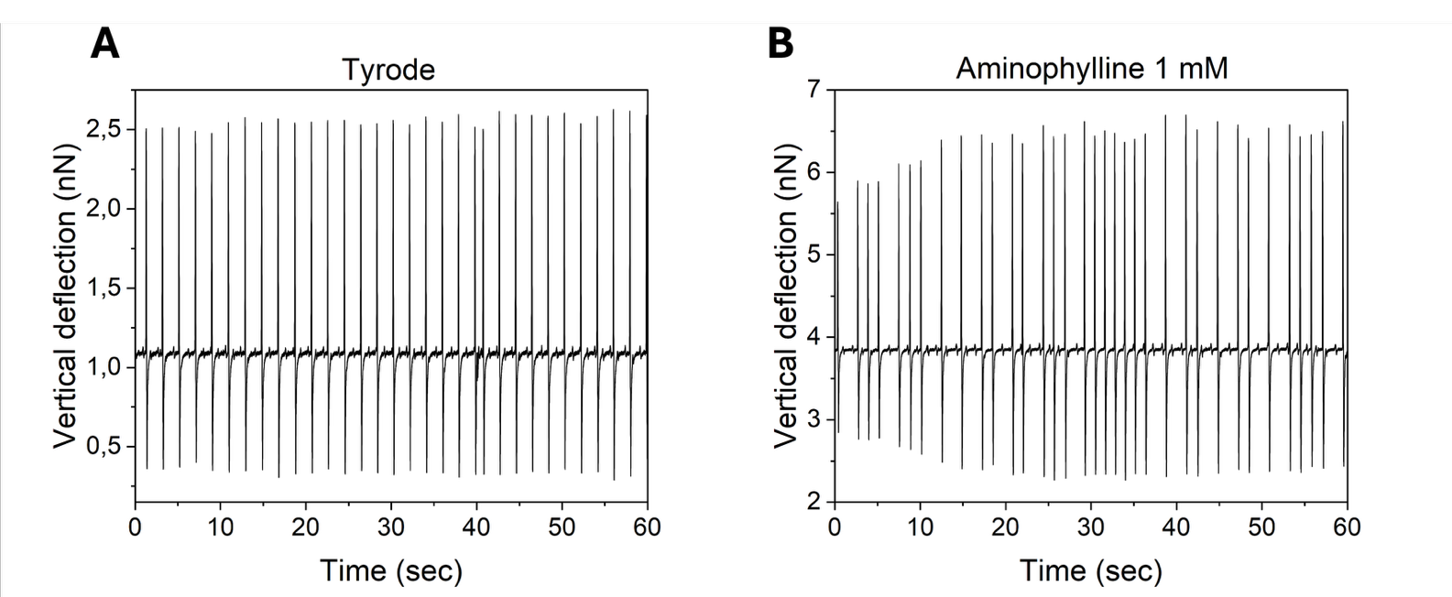

Figure S1 : Example of raw data obtained during measurement of hPSC-CMs embryoid bodies (EB) on AFM. (A) Changes in vertical deflection caused by the mechanical movement of EB during a control measurement in Tyrode solution. (B) Subsequent measurement with 1mM Aminophylline, which caused arrhythmic behavior.
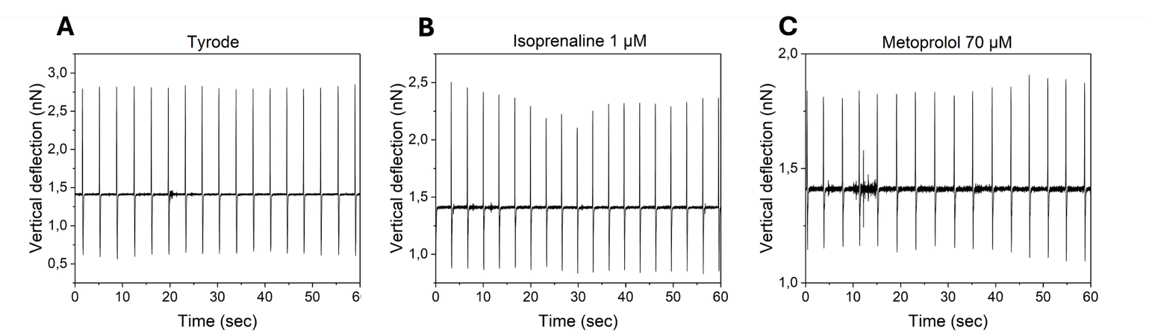

Figure S2: Example of raw data obtained during measurement of hPSC-CMs embryoid bodies (EB) on AFM. (A) Changes in vertical deflection caused by the mechanical movement of EB during a control measurement in Tyrode solution. Subsequent measurement with (B) 1 µM isoprenaline and (C) 70 µM metoprolol.

Figure S3: Example of raw data obtained during measurement of HL-1 cells on MEA. (A) Field potential obtained as a control measurement in Claycomb medium. (B) Subsequent measurement with 128 µM aminophylline.
Figure S4: Example of raw data obtained during measurement of HL-1 cells on MEA. (A) Field potential obtained as a control measurement in Claycomb medium. (B) Subsequent measurement with 0.1 µM isoprenaline.

Figure S5: Example of raw (A) dataset obtained from control Hl-1 sample on MEA for 3 minutes and after filtering (B) by 50 Hz notch filter (IIR notch, Q ≈ 35) and band-pass Butterworth filter (0.8 – 35 Hz, 6th order)

Figure S6: Experimental optimization of measurement position for AFM experiments on EBs. (A) Examples of cantilever position on EB. (B) Variance of signal amplitude (vertical deflection) during 3 minute measurement. (C) BPM variance during 3 minute measurement. Variance can be described by natural variability of contractions and signal quality affecting the processing. Most optimal border position can be defined by minimal coverage of cell surface and cantilever, which allows to collect signal with minimum noise and additional local signals.

