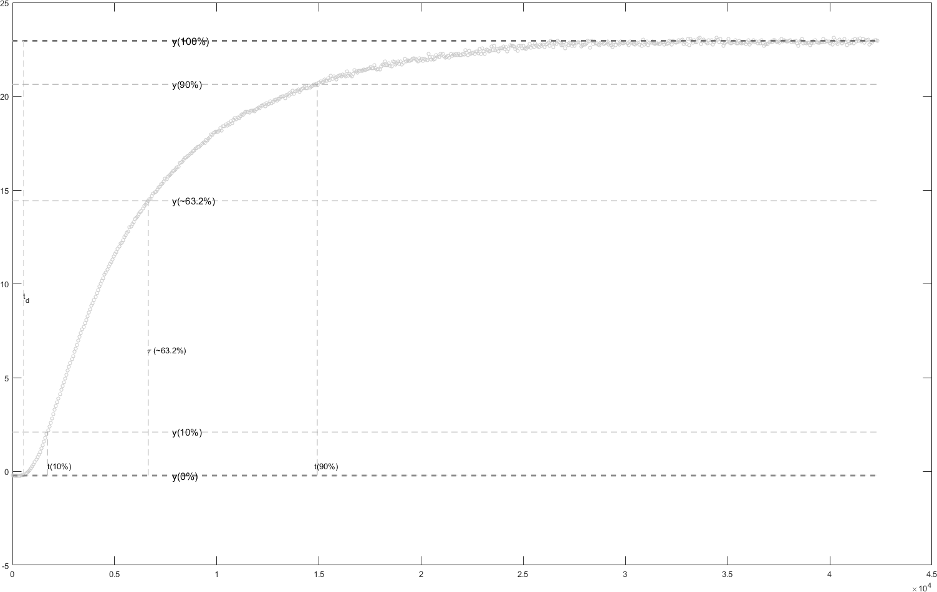

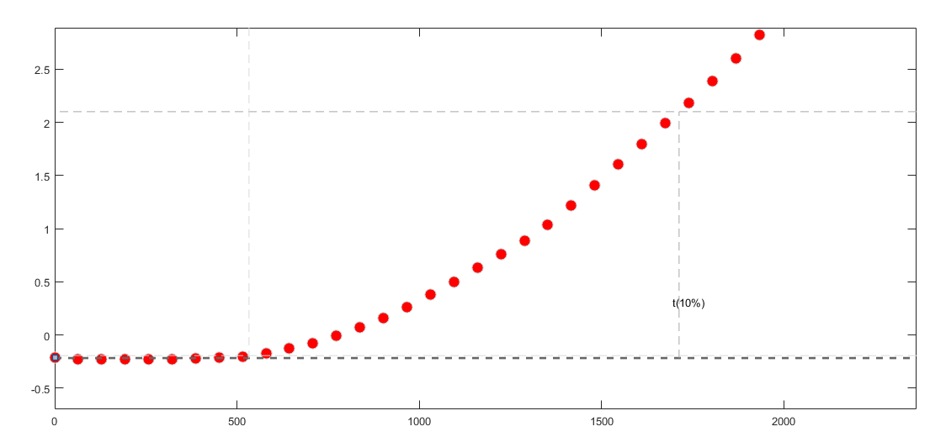

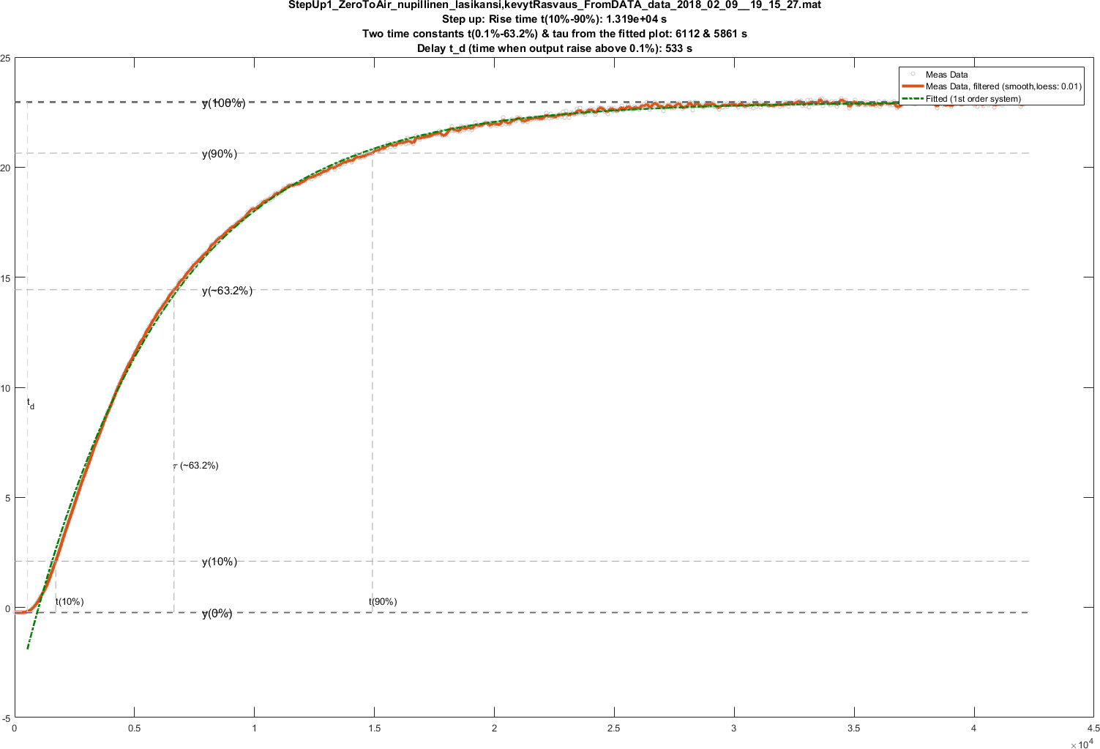

offset = min([Values1;Values2]); k_dc = TotRange;

y = (DataO2filtered-offset)';

t = timeVector'; % figure, plot(t,y)

zeros_amount=4;

uin=[zeros(1,zeros_amount),ones(1,length(y)-zeros_amount)]';

type = 'P1D';

data = iddata(y,uin,1,'InterSample','foh');

sysP1D = procest(data,type);

figure, subplot(221), compare(data,sysP1D)

subplot(222),lsim(sysP1D,uin,t) , hold all, plot(t,y,'r.')

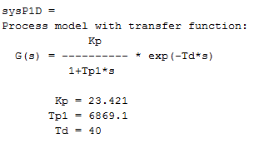

% with meas data, interp1 so that Ts = 1

ymORG = (Data_O2(:,2)-offset);

tmORG = Data_O2(:,1);

tm = [0:max(tmORG)]';

ym = [interp1(tmORG,ymORG,tm,'pchip')];

zeros_amount=4;

uinm=[zeros(1,zeros_amount),ones(1,length(ym)-zeros_amount)]';

datam = iddata(ym,uinm,1,'InterSample','foh');

sysP1Dm = procest(datam,type);

subplot(223), compare(datam,sysP1Dm)

subplot(224),lsim(sysP1Dm,uinm,tm) , hold all, plot(tm,ym,'r.')

