# Abstract

This minimal example document explains, how you can create \LaTeX{} (.tex) and .pdf files using Word. Shortly, idea is to write text in Word document with some additional \LaTeX{} commands included. Powershell scripts are used to convert this Word document to .tex file using \href{https://pandoc.org/}{Pandoc}, which can be then used to build final pdf-file using e.g. pdflatex.

# Introduction

\LaTeX{} is a great typesetting system, where idea is to focus more on text, not the outlook, during writing process, and let the program to convert the text to then final outlook. Compared to WYSIWYG (What You See Is What You Get) editors like Microsoft Word, no special software is needed during writing, allowing to use any text editor. To learn how to write your documents with \LaTeX{}, for example \href{https://www.ctan.org/tex-archive/info/lshort/english/}{The not so Short Introduction to \LaTeX{}} by Tobias Oetiker is a great document to start. It also lists multiple advantages of \LaTeX{} over normal word processors, such as encouraging authors to write well-structures documents.

At this point, you might think **why would you even consider using Word if you know already, or you are willing to learn, \LaTeX{}?**

Firstly, Microsoft Word provides great commenting tools and grammar checking for multiple languages. Secondly, **if your co-authors, colleagues, or supervisors are not using \LaTeX{}**, you typically need to convert your document to Word (or .pdf) format for them. This conversion is not typically a big problem, even though some manual editing is usually required. However, there is **no easy way to automatically move comments and text changes** **from Word (or .pdf) document (from your co-authors) back to your original .tex file**. Instead, you need to manually move all changes back to original document. *If you think there is a nice solution for this, please let me know!* Finally, and this is more an opinion from a not so code-oriented person than absolute truth, it is typically easier and faster to read and write (plain) Word document than plain \LaTeX{}-document.

General workflow to write \LaTeX{}-documents using Microsoft Word is following. Main writing work is done by editing Word document, \verb|WriteLaTeXusingWord.docx| in this example, which then will be converted to \verb|main_text.tex| file that includes most of the document text. This file is then included in your main \LaTeX{}-document, \verb|WriteLaTeXusingWord.tex| in this example, using \verb|\input{main_text}| command.

# Methods

In this section, instruction how to write certain parts are described. In this example, “IEEE draft style” is implemented for the final .pdf outlook, but this can easily be changed to fitting for your purpose.

## Prerequisite

This approach uses Windows PowerShell script to run \href{https://pandoc.org/}{Pandoc} commands. Furthermore, \LaTeX{} environment is naturally needed (e.g. by installing \href{https://miktex.org/}{MikTeX}) including pdflatex for .pdf files. Furthermore, it is required to download \href{ https://www.ctan.org/pkg/catchfilebetweentags}{catchfilebetweentags} package to your \LaTeX{}-environment.

## Refences

In this example, IEEE citation style is used. For citations, use style \verb|~\cite{your_citation}|. You can include multiple citations like~\cite{Maki2018, Maki2016} using command \verb|~\cite{citation1, citation2}|, or when referring a book page use \verb|~\cite[p.~page_number]{your_citation}|, for example when refering to book by Dorf and Bishop~\cite[p.~391]{Dorf2005}.

## Text and symbols

Write specific \LaTeX{} commands to include symbols and special characters. There are multiple sources to find these commands, for example see \href{https://artofproblemsolving.com/wiki/index.php/LaTeX:Symbols}{this} or \href{https://oeis.org/wiki/List_of_LaTeX_mathematical_symbols}{this}.

## Adding figures

You can copy-paste figures, equations and tables to your .docx document together with \verb|\loadPart|. This is not necessary but can help reading. The quality of snapshots do not affect the final results as images will be created during \LaTeX{}-conversion process. However, **check that “Alt Text” field is empty for these figures** as highlighted below. Notice, that **figure below is not shown in the .pdf file** as it is not loaded with \verb|\loadPart| command!

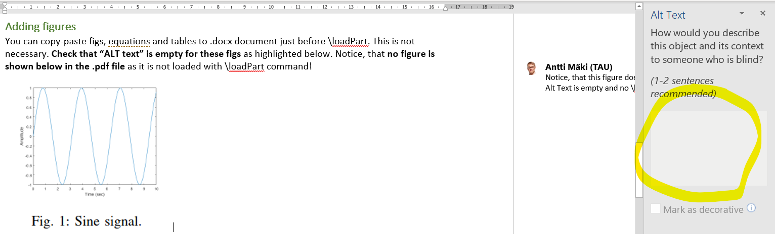

When you want to add figures to your final document, use \verb|\loadPart| command. First, if you would like to refer to figure below, use command \verb|Fig.~\ref{fig:sine}|, where \verb|fig:sine| is tag of the figure given in \verb|\loadPart| command. For example, to refer figure below, you could something like Sine signal is shown in Fig.~\ref{fig:sine}. Next, to add figure to final document, use command \verb|\loadPart{fig:sine}|

\loadPart{fig:sine}

As a second example, another figure, Fig.~\ref{fig:closedloop}, is presented below to demonstrate how figure numbering is created in \LaTeX{} environment.

\loadPart{fig:closedloop}

## Writing equations

Write equations using \LaTeX{}. One example is given next. Typical controller is PID (Proportional-Integral-Derivate). Mathematically, it can be presented using Eq.~\ref{eq:contpid}

\loadPart{eq:contpid}



\noindent where $K_p$, $K_i$ and $K_d$ are non-negative coefficients of proportional, integra, and derivative parts.

Above equation is written in \LaTeX{} using commands

\begin{verbatim}

\begin{equation} \label{eq:contpid}

    u(t)=K_pe(t) + K_i\int_{0}^{t} e(\tau) d\tau + K_d\frac{de(t)}{dt}

\end{equation}

\end{verbatim}

## Writing tables

Example table is given using command \verb| Table~\ref{table:messivsronaldo}|; see this table in Table~\ref{table:messivsronaldo}.

\loadPart{table:messivsronaldo}

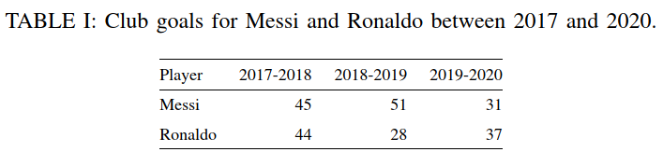

# Conclusion

This tutorial introduced the workflow how to write your paper using Word and convert that to \LaTeX{}-document and furthermore to final outlook. For example of “final” outlook, see .pdf version of this document. Future work could include more automation and control of your workflow. But probably then you should consider \href{https://en.wikipedia.org/wiki/Makefile}{Makefile} or similar approaches.

# Acknowledgment

There are several people that have been helped me in this process. I warmly thank Juhana Ketola for his *pro bono* help related to PowerScipt. Thanks to my current and former colleagues, Sampo Tuukkanen, Mikko Peltokangas and Ville Rantanen helping with \LaTeX{}, especially introducing *catchfilebetweentags,*  developed by Florent Chervet. Special thanks for Florent, saved me a lot of time! Furthermore, “tom’s” (sorry, couldn’t find author information, please share!) great \href{ https://texblog.org/2012/12/04/keeping-things-organized-in-large-documents/}{blog post in texblog} helped to implement *catchfilebetweentags* package.

# References