NORTHEASTERN UNIVERSITY COLLEGE
OF PROFESSIONAL STUDIES



Master of Professional Studies
in Digital Media Connect

COURSE:

Programming Foundations for Digital Media

ASSIGNMENT:

Final Term Project

AUTHOR:

Ana Lucia Lira Calderón

INSTRUCTOR:

Alfredo Iván López Sherman

Vancouver, Canada
March 2026

Data Visualization Analysis: The Emojis Stress Calendar

- Introduction & Hypothesis

- Introduction:

  - I moved to Canada to pursue my master’s degree in Digital Media Connect because I wanted to improve my ability to create strategies for management within a digital media context. Having worked in design for eight years, I wanted to shift my focus toward the strategic side of the field, so I moved to Vancouver to achieve that goal.

Once I arrived, I realized that the cold weather and the anxiety of studying and living in a different country began to surface. At that moment, I started my project for this assignment and thought: "Perhaps playing a video game I truly enjoy could help manage my stress and help me cope with the temperature and the transition to this country." Since The Sims 4 is one of my favorite games, I decided to analyze how external factors impact my stress levels by comparing an internal factor I can control (the game) with an external factor I cannot (the temperature). This project could help me understand how to manage my stress, live happily during this important life transition, and prioritize my mental health.

Additionally, I tracked the specific time of day I played the video game, as it is a relevant variable in my research. This data could show exactly when I take my breaks and helps me determine which moments are most effective for resting.

- Hypothesis and Research question:

  - As my daily time playing The Sims 4 (which is my favorite video game) increases, my stress decreases. One other factor that could impact my stress is the temperature of the day.

  - Can external factors such as playing The Sims 4 (which is my favorite video game) and daily temperature effectively reduce my stress levels?

- Data Collection Rationale and Process

- Objective Data

  - Sims 4 Playtime

    - I recorded my Sims 4 playtime using my phone and logged the data into an Excel spreadsheet in minutes, using numbers, between (0-1440 minutes)

  - Daily Temperature

    - I recorded the temperature in Celsius using a weather platform and classified it into three categories: Cold Days (5 degrees or less), Moderate Days (between 6 and 10 degrees), and Warm Days (more than 10 degrees), and logged the data into an Excel spreadsheet.

  - Time of the day

    - I recorded the times of day that I played The Sims 4 and logged the data into an Excel spreadsheet, dividing it into four categories: Morning (10:00 a.m. to 12:00 p.m.), Afternoon (12:00 p.m. to 5:00 p.m.), Evening (5:00 p.m. to 8:00 p.m.), and didn’t play (none).

- Subjective Data

  - Daily Stress Level before and after play The Sims 4

    - I used a self-recorded scale with emojis, logging the data daily in Excel: 0 to 1 (Relax) 😌, 2 to 3 (Tense) 😐, and 4 to 5 (Very Stressed) 😵.
Note on Data Source: The complete dataset, including daily observations for temperature, playtime, and stress levels from January 24th to March 12th, 2026, can be found in Section 8 (Appendix) of this report.

- Final Visualization Rationale

For my final visualization I chose a calendar grid because my data is time-based; a calendar format is the most natural way to show patterns across days. Additionally, the emojis allow the audience to understand the information quickly and easily. Each cell represents one day, making it easy to visually compare entries without needing to click or hover over anything. The calendar format also allows stress level, playtime, and temperature to appear together in each entry making it easier to compare patterns across days and weeks.

Also, I use many visual elements, such as colored circles and emojis, to create a clear structure so users can understand the graphic quickly. The visual language of this project was inspired by the hand-drawn metaphors used in Dear Data (Lupi and Posavec), specifically the way they map emotions to simple geometric symbols. I found it very creative and easy to understand, especially the way it aligns multiple graphics to create a weekly calendar. I found it fascinating how Stefanie recorded the laughs using points of different sizes, depending on the intensity of the laughter, at least that’s how I understood it, as it isn’t explicitly explained.
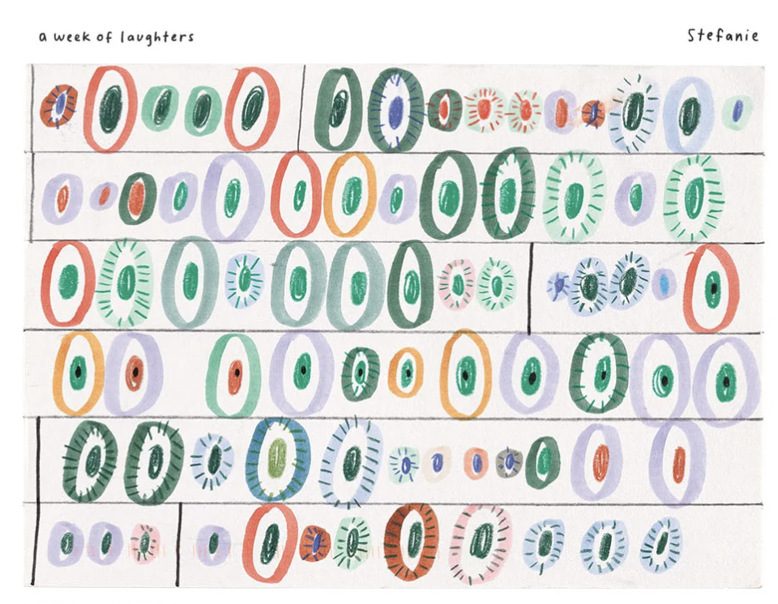
Figure 1. Example of a data postcard mapping personal habits. Source: Lupi and Posavec, Dear Data, 2016.

- Alternate Idea Sketch & Comparison

While developing my ideas through three different sketches, I found it useful to explore various levels of complexity. I started with a simple scatterplot to show how basic the data could be. Then, I created a medium-fidelity sketch using an Alluvial diagram for a more formal and professional approach. Finally, I developed a creative option using a calendar layout.

  - Sketch 1: The Bubble plot practiced in class

    - This proposal analyzes the direct correlation between final stress level in the scale of 0-5 (Y) and time playing the Sims 4 in minutes (X), utilizing geometric shapes to represent different temperature categories.

  - Sketch 2: Alluvial Diagram

    - This research-based flow visualization maps the correlation between time playing The Sims 4, final stress levels (on a scale of 0–5), and temperature. It illustrates the 'flow' of sessions from temperature through playtime duration to the final stress level, demonstrating how hot days act as a catalyst for relaxation. However, after discussing the sketch with my professor, we realized it wasn't clear enough for its intended data visualization purpose. While we considered a sorted streamgraph as a better alternative, it was not the final choice for the project.

  - Sketch 3: Creative calendar

    - This sketch was based in a narrative breakdown using a custom glyph system. Each icon simultaneously encodes stress (emoji), temperature (border colour), time of day (sun/moon icons), and minutes played (numerical value).

Ultimately, I chose the creative calendar approach because it was the most engaging way to represent the data, using emojis and color-coded circles to display daily stress levels and temperature. Additionally, coding this visualization was a great challenge for me, as it moved away from the conventional scatterplots we created throughout the course.

- Conclusions

  - Cold day – Best results:

    - Ultimately, the data reveals that the effectiveness of The Sims 4 as a stress-reduction tool is deeply dependent on environmental context, specifically temperature and timing. Cold days are the most successful outcomes, where evening sessions lasting between 40 and 60 minutes consistently lowered stress levels from a 3 to a 1 or maintained a perfect state of calm at 0. These findings suggest that a cool environment significantly enhances the game’s therapeutic potential, allowing for deeper relaxation and recovery.
  - Hot day – Worst results:

    - In contrast, hot days acted as a disruptive factor, where the heat appeared to counteract the game’s relaxing effects and kept stress levels high at 4 or 5, even after short gameplay sessions. A notable exception occurred on February 4, where a stress level of 0 was maintained despite the heat and without any playtime, indicating that while The Sims 4 is a powerful tool for stress management, environmental comfort remains a dominant variable.

In conclusion data confirms that increasing daily playtime is the strongest predictor of stress reduction. This project demonstrates that achieving mental well-being requires a careful balance between play Sims 4, the time spend in the session, and the temperature.

- Past/Future Data Collection

Through this analysis, I have gained a much deeper understanding of the internal activities and external factors that directly influence my stress levels. By identifying these specific patterns, I now feel more equipped to strategically incorporate new habits and activities into my daily routine to effectively manage my mood.

Ultimately, this data-driven approach has shown me how to move beyond simple observation and toward proactive stress management. I now understand that by balancing my digital engagements with a better awareness of my physical environment, I can create a more mindful and regulated lifestyle.

Additionally, this project has helped me understand the complete data process, from organizing information to performing complex analyses with code. By moving away from standard tools, I gained hands-on experience in how to structure and interpret raw data through programming to uncover meaningful insights, information that I could applied in future projects.

Looking ahead, I plan to improve the project’s visual communication by incorporating more graphic elements, such as specific icons to represent different times of the day. Although these features were not included in this iteration due to time constraints, adding them would create a more intuitive and visually engaging experience for the viewer.

- Project Directory
  - Draft 1
  - Draft 2
  - Final Project:

- Works Cited

AccuWeather. “Vancouver, British Columbia, Canada Weather History: March 2026.” AccuWeather, 2026, https://www.accuweather.com/es/ca/vancouver/v6c/march-weather/53286. Accessed 25 March 2026.

Mozilla. “Array.prototype.forEach().” MDN Web Docs, 2024, https://developer.mozilla.org/en-US/docs/Web/JavaScript/Reference/Global_Objects/Array/forEach. Accessed 25 March 2026.

GeeksforGeeks. “JavaScript Anonymous Functions.” GeeksforGeeks, 2024, https://www.geeksforgeeks.org/javascript-anonymous-functions/. Accessed 25 March 2026.

Stack Overflow. “Adding FontAwesome Icons to a D3 Graph.” Stack Overflow, 2013, https://stackoverflow.com/questions/18416749/adding-fontawesome-icons-to-a-d3-graph. Accessed 25 March 2026.

GeeksforGeeks. “JavaScript Anonymous Functions.” GeeksforGeeks, 2024, https://www.geeksforgeeks.org/javascript-anonymous-functions/. Accessed 25 March 2026.

Kantor, Ilya. “Conditional Branching: If, '?'.” The Modern JavaScript Tutorial, 2024, https://javascript.info/ifelse. Accessed 25 March 2026.

López Sherman, Alfredo Iván. “Data Loading and Promise Handling with D3.js.” Programming Foundations for Digital Media, Northeastern University, Spring 2026, Vancouver, BC. Course Lecture and Lab Materials.
Stack Overflow. “How to Group G Elements in D3.” Stack Overflow, 2018, https://stackoverflow.com/questions/52216447/how-to-group-g-elements-in-d3. Accessed 25 March 2026.
Kantor, Ilya. “Logical Operators.” The Modern JavaScript Tutorial, 2024, https://javascript.info/logical-operators. Accessed 25 March 2026.

López Sherman, Alfredo Iván. “d3.js and JavaScript Quick Reference for Project 1.” Programming Foundations for Digital Media, Northeastern University, Spring 2026, Vancouver, BC. Course Handout.

López Sherman, Alfredo Iván. “Term Project Framework.” Programming Foundations for Digital Media, Northeastern University, Week 9, Spring 2026, Vancouver, BC. Course Handout.

Lupi, Giorgia, and Stefanie Posavec. “The Project.” Dear Data, 2016, https://www.dear-data.com/theproject. Accessed 25 March 2026.

Holtz, Yan, and Conor Healy. “Scatter Plot.” From Data to Viz, 2024, https://www.data-to-viz.com/graph/scatter.html. Accessed 25 March 2026.

Ferdio. “Data Viz Project.” Data Viz Project, 2024, https://datavizproject.com/. Accessed 25 March 2026.

- Appendix: Raw Dataset

The data was meticulously recorded daily using a Microsoft Excel spreadsheet, which served as the primary database for this study. This original file includes time-stamped observations for all variables: gaming duration, ambient temperature, and self-reported stress levels. The spreadsheet was later exported to JSON format for integration with the D3.js library.

Date | Played Sims 4? | Playtime (min) | Temp (°C) | Time of Day | Stress (Before) | Stress (After)
Jan 24 | No | 0 | -1 | None | 4 | 4
Jan 25 | No | 0 | 5 | None | 5 | 5
Jan 26 | Yes | 30 | 3 | Afternoon | 3 | 2
Jan 27 | No | 0 | 5 | None | 1 | 1
Jan 28 | Yes | 30 | 6 | Afternoon | 3 | 0
Jan 29 | Yes | 30 | 9 | Evening | 4 | 3
Jan 30 | Yes | 60 | 9 | Evening | 3 | 1
Jan 31 | Yes | 30 | 12 | Evening | 4 | 3
Feb 1 | Yes | 42 | 8 | Evening | 5 | 3
Feb 2 | Yes | 30 | 9 | Afternoon | 3 | 1
Feb 3 | Yes | 40 | 11 | Evening | 2 | 1
Feb 4 | No | 0 | 16 | None | 0 | 0
Feb 5 | Yes | 50 | 14 | Evening | 1 | 0
Feb 6 | Yes | 40 | 15 | Evening | 2 | 0
Feb 7 | Yes | 30 | 11 | Afternoon | 1 | 0
Feb 8 | Yes | 30 | 10 | Afternoon | 2 | 1
Feb 9 | Yes | 45 | 7 | Evening | 3 | 2
Feb 10 | Yes | 32 | 3 | Evening | 1 | 0
Feb 11 | Yes | 30 | 9 | Evening | 3 | 1
Feb 12 | No | 0 | 8 | None | 3 | 3
Feb 13 | Yes | 36 | 8 | Afternoon | 2 | 0
Feb 14 | Yes | 30 | 9 | Afternoon | 4 | 2
Feb 15 | Yes | 32 | 3 | Evening | 3 | 1
Feb 16 | Yes | 40 | 5 | Afternoon | 4 | 2
Feb 17 | Yes | 35 | 6 | Afternoon | 3 | 1
Feb 18 | Yes | 37 | 1 | Evening | 5 | 3
Feb 19 | No | 0 | 4 | None | 4 | 4
Feb 20 | Yes | 41 | 4 | Afternoon | 4 | 3
Feb 21 | Yes | 35 | 8 | Afternoon | 2 | 0
Feb 22 | Yes | 30 | 4 | Evening | 4 | 3
Feb 23 | Yes | 41 | 3 | Evening | 5 | 4
Feb 24 | Yes | 50 | 1 | Afternoon | 5 | 3
Feb 25 | Yes | 41 | 3 | Evening | 3 | 2
Feb 26 | No | 0 | 6 | None | 4 | 4
Feb 27 | Yes | 41 | 6 | Afternoon | 4 | 3
Feb 28 | Yes | 37 | 3 | Afternoon | 2 | 2
Mar 1 | Yes | 30 | 3 | Evening | 5 | 1
Mar 2 | Yes | 34 | 4 | Afternoon | 5 | 3
Mar 3 | Yes | 31 | 8 | Afternoon | 2 | 0
Mar 4 | No | 0 | 7 | None | 3 | 3
Mar 5 | Yes | 40 | 4 | Afternoon | 5 | 1
Mar 6 | Yes | 32 | 5 | Afternoon | 3 | 1
Mar 7 | Yes | 34 | 7 | Evening | 4 | 3
Mar 8 | Yes | 45 | 4 | Afternoon | 4 | 0
Mar 9 | Yes | 46 | 1 | Afternoon | 5 | 1
Mar 10 | No | 0 | 1 | None | 5 | 5
Mar 11 | Yes | 34 | 1 | Evening | 4 | 3
Mar 12 | Yes | 35 | 2 | Afternoon | 3 | 0

