**REPORT**

Zajęcia: Analog and digital electronic circuits

Teacher: prof. dr hab. Vasyl Martsenyuk

**Lab 01**

Date 26.10.2024

**Topic:** "Windowing"

**Variant 10**

Anna Więzik

Informatyka II stopień,

niestacjonarne,

1 semestr,

Gr.1b

1. **Problem statement:**

Generate three sine signals of given f1, f2, and f3 and amplitude |x[k]|max for the sampling frequency fs in the range of 0 ≤ k < N.

Plot: 1 1. the "normalized" level of the DFT spectra. 2. the window DTFT spectra normalized to their mainlobe maximum. The intervals for f, Ω, and amplitudes should be chosen by yourself for the best interpretation purposes.

1. **Input data:**

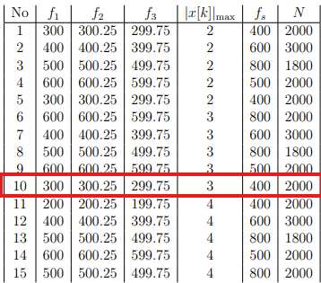

1. **Commands used (or GUI):**
2. source code

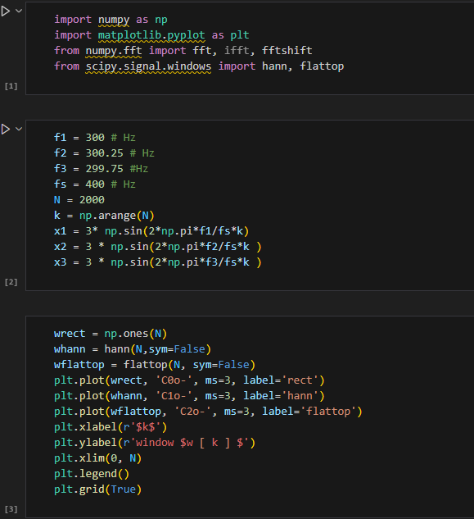

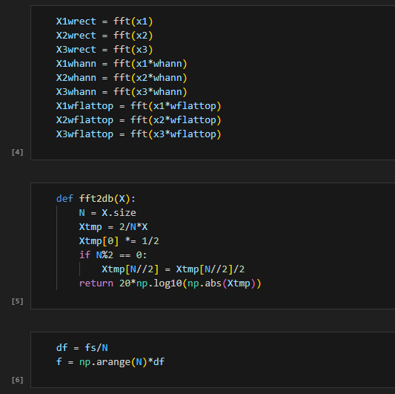

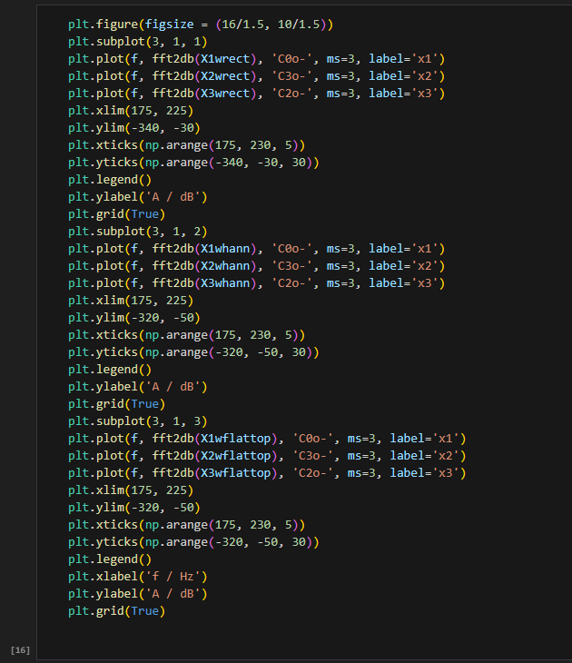

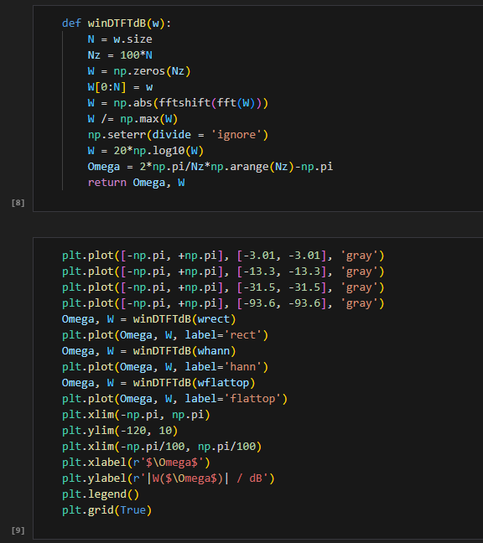

Link to remote repozytorium:

https://github.com/AnaShiro/DSP_2024

1. **Outcomes:**

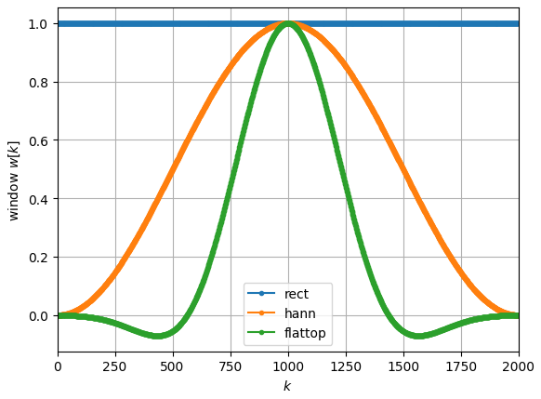

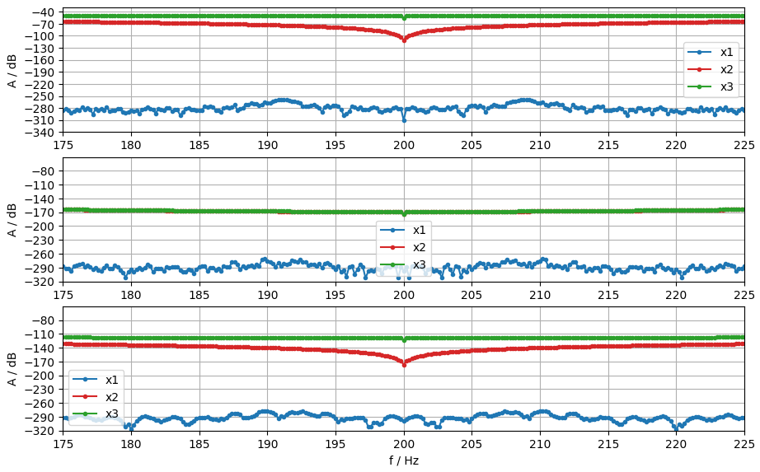

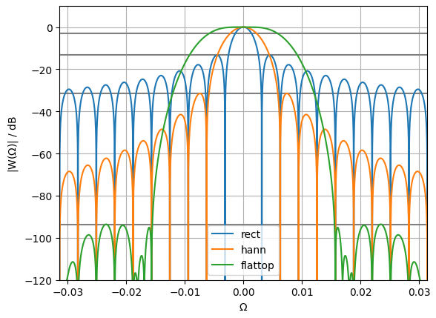

1. **Conclusions:**

At a low sampling frequency (fs), the f2 function nearly aligns with f1, causing significant overlap. A reduced sampling frequency often results in overlapping functions or pronounced fluctuations, necessitating substantial adjustments to the plot for accurate visualization.