**REPORT**

Zajęcia: Analog and digital electronic circuits

Teacher: prof. dr hab. Vasyl Martsenyuk

**Lab 5-6**

Date 23.11.2024

**Topic:** "5. Digital Filter Design and Analysis: Implementing

FIR and IIR filters in Python.

6. Adaptive Filtering: Applying adaptive filtering

algorithms to noise reduction."

**Variant 10**

Anna Więzik

Informatyka II stopień,

niestacjonarne,

1 semestr,

Gr.1b

1. **Problem statement:**

Each task requires you to implement all three types of filters: FIR, IIR, and Adaptive LMS, using different parameters and observe the performance for noise reduction.

1. **Input data:**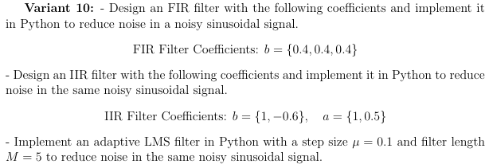

link to remote repozytorium: <https://github.com/AnaShiro/DSP_2024>

1. **Commands used (or GUI):**

* FIR

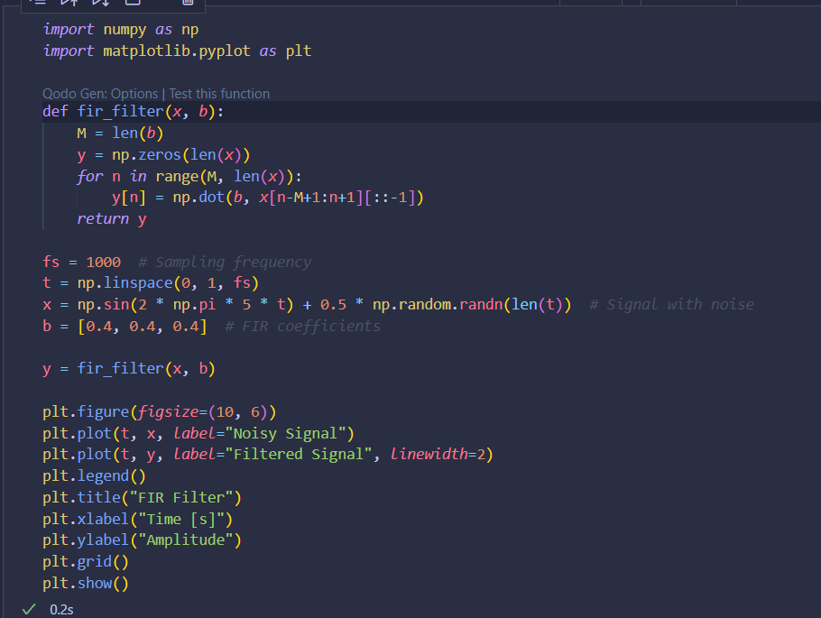

* IIR

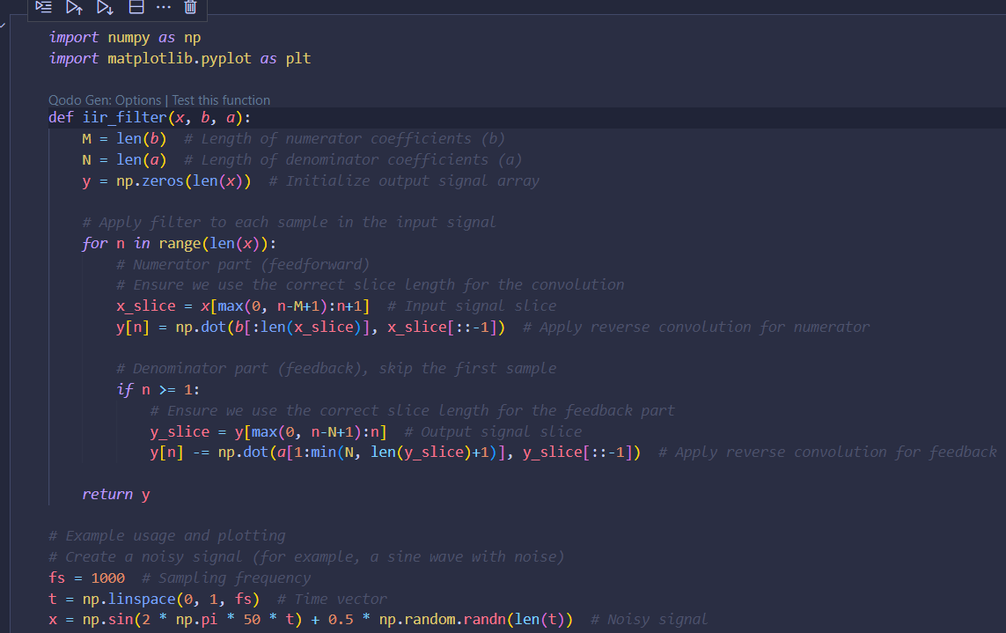

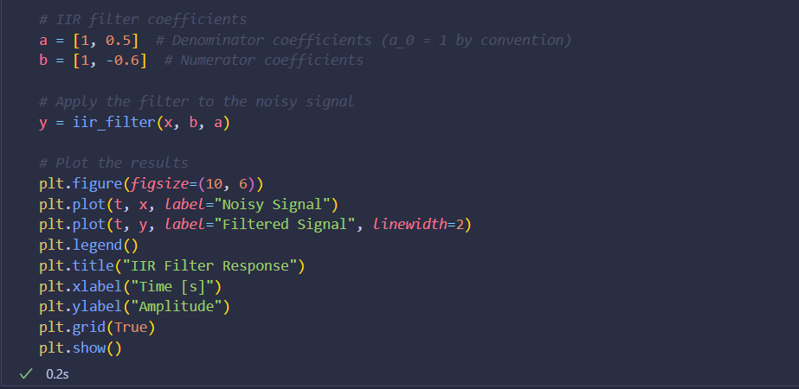

* LMS

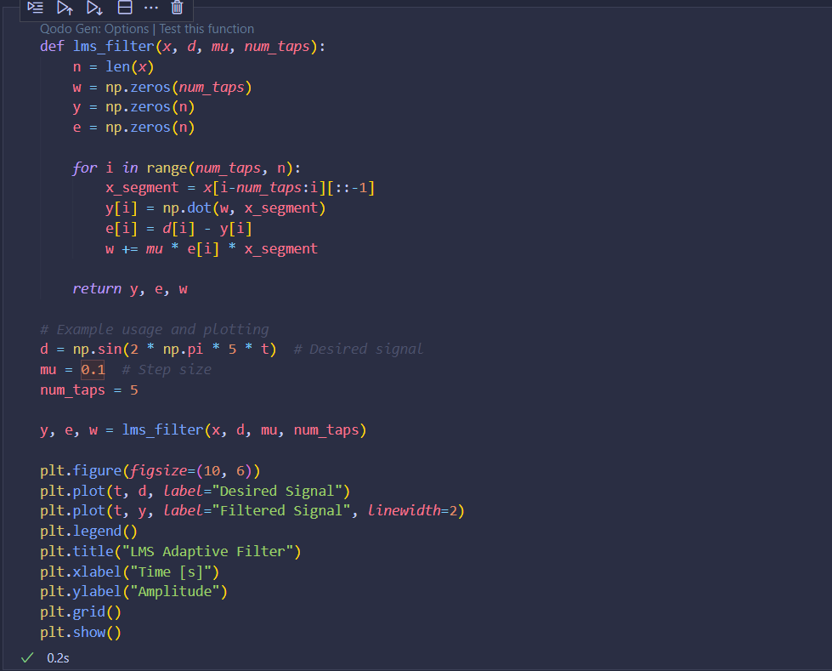

1. **Outcomes:**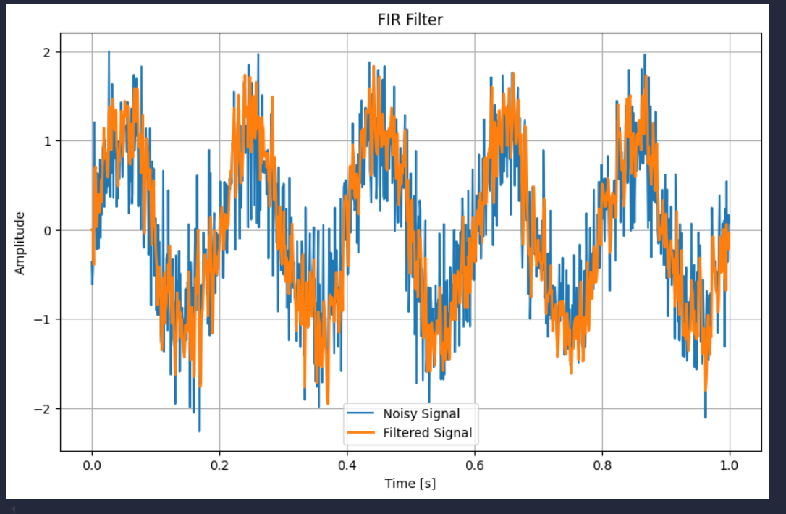

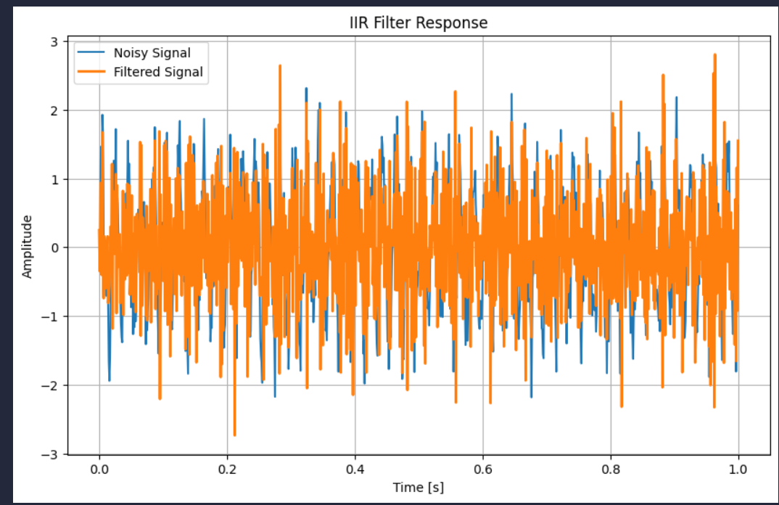

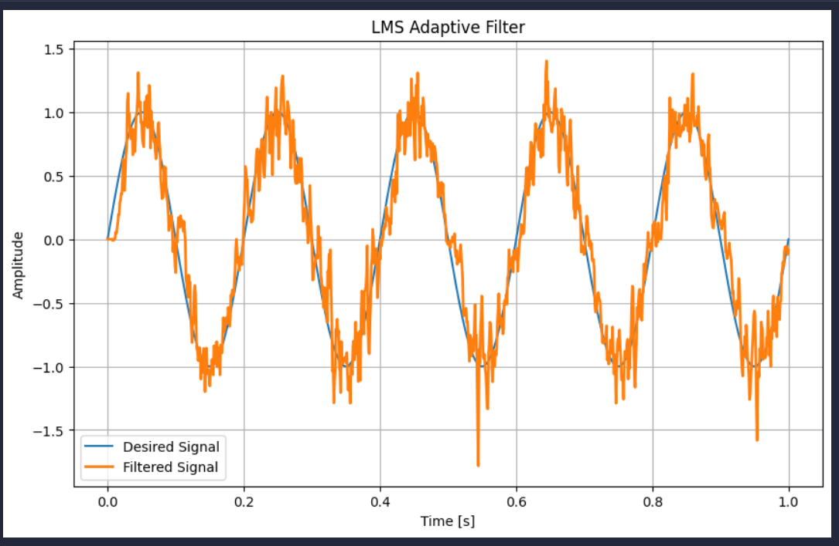

1. **Conclusions:**

This manual offers a comprehensive overview of the mathematical principles underlying FIR (Finite Impulse Response), IIR (Infinite Impulse Response), and LMS (Least Mean Squares) adaptive filters. It not only provides the theoretical background but also includes practical Python implementations for each filter type. Furthermore, the manual incorporates various visualization techniques to effectively demonstrate the performance and efficiency of these filters in real-world scenarios. This combination of theory, implementation, and visual aids ensures a clear understanding of the filters' functionality and their applications.