**REPORT**

Zajęcia: Analog and digital electronic circuits

Teacher: prof. dr hab. Vasyl Martsenyuk

**Lab 7 - 8**

Date 21.12.2024

**Topic:** "7. Sampling and Reconstruction of Signals: Analysis of Aliasing Effects and Proper Signal Reconstruction. 8. Coding and Decoding Digital Signals"

**Variant 10**

Anna Więzik

Informatyka II stopień,

niestacjonarne,

1 semestr,

Gr.1b

1. **Problem statement:**

Task Assignments for sampling and reconstruction



Task Assignments on Coding/Decoding

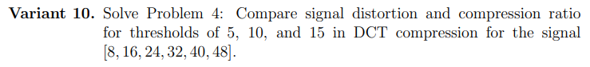

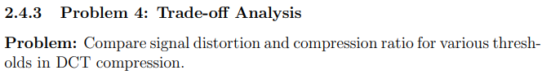

1. **Input data:**
2. **Commands used (or GUI):**

* source code

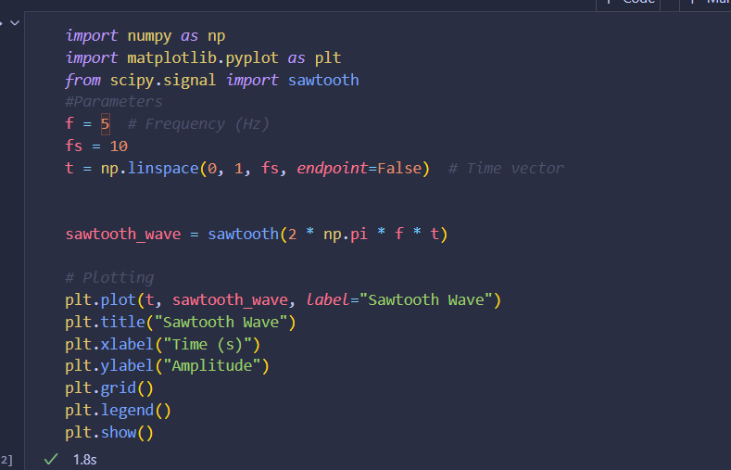

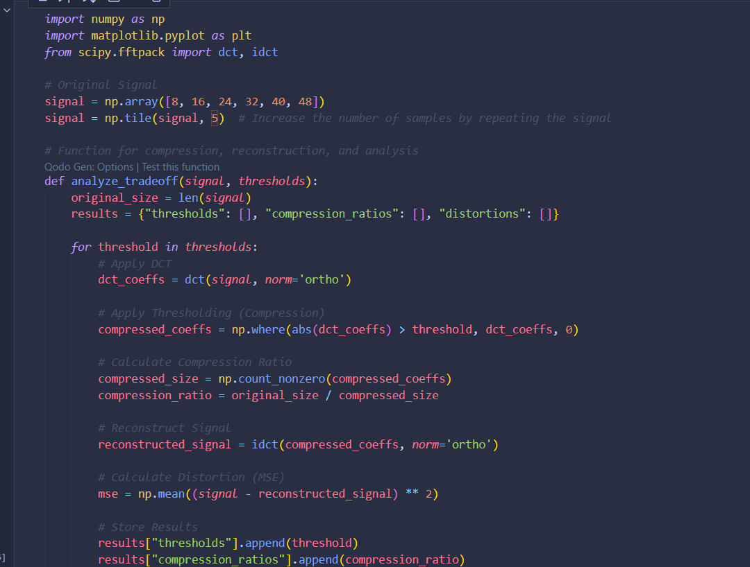

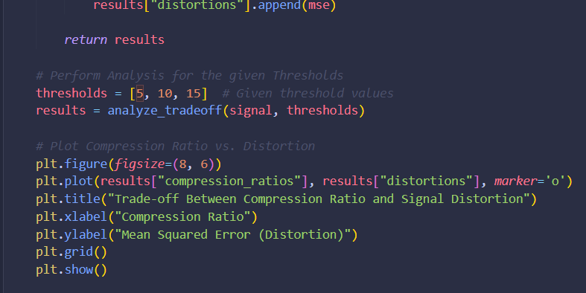

* screenshots

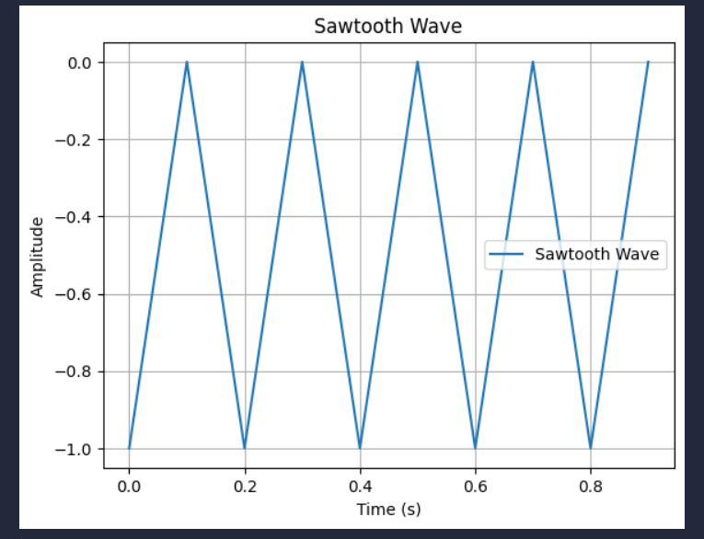

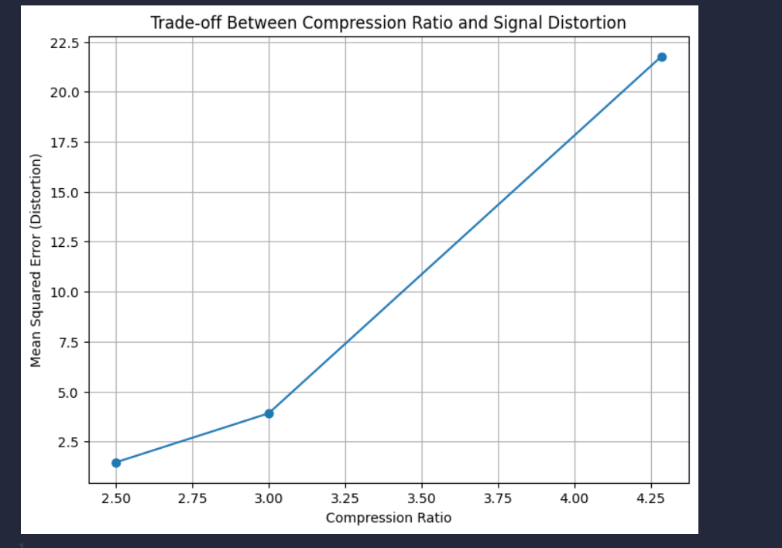

* Link to remote repozytorium https://github.com/AnaShiro/UM_2024

1. **Conclusions:**

This laboratory delves into the essential concepts of sampling and reconstructing signals within the field of signal processing. It encompasses the Nyquist-Shannon sampling theorem, the phenomena of aliasing, and various techniques for signal reconstruction. The goal of this lab session is to acquaint students with the fundamentals of encoding and decoding digital signals. This includes practical applications of compression algorithms to enhance the representation and transmission of signals. The session specifically emphasizes the processes of signal coding, decoding, and reconstruction using Python.