Stock Market Risk Analysis



Credit Models
Ana Sofía Hinojosa Bale
742594

February 23, 2026
Credit risk assessment is a fundamental component of financial analysis and banking practice. Financial institutions, investors, and regulators rely on quantitative models to evaluate the probability that a firm may default on its obligations. In this assignment, a credit risk decision framework is developed, one that integrates two well-established methodologies: the Altman Z-Score model and the Merton structural default model.
The Altman Z-Score provides an accounting-based measure of financial distress using key balance sheet and income statement ratios. In contrast, the Merton model derives the probability of default from a market-based structural framework, modeling a firm’s equity as a call option on its assets. By combining these approaches, the system captures both accounting fundamentals and market-implied risk signals.
The implemented solution retrieves real financial and market data for publicly traded companies, computes the Altman Z-Score and the Merton-based probability of default, and produces a credit approval decision based on predefined risk thresholds. Additionally, it includes an interactive dashboard that visualizes results and allows for multi-company comparison.
Altman Z-Score
Altman Z-score model is a numerical measurement that is used to predict the chances of a business going bankrupt in the next two years. The model was developed by American finance professor Edward Altman in 1968 as a measure of the financial stability of companies (Corporate Finance Institute).
Its formula is written as follows:
$$Z=1.2x_{1}+1.4x_{2}+3.3x_{3}+0.6x_{4}+1.0x_{5}$$
Where
$$x_{1}: \frac{Working Capital}{Total Assets}$$
$$x_{2}: \frac{Retained Earnings}{Total Assets}$$
$$x_{3}:\frac{EBIT}{Total Assets}$$
$$x_{4}:\frac{Market Value of Equity}{Total Liabilities}$$
$$x_{5}:\frac{Sales}{Total Assets}$$
Merton Model:
The KMV Merton model is a credit risk model that Kealhofer, Merton, and Vasicek developed to estimate the probability of default (PD) and the expected loss given default (LGD) for a company or a portfolio of companies. It incorporates market-based information and company-specific financial data to estimate the likelihood of default and potential losses (Mehta et al., 2023).
It is calculated as follows:
$$distance to default=\frac{\ln\left(\frac{V}{D}\right)+\left(r+\frac{σ^{2}}{2}\right)T }{σ\sqrt{T}}$$
Where:
$$V:Market value of a company^{'}s assets$$
$$D:Market value of a company^{'}s debt$$
$$r:Risk free interest rate$$
$$σ:Volatility of thecompany^{'}sasset value$$
$$T:Time measured in years$$

It should be noted that for the the analysis made the following variables and assumptions were used:
Market value of a company’s debt: In this model, total liabilities were used instead of only interest-bearing debt to better reflect the firm’s overall financial obligations. Default does not occur only when formal debt cannot be repaid, but when the company is unable to meet all contractual commitments, including short-term payables and other liabilities. Using total liabilities therefore provides a more comprehensive and conservative measure of the default threshold. This approach is consistent with the economic definition of insolvency, where default occurs when the value of assets falls below the firm’s total claims (Merton, 1974).
Risk-free rate: In this implementation, the expected asset return was estimated using the historical mean of asset log returns instead of the risk-free rate. This choice reflects a credit risk perspective rather than an option-pricing perspective. While the risk-free rate is appropriate under strict risk-neutral valuation assumptions, estimating default probability focuses on the firm’s real economic performance. Using the mean asset return captures the firm’s actual growth dynamics and operating risk, providing a more realistic measure of the probability that asset values will fall below the default threshold. This approach is commonly adopted in practical applications of the KMV model, where empirical asset behavior is emphasized over theoretical risk-neutral assumptions (Crosbie & Bohn, 2003).
An object-oriented program (OOP) was implemented for the analysis, as illustrated in the diagram below.
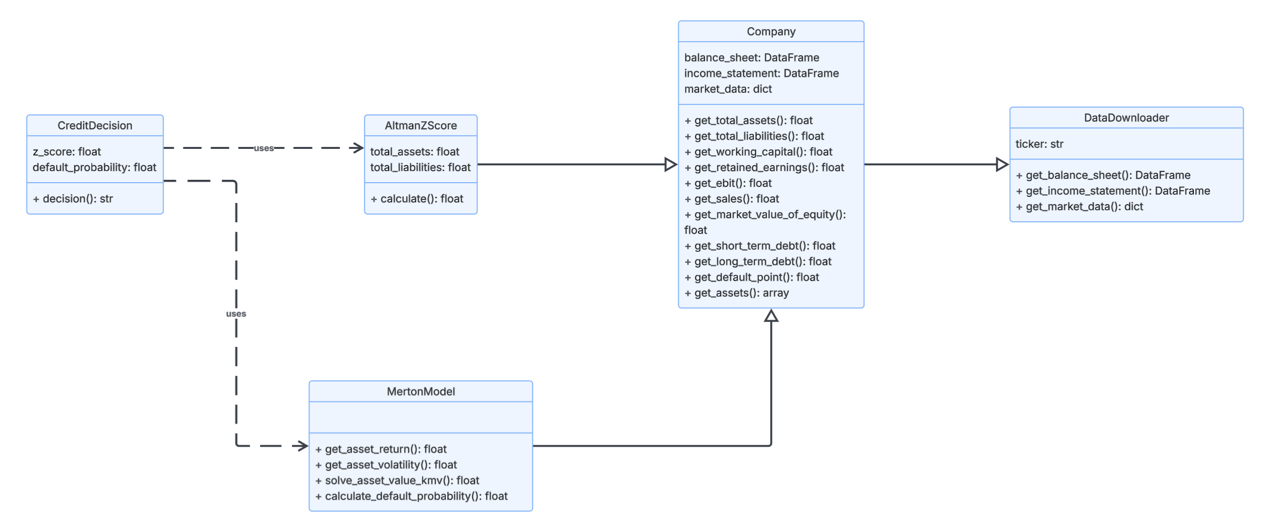

The framework begins by fetching financial data for a company using the DataDownloader superclass. The Company class, which inherits from DataDownloader, then organizes this data and calculates key financial metrics. Afterwards, the models classes, AltmanZScore and MertonModel, inherit from Company to assess credit risk using the Altman Z-Score and the Merton/KMV model, respectively. Finally, the CreditDecision class uses these outputs to make a credit approval decision.
For the analysis, both Altman’s Z-score model and the Merton model were applied to three different companies—COST, ORCL, and AVGO—to observe how the framework performed with different datasets. The results are shown first in a summary table, showing both models and the final credit decisión. After this, other types of visualization tools are used to further explain the decisión.
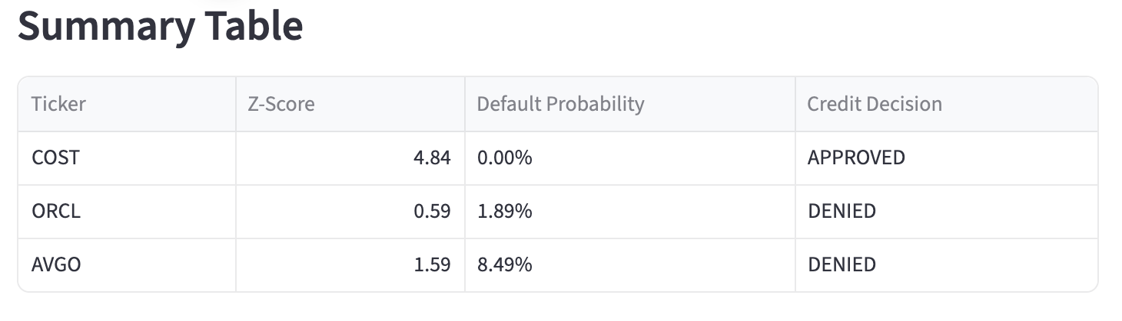
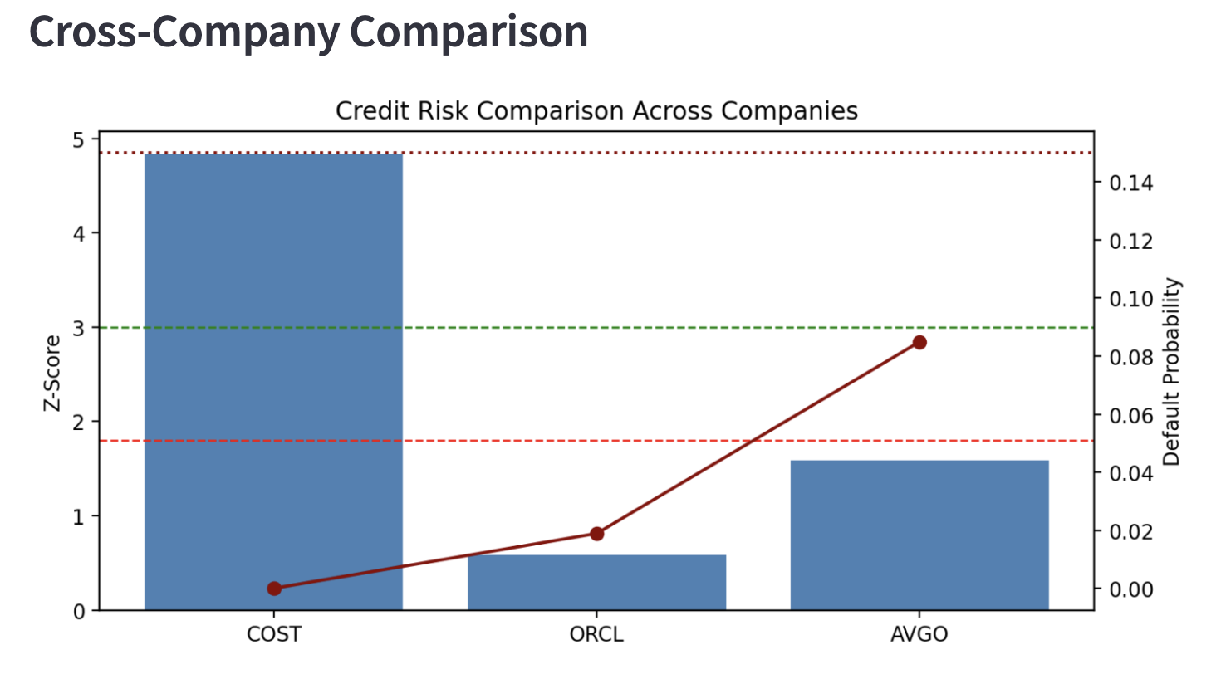
The graph above shows the results from both models, for each of the companies used.

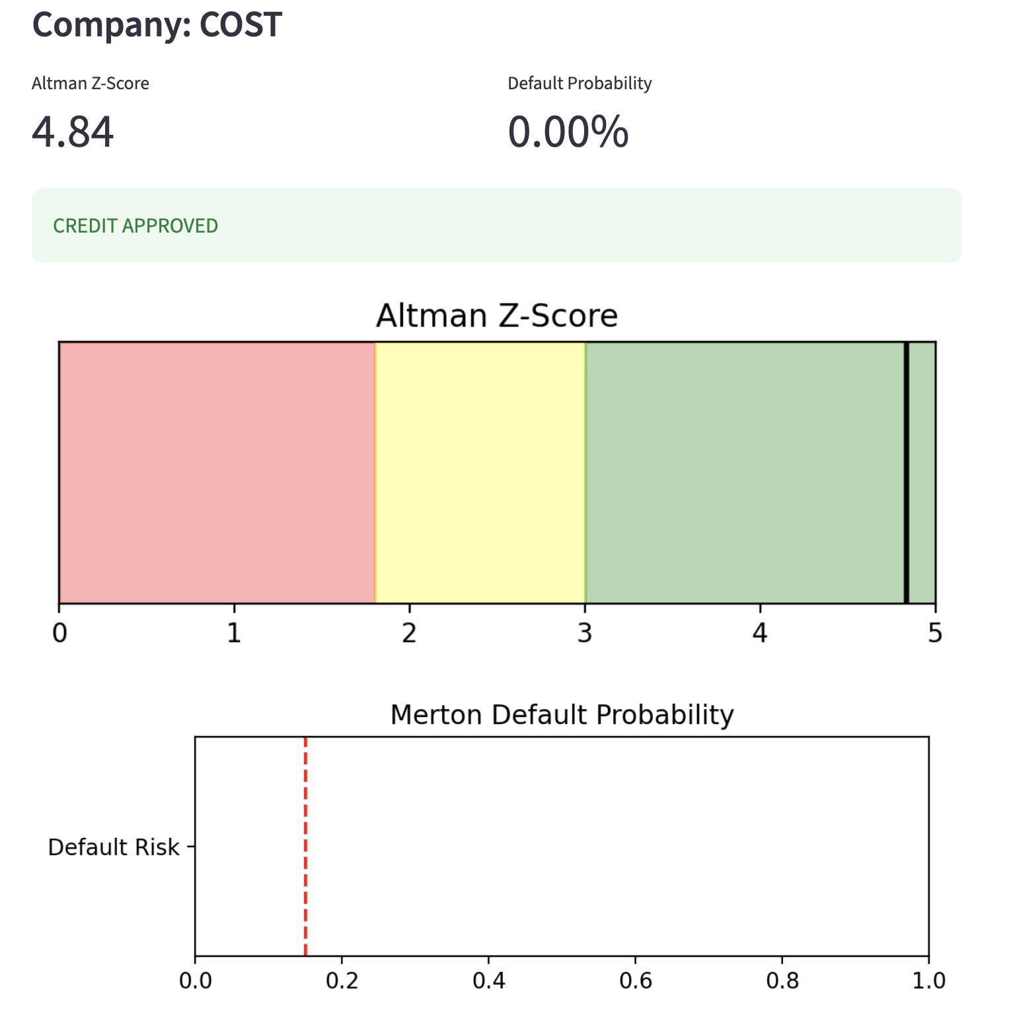
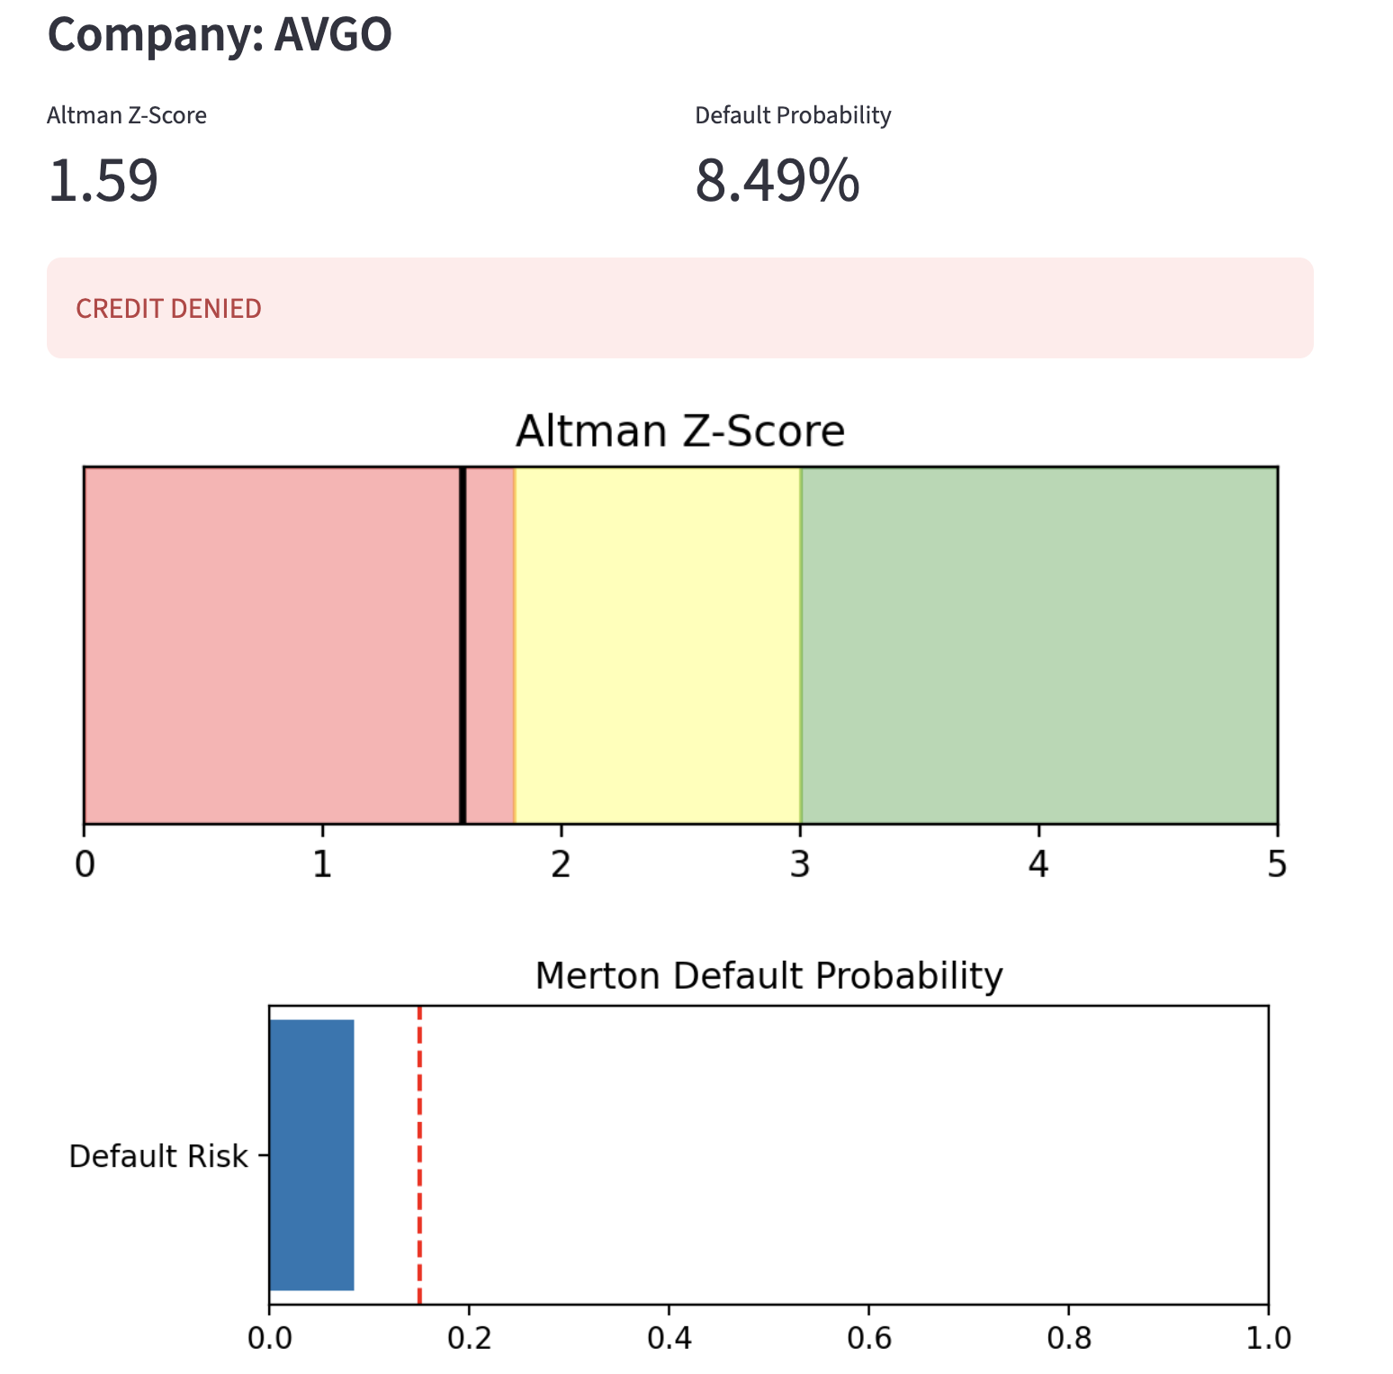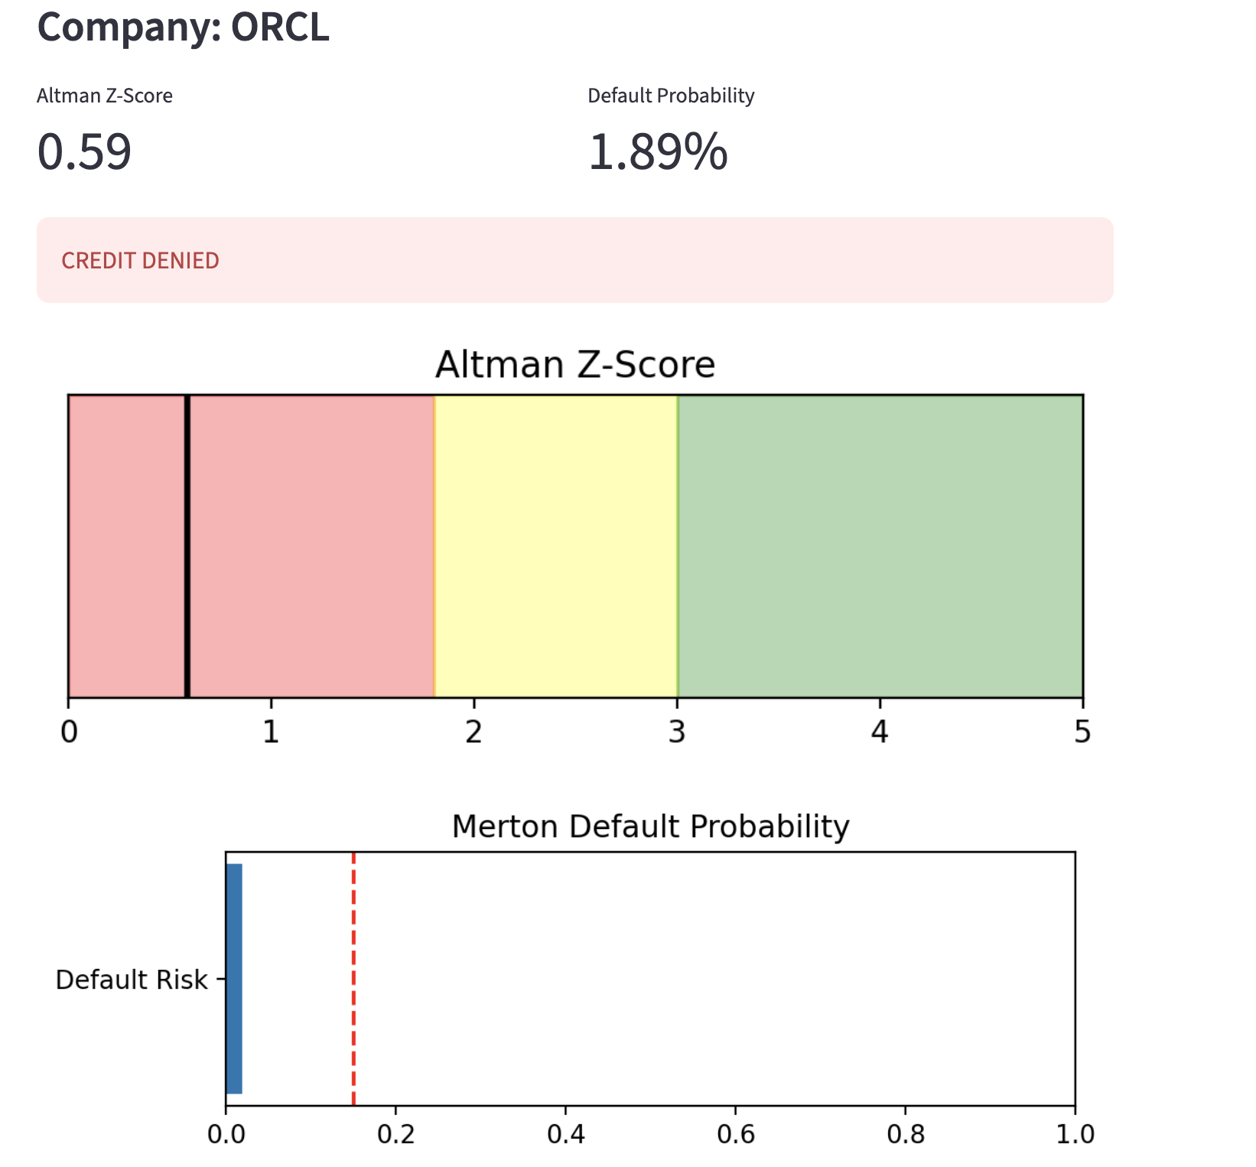
Sources:
Corporate Finance Institute. (n.d.). Altman’s Z-Score Model – Overview, formula, interpretation. Corporate Finance Institute. https://corporatefinanceinstitute.com/resources/commercial-lending/altmans-z-score-model
Mehta, K., Srivastav, A., & Vaidya, D. (2023, July 19). KMV model – What is it, application, significance, how to calculate. WallStreetMojo. https://www.wallstreetmojo.com/kmv-model/
Crosbie, P., & Bohn, J. (2003). Modeling default risk. Moody’s KMV. https://www.moodysanalytics.com/-/media/whitepaper/2003-02-25-modeling-default-risk.pdf

