**Introduction**

Analysis: Present Day CO2 Emission

We took the data from Our World in Data (<https://ourworldindata.org/co2-and-greenhouse-gas-emissions>)

**Slide One**

We cleaned the data to only select the relevant columns using a group by.

Once we have the relevant data, we plotted them on a graph to see the present day co2 emission status. We can see we are at the highest level since 1750 (Fig 1)

Fig: 1

**Slide Two**

Next we analyse the source of CO2.

Again, cleaning and removing unnecessary columns using unique and group by, we can see

Coal has surpassed oil in resent day as a source of CO2. (Fig 2)

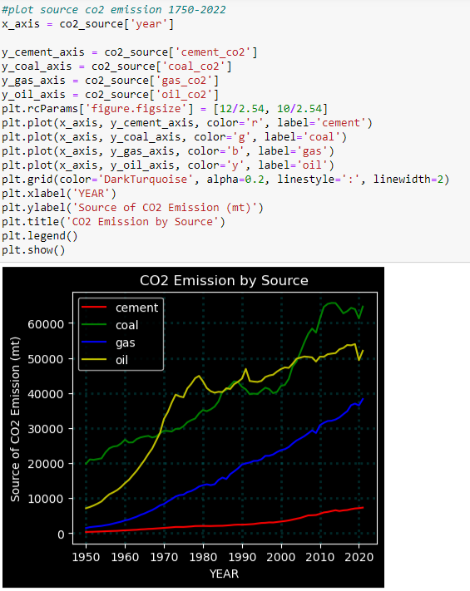

Fig 2

**Slide Three**

And finally using Geopy and Folium, third party library for Python, we put the countries responsible for co2 emission in 2020 in a map. On Fig 3 shows Europe is the largest region for co2 emission in 2020.

Fig 3