1. Генерация данных для таблицы tMaterials

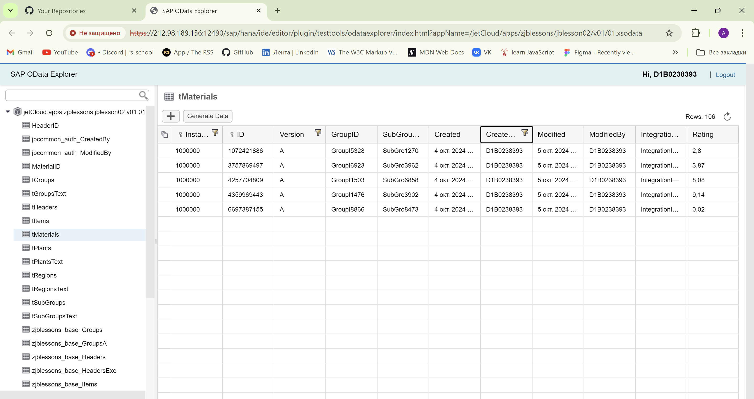

2.

POST

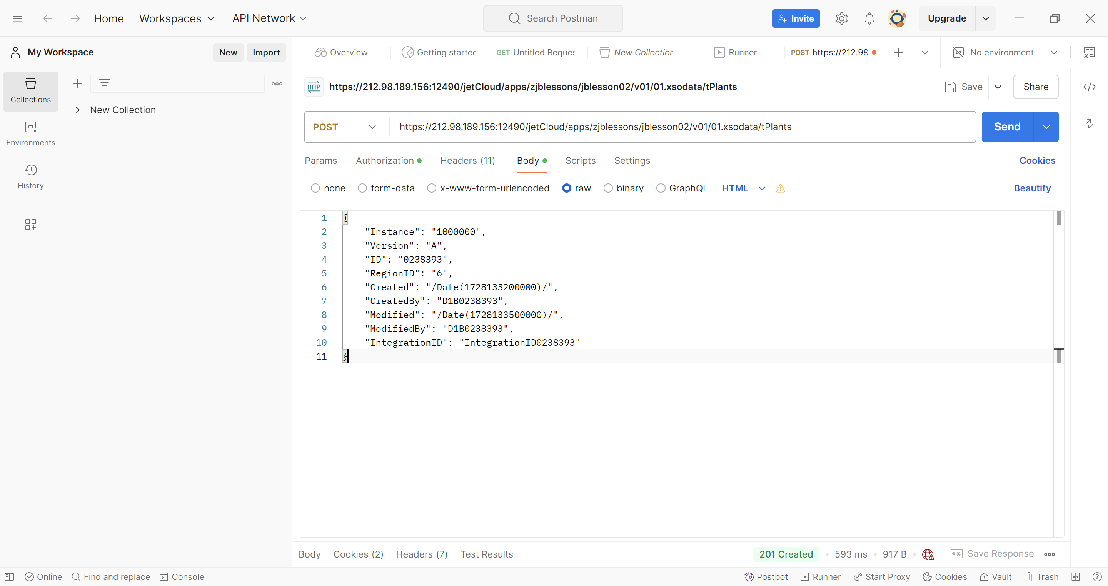

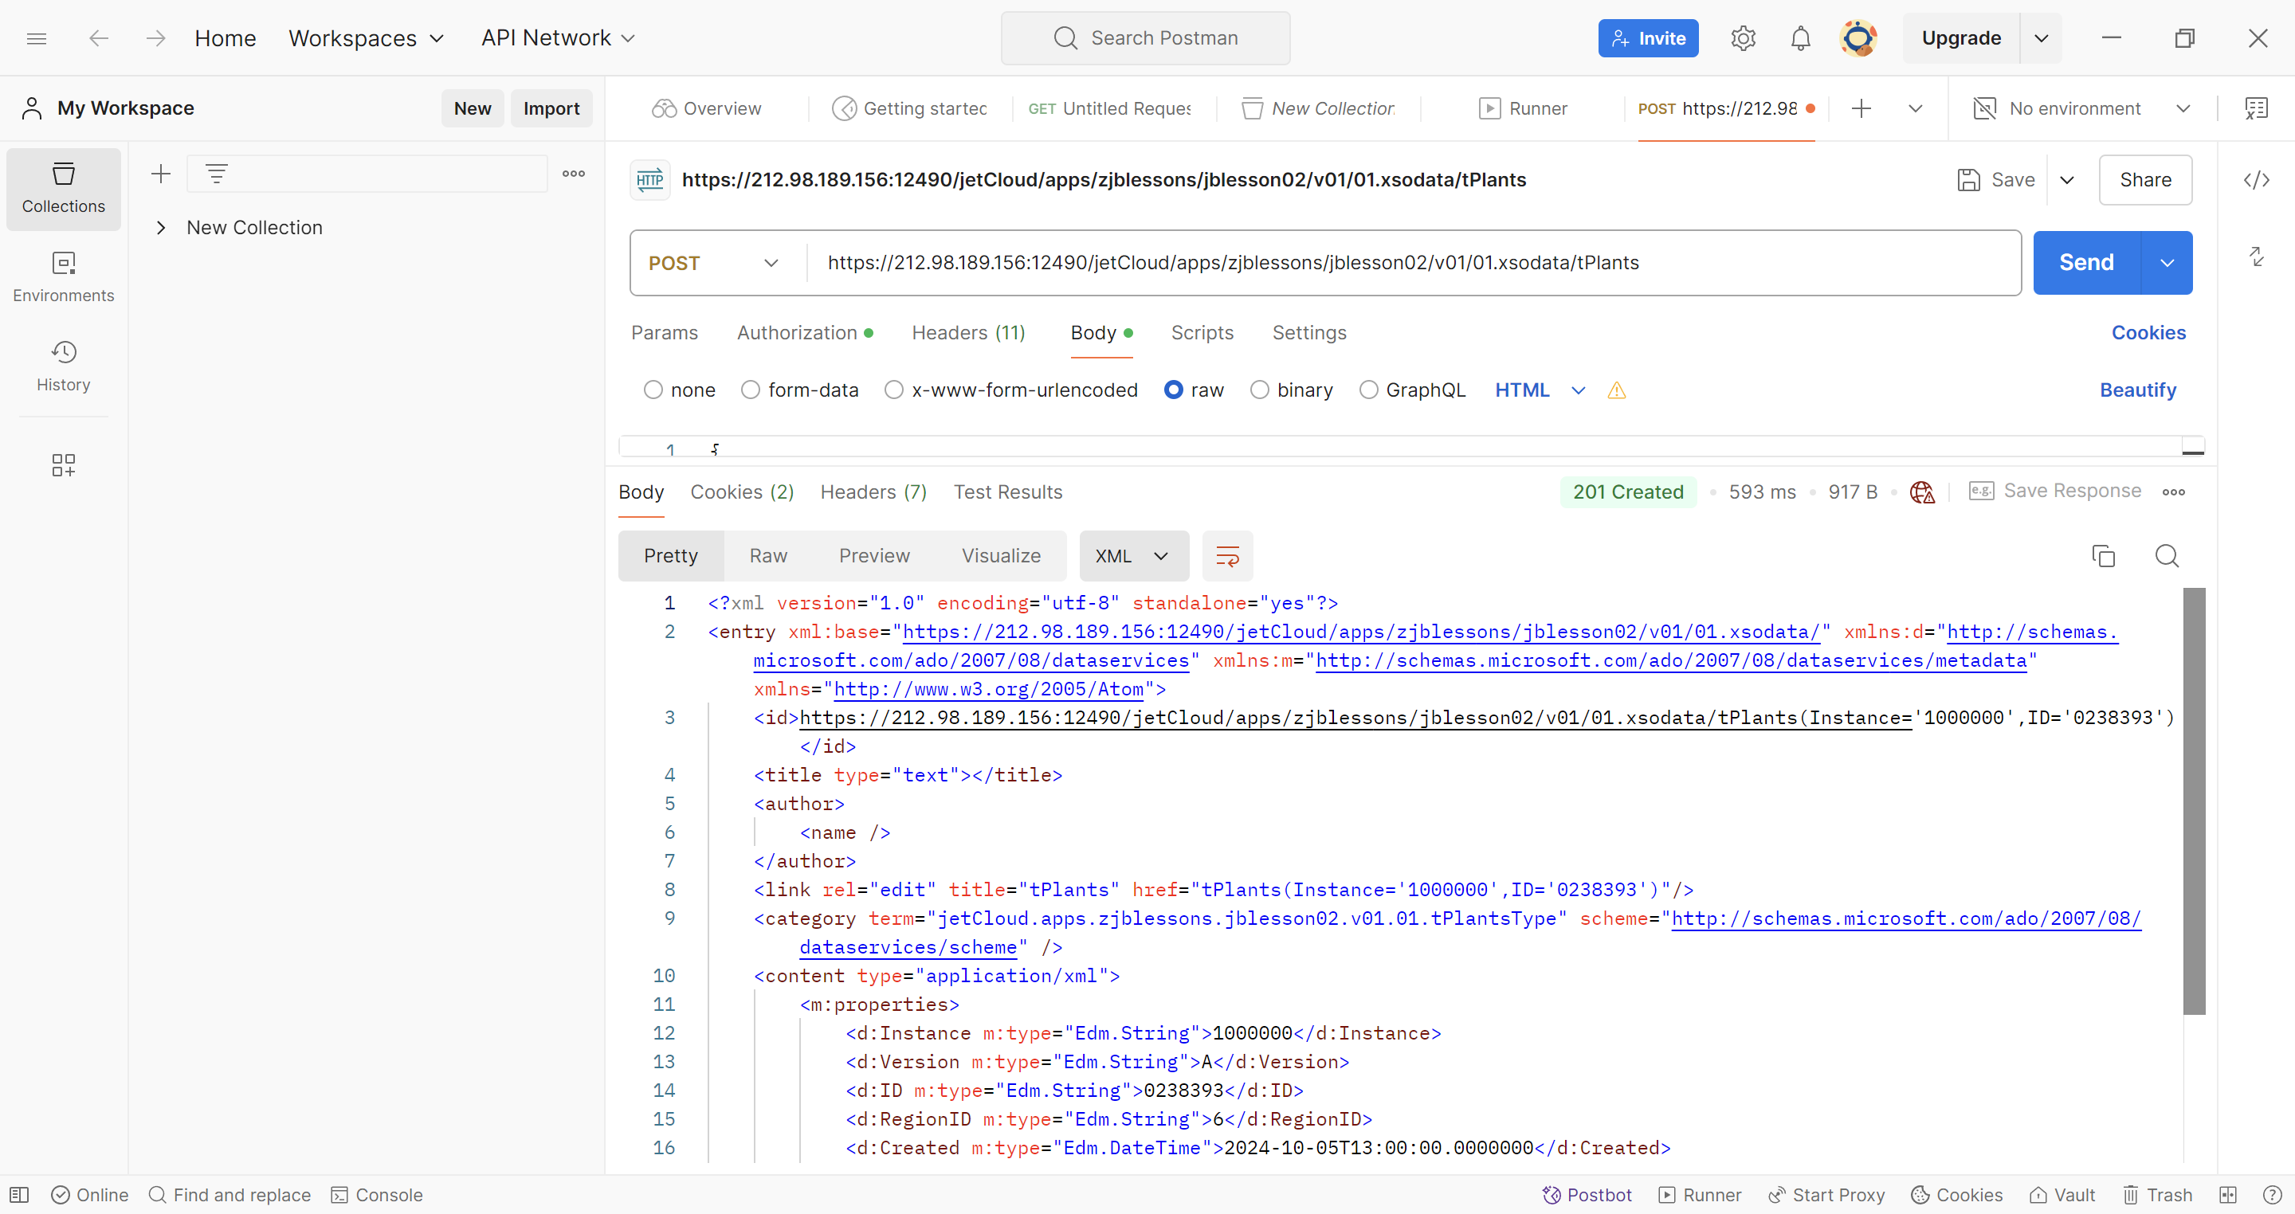

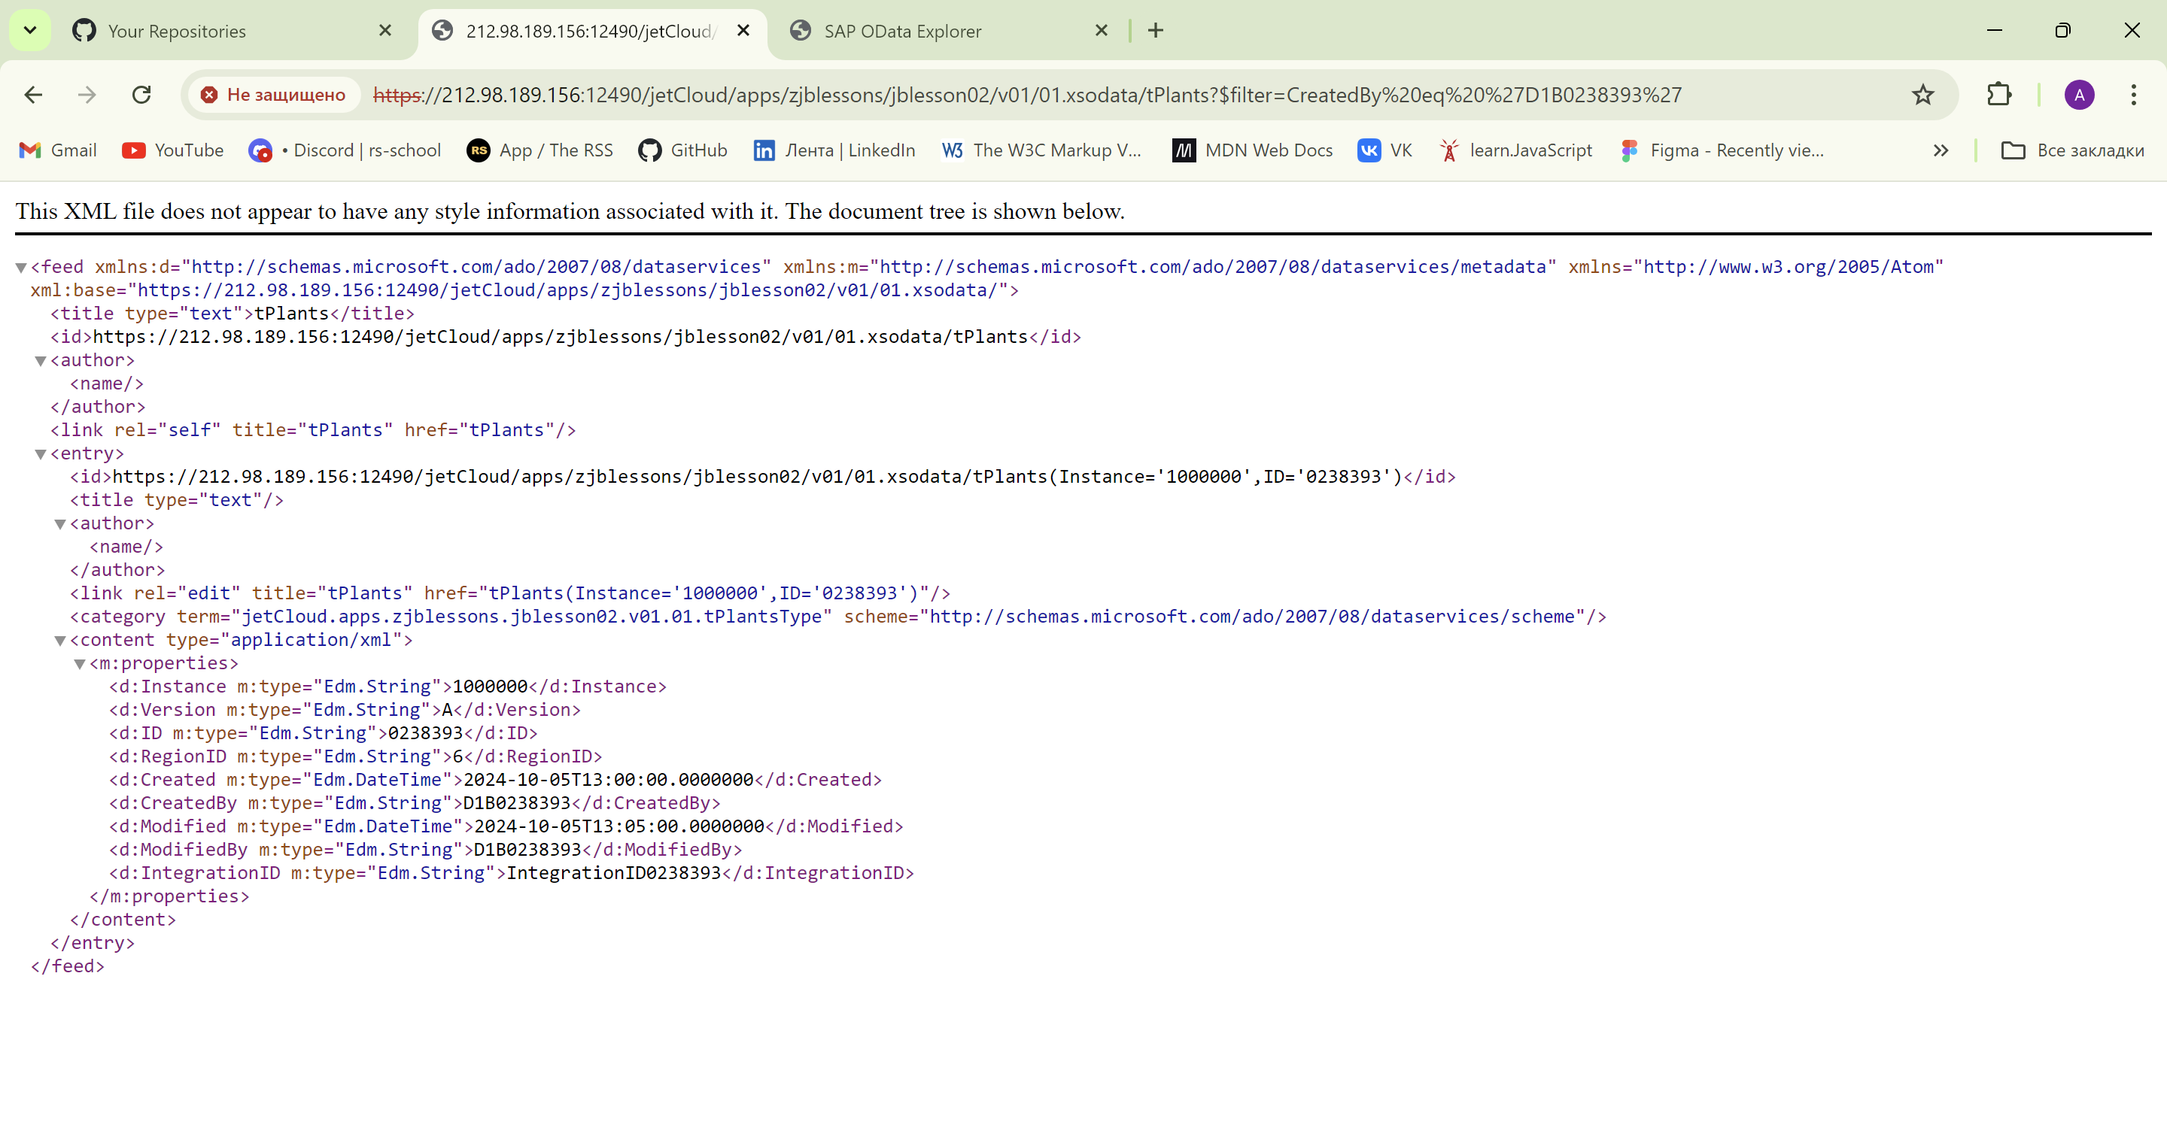

MERGE

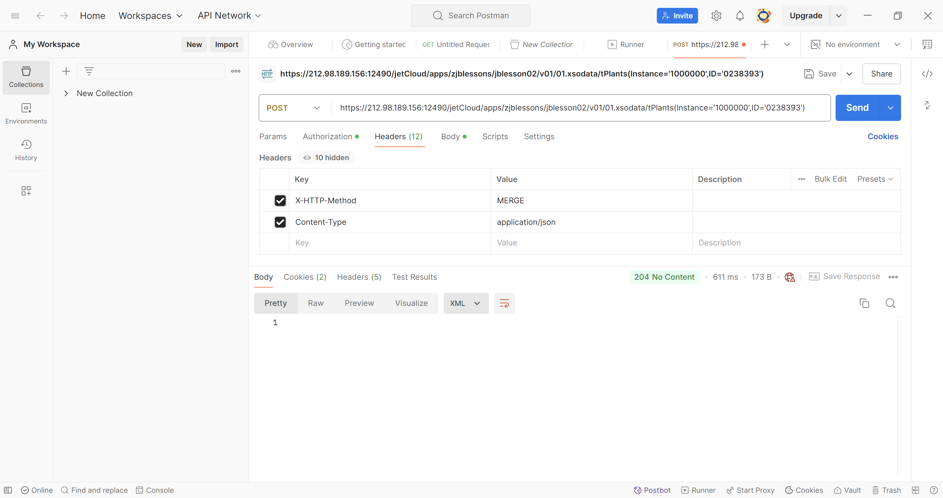

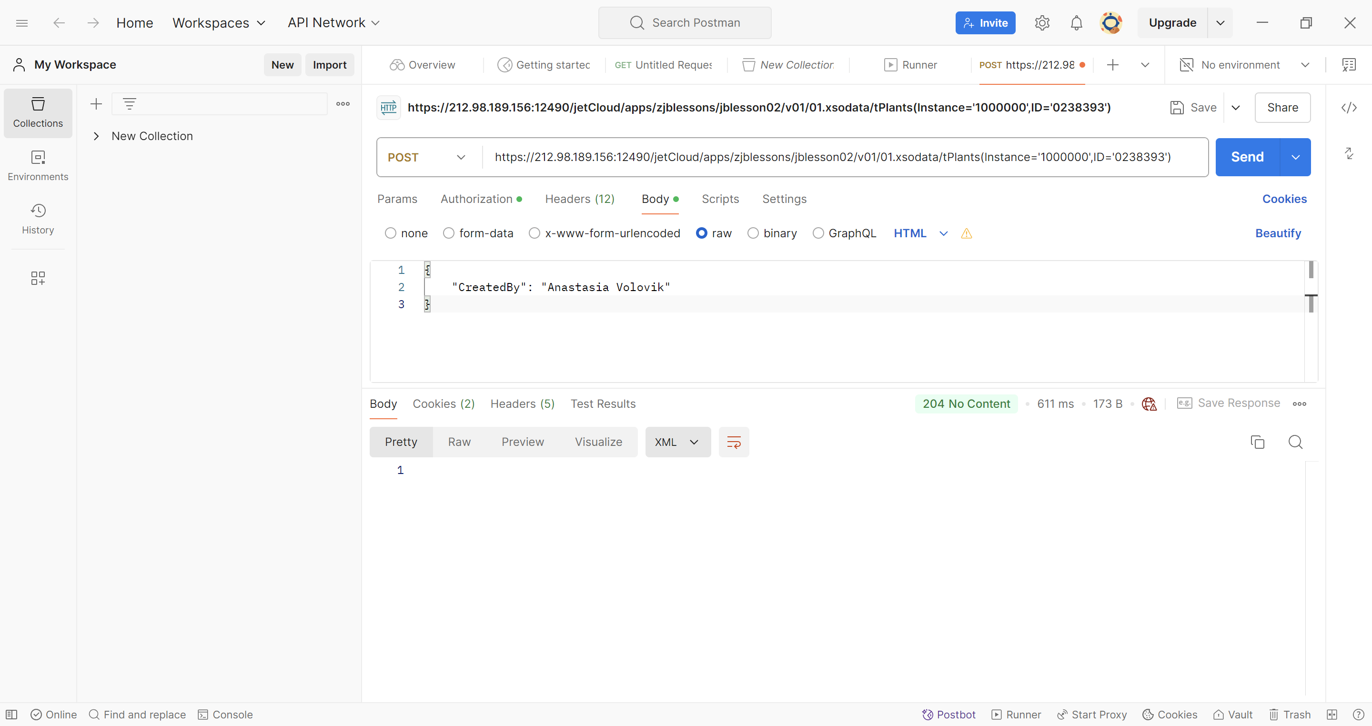

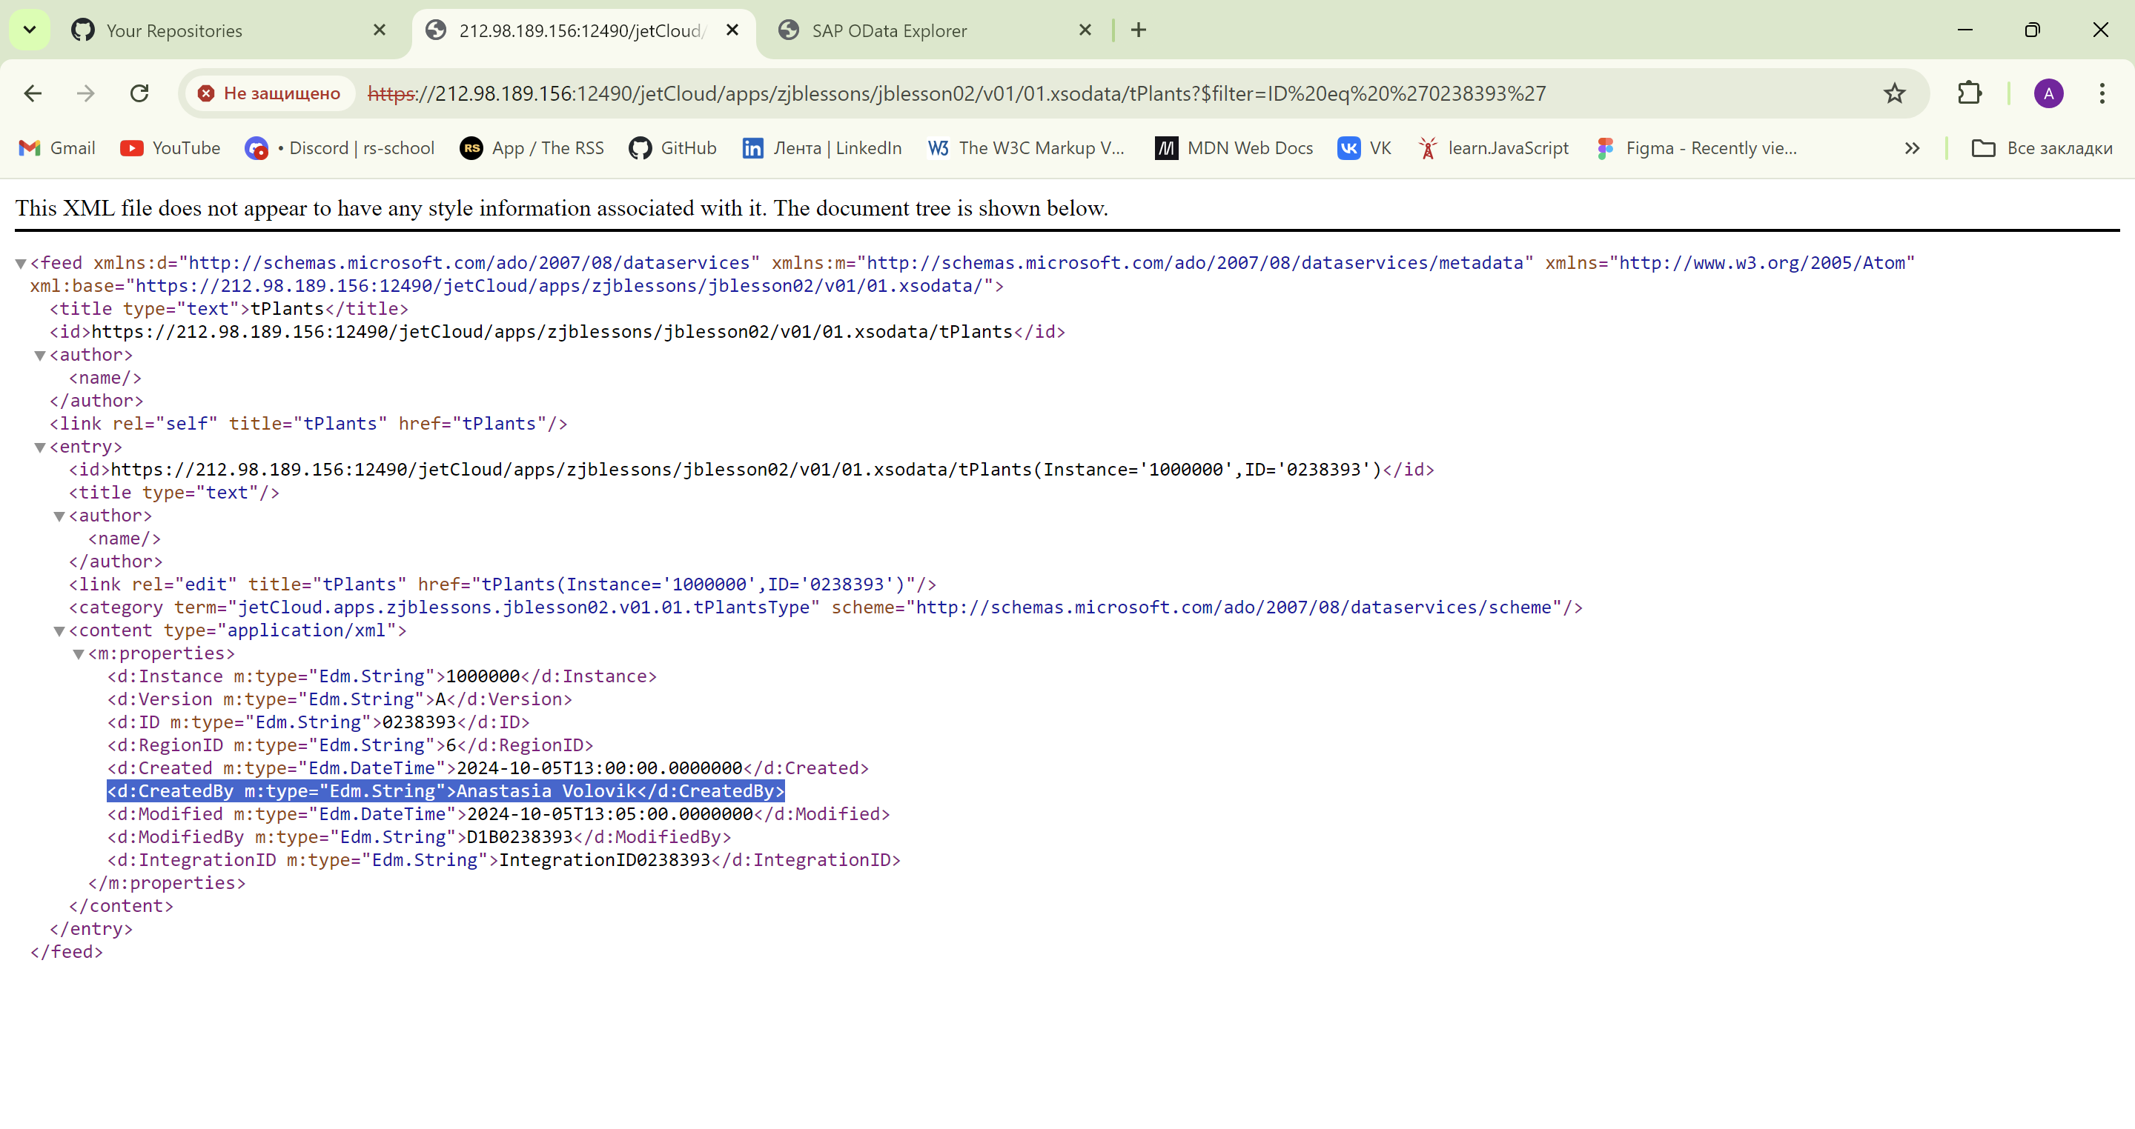

3. GET

<https://212.98.189.156:12490/jetCloud/apps/zjblessons/jblesson02/v01/01.xsodata/zjblessons_base_Headers?$filter=CreatedByFullName> eq 'Yuliya Yatsukhno'

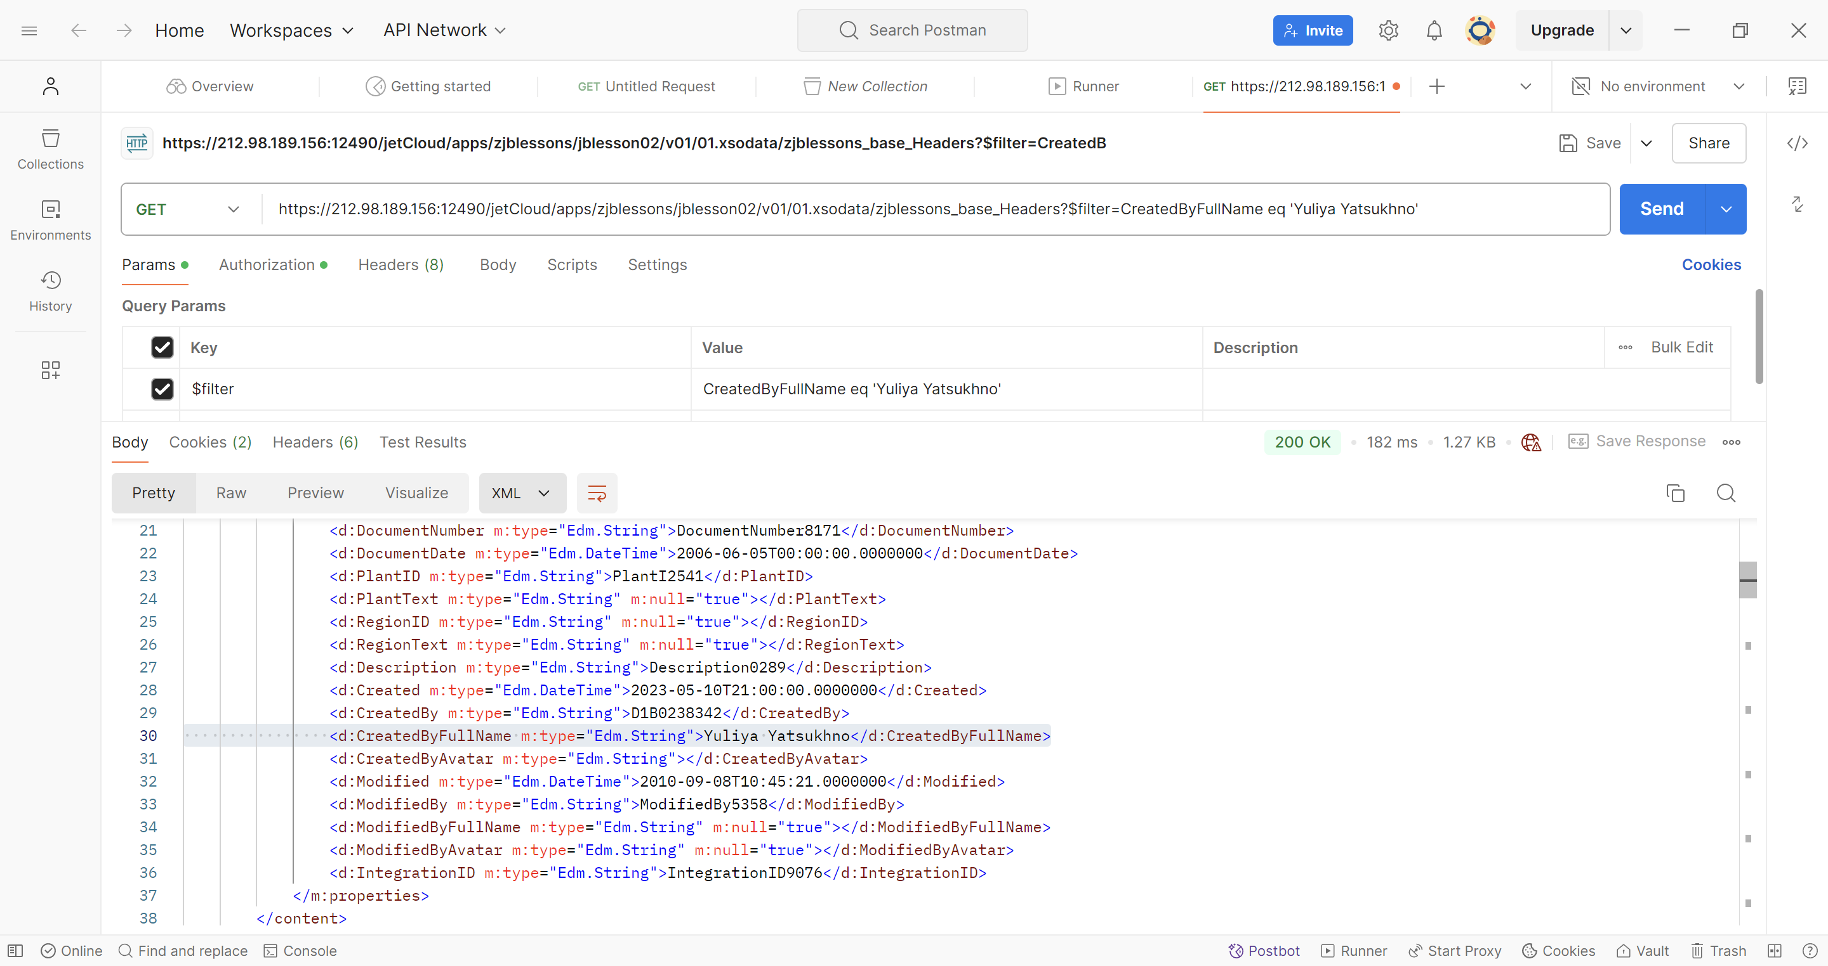

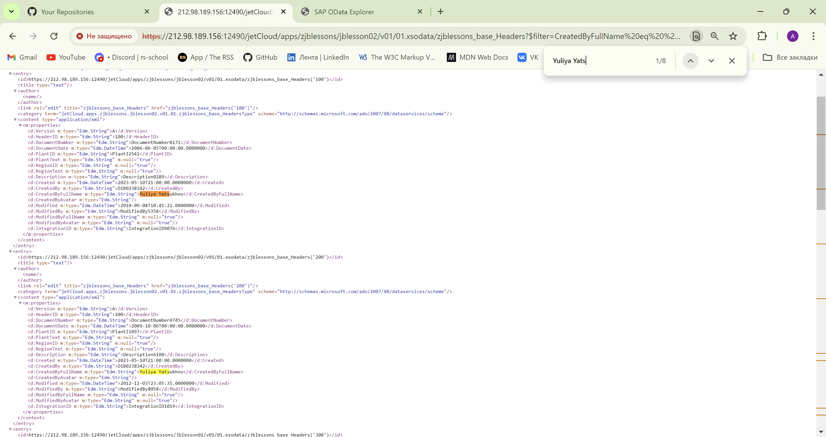

<https://212.98.189.156:12490/jetCloud/apps/zjblessons/jblesson02/v01/01.xsodata/zjblessons_base_Headers?$select=CreatedByFullName,PlantID>

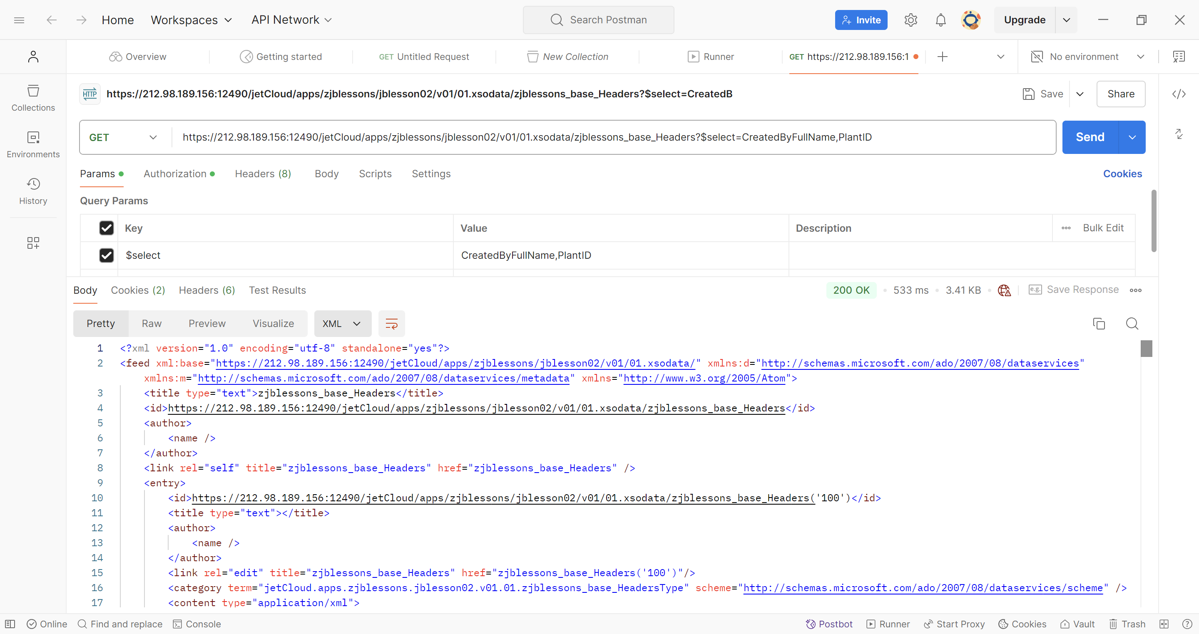

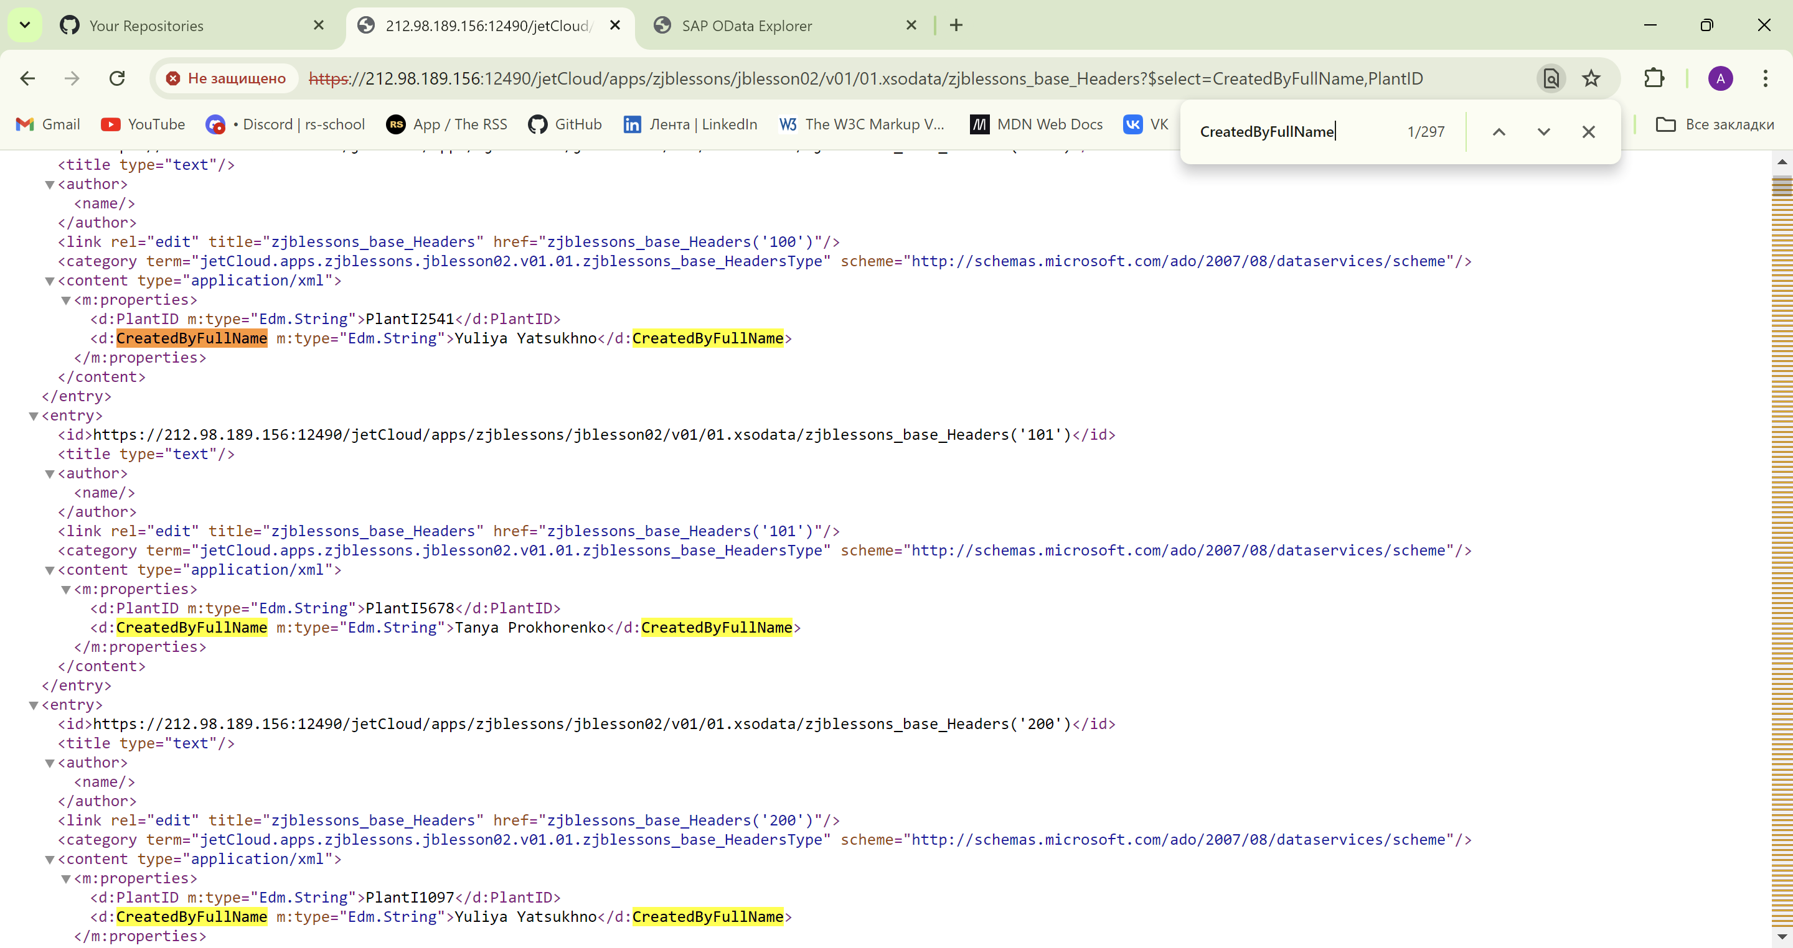

<https://212.98.189.156:12490/jetCloud/apps/zjblessons/jblesson02/v01/01.xsodata/zjblessons_base_Headers?$top=10>

