# Lab: Table Relations

This document defines the lab assignments for [“Databases Basics with MySQL Course” at Software University](https://softuni.bg/courses/databases-basics-mysql).

Get familiar with the **camp** database. You will use it in the following exercises bellow.

## Mountains and Peaks

Write a query to create two tables – mountains and peaks and link their fields properly. Tables should have:

* Mountains:
* id
* name
* Peaks:
* id
* name
* mountain_id

Check your solutions using the “**Run Queries and Check DB**” strategy.

## Posts and Authors

Write a query to create a **one-to-many** relationship between a table, holding information about **books** and other -about **authors**, so that when an author gets removed from the database **all his books are deleted too**. The tables should have:

* Books
* id
* name
* author_id
* Authors
* id
* name

Submit your queries using the “**MySQL run queries & check DB**” strategy.

## Trip Organization

Write a query to retrieve information about the SoftUni camp’s transportation organization. Get information about the people who drive(name and age) and their vehicle type. Submit your queries using the “**MySQL prepare DB and Run Queries**” strategy.

### Example

|  |  |  |
| --- | --- | --- |
| **driver_id** | **vehicle_type** | **driver_name** |
| **1** | **bus** | **Simo Sheytanov** |
| **2** | **Van** | **Roli Dimitrova** |
| **…** | **…** | **…** |

## SoftUni Hiking

Get information about the hiking **routes** and their **leaders** – name and id. Submit your queries using the “**MySQL prepare DB and Run Queries**” strategy.

### Example

|  |  |  |  |
| --- | --- | --- | --- |
| **route_starting_point** | **route_ending_point** | **leader_id** | **leader_name** |
| Hotel Malyovitsa | Malyovitsa Peak | 3 | RoYaL Yonkov |
| Hotel Malyovitsa | Malyovitsa Hut | 3 | RoYaL Yonkov |
| Ribni Ezera Hut | Rila Monastery | 3 | RoYaL Yonkov |
| Borovets | Musala Peak | 4 | Ivan Ivanov |

## Project Management DB*

Write a query to create a project management db according to the following E/R Diagram:

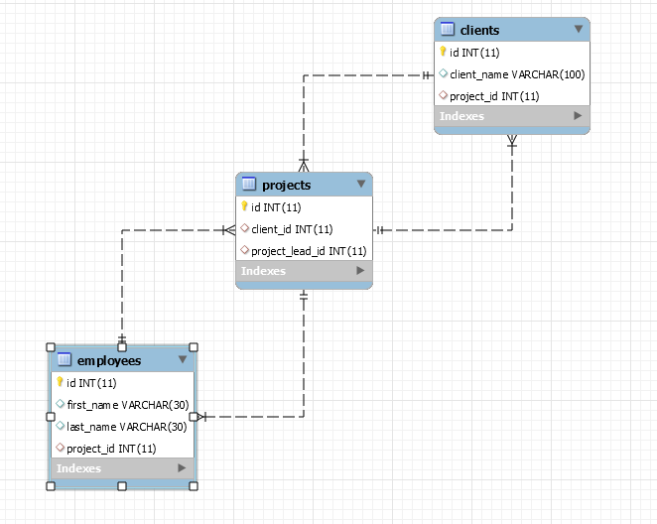

Submit your queries using the “**MySQL Run Queries and Check DB**” strategy.