**Using Amazon Web Services (AWS)**

This section illustrates how we utilized a few services available in AWS:

1. S3 Bucket
2. RDS
3. EC2
4. Quicksight

Other tools used:

1. Google Collaborator
2. Python
3. Postgres

dbproj3 bucket with CSV files

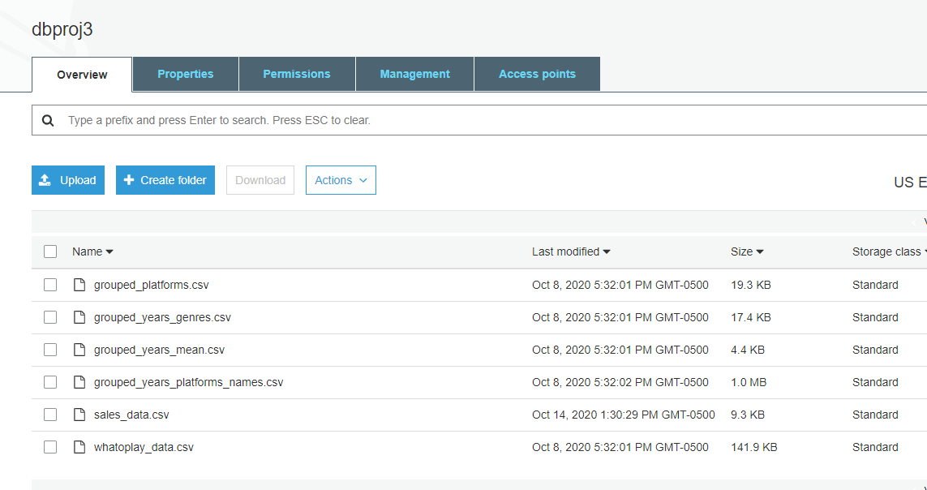

RDS database

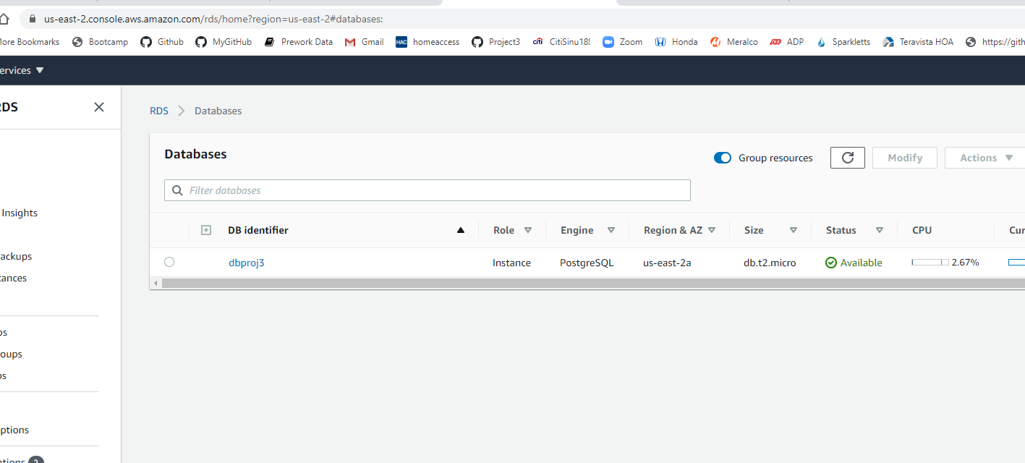

Python file used to write the dataframes to Postgres using Google Collaborator

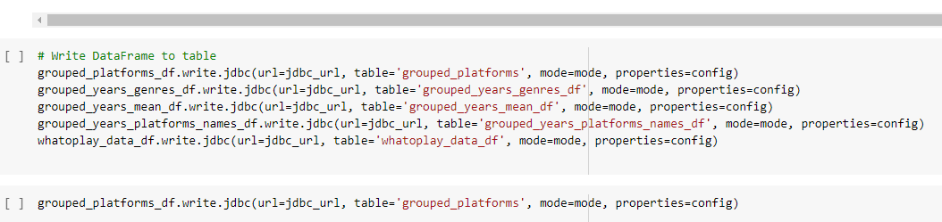

RDS dbproj3 and Postgres SQL Query Editor

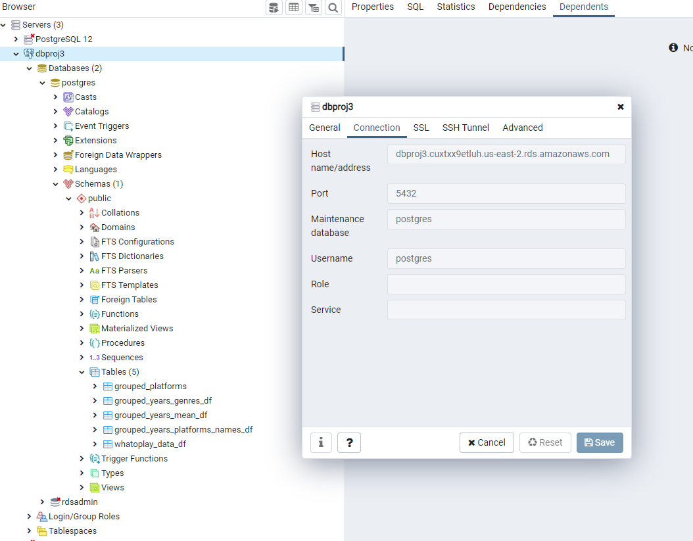

Quicksight Analytics using RDS as a data source

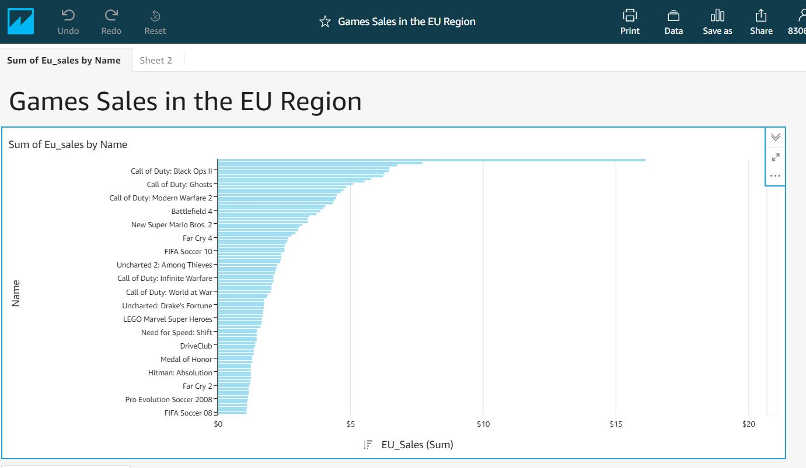

EC2 showing Tableau graphs

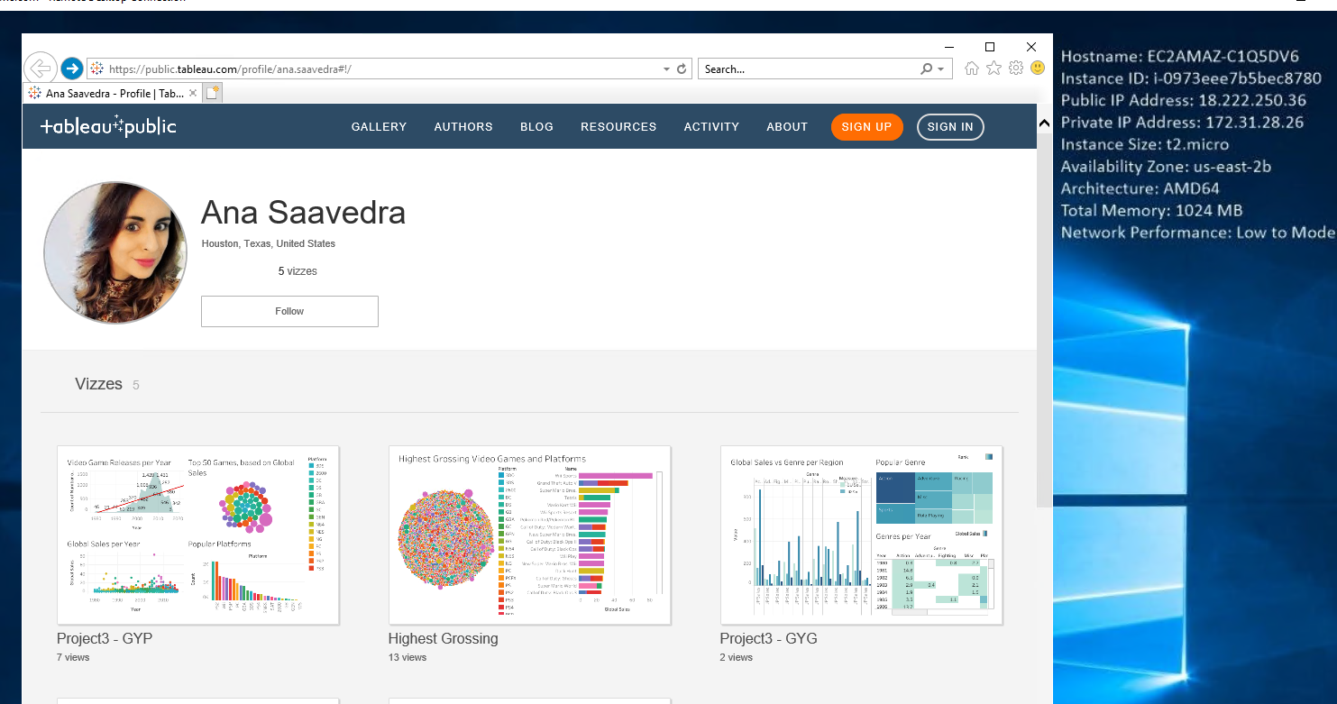

Challenge: No Admin rights to upgrade the IE browser or install Google Chrome. Unable to access the Quicksight website. Very slow.