ASP.NET CORE Project

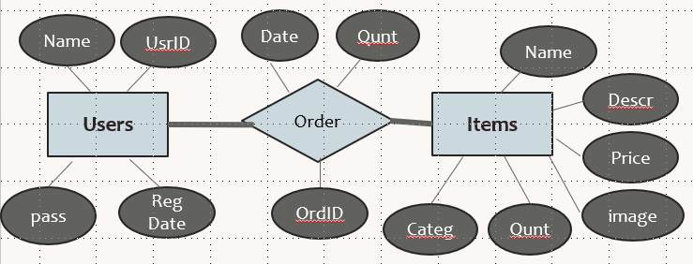

- Login page (admin, customer) 
- 2 Layouts, one for customers pages and another Layout for admin pages 
- In the Layouts include the NavBar 
- 3 Tables (users, items, orders) 
For Customers Add following pages:
  - Only Customers can access these pages
  - Customer Home page that shows a Welcome title_____ , discounted items 
  - My Purchase page that shows: all bought items title, price ____
  - Items image slider page where Customer Get to see all items and its prices 
    - ADD buy link to the Items where Customer can click to make the buy at the buy page 
  - Create buy page
    - Show the item detail note that the price with will have 10% discount if it is on a discount (javascript) 
    - If the buy is submitted then it saves these details (customer name, item id , date of buy ) in the order table _____
  - Create a register page :A user can register himself as a customer from the customer registration page _
    - For this register page include proper validation ____
- Mobile app to allow customer to login and buy from shopping cart ____
For Admin Add following pages:
  - Only Admin can access these pages 
  - Admin Home page that shows a Welcome title, _____
  - Manage Items page where admin can manage any item _____
  - Send email page add a welcome email to a customer _____
  - Items List page within 
  - Insert a new admin page. validate all inputs
  - User Search page to search a user based on his role ___
  - Manage users page where admin can manage any item _____
  - Purchase report page that will show all customers total purchase amount of in a table, When clicking customer order detail will be displayed ordered by the purchase date ____
  - Dashboard where customer can see the statistics category items and the sum of bought items quantity 
So finally the Project will have 4 Controllers with the Following actions

- Usersall Controller (Entity Framework)
  - Index action (default) _
  - Details action (default) 
  - Edit action (default) 
  - Delete action (default) 
  - Create action (default) 
  - Users_search action 
  - addadmin action
  - registration action
  - customer_home action 
  - admin_home action 
  - email action
  - login action 

- Items Controller (Entity Framework)
  - Index action (default)
    - For admin it shows all controls that manages items
    - For customer only detail button is available 
  - Details action (default) 
  - Edit action (default) 
  - Delete action (default) 
  - Create action (default) 
  - list action 
  - image_slider 
  - Dashboard action 
- Orders Controller
  - create_order action ________
  - order_detail action ________
  - my_purchase action ________
  - purchase_report action ________
  - buy action
- getnameAPI Controller
  - get action (returns all users name based on role value) 

Project specification and GUI
- Create 3 tables (you can change table and attributes names to select proper naming)
(all Ids should be auto increment) usersall items, orders
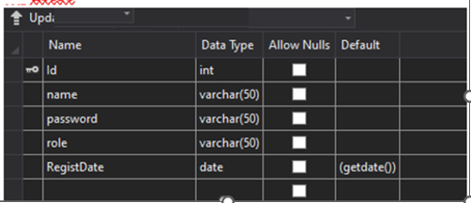

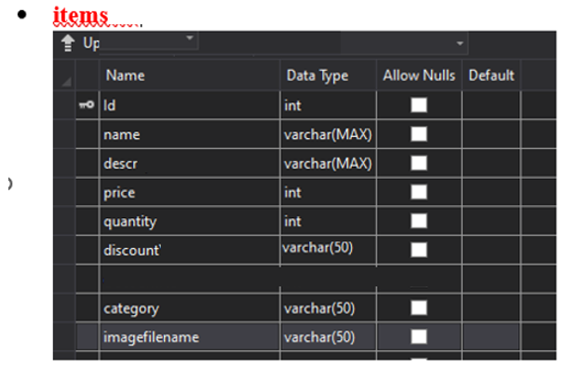
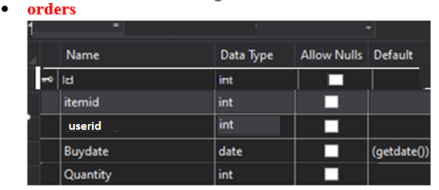

- Create 2 Layouts ( layoutMaster , layoutCustomer) to be included in all pages
- Inside the layouts include NavBar
  - For the admin NavBar (home, Manage Items, Send email, Customer Search, Report Page, dashboard, Add Admin, User Management,Logout button )
  - For the customer NavBar (home, Items Slider, My Purchase, items list)
  - Also include the Logo, Website Title, Logout button)
- The Project will have 3 Models
- Usersall
- Items
- Orders
- For these models create 3 controllers Entities (Usersall, Items, Orders)

- Login page (which will redirect users to maser Home page or customer Home Page)
(Enable Auto Login checkbox)
(at Usersall controller – login)
- use Null layout and use CSS class at the head section
(Use div, table, and background color, image for proper design as shown)
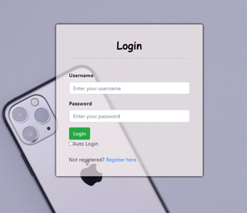

For admin implement these pages (check for correct role session variable used at view to redirect unauthorized users to login page)
- AdminHome Page (at Usersall controller - admin_home )
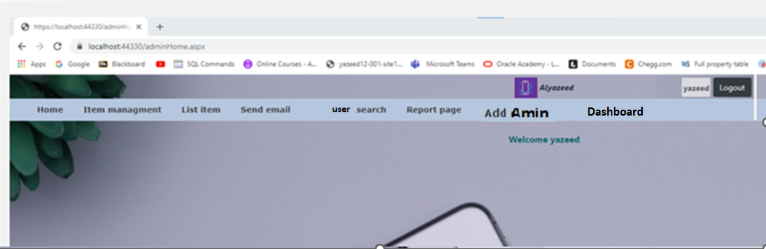

- Item manage page: make sure to add the picture (at item control – index) Also Make sure to use partial view with modal effect for at least (Add, Detail, Edit, Delete)
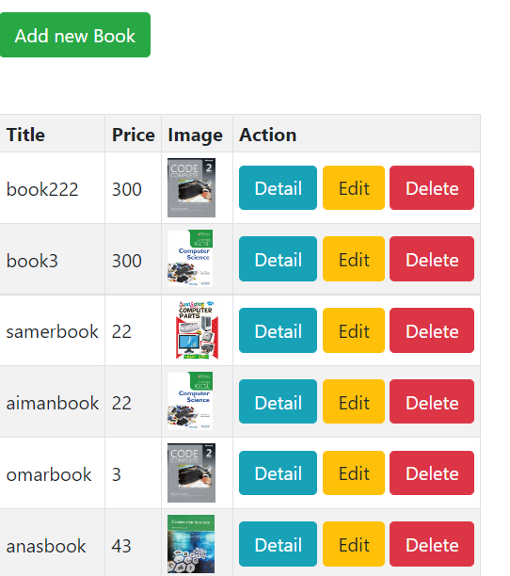

- List items page: item table ordered by Category
  - (at item controller list action )
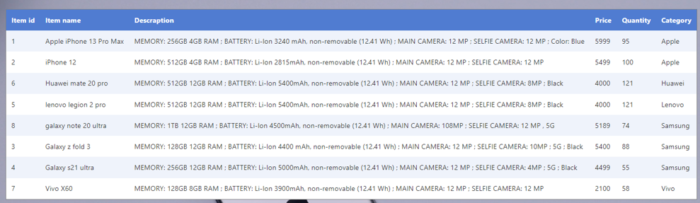

- email page
(at Usersall controller email action )

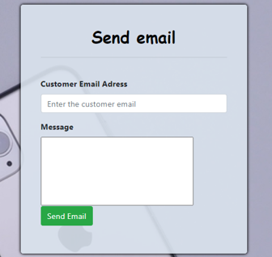

- User search page to search a users based on his role then his name and then shows his detail (at usersall controller customer_search action )

- Search Role List
- Search Name List
- when click the find button it will show user name, id , etc......
- use cascading lists for this search and also use API for getting names based on selected role at the role list
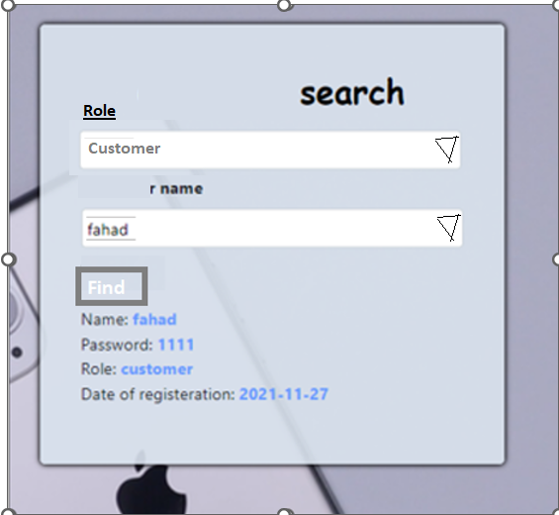

<select class="form-control" name="cata" id="ca" onchange= "gettitle()">
<option value="0">Please select</option>
<option value="admin">Admin</option>
<option value="customer">Customer</option>
</select>
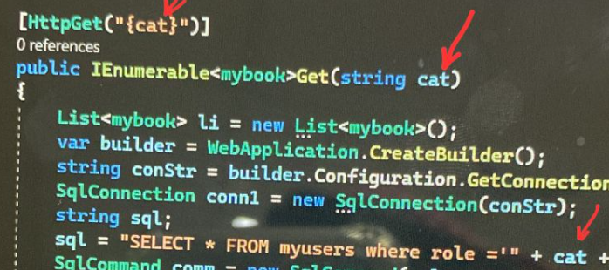
- User management page: show all users index page with all management functions(detail, delete, update)

- Purchase report page: that will show all customers total purchase amount of in a as shown (at order controller - purchase_report action)

- First Need to define a report class at the model
{
public int Id { get; set; }
public string customername { get; set; }
public int total { get; set; }
}
- Check the Data Folder (at ApplicationContext.cs file) that report context is added:
  - public DbSet<WebApplicationxx.Models.report > itemsall { get; set; }
- add this entity code at the action
var orItems = await _context.report.FromSqlRaw(“select
usersall.id as Id,
usersall.name as customername,
sum (quantity * price) as total
from itemsall, orders , usersall
where itemid= itemsall.Id ,and custid= usersall.Id
group by usersall.id, usersall.name “).ToListAsync();

- make sure that the orders report is order by date

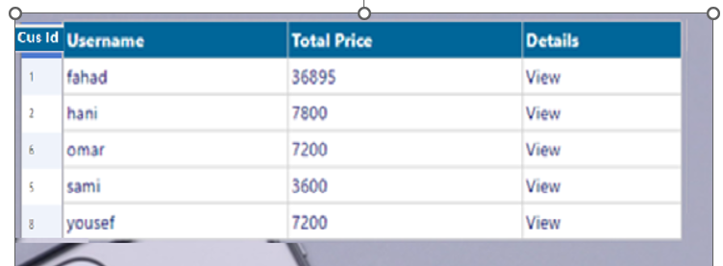

- add the Detail link (sending customer id)
<a asp-action="ordersdetail" asp-route-id="@item.Id ">Details</a>

When click at View that customer orders detail will be shown at customer order
- detail page
- Add orderdetail class(id, username, buydate, totalprice, quantity) at the model folder
- Check the Data Folder (at ApplicationContext.cs file) that the orderdetail context is added:
  - public DbSet<WebApplicationxx.Models. orderdetail> itemsall { get; set; }

- (at order controller – orderdetail action)
public async Task<IActionResult> ordersdetail (int? idd)
var orItems = await _context.details.FromSqlRaw("select usersalls.id, usersalls.name as username, orders.Buydate as BuyDate, items.price*orders.Quantity as totalprice ,orders.Quantity as quantity from orders, usersalls,items where userid= '" + idd + "' and usersalls.Id = order.userid and orders.itemid = items.id and ")
.ToListAsync();
return View(orItems);
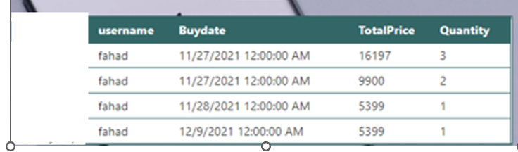

- Add admin Page (at usersall controller – add admin action)

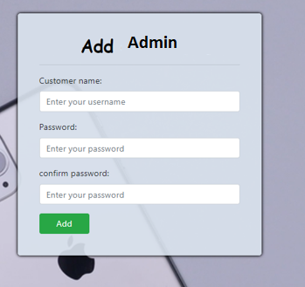

- Dashboard page:
(item controller - dashboard action )
- One pie chart showing the categories item counts
- Card showing total items, card for sum quantity from item orders table
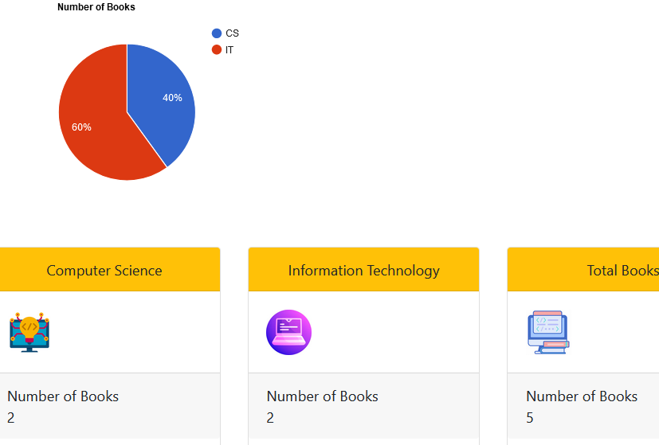

- customerHome page ( welcome: customer name + description , only Discounted Items , Footer: contact detail: email,, Tel ,etc)
(at Usersall controller- customer_home )

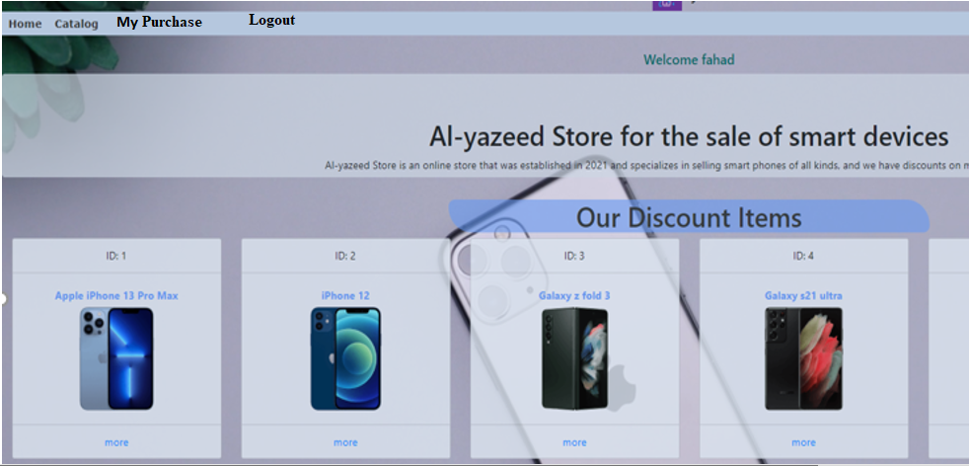

- When the customer click the more it shows the item info at the product item Detail page

(at item controller - Details action (default))

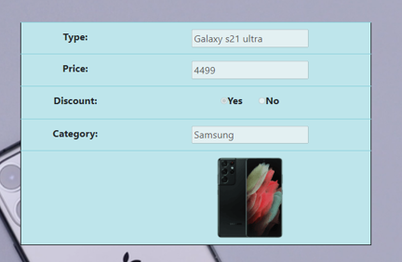

- Item image slider (Carousel) page:
(item controller - image_slider action )

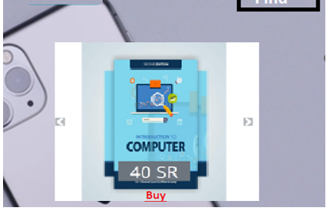
- When customer click on the item name it will redirect to the Buy page
(at order controller – buy action)
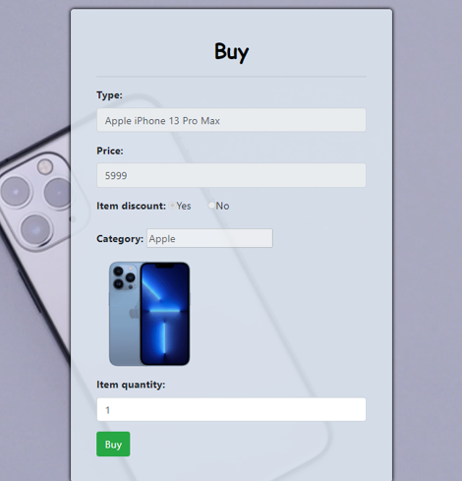
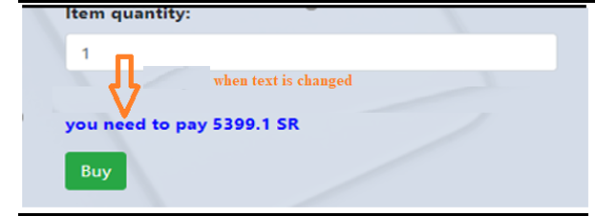
  - Use a java script code When the quantity is inserted the input onchange event
    - get the price and Quantity from the inputs and then a div message that shows how much you need to pay (price * quantity * discount)
  - only if the item has a discount, then subtract 10% from the price
………
- when buy button is clicked make sure that the quantity is more than the quantity in store otherwise show an error message
- if there is enough quantity then the buy record should be inserted in the order table and the quantity – input text value and also show a successful message

- create page for Customer (use required field and compare password validation)
(at user controller – create action)
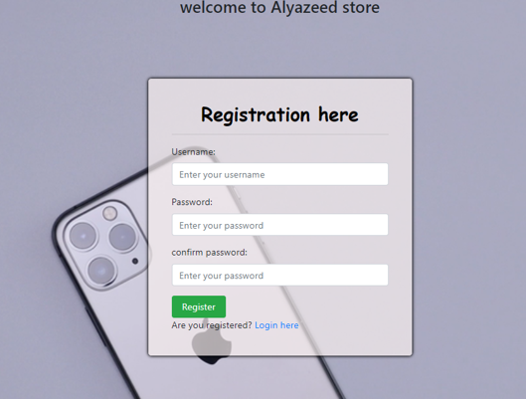
- Make sure that the user name does not exist in the database. If ok then register method else show an error message
- If sign up correctly then direct to customer home page and save customer name, Id, Role at sessions
- My Purchase page that shows: all bought items title, price
(at order controller - my_purchase action)
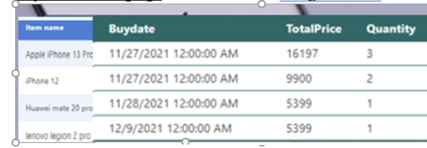
int userid = Convert.ToInt32(HttpContext.Session.GetString("userid"));
var orItems = await _context.orders.FromSqlRaw("select * from orders where userid = '" + userid + "' ").ToListAsync();
item index page:
- -(item controller -index action)

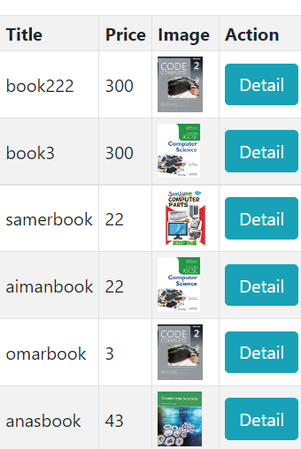

- Shopping Cart Mobile App (Bonus 2 marks)

