Feature Based Plant Seedlings Classification
Dmitri Jakovlev[0000-0002-0729-9311], Iuliia Kamaletdinova and Georgy Shevlyakov[0000-0001-7559-5633]
Peter the Great Saint-Petersburg Polytechnic University,
Higher School of Applied Mathematics and Computational Physics, Russia
georgy.shevlyakov@phmf.spbstu.ru
Abstract. The application of image features in the plant classification task is studied. The used dataset was created at Aarhus University Flakkebjerg Research. This work aims at different approaches in plant species categorization. In this study, the feature-based approach is used. It allows to perform classifying using less computational resources. The features usage is motivated by the following purpose: to distinguish weeds from other plants by selecting the defining features of all classes of plants. The proposed method combines image thresholding, feature selection and feature extraction for the further multiclass classification by such well-known machine learning algorithms as the Support Vector Machines, K-Nearest Neighbors, Decision Tree and Naive Bayes. To a greater extent, we use computer vision algorithms for the image processing step. The main classification method we choose for the task is the Support Vector Machines: it shows the best performance among other tested algorithms; the K-Nearest Neighbors algorithm is slightly worse.
.
Keywords: Image Processing, Feature Extraction, Computer Vision.
- Introduction
The demand for agricultural products is increasing day by day, as the population of the Earth is growing. Even though people work on plant classification algorithms, approaches are still not as efficient and robust as desired. A significant part of this work has still been done by people. The question arises of the efficiency with which human resources are used. We will use exhaustible natural resources wisely and increase harvests if we automatize quality assurance, which objectives are to detect and distinguish weeds among the variety of crop seedlings.
All this naturally leads to the idea of automation of the classification process with the help of machine learning algorithms. From the recent experience, neural networks are well suited for image processing, but we have to pay for it by computational costs. On the other hand, we could use less costly algorithms, but they require finer tuning to achieve comparable results.
A feature-based method is a popular approach in image classification problems, there are many advantages and results with a good performance in many related pieces of research, as in [1], [2]. The main idea of this method is to process the only relevant information of an image, and to reduce the feature space dimension as much as possible. Likewise, dimensionality reduction is the way of solving the curse of dimensionality problem formulated by Richard Bellman in 1957 [3]. The suggested method is described in [4].
The goal of our work is to implement segmentation and classification of a specific type of datasets for lower processing time and computational complexity. In this paper, we study binary classifier capabilities on the dataset [5] consisting of images of 12 species and containing the most common weed species in Danish agriculture.
The remainder of the paper is as follows. In Section 2, the dataset used is described, and the methods of classification are considered. In Section 3, the classification results are given. In Section 4, some conclusions are drawn.
- Materials and methods
  - Data
The considered dataset is a part of the database that has been recorded at the Aarhus University Flakkebjerg Research station in the collaboration between the University of Southern Denmark and Aarhus University. Images are available to researchers at https://vision.eng.au.dk/plant-seedlings-dataset/. The specifics of this dataset is that recorded plants are in different growth stages since detecting a weed in its early stage is the thing which makes the task problematic.
The dataset contains 960 unique plant images of 12 species. The sizes of plant classes are not balanced among themselves—they range from 221 to 654 labeled samples for each class. Original images are cropped by plant boundaries, but their resolutions vary from 50x50px to 2000x2000px. Also, images have different backgrounds—some of them are on the ground, other are on the marked paper.
  - Data preprocessing

Resolution reducing. We reduce the resolution of all images to the same resolution 200x200px using the bilinear interpolation. The main idea of the bilinear interpolation is that a new image pixel is defined as the weighted sum of neighboring pixels of the original image. It helps to decrease computational complexity and build normalized features[6].
Segmentation. The objects of our study are plants, and they are painted green. Therefore, we can create a mask that filters the range of green channel and ignores the other pixels. For these purposes, the HSV (Hue Saturation Value) color model is a suitable representation [7]. In the BGR (Blue Green Red) format, the value of each component depends on the amount of light hitting the object. HSV allows us to distinguish between the image color and brightness. We set the lower and upper bounds of the green color using HSV representation. Then we merely mark the pixels in the green range and get a color mask (Fig.2b). Now we apply the operation of logical multiplication to the original image, assign the value of the background pixels to a black color value, and get a segmented plant.

Denoising. Segmentation does not always work well (see Fig. 2c). Small areas of the background may fall into the range of green values which distorts the binary mask as in Fig. 3a.
Such drawbacks can be eliminated by the morphological operations of the nonlinear transformation associated with the shape and structure of an image. The morphology is used to study the interaction of an image with a specific structural element, the kernel. The kernel iterates over the entire image and compares the neighborhoods of pixels after which we apply morphological operations [8].

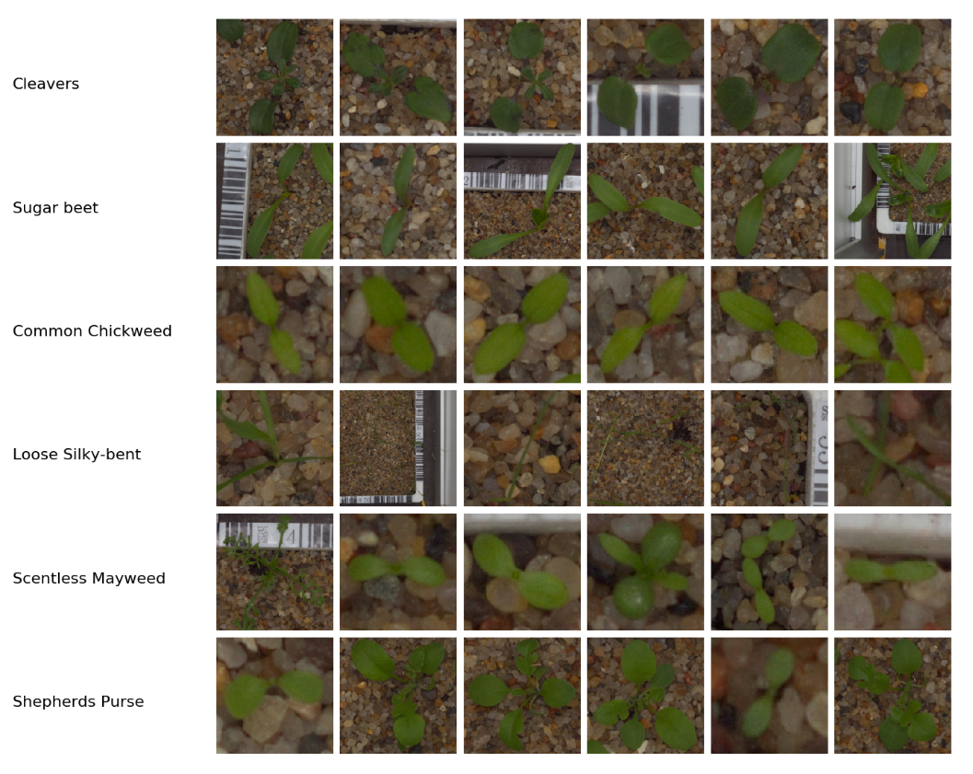Fig. 1. Data overview
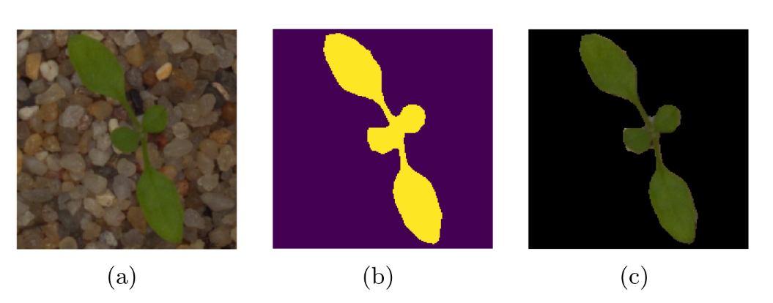Fig. 2. (a) Source image; (b) Mask; (c) Segmented image
To improve segmentation, we use the operation of the morphological closure — a combination of the dilatation and erosion operations [9].
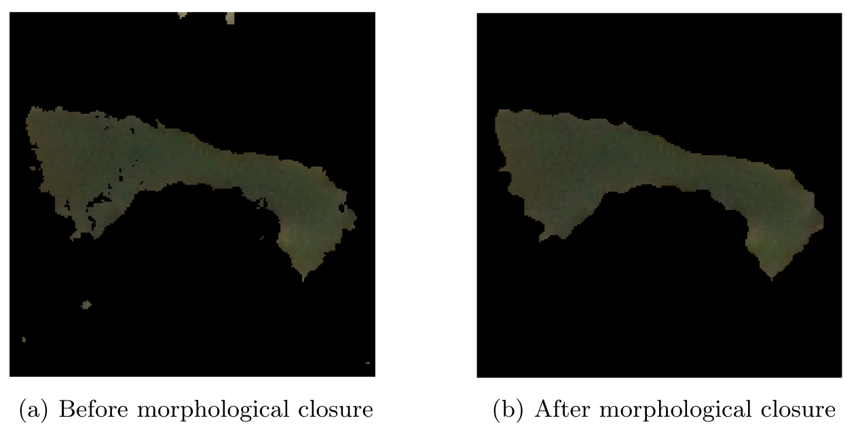 Fig. 3. Segmentation improvement example
Then we apply the morphological closure operation to the image (Fig. 4a) by selecting an elliptical core of 6x6px size and delete the remaining objects within an area of less than 160px. The plant on the image (Fig. 4b) has no cavities, and the background is cleared of non-plant elements. But the morpho-logical closure does not always improve the segmentation result. Estimate the result of processing an image of the class Loose silky-bent in Fig. 4: the cavities corresponding to the background were restored that does not correspond to the desired result. We restrict ourselves to the removal of objects whose contours limit a small area.
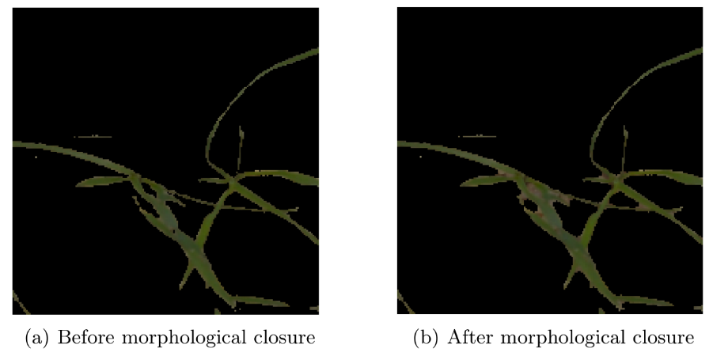
Fig. 4. Segmentation degradation example
  - Feature selection
The features of images define their content. Consideration of a great number of features helps us to recognize the information better. Image features let the classifier propose the output decision. Another advantage of the approach is that it reduces feature space for a machine learning algorithm. We often need only a part of the information on the image, hence we do not need to process and evaluate all the pixels, which can cause additional computational expenses.
Selecting features is a complicated and convoluted research area itself, the statement is supported by the variety of feature types, and the need of presenting essential properties on an equal basis with the previous assertion.
The goal is to define the set of features describing the dataset in the best way. Supposed features must satisfy the following criteria:
- The feature space should be low-dimensional
- The features should not correlate or correlate as little as possible
- Selected features should represent the content of an image as fully as possible
Now we are going to define the selected features.
  - Color features
Overviewing the dataset, we notice that all the plant species are mostly green. Additionally, their images are recorded under specific conditions. We use the RGB color model, which stands for red, green, and blue colors, and calculate features described below.
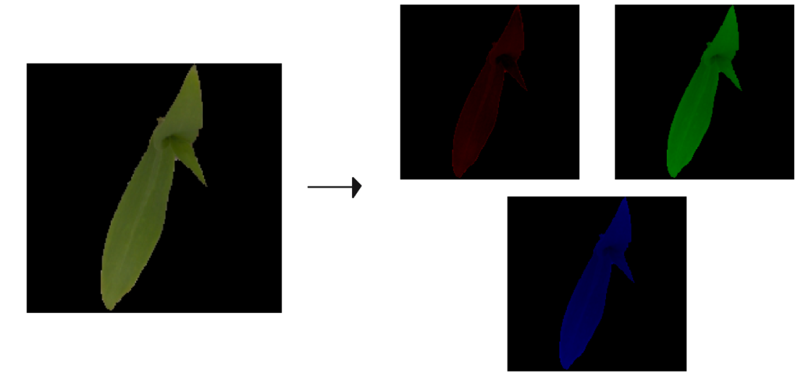 Fig. 5. RGB transformation
Let , where is an index of a channel in the RGB color space, respectively; is a total number of the image pixels; is an i-th pixel of the -th channel. Next, compute the sample mean and standard deviation for each channel:

,
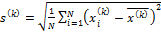.
  - Shape features
A widely-used approach to retrieve shape features is to detect and analyze bounding contours. Here we use the boundary tracing algorithm for the boundary extraction. The designated algorithm [10] is implemented in the OpenCV [11] library for the Python programming language. The studies do not take into account the contours bounding areas below a certain threshold, which is empirically chosen.
Let be a number of detected bounding contours above the threshold in the further contour-related characteristics.

Total perimeter. For this feature, we count the sum of perimeters of all the areas bounded by contours:
,
where is an -th perimeter.

Entire area. In includes all the areas bounded by contours:
,
where is an -th area.

Maximal contour area. Here we analyze the contours bounding maximal areas:
.

Rectangularity. One of the methods to estimate rectangularity is to plot minimum bounding rectangle. Rectangularity is the ratio of the entire object area to the minimum bounding rectangle area. This feature represents how rectangular an object is:
,
where is the entire area, is the minimum bounding rectangle area.
Circularity. Another title of this shape factor is the isoperimetric quotient, and it shows how much area per perimeter is bounded:
,
where is an entire perimeter; is an entire area of all detected elements of a plant.
The correlation matrix of the described features has the form:
Table 1. Feature correlation matrix 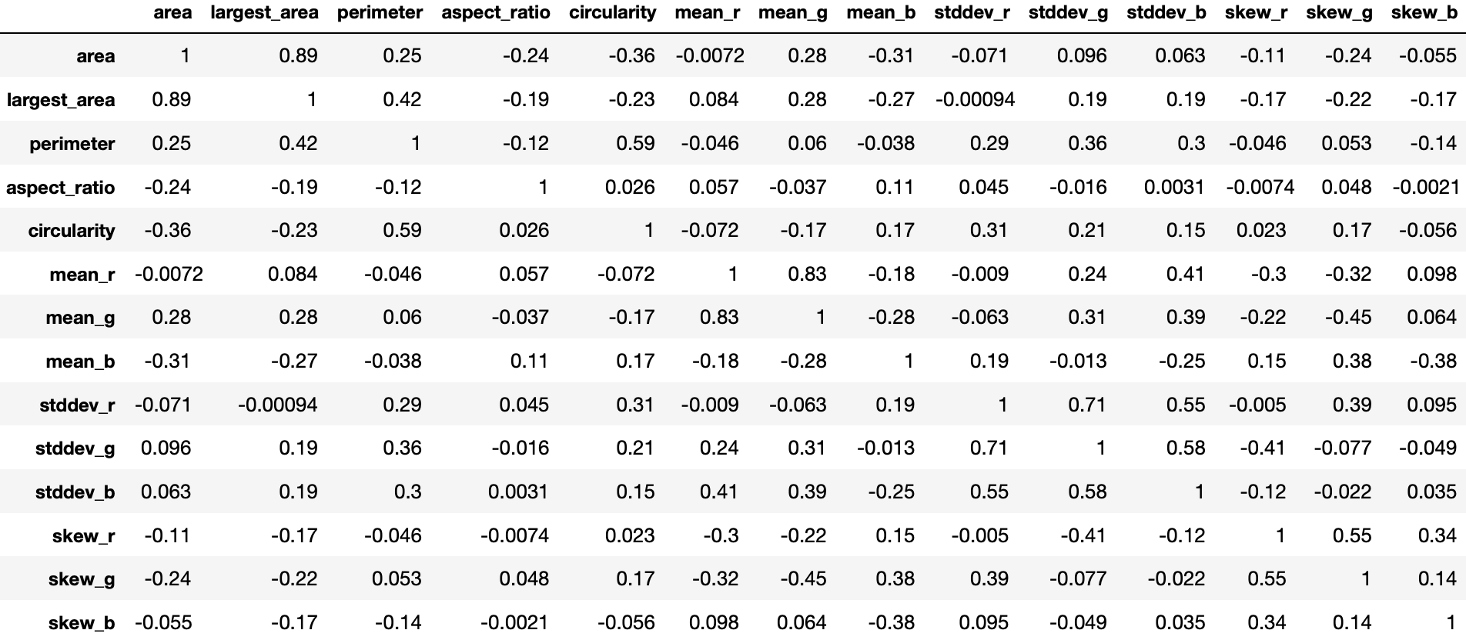
Based on the data in Table 1, we conclude that the most linearly dependent features are the entire area and the largest area. This is not true for all classes due to the predominance of plants bounded by the only one contour. Therefore, the largest area feature is not rejected.
  - Classification
The main method for solving this task is the Support Vector Machine (SVM)[12], a binary classification algorithm based on building a separating hyperplane. The other methods we apply are the K-Nearest Neighbors [13], Naive Bayes [14] and Decision Tree [15] classifiers. These algorithms are implemented in the Scikit-learn [16] library for the Python programming language.
We use the Radial Basis Function (RBF) as the kernel function for SVM. This choice is made because the RBF allows to build a hyperplane when the data is not linearly separable.
Data normalization. The SVM algorithm is sensitive to non-normalized data, especially when using the RBF kernel, which is just the Euclidian distance. In the case when the feature values are at different intervals, a slight difference in one of them can lead to going out of range in second feature values. The solution is to map all the values into one segment. In this task, we choose the segment [0,1].
- Results
  - Metric
Results of classification are evaluated by the micro-averaged F-score. Given the positive and negative rates for each class, the resulting score is computed as follows:
,,

,
where is a set of the plant classes.
The choice of such a metric is supported by the fact that classes are imbalanced. In this case, the influence of classes decreases due to averaging by classification characteristics, not by F-scores.
The classification output is shown in Table 2. The worst classification result is received for the Black-grass class. This type of plant is difficult to segment on an equal basis with the Loose Silky-bent class (Fig. 4), for which the result is significantly better. The Black-grass plants have purple roots, but the segmentation algorithm we use does not work properly in the purple color values range. Another cause of this result is in the predominance of the Loose Silky-bent training data size. One of the highest scores belongs to the Common Chickweed class (Fig. 2). The segmentation algorithm demonstrates good results on these plants, because there is a definite green colour values range, which defines the entire plant. Additionally, plants of this class cover a sizable area. It decreases the chance of treating the parts of the target object as the parts of the background.
  - Models comparison
The choice of the SVM is justified by better results in comparison with other classical methods of machine learning. Table 3 shows micro-averaged F-scores for the Naive Bayes, K-Nearest Neighbors and Decision Tree classifiers. The Naive Bayes shows the worst results because it is sensitive to the correlation between features. The Decision Tree performs vastly worse than SVM, because we use the RBF kernel in SVM. This effect is called ”kernel trick” [17], it allows us to work in a transformed space, where the data is linearly separable. Since the k-nearest neighbors algorithm is insensitive to nonlinear data, the result is as good as SVM. These methods are implemented in Scikit-learn library. All the experimental results are obtained using cross-validation technique [18].
Table 2. Detailed metrics for the SVM classification
Type | Precision | Recall | F-Score
Sugar beet | 0.90 | 0.93 | 0.91
Fat Hen | 0.87 | 0.90 | 0.89
Scentless Mayweed | 0.85 | 0.90 | 0.87
Charlock | 0.95 | 0.93 | 0.94
Small-flowered Cranesbill | 0.96 | 0.99 | 0.97
Maize | 0.95 | 0.89 | 0.92
Shepherds Purse | 0.83 | 0.71 | 0.77
Common Wheat | 0.80 | 0.89 | 0.84
Common Chickweed | 0.96 | 0.96 | 0.96
Cleavers | 0.89 | 0.85 | 0.87
Loose Silky-bent | 0.83 | 0.89 | 0.86
Black-grass | 0.76 | 0.53 | 0.62
Micro-averaged F-score | 0.88
Table 3. Metrics for classification
Method | Micro-averaged F-score
naiveBayes | 0.72
kNN | 0.84
Decision Tree | 0.73
SVM | 0.88
- Conclusion
In this paper, we apply the feature-based method to the image classification task. The constructed algorithm is implemented and evaluated on the real plant dataset containing images of 12 different types of seedlings. We select and extract features using computer vision algorithms. As it is shown in Table 3, the best performance is reached with the Support Vector Machines algorithm. The detailed result for the best method is shown in Table 2. Some of the classes are not recognized well because of the minor differences between some types of proposed plants. The future work aims at improving segmentation output and at the usage of other types of image features.

References
- Shi, L., Wan, Y., Gao, X., Wang, M.: Feature selection for object-based classification of high-resolution remote sensing images based on the combination of a genetic algorithm and tabu search. Computational Intelligence and Neuroscience 2018, 1–13 (2018). https://doi.org/10.1155/2018/6595792.
- Mingqiang, Y., Kidiyo, K., Joseph, R.: A survey of shape feature extraction techniques. In: Pattern Recognition, chap. 3. IntechOpen, Rijeka (2008). https://doi.org/10.5772/6237.
- Bellman, R.: Dynamic Programming. Princeton University Press, Princeton, NJ, USA, 1st edn. (1957).
- Pechenizkiy, M., Puuronen, S., Tsymbal, A.: Feature extraction for classification in knowledge discovery systems. In: Knowledge-Based Intelligent Information and Engineering Systems. pp. 526–532. Springer Berlin Heidelberg, Berlin, Heidelberg (2003).
- Mosgaard Giselsson, T., Nyholm Jørgensen, R., Kryger Jensen, P., Dyrmann, M., Skov Midtiby, H.: A public image database for benchmark of plant seedling classification algorithms. arXiv e-prints arXiv:1711.05458 (2017).
- Davis, P.J.: Interpolation and Approximation. Dover Publications, New York, USA, 1 edn. (1963).
- Smith, A.R.: Color gamut transform pairs. In: Proceedings of the 5th Annual Conference on Computer Graphics and Interactive Techniques. pp. 12–19. SIGGRAPH’78, ACM, New York, NY, USA (1978). https://doi.org/10.1145/800248.807361.
- Friel, J.J.: Practical Guide to Image Analysis. ASM International (2000).
- Efford, N.: Digital Image Processing: A Practical Introduction Using Java (with CD-ROM). Addison-Wesley Longman Publishing Co., Inc., Boston, MA, USA, 1st edn. (2000).
- Suzuki, S., Abe, K.: Topological structural analysis of digitized binary images by border following. Computer Vision, Graphics, and Image Processing 30, 32–46 (1985).
- Bradski, G.: The opencv library. Dr. Dobb’s Journal of Software Tools 25, 120–125 (2000).
- Hsu, C.W., Chang, C.W., Lin, C.J.: A practical guide to support vector classification. Tech. rep., Department of Computer Science and Information Engineering, University of National Taiwan, Taipei (2003), http://www.csie.ntu.edu.tw/ ∼ cjlin/papers/guide/guide.pdf.
- Cunningham, P., Delany, S.: k-Nearest neighbour classifiers. Multiple Classifier Systems 34, 1–17 (2007).
- Rish, I.: An empirical study of the naive bayes classifier. In: IJCAI 2001 workshop on empirical methods in artificial intelligence. vol. 3, pp. 41–46. IBM New York (2001).
- Breiman, L., Friedman, J.H., Olshen, R.A., Stone, C.J.: Classification and Regression Trees. Wadsworth and Brooks, Monterey, CA (1984).
- Pedregosa, F., Varoquaux, G., Gramfort, A., Michel, V., Thirion, B., Grisel, O., Blondel, M., Prettenhofer, P., Weiss, R., Dubourg, V., Vanderplas, J., Passos, A., Cournapeau, D., Brucher, M., Perrot, M., Duchesnay, E.: Scikit-learn: Machine learning in Python. Journal of Machine Learning Research 12, 2825–2830 (2011).
- Hofmann, T., Schölkopf, B., Smola, A.: Kernel methods in machine learning. Annals of Statistics 36(3), 1171–1220 (2008).
- Hastie, T., Tibshirani, R., Friedman, J.: The Elements of Statistical Learning: Data Mining, Inference, and Prediction. Springer Series in Statistics, 2nd edn. (2009).
- Shevlyakov, G. L., Vil’chevski, N. O.: Robustness in data analysis: criteria and methods. VSP, Utrecht-Boston-Tokio (2002).
- Shevlyakov, G. L., Vil’chevski, N. O.: Robustness in data analysis. De Gruyter, Boston (2011).

