Design and Implementation of ArynKost: A Flutter–Laravel Based Boarding House Management Information System
 | 1st Anadza Wafiqotul Azizan  Informatics Engineering  Muhammadiyah University of Bandung  Bandung, Indonesia  anadzazizah162@gmail.com  3rd Rahma Laila Sabina  Informatics Engineering  Muhammadiyah University of Bandung  Bandung, Indonesia  rahmals238@gmail.com | 2nd Nashwa Aufa Wiguna  Informatics Engineering  Muhammadiyah University of Bandung  Bandung, Indonesia  nashwaaufawiguna@gmail.com  4th Yusyfina Yuniarti  Informatics Engineering  Muhammadiyah University of Bandung  Bandung, Indonesia  yusyfina@gmail.com

The rapid growth of boarding house businesses has increased the need for integrated information systems capable of supporting administrative processes, room management, tenant services, and financial transactions. Conventional management methods frequently lead to data redundancy, delayed information updates, and inefficient communication between boarding house administrators and tenants. This study presents the design and implementation of ArynKost, a boarding house management information system developed using Flutter for the mobile application and Laravel for the web-based administration system and RESTful API services. The system adopts a client–server architecture in which the Flutter application communicates with the Laravel backend through REST APIs secured using Laravel Sanctum authentication. Based on the implementation analysis, the system provides role-based access for administrators, owners, and tenants, covering authentication, room management, tenant management, complaint management, billing management, user profile management, and dashboard visualization. The implementation also integrates a MySQL relational database with Eloquent ORM for data persistence. The technical audit reveals that although the core management features have been successfully implemented, several mobile functionalities including room booking, payment proof submission, notification services, and profile photo upload remain partially implemented or unavailable through the REST API. These findings indicate that the current implementation has established a functional foundation for boarding house management while requiring further development to achieve complete feature parity between the web and mobile platforms.
Keywords—Boarding House Management System, Flutter, Laravel, REST API, Information System

Introduction
The rapid advancement of information technology has encouraged the digital transformation of various business sectors, including boarding house management. Conventional management processes that rely on manual record keeping often create challenges in maintaining room availability, tenant records, payment information, and complaint handling. As the number of tenants increases, manual administration becomes increasingly inefficient and prone to human error.
To address these challenges, information systems have been widely adopted to improve operational efficiency, data accuracy, and service quality. Mobile and web technologies enable administrators and tenants to access services more conveniently while supporting centralized data management through client-server architecture [1], [2]. The combination of Flutter for cross-platform mobile development and Laravel as a web framework provides an effective solution for developing integrated information systems with RESTful communication [3], [4].
Based on these considerations, this study presents the design and implementation of ArynKost, a boarding house management information system consisting of a Laravel-based web application and a Flutter-based mobile application. The system supports three user roles, namely administrator, owner, and tenant, each with different access privileges. The implemented features include user authentication, room management, tenant management, complaint management, billing management, dashboard visualization, and user profile management.
Unlike studies that primarily discuss conceptual system design, this paper focuses on the actual implementation of the developed system. The discussion is based on a comprehensive technical audit of the application source code, ensuring that every feature described reflects the existing implementation. Furthermore, the paper identifies several implementation limitations, particularly regarding the integration between the Flutter application and the backend REST API, which provide valuable insights for future system development. follow.

RESEARCH METHODOLOGY

Requirement Analysis
The system was designed to support three categories of users with different responsibilities:
- Administrator manages room data, tenant information, complaints, billing, and system monitoring.
- Owner monitors boarding house operations, including room availability, tenant data, complaints, and payment information.
- Tenant accesses room information, submits complaints, views billing information, and manages personal profile data.
These functional requirements were implemented through role-based authorization using Laravel and integrated with the corresponding interfaces in the Flutter application.

System Architecture
ArynKost adopts a client-server architecture consisting of a Flutter mobile application and a Laravel web application connected through RESTful APIs. The Laravel backend manages business logic, authentication, database operations, and API services, while Flutter provides the mobile user interface for tenants and administrators. Both applications share the same MySQL database to maintain data consistency.
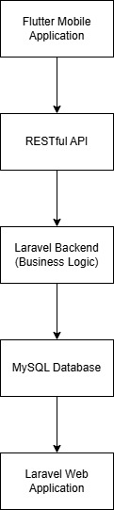
Figure 1. System Architecture

System Implementation
The backend application was developed using the Laravel framework following the Model–View–Controller (MVC) architecture. Business processes are handled by controllers, database operations are performed through Eloquent models, and web interfaces are implemented using Blade templates. Authentication for the web application utilizes Laravel Breeze, while mobile authentication is implemented using Laravel Sanctum with token-based authentication.
The Flutter application is organized into screens, services, models, and reusable widgets. Communication with the backend is performed using HTTP requests that consume REST API endpoints. Authentication tokens are stored locally using SharedPreferences to maintain user sessions.
The database implementation consists of several primary entities, including users, rooms, tenants, bookings, complaints, billing, notifications, and user roles. These entities support the operational processes implemented in both the web and mobile applications.
Overall, the implemented architecture enables centralized data management while providing platform-specific interfaces for administrators, owners, and tenants.

RESULTS AND DISCUSSION

System Overview
ArynKost is an integrated boarding house management information system consisting of a Laravel-based web application and a Flutter-based mobile application. The web application is primarily designed for administrators and owners to manage operational activities, while the mobile application provides services for administrators, owners, and tenants through RESTful APIs.
Based on the source code implementation, the backend follows the Model–View–Controller (MVC) architecture, where controllers process business logic, Eloquent models interact with the database, and Blade templates generate web interfaces. Meanwhile, the Flutter application is organized into screens, services, models, and reusable widgets to separate presentation and data communication.
The system implements role-based access control, allowing different functionalities according to the authenticated user's role. Three user roles are available:
- Administrator, responsible for managing rooms, tenants, complaints, payments, and monitoring system activities.
- Owner, responsible for supervising boarding house operations and monitoring operational data.
- Tenant, responsible for accessing room information, submitting complaints, viewing billing information, and managing personal profile data.
User authentication is implemented using Laravel Breeze for the web application and Laravel Sanctum for the mobile application. After successful authentication, users are redirected to dashboards according to their assigned roles.

User Authentication
Authentication serves as the entry point of the entire system. The Flutter application provides login and registration interfaces that communicate with the Laravel backend through RESTful APIs. User credentials are validated on the server before a Sanctum access token is generated and returned to the mobile application.
The authentication process is illustrated as follows.
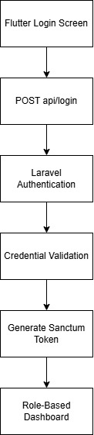
Figure 2. User Authenthication Flow
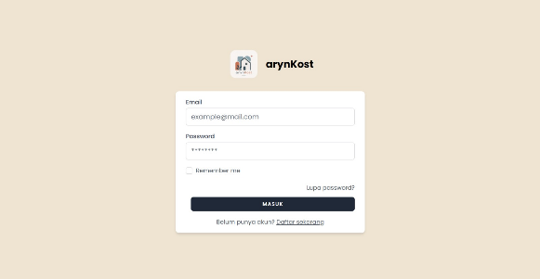
Figure 3. Login Interface
After authentication, the generated token and user role are stored locally using SharedPreferences. This mechanism allows users to remain authenticated without performing repeated login operations whenever the application is reopened.
The implemented authentication mechanism successfully separates user access according to the assigned roles. Administrators, owners, and tenants are automatically directed to different dashboard interfaces after login, ensuring that each user accesses only the functions intended for their responsibilities.

Dashboard Implementation
The dashboard provides summarized information that supports daily operational activities. Different dashboards are implemented according to user roles.
The administrator dashboard displays statistical information, including the total number of rooms, active tenants, monthly income, pending payments, and recent complaints. These data are retrieved from multiple database tables through the Laravel backend and presented graphically in the Flutter application.
The owner dashboard provides operational monitoring similar to the administrator dashboard, enabling owners to observe boarding house performance through summarized information.
Meanwhile, the tenant dashboard focuses on personal information, including occupied room data, active billing information, and payment history. This dashboard enables tenants to monitor their current status without accessing administrative functions.
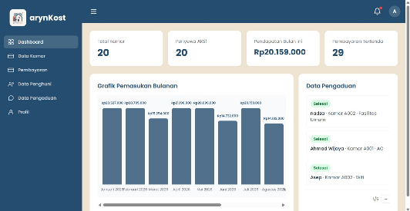
Figure 4. Administrator Dashboard Display.
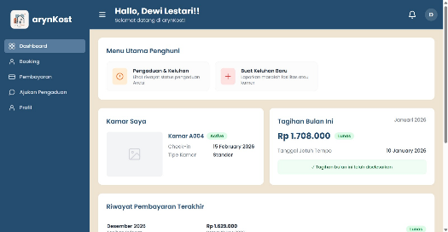
Figure 5. Tenant Dashboard Display.

Overall, the dashboard implementation provides role-specific information while maintaining centralized data processing on the backend.

Room Management
Room management is one of the core functions of ArynKost. The implemented features include creating, updating, displaying, and managing room information.
Each room stores information such as room number, room type, rental price, occupancy status, room capacity, room size, bed type, facilities, and room image. Administrators and owners are authorized to manage these data through both the web application and the available mobile interfaces.
The Flutter application retrieves room information through REST API requests to the Laravel backend. The backend validates user input before storing or updating records in the database.
Although the backend provides CRUD operations for room management, the implementation audit indicates that the mobile application currently does not provide a complete interface for deleting room data. Therefore, room deletion functionality is only partially available from the system perspective.
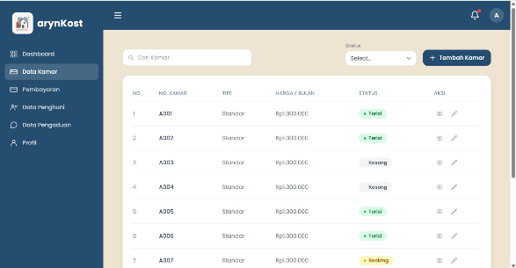
Figure 6. Room Management Interface.
Overall, the room management feature has been successfully implemented and supports centralized room administration while maintaining data consistency through the backend database.

Tenant Management
The tenant management module is implemented to maintain tenant information and support boarding house administration. The administrator and owner can manage tenant records through the web application and the available mobile interface.
The system stores tenant information including tenant name, room number, contact number, check-in date, and occupancy status. The backend performs input validation before data are inserted or updated in the database. In addition, when a tenant's status changes to Active, the system automatically generates a notification for the tenant through the notification module.
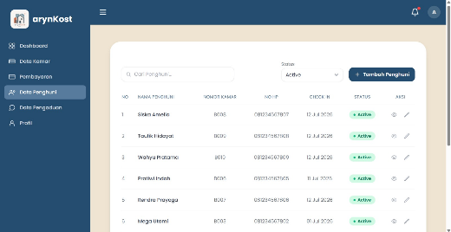
Figure 7. Tenant Management Interface.
The implemented functionality supports creating, updating, and displaying tenant data. However, the implementation audit shows that the mobile application does not yet provide a complete deletion feature, although the backend API already supports this operation. Therefore, tenant management is only partially integrated between the frontend and backend.

Complaint Management
The complaint management feature enables tenants to report maintenance issues or other problems related to the boarding house. This module facilitates communication between tenants and administrators while allowing complaint status monitoring.
Through the Flutter application, tenants can submit complaints by providing room information, complaint category, and description. The submitted data are sent to the Laravel backend through REST API services and stored in the complaint database.
Administrators and owners can review all submitted complaints and update their processing status to indicate whether a complaint is pending, being processed, or completed. The updated status is then reflected in the mobile application when tenants retrieve their complaint history.
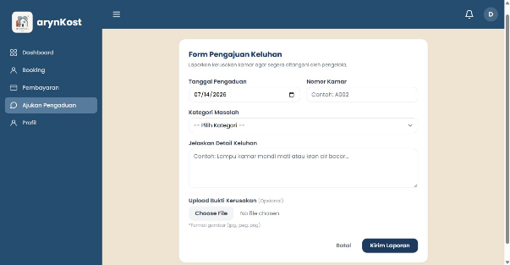
Figure 8. Complaint Management Interface.
Although the complaint workflow has been successfully implemented, the technical audit identified that image upload for complaint evidence is only available in the web implementation. The REST API currently accepts textual complaint information only, preventing mobile users from attaching supporting images. Furthermore, the system does not automatically notify tenants when the complaint status changes.

Billing and Payment Management
Billing management is implemented to monitor tenant payment obligations. Administrators are responsible for managing billing records, while tenants can access their billing information through the mobile application.
The administrator dashboard provides billing information, payment status, and the ability to update payment status. Once the payment status is confirmed, the system records the updated information in the database.
From the tenant perspective, the Flutter application displays active bills and payment history obtained from the backend API. This allows tenants to monitor outstanding payments and payment status in real time.
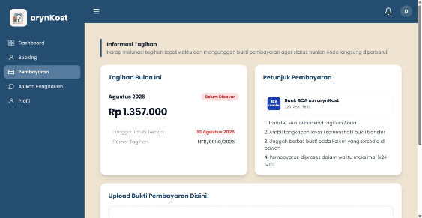
Figure 9. Tenant Billing Information Interface.
However, the implementation audit indicates that payment proof submission has not yet been integrated into the mobile application. While the web application supports uploading payment evidence, the corresponding REST API and Flutter interface have not been implemented. Consequently, payment confirmation from mobile devices is not currently supported.

User Profile Management
The profile management feature allows authenticated users to view and update their personal information. The implemented functionality includes updating basic user information such as name and email through REST API communication.
After successful authentication, profile information is retrieved from the backend and displayed according to the authenticated user. Any profile modifications are validated by the Laravel backend before being saved to the database.
Despite the successful implementation of profile updates, the technical audit found that profile photo management has not been fully implemented. Although profile-related routes have been prepared in the backend, the upload functionality remains incomplete and is not yet available through the mobile application. Therefore, profile management currently supports only basic account information without image management.
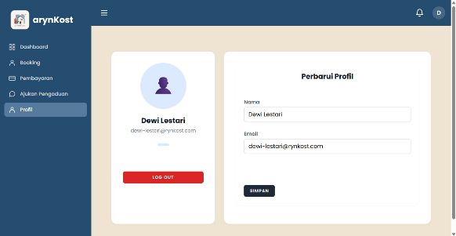
Figure 10. User Profile Management
Overall, the implemented modules demonstrate successful integration between Flutter and Laravel for core data management. Nevertheless, several advanced features remain partially implemented, indicating opportunities for further development and improved integration across both platforms.

System Integration Analysis
The implementation audit shows that the integration between the Flutter mobile application and the Laravel backend has been successfully established through RESTful APIs for several core modules, including authentication, dashboard visualization, room management, tenant management, complaint management, billing information, and profile management.
The overall communication process follows a client-server architecture in which Flutter sends HTTP requests to the Laravel backend, the backend processes business logic and database operations, and JSON responses are returned to the mobile application.
Overall, the implemented architecture provides centralized data management while allowing different user interfaces for administrators, owners, and tenants.

Discussion
The technical audit indicates that ArynKost has successfully implemented most of the primary business processes required for boarding house management. The integration between Laravel and Flutter enables centralized management of operational data while supporting role-based access control for different categories of users.
From the implementation perspective, several strengths of the system can be identified:
- Integration between web and mobile applications through RESTful APIs.
- Role-based authentication using Laravel Sanctum and Laravel Breeze.
- Centralized database management using Laravel Eloquent.
- Separation between frontend and backend, making future maintenance easier.
- Implementation of CRUD operations for major entities such as rooms, tenants, complaints, and billing.
Despite these achievements, several limitations were identified during the source code audit.
First, several mobile features are not yet fully connected to the backend API. The room booking process has been implemented only in the web application, while the Flutter application currently provides only the room browsing interface without completing the booking transaction.
Second, payment proof submission is available only through the web application. Although tenants can view billing information from the mobile application, they cannot upload payment evidence directly from their smartphones.
Third, the notification system has been implemented only for the web application. The Flutter application does not yet provide notification interfaces or API integration for receiving notification updates.
Finally, the technical audit identified several implementation issues, including duplicated source code, unused classes, incomplete profile photo functionality, inconsistent database relationships that still rely on string fields instead of foreign keys, and several backend routes that require further refinement. These findings indicate that the system has reached a functional implementation stage but still requires additional improvements to achieve complete integration and better maintainability.

CONCLUSION
This study presented the design and implementation of ArynKost, a boarding house management information system developed using Flutter for the mobile application and Laravel for the web application. The implemented system adopts a client-server architecture with RESTful API communication and role-based access control to support administrators, owners, and tenants.
Based on the technical audit of the source code, the core functionalities—including authentication, dashboard management, room management, tenant management, complaint management, billing management, and profile management—have been successfully implemented. The integration between the mobile and web applications enables centralized data management and improves operational efficiency in boarding house administration.
However, the audit also identified several limitations. Some mobile features, including room booking, payment proof submission, notification services, and profile photo management, have not yet been fully integrated with the backend API. In addition, several code quality issues, duplicated implementations, and database design inconsistencies were found and should be addressed in future development.
Future work should focus on completing the mobile-backend integration, improving database normalization through proper foreign key relationships, enhancing notification services, implementing missing mobile functionalities, and refactoring duplicated code to improve maintainability, scalability, and overall software quality.

References
- Sommerville, Software Engineering, 10th ed. Boston, MA, USA: Pearson, 2021.
- R. S. Pressman and B. Maxim, Software Engineering: A Practitioner's Approach, 9th ed. New York, NY, USA: McGraw-Hill, 2021.
- Flutter Team, Flutter Documentation. Google, 2025.
- Laravel LLC, Laravel 13 Documentation, 2025.
- M. Fowler, Patterns of Enterprise Application Architecture. Addison-Wesley, 2021.
- L. Richardson and M. Amundsen, RESTful Web APIs. Sebastopol, CA, USA: O'Reilly Media, 2021.
- R. Fielding, "Architectural Styles and the Design of Network-Based Software Architectures," Doctoral Dissertation, University of California, Irvine, USA.
- A. Dennis, B. Wixom, and D. Tegarden, Systems Analysis and Design: An Object-Oriented Approach with UML, 6th ed., Wiley, 2022.
- M. Fowler, Refactoring: Improving the Design of Existing Code, 2nd ed., Addison-Wesley, 2021.
- P. Kruchten, "The 4+1 View Model of Architecture," IEEE Software, vol. 12, no. 6, pp. 42–50.
- IEEE Computer Society, "IEEE Guide for Software Engineering Body of Knowledge (SWEBOK)," Version 4.0, 2024.
- M. Richards and N. Ford, Fundamentals of Software Architecture. O'Reilly Media, 2021.
- A. Albahri et al., "IoT-Based Smart Management Systems: A Review," IEEE Access, vol. 10, pp. 11015–11043, 2022.
- M. A. Babar and A. Brown, "Software Architecture for Modern Information Systems," IEEE Software, vol. 39, no. 3, pp. 52–60, 2022.
- S. Kumar and R. Singh, "REST API Design for Modern Web Applications," Journal of Web Engineering, vol. 22, no. 4, pp. 567–584, 2023.
- N. M. Yusop, M. H. Ismail, and A. Rahman, "Development of Mobile Information Systems Using Flutter Framework," International Journal of Advanced Computer Science and Applications, vol. 14, no. 2, pp. 210–219, 2023.
- A. Putra, D. Kurniawan, and R. Prasetyo, "Implementation of Boarding House Information System Using Web Technology," Journal of Information Systems Engineering, vol. 9, no. 1, pp. 35–44, 2022.
- S. Hidayat and F. Nugroho, "Digital Transformation in Property Management Information Systems," Procedia Computer Science, vol. 216, pp. 455–463, 2023.
- A. Nugroho, "Implementation of RESTful API for Mobile Information Systems," Journal of Information Technology, vol. 18, no. 3, pp. 141–150, 2024.
- Y. Bassil, "Modern Client–Server Architecture for Mobile and Web Applications," International Journal of Computer Applications, vol. 186, no. 8, pp. 15–23, 2024.

IEEE conference templates contain guidance text for composing and formatting conference papers. Please ensure that all template text is removed from your conference paper prior to submission to the conference. Failure to remove template text from your paper may result in your paper not being published.

