VISVESVARAYA TECHNOLOGICAL UNIVERSITY
“JnanaSangama”, Belgaum -590014, Karnataka.

LAB REPORT
on
Artificial Intelligence (23CS5PCAIN)
Submitted by
Anag Devnani (1BM23CS031)
in partial fulfillment for the award of the degree of
BACHELOR OF ENGINEERING
in
COMPUTER SCIENCE AND ENGINEERING

B.M.S. COLLEGE OF ENGINEERING
(Autonomous Institution under VTU)
BENGALURU-560019
Sep-2024 to Jan-2025

B.M.S. College of Engineering,
Bull Temple Road, Bangalore 560019
(Affiliated To Visvesvaraya Technological University, Belgaum)
Department of Computer Science and Engineering

CERTIFICATE
This is to certify that the Lab work entitled “Artificial Intelligence (23CS5PCAIN)” carried out by Anag Devnani (1BM23CS031), who is a bonafide student of B.M.S. College of Engineering. It is in partial fulfillment for the award of Bachelor of Engineering in Computer Science and Engineering of the Visvesvaraya Technological University, Belgaum. The Lab report has been approved as it satisfies the academic requirements in respect of an Artificial Intelligence (23CS5PCAIN) work prescribed for the said degree.

Dr. K. R. Mamatha  Associate Professor  Department of CSE, BMSCE | Dr. Kavitha Soodha  Professor & HOD  Department of CSE, BMSCE

Index
Sl.  No. | Experiment Title | Page No.
1 | Implement Tic –Tac –Toe Game  Implement vacuum cleaner agent
2 | Implement 8 puzzle problems using Depth First Search (DFS)  Implement Iterative deepening search algorithm
3 | Implement A* search algorithm
4 | Implement Hill Climbing search algorithm to solve N-Queens problem
5 | Simulated Annealing to Solve 8-Queens problem
6 | Create a knowledge base using propositional logic and show that the given query entails the knowledge base or not.
7 | Implement unification in first order logic
8 | Create a knowledge base consisting of first order logic statements and prove the given query using forward reasoning.
9 | Create a knowledge base consisting of first order logic statements and prove the given query using Resolution
10 | Implement Alpha-Beta Pruning.

Infosys Springboard Certificates
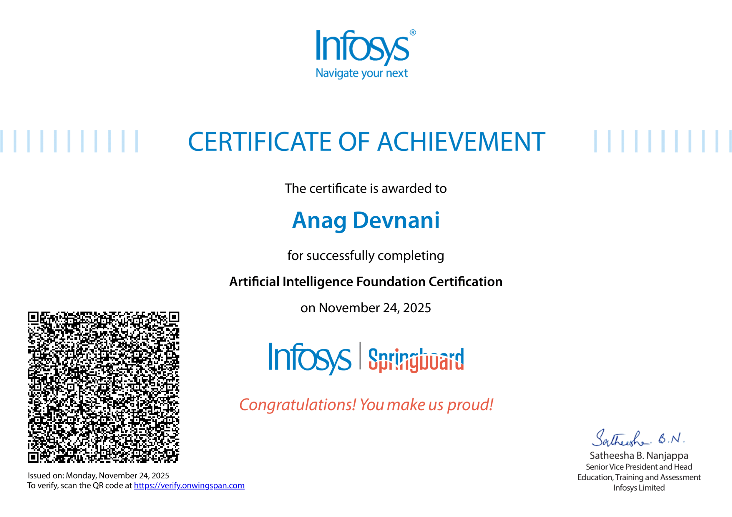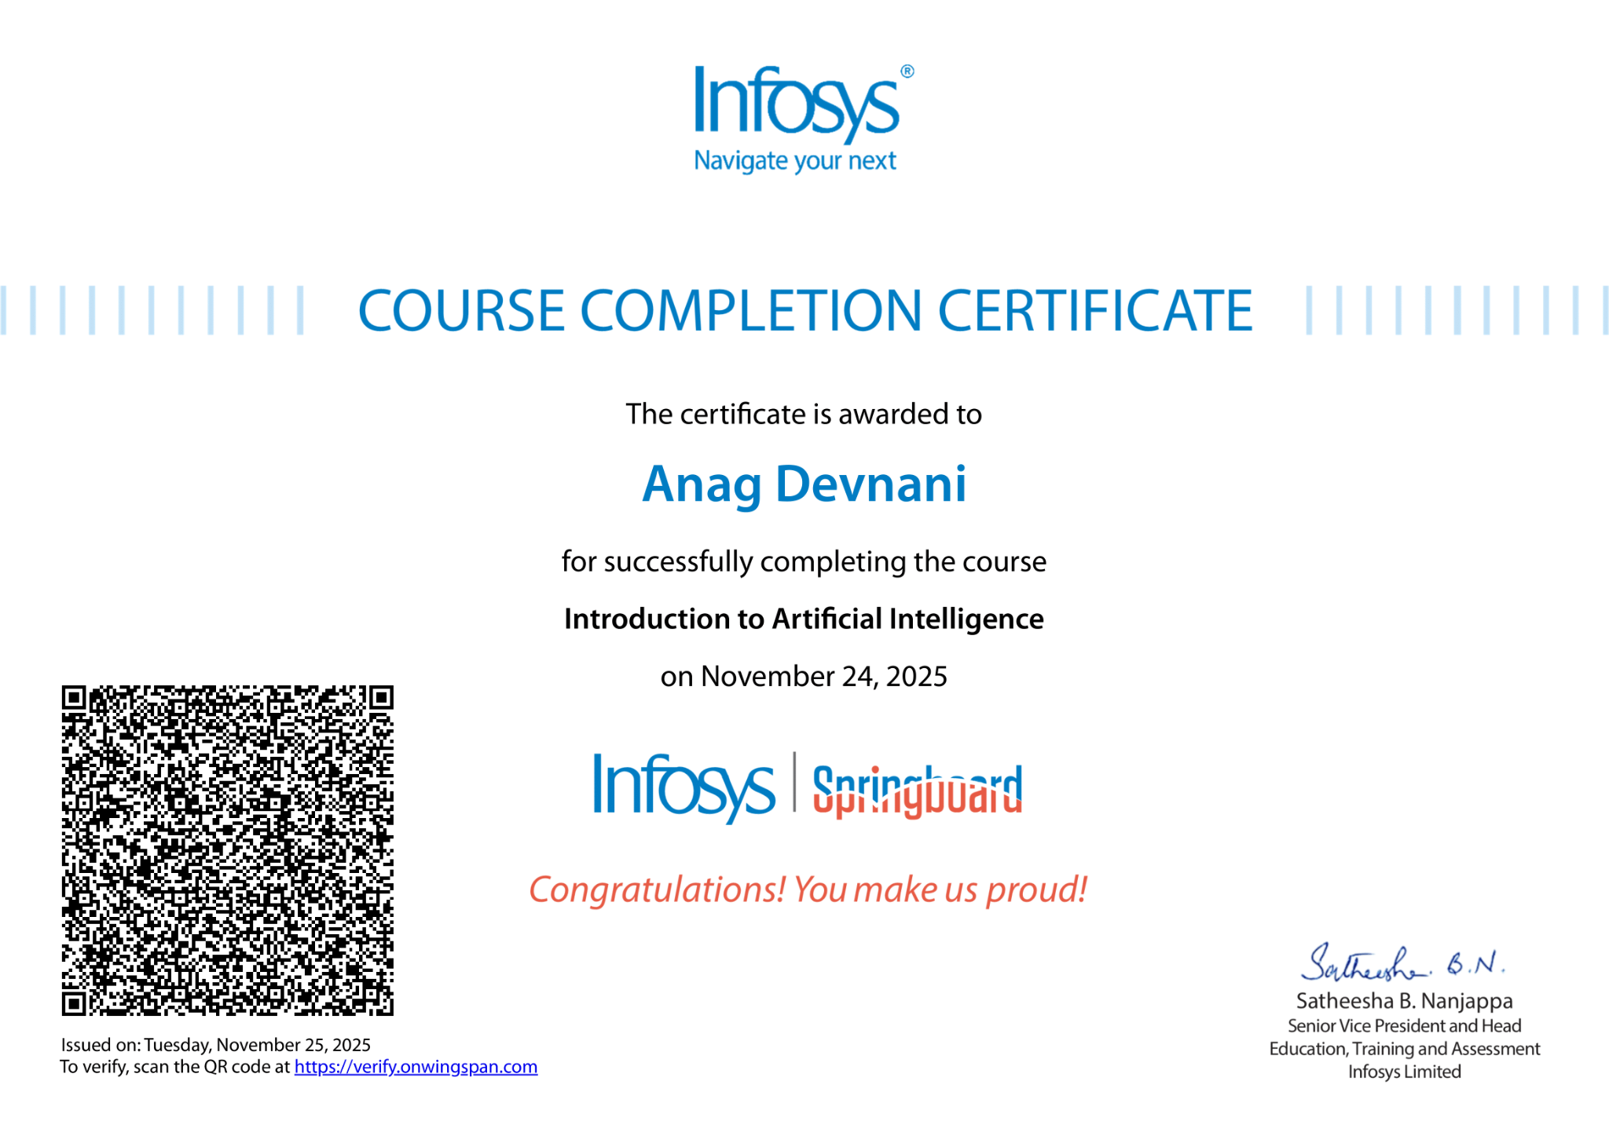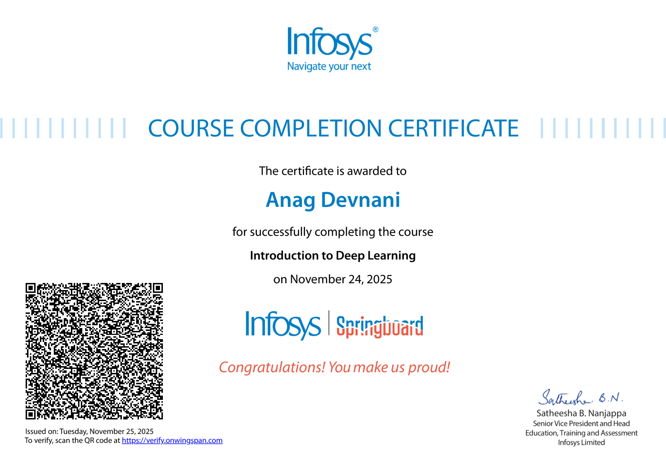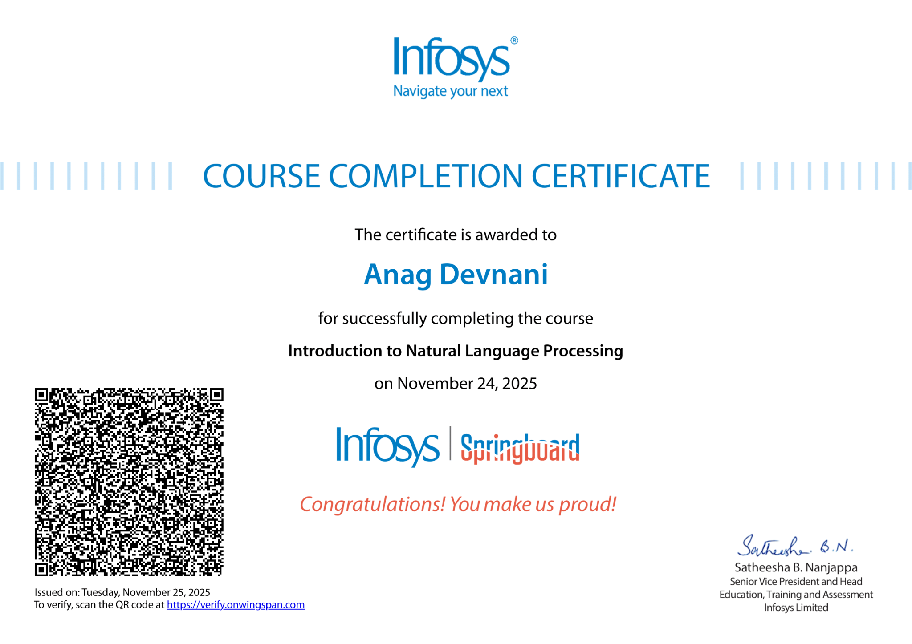
Github Link:
https://github.com/AnagDevnani/BMS-Lab/tree/main/AI

Program 1
Implement Tic –Tac –Toe Game
Implement vacuum cleaner agent

Algorithm:
(You should provide the screen shot of your observation book of Algorithm/Logic/Solving of respective problem)

Code:
import math

def print_board(board):
for row in board:
print(" | ".join(row))
print("-" * 5)

def check_winner(board, player):
# Rows, columns, diagonals
for row in board:
if all(cell == player for cell in row):
return True

for col in range(3):
if all(board[row][col] == player for row in range(3)):
return True

if all(board[i][i] == player for i in range(3)) or \
all(board[i][2-i] == player for i in range(3)):
return True

return False

def is_full(board):
return all(cell != " " for row in board for cell in row)

def minimax(board, depth, is_maximizing):
if check_winner(board, "O"): # Computer wins
return 1
if check_winner(board, "X"): # Player wins
return -1
if is_full(board):
return 0

if is_maximizing: # Computer's move
best_score = -math.inf
for i in range(3):
for j in range(3):
if board[i][j] == " ":
board[i][j] = "O"
score = minimax(board, depth + 1, False)
board[i][j] = " "
best_score = max(score, best_score)
return best_score
else: # Player's move
best_score = math.inf
for i in range(3):
for j in range(3):
if board[i][j] == " ":
board[i][j] = "X"
score = minimax(board, depth + 1, True)
board[i][j] = " "
best_score = min(score, best_score)
return best_score

def best_move(board):
best_score = -math.inf
move = None
for i in range(3):
for j in range(3):
if board[i][j] == " ":
board[i][j] = "O"
score = minimax(board, 0, False)
board[i][j] = " "
if score > best_score:
best_score = score
move = (i, j)
return move

def tic_tac_toe():
board = [[" " for _ in range(3)] for _ in range(3)]
print("Welcome to Tic-Tac-Toe! You are 'X' and computer is 'O'.")
print_board(board)

while True:
# Player move
while True:
try:
row = int(input("Enter row (0-2): "))
col = int(input("Enter col (0-2): "))
if board[row][col] == " ":
board[row][col] = "X"
break
else:
print("Cell already taken, try again.")
except (ValueError, IndexError):
print("Invalid input! Enter numbers 0-2.")

print_board(board)

if check_winner(board, "X"):
print("You win!")
break
if is_full(board):
print("It's a draw!")
break

# Computer move
print("Computer's turn...")
move = best_move(board)
if move:
board[move[0]][move[1]] = "O"

print_board(board)

if check_winner(board, "O"):
print("💻 Computer wins!")
break
if is_full(board):
print("It's a draw!")
break

if __name__ == "__main__":
tic_tac_toe()
# vacuum cleaner
def vacuum_cleaner(rooms):
print("Initial Room Status:")
print(rooms)

# Traverse through each room
for i in range(len(rooms)):
if rooms[i] == 0:
print(f"Room {i+1} is Dirty. Cleaning...")
rooms[i] = 1
else:
print(f"Room {i+1} is already Clean.")

print("\nFinal Room Status:")
print(rooms)

# 0 = Dirty, 1 = Clean
# Example: [0, 1, 0, 1] means Room1=Dirty, Room2=Clean, Room3=Dirty, Room4=Clean
rooms = [0, 1, 0, 1]

vacuum_cleaner(rooms)

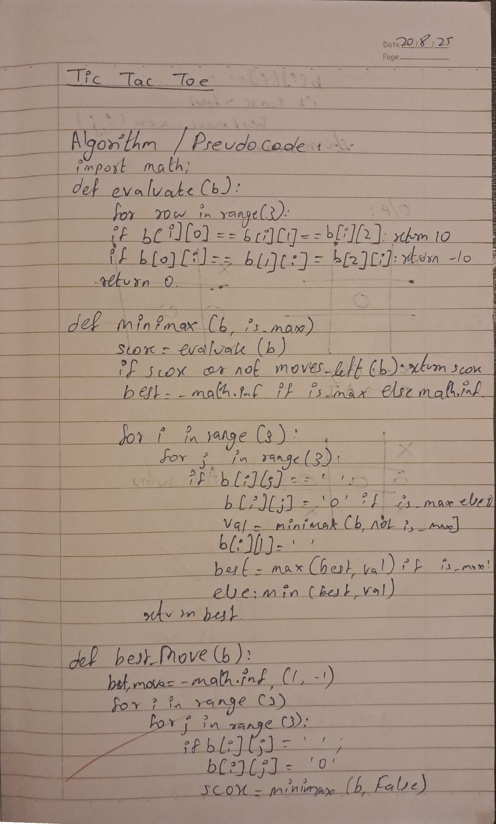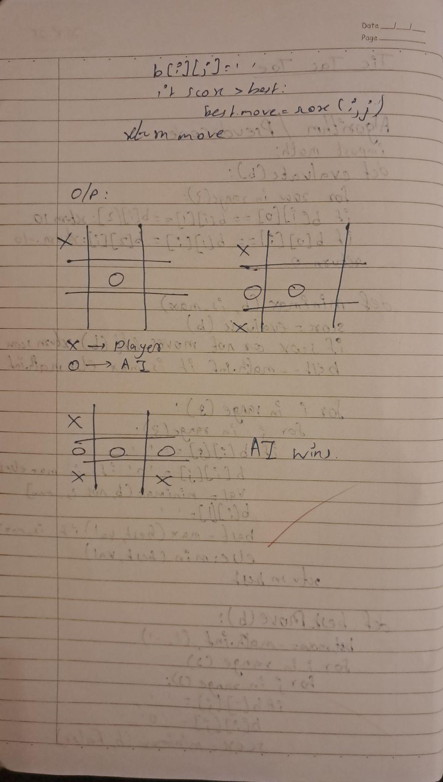

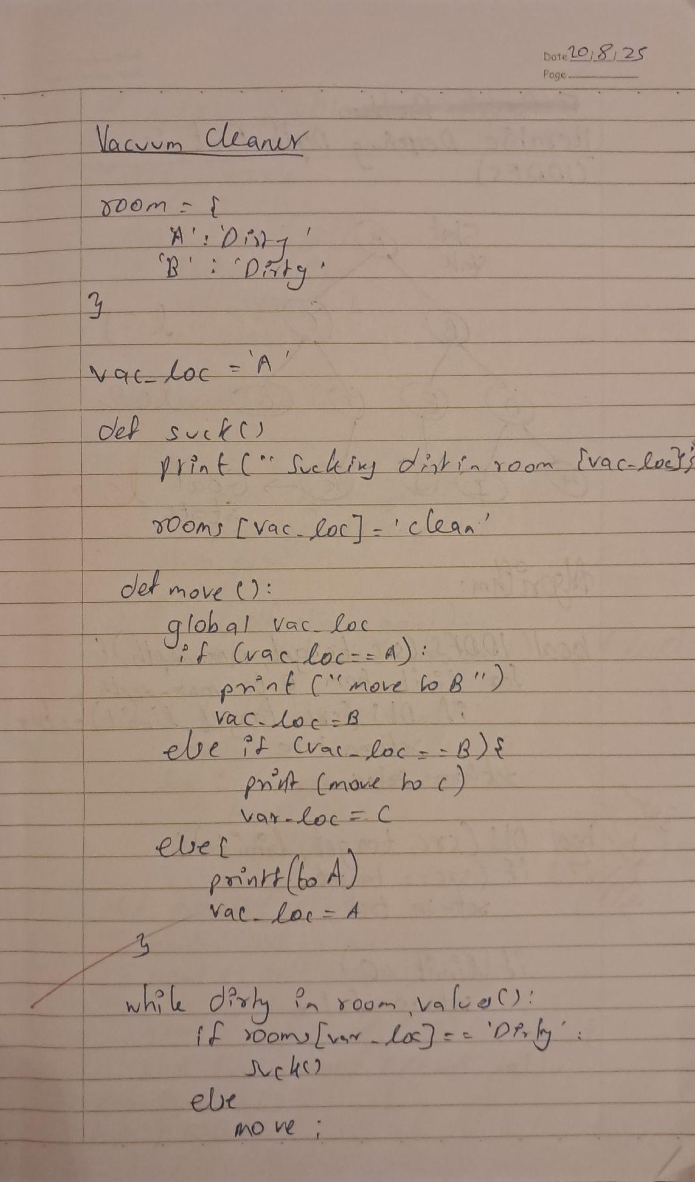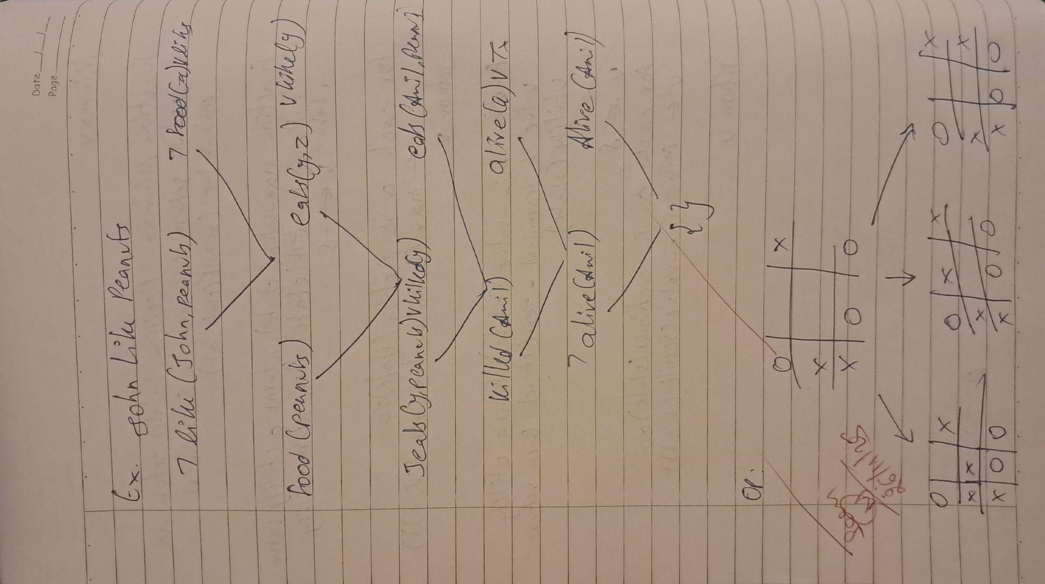

Program 2
Implement 8 puzzle problems using Depth First Search (DFS)
Implement Iterative deepening search algorithm

Algorithm:
(You should provide the screen shot of your observation book of Algorithm/Logic/Solving of respective problem)

Code:
import heapq
from itertools import count
from typing import Callable, Dict, Iterable, List, Optional, Tuple
from functools import lru_cache

State = Tuple[int, ...] # 9-length tuple; 0 represents the blank
GOAL: State = (1, 2, 3, 4, 5, 6, 7, 8, 0)

# Directions for blank movement: (dr, dc, move_char)
DIRS = [(-1, 0, 'U'), (1, 0, 'D'), (0, -1, 'L'), (0, 1, 'R')]

def index_to_rc(i: int) -> Tuple[int, int]:
return divmod(i, 3)

def rc_to_index(r: int, c: int) -> int:
return r * 3 + c

def is_solvable(state: State) -> bool:
"""An 8-puzzle is solvable iff the inversion count (ignoring 0) is even."""
arr = [x for x in state if x != 0]
inv = 0
for i in range(len(arr)):
for j in range(i + 1, len(arr)):
if arr[i] > arr[j]:
inv += 1
return inv % 2 == 0

def neighbors(state: State) -> Iterable[Tuple[State, str]]:
"""Yield (neighbor_state, move_char) for each legal slide."""
i0 = state.index(0)
r0, c0 = index_to_rc(i0)
for dr, dc, mv in DIRS:
nr, nc = r0 + dr, c0 + dc
if 0 <= nr < 3 and 0 <= nc < 3:
ni = rc_to_index(nr, nc)
new_state = list(state)
new_state[i0], new_state[ni] = new_state[ni], new_state[i0]
yield tuple(new_state), mv

def reconstruct_path(parents: Dict[State, State], end: State) -> List[State]:
path = [end]
while end in parents:
end = parents[end]
path.append(end)
path.reverse()
return path

def path_to_moves(path: List[State]) -> str:
"""Convert a path of states into a string of moves 'UDLR'."""
moves = []
for a, b in zip(path, path[1:]):
ia, ib = a.index(0), b.index(0)
ra, ca = index_to_rc(ia)
rb, cb = index_to_rc(ib)
if rb == ra - 1 and cb == ca:
moves.append('U')
elif rb == ra + 1 and cb == ca:
moves.append('D')
elif rb == ra and cb == ca - 1:
moves.append('L')
elif rb == ra and cb == ca + 1:
moves.append('R')
else:
moves.append('?')
return ''.join(moves)

def misplaced_tiles(state: State, goal: State = GOAL) -> int:
"""Heuristic: number of tiles not in their goal position (ignore blank)."""
return sum(1 for i, v in enumerate(state) if v != 0 and v != goal[i])

@lru_cache(maxsize=None)
def _goal_positions(goal: State) -> Tuple[Tuple[int, int], ...]:
"""Cache goal positions as a tuple indexed by tile value (0..8)."""
pos = [(0, 0)] * 9
for i, v in enumerate(goal):
r, c = index_to_rc(i)
pos[v] = (r, c)
return tuple(pos)

def manhattan_distance(state: State, goal: State = GOAL) -> int:
"""Heuristic: sum of Manhattan distances of each tile to its goal position."""
pos = _goal_positions(goal)
total = 0
for i, v in enumerate(state):
if v == 0:
continue
r, c = index_to_rc(i)
gr, gc = pos[v]
total += abs(r - gr) + abs(c - gc)
return total

def a_star(
start: State,
heuristic: Callable[[State, State], int] = manhattan_distance,
goal: State = GOAL,
) -> Optional[Dict[str, object]]:
"""
A* search for the 8-puzzle.
Returns a dict with keys: path, moves, expanded_nodes, or None if unsolvable.
"""
if start == goal:
return {"path": [start], "moves": 0, "expanded_nodes": 0}

if not is_solvable(start):
return None

# Each heap item: (f, g, tie, state)
heap: List[Tuple[int, int, int, State]] = []
tie = count()
g0 = 0
h0 = heuristic(start, goal)
heapq.heappush(heap, (g0 + h0, g0, next(tie), start))

best_g: Dict[State, int] = {start: 0}
parents: Dict[State, State] = {}
expanded = 0

while heap:
f, g, _, state = heapq.heappop(heap)
expanded += 1

if state == goal:
path = reconstruct_path(parents, state)
return {
"path": path,
"moves": len(path) - 1,
"expanded_nodes": expanded,
"move_sequence": path_to_moves(path),
}

for nb, _mv in neighbors(state):
new_g = g + 1
if nb not in best_g or new_g < best_g[nb]:
best_g[nb] = new_g
parents[nb] = state
h = heuristic(nb, goal)
heapq.heappush(heap, (new_g + h, new_g, next(tie), nb))

return None # Shouldn't happen for solvable instances

def print_board(state: State) -> None:
"""Pretty-print a 3x3 board."""
for r in range(3):
row = state[3 * r : 3 * r + 3]
print(" ".join(str(x) if x != 0 else "·" for x in row))
print()

def parse_state(s: str) -> State:
"""
Parse a state from a string like "1,2,3,4,0,6,7,5,8" or "123406758".
"""
s = s.strip().replace(" ", "")
if "," in s:
nums = [int(x) for x in s.split(",")]
else:
if len(s) != 9 or not s.isdigit():
raise ValueError("Provide 9 digits including 0 for the blank, or 9 comma-separated numbers.")
nums = [int(ch) for ch in s]
if len(nums) != 9 or set(nums) != set(range(9)):
raise ValueError("State must contain exactly the numbers 0..8 once each.")
return tuple(nums) # type_ignore[return-value]

def main(start_state_str: str = "1,2,3,4,0,6,7,5,8", goal_state_str: str = "1,2,3,4,5,6,7,8,0", heuristic_name: str = "manhattan", show_path: bool = True):
start = parse_state(start_state_str)
goal = parse_state(goal_state_str)

# Reset goal positions cache if using a different goal
_goal_positions.cache_clear()

heur: Callable[[State, State], int] = manhattan_distance if heuristic_name == "manhattan" \
else misplaced_tiles

result = a_star(start, heuristic=heur, goal=goal)
if result is None:
print("This puzzle is unsolvable.")
return

path: List[State] = result["path"] # type_ignore[assignment]
moves: int = result["moves"] # type_ignore[assignment]
expanded: int = result["expanded_nodes"] # type_ignore[assignment]
seq: str = result.get("move_sequence", "") # type_ignore[assignment]

print(f"Solved in {moves} moves using {heuristic_name} (expanded {expanded} states).")
print(f"Move sequence: {seq}")
if show_path:
print("\nPath:")
for i, st in enumerate(path):
print(f"Step {i}:")
print_board(st)

main()

# iddfs
import heapq
from itertools import count
from typing import Callable, Dict, Iterable, List, Optional, Tuple
from functools import lru_cache

State = Tuple[int, ...] # 9-length tuple; 0 represents the blank
GOAL: State = (1, 2, 3, 4, 5, 6, 7, 8, 0)

# Directions for blank movement: (dr, dc, move_char)
DIRS = [(-1, 0, 'U'), (1, 0, 'D'), (0, -1, 'L'), (0, 1, 'R')]

def index_to_rc(i: int) -> Tuple[int, int]:
return divmod(i, 3)

def rc_to_index(r: int, c: int) -> int:
return r * 3 + c

def is_solvable(state: State) -> bool:
"""An 8-puzzle is solvable iff the inversion count (ignoring 0) is even."""
arr = [x for x in state if x != 0]
inv = 0
for i in range(len(arr)):
for j in range(i + 1, len(arr)):
if arr[i] > arr[j]:
inv += 1
return inv % 2 == 0

def neighbors(state: State) -> Iterable[Tuple[State, str]]:
"""Yield (neighbor_state, move_char) for each legal slide."""
i0 = state.index(0)
r0, c0 = index_to_rc(i0)
for dr, dc, mv in DIRS:
nr, nc = r0 + dr, c0 + dc
if 0 <= nr < 3 and 0 <= nc < 3:
ni = rc_to_index(nr, nc)
new_state = list(state)
new_state[i0], new_state[ni] = new_state[ni], new_state[i0]
yield tuple(new_state), mv

def reconstruct_path(parents: Dict[State, State], end: State) -> List[State]:
path = [end]
while end in parents:
end = parents[end]
path.append(end)
path.reverse()
return path

def path_to_moves(path: List[State]) -> str:
"""Convert a path of states into a string of moves 'UDLR'."""
moves = []
for a, b in zip(path, path[1:]):
ia, ib = a.index(0), b.index(0)
ra, ca = index_to_rc(ia)
rb, cb = index_to_rc(ib)
if rb == ra - 1 and cb == ca:
moves.append('U')
elif rb == ra + 1 and cb == ca:
moves.append('D')
elif rb == ra and cb == ca - 1:
moves.append('L')
elif rb == ra and cb == ca + 1:
moves.append('R')
else:
moves.append('?')
return ''.join(moves)

def misplaced_tiles(state: State, goal: State = GOAL) -> int:
"""Heuristic: number of tiles not in their goal position (ignore blank)."""
return sum(1 for i, v in enumerate(state) if v != 0 and v != goal[i])

@lru_cache(maxsize=None)
def _goal_positions(goal: State) -> Tuple[Tuple[int, int], ...]:
"""Cache goal positions as a tuple indexed by tile value (0..8)."""
pos = [(0, 0)] * 9
for i, v in enumerate(goal):
r, c = index_to_rc(i)
pos[v] = (r, c)
return tuple(pos)

def manhattan_distance(state: State, goal: State = GOAL) -> int:
"""Heuristic: sum of Manhattan distances of each tile to its goal position."""
pos = _goal_positions(goal)
total = 0
for i, v in enumerate(state):
if v == 0:
continue
r, c = index_to_rc(i)
gr, gc = pos[v]
total += abs(r - gr) + abs(c - gc)
return total

def a_star(
start: State,
heuristic: Callable[[State, State], int] = manhattan_distance,
goal: State = GOAL,
) -> Optional[Dict[str, object]]:
"""
A* search for the 8-puzzle.
Returns a dict with keys: path, moves, expanded_nodes, or None if unsolvable.
"""
if start == goal:
return {"path": [start], "moves": 0, "expanded_nodes": 0}

if not is_solvable(start):
return None

# Each heap item: (f, g, tie, state)
heap: List[Tuple[int, int, int, State]] = []
tie = count()
g0 = 0
h0 = heuristic(start, goal)
heapq.heappush(heap, (g0 + h0, g0, next(tie), start))

best_g: Dict[State, int] = {start: 0}
parents: Dict[State, State] = {}
expanded = 0

while heap:
f, g, _, state = heapq.heappop(heap)
expanded += 1

if state == goal:
path = reconstruct_path(parents, state)
return {
"path": path,
"moves": len(path) - 1,
"expanded_nodes": expanded,
"move_sequence": path_to_moves(path),
}

for nb, _mv in neighbors(state):
new_g = g + 1
if nb not in best_g or new_g < best_g[nb]:
best_g[nb] = new_g
parents[nb] = state
h = heuristic(nb, goal)
heapq.heappush(heap, (new_g + h, new_g, next(tie), nb))

return None # Shouldn't happen for solvable instances

def print_board(state: State) -> None:
"""Pretty-print a 3x3 board."""
for r in range(3):
row = state[3 * r : 3 * r + 3]
print(" ".join(str(x) if x != 0 else "·" for x in row))
print()

def parse_state(s: str) -> State:
"""
Parse a state from a string like "1,2,3,4,0,6,7,5,8" or "123406758".
"""
s = s.strip().replace(" ", "")
if "," in s:
nums = [int(x) for x in s.split(",")]
else:
if len(s) != 9 or not s.isdigit():
raise ValueError("Provide 9 digits including 0 for the blank, or 9 comma-separated numbers.")
nums = [int(ch) for ch in s]
if len(nums) != 9 or set(nums) != set(range(9)):
raise ValueError("State must contain exactly the numbers 0..8 once each.")
return tuple(nums) # type_ignore[return-value]

def main(start_state_str: str = "1,2,3,4,0,6,7,5,8", goal_state_str: str = "1,2,3,4,5,6,7,8,0", heuristic_name: str = "manhattan", show_path: bool = True):
start = parse_state(start_state_str)
goal = parse_state(goal_state_str)

# Reset goal positions cache if using a different goal
_goal_positions.cache_clear()

heur: Callable[[State, State], int] = manhattan_distance if heuristic_name == "manhattan" \
else misplaced_tiles

result = a_star(start, heuristic=heur, goal=goal)
if result is None:
print("This puzzle is unsolvable.")
return

path: List[State] = result["path"] # type_ignore[assignment]
moves: int = result["moves"] # type_ignore[assignment]
expanded: int = result["expanded_nodes"] # type_ignore[assignment]
seq: str = result.get("move_sequence", "") # type_ignore[assignment]

print(f"Solved in {moves} moves using {heuristic_name} (expanded {expanded} states).")
print(f"Move sequence: {seq}")
if show_path:
print("\nPath:")
for i, st in enumerate(path):
print(f"Step {i}:")
print_board(st)

main()

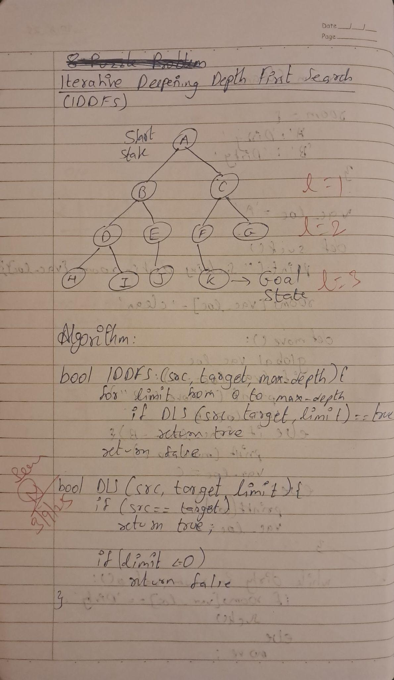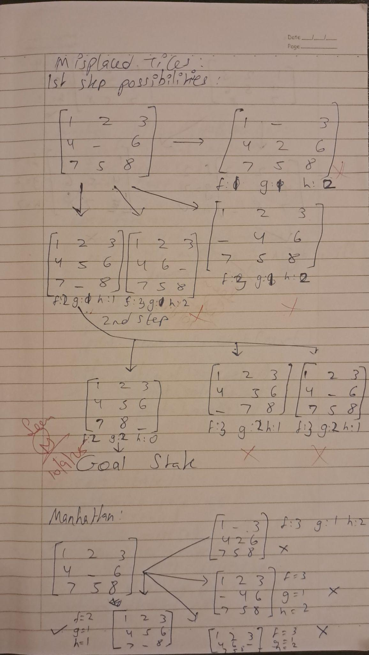
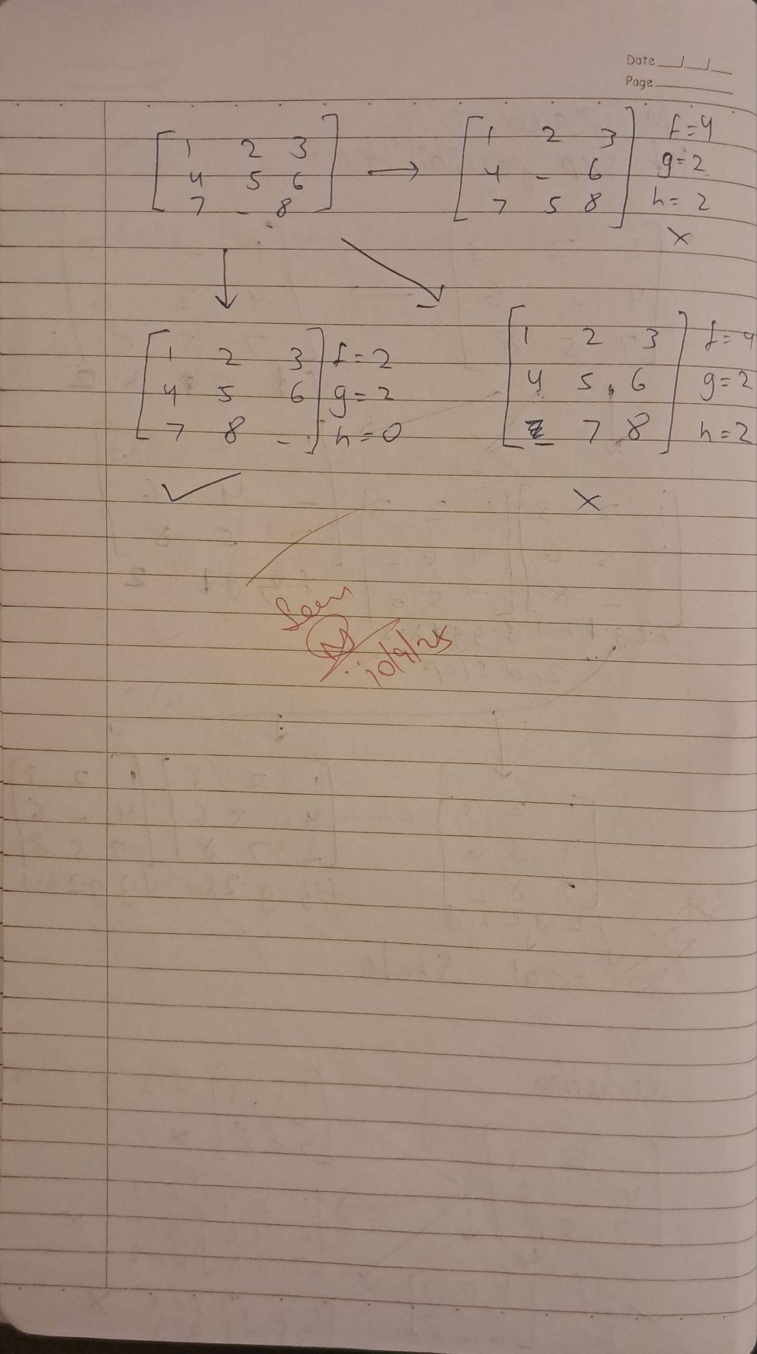

Program 3
Implement A* search algorithm

Algorithm:
(You should provide the screen shot of your observation book of Algorithm/Logic/Solving of respective problem)

Code:
class Node:
def __init__(self,data,level,fval):
""" Initialize the node with the data, level of the node and the calculated fvalue """
self.data = data
self.level = level
self.fval = fval

def generate_child(self):
""" Generate child nodes from the given node by moving the blank space
either in the four directions {up,down,left,right} """
x,y = self.find(self.data,'_')
""" val_list contains position values for moving the blank space in either of
the 4 directions [up,down,left,right] respectively. """
val_list = [[x,y-1],[x,y+1],[x-1,y],[x+1,y]]
children = []
for i in val_list:
child = self.shuffle(self.data,x,y,i[0],i[1])
if child is not None:
child_node = Node(child,self.level+1,0)
children.append(child_node)
return children

def shuffle(self,puz,x1,y1,x2,y2):
""" Move the blank space in the given direction and if the position value are out
of limits the return None """
if x2 >= 0 and x2 < len(self.data) and y2 >= 0 and y2 < len(self.data):
temp_puz = []
temp_puz = self.copy(puz)
temp = temp_puz[x2][y2]
temp_puz[x2][y2] = temp_puz[x1][y1]
temp_puz[x1][y1] = temp
return temp_puz
else:
return None

def copy(self,root):
""" Copy function to create a similar matrix of the given node"""
temp = []
for i in root:
t = []
for j in i:
t.append(j)
temp.append(t)
return temp

def find(self,puz,x):
""" Specifically used to find the position of the blank space """
for i in range(0,len(self.data)):
for j in range(0,len(self.data)):
if puz[i][j] == x:
return i,j

class Puzzle:
def __init__(self,size):
""" Initialize the puzzle size by the specified size,open and closed lists to empty """
self.n = size
self.open = []
self.closed = []

def accept(self):
""" Accepts the puzzle from the user """
puz = []
for i in range(0,self.n):
temp = input().split(" ")
puz.append(temp)
return puz

def f(self,start,goal):
""" Heuristic Function to calculate hueristic value f(x) = h(x) + g(x) """
return self.h(start.data,goal)+start.level

def h(self,start,goal):
""" Calculates the different between the given puzzles """
temp = 0
for i in range(0,self.n):
for j in range(0,self.n):
if start[i][j] != goal[i][j] and start[i][j] != '_':
temp += 1
return temp

def process(self):
""" Accept Start and Goal Puzzle state"""
print("Enter the start state matrix \n")
start = self.accept()
print("Enter the goal state matrix \n")
goal = self.accept()

start = Node(start,0,0)
start.fval = self.f(start,goal)
""" Put the start node in the open list"""
self.open.append(start)
print("\n\n")
while True:
cur = self.open[0]
print("")
print(" | ")
print(" | ")
print(" \\\'/ \n")
for i in cur.data:
for j in i:
print(j,end=" ")
print("")
""" If the difference between current and goal node is 0 we have reached the goal node"""
if(self.h(cur.data,goal) == 0):
break
for i in cur.generate_child():
i.fval = self.f(i,goal)
self.open.append(i)
self.closed.append(cur)
del self.open[0]

""" sort the opne list based on f value """
self.open.sort(key = lambda x:x.fval,reverse=False)

puz = Puzzle(3)
puz.process()

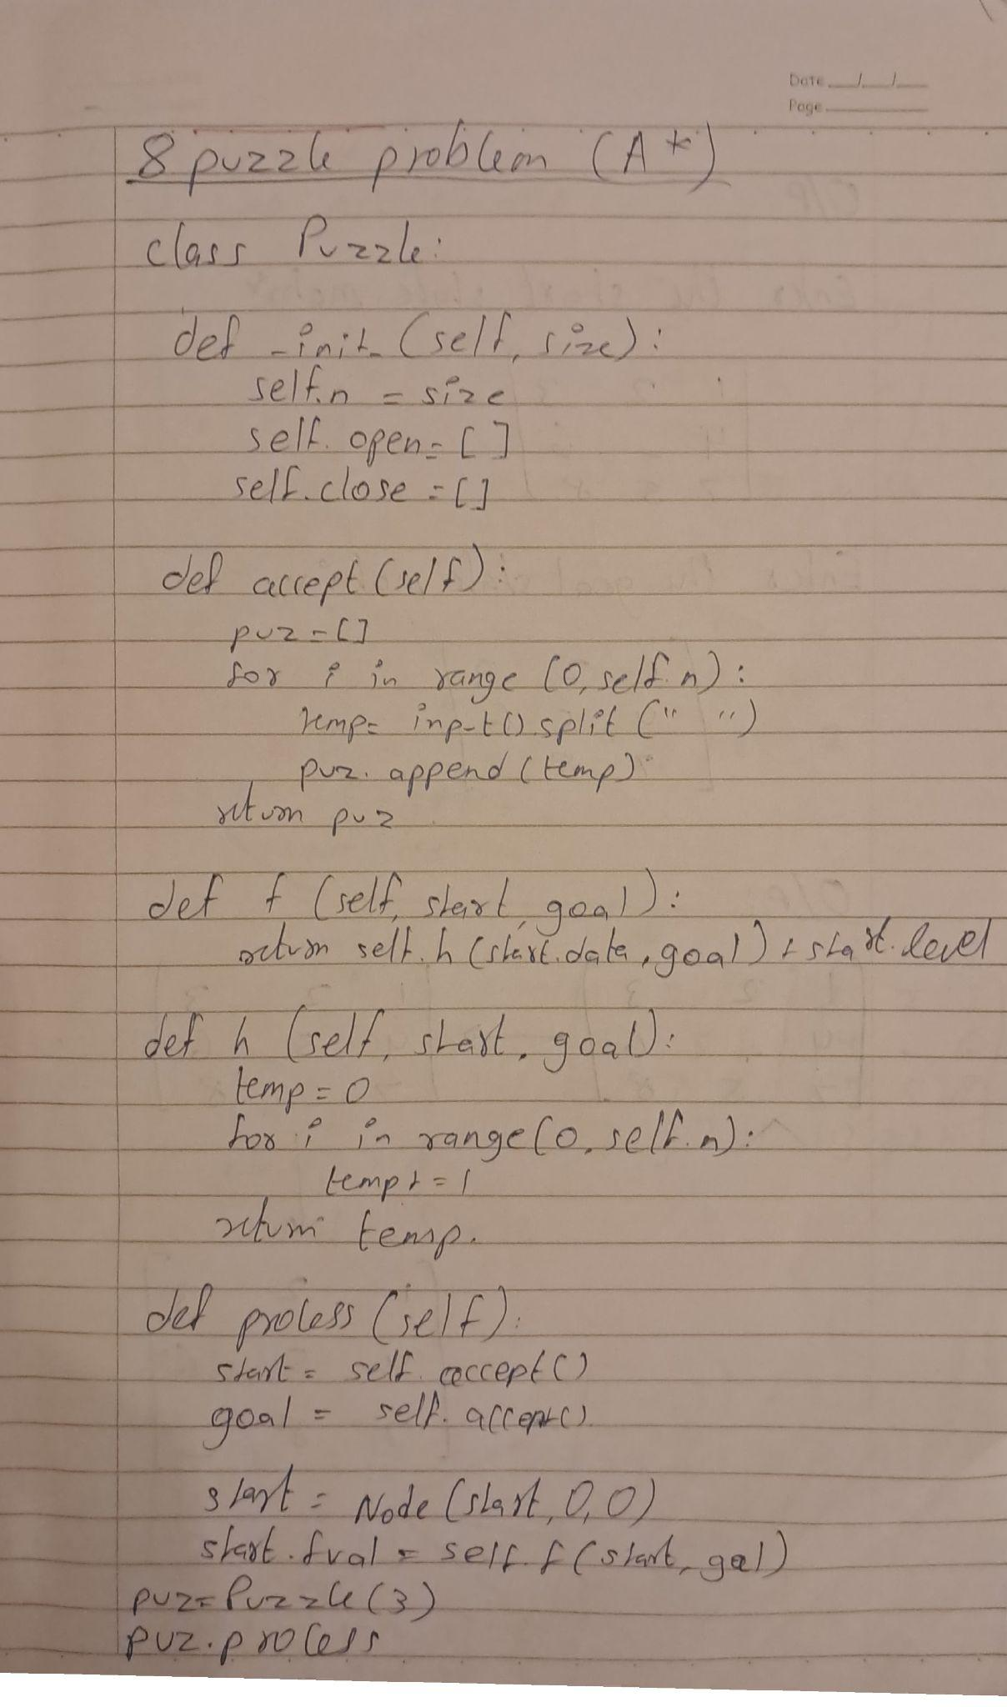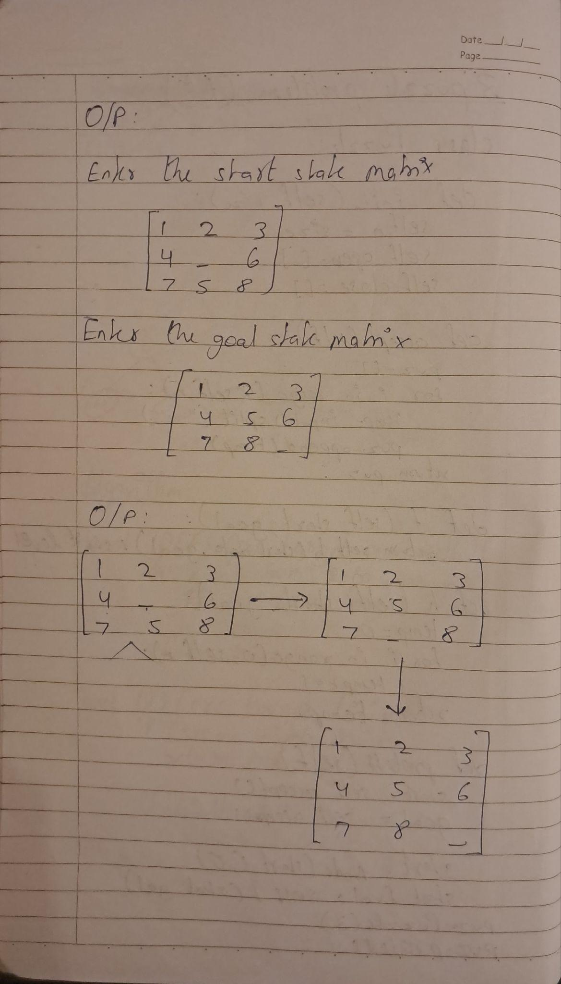

Program 4
Implement Hill Climbing search algorithm to solve N-Queens problem

Algorithm:
(You should provide the screen shot of your observation book of Algorithm/Logic/Solving of respective problem)

Code:
def print_board(state):
"""Prints the 4x4 board representation with 'Q' and '.'."""
n = len(state)
for row in range(n):
for col in range(n):
if state[col] == row:
print("Q", end=" ")
else:
print(".", end=" ")
print()
print()

def calculate_cost(state):
"""Returns number of attacking pairs of queens."""
cost = 0
n = len(state)
for i in range(n):
for j in range(i + 1, n):
# same row
if state[i] == state[j]:
cost += 1
# same diagonal
elif abs(state[i] - state[j]) == abs(i - j):
cost += 1
return cost

def get_neighbors(state):
"""Generates all neighbors by swapping two queen positions."""
neighbors = []
n = len(state)
for i in range(n):
for j in range(i + 1, n):
neighbor = state.copy()
neighbor[i], neighbor[j] = neighbor[j], neighbor[i]
neighbors.append((neighbor, (i, j)))
return neighbors

def hill_climbing(state):
print("\nInitial State:", state)
print_board(state)
current_cost = calculate_cost(state)
step = 1

while True:
print(f"Step {step}: Current cost = {current_cost}")
neighbors = get_neighbors(state)
neighbor_costs = []

# Calculate cost for all neighbors
for neighbor, swapped in neighbors:
cost = calculate_cost(neighbor)
neighbor_costs.append((cost, neighbor, swapped))

# Sort by cost and then by smallest column pair
neighbor_costs.sort(key=lambda x: (x[0], x[2][0], x[2][1]))

# Display neighbor costs
print("Neighbor states and their costs:")
for cost, neighbor, swapped in neighbor_costs:
print(f"Swap x{swapped[0]} & x{swapped[1]} => {neighbor}, Cost = {cost}")

best_cost, best_state, swap = neighbor_costs[0]
print("\nBest Neighbor after swap", swap, "is", best_state, "with cost =", best_cost)
print_board(best_state)

if best_cost >= current_cost: # No improvement (local minimum)
print("No better neighbor found. Hill Climbing terminated.")
print("Final state:", state)
print_board(state)
break
else:
state = best_state
current_cost = best_cost

if current_cost == 0:
print("Goal state reached!")
print_board(state)
break

step += 1

# ---------------- MAIN ----------------
if __name__ == "__main__":
print("Hill Climbing for 4-Queens Problem")
print("Enter the row positions of 4 queens (each between 0 and 3):")
state = list(map(int, input("Example (1 2 0 3): ").split()))
hill_climbing(state)

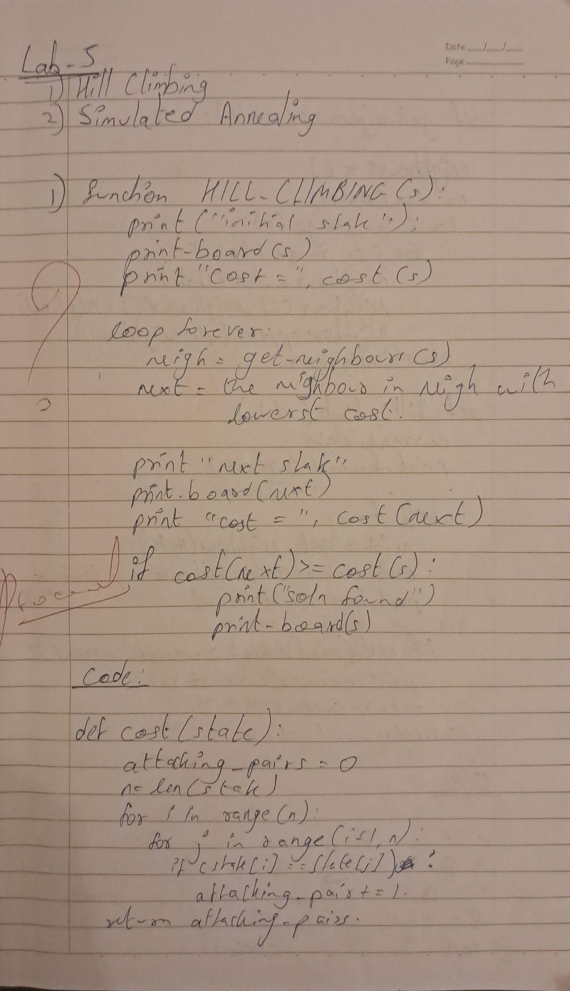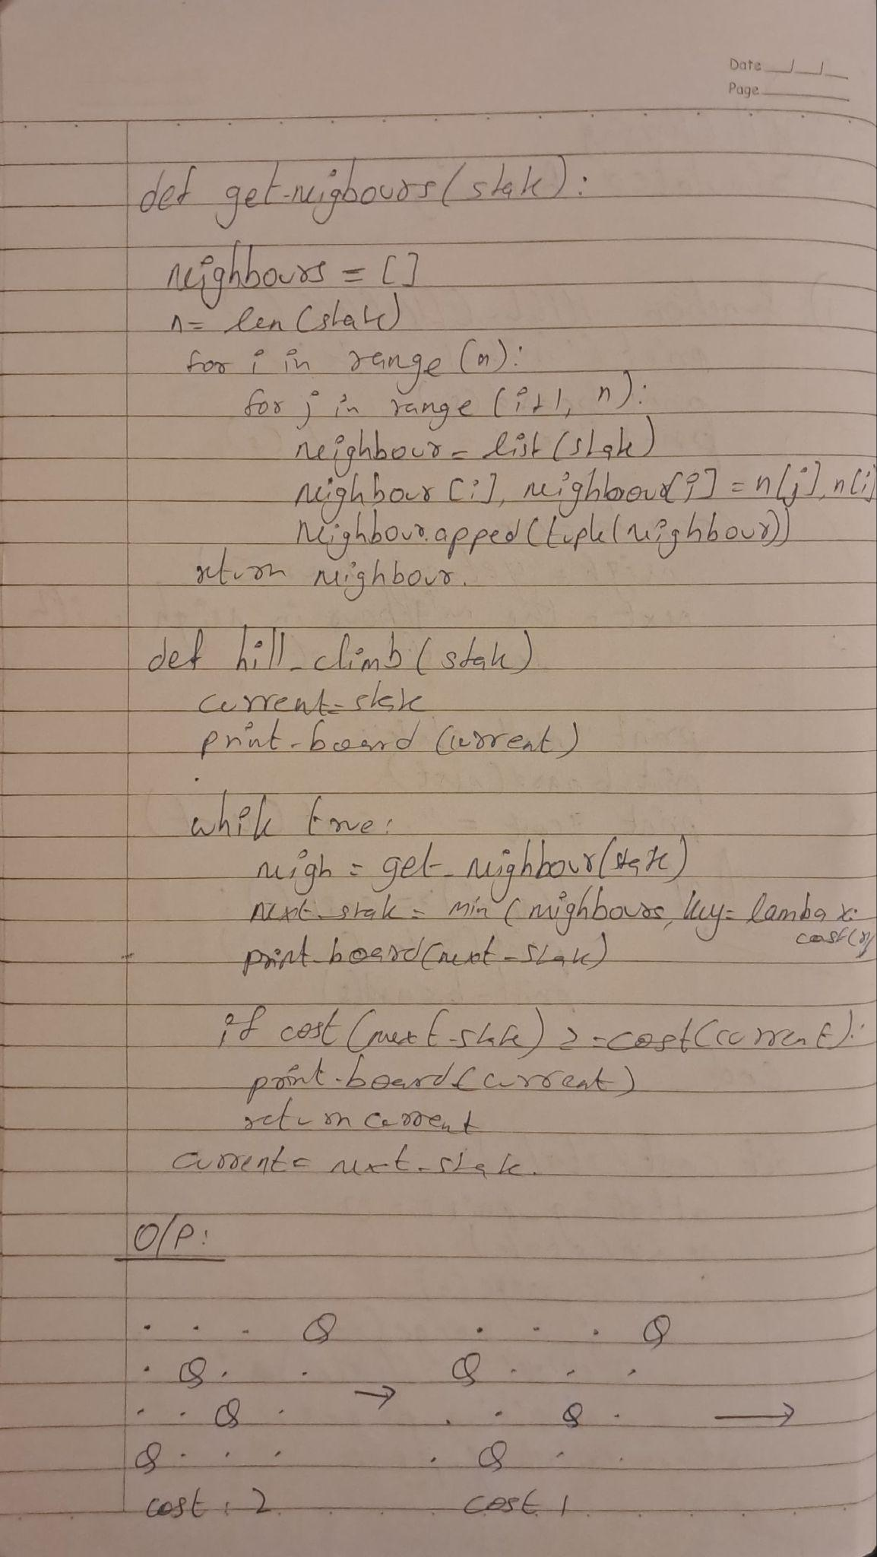

Program 5
Simulated Annealing to Solve 8-Queens problem

Algorithm:
(You should provide the screen shot of your observation book of Algorithm/Logic/Solving of respective problem)

Code:
import random
import math

def print_board(state):
"""Prints the 4x4 board representation with 'Q' and '.'."""
n = len(state)
print("Board State:")
for row in range(n):
line = ""
for col in range(n):
if state[col] == row:
line += "Q "
else:
line += ". "
print(line)
print()

def calculate_cost(state):
"""Returns the number of attacking pairs of queens (heuristic cost)."""
cost = 0
n = len(state)
for i in range(n):
for j in range(i + 1, n):
# Check for queens in the same row or on the same diagonal
if state[i] == state[j] or abs(state[i] - state[j]) == abs(i - j):
cost += 1
return cost

# ----------------- HILL CLIMBING ALGORITHM -----------------

def get_all_neighbors(state):
"""Generates all possible neighbors by swapping two queen positions."""
neighbors = []
n = len(state)
for i in range(n):
for j in range(i + 1, n):
neighbor = state.copy()
neighbor[i], neighbor[j] = neighbor[j], neighbor[i]
neighbors.append((neighbor, (i, j)))
return neighbors

def hill_climbing(state):
"""
Solves the 4-Queens problem using steepest-ascent Hill Climbing.
It evaluates all neighbors and picks the best one.
"""
print("\n--- Starting Hill Climbing ---")
current_state = state.copy()
current_cost = calculate_cost(current_state)
step = 1

print("Initial State:", current_state, "with Cost:", current_cost)
print_board(current_state)

while True:
print(f"--- Step {step} ---")
neighbors = get_all_neighbors(current_state)
neighbor_costs = []

# Calculate cost for all neighbors
for neighbor, swapped in neighbors:
cost = calculate_cost(neighbor)
neighbor_costs.append((cost, neighbor, swapped))

# Sort by best cost, then by the smallest column pair as a tie-breaker
neighbor_costs.sort(key=lambda x: (x[0], x[2][0], x[2][1]))

best_cost, best_neighbor, best_swap = neighbor_costs[0]

print(f"Current State: {current_state}, Cost: {current_cost}")
print(f"Best neighbor is {best_neighbor} with cost {best_cost} (Swap columns {best_swap[0]} & {best_swap[1]})")

# If the best neighbor is not better than the current state, we are stuck
if best_cost >= current_cost:
print("\nNo better neighbor found. Reached a local minimum or plateau.")
print("Final State:", current_state)
print_board(current_state)
print("Final Cost:", current_cost)
break

# Move to the best neighbor
current_state = best_neighbor
current_cost = best_cost
print_board(current_state)

# If goal is reached
if current_cost == 0:
print("\nGoal state reached! ðŸ‘‘")
print("Final State:", current_state)
print_board(current_state)
print("Final Cost:", current_cost)
break

step += 1

# ----------------- SIMULATED ANNEALING ALGORITHM -----------------

def get_random_neighbor(state):
"""Generates a single random neighbor by swapping two queen positions."""
n = len(state)
neighbor = state.copy()
# Pick two distinct random columns to swap
i, j = random.sample(range(n), 2)
neighbor[i], neighbor[j] = neighbor[j], neighbor[i]
return neighbor

def simulated_annealing(state, initial_temp=100.0, cooling_rate=0.95, max_steps=1000):
"""
Solves the 4-Queens problem using Simulated Annealing.
It explores the search space by sometimes accepting worse moves.
"""
print("\n--- Starting Simulated Annealing ---")
current_state = state.copy()
current_cost = calculate_cost(current_state)
temp = initial_temp

print("Initial State:", current_state, "with Cost:", current_cost)
print_board(current_state)

for step in range(max_steps):
if temp < 0.01:
print("\nTemperature cooled down. Algorithm terminated.")
break

# Check for goal state
if current_cost == 0:
print(f"\nGoal state reached in {step+1} steps! ðŸ‘‘")
break

# Generate a random neighbor
neighbor_state = get_random_neighbor(current_state)
neighbor_cost = calculate_cost(neighbor_state)

# Calculate the change in cost (energy)
delta_cost = neighbor_cost - current_cost

# Decide whether to move to the neighbor
# Always move if the neighbor is better
if delta_cost < 0:
print(f"Step {step+1}: Good move. Moved to {neighbor_state} (Cost: {neighbor_cost})")
current_state = neighbor_state
current_cost = neighbor_cost
# If neighbor is worse, maybe move based on probability
else:
acceptance_prob = math.exp(-delta_cost / temp)
if random.random() < acceptance_prob:
print(f"Step {step+1}: Bad move accepted! Moved to {neighbor_state} (Cost: {neighbor_cost}) with prob {acceptance_prob:.2f}")
current_state = neighbor_state
current_cost = neighbor_cost
else:
print(f"Step {step+1}: Bad move rejected. Staying at {current_state} (Cost: {current_cost})")

# Cool the temperature
temp *= cooling_rate

print("\nFinal State:", current_state)
print_board(current_state)
print("Final Cost:", current_cost)

# ----------------- MAIN EXECUTION -----------------
if __name__ == "__main__":
print("--- 4-Queens Problem Solver ---")
print("The state is a list of 4 numbers representing the row of the queen in each column.")
print("For example, '1 3 0 2' means:")
print(" - Queen in column 0 is in row 1")
print(" - Queen in column 1 is in row 3")
print(" - Queen in column 2 is in row 0")
print(" - Queen in column 3 is in row 2\n")

try:
initial_state = list(map(int, input("Enter the initial state (e.g., 2 0 3 1): ").split()))
if len(initial_state) != 4 or not all(0 <= x <= 3 for x in initial_state):
print("Invalid input. Please enter 4 numbers, each between 0 and 3.")
else:
simulated_annealing(initial_state)

except ValueError:
print("Invalid input format. Please enter numbers separated by spaces.")

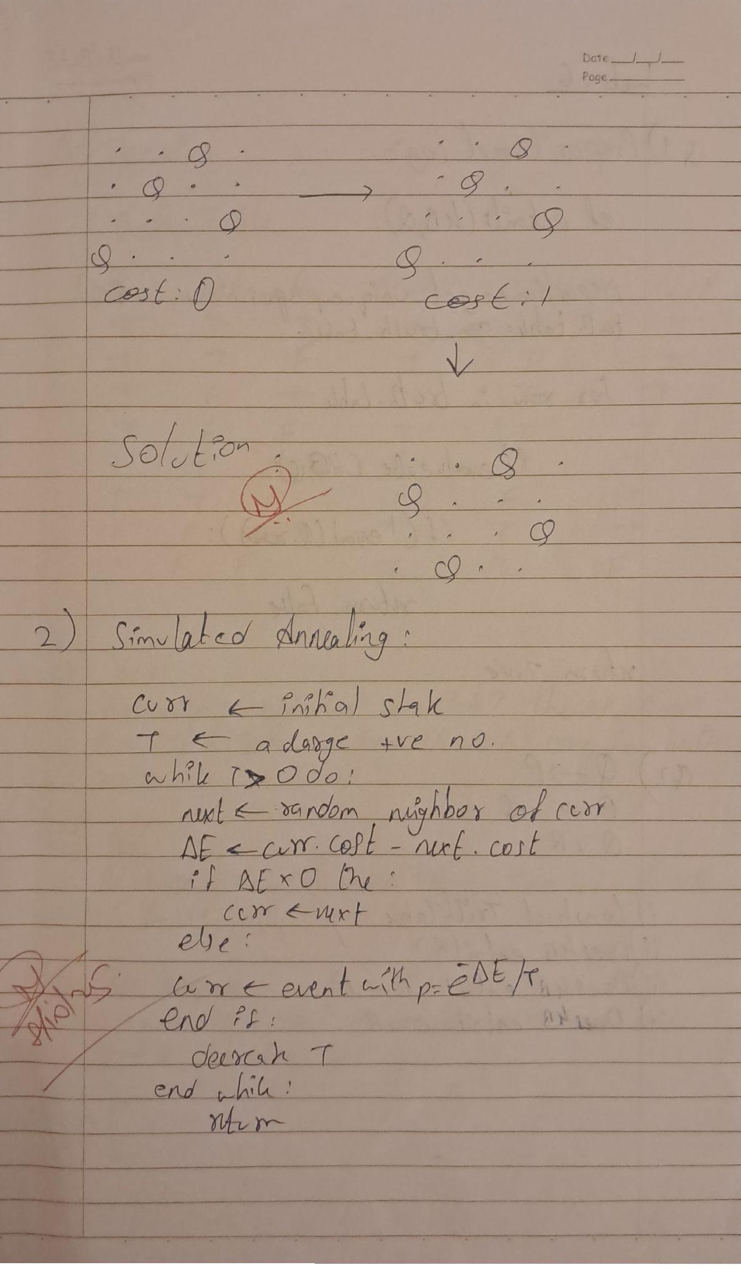
Program 6
Create a knowledge base using propositional logic and show that the given query entails the knowledge base or not.

Algorithm:
(You should provide the screen shot of your observation book of Algorithm/Logic/Solving of respective problem)

Code:
import itertools
import pandas as pd

variables = ['P', 'Q', 'R']

def q_implies_p(p, q, r):
return not q or p

def p_implies_not_q(p, q, r):
return not p or not q

def q_or_r(p, q, r):
return q or r

sentences = {
'Q implies P': q_implies_p,
'P implies not(Q)': p_implies_not_q,
'Q or R': q_or_r
}

truth_values = [True, False]
combinations = list(itertools.product(truth_values, repeat=len(variables)))

truth_table_data = []
for combination in combinations:
p, q, r = combination
row = {'P': p, 'Q': q, 'R': r}
for sentence_name, sentence_func in sentences.items():
row[sentence_name] = sentence_func(p, q, r)
truth_table_data.append(row)

truth_table_df = pd.DataFrame(truth_table_data)

sentence_columns = list(sentences.keys())
truth_table_df['KB is True'] = truth_table_df[sentence_columns].all(axis=1)

models = truth_table_df[truth_table_df['KB is True']]

kb_entails_r = models['R'].all()
kb_entails_r_implies_p = (models['R'].apply(lambda x: not x) | models['P']).all()
kb_entails_q_implies_r = (models['Q'].apply(lambda x: not x) | models['R']).all()

print("Truth Table:")
print(truth_table_df)

print("\nModels where KB is True:")
print(models)

print("\nEntailment Results:")
print(f"KB entails R: {kb_entails_r}")
print(f"KB entails R implies P: {kb_entails_r_implies_p}")
print(f"KB entails Q implies R: {kb_entails_q_implies_r}")
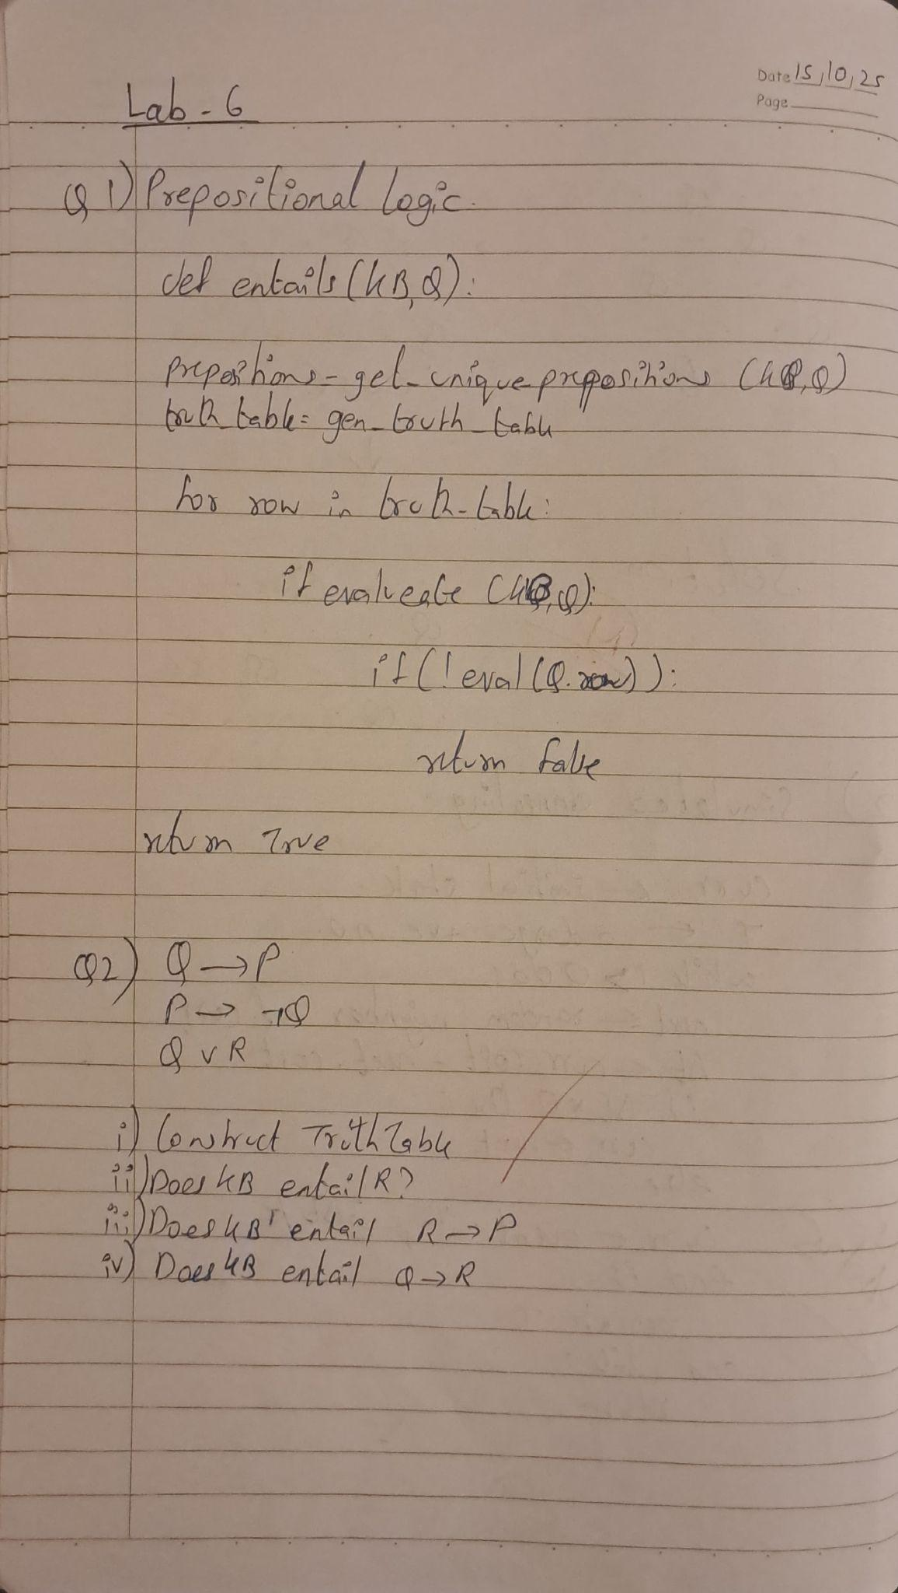

Program 7
Implement unification in first order logic

Algorithm:
(You should provide the screen shot of your observation book of Algorithm/Logic/Solving of respective problem)

Code:
import re

# Utility: parse the expression into function/operator and arguments
def parse(expr):
expr = expr.strip()
if '(' not in expr:
return expr, []
func = expr[:expr.index('(')].strip()
args = expr[expr.index('(')+1:-1]
args = [a.strip() for a in split_args(args)]
return func, args

# Split arguments correctly (handles nested brackets)
def split_args(args_str):
args, level, start = [], 0, 0
for i, ch in enumerate(args_str):
if ch == ',' and level == 0:
args.append(args_str[start:i].strip())
start = i + 1
elif ch == '(':
level += 1
elif ch == ')':
level -= 1
args.append(args_str[start:].strip())
return args

# Apply substitution to an expression
def substitute(expr, subs):
for var, val in subs.items():
expr = re.sub(rf'\b{var}\b', val, expr)
return expr

# Check if variable occurs inside term (Occurs check)
def occurs_check(var, term):
if var == term:
return True
if '(' not in term:
return False
_, args = parse(term)
return any(occurs_check(var, arg) for arg in args)

# Unification algorithm
def unify(e1, e2, subs=None):
if subs is None:
subs = {}

e1 = substitute(e1, subs)
e2 = substitute(e2, subs)

if e1 == e2:
return subs

f1, args1 = parse(e1)
f2, args2 = parse(e2)

# Case 1: Both are compound terms
if args1 and args2:
if f1 != f2 or len(args1) != len(args2):
print(f" Function symbols or arity mismatch: {f1} vs {f2}")
return None
for a1, a2 in zip(args1, args2):
subs = unify(a1, a2, subs)
if subs is None:
return None
return subs

# Case 2: Variable binding
elif e1.islower() and e1.isalpha(): # e1 is variable
if occurs_check(e1, e2):
print(f" Occurs check failed: {e1} occurs in {e2}")
return None
subs[e1] = e2
return subs
elif e2.islower() and e2.isalpha(): # e2 is variable
if occurs_check(e2, e1):
print(f" Occurs check failed: {e2} occurs in {e1}")
return None
subs[e2] = e1
return subs

# Otherwise mismatch
else:
print(f"Cannot unify {e1} with {e2}")
return None

# --- MAIN PROGRAM ---
print("=== Unification Algorithm ===")
expr1 = input("Enter first expression: ").strip()
expr2 = input("Enter second expression: ").strip()

result = unify(expr1, expr2)

if result:
print("\n Unification Successful!")
print("Substitutions:")
for k, v in result.items():
print(f" {k} / {v}")
else:
print("\n Unification Failed.")
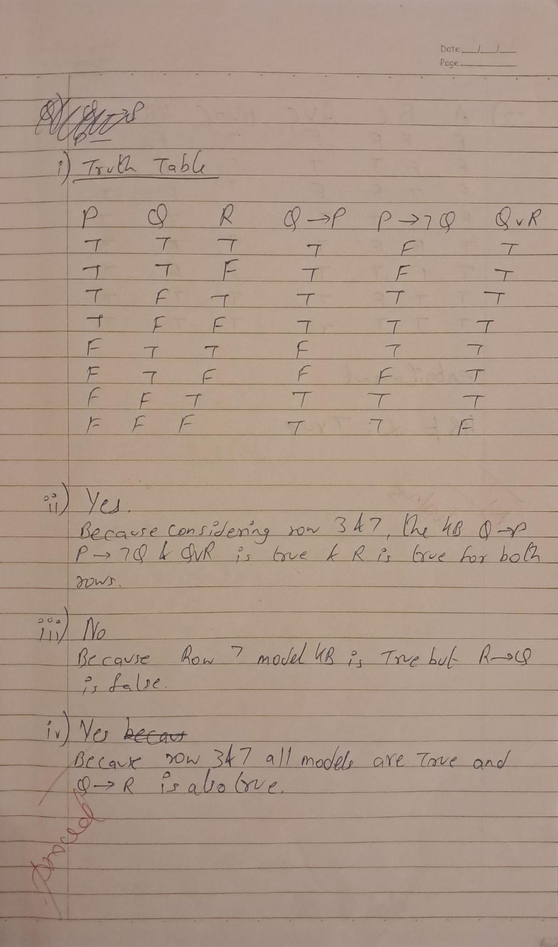
Program 8
Create a knowledge base consisting of first order logic statements and prove the given query using forward reasoning.

Algorithm:
(You should provide the screen shot of your observation book of Algorithm/Logic/Solving of respective problem)

Code:
import re

def isVariable(x):
return len(x) == 1 and x.islower() and x.isalpha()

def getAttributes(string):
expr = r'\([^)]+\)'
matches = re.findall(expr, string)
return matches

def getPredicates(string):
expr = r'([a-z~]+)\([^&|]+\)'
return re.findall(expr, string)

class Fact:
def __init__(self, expression):
self.expression = expression
predicate, params = self.splitExpression(expression)
self.predicate = predicate
self.params = params
self.result = any(self.getConstants())

def splitExpression(self, expression):
predicate = getPredicates(expression)[0]
params = getAttributes(expression)[0].strip('()').split(',')
return [predicate, params]

def getResult(self):
return self.result

def getConstants(self):
return [None if isVariable(c) else c for c in self.params]

def getVariables(self):
return [v if isVariable(v) else None for v in self.params]

def substitute(self, constants):
constants_copy = constants.copy()
expr = f"{self.predicate}({','.join([constants_copy.pop(0) if isVariable(p) else p for p in self.params])})"
return Fact(expr)

class Implication:
def __init__(self, expression):
self.expression = expression
l = expression.split('=>')
self.lhs = [Fact(f) for f in l[0].split('&')]
self.rhs = Fact(l[1])

def evaluate(self, facts):
constants = {}
new_lhs = []
for fact in facts:
for val in self.lhs:
if val.predicate == fact.predicate:
for i, v in enumerate(val.getVariables()):
if v:
constants[v] = fact.getConstants()[i]
new_lhs.append(fact)

predicate = getPredicates(self.rhs.expression)[0]
attributes = str(getAttributes(self.rhs.expression)[0])

for key in constants:
if constants[key]:
attributes = attributes.replace(key, constants[key])

expr = f'{predicate}{attributes}'
return Fact(expr) if len(new_lhs) and all([f.getResult() for f in new_lhs]) else None

class KB:
def __init__(self):
self.facts = set()
self.implications = set()

def tell(self, e):
if '=>' in e:
self.implications.add(Implication(e))
else:
self.facts.add(Fact(e))
for i in self.implications:
res = i.evaluate(self.facts)
if res:
self.facts.add(res)

def ask(self, e):
facts = set([f.expression for f in self.facts])
print(f'\nQuerying {e}:')
i = 1
found = False
for f in facts:
if Fact(f).predicate == Fact(e).predicate:
print(f'\t{i}. {f}')
i += 1
found = True
if not found:
print("\tNo matching facts found.")

def display(self):
print("\nAll facts:")
for i, f in enumerate(set([f.expression for f in self.facts])):
print(f'\t{i+1}. {f}')

def main():
kb = KB()
print("Enter the number of FOL expressions present in KB:")
n = int(input())
print("Enter the expressions:")
for i in range(n):
fact = input().strip()
kb.tell(fact)

print("Enter the query:")
query = input().strip()
kb.ask(query)
kb.display()

if __name__ == "__main__":
main()import re

def isVariable(x):
return len(x) == 1 and x.islower() and x.isalpha()

def getAttributes(string):
expr = r'\([^)]+\)'
matches = re.findall(expr, string)
return matches

def getPredicates(string):
expr = r'([a-z~]+)\([^&|]+\)'
return re.findall(expr, string)

class Fact:
def __init__(self, expression):
self.expression = expression
predicate, params = self.splitExpression(expression)
self.predicate = predicate
self.params = params
self.result = any(self.getConstants())

def splitExpression(self, expression):
predicate = getPredicates(expression)[0]
params = getAttributes(expression)[0].strip('()').split(',')
return [predicate, params]

def getResult(self):
return self.result

def getConstants(self):
return [None if isVariable(c) else c for c in self.params]

def getVariables(self):
return [v if isVariable(v) else None for v in self.params]

def substitute(self, constants):
constants_copy = constants.copy()
expr = f"{self.predicate}({','.join([constants_copy.pop(0) if isVariable(p) else p for p in self.params])})"
return Fact(expr)

class Implication:
def __init__(self, expression):
self.expression = expression
l = expression.split('=>')
self.lhs = [Fact(f) for f in l[0].split('&')]
self.rhs = Fact(l[1])

def evaluate(self, facts):
constants = {}
new_lhs = []
for fact in facts:
for val in self.lhs:
if val.predicate == fact.predicate:
for i, v in enumerate(val.getVariables()):
if v:
constants[v] = fact.getConstants()[i]
new_lhs.append(fact)

predicate = getPredicates(self.rhs.expression)[0]
attributes = str(getAttributes(self.rhs.expression)[0])

for key in constants:
if constants[key]:
attributes = attributes.replace(key, constants[key])

expr = f'{predicate}{attributes}'
return Fact(expr) if len(new_lhs) and all([f.getResult() for f in new_lhs]) else None

class KB:
def __init__(self):
self.facts = set()
self.implications = set()

def tell(self, e):
if '=>' in e:
self.implications.add(Implication(e))
else:
self.facts.add(Fact(e))
for i in self.implications:
res = i.evaluate(self.facts)
if res:
self.facts.add(res)

def ask(self, e):
facts = set([f.expression for f in self.facts])
print(f'\nQuerying {e}:')
i = 1
found = False
for f in facts:
if Fact(f).predicate == Fact(e).predicate:
print(f'\t{i}. {f}')
i += 1
found = True
if not found:
print("\tNo matching facts found.")

def display(self):
print("\nAll facts:")
for i, f in enumerate(set([f.expression for f in self.facts])):
print(f'\t{i+1}. {f}')

def main():
kb = KB()
print("Enter the number of FOL expressions present in KB:")
n = int(input())
print("Enter the expressions:")
for i in range(n):
fact = input().strip()
kb.tell(fact)

print("Enter the query:")
query = input().strip()
kb.ask(query)
kb.display()

if __name__ == "__main__":
main()

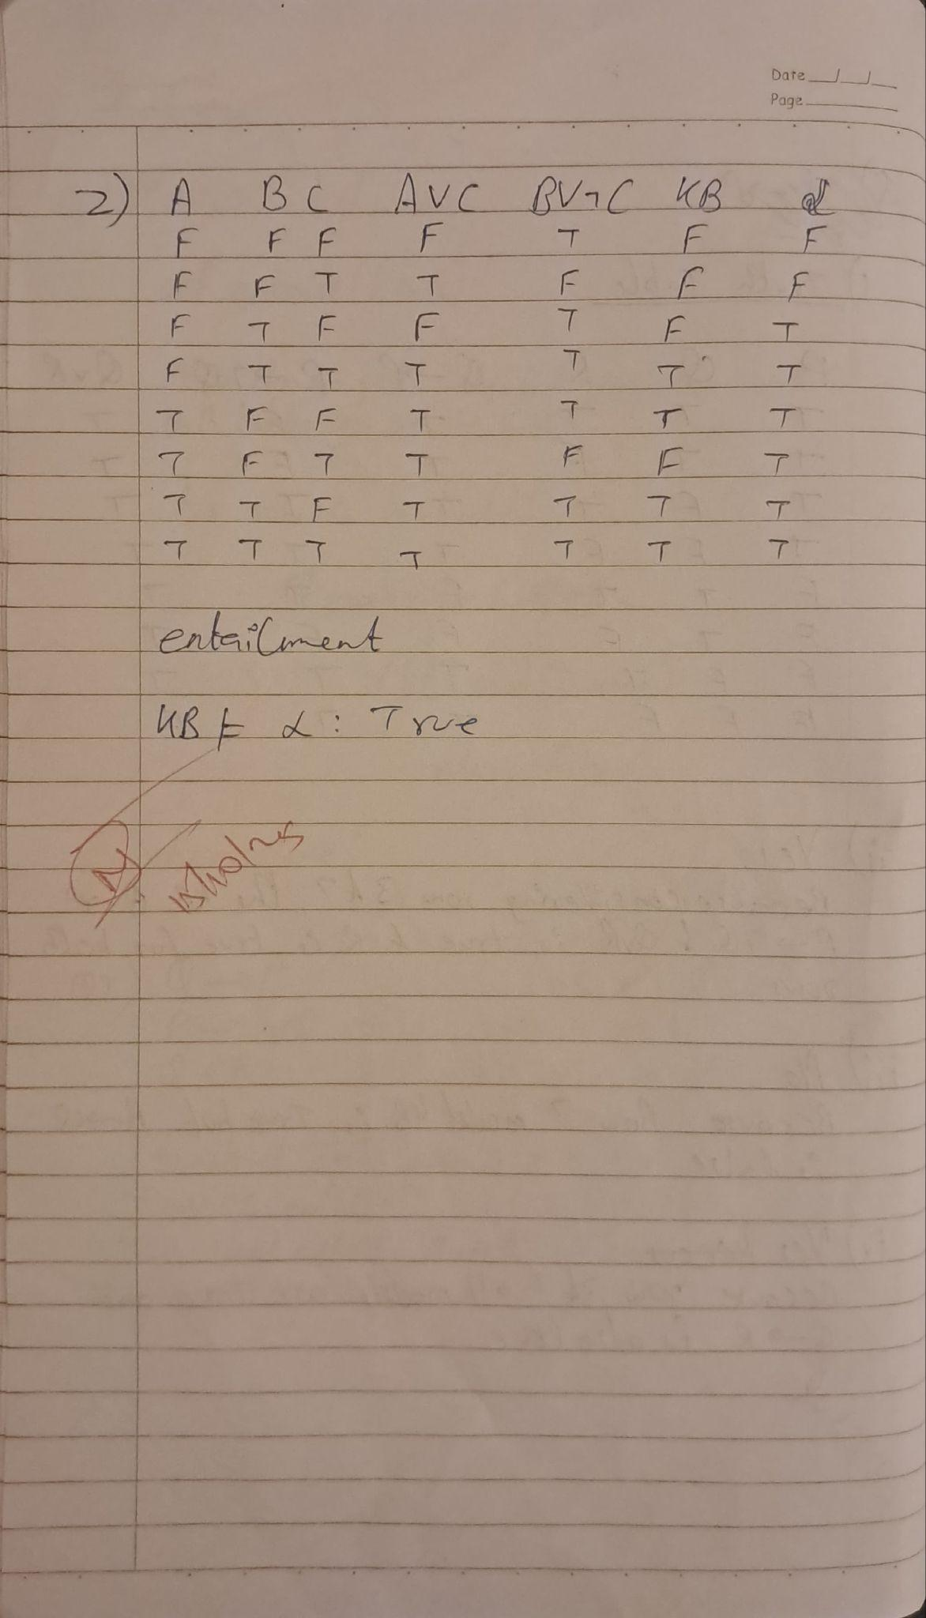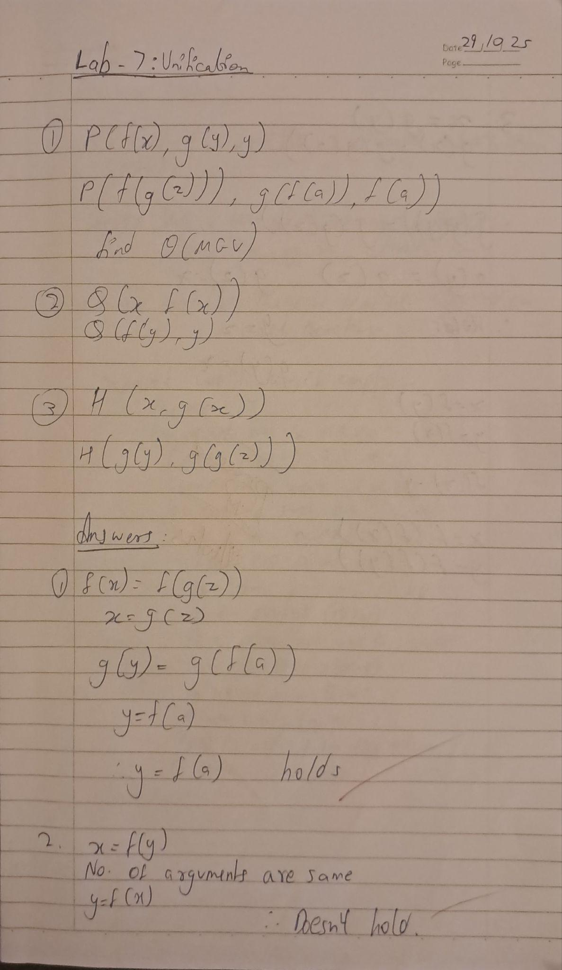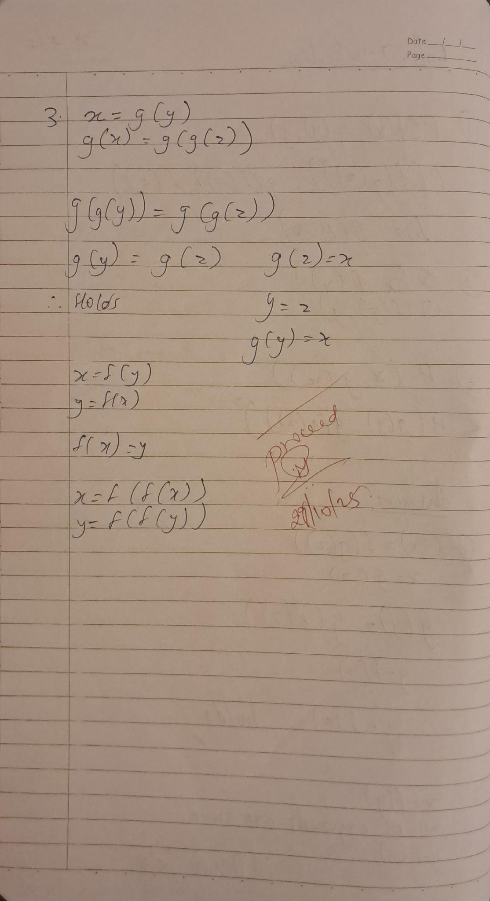
Program 9
Create a knowledge base consisting of first order logic statements and prove the given query using Resolution

Code:
def parse_clause(clause_str):
return set(clause_str.split('v'))

def get_complement(literal):
return literal[1:] if literal.startswith('~') else '~' + literal

def resolve(ci, cj):
resolvents = set()
for literal in ci:
complement = get_complement(literal)
if complement in cj:
new_clause = (ci - {literal}) | (cj - {complement})
resolvents.add(frozenset(new_clause))
return resolvents

def resolution(kb_clauses, query):
negated_query = get_complement(query)
kb = [parse_clause(clause) for clause in kb_clauses] + [parse_clause(negated_query)]

print("\n-----------------------------")
print("KnowledgeBase - Resolution")
print("-----------------------------")
print(f"\nKnowledge Base Clauses: {kb_clauses}")
print(f"Query: {query}")
print(f"Negated Query Added: {negated_query}")
print("\nResolution Steps:\n")

new = set()

while True:
pairs = [(kb[i], kb[j]) for i in range(len(kb)) for j in range(i + 1, len(kb))]
for (ci, cj) in pairs:
resolvents = resolve(ci, cj)
for resolvent in resolvents:
print(f"Resolving {set(ci)} and {set(cj)} => {set(resolvent)}")
if not resolvent:
print("\n Knowledge Base entails the query (empty clause derived).")
return True
new.add(resolvent)

if new.issubset(set(map(frozenset, kb))):
print("\n Knowledge Base does NOT entail the query (no empty clause derived).")
return False

for clause in new:
if clause not in kb:
kb.append(clause)

print("KnowledgeBase - Resolution")
print("-----------------------------")
print("Enter clauses for the Knowledge Base.")
print("Use 'v' for OR between literals (e.g., '~qv~pvr'), and separate each clause with a space.\n")

kb_input = input("Enter clauses: ").split()
query_input = input("Enter the query: ")

resolution(kb_input, query_input)

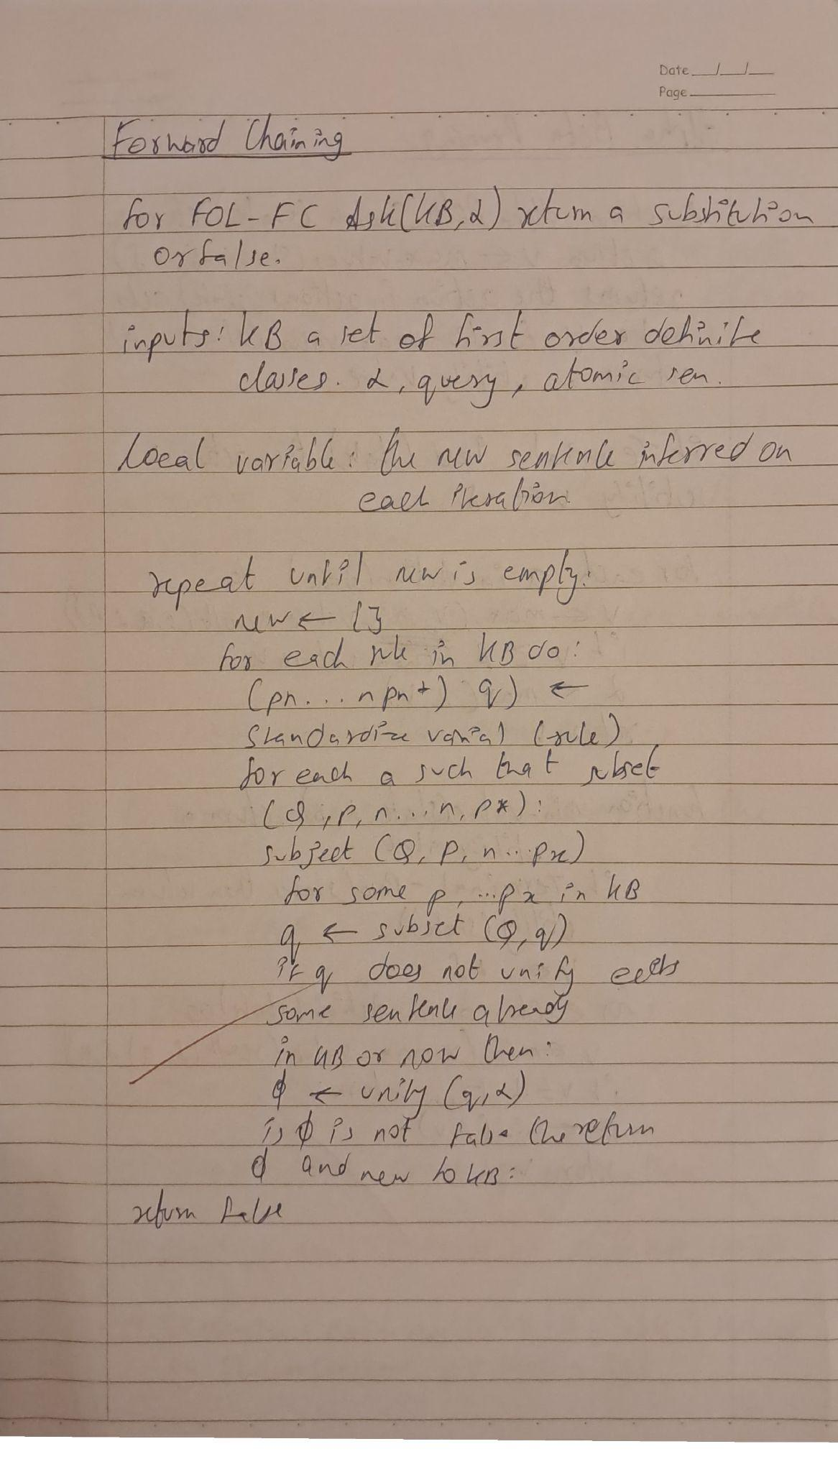
Program 10
Implement Alpha-Beta Pruning.

Algorithm:
(You should provide the screen shot of your observation book of Algorithm/Logic/Solving of respective problem)

Code:
import math
import random

# Use an external "real" board only for the main game loop; recursive functions use state parameters.
board = [" " for _ in range(9)] # 3x3 board

def print_board(state):
print("\n")
for i in range(3):
print(" " + " | ".join(state[i*3:(i+1)*3]))
if i < 2:
print("---+---+---")
print("\n")

def is_winner(state, player):
win_combinations = [
[0, 1, 2], [3, 4, 5], [6, 7, 8],
[0, 3, 6], [1, 4, 7], [2, 5, 8],
[0, 4, 8], [2, 4, 6]
]
return any(all(state[i] == player for i in combo) for combo in win_combinations)

def is_full(state):
return " " not in state

def actions(state):
return [i for i in range(9) if state[i] == " "]

def result(state, action, player):
new_state = state.copy()
new_state[action] = player
return new_state

def utility(state):
if is_winner(state, "O"):
return +1
elif is_winner(state, "X"):
return -1
else:
return 0

def terminal_test(state):
return is_winner(state, "X") or is_winner(state, "O") or is_full(state)

# --- Alpha-Beta Functions ---
def max_value(state, alpha, beta):
if terminal_test(state):
return utility(state)
v = -math.inf
for a in actions(state):
v = max(v, min_value(result(state, a, "O"), alpha, beta))
if v >= beta:
return v
alpha = max(alpha, v)
return v

def min_value(state, alpha, beta):
if terminal_test(state):
return utility(state)
v = math.inf
for a in actions(state):
v = min(v, max_value(result(state, a, "X"), alpha, beta))
if v <= alpha:
return v
beta = min(beta, v)
return v

def alpha_beta_search(state):
best_score = -math.inf
best_action = None
if not actions(state):
return None
for a in actions(state):
value = min_value(result(state, a, "O"), -math.inf, math.inf)
if value > best_score:
best_score = value
best_action = a
# Fallback: if something goes wrong, return a random legal move
if best_action is None:
legal = actions(state)
return random.choice(legal) if legal else None
return best_action

# --- Game Loop ---
def human_move():
while True:
try:
move = int(input("Enter your move (1-9): ")) - 1
except ValueError:
print("Please enter a number 1-9.")
continue
if move < 0 or move > 8:
print("Move out of range. Choose 1-9.")
continue
if board[move] != " ":
print("Cell already taken. Try another.")
continue
return move

def choose_first():
while True:
ans = input("Who goes first? (me/ai) [me]: ").strip().lower()
if ans == "" or ans.startswith("m"):
return "me"
if ans.startswith("a"):
return "ai"
print("Type 'me' or 'ai' (or press Enter for me).")

def main():
global board
board = [" " for _ in range(9)]
print("Welcome to Tic-Tac-Toe! You are X, AI is O.")
first = choose_first()
print_board(board)

while True:
if first == "me":
# Human turn
move = human_move()
board[move] = "X"
print_board(board)
if is_winner(board, "X"):
print("You win!")
break
if is_full(board):
print("It's a draw!")
break

# AI turn
print("AI is thinking...")
ai_move = alpha_beta_search(board)
if ai_move is None:
print("AI could not find a move — it's a draw.")
break
board[ai_move] = "O"
print_board(board)
if is_winner(board, "O"):
print("AI wins!")
break
if is_full(board):
print("It's a draw!")
break

else: # AI first
print("AI is thinking...")
ai_move = alpha_beta_search(board)
if ai_move is None:
print("AI could not find a move — it's a draw.")
break
board[ai_move] = "O"
print_board(board)
if is_winner(board, "O"):
print("AI wins!")
break
if is_full(board):
print("It's a draw!")
break

# Human turn
move = human_move()
board[move] = "X"
print_board(board)
if is_winner(board, "X"):
print("You win!")
break
if is_full(board):
print("It's a draw!")
break

if __name__ == "__main__":
main()
