AI Study Assistant Chatbot Using Generative AI (Google Gemini)
Mini Project Report – Learning Block 1

Name: ANAGANDULA SHIVANI
Roll Number: 236F1A6703
Branch: CSE (Data Science)
College: Pallavi Engineering College
Academic Year: 2026–2027
Guided by: Mr. Ragavendra Roa

1. Abstract
This project presents the AI Study Assistant, a web-based chatbot built with Python, Streamlit and the Google Gemini Generative AI model. A student types a study question and receives a clear, generated answer in one of three styles: Simple, Exam-oriented or Example-based. The application uses prompt engineering, chat memory and error handling to give useful answers on topics such as Artificial Intelligence, Data Science and Python. The project shows how a pre-trained Generative AI model can be integrated into a practical application through an API.

2. Introduction
Generative AI refers to models that create new content, such as text, from patterns learned during training on very large datasets. Large Language Models (LLMs) such as Google Gemini can understand a question written in natural language and generate a meaningful reply. Unlike a retrieval-based chatbot, which only picks a stored answer, a generative chatbot writes a new answer for every question.
College students often need quick and clear explanations while studying technical subjects. This project uses a Generative AI model to act as a personal study assistant that explains concepts in the style the student prefers.

3. Problem Statement
Students usually depend on search engines, textbooks and fixed-answer FAQ bots to understand technical topics. These sources are time-consuming to search, give scattered and inconsistent explanations, and cannot adjust their language to the student's level. There is a need for an automated tool that gives clear, exam-ready answers in seconds and can change its style on request.

4. Objectives
- To build a functional web application that students can use without technical setup.
- To integrate a Generative AI model (Google Gemini) through its API.
- To design effective prompts that produce accurate, relevant and well-structured answers.
- To provide a simple and clean user interface for asking questions.
- To evaluate the quality of the generated answers through testing.

5. Scope
The application answers study questions related to Artificial Intelligence, Data Science, Python and Computer Science. It accepts a typed text question and returns a generated text answer. It supports the English language and offers three answer styles. The system depends on an internet connection and on the availability of the Gemini API.

6. Tools and Technologies Used
Component | Technology
Programming language | Python 3.13
User interface | Streamlit (chat-style web interface)
Generative AI model | Google Gemini (model gemini-3.8-flash, with fallback models)
API library | google-genai (official Google GenAI Python SDK)
Platform | Windows, run through Command Prompt and a web browser

7. System Architecture and Methodology
The system follows a five-stage pipeline:
- User input: The student types a question in the chat box of the web interface.
- Prompt construction: The question is combined with a system prompt, the selected answer style and the last few chat messages to build a complete prompt.
- GenAI model API call: The prompt is sent to the Google Gemini model through an authenticated API request using an API key.
- Response processing: The generated text is received and checked for errors. If a model is unavailable, the next model in the fallback list is tried.
- Output display: The answer is shown in the chat window, and the conversation is stored for follow-up questions.

Prompt Engineering
Prompt engineering means writing clear instructions so that the model gives useful output. This project uses two parts:
- System prompt: Tells the model to act as a friendly study assistant, to answer only study-related questions, to keep answers under 200 words, and to politely refuse unrelated questions.
- Style instruction: Changes with the student's choice. The Simple style asks for easy words with one example. The Exam-oriented style asks for a definition, four to five key points and a short conclusion. The Example-based style asks for two real-life examples.

8. Implementation
The application is written in a single Python file, ai_study_assistant.py. Its main parts are:
- Sidebar: Contains the Gemini API Key field (entered as a password, so it is never written in the code), the Answer style selector and a Clear chat button.
- Chat interface: Streamlit chat elements display the conversation and accept the question.
- Input validation: Questions are trimmed to 500 characters, and a warning is shown if the API key is missing.
- Response generation: A function builds the prompt and calls the Gemini model with a temperature of 0.5, which gives balanced and consistent answers.
- Error handling: If the first model fails, the program tries the next one and shows a clear message if none is available.
The application is started with the command python -m streamlit run ai_study_assistant.py and opens in the browser at localhost:8501.

9. Results and Testing
The application was run and tested with different questions and answer styles. The screenshots below show the home page, the input screen and the generated answers.
Test | Question | Answer style | Observed result
1 | What is machine learning? | Exam-oriented | A definition followed by key points on the data-driven approach, learning types and generalization
2 | give python main topics | Simple | A numbered list of core Python topics (variables, data structures, conditionals, loops, functions, OOP) with an easy example

In both tests the model produced clear, relevant and well-structured answers. The answer changed with the selected style, which shows that the prompt engineering works as intended.
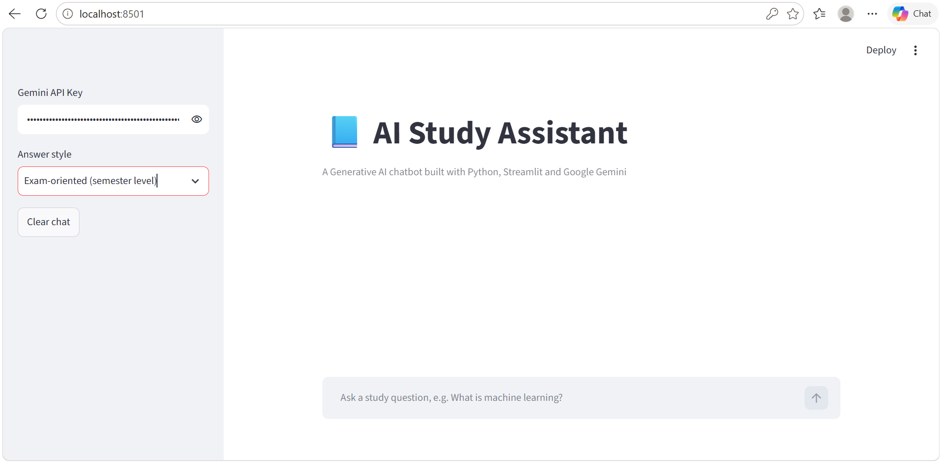
Figure 1: Home page of the AI Study Assistant
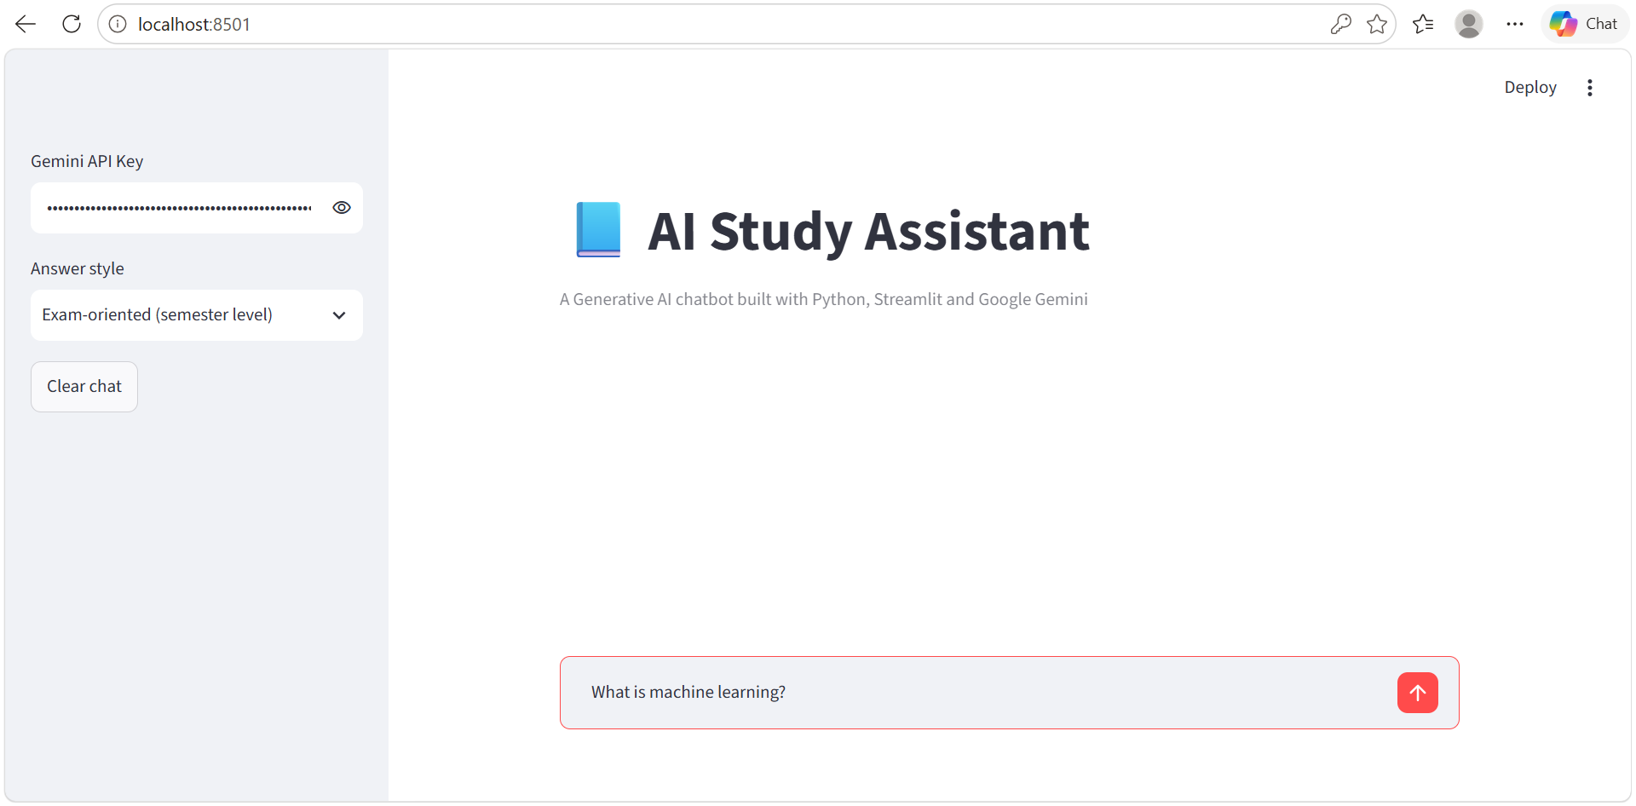
Figure 2: Question typed in the input box
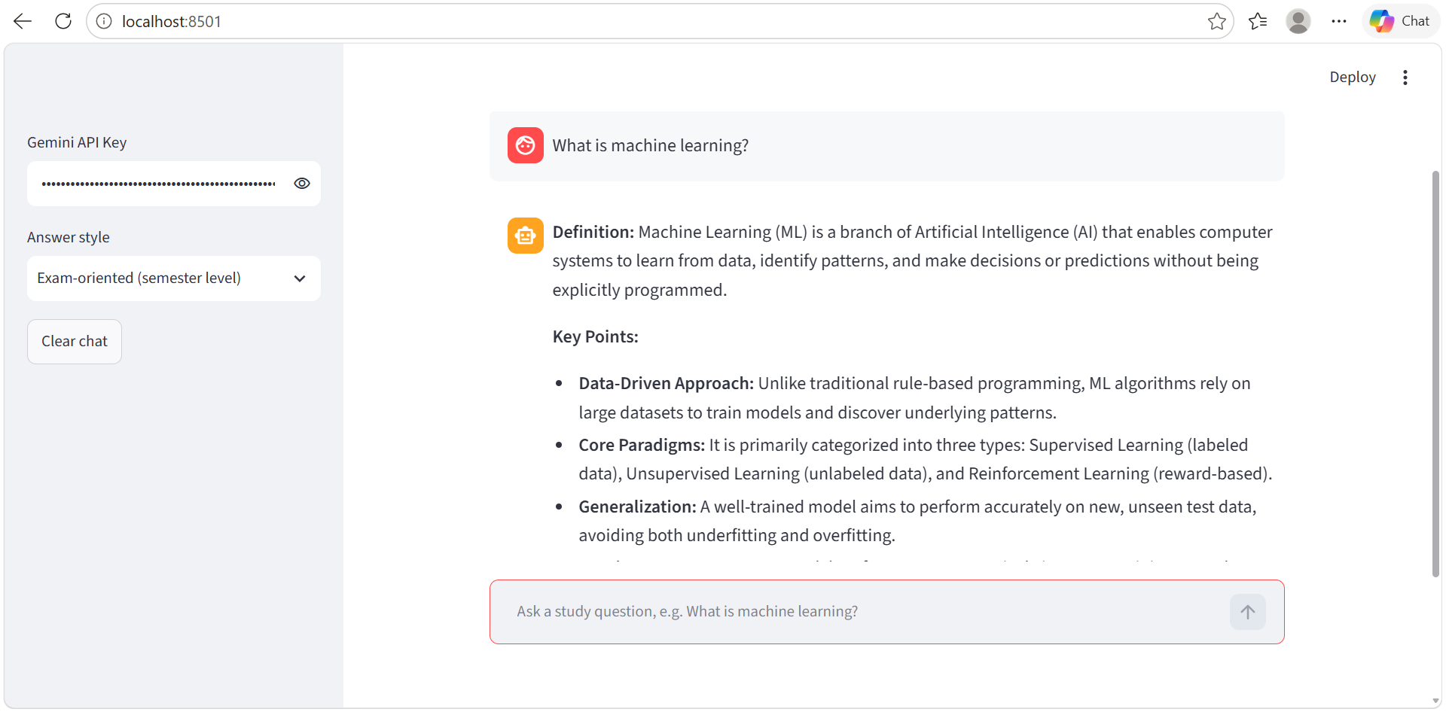
Figure 3: Exam-style answer for "What is machine learning?"
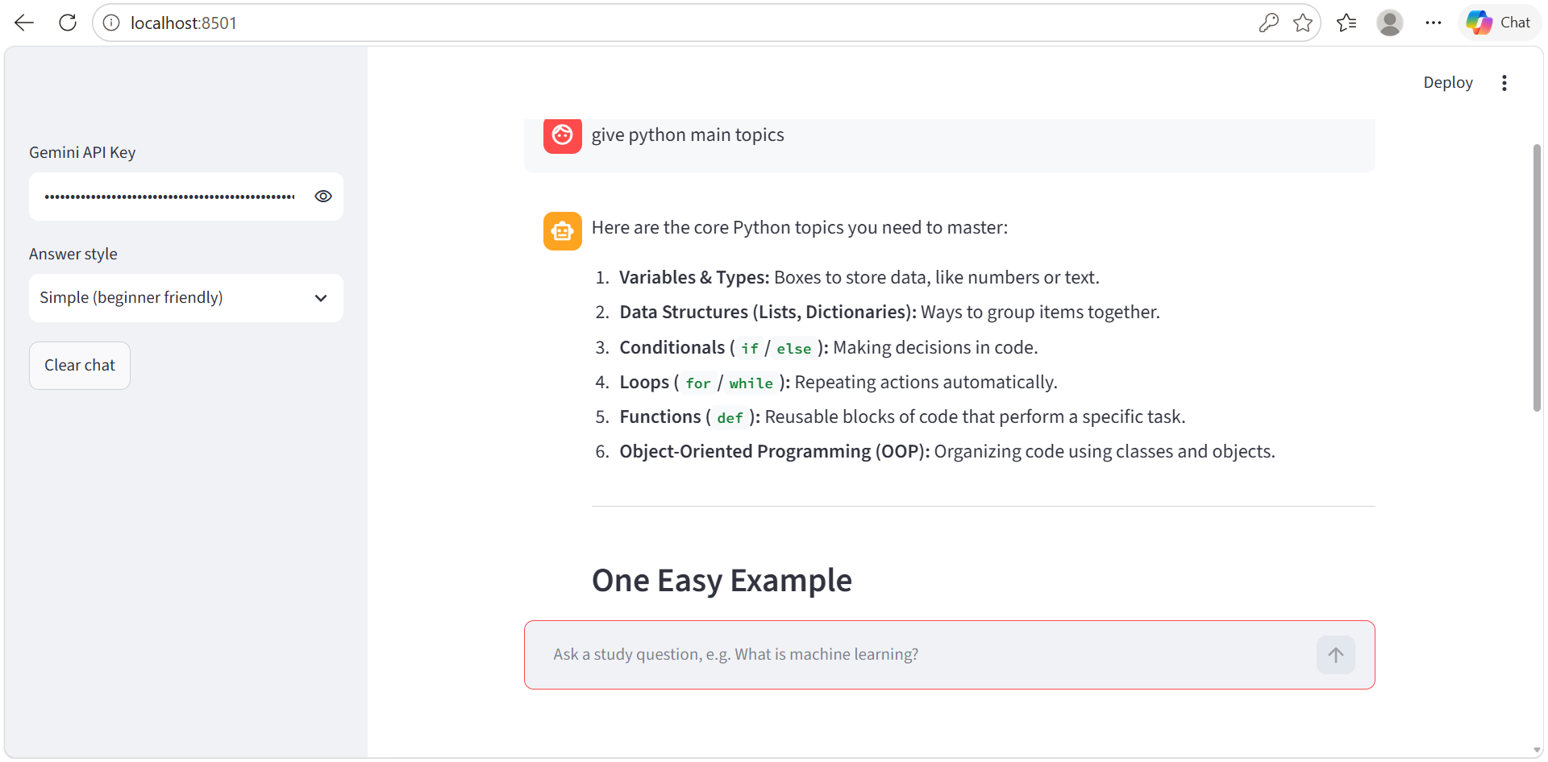
Figure 4: Simple-style answer for "give python main topics"

10. Challenges Faced
- Model availability: Google retired an older model name during development, which caused a 404 error. This was solved by updating the model to a current version and adding fallback models.
- API key handling: The key must not be stored in the source code. It is entered at run time in the sidebar.
- Prompt design: Getting answers of the right length and style required refining the system prompt and style instructions.

11. Limitations
- The application needs an internet connection and a valid API key.
- The free API tier has usage limits, so many questions in a short time can return a rate-limit error.
- Generative AI can sometimes produce incorrect or incomplete answers, so important facts should be verified.
- Only the English language is supported, and only text input is accepted.

12. Future Scope
- Add support for uploading notes or PDFs so the assistant can answer from the student's own material.
- Add Telugu and Hindi language support.
- Add a quiz-generation mode for self-testing.
- Deploy the application online so that students can use it from any device.

13. Conclusion
The AI Study Assistant shows how a Generative AI model can be integrated into a simple and useful web application. By combining Streamlit, the Gemini API and careful prompt engineering, the system gives students clear answers in seconds and adapts its style to their needs. The project gave practical experience in API integration, prompt design, user interface development and error handling. With more features such as document upload and multilingual support, it can grow into a complete learning companion.

14. References
- Google Gemini API Documentation — https://ai.google.dev/gemini-api/docs
- Google AI Studio — https://aistudio.google.com
- Streamlit Documentation — https://docs.streamlit.io
- Python Documentation — https://docs.python.org
- Google GenAI Python SDK — https://github.com/googleapis/python-genai
- A. Vaswani et al., "Attention Is All You Need", NeurIPS, 2017.
- T. Brown et al., "Language Models are Few-Shot Learners", NeurIPS, 2020.
- S. Russell and P. Norvig, Artificial Intelligence: A Modern Approach, Pearson, 2020.

