AI Study Assistant Chatbot Using Generative AI (Google Gemini)
Mini Project Report – Learning Block 1: Generative AI Application

Name: ANAGANDULA SHIVANI
Roll Number: 236F1A6703
Branch: CSE (Data Science)
College: Pallavi Engineering College
Academic Year: 2026–2027
Guide Name: Raghavendra Rao M S
GitHub Repository: https://github.com/Anagandulashivani/ai-study-assistant-chatbot

Abstract
This project presents the AI Study Assistant, a web-based chatbot built with Python, Streamlit and the Google Gemini Generative AI model. A student types a study question and receives a clear, generated answer in one of three styles: Simple, Exam-oriented or Example-based. The application uses prompt engineering, chat memory, input validation and fallback error handling to give useful answers on topics such as Artificial Intelligence, Data Science and Python. The project shows how a pre-trained Generative AI model can be integrated into a practical application through an API.

1. Introduction

1.1 Overview
The AI Study Assistant is a Generative AI–powered web application that answers students' study questions in simple, exam-oriented language. College students often need quick and clear explanations while studying technical subjects, and this application gives them an intelligent, automated alternative to searching through books and websites.

1.2 Role of Generative AI
Generative AI refers to models that create new content, such as text, from patterns learned during training on very large datasets. Large Language Models (LLMs) such as Google Gemini understand a question written in natural language and generate a meaningful reply. Unlike a retrieval-based chatbot, which only picks a stored answer, a generative chatbot writes a new answer for every question. In this project, Google Gemini is the core engine that produces the explanations.

1.3 Key Features
- AI question answering using the Google Gemini API
- Three answer styles: Simple, Exam-oriented and Example-based
- Chat memory for follow-up questions
- Input validation and fallback models for error handling

1.4 Target Audience
The application is built for college students who need quick, clear explanations of AI, Data Science and Python topics.

2. Problem Statement

2.1 The Problem Today
Students usually depend on search engines, textbooks and fixed-answer FAQ bots to understand technical topics. These sources have the following problems:
- Slow, manual searching across many websites
- Fixed-answer bots that cannot adapt to the question
- Inconsistent quality and hard-to-understand wording

2.2 Why Generative AI is the Answer
A Generative AI model can understand a question in natural language, reason about its context and generate a clear answer in the style the student needs. This saves time, gives consistent quality and allows the explanation to be adjusted to the student's level, which a rule-based system cannot do.

3. Objectives
- To build a functional web application that students can use without technical setup.
- To integrate a Generative AI model (Google Gemini) through its API.
- To design effective prompts that produce accurate, relevant and well-structured answers.
- To provide a simple and clean user interface for asking questions.
- To evaluate the quality of the generated answers through testing.

4. Project Scope

4.1 What Is Included
Area | Details
Use cases | Answering study questions on AI, Data Science, Python and Computer Science
Target users | College students who need quick explanations and exam-ready answers
GenAI features | Question answering, answer-style control and context-aware follow-up replies
Input / output | A typed text question as input, and a generated text answer as output

4.2 Boundaries
- Supports the English language only
- Depends on external API availability and rate limits
- No dedicated mobile application in this release
- Domain coverage is limited to study topics in AI, Data Science and Python

5. Proposed System and Methodology

5.1 Step-by-Step Process
- User input: The student types a question in the chat box of the web interface.
- Prompt construction: The question is combined with a system prompt, the selected answer style and the last few chat messages to build a complete prompt.
- GenAI model API call: The prompt is sent to the Google Gemini model through an authenticated API request using an API key.
- Response processing: The generated text is received and checked for errors. If a model is unavailable, the next model in the fallback list is tried.
- Output display: The answer is shown in the chat window, and the conversation is stored for follow-up questions.

5.2 Prompt Engineering
Prompt engineering means writing clear instructions so that the model gives useful output. This project uses two parts:
- System prompt: Tells the model to act as a friendly study assistant, to answer only study-related questions, to keep answers under 200 words, and to politely refuse unrelated questions.
- Style instruction: Changes with the student's choice. The Simple style asks for easy words with one example. The Exam-oriented style asks for a definition, four to five key points and a short conclusion. The Example-based style asks for two real-life examples.

5.3 Key Design Decisions
- Answer-style prompt templates keep responses consistent.
- Input validation blocks empty text and limits the question length to 500 characters.
- Fallback to alternate Gemini models handles API errors gracefully.
- The API key is entered at run time, so it is never stored in the source code.

6. System Architecture and Workflow
The diagram below shows the complete data flow from the user's question to the AI-generated answer.
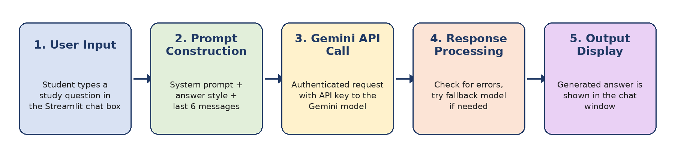
Figure 1: System architecture and workflow of the AI Study Assistant
- Frontend layer: A browser-based Streamlit interface where the student types the question, validated before it is forwarded to the backend.
- Backend layer: The Python code builds the prompt, authenticates the Gemini API call, tries fallback models if needed and returns the generated answer to the chat window.

7. Implementation

7.1 Technology Stack
Component | Technology
Programming language | Python 3.13
User interface | Streamlit (chat-style web interface)
Generative AI model | Google Gemini (model gemini-3.8-flash, with fallback models)
API library | google-genai (official Google GenAI Python SDK)
Platform | Windows, run through Command Prompt and a web browser

7.2 Integration and Prompt Engineering
The GenAI model is integrated through authenticated API calls using Google's official google-genai SDK. The API key is entered in the sidebar as a password field and is never written in the code. The main part of the code is shown below.
MODELS = ["gemini-3.8-flash", "gemini-3.5-flash", "gemini-2.5-flash"]

prompt = f"{STYLES[style]}\n\nPrevious chat:\n{history}\n\nQuestion: {question}"
config = types.GenerateContentConfig(
system_instruction=SYSTEM_PROMPT, temperature=0.5)

for model in MODELS:
try:
response = client.models.generate_content(
model=model, contents=prompt, config=config)
return response.text
except Exception as error:
if last_error is None:
last_error = error

A temperature of 0.5 gives balanced and consistent answers. The response text is checked for errors and displayed in the chat window by Streamlit.

7.3 Source Code and GitHub Repository
The complete source code and all project files are available in the public GitHub repository: https://github.com/Anagandulashivani/ai-study-assistant-chatbot
File | Purpose
ai_study_assistant.py | Main application: user interface, prompt building and Gemini API call
requirements.txt | List of Python libraries needed to run the project
README.md | Project description and instructions to run the application
report.docx | Project documentation
Project-Title_Shivani.pptx | Project presentation
Screenshot files (.png) | Screenshots of the working application

7.4 How to Run the Application
- Install Python 3 and download the repository (Code, then Download ZIP) and extract it.
- Install the libraries with the command: pip install -r requirements.txt
- Get a free API key from Google AI Studio (aistudio.google.com).
- Start the application with the command: python -m streamlit run ai_study_assistant.py
- Open localhost:8501 in the browser, paste the API key in the left sidebar and ask a study question.

8. User Interface and Application Screenshots
The following screenshots show the working application, from the home page to the AI-generated answers.
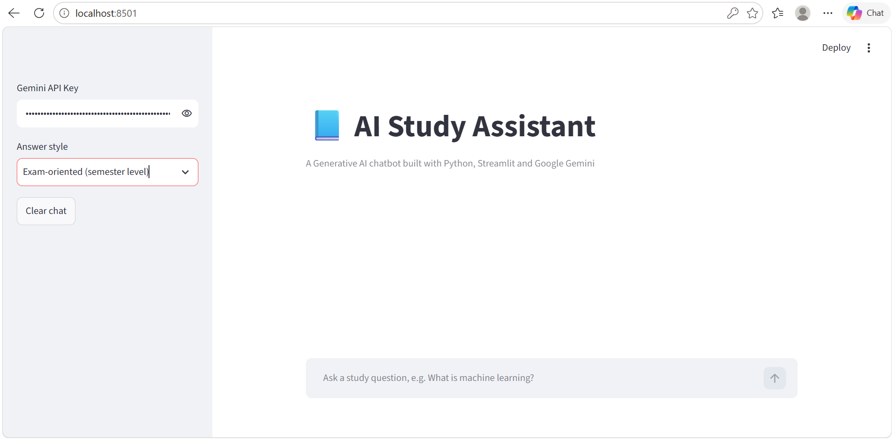
Figure 2: Home page with the API key field, answer-style selector, Clear chat button and chat input box
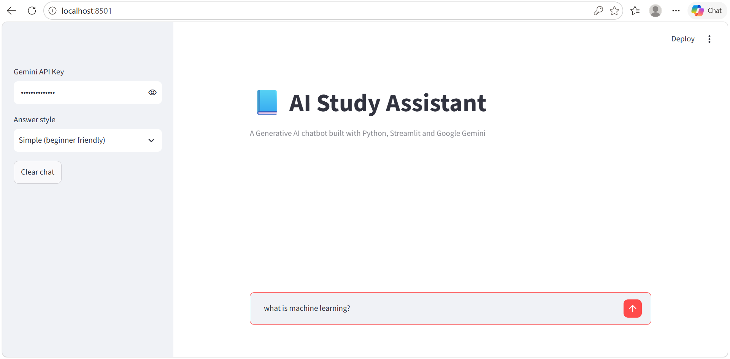
Figure 3: Input screen with the question "what is machine learning?" typed and the Simple answer style selected
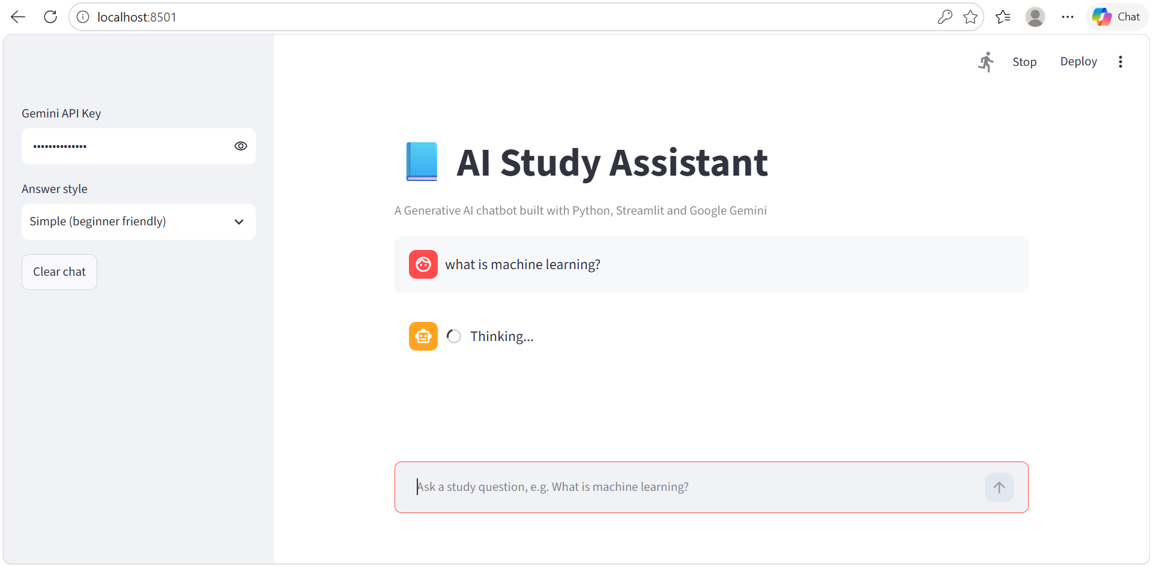
Figure 4: Processing state – the app shows "Thinking..." while the Gemini model generates the answer
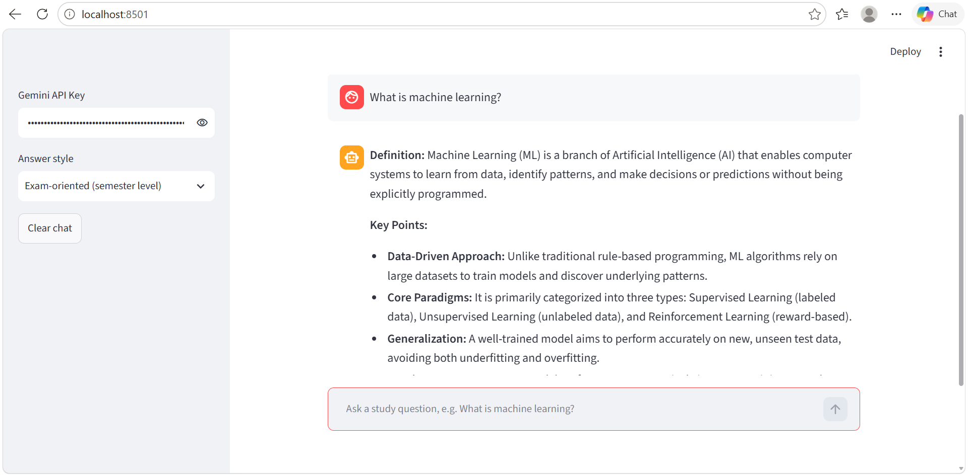
Figure 5: AI-generated output in the Exam-oriented style for "What is machine learning?" (definition and key points)
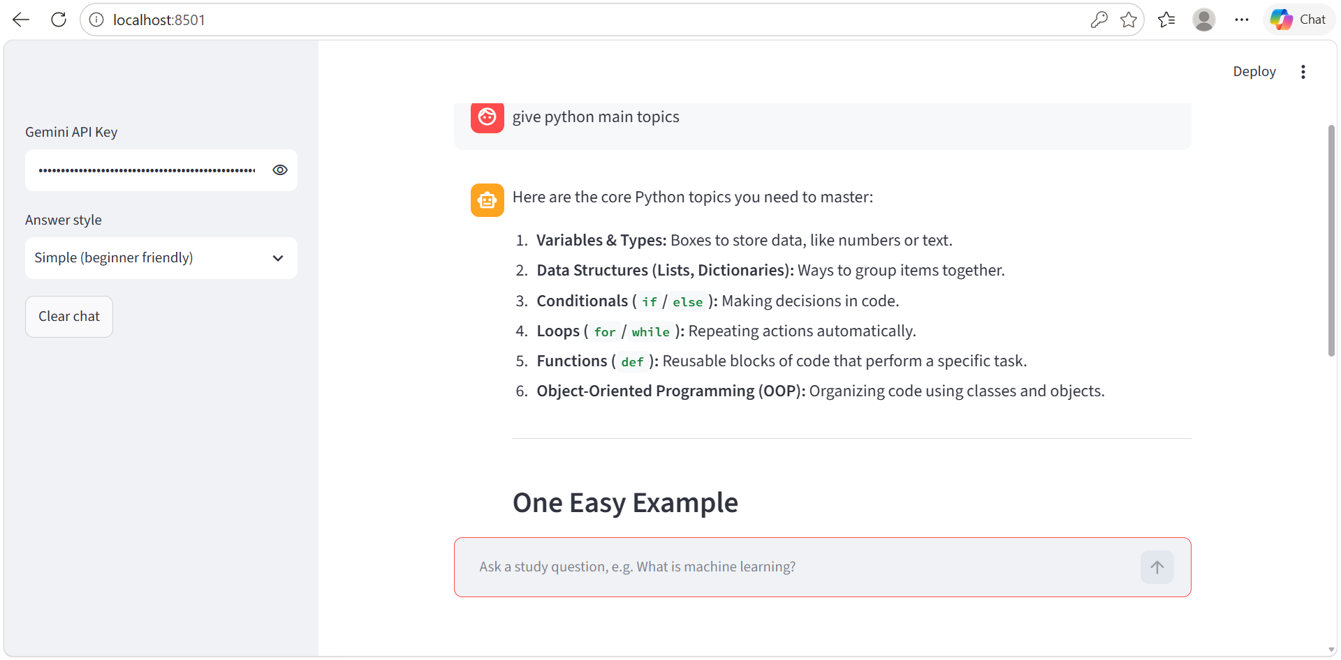
Figure 6: AI-generated output in the Simple style for "give python main topics"

8.1 Testing and Output Quality
Test | Question | Answer style | Observed result
1 | What is machine learning? | Exam-oriented | A definition followed by key points on the data-driven approach, learning types and generalization
2 | give python main topics | Simple | A numbered list of core Python topics (variables, data structures, conditionals, loops, functions, OOP) with an easy example

In both tests the model produced clear, relevant and well-structured answers. The answer changed with the selected style, which shows that the prompt engineering works as intended.

9. Challenges and Limitations

9.1 Technical Challenges Faced
- Model selection: Google retired an older model name during development, which caused a 404 error. This was solved by updating the model to a current version and adding fallback models.
- Prompt engineering: Getting answers of the right length and style required refining the system prompt and style instructions.
- API key handling: The key must not be stored in the source code, so it is entered at run time in the sidebar.

9.2 Current Limitations
- The application needs an internet connection and a valid API key.
- The free API tier has usage limits, so many questions in a short time can return a rate-limit error.
- Generative AI can sometimes produce incorrect or incomplete answers, so important facts should be verified.
- Only the English language is supported, and only text input is accepted.

10. Conclusion
The AI Study Assistant shows how a Generative AI model can be integrated into a simple and useful web application. By combining Streamlit, the Gemini API and careful prompt engineering, the system gives students clear answers in seconds and adapts its style to their needs. The project gave practical experience in API integration, prompt design, user interface development and error handling.

11. Future Scope
- Add support for uploading notes or PDFs so the assistant can answer from the student's own material.
- Add Telugu and Hindi language support.
- Add a quiz-generation mode for self-testing.
- Deploy the application online so that students can use it from any device.

12. References
- Project source code (GitHub repository) — https://github.com/Anagandulashivani/ai-study-assistant-chatbot
- Google Gemini API Documentation — https://ai.google.dev/gemini-api/docs
- Google AI Studio — https://aistudio.google.com
- Streamlit Documentation — https://docs.streamlit.io
- Python Documentation — https://docs.python.org
- Google GenAI Python SDK — https://github.com/googleapis/python-genai
- A. Vaswani et al., "Attention Is All You Need", NeurIPS, 2017.
- T. Brown et al., "Language Models are Few-Shot Learners", NeurIPS, 2020.
- S. Russell and P. Norvig, Artificial Intelligence: A Modern Approach, Pearson, 2020.

