EvenTrek

Home

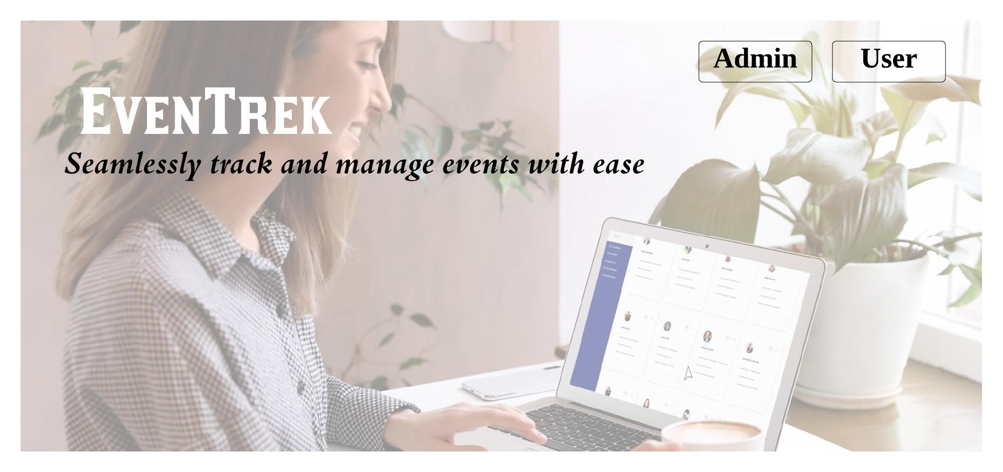

Sign Up

Log In for Administrators

Log In For User

Admin dashboard

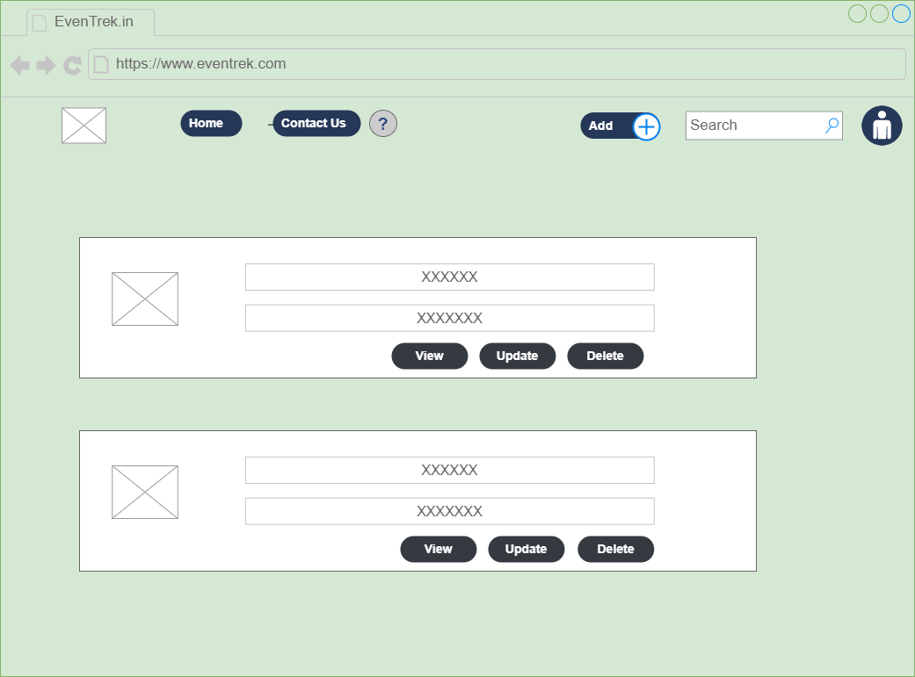

Add task

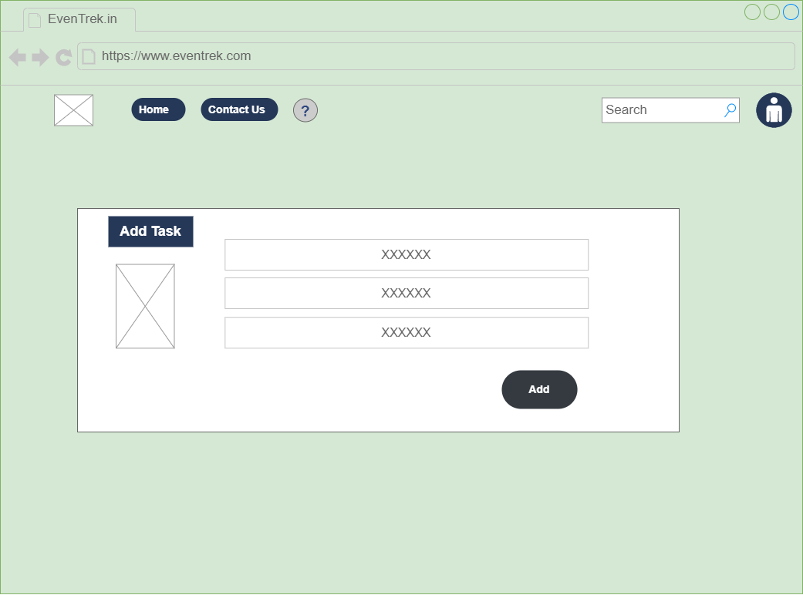

Update task

Delete Task

Add Comment

