Name: ANAGHA K | Roll No:03 | Name of lab: Object Oriented Programming Language | Period:
Class: S2, MCA | Date: | Name of lab work: practical | Batch:2025- 2027
REPORT ON LABORATORY WORK

PROGRAM NO-1
Aim: Define a class “product” with data members Pcode, Pname and Price create 3 objects of the class and find the product having the lowest price.
Algorithm: Product Details and Price Comparison
- Start
- Define a class Product with:
Variables: id, name, price
Method get() to assign values to variables
Method show() to display product details
- In the main method:
- Create first product object p1
Call get(1, "Pen", 4.0)
Call show() to display details
- Create second product object p2
Call get(2, "Book", 32.0)
Call show() to display details
- Create third product object p3
Call get(3, "Scale", 10.0)
Call show() to display details
- Compare prices
- Stop

Input:
class Product
{
int id;
String name;
float price;

void get(int id1, String n, float p)
{
id = id1;
name = n;
price = p;
}

void show()
{
System.out.println("product id is " + id);
System.out.println("Product name is " + name);
System.out.println("Price is " + price);
}

public static void main(String args[])
{
Product p1 = new Product();
p1.get(1, "Pen", 4.0f);
p1.show();

Product p2 = new Product();
p2.get(2, "Book", 32.0f);
p2.show();

Product p3 = new Product();
p3.get(3, "Scale", 10.0f);
p3.show();
if(p1.price>p2.price&&p1.price>p3.price)
{
System.out.println("Price of Product 1 is Lower");
}
else if(p2.price>p1.price&&p2.price>p3.price)
{
System.out.println("Price of Book is Greater");
}
else
{
System.out.println("Price of Scale is Lower");
}
}

}

Output:

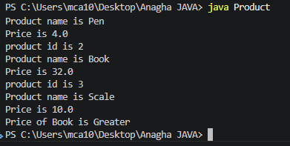

Result/observation: successfully completed the program and output is obtained

Marks:

Viva (5) | Performance (5) | Total (10)

Assessor:

REPORT ON LABORATORY WORK

PROGRAM NO-2
Name: ANAGHA K | Roll No:03 | Name of lab: Object Oriented Programming Language | Period:
Class: S2, MCA | Date: | Name of lab work: practical | Batch:2025- 2027
Aim: To read 2 matrices from the console and perform matrix addition.
Algorithm:
1. Start
2. Input number of rows and columns of first matrix
Read p (rows) and q (columns)
3. Input number of rows and columns of second matrix
Read m (rows) and n (columns)
4. Check condition for addition
If p == m AND q == n, go to next step
Else, display "Matrix addition is not possible" and Stop
5. Declare matrices
a[p][q] for first matrix
b[m][n] for second matrix
c[p][n] for result matrix
6. Input elements of first matrix
For each row i from 0 to p-1
For each column j from 0 to q-1
Read a[i][j]
7. Input elements of second matrix
For each row i from 0 to m-1
For each column j from 0 to n-1
Read b[i][j]
8. Display first matrix
9. Display second matrix
10. Perform matrix addition
For each row i from 0 to p-1
For each column j from 0 to n-1
Compute c[i][j] = a[i][j] + b[i][j]
11. Display resultant matrix
12. Stop
Input:
import java.util.*;
public class matrixadd
{
public static void main(String[] args)
{
Scanner sc = new Scanner(System.in);
System.out.println("Enter the number of rows and columns of 1st matrix:");
int p = sc.nextInt();
int q = sc.nextInt();

System.out.println("Enter the number of rows and columns of 2nd matrix:");
int m = sc.nextInt();
int n = sc.nextInt();

int a[][] = new int[p][q];
int b[][] = new int[m][n];
int c[][] = new int[p][n];

if(p==m && q==n)
{
System.out.println("Enter the elements of 1st matrix:");
for(int i=0;i<p;i++)
{
for(int j=0;j<q;j++)
{
a[i][j] = sc.nextInt();
}
}

System.out.println("Enter the elements of 2nd matrix:");
for(int i=0;i<m;i++)
{
for(int j=0;j<n;j++)
{
b[i][j] = sc.nextInt();
}
}

System.out.println("The First Matrix is:");
for(int i=0;i<p;i++)
{
for(int j=0;j<q;j++)
{
System.out.print(a[i][j] + " ");
}
System.out.println();
}

System.out.println("The Second Matrix is:");
for(int i=0;i<m;i++)
{
for(int j=0;j<n;j++)
{
System.out.print(b[i][j] + " ");
}
System.out.println();
}

for(int i=0;i<p;i++)
{
for(int j=0;j<n;j++)
{
c[i][j]=a[i][j]+b[i][j];
}
}

System.out.println("Resultant matrix is:");
for(int i=0;i<p;i++)
{
for(int j=0;j<n;j++)
{
System.out.print(c[i][j] + " ");
}
System.out.println();
}
}
else
{
System.out.println("Matrix addition is not possible");
}
}
}

Output:

Result/observation: successfully completed the program and output is obtained

Marks:

Viva (5) | Performance (5) | Total (10)

Assessor:

REPORT ON LABORATORY WORK
Name: ANAGHA K | Roll No:03 | Name of lab: Object Oriented Programming Language | Period:
Class: S2, MCA | Date: | Name of lab work: practical | Batch:2025- 2027

PROGRAM NO-3

Aim: To add two complex numbers.
Algorithm: Addition of Two Complex Numbers
- Start
- Define a class Complex with:
Integer variables: real, imaginary
- Create a constructor
Accept real_get and imag_get
Assign values to real and imaginary
- Define a static method sum(c1, c2)
Create a temporary object temp with values (0, 0)
Add real parts:
temp.real = c1.real + c2.real
Add imaginary parts:
temp.imaginary = c1.imaginary + c2.imaginary
Return temp
- In the main method:
Create object first with values (1, 2)
Create object second with values (32, 22)
- Call sum method
Store result in temp = sum(first, second)
- Display result
Print: "Sum is: " + temp.real + "+" + temp.imaginary + "i"
- Stop

Input:
class Complex
{
int real;
int imaginary;

public Complex(int real_get,int imag_get){
this.real = real_get;
this.imaginary =imag_get;
}
public static Complex sum(Complex c1,Complex c2){
Complex temp = new Complex(0,0);
temp.real = c1.real +c2.real;
temp.imaginary = c1.imaginary + c2.imaginary;
return temp;
}
public static void main(String[]args){
Complex first = new Complex(1,2);
Complex second = new Complex(32,22);
Complex temp = sum(first,second);
System.out.println("Sum is:" + temp.real + "+" +temp.imaginary + "i");
}
}

Output:

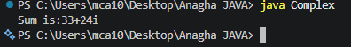

Result/observation: successfully completed the program and output is obtained

Marks:

Viva (5) | Performance (5) | Total (10)

Assessor:
REPORT ON LABORATORY WORK

Name: ANAGHA K | Roll No:03 | Name of lab: Object Oriented Programming Language | Period:
Class: S2, MCA | Date: | Name of lab work: practical | Batch:2025- 2027
PROGRAM NO-4

Aim: To read a matrix from the console and check whether it is symmetric or not.
Algorithm:
- Start.
- Read number of rows p and columns q from the user.
- Declare matrix a[p][q].
- Input elements of the matrix using two nested loops.
- Display the matrix using two nested loops.
- Check whether p == q.
- If p != q, print "Matrix is not symmetric" and stop.
- Set a flag variable isSymmetric = true.
- Use nested loops to compare elements:
If a[i][j] != a[j][i], set isSymmetric = false and exit loop.
- If isSymmetric == true, print "Matrix is symmetric".
- Else print "Matrix is not symmetric".
- Stop.
Input:
import java.util.*;
public class symmetric
{
public static void main(String[] args)
{
Scanner sc = new Scanner(System.in);
System.out.println("Enter the number of rows and columns of matrix:");
int p = sc.nextInt();
int q = sc.nextInt();

int a[][] = new int[p][q];

System.out.println("Enter the elements of matrix:");
for(int i=0;i<p;i++)
{
for(int j=0;j<q;j++)
{
a[i][j] = sc.nextInt();
}
}

System.out.println("The Matrix is:");
for(int i=0;i<p;i++)
{
for(int j=0;j<q;j++)
{
System.out.print(a[i][j] + " ");
}
System.out.println();
}

if(p!=q)
{
System.out.println("The matrix is not symmetric");
}
else
{
boolean isSymmetric = true;
for(int i=0;i<p;i++)
{
for(int j=0;j<q;j++)
{
if(a[i][j] != a[j][i])
{
System.out.println("The matrix is not symmetric");
return;
}
}
}
System.out.println("The matrix is symmetric");
}
}
}

Output:

Result/observation: successfully completed the program and output is obtained

Marks:

Viva (5) | Performance (5) | Total (10)

Assessor:

REPORT ON LABORATORY WORK
Name: ANAGHA K | Roll No:03 | Name of lab: Object Oriented Programming Language | Period:
Class: S2, MCA | Date: | Name of lab work: practical | Batch:2025- 2027

PROGRAM NO-5

Aim: To create CPU with attribute price. Create inner class processor (no of cores, manufactures)and static nested class RAM (memory , manufacturer).Create an object of CPU and print information of processor and RAM.
Algorithm:
1. Start.
2. Define class Cpu with variable price and a constructor to initialize it.
3. Define a non-static inner class Processor with variables cores and manufacture, and a constructor to initialize them.
4. Define a method display() inside Processor to print processor details.
5. Define a static nested class Ram with variables memory and manufacture, and a constructor to initialize them.
6. Define a method display() inside Ram to print RAM details.
7. Define a method display() in Cpu class to print CPU price.
8. In the main method, create an object intel of class Cpu with price 23000.
9. Create an object i_processor of inner class Processor using intel object with values (4, "intel").
10. Create an object i_ram of static class Ram with values (1024, "Asus").
11. Call intel.display() to print CPU price.
12. Call i_processor.display() to print processor details.
13. Call i_ram.display() to print RAM details.
14. Stop.

Input:
class Cpu {
int price;

Cpu(int p) {
this.price = p;
}

class Processor {
int cores;
String manufacture;

Processor(int n, String m) {
this.cores = n;
this.manufacture = m;
}

void display() {
System.out.println("No of Cores : " + this.cores);
System.out.println("Processor manufactures : " + this.manufacture);
}
}

static class Ram {
int memory;
String manufacture;

Ram(int n, String m) {
this.memory = n;
this.manufacture = m;
}

void display() {
System.out.println("Memory Size : " + this.memory);
System.out.println("Memory manufactures : " + this.manufacture);
}
}

void display() {
System.out.println("Price of CPU : " + this.price);
}

public static void main(String[] args) {
Cpu intel = new Cpu(23000);
Cpu.Processor i_processor = intel.new Processor(4, "intel");
Cpu.Ram i_ram = new Ram(1024, "Asus");
intel.display();
i_processor.display();
i_ram.display();
}
}

Output:

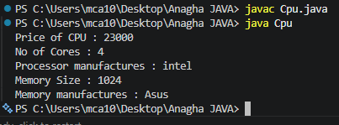

Result/observation: successfully completed the program and output is obtained

Marks:

Viva (5) | Performance (5) | Total (10)

Assessor:

REPORT ON LABORATORY WORK

PROGRAM NO-6

Aim: To write menu driven program that would choose either inbuild method or call a user defined method to sort an array of strings.
Algorithm:
- Add user to enter number of strings to sort, as count.
- Ask user to enter count number of strings and store them into an array of strings.
- Give the user the menu where 1 chooses using inbuild sort method and 2 chooses using user defined sorting function.
- If 1 is chosen use Array.sort()
- If 2 is chosen call the user.defined method to sort where
- Each string is compared with other string
- Swap the string so that lexicographic order of string is obtained

Name: ANAGHA K | Roll No:03 | Name of lab: Object Oriented Programming Language | Period:
Class: S2, MCA | Date: | Name of lab work: practical | Batch:2025- 2027
Input:
import java.util.Arrays;
import java.util.Scanner;
public class StringSort
{
public static void main(String[] args)
{
int count=0;
String tmp;
Scanner scan=new Scanner(System.in);
System.out.println("Enter~number~of~strings~to~sort:");
count=scan.nextInt();
String str_list[]=new String[count];
Scanner scan1=new Scanner(System.in);
System.out.println("Enter~your~strings:");
for(int i=0;i<count;i++)
str_list[i]=scan1.nextLine();
System.out.println("choose~1~or~2~from~the~menu~below");
System.out.println("1:~inbuilt~sort()");
System.out.println("2:~user~defined~sorting~logic()");
int choice;
choice=scan.nextInt();
switch(choice)
{
case 1:Arrays.sort(str_list);
System.out.println(Arrays.toString(str_list));
break;
case 2:for(int i=0;i<count-1;i++)
for(int j=i+1;j<str_list.length;j++)
if(str_list[i].compareTo(str_list[j])>0)
{
tmp=str_list[i];
str_list[i]=str_list[j];
str_list[j]=tmp;
}
System.out.println(Arrays.toString(str_list));
break;
}
}
}

Output:

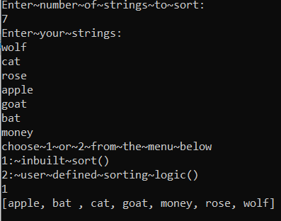

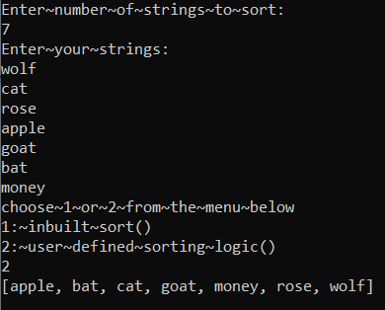

Result/observation: successfully completed the program and output is obtained

Marks:

Viva (5) | Performance (5) | Total (10)

Assessor:

REPORT ON LABORATORY WORK
Name: ANAGHA K | Roll No:03 | Name of lab: Object Oriented Programming Language | Period:
Class: S2, MCA | Date: | Name of lab work: practical | Batch:2025- 2027

PROGRAM NO-7

Aim: To write program for linear search and binary search.
Algorithm:
Linear search
1. Start the program.
2. Declare variables c, n, search and array array[].
3. Create a Scanner object to take input from the user.
4. Read the number of elements n.
5. Declare an array of size n.
6. Input n elements into the array using a loop (c = 0 to n-1).
7. Read the value to be searched (search).
8. Traverse the array using a loop from c = 0 to n-1.
9. For each element, compare array[c] with search.
10. If a match is found:
Print that the element is present at position (c + 1) and exit the loop using break.
11. After the loop, check if c == n.
12. If true, print that the element is not present in the array.
13. Stop the program.
Binary search
- Implement the naive binary search algorithm given in procedure binary search
- Implement binary search recursively
- Use in-built binary search
- Ask user among 1,2 and 3 above which is users’ choice of searching logic

Input:
import java.util.Scanner;
public class LinearSearch
{
public static void main(String[]args)
{
int c,n,search,array[];
Scanner in=new Scanner(System.in);
System.out.println("Enter number of elements");
n=in.nextInt();
array=new int[n];
System.out.println("Enter those "+n+" elements");
for(c=0;c<n;c++)
array[c]=in.nextInt();
System.out.println("Enter value to find");
search=in.nextInt();
for(c=0;c<n;c++)
{
if(array[c]==search)
{
System.out.println(search+" is present at location "+(c+1));
break;
}
} if(c==n)
System.out.println(search+" is not present in array");
}
}

Output:
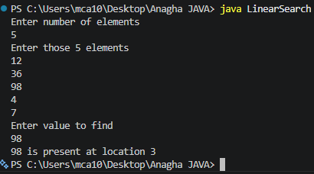

BINARY SEARCH

import java.util.Arrays;
import java.util.Scanner;
public class BinarySearch
{
public static int myBinarySearch(int arr[],int first,int last,int key)
{
int mid=(first + last)/2;
while(first<=last)
{
if(arr[mid]<key)
{
first=mid + 1;
}
else if(arr[mid]==key)
{
System.out.println("Element is found at index:" +mid);
return mid;
}
else
{
last=mid-1;
}
mid=(first + last)/2;
}
return -1;
}
public static int binarysearchRecursion(int arr[],int first,int last,int key)
{
if(last>=first)
{
int mid=first + (last-first)/2;
if(arr[mid]==key)
{
return mid;
}
if(arr[mid]>key)
{
return binarysearchRecursion(arr,first,mid-1,key);
}
else
{
return binarysearchRecursion(arr,mid+1,last,key);
}
}
return -1;
}
public static void main(String[] args)
{
System.out.println("Enter your choice of binary search logic:");
System.out.println("1.Simple binary search");
System.out.println("2.Recursive binary search");
System.out.println("3:Using arrays binarySearch");
Scanner sc=new Scanner(System.in);
int ch=sc.nextInt();
Scanner in=new Scanner(System.in);
System.out.println("Enter number of elements:");
int n=in.nextInt();
int array[]=new int[n];
System.out.println("Enter those " +n+ " elements:");
for(int c=0;c<n;c++)
array[c]=in.nextInt();
System.out.println("Enter value to find:");
int search=in.nextInt();
Arrays.sort(array);
int found=-1;
switch(ch)
{
case 1:found=myBinarySearch(array,0,n,search);
break;
case 2:found=binarysearchRecursion(array,0,n,search);
break;
case 3:found=Arrays.binarySearch(array,search);
break;
}
if(found>=0)
{
System.out.println("Elements is found at " +found);
}
else
{
System.out.println("Elements is not found !");
}
}
}

Output:

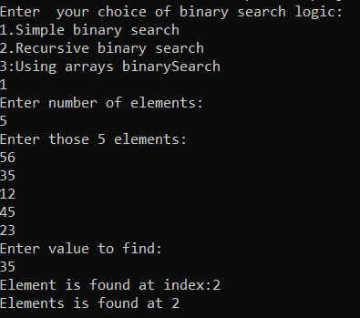

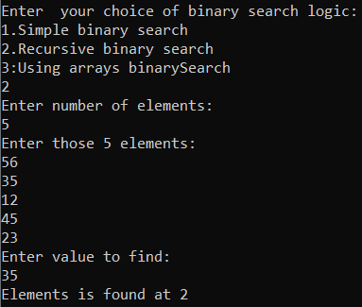

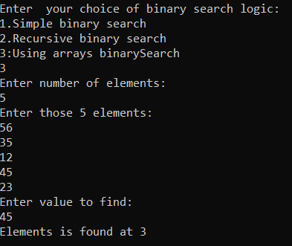

Result/observation: successfully completed the program and output is obtained

Marks:

Viva (5) | Performance (5) | Total (10)

Assessor:

REPORT ON LABORATORY WORK
Name: ANAGHA K | Roll No:03 | Name of lab: Object Oriented Programming Language | Period:
Class: S2, MCA | Date: | Name of lab work: practical | Batch:2025- 2027

PROGRAM NO-8

Aim: To illustrate string manipulation methods.
Algorithm:
1. Start the program.
2. Declare and initialize two strings:
str1 = " String Manipulation "
str2 = "java programming"
3. Find the length of str1 using length() and display it.
4. Concatenate str1 and str2 using + operator, store in str3, and display it.
5.: Concatenate str1 and str2 using concat() method, store in str4, and display it.
6. Declare another string str5 = "Computer lab".
7. Compare str2 and str5 using equals() and display the result.
8. Compare str2 and str5 using compareTo() and display the result.
9. Find the index of character 'M' in str1 using indexOf() and display it.
10. Convert str1 to uppercase using toUpperCase() and display it.
11. Convert str1 to lowercase using toLowerCase() and display it.
12. Replace character 'M' with 'd' in str1 using replace() and display the result.
13. Compare str2 and str5 ignoring case using equalsIgnoreCase() and display the result.
14. Extract a substring from str1 (index 3 to 8) using substring() and display it.
15. Remove leading and trailing spaces from str1 using trim() and display it.
16. Again trim whitespace from str1 and display it.
17. Create a byte array {75, 71, 70} and convert it into a string str7, then display it.
18. Convert str1 into a byte array using getBytes().
19. Display ASCII values of each character using a loop.
20. Stop the program.

Input:
class stringmanipulation
{
public static void main(String[] args)
{
String str1 =" String Manipulation ";
String str2 ="java programming";

int length = str1.length();
System.out.println("Length of str1: " + length);

/*string concatination */
String str3 = str1 + " " + str2;
System.out.println("Concatenated string : " + str3);

String str4 = str1.concat(" ").concat(str2);
System.out.println("Concatenated string using concat(): " + str4);

/* string comparison with equals*/
String str5 = "Computer lab";
boolean isEqual = str2.equals(str5);
System.out.println("str2 equals str5: " + isEqual);

/* string comparison with compareTo */
int result = str2.compareTo(str5);
System.out.println("str2 compared to str5: " + result);

/*Index of a character in a string */
int index = str1.indexOf('M');
System.out.println("Index of 'M' in str1: " + index);

/* Upper case and lower case */
String upperCase = str1.toUpperCase();
String lowerCase = str1.toLowerCase();
System.out.println("Upper case of str1: " + upperCase);
System.out.println("Lower case of str1: " + lowerCase);

/* Replace a character in a string */
String replaced = str1.replace('M', 'd');
System.out.println("String after replacing 'M' with 'd': " + replaced);

/*Compare to ignore case */
boolean isEqualIgnoreCase = str2.equalsIgnoreCase(str5);
System.out.println("str2 equals str5 (ignoring case): " + isEqualIgnoreCase);

/*sub string */
String subString = str1.substring(3, 8);
System.out.println("Substring of str1: " + subString);

/*Trim */
String trimmed = str1.trim();
System.out.println("Trimmed string: " + trimmed);

/*trim whitespace */
String trimmedWhitespace = str1.trim();
System.out.println("Trimmed string (whitespace): " + trimmedWhitespace);

/*byte ascii value */
byte [] ascii= {75,71,70};
String str7 = new String(ascii);
System.out.println("string from ascii values: " + str7);

byte[] array = str1.getBytes();
System.out.println("ASCII values of characters in str1:");
for (byte b : array)
{
System.out.print(b + " ");
}
}
}

Output:

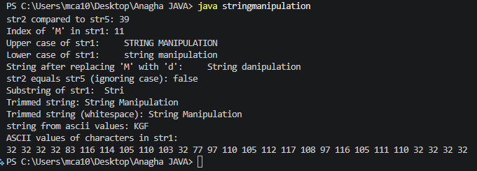

Result/observation: successfully completed the program and output is obtained

Marks:

Viva (5) | Performance (5) | Total (10)

Assessor:

REPORT ON LABORATORY WORK
Name: ANAGHA K | Roll No:03 | Name of lab: Object Oriented Programming Language | Period:
Class: S2, MCA | Date: | Name of lab work: practical | Batch:2025- 2027

PROGRAM NO-9

Aim: Program to create a class for employee having attributes eNo, eName, and eSalary. Read n employee information and search for an employee given eNo using the concept of array of objects.
Algorithm:
1. Start.
2. Define a class Employee with variables id, name, and salary.
3. Define method get() to:
- Create a Scanner object
- Read id, name, and salary from the user
4. Define method display() to print id, name, and salary.
5. In the main method, create object e of class Employee.
6. Call e.get() to input details.
7. Call e.display() to show details.
8. Create another object e1.
9. Call e1.get() and e1.display().
10. Create another object e2.
11. Call e2.get() and e2.display().
12. Stop.

Input:
import java.util.*;
class Employee
{
int id;
String name;
float salary;
public void get()
{
Scanner sc=new Scanner(System.in);
System.out.print("Enter ID: ");
id = sc.nextInt();
System.out.print("Enter Name: ");
name = sc.next();
System.out.print("Enter Monthly Salary:");
salary = sc.nextFloat();
}
public void display()
{
System.out.println("id:"+id);
System.out.println("name:"+name);
System.out.println("salary:"+salary);

}
public static void main(String[]args)
{
Employee e=new Employee();
e.get();
e.display();

Employee e1=new Employee();
e1.get();
e1.display();

Employee e2=new Employee();
e2.get();
e2.display();
}
}

Output:
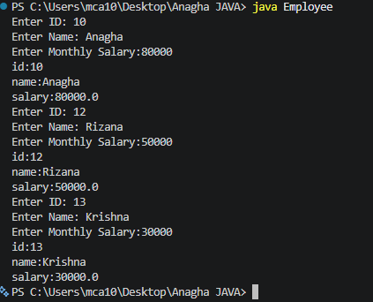

Result/observation: successfully completed the program and output is obtained

Marks:

Viva (5) | Performance (5) | Total (10)

Assessor:

REPORT ON LABORATORY WORK
Name: ANAGHA K | Roll No:03 | Name of lab: Object Oriented Programming Language | Period:
Class: S2, MCA | Date: | Name of lab work: practical | Batch:2025- 2027

PROGRAM NO-10

Aim: To find the area of different shape using overloaded function.

Algorithm:

1. Start.
2. Define a class shape.
3. Define method calculateArea(float side) to calculate and display area of a square
4. Define method calculateArea(int length, int breadth) to calculate and display area of a
5. Define method calculateArea(double radius) to calculate and display area of a circle
6. In the main method, create an object s of class shape.
7. Create a Scanner object to take input from the user.
8. Read the side of the square.
9. Call s.calculateArea(side) to compute and display square area.
10. Read length and breadth of the rectangle.
11. Call s.calculateArea(length, breadth) to compute and display rectangle area.
12. Read the radius of the circle.
13. Call s.calculateArea(radius) to compute and display circle area.
14. Stop.

Input:

import java.util.Scanner;
class shape
{
void calculateArea(float side)
{
System.out.println("Area of Square:" + (side*side));
}
void calculateArea(int length, int breadth)
{
System.out.println("Area of Rectangle:" + (length*breadth));
}
void calculateArea(double radius)
{
double area = 3.14 * radius *radius;
System.out.println("Area of Circle:" + area);
}
public static void main(String arg[])
{
shape s = new shape();
Scanner sc = new Scanner(System.in);

System.out.println("Enter the Side of Square:");
float side = sc.nextFloat();
s.calculateArea(side);

System.out.println("Enter the Length and Breadth of Rectangle:");
int length = sc.nextInt();
int breadth = sc.nextInt();
s.calculateArea(length,breadth);

System.out.println("Enter the Raius of the Circle:");
double radius = sc.nextDouble();
s.calculateArea(radius);
}
}

Output:

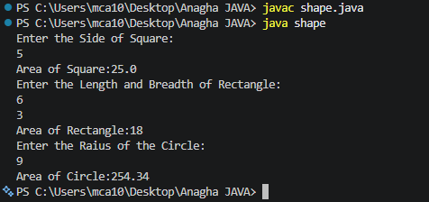

Result/observation: successfully completed the program and output is obtained

Marks:

Viva (5) | Performance (5) | Total (10)

Assessor:

REPORT ON LABORATORY WORK
Name: ANAGHA K | Roll No:03 | Name of lab: Object Oriented Programming Language | Period:
Class: S2, MCA | Date: | Name of lab work: practical | Batch:2025- 2027

PROGRAM NO-11

Aim: Create a class ‘Employee’ with data members Empid, Name, Salary, Address and constructors to initialize the data members, create another class ‘Teacher’ that inherit the properties of class employee and contain its own data members department, subject taught and constructors to initialize these data members and also include display function to display all the data members. Use array of object to display details of N teachers.

Algorithm:

1. Start the program.
2. Define a class emparray with variables id, name, and salary.
3. Define method get() to:
- Create a Scanner object
- Read id, name, and salary from the user
4. Define method display() to print employee details.
5. In the main method, declare variables i, n = 3, and No.
6. Create an array emp[] of size n to store employee objects.
7. Use a loop from i = 0 to n-1:
- Create a new emparray object
- Call get() to input employee details
8. Display "Search".
9. Start an infinite loop using while(true).
10. Inside the loop:
- Create a Scanner object
- Read employee ID No to search
11. Traverse the array using a loop from i = 0 to n-1.
12. Compare emp[i].id with No.
13. If match is found:
- Call display() to show employee details
- Exit the loop using break
14. Repeat the search process continuously.
15. Stop the program (manually, since loop is infinite).

Input:

import java.util.*;
class emparray
{
int id;
String name;
float salary;
public void get()
{
Scanner sc=new Scanner(System.in);
System.out.print("Enter ID: ");
id = sc.nextInt();
System.out.print("Enter Name: ");
name = sc.next();
System.out.print("Enter Monthly Salary:");
salary = sc.nextFloat();
}
public void display()
{
System.out.println("id:"+id);
System.out.println("name:"+name);
System.out.println("salary:"+salary);

}
public static void main(String[]args)
{
int i,n = 3;
int No;
emparray emp[]=new emparray[n];
for(i=0;i<n;i++){
emp[i]=new emparray();
emp[i].get();
}
System.out.println("Search");
while(true)
{
Scanner sc=new Scanner(System.in);
System.out.print("Enter ID:");
No = Integer.parseInt(sc.nextLine());
for(i=0;i<n;i++)
{
if(emp[i].id==No)
{
emp[i].display();
break;
}
}
}
}
}

Output:

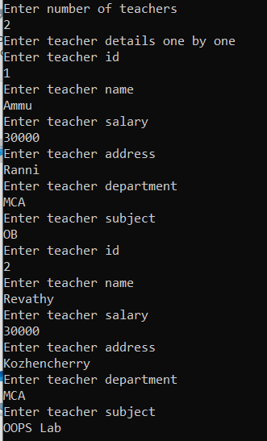

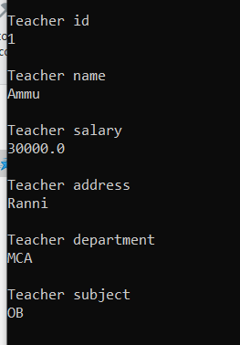

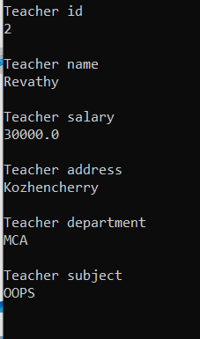

Result/observation: successfully completed the program and output is obtained

Marks:

Viva (5) | Performance (5) | Total (10)

Assessor:
REPORT ON LABORATORY WORK
Name: ANAGHA K | Roll No:03 | Name of lab: Object Oriented Programming Language | Period:
Class: S2, MCA | Date: | Name of lab work: practical | Batch:2025- 2027

PROGRAM NO-12
Aim: Create a class ‘person’ with data members Name, Gender, Age, Address and constructors to initialize the data members, create another class ‘Employee’ that inherit the properties of class person and contain its own data members like Empid, Company name, Qualification, Salary, and its own constructor. Create another class ’Teacher’
that inherits the properties of class Employee and contain its own data members like subject, department, Teacher id and also contain constructor and methods to display the data members. Use array of objects to display details of N teachers.

Algorithm:

- Start
- Created class person with its members and a constructor
- Created another class Employee by inheriting person and define its members and its own constructor
- Created another class Teacher by inheriting Employee and define its method display()
- Display details of N teachers using array of objects
- Stop

Inputs:

import java.util.Scanner;
class Person
{
String Name, Gender,Address;
protected int Age;
public Person()
{

}
public Person (String n , String g, String addr, int a)
{
this.Name=n;
this.Gender=g;
this.Address =addr;
this.Age=a;
}
public void displayPerson()
{
System.out.println("Name:___"+Name);
System.out.println("Gender:___"+ Gender);
System.out.println("Address:___" + Address);
System.out.println("Age:____"+Age);
}
}
class Employee extends Person
{
int Empid,Salary;
String Company_name,Qualification;
public Employee()
{

}
public Employee (String n,String g , String addr, int a,int eid,String cname,String qual, int sal)
{
super(n,g,addr,a);
Empid=eid;
Company_name=cname;
Qualification=qual;
Salary=sal;
}
public void displayEmployee()
{
super.displayPerson ();
System.out.println("Empid:___"+Empid);
System.out.println("Company name:___" +Company_name);
System.out.println("Qualification :___"+Qualification);
System.out.println("Salary:___"+ Salary);
}
}
class Teacher1 extends Employee
{
String Subject,Department;
int Teacherid;
public Teacher1(String n, String g, String addr, int a,int eid, String cname, String qual, int sal ,String sub, String dept,int tid)
{
super(n,g,addr,a, eid, cname, qual, sal );
Subject=sub;
Department=dept;
Teacherid=tid;
}
public void displayTeacher()
{
super.displayEmployee();
System.out.println ("Teacher_id____"+Teacherid);
System.out.println("Subject :____"+ Subject);
System.out.println ("Department:____"+ Department);
}
}
public class InheritencePersonExample
{
public static void main(String args[])
{
System.out.println("Enter number of teachers" );
Scanner sc = new Scanner (System.in);
int N= sc.nextInt ();
Teacher1[] teacherls = new Teacher1[N];
Scanner scs = new Scanner(System.in);
for (int i = 0; i<N;i++)
{
System.out.println("Enter_name_of_the_teacher.");
String name=scs.next();
System.out.println("Enter_gender of the teacher.");
String gen=scs.next();
System.out.println("Enter address of the teacher.");
String addr = scs.next();
System.out.println("Enter age of the teacher.");
int ag = sc.nextInt ();
System.out.println("Enter Empid_of_the_teacher.");
int eid=sc.nextInt ();
System.out.println("Enter Company name.");
String cn=scs.next();
System.out.println("Enter qualification of the teacher.");
String quali = scs. next();
System.out.println("Enter_salary of the teacher.");
int sal=sc. nextInt ();
System.out.println("Enter Teacher_id");
int tid=sc.nextInt ();
System.out.println("Enter Subject of the teacher.");
String sub=scs.next();
System.out.println("Enter Department of the teacher.");
String dept = scs.next();
Teacher1 t= new Teacher1 (name, gen, addr, ag, eid, cn, quali,sal,sub, dept, tid);
teacherls[i] = t;
}
for (Teacher1 t:teacherls)
{
t. displayTeacher();
}
}
}

Output:

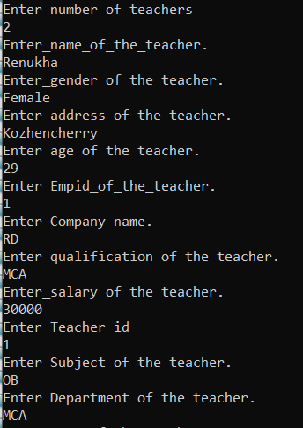
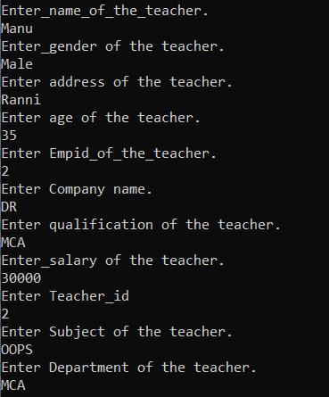
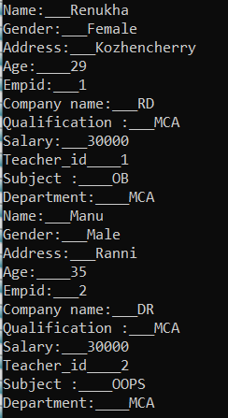

Result/observation: successfully completed the program and output is obtained

Marks:

Viva (5) | Performance (5) | Total (10)

Assessor:

REPORT ON LABORATORY WORK
Name: ANAGHA K | Roll No:03 | Name of lab: Object Oriented Programming Language | Period:
Class: S2, MCA | Date: | Name of lab work: practical | Batch:2025- 2027

PROGRAM NO-13

Aim: Write a program has class publisher, Book, Literature and Fiction. Read the information and print the details of books from either the category using inheritance.

Algorithm: Inheritance Book Example

- Start
- Create Publisher class
  - Define a variable publisher
  - Create a constructor to initialize publisher name
- Create Book class
  - Define variables: name and publisher
  - Create a constructor to initialize these values
- Create Literature class (inherits Book)
  - Define type as "Literature"
  - Use super() to call Book constructor
  - Create display() method to print:
    - Book name
    - Type
    - Publisher name
- Create Fiction class (inherits Book)
  - Define type as "Fiction"
  - Use super() to call Book constructor
  - Create display() method to print:
    - Book name
    - Type
    - Publisher name
- In main method
  - Create Publisher object for Literature
  - Create Literature object with name and publisher
  - Call display() method
- Repeat
  - Create Publisher object for Fiction
  - Create Fiction object with name and publisher
  - Call display() method
- End

Input:
class Publisher
{
String publisher;
Publisher(String publi){
this.publisher = publi;
}
}
class Book {
String name;
Publisher publisher;

Book(){}
public Book(String name, Publisher publisher){
this.name = name;
this.publisher = publisher;
}
}
class Literature extends Book{
String Lit_type = "Literature";
Literature(String name, Publisher publisher){
super(name,publisher);
}
void display(){
System.out.println("Name:"+super.name);
System.out.println("Type:"+this.Lit_type);
System.out.println("Publisher:"+ this.publisher.publisher);
}
}
class Fiction extends Book{
String Lit_type = "Fiction";
Fiction(String name, Publisher publisher){
super(name,publisher);
}
void display(){
System.out.println("Name:"+super.name);
System.out.println("Type:"+this.Lit_type);
System.out.println("Publisher:"+ this.publisher.publisher);
}
}
public class InheritanceBookExample {
public static void main(String[] args){
Publisher lp = new Publisher("S.Chand");
Literature l = new Literature("As You Like it",lp);
l.display();
Publisher fp = new Publisher("Tata MeGraw Hill");
Fiction f = new Fiction("Tempest",fp);
f.display();
}
}
Output:

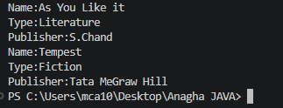

Result/observation: successfully completed the program and output is obtained

Marks:

Viva (5) | Performance (5) | Total (10)

Assessor:

REPORT ON LABORATORY WORK
Name: ANAGHA K | Roll No:03 | Name of lab: Object Oriented Programming Language | Period:
Class: S2, MCA | Date: | Name of lab work: practical | Batch:2025- 2027

PROGRAM NO-14

Aim: Create classes Student and sports. Create another class Result inherited from student and Sports. Display the academic and sports score of a student.

Algorithm:
- Start
- Create interface student
  - Declare variable score = 10
  - Declare method displayscore()
- Create interface sports
  - Declare variable score = 25
  - Declare method displaysports()
- Create class result
  - Implement both interfaces student and sports
- Define method displayscore()
  - Print academic score using student.score
- Define method displaysports()
  - Print sports score using sports.score
- Create main class Sportsresult
- Inside main method
  - Create object r of class result
  - Call r.displayscore()
  - Call r.displaysports()
- Display output
  - Academic score = 10
  - Sports score = 25
- End

Input:

interface student
{
int score=10;
void displayscore();
}
interface sports
{
int score=25;
void displaysports();
}
class result implements student,sports
{
public void displayscore()
{
System.out.println("Academic score is "+student.score);
}
public void displaysports()
{
System.out.println("sports score is "+sports.score);
}
}
public class Sportsresult
{
public static void main(String[] args)
{
result r=new result();
r.displayscore();
r.displaysports();
}
}

Output:

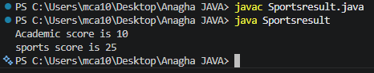

Result/observation: successfully completed the program and output is obtained

Marks:

Viva (5) | Performance (5) | Total (10)

Assessor:

REPORT ON LABORATORY WORK
Name: ANAGHA K | Roll No:03 | Name of lab: Object Oriented Programming Language | Period:
Class: S2, MCA | Date: | Name of lab work: practical | Batch:2025- 2027

PROGRAM NO-15

Aim: To create a graphics package that has classes and interfaces for figures Triangle, Square, and Circle and test the package by finding the area of these figures.

Algorithm:

1. Create a folder called org in our path.
2. Open the folder, create another folder called shapes.
3. Write three programs called Circle, Square, and triangle. the first line of the program will be org. shapes;
4. Go to our own path and write another program which invokes the package.
5. Now execute it.

Input:

package org.shape;
public class Square
{
private int side;
public Square(int s)
{
side=s;
}
public int area( )
{
return(side*side);
}
}

package org.shape;
public class Triangle
{
private int side1,side2,side3;
public Triangle(int s1,int s2, int s3)
{
side1=s1;
side2=s2;
side3=s3;
}
public double area( )
{
double s=( side1+side2+side3)/2;
double a=Math.sqrt((s-side1 )+( s-side2)+( s-side3));
return a;
}
}

package org.shape;
public class Circle
{
private int radius;
public Circle(int r)
{
radius=r;
}
public double area( )
{
return(3.14*radius*radius);
}
}

import org.shape.*;
import java.util .*;
class TestPackage
{
public static void main(String[ ] args)
{
Scanner sc=new Scanner(System.in);
System.out.println("Enter the side of the Square : ");
int s=sc.nextInt();
Square sq=new Square(s);
System.out.println("Area of Square is "+ sq . area( ));
System.out.println( " Enter the radius of the Circle : " );
int r=sc.nextInt();
Circle ci=new Circle(s);
System.out.println( "Area of Circle is "+ ci . area());
System.out.println( "Enter the Side1 of the Triangle :");
int s1=sc.nextInt();
System.out.println( "Enter the Side2 of the Triangle: ");
int s2=sc.nextInt();
System.out.println("Enter the Side3 of the Triangle : ");
int s3=sc.nextInt();
Triangle t=new Triangle(s1,s2,s3);
System.out.println("Area of T riangle is "+ t .area( ));
}
}

Output:

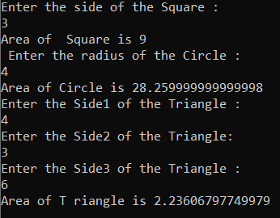

Result/observation: successfully completed the program and output is obtained

Marks:

Viva (5) | Performance (5) | Total (10)

Assessor:

REPORT ON LABORATORY WORK
Name: ANAGHA K | Roll No:03 | Name of lab: Object Oriented Programming Language | Period:
Class: S2, MCA | Date: | Name of lab work: practical | Batch:2025- 2027

PROGRAM NO-16
Aim: To create an arithmetic package that has classes and interfaces for the 4 basic arithmetic operations and test the packages by implementing all operations on two given numbers.

Algorithm:

1. create a folder called org in our path.
2. open the folder, create another folder called calc.
3. write three programs called Add, Sub, Multiply and Divide. the first line of the program will be package org. calc;
4. go to our own path and write another program which invokes the package.
5. Now execute it.

Input:

package org.calc;
public class Add
{
private int x,y;
public Add(int a,int b)
{
x=a;
y=b;
}
public int add()
{
return(x+y);
}
}

package org.calc;
public class Divide
{
private int x,y;
public Divide (int a,int b)
{
x=a;
y=b;
}
public int div()
{
return(x/y);
}
}

package org.calc;
public class Multiply
{
private int x,y;
public Multiply(int a,int b)
{
x=a;
y=b;
}
public int mul()
{
return(x*y);
}
}

package org.calc;
public class Sub
{
private int x,y;
public Sub(int a,int b)
{
x=a;
y=b;
}
public int sub()
{
return(x-y);
}
}

import org.calc.*;
import java.util.*;
public class Test
{
public static void main(String[] args)
{
Scanner sc=new Scanner(System.in);

System.out.println("Enter the number,a:");
int a=sc.nextInt();

System.out.println("Enter the number,b:");
int b=sc.nextInt();

Add add=new Add(a,b);
System.out.println("Addition:a+b="+add.add());

Sub s=new Sub(a,b);
System.out.println("Substraction:a-b="+s.sub());

Multiply m=new Multiply(a,b);
System.out.println("Multiply:a*b="+m.mul());

Divide d=new Divide(a,b);
System.out.println("Division:a/b="+d.div());
}
}

Output:

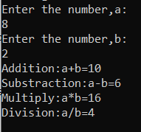

Result/observation: successfully completed the program and output is obtained

Marks:

Viva (5) | Performance (5) | Total (10)

Assessor:

REPORT ON LABORATORY WORK
Name: ANAGHA K | Roll No:03 | Name of lab: Object Oriented Programming Language | Period:
Class: S2, MCA | Date: | Name of lab work: practical | Batch:2025- 2027

PROGRAM NO-17

Aim: Write a user defined exception class to authenticate the user name and password.

Algorithm: Check Login Credential
- Start
- Create custom exception classes
  - Define UsernameException (for invalid username)
  - Define PasswordException (for incorrect password)
- Begin main method
- Create Scanner object to read input
- Read user input
  - Input username
  - Input password
- Find username length
  - Store length using username.length()
- Use try block
  - Check if username length < 6
→ Throw UsernameException
  - Else check if password is not equal to "hello"
→ Throw PasswordException
  - Else
→ Print "Login Successful"
- Catch block
  - Catch UsernameException and display error
  - Catch PasswordException and display error
- Finally block
  - Print: "The finally statement is executed"
- End

Input:

import java.util.Scanner;
class UsernameException extends Exception
{
public UsernameException(String msg)
{
super(msg);
}
}
class PasswordException extends Exception
{
public PasswordException(String msg)
{
super(msg);
}
}
public class CheckLoginCredential
{
public static void main(String[]args)
{
Scanner s=new Scanner(System.in);
String username,password;
System.out.print("enter username: :");
username=s.nextLine();
System.out.print("enter passworde: :");
password=s.nextLine();
int length =username.length();
try
{
if(length<6)
throw new UsernameException("Username must be greater than 6 characters???");
else if(!password.equals("hello"))
throw new PasswordException("Incorrect password\n Type correct password???");
else
System.out.println("Login Successfull!!!");
}
catch(UsernameException u)
{
u.printStackTrace();
}
catch(PasswordException p)
{
p.printStackTrace();
}
finally
{
System.out.println("The finally statement is executed");
}
}
}

Output:

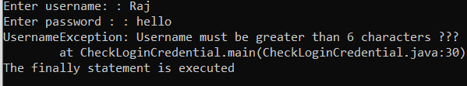

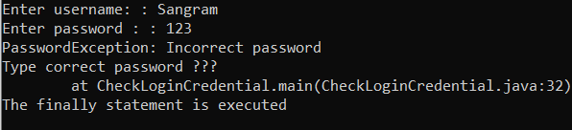

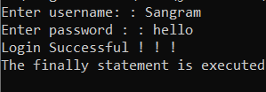

Result/observation: successfully completed the program and output is obtained

Marks:

Viva (5) | Performance (5) | Total (10)

Assessor:

REPORT ON LABORATORY WORK
Name: ANAGHA K | Roll No:03 | Name of lab: Object Oriented Programming Language | Period:
Class: S2, MCA | Date: | Name of lab work: practical | Batch:2025- 2027

PROGRAM NO-19

Aim: To define 2 classes; one for generating multiplication table of 5 and other for displaying first N prime numbers. Implement using threads.

Algorithm: Thread Class Example
- Start
- Create class Multiple5 (extends Thread)
  - Override run() method
  - Initialize num = 5
  - Use loop from i = 1 to 10
  - Print multiplication table of 5
- Create class primeN (extends Thread)
  - Override run() method
  - Initialize variables:
    - n = 0 (count of prime numbers)
    - i = 1 (current number)
  - Repeat until 5 prime numbers are found:
    - Set count = 0
    - Check divisibility of i
    - If number has exactly 2 factors → it is prime
    - Print the prime number
    - Increment prime count n
    - Increment i
- Create main class ThreadClassExp
- Inside main method
  - Create object m5 of Multiple5
  - Create object pn of primeN
- Start threads
  - Call pn.start() → prints prime numbers
  - Call m5.start() → prints table of 5
- Threads run simultaneously (multithreading)
- Display output
  - First 5 prime numbers
  - Table of 5
- End
Input:

class Multiple5 extends Thread
{
public void run()
{
int num=5;
for(int i=1;i<=10;++i)
System.out.printf("Thread1-Table5:%d*%d=%d\n",num,i,num*i);
}
}
class primeN extends Thread
{
public void run()
{
int ct=0,n=0,i=1,j=1;
while(n<5)
{
j=1;ct=0;
while(j<=i)
{
if(i%j==0)
ct++;j++;
}
if(ct==2)
{
System.out.printf("Thread2-Prime Number:%d\n",i);
n++;
}
i++;
}
}
}
public class ThreadClassExp
{
public static void main(String[]args)
{
Multiple5 m5 = new Multiple5();
primeN pn = new primeN();
pn.start();
m5.start();

}
}

Output:

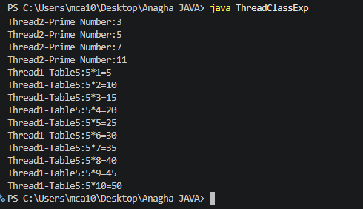

Result/observation: successfully completed the program and output is obtained

Marks:

Viva (5) | Performance (5) | Total (10)

Assessor:

REPORT ON LABORATORY WORK

PROGRAM NO-20

Name: ANAGHA K | Roll No:03 | Name of lab: Object Oriented Programming Language | Period:
Class: S2, MCA | Date: | Name of lab work: practical | Batch:2025- 2027
Aim: To define 2 classes; one for generating Fibonacci numbers and other for displaying even numbers in a given range. Implement using thread.

Algorithm: Fibonacci and Even Numbers using Threads
- Start
- Create class FibThread (implements Runnable)
  - Override run() method
  - Initialize a = 0, b = 1
  - Print first two Fibonacci numbers
  - Use loop (7 times):
    - Calculate c = a + b
    - Print c
    - Update values:
      - a = b
      - b = c
- Create class EvenRangeThread (implements Runnable)
  - Override run() method
  - Initialize a = 2, b = 10
  - Loop from 2 to 10 with step 2
  - Print even numbers
- Create main class FibEven
- Inside main method
  - Create object ft of FibThread
  - Create object e1 of EvenRangeThread
- Create Thread objects
  - t1 = new Thread(ft)
  - t2 = new Thread(e1)
- Start threads
  - Call t1.start() → prints Fibonacci series
  - Call t2.start() → prints even numbers
- Threads execute simultaneously (multithreading)
- Display output
  - Fibonacci numbers
  - Even numbers from 2 to 10
- End

Input:

class FibThread implements Runnable
{
public void run()
{
int a=0,b=1,c;
System.out.printf("FibThread-"+a);
System.out.printf("FibThread-"+b);
for(int h=1;h<=7;++h)
{
c=a+b;
System.out.println("FibThread-"+c);
a=b;
b=c;
}
}
}
class EvenRangeThread implements Runnable
{
public void run()
{
int a=2, b=10;
for(int k=a;k<=b;k+=2)
{
System.out.println("EvenRangeThread-"+k);
}
}
}
public class FibEven
{
public static void main(String[] args)
{
FibThread ft=new FibThread();
EvenRangeThread e1=new EvenRangeThread();
Thread t1=new Thread(ft);
Thread t2=new Thread(e1);
t1.start();
t2.start();
}
}

Output:

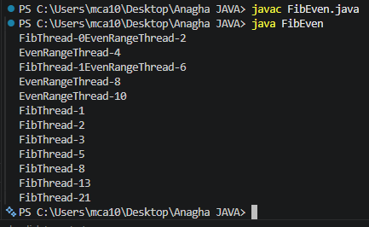

Result/observation: successfully completed the program and output is obtained

Marks:

Viva (5) | Performance (5) | Total (10)

Assessor:

REPORT ON LABORATORY WORK
Name: ANAGHA K | Roll No:03 | Name of lab: Object Oriented Programming Language | Period:
Class: S2, MCA | Date: | Name of lab work: practical | Batch:2025- 2027

PROGRAM NO-24

Aim: To maintain a list of strings using Array list from collection framework, and perform built-in operations.

Algorithm:

- Start
- Create an ArrayList
- Add initial elements
- Display first element
- Display all elements
- Sort the ArrayList
- Add more elements
- Display updated list
- Sort in reverse order
- Find maximum element
- Traverse the ArrayList
- Modify element
- Remove element
- Find size
- End

Input:

import java.util.*;
public class arraylist
{
public static void main(String[] args)
{
ArrayList<String> arrayList=new ArrayList<>();
arrayList.add("vibgiyor");
arrayList.add("indigo");
arrayList.add("violte");
arrayList.add("green");
System.out.println("First Element is "+arrayList.get(0));
System.out.println("The Elements of the arraylist is - "+arrayList);
Collections.sort(arrayList);
System.out.println("\nThe Array list sorted : "+arrayList);
Collections.addAll(arrayList,"red","blue","orange","yellow");
System.out.println("\nAdding new items in the arraylist:"+arrayList);
Collections.sort(arrayList,Collections.reverseOrder());
System.out.println("\nThe reverse order of the arrayList "+arrayList);
System.out.println("\nThe maximum element of the arraylist : "+Collections.max(arrayList));
for(String word:arrayList)
{
System.out.println(word);
}

arrayList.set(3,"pink");
System.out.println("The Elements of the arraylist is - "+arrayList);

arrayList.remove(5);
System.out.println("The Elements of the arraylist is - "+arrayList);

arrayList.size();
System.out.println("The size of the arraylist is - "+arrayList.size());
}
}

Output:

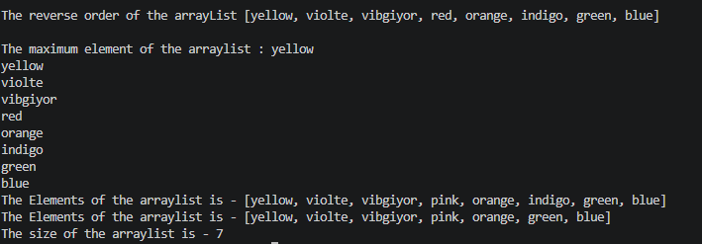

Result/observation: successfully completed the program and output is obtained

Marks:

Viva (5) | Performance (5) | Total (10)

Assessor:

REPORT ON LABORATORY WORK
Name: ANAGHA K | Roll No:03 | Name of lab: Object Oriented Programming Language | Period:
Class: S2, MCA | Date: | Name of lab work: practical | Batch:2025- 2027

PROGRAM NO-25

Aim: Program to remove all the elements from a linked list.

Algorithm:

1. Insert values into a LinkedList using add()
2. display original linked list.
3. call clear() on the linkedlist
4. Repeat step 1 and 2

Input:

import java.io.*;
import java.util.LinkedList;
public class RemoveElementsLinkedList
{
public static void main(String args[])
{
LinkedList<String>list=new LinkedList<String>();
list.add("Good");
list.add("Morning");
list.add("have");
list.add("a");
list.add("Great day");
list.add("2");
list.add("day");
System.out.println("Original LinkedList: " +list);
list.clear();
System.out.println("List after cleaning all elements:" +list);
list.add("looks");
list.add("good");
System.out.println("After adding elements to empty list:" +list);
}
}

Output:

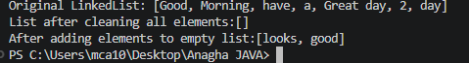

Result/observation: successfully completed the program and output is obtained

Marks:

Viva (5) | Performance (5) | Total (10)

Assessor:

REPORT ON LABORATORY WORK
Name: ANAGHA K | Roll No:03 | Name of lab: Object Oriented Programming Language | Period:
Class: S2, MCA | Date: | Name of lab work: practical | Batch:2025- 2027

PROGRAM NO-32

Aim: Program to implement a simple calculator using AWT components.

Algorithm: AWT Calculator
- Start
- Create Frame, Labels, TextFields, and Buttons
- Set positions and add components to Frame
- Add ActionListener to all buttons
- Display the Frame
- On button click:
  - Read two numbers from text fields
  - If ADD → add numbers
  - If SUB → subtract
  - If MUL → multiply
  - If DIV → divide
  - If CANCEL → exit program
- Display result in result field
- End

Input:

import java.awt.*;
import java.awt.event.*;
class Calculator extends Frame implements ActionListener
{
Frame f1=new Frame();
Label l1=new Label("Enter 1st no:");
Label l2=new Label("Enter 2nd no:");
Label l3=new Label("Result:");
Label l4=new Label("CALCULATOR");

TextField t1=new TextField();
TextField t2=new TextField();
TextField t3=new TextField();

Button b1=new Button("ADD");
Button b2=new Button("SUB");
Button b3=new Button("MUL");
Button b4=new Button("DIV");
Button b5=new Button("CANCEL");

Calculator()
{
l1.setBounds(50,100,100,20);
l2.setBounds(50,140,100,20);
l3.setBounds(50,180,100,20);
l4.setBounds(150,60,100,20);

t1.setBounds(200,100,100,20);
t2.setBounds(200,140,100,20);
t3.setBounds(200,180,100,20);

b1.setBounds(50,250,50,20);
b2.setBounds(110,250,50,20);
b3.setBounds(170,250,50,20);
b4.setBounds(230,250,50,20);
b5.setBounds(290,250,50,20);

f1.add(l1);
f1.add(l2);
f1.add(l3);
f1.add(l4);

f1.add(t1);
f1.add(t2);
f1.add(t3);

f1.add(b1);
f1.add(b2);
f1.add(b3);
f1.add(b4);
f1.add(b5);

b1.addActionListener(this);
b2.addActionListener(this);
b3.addActionListener(this);
b4.addActionListener(this);
b5.addActionListener(this);

f1.setLayout(null);
f1.setVisible(true);
f1.setSize(500,500);

l1.setForeground(Color.black);

f1.setBackground(Color.pink);
}

public void actionPerformed(ActionEvent e)
{
int n1=Integer.parseInt(t1.getText());
int n2=Integer.parseInt(t2.getText());

if(e.getSource()==b1)
{
t3.setText(String.valueOf(n1+n2));
}

if(e.getSource()==b2)
{
t3.setText(String.valueOf(n1-n2));
}

if(e.getSource()==b3)
{
t3.setText(String.valueOf(n1*n2));
}

if(e.getSource()==b4)
{
t3.setText(String.valueOf(n1/n2));
}

if(e.getSource()==b5)
{
System.exit(0);
}
}
public static void main(String args[])
{
new Calculator();
}
}

Output:

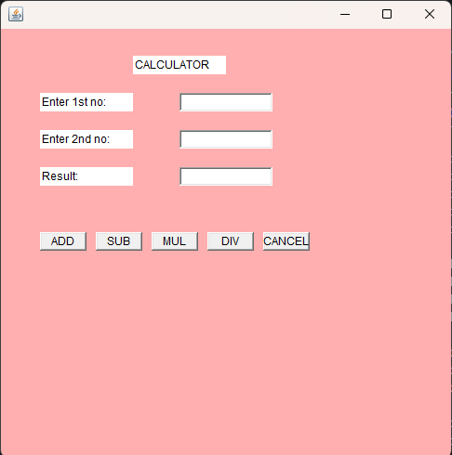

Result/observation: successfully completed the program and output is obtained

Marks:

Viva (5) | Performance (5) | Total (10)

Assessor:

REPORT ON LABORATORY WORK

Name: ANAGHA K | Roll No:03 | Name of lab: Object Oriented Programming Language | Period:
Class: S2, MCA | Date: | Name of lab work: practical | Batch:2025- 2027
PROGRAM NO-33

Aim: Program to find maximum of three numbers using AWT.

Algorithm:
1.Start
2. Create Frame, Labels, TextFields, and Buttons
3. Set layout, positions, and add components to Frame
4.Add ActionListener to buttons
5. On Find Max button click:
- Read three numbers
- Compare numbers
- Find maximum
- Display result
6. On Cancel button click:
- Exit program
- End

Input:

import java.awt.*;
import java.awt.event.*;
class findmax extends Frame implements ActionListener
{
Frame f1=new Frame();
Label l1=new Label("Enter 1st number:");
Label l2=new Label("Enter 2nd number:");
Label l3=new Label("Enter 3rd number:");
Label l4=new Label("Maximum number:");

TextField t1=new TextField();
TextField t2=new TextField();
TextField t3=new TextField();
TextField t4=new TextField();

Button b1=new Button("Find Max");
Button b2=new Button("Cancel");

findmax()
{
f1.setSize(400,400);
f1.setLayout(null);
f1.setVisible(true);

l1.setBounds(50,50,100,20);
t1.setBounds(200,50,100,20);

l2.setBounds(50,100,100,20);
t2.setBounds(200,100,100,20);

l3.setBounds(50,150,100,20);
t3.setBounds(200,150,100,20);

l4.setBounds(50,200,100,20);
t4.setBounds(200,200,100,20);

b1.setBounds(50,250,80,30);
b2.setBounds(150,250,80,30);

f1.add(l1);f1.add(t1);
f1.add(l2);f1.add(t2);
f1.add(l3);f1.add(t3);
f1.add(l4);f1.add(t4);
f1.add(b1);f1.add(b2);

b1.addActionListener(this);
b2.addActionListener(this);

}
public void actionPerformed(ActionEvent e)
{
int n1=Integer.parseInt(t1.getText());
int n2=Integer.parseInt(t2.getText());
int n3=Integer.parseInt(t3.getText());
int max=0;
if(e.getSource()==b1)
{
if(n1>n2 && n1>n3)
max=n1;
else if(n2>n1 && n2>n3)
max=n2;
else
max=n3;
t4.setText(String.valueOf(max));
}
if(e.getSource()==b2)
{
System.exit(0);
}

}
public static void main(String args[])
{
new findmax();
}
}

Output:

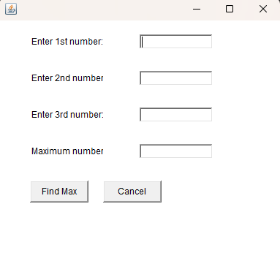

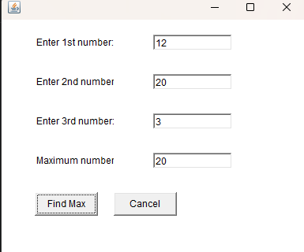

Result/observation: successfully completed the program and output is obtained

Marks:

Viva (5) | Performance (5) | Total (10)

Assessor:

