Version control (Git) Notes

If your file structure looks like:
(root)
-foo
-bar.txt with hello world in it,
then root and foo are called trees, the directories are called trees, and the files are called blobs

History - Linear sequence of snapshots.
Git uses a directed acyclic graph to get the snapshots instead of a linear sequence

The newest state your project is in points back to the state your project was previously in

If there are two separate changes from one history, you can "merge" both changes

There's potential for errors when you merge two of changes together, and if git notices something like this, git reports an error - "merge conflict"

Pseudo Code – what git looks like

type blob = array <byte>
type tree = map <string, tree | blob >
type Commit = structure {
parents array<commits>
}
author, message - strings
snapshots - tree

All the references - the “history” is immutable - you cant change anything about it

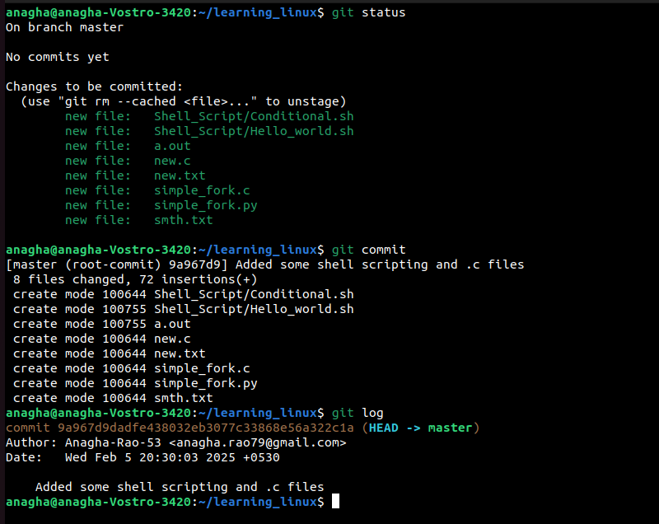
In this thing, when I did git log, the hash function that I get, the sha1 hash is for the entire commit

You CAN technically commit everything with git commit -a, or there are features with git add that let you do something like that. You might have log files that you don’t want to commit, and that would just be an inconvenience!

Every time we add or change something to an individual file, you say git add, and get it to the staging area.

You can do
git

