Task 2 - AI Content Marketing Using UGC Ads
FUTURE_PE_02 | GlowNest Barrier Repair Gel Cream | Future Interns Prompt Engineering Track

Introduction
GlowNest Barrier Repair Gel Cream is the selected reference brand for Task 2 - AI Content Marketing Using UGC Ads. This document records the complete AI prompt workflow, the generated outputs, and the final submission files prepared for the Future Interns Prompt Engineering track.

Objective
- Create a complete AI-generated content pack using structured prompts.
- Document each prompt with its respective output for evaluation.
- Include screenshot evidence for prompts, outputs, and final product views.
- Prepare TXT files, DOCX documentation, a README file, and a demo page link.

Tools used
- ChatGPT / Claude / Gemini style prompt workflow - prompt generation and output refinement.
- Python document tooling - DOCX report and screenshot asset creation.
- GitHub - repository documentation and internship submission.
- HTML demo page - simple website-style preview of the final content pack.

Project Links
Repository Name: FUTURE_PE_02
Website / Demo Link: demo/index.html
Final Output File: outputs/ugc_ad_content_pack.md

Prompt Screenshots and Respective Outputs

Prompt 1: Business Context Builder
Create a marketing brief for GlowNest Barrier Repair Gel Cream, including audience pain points, objections, emotional triggers, benefits, and UGC content angles.
Prompt Screenshot
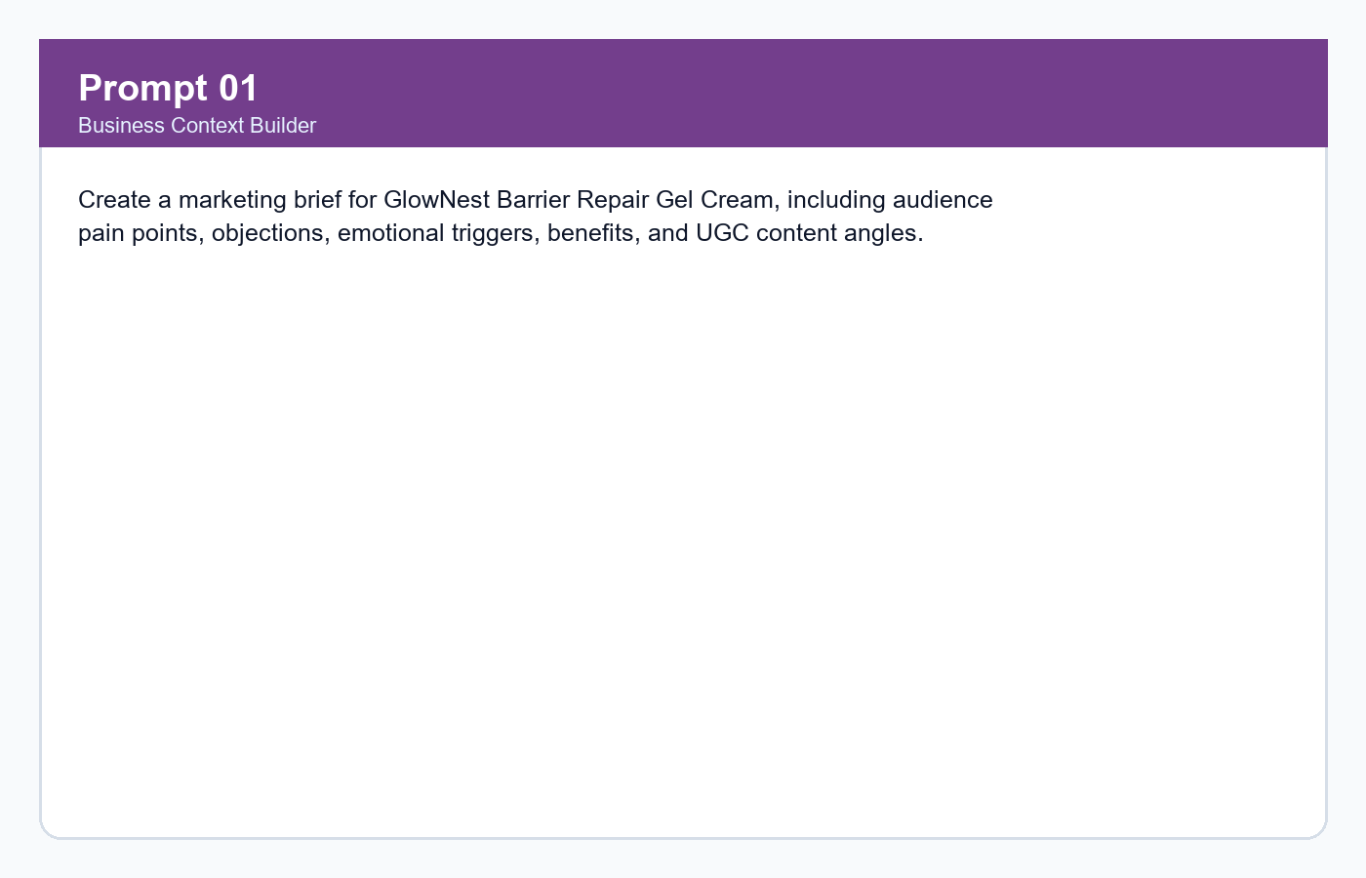
Respective Output
Audience pain points include tight skin after washing, greasy moisturizer concerns, sensitivity, dry patches under sunscreen, and desire for simple routines.
Output Screenshot
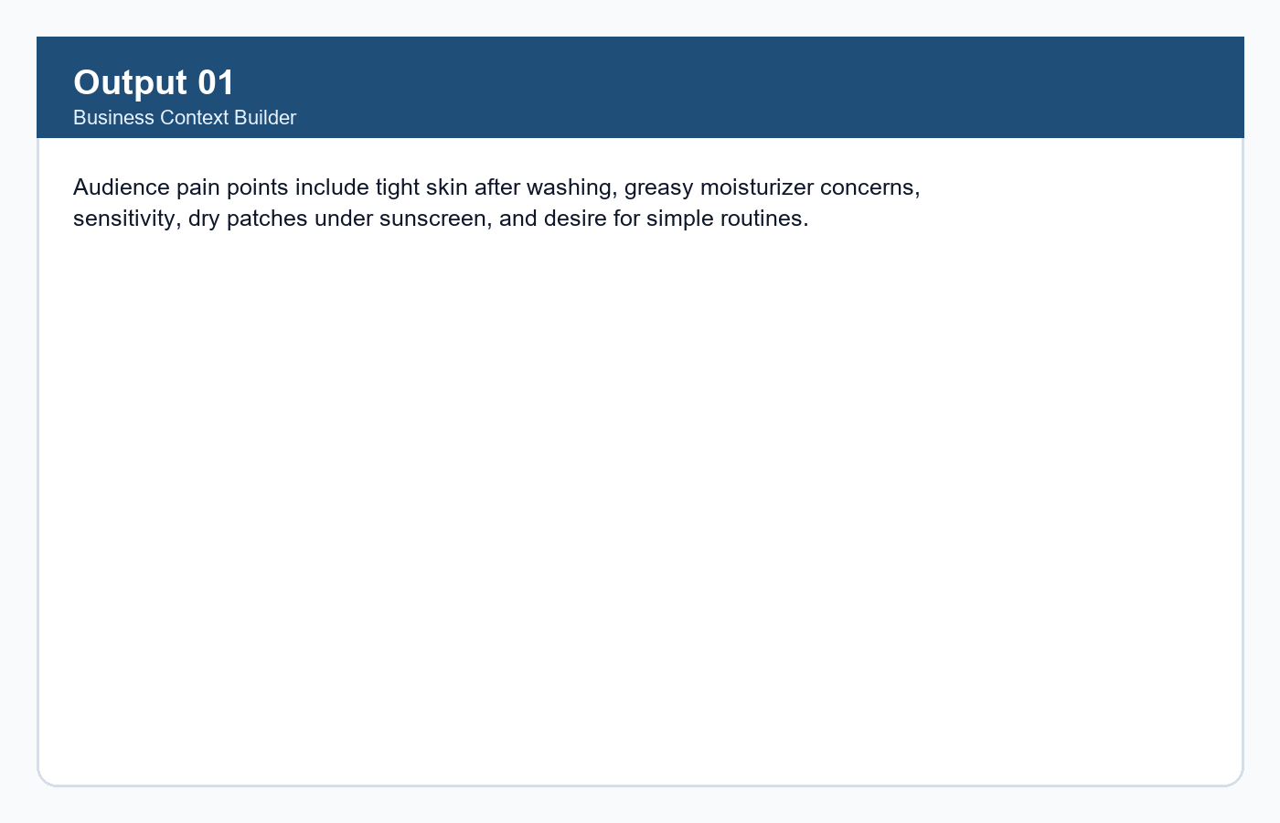

Prompt 2: Brand Voice Prompt
Define a brand voice for a D2C skincare product that is warm, practical, honest, and conversion-focused without medical claims.
Prompt Screenshot
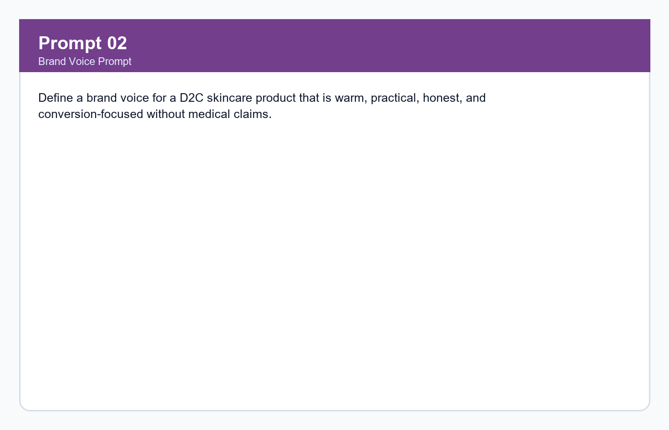
Respective Output
The voice should sound friendly, calm, realistic, benefit-led, and suitable for creators speaking naturally on camera.
Output Screenshot
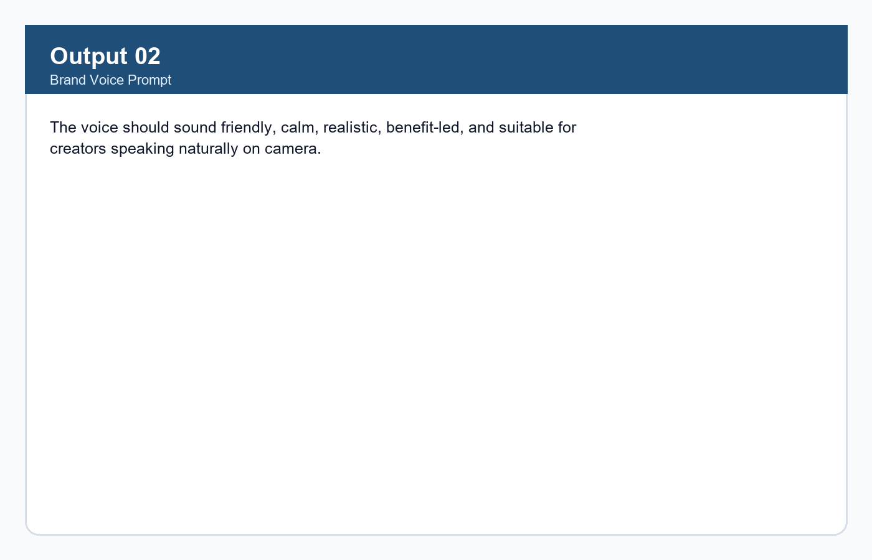

Prompt 3: Hook Generator
Generate short-form UGC ad hooks under 14 words using pain point, curiosity, routine, mistake, and contrast angles.
Prompt Screenshot
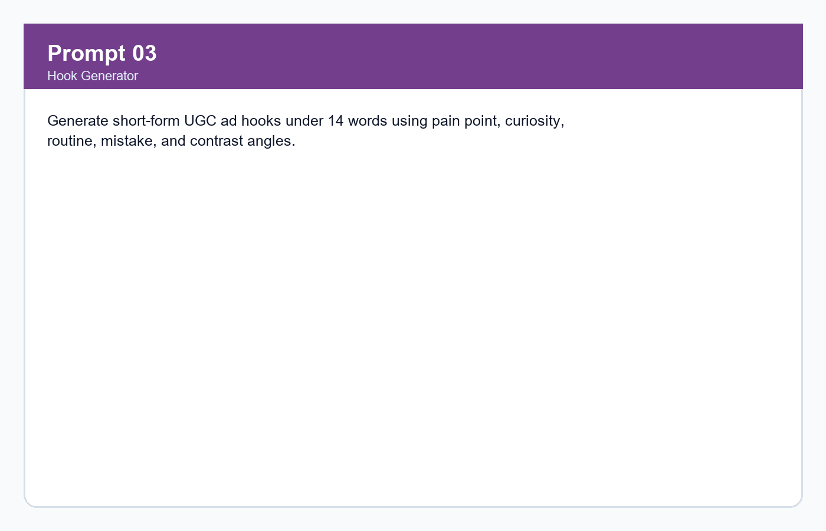
Respective Output
Hooks include 'Sensitive skin people, this one is for us' and 'If moisturizer always feels sticky, try this.'
Output Screenshot
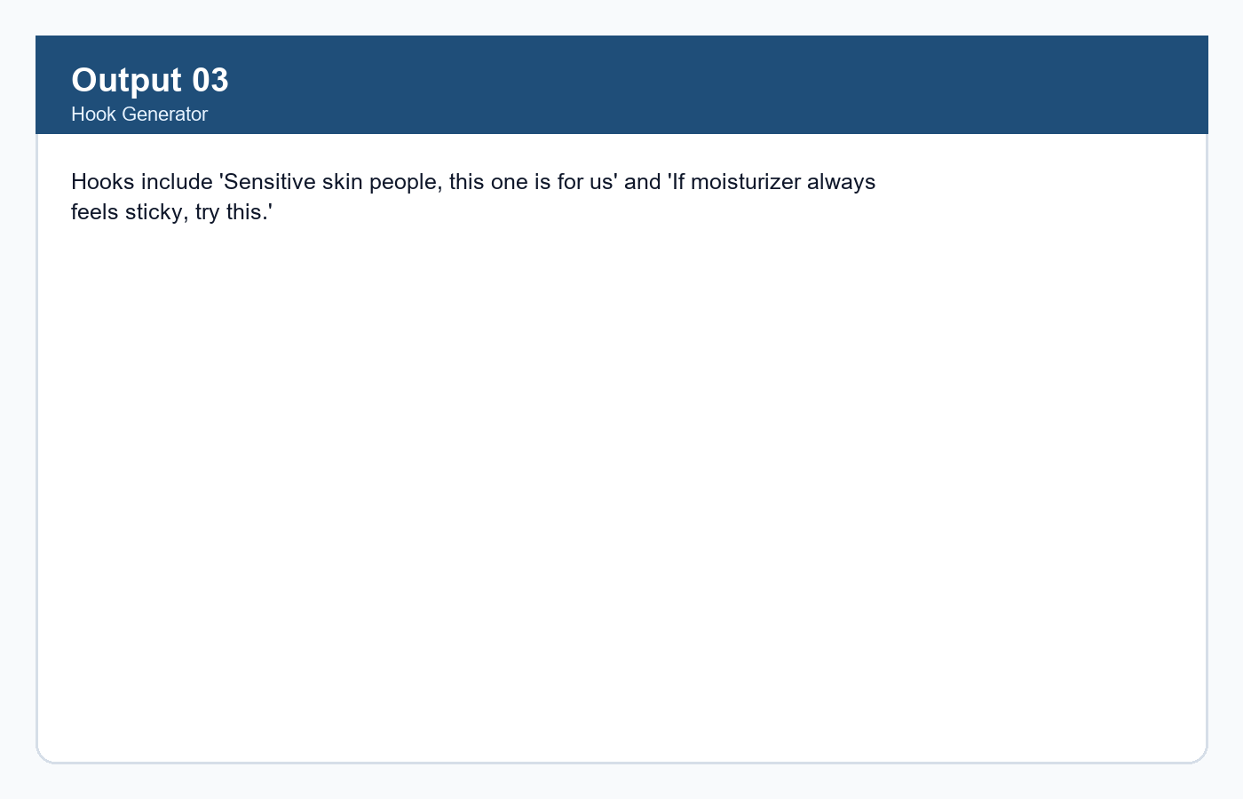

Prompt 4: Instagram Script Prompt
Write a 30-second Instagram Reel script for sensitive skin users using hook, problem, product intro, benefit, visual demo, and CTA.
Prompt Screenshot
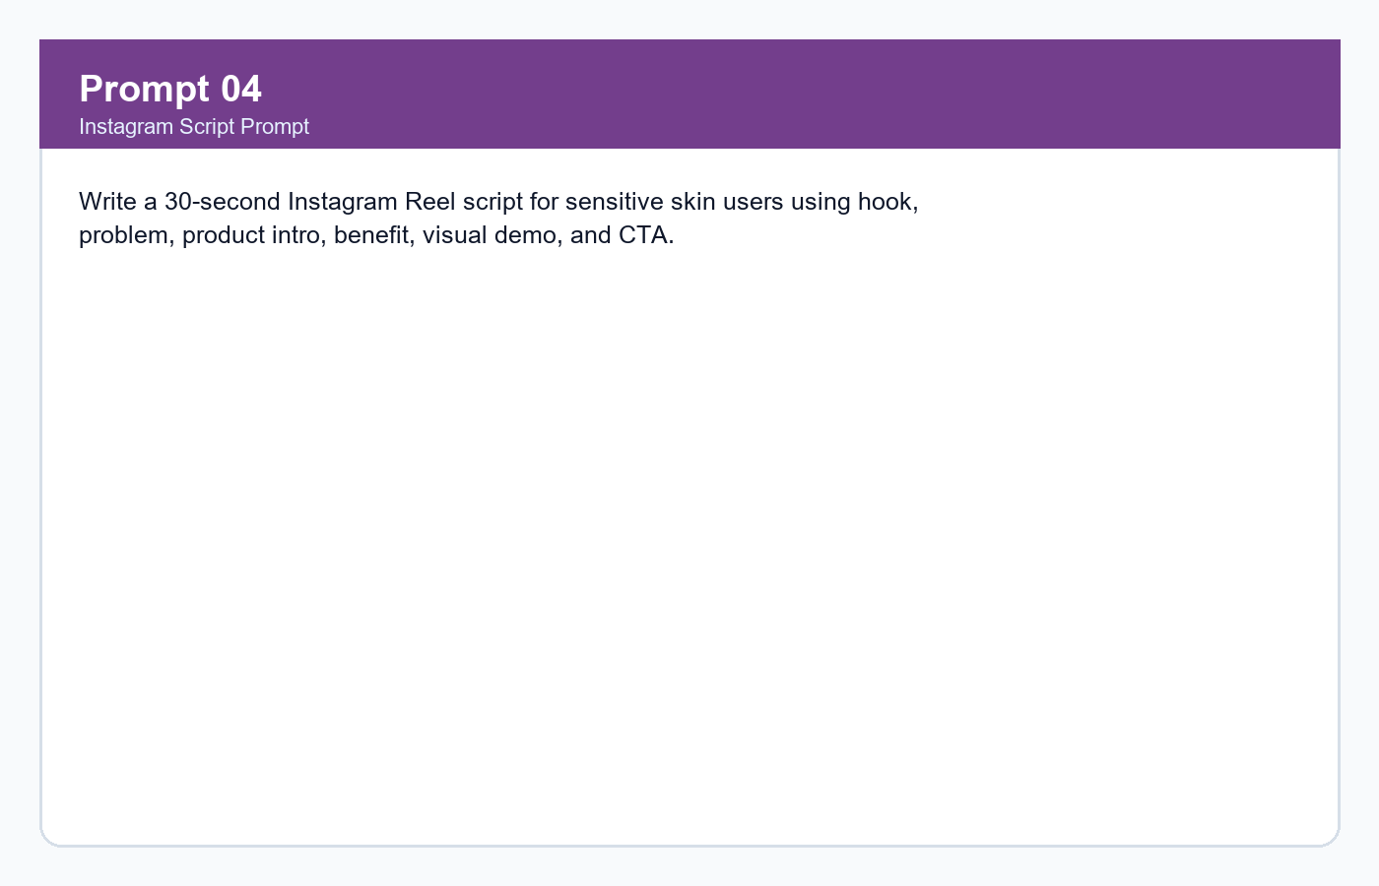
Respective Output
The script uses a creator-to-camera style and presents GlowNest as a simple morning routine step before sunscreen.
Output Screenshot
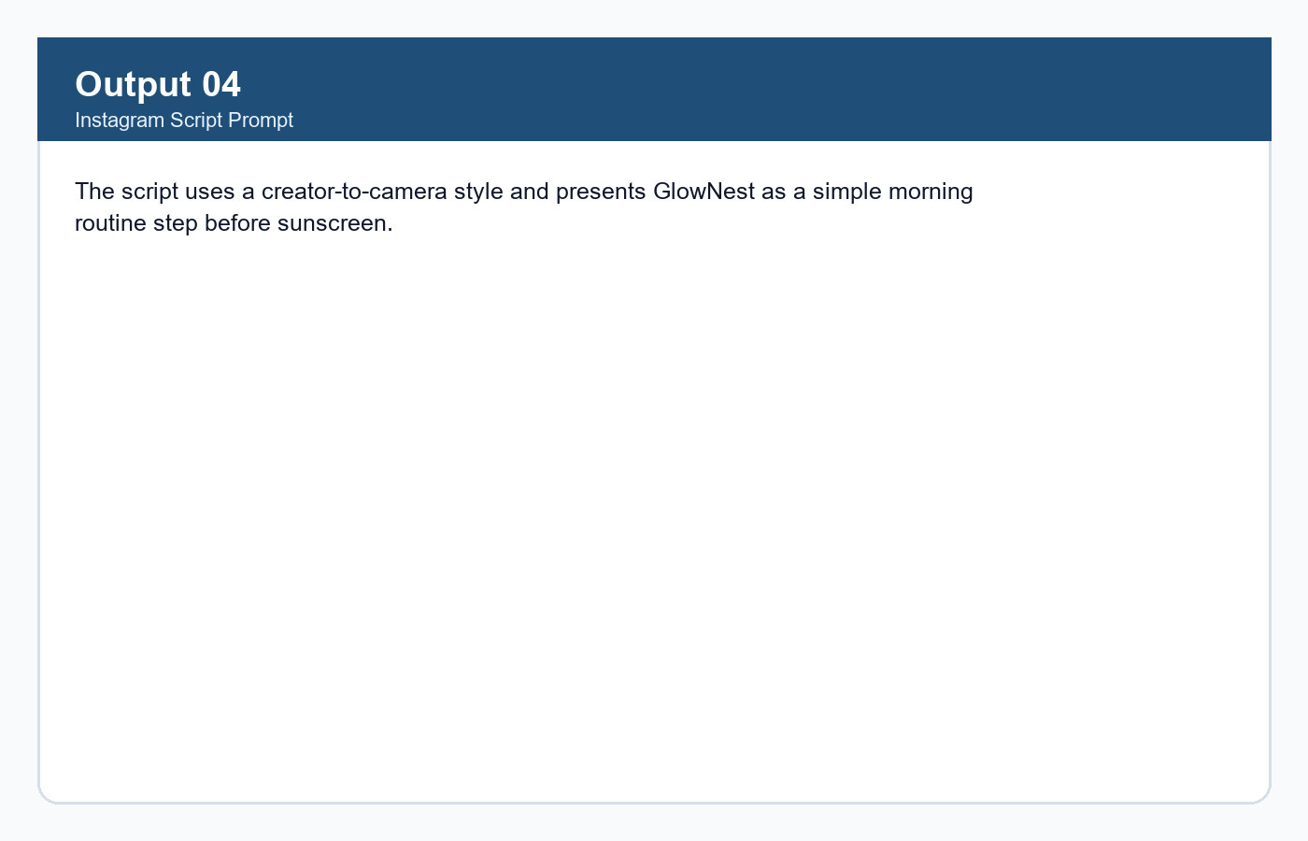

Prompt 5: Facebook Ad Prompt
Write a 35-second Facebook video ad script focused on dry patches under sunscreen and lightweight hydration.
Prompt Screenshot
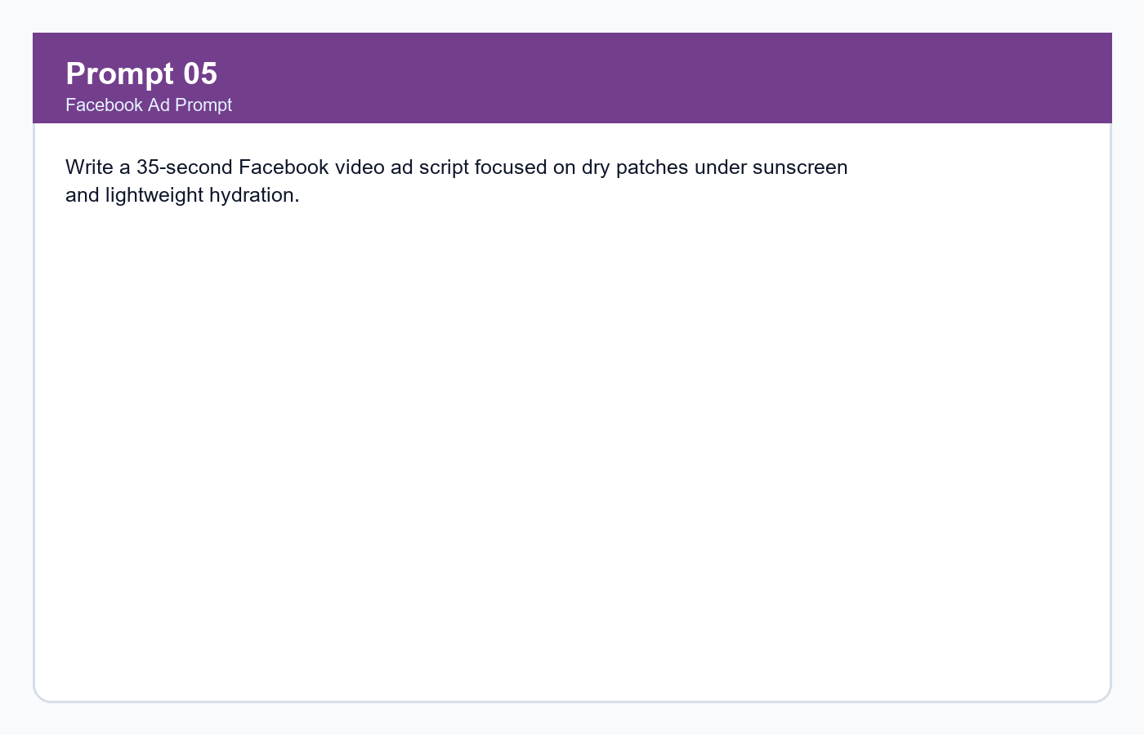
Respective Output
The output explains the problem clearly, shows product use before SPF, and ends with 'Shop GlowNest Barrier Repair Gel Cream today.'
Output Screenshot
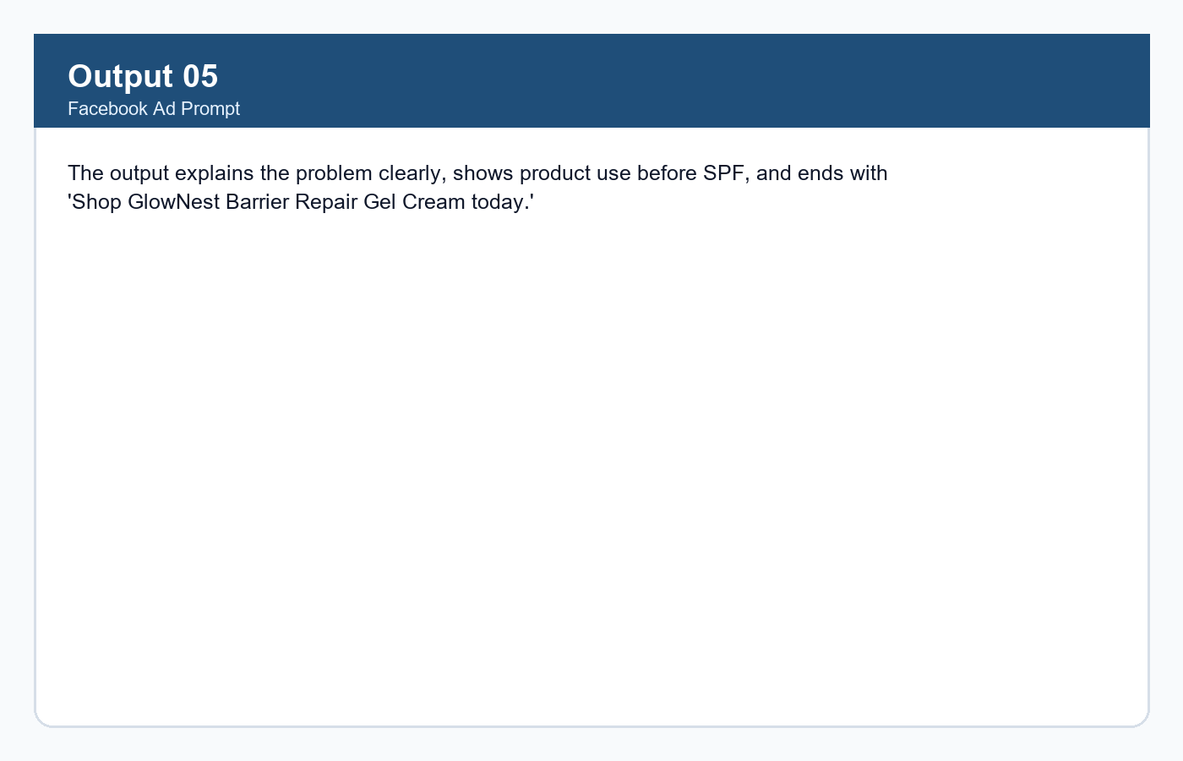

Prompt 6: YouTube Shorts Prompt
Write a fast 25-second YouTube Shorts script for people who dislike sticky moisturizers.
Prompt Screenshot
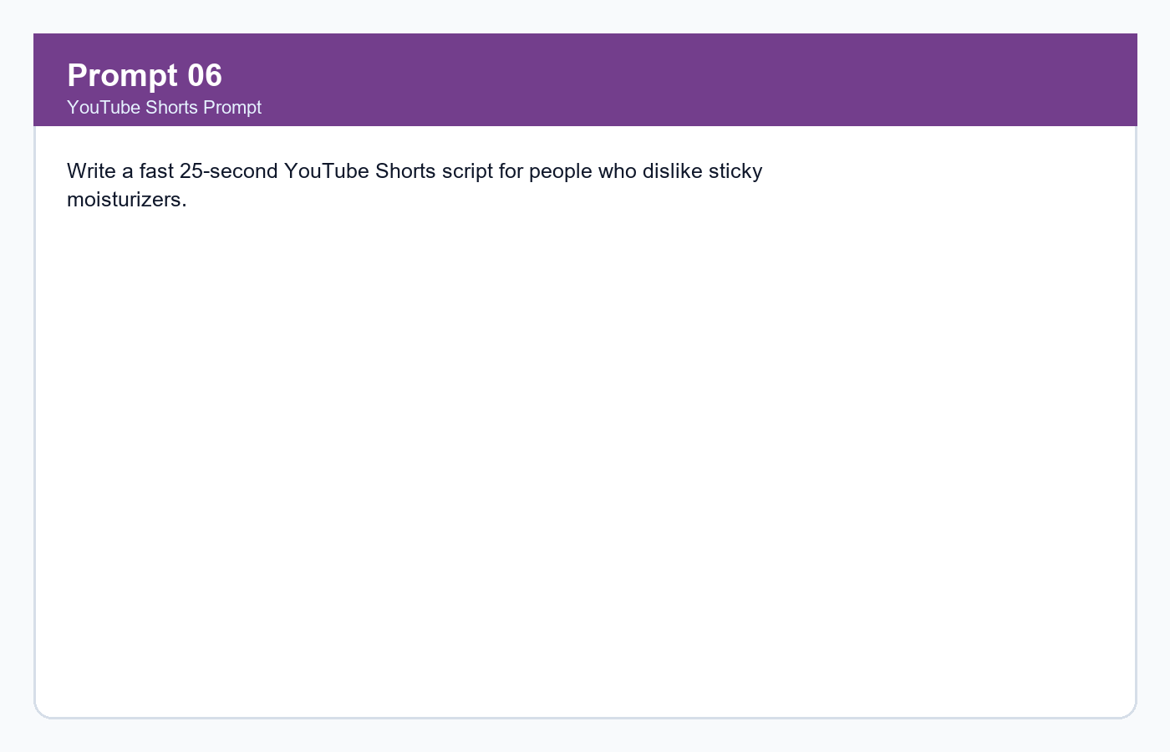
Respective Output
The output uses fast pacing, visual contrast, and a save-worthy morning routine CTA.
Output Screenshot
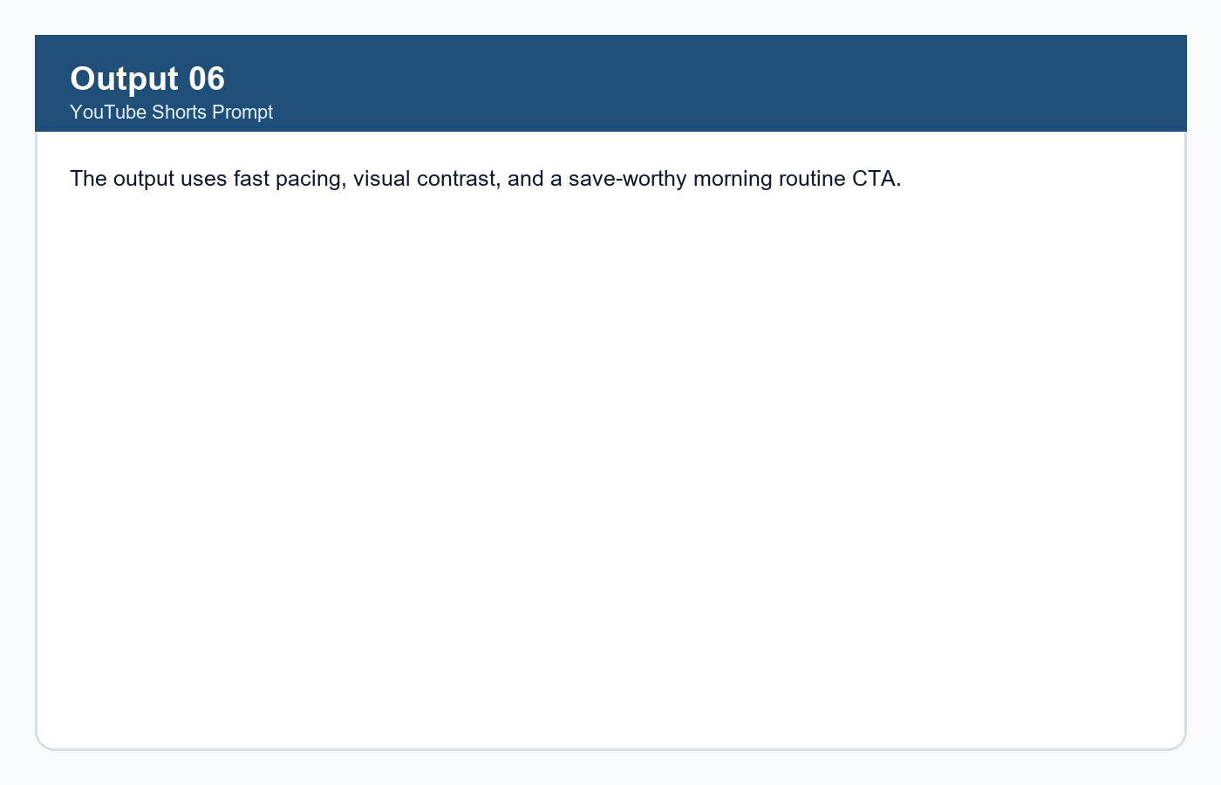

Prompt 7: Caption Generator
Create Instagram, Facebook, and YouTube captions for the UGC scripts, plus CTA options and hashtags.
Prompt Screenshot
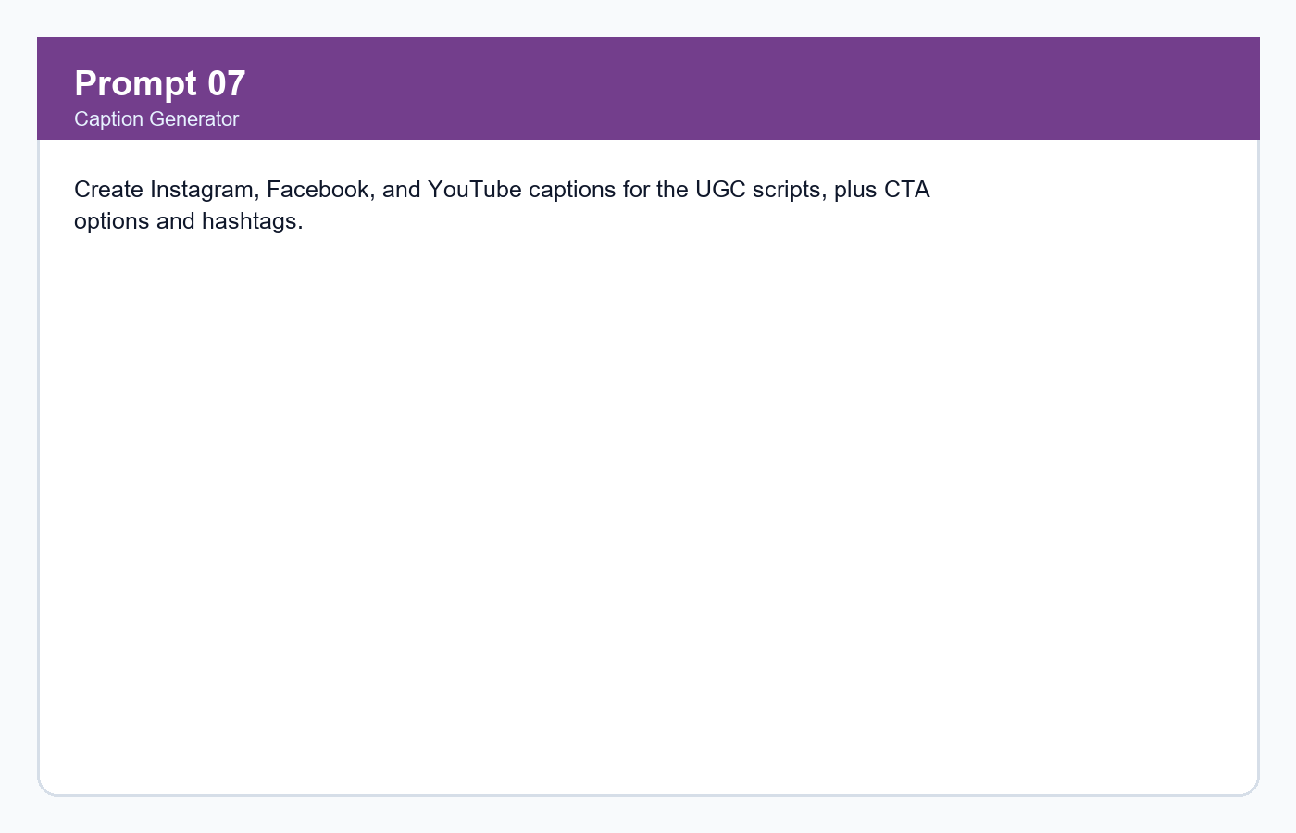
Respective Output
Captions are platform-specific, benefit-led, and include CTA options such as 'Shop GlowNest today' and 'Save this skincare routine.'
Output Screenshot
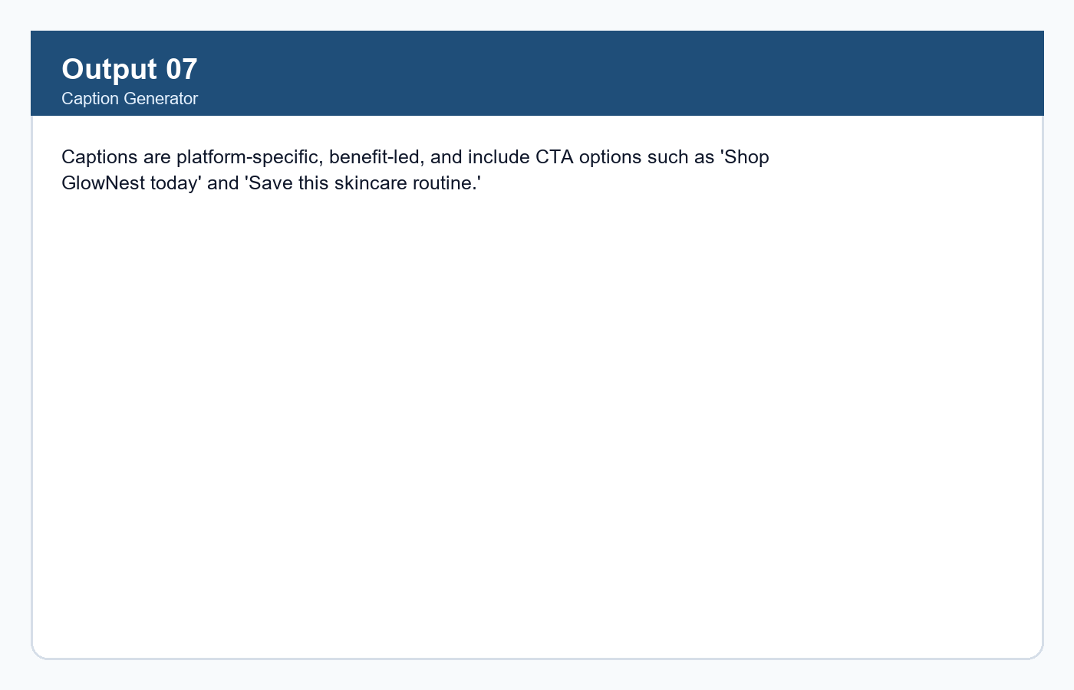

Prompt 8: Visual Direction Prompt
Create filming directions, on-screen text, and product demonstration instructions for each UGC ad.
Prompt Screenshot
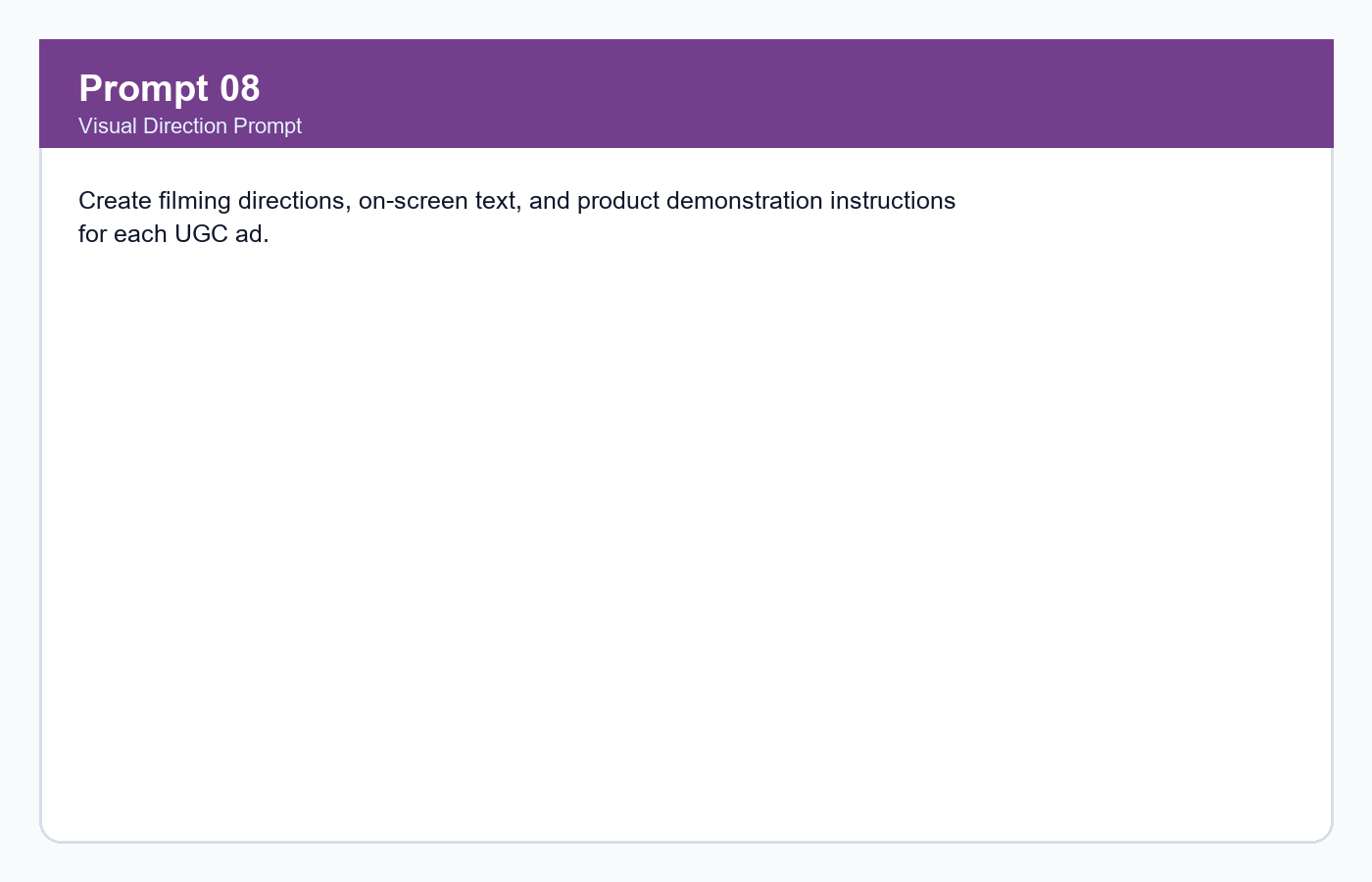
Respective Output
Visuals include texture close-ups, cleanser-to-moisturizer-to-SPF sequence, and creator lifestyle shots.
Output Screenshot
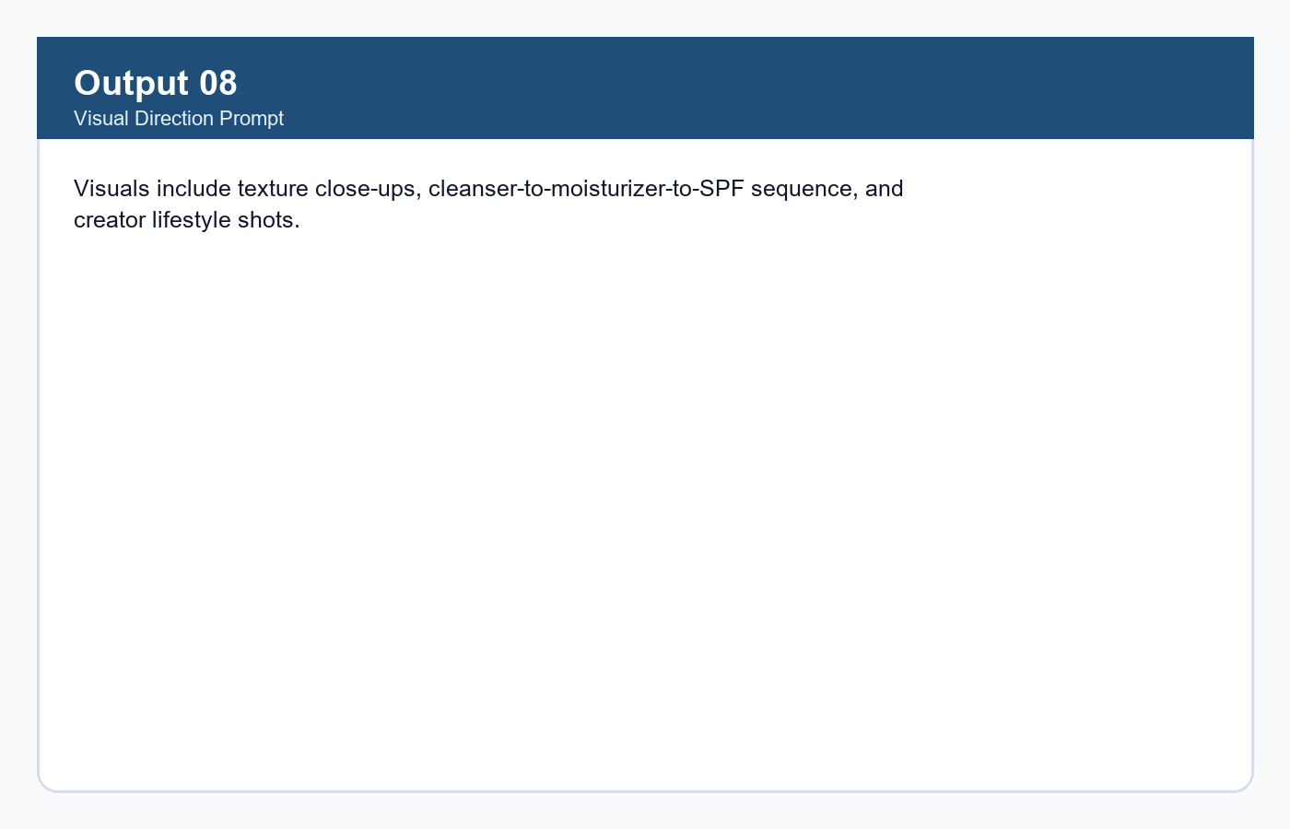

Prompt 9: CTA Testing Prompt
Create CTA variations and explain which conversion action each CTA supports.
Prompt Screenshot
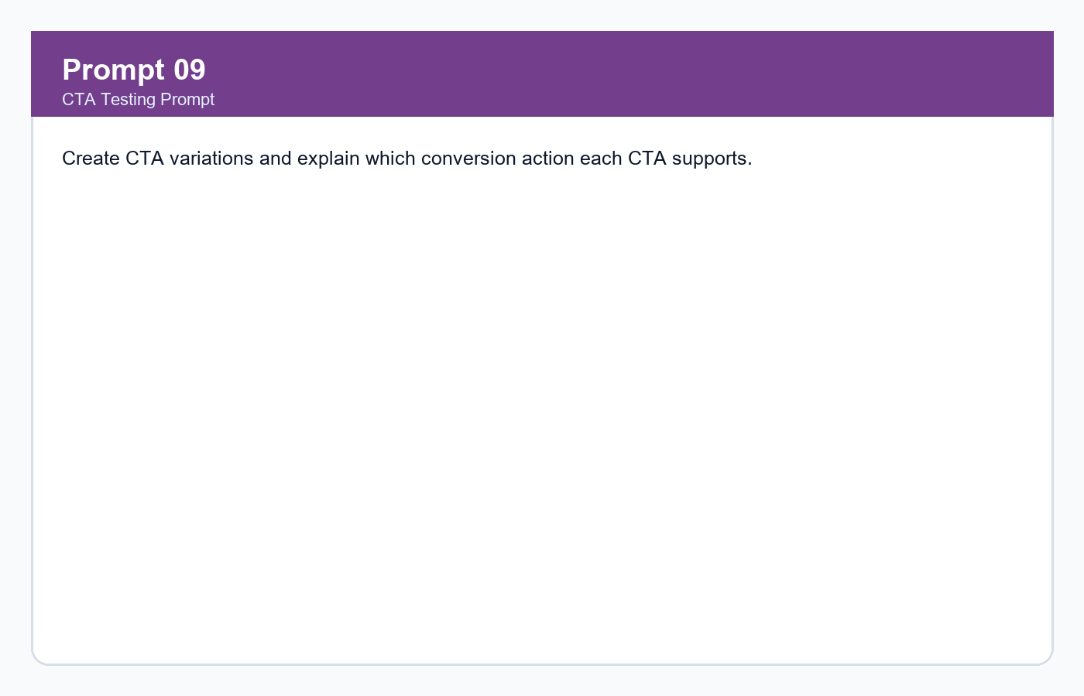
Respective Output
CTA options support purchase intent, saves, routine adoption, and product-page visits.
Output Screenshot
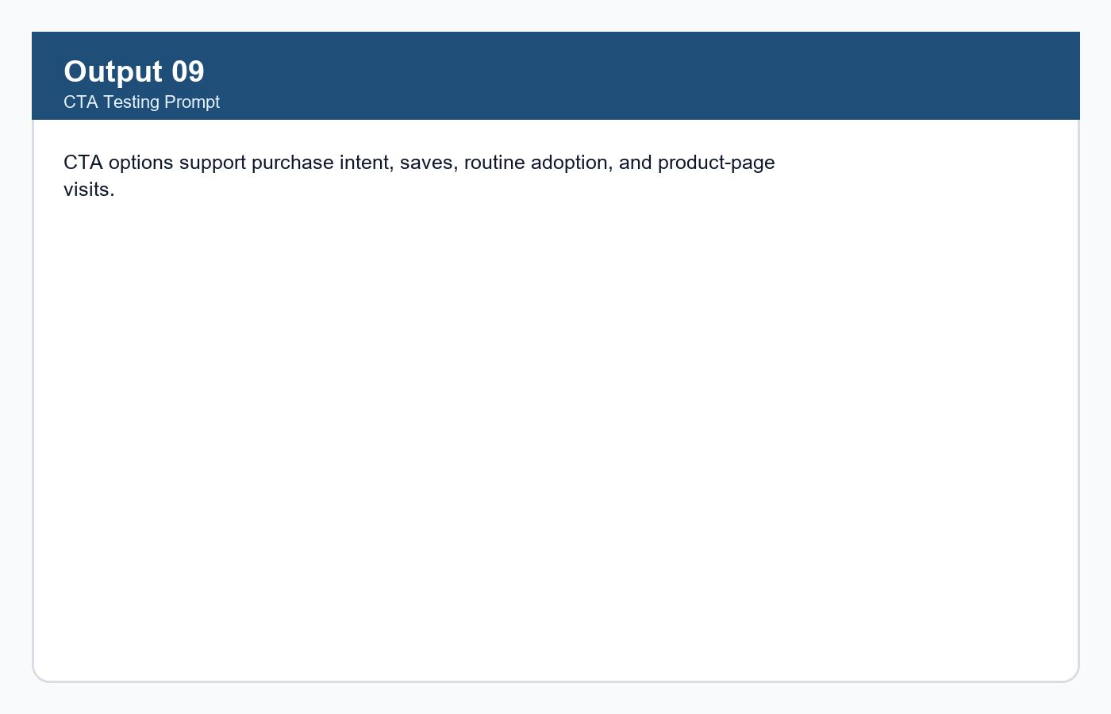

Prompt 10: Content Testing Plan
Build a testing plan for hooks, CTA styles, platform performance, and visual proof angles.
Prompt Screenshot
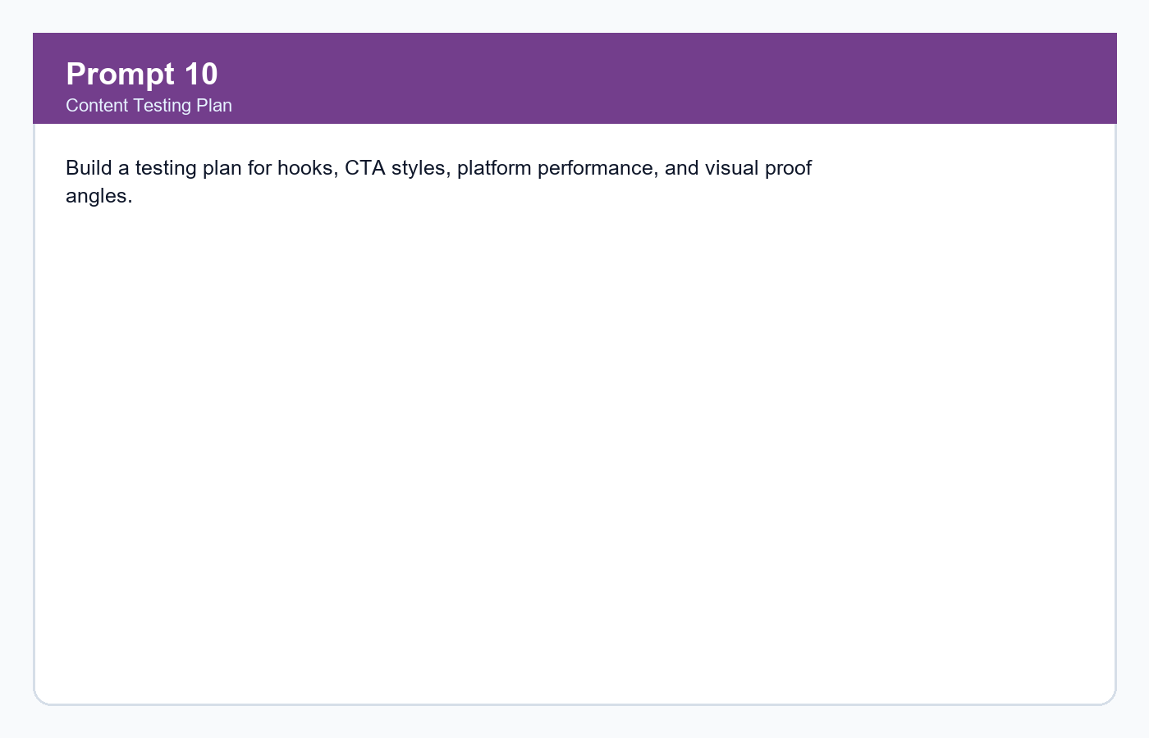
Respective Output
The plan compares hook styles, shop vs save CTAs, Instagram vs YouTube Shorts, and texture close-up vs routine demo.
Output Screenshot
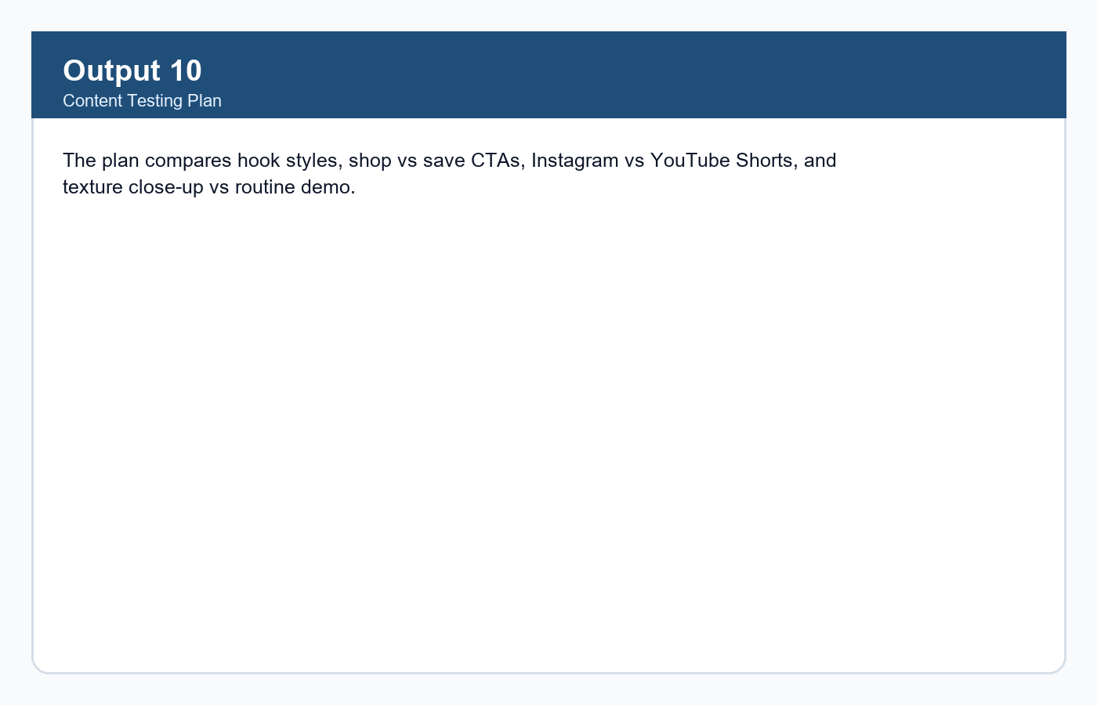

Final Product Screenshots
Final Product 01
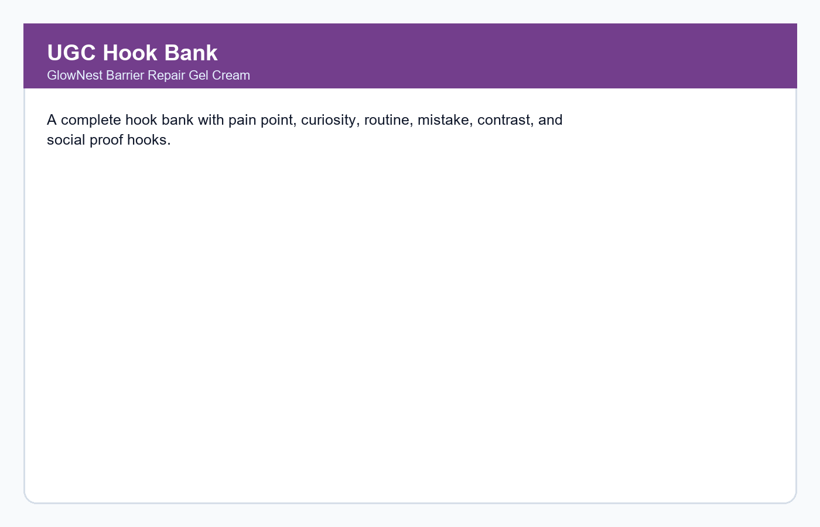
Final Product 02
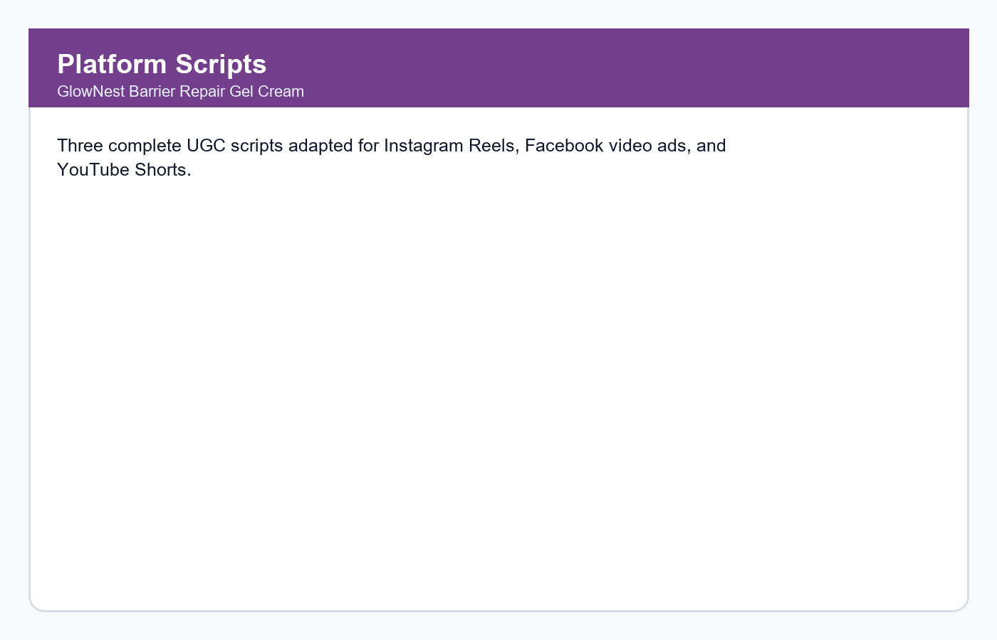
Final Product 03
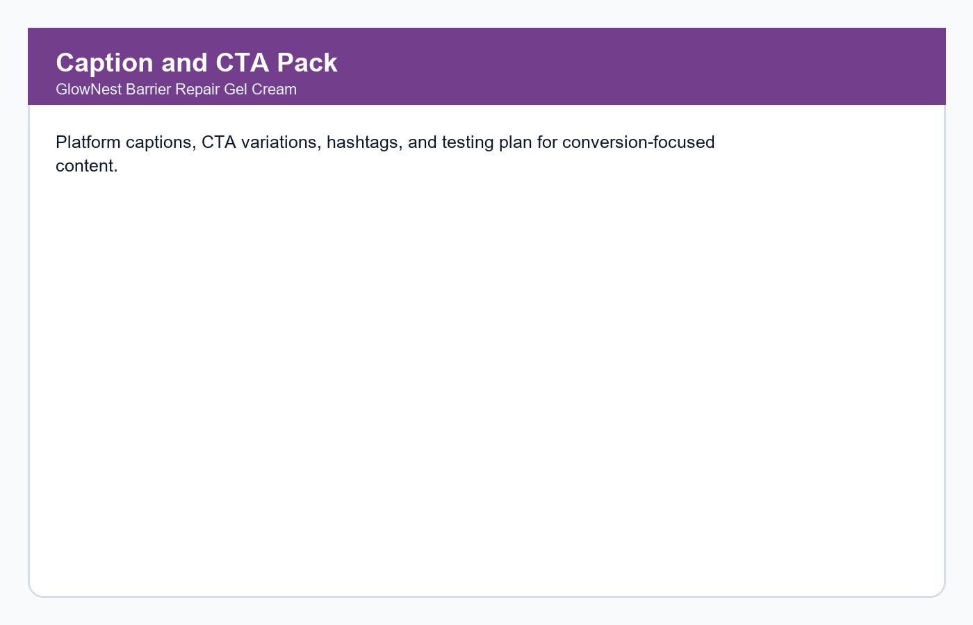

README File

Task 2 - AI Content Marketing Using UGC Ads

GlowNest Barrier Repair Gel Cream | Future Interns - Prompt Engineering Track
![Track](https://img.shields.io/badge/Track-Prompt%20Engineering-blue)
![Task](https://img.shields.io/badge/Task-02-orange)
![Status](https://img.shields.io/badge/Status-Completed-green)

Intern Details
| Field | Details |
|---|---|
| Track | Prompt Engineering (PE) |
| Repository | FUTURE_PE_02 |
| Task | AI Content Marketing using UGC Ads |
| Product | GlowNest Barrier Repair Gel Cream |
| Tools Used | ChatGPT / Claude / Gemini style prompts, Markdown, DOCX, GitHub |

Project Overview
This project contains a complete AI-generated UGC Ad Content Pack for a realistic D2C skincare product. The content pack includes hooks, scripts, captions, CTAs, visual directions, platform adaptations, testing ideas, prompt screenshots, output screenshots, TXT files, and a DOCX report.

Website / Demo Link
[Open the project demo](demo/index.html)
Replace this local demo link with a GitHub Pages, live website, or video demo link after deployment.

Product Details
| Field | Details |
|---|---|
| Brand | GlowNest |
| Product | Barrier Repair Gel Cream |
| Category | D2C skincare |
| Audience | Students and working professionals aged 18-30 |
| Core Promise | Lightweight daily hydration for dry or sensitive-feeling skin |
| Tone | Warm, honest, practical, friendly |

Prompt Engineering Approach
1. Business and audience framing
2. Brand voice and tone definition
3. Hook generation for short-form ads
4. Platform-specific UGC script generation
5. Caption, CTA, hashtag, and testing-plan refinement
6. Final documentation with screenshots and outputs

Prompt Index
| # | File | Screenshot | Output Screenshot | Purpose |
|---|---|---|---|---|
| 1 | `txt/prompt_output_01.txt` | `screenshots/prompts/prompt_01.png` | `screenshots/outputs/output_01.png` | Business context |
| 2 | `txt/prompt_output_02.txt` | `screenshots/prompts/prompt_02.png` | `screenshots/outputs/output_02.png` | Brand voice |
| 3 | `txt/prompt_output_03.txt` | `screenshots/prompts/prompt_03.png` | `screenshots/outputs/output_03.png` | Hook generation |
| 4 | `txt/prompt_output_04.txt` | `screenshots/prompts/prompt_04.png` | `screenshots/outputs/output_04.png` | Instagram script |
| 5 | `txt/prompt_output_05.txt` | `screenshots/prompts/prompt_05.png` | `screenshots/outputs/output_05.png` | Facebook ad script |
| 6 | `txt/prompt_output_06.txt` | `screenshots/prompts/prompt_06.png` | `screenshots/outputs/output_06.png` | YouTube Shorts script |
| 7 | `txt/prompt_output_07.txt` | `screenshots/prompts/prompt_07.png` | `screenshots/outputs/output_07.png` | Captions and CTAs |
| 8 | `txt/prompt_output_08.txt` | `screenshots/prompts/prompt_08.png` | `screenshots/outputs/output_08.png` | Visual direction |
| 9 | `txt/prompt_output_09.txt` | `screenshots/prompts/prompt_09.png` | `screenshots/outputs/output_09.png` | CTA testing |
| 10 | `txt/prompt_output_10.txt` | `screenshots/prompts/prompt_10.png` | `screenshots/outputs/output_10.png` | Content testing plan |

Repository Structure
```text
FUTURE_PE_02/
├── README.md
├── demo/
│ └── index.html
├── documents/
│ └── FUTURE_PE_02_submission_report.docx
├── outputs/
│ └── ugc_ad_content_pack.md
├── prompts/
│ ├── 01_prompt_strategy.md
│ └── 02_reusable_prompt_templates.md
├── screenshots/
│ ├── final_product/
│ ├── outputs/
│ └── prompts/
└── txt/
├── final_product_summary.txt
└── prompt_output_01.txt ... prompt_output_10.txt
```

Final Product Screenshots
![UGC Hook Bank](screenshots/final_product/final_product_01.png)
![Platform Scripts](screenshots/final_product/final_product_02.png)
![Caption and CTA Pack](screenshots/final_product/final_product_03.png)

Deliverables
- 10 prompt screenshots
- 10 respective output screenshots
- TXT prompt-output files
- Final UGC ad content pack
- DOCX submission report
- README file
- Demo HTML link

Submission Checklist
- [x] Repository named `FUTURE_PE_02`
- [x] README file added
- [x] Prompt files added
- [x] Output files added
- [x] Prompt screenshots added
- [x] Respective output screenshots added
- [x] DOCX report added
- [x] Demo link added
This project was created as part of the Future Interns Prompt Engineering Internship Program. Product details are fictional and created for learning purposes.

