|  |  |
| --- | --- |
| Template No. | 1 |
| Version No. | 1.0 |
| Release Date | 15th Dec 2022 |

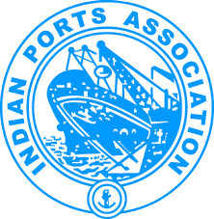

User Manual: e-Berthing Meeting Module

Project: National Logistics Portal Marine

Version No.:1.0

**Table of Contents**

1. National Logistics Portal Marine : Project Overview 4

2. Purpose 5

3. Scope 5

4. NLP Marine Stakeholders 6

4.1. NLP Marine Iteration wise Modules details 11

4.2. Frequently Used Icons to Refer 12

5. Getting Started 13

5.1. Landing page: 13

6. E-Birthing Module: 16

6.1. E-Birthing flow 16

# National Logistics Portal Marine : Project Overview

# National Logistics Portal (Marine) is a national maritime single window platform encompassing complete end-to-end logistics solutions to help exporters, importers, and service providers exchange documents seamlessly and transact business. The overarching NLP Marine Vision is to cater to various stakeholders in G2G, G2B and B2B model. An "open platform" that allows coexistence of multiple service providers to provide EXIM related services independently or by using connectivity options. It has the capability to integrate with various Port Operating Systems/ Terminal Operating Systems and other stakeholder(s) systems in the ecosystem. It will facilitate real-time information of activities that are generally not in reach of the importer, exporter, customs broker, including vessel-related information, terminal gate, and container freight station (CFS) gate transactions. It also enables digital transactions for payments required for the clearance process of import and export like CFS charges, shipping line charges, transportation charges, etc. It also includes a single-window certification device to approve transactions, as well as the integration of an online payment service. All services and documents generated will be in line with global best practices and standards. Enhanced further with the Latch On feature, which facilitates the trade in providing the required features that cannot be directly embedded into any Single Window Platform even though the features/ functionalities are required for seamless data and document exchange. Latch-on achieve this without duplicating the effort. It is envisaged that many standalone applications, developed by multiple vendors, users and other stakeholders may be integrated with NLP Marine through appropriate curation. NLP Marine enriches the user experience through complete tracking of the shipment with notifications on each stage, seamlessly exchange of documents and ability to securely transact in transparent and quick manner. The Key Considerations for NLP Marine. To make India one of the most cost effective plus competitive countries in terms of carrying international trade. To become a trusted network with secure data access across all stakeholders, simplifying and accelerating procedures for goods entry, exit or transit. To promote digital entrepreneurship by providing robust digital ecosystem on which multiple latch - on(s) can be built.

# Purpose

NLP-Marine will offer the ability to perform e-Berthing on the NLP Marine platform. The e-Berthing Meeting Model will assist NLP Marine Users in performing berthing activities using e-Berthing Services from various Indian Ports and Terminals based on the user role and rights. The module will allow Ports, Terminals, Shipping Lines, and Vessel Agents to communicate with one another for berthing activities such as additional details and documents with the most recent ETA, ETD, and Cargo information.

The module will be integrated with the Port/Terminal system to display the most recent vessel details to the user. This will eventually allow the stakeholder to determine an approximate time for berth availability. Ports/Terminals will be able to share the most recent berthing plan and vacant berth details with stakeholders such as Shipping Line Vessel Agent by using the module. There are also additional facilities for stakeholders to share various documents required by the Ports and Terminals.

Stakeholders will be able to share the following information with relevant ports and terminals:

* Vessel's ETA (Estimated Time of Arrival)
* The draught, beam, and length of the vessel.
* Customs documentation position and cargo clearance.
* Payment of any applicable customs duties.
* Any vessel-related issues for cargo delivery.
* Submit a service request to the ports and terminals and pay for the services.
* EPC / PGA approval, if applicable.
* Berth requirements (specific to cargo characteristics / shore crane requirements / pipelines)
* Priority berthing, if available (for Major Customers)

# Scope

The 'e-Berthing meeting Module' screen will be accessed by legitimate NLP Marine platform users with module access rights. To access the e-Berthing Meeting Module, the user must navigate to Carrier > NLP marine Service > Cargo > e-Berthing Meeting Module. This form / functionality allows users to obtain e-Berthing meeting-related services and engage in e-Berthing activity. After the user selects e-Berthing Meeting, the above screen will be displayed. This will include e-berthing transaction and details, as well as the latest vessel at berthing, expected vessel, and vessel sailed details. This page will display three different types of vessel status.

# NLP Marine Stakeholders

Below Mentioned are the NLP Marine Stakeholders:

|  |  |
| --- | --- |
| Stakeholder Name | Role Description |
| Cargo Owner (IW) | A cargo owner is well-versed in dealing with the whole process of shipping. He administers and supervises the entire shipping process on behalf of the importers. He is the person to go to for all your import needs |
| Terminal Operator - IW | The terminal operator manages the terminal operations on behalf of the Port and receives, stores, loads/discharges and  delivers the containers/cargo within the terminal. They collect  the terminal handling and storage charges while the port  collects the vessel related charges. |
| Barge Owner (IW) | The Barge Owner / Operator transports Iron Ore from mine to  Port and transports the consignment to the importer’s location. |
| Ship Chandler | A ship chandler supplies all the necessary and requisite commodities to a ship when at port. The job of a ship chandler is unique because it caters specifically to only one line of business, therefore, allowing a complete exclusivity to both parties – the seller as well as the client. |
| Port Authority - Sea Exim + Coastal | Port Authority is a state establishment in charge of development and promotion of port equipment and ensuring the compliance of the regulations. Port takes care of Berth Allotment piloting vessels in and out of the port and provides other vessel and cargo related services. |
| Inland Waterways Authority | The Authority primarily undertakes projects for development and maintenance of IWT infrastructure on national waterways through grant received from Ministry of Shipping. |
| Terminal Operator - Sea | The terminal operator manages the terminal operations on behalf of the Port and receives, stores, loads/discharges and  delivers the containers/cargo within the terminal. They collect  the terminal handling and storage charges while the port  collects the vessel related charges. |
| Bunker Supplier | Bunker Supplier means the party supplying Bunkers to a Ship, receiving Bunkers from a Ship to road tankers or shore facilities, or receiving Ship-generated Waste from a Ship. |
| CFS | The CFS is the custodian of containers and the cargo till the  cargo is released to the importers after de-stuffing in case of  imports and for exports till the cargo is shifted to port after  stuffing. In the case of exports, the cargo is brought to the CFS  for examination by the Customs, stuffed in the containers and  shifted to the port for loading on to the vessel. |
| ICD | ICD (Inland Container Depot) is a temporary storage for import/export laden and empty containers. According to the guidelines of the Indian Government, functionally there is no difference between CFS and ICD. While CFS is an off-dock facility located near the servicing port, ICD is located  outside the port towns. In PCS also, ICD is mentioned as CFS for simplicity. |
| Empty Yard | Empty container repositioning refers to moving empty containers from an area with a surplus of containers to a location with a deficit. For container owners, empty container repositioning has a substantial economic downside. |
| Warehouse Provider | A warehouse service provider company comes under the storage facilities provider category. This company facilitates the enterprises that deal with manufacturing, distribution, and procurement of inventories of tangible goods in domestic and global trade. Security and safety in the Warehousing service are mandatory to build trust in customers. |
| Shipping Agent | A shipping agent is a person who deals with the transactions of a ship in every port that the ship visits or docks. In simple terms, it is a shipping agent who with a local expert act as a representative of the owner of the ship and carries out all essential duties and obligations required by the crew of the ship. |
| Shipping Line | Shipping Line operates a fleet of ships and other carriers, and the Shipping Agent provides the services on behalf of Shipping Lines. Shipping Agent decides for ship arrival, berthing, discharge/loading, and departure of the vessel with the port, customs and other regulatory bodies. |
| NVOCC | NVOCC stands for Non-Vessel Owning Common Carrier. NVOCC operation comprises of sales, stuffing, and transport of the containers to gateway ports. The bill of lading issue and overseas distribution is taken care by the agents of NVOCC. |
| Stevedore | Stevedores arrange for the labour gangs to handle containers,  trailers, pallets, boxes, etc., maintain the tally sheets, and report the container/cargo loading and discharging details to the port and shipping agent. They also ensure the transport of handling units through the port area. |
| Surveyor | The Surveyor is hired by the port/ Importer/Exporter as well as of the shipping agent to survey the vessel, container, and cargo.  The survey reports are used for ascertaining the damages, if  any. The surveyors also monitor the stevedoring activities and  coordinate stuffing/de-stuffing, movement of containers/cargo and loading/discharging. |
| Exporter | Exporter: Also known as the seller or shipper, the exporter is the natural or legal individual that makes a sale to a foreign country. Importer: Also known as the buyer, the importer is the natural or legal individual that purchases goods from a foreign country. |
| Importer | Importer is an individual or a firm authorized by the government of respective country to function as an 'Importer' to bring goods or services in a country from outside countries. The importer is responsible completing necessary legal import customs clearance procedures and formalities on arrival of goods into a country. |
| Custom Broker | Importers /exporters are the owners of the goods being imported/exported. They are responsible for the completion of customs and Port formalities either by themselves or through a Customs House Agent (CHA). CHA helps the importer/exporter in getting the customs clearance for their consignments. CHA declares the goods with Customs, and gets goods examined by the Customs, pays the duty in the Customs designated bank and takes the physical possession of the cargo from the Custodian after paying all the Port dues/charges. |
| Freight Forwarders | They represent the container Lines and provide the steamer  agent with details of the containers belonging to them in the  vessel. They also give the delivery order to the Clearing  Agent/Importer for clearing the container. Similarly, the liner  gives the authorization for loading containers to a vessel to the clearing agent. They recover terminal handling charges and container detention charges as also issue Bill of lading and agent’s delivery order to the consignees. |
| Banks | Bank facilitates the payment of service charges by the stakeholders to the port, service provider and other statutory charges like excise/stamp duties and taxes to Customs and service provider as well as other government agencies. |
| Insurance Provider | Marine Cargo insurance is a type of insurance policy that covers the loss or damages caused to marine cargo during transit. The protection is offered to the cargo owner along with the cover to the cargo for any loss or damage caused due to delay in the voyage, ship accident or unloading. |
| Packaging Service Provider | The primary purpose of packaging is to protect its contents from any damage that could happen during transport, handling, and storage. Packaging retains the product intact throughout its planning chain from manufacturer to the end user |
| Customs | Customs is the government department oversees collecting duty and taxes and of the border control. Customs also enforces the provisions of the Customs Act governing the imports and exports of cargo, arrival and departure of vessels and prevention of smuggling including interdiction of narcotics drug trafficking. Customs grants entry inward / entry outwards permission for the vessel and clear goods for both import and export. |
| Port Health Organisation | The agency that is responsible for the inspection of hygiene in  the ship and amongst the crew, to control the spread of  infectious diseases from incoming vessels and aircraft, inspecting food/agricultural products entering the Port, for wholesomeness, fitness, and compliance with Indian legislation. Some of the cargo samples like edible oil is inspected by PHO and permitted for domestic use based on the lab certification. On arrival, the PHO also issues de-ratting exemption certificate to the vessel. |
| Plant Quarantine Organisation | PQO examines the consignments (identity and physical checks)  and accompanying documentation by the administrative enforcement. He inspects plants and plant products for any suspicious containment of harmful organisms. "Phytosanitary  certificate" is issued in the model format prescribed under the  International Plant Protection Convention of the Food & Agricultural Organization and issued by an authorized officer at  the country of origin of consignment or re-export. |
| Mercantile Marine Department | The main functions of the Mercantile Marine Departments include administration of the various Merchant Shipping Laws  and Rules relating to the registration, tonnage measurement and crew accommodation of ships, surveys for Safety of Ships, Load line inspection, enquiries into shipping casualties and wrecks, holding of examinations for Certificates of Competency, survey of passenger ships, inspection and approval of statutory equipment’s vis-à-vis Life Saving and Fire Fighting, Appliances, communication equipment and other Navigational Aids, detention of overloaded and or unsafe ships, supervision of ship repairs and construction of new vessels at request of State and Central Government Agencies. |
| Immigration | The agency that is responsible for applying the immigration laws of the country and providing the needed documents for foreign crew and passengers to disembark and embark. |
| DGLL | The Directorate General of Lighthouses and Lightships is a subordinate office under the Ministry of Ports, Shipping and Waterways. It provides General Aids to Marine Navigation along the Indian coast. DGLL help the mariners and local fisher to navigate safely in the Indian waters. |
| DG Shipping | The Directorate General of Shipping, India deals with implementation of shipping policy and legislation so as to ensure the safety of life and ships at sea, prevention of marine pollution, promotion of maritime education and training in co-ordination with the International Maritime Organization, regulation of employment and welfare of seamen, development of coastal shipping, augmentation of shipping tonnage, examination and certification of Merchant Navy Officers, Supervision and Control of the allied offices under its administrative jurisdiction. |
| DGFT | This Directorate, with headquarters at New Delhi, is responsible for formulating and implementing the Foreign Trade Policy with the main objective of promoting India's exports. The DGFT also issues scrips/authorization to exporters and monitors their corresponding obligations through a network of 24 regional offices. |
| PGAs x 29 | A PGA (Partner Government Agency) is a government agency that works alongside the Customs and Border Protection (CBP) that regulate commodities entering India.  Some PGAs include:  Animal and Plant Health Inspection Service (APHIS)  Federal Drug Administration (FDA)  Environmental Protection Agency (EPA)  Bureau of Alcohol, Tobacco, and Firearms (ATF) |
| EPCs x 38 | Currently 14 Export Promotion Councils under the administrative control of the Department of Commerce. These Councils are registered as non-profit organizations under the Companies Act/ Societies Registration Act. The Councils perform both advisory and executive functions. |
| Road Transport Operator | The transporter shifts the containers or cargo from the port area to a designated CFS in case of imports. The transporters are also involved in shifting the empty containers from CFS to empty container storage yard. In case of export, transporter moves the containers to the Port yard. The transporter engaged by the Port moves the containers from yard to the vessel in the case of exports and vice versa in the case of imports. |
| Rail Transport Operator | The Rail Transport Operator acts both as a custodian of cargo and as an agency for transporting the containers to/from the port from/to the Inland Container Depots (ICDs). They move the containers by rail / road directly from the port to ICDs and back. CONCOR is used as synonym for Rail Transport Operator in Port Community as there are not many rail transporters on board. |
| Cargo Owner-Tank Farm Operator | Tank Farm Operators provides storage for the bulk liquid cargo  and pipeline facilities to transport the liquid cargo to/from the  vessel. |
| Navy | Port daily sends an arrival and departure report of the vessel at the mutually agreed time, normally early morning for intelligence purpose. Same reports are also communicated to the Coast Guard. |
| Coast Guard | Providing protection and assistance to fishers in distress while at Sea. Preservation and protection of our maritime environment including prevention and control of marine pollution. Assisting the Customs and other authorities in anti-smuggling operations. |

## NLP Marine Iteration wise Modules details

The NLP Marine application are developed in Iteration wise in Agile methodology lifecycle . Below are details of Iterative module list of NLP-Marine.

|  |  |  |
| --- | --- | --- |
| Iteration one | Iteration two | Iteration three |
| 1. Landing Page | 1. **e-Seal Module** | **1) Empty Yard Module** |
| 1. Service Catalogue | 1. **Trade Finance** | **2) Warehouse Module** |
| 1. Registration Module | 1. **Marine Insurance** | **3) Freight Forwarding Module (Full Service)** |
| 1. Login Module | 1. **Document Management System** | **4)Route Planning Module** |
| 1. Grievance Module |  | **5)Admin Config Module** |
| 1. CAF Module |  | **6)Content Management** |
| 1. e-VGM Module |  | **7)Vendor Management** |
| 1. Booking |  |  |
| 1. Transport |  |  |

|  |  |  |
| --- | --- | --- |
| Iteration four | Iteration five | Iteration six |
| 1)Packaging Service Provider | **1)PCS 1X Trade ( Migration )** | **1)Costal Module** |
| 2)Generated Certificate | **2)e-Berthing Module** | **2)Rail ( CTO )** |
| 3)Integrated PGA & EPC | **3)Terminal Module** | **3)Shipping Line** |
| 4)Dashboard Analytics & MIS | **4)Track & Trace Module** | **4)Inland Waterway** |
|  | **5)Order Management** | **5)CFS- Container Freight Station** |
|  | **6)Ratings Module** | **6)ICD- Inland Container Depot** |
|  | **7)Listing Module** | **7)Mobile App** |
|  | **8)Integrated Regulatory Platform** |  |

## Frequently Used Icons to Refer

|  |  |  |
| --- | --- | --- |
|  |  |  |
|  | New Request button | On clicking the Request Quotation user can request new rates for selected service. |
| & | Previous step button | On clicking Back or Previous button user can go to previous step/page. |
|  | Calendar Icon | Select date as per selection through calendar icon. |
|  | Minimize/Maximize Icon Drop Down Button | On clicking the drop-down button ,required number of entries in grid gets displayed. |
|  | Detail view Button | User can view details of the submitted records from the grid. |
|  | Language Selection Icon | User can change language as per their convenient. |
|  | Notification Button | User can check received notification from this button. |
|  | Contact support Icon | User can contact support team if need any help. |
|  | Search Button | Search icon will help the user to find data entered |
|  | Clear Button | Clear icon will help the user to clear filled form or detail from page. |
|  | Export/Filter Button | Export button enables the user to  export the data in the grid. |
|  | Upload Icon | Upload icon will help the user to upload any documents. |
|  | Download Icon | Download icon will help the user to download selected file. |
|  | Next step | Next icon will help the user to go to next step/form. |
|  | Edit Icon | Edit Icon indicates the user to edit the details of the submitted records from the grid. |
|  | Mandatory field Icon | This icon shows when mandatory field are missing in the form . |
|  | Add New | Add new icon help the user to add new request |

# Getting Started

To access the National Logistics Portal Marine, enter the below mentioned URL in the browser: https://nlpmarine.gov.in

To access the main functions of the site, log in by entering a valid user ID and password. The National Logistics Portal Marine System’s homepage is displayed.

## Landing page:

The NLP Marine Landing page is for all the stakeholder which are related to the Marine. You can view all the publicly available data, graphs, Tracking of Vessel, Tracking of container, etc.

This will have documents such as You need to know about NLP Marine, about Module, User Manuals, API integration Kit, etc

You can view only the that are publicly available else you need to login/ register into the system to view more details as per this role and rights.

This will be the main page where will arrive when he puts the NLP marine link. The landing page will showcase information and details that are publicly available and that are related to Marine. Since this will be pre login page the information that is shown to view will be very limited and if you want to view detailed information or if he wants to transact using NLP Marine service then, the stakeholder needs to register or Login the Platform.

The Landing page will not only educate stakeholder about NLP Marine service, but it will also educate stakeholders about various Logistic marine procedure they need to follow for shipment of Cargo inside India or with other countries.

This document will also give a brief information about various service provider that are available in NLP marine to compare the best suitable service provider and to start their shipment.

The Landing page will have user Manual and integration Kit for user guidance and staring they shipment using NLP marine Platform.

# E-Birthing Module:

NLP-Marine will offer the ability to perform e-Berthing on the NLP Marine platform.

The e-Berthing Meeting Model will assist NLP Marine Users in performing berthing activities using e-Berthing Services from various Indian Ports and Terminals based on the user role and rights.

The module will allow Ports, Terminals, Shipping Lines, and Vessel Agents to communicate with one another for berthing activities such as additional details and documents with the most recent ETA, ETD, and Cargo information.

## E-Birthing flow

**Flow: Registration on NLP Marine >> Login to NLP Marine (Login as Custodian for Port User & Service Provider for Shipping Agent )>> Carrier >> e-Berthing Module>>** **e-Berthing Meeting update**

**Steps:**

Step 1) User enters the NLP Marine Portal.

Step 2) User will Login and navigated to Service Catalogue, user need to click on **CARRIER** tab then select Booking Module for further process.

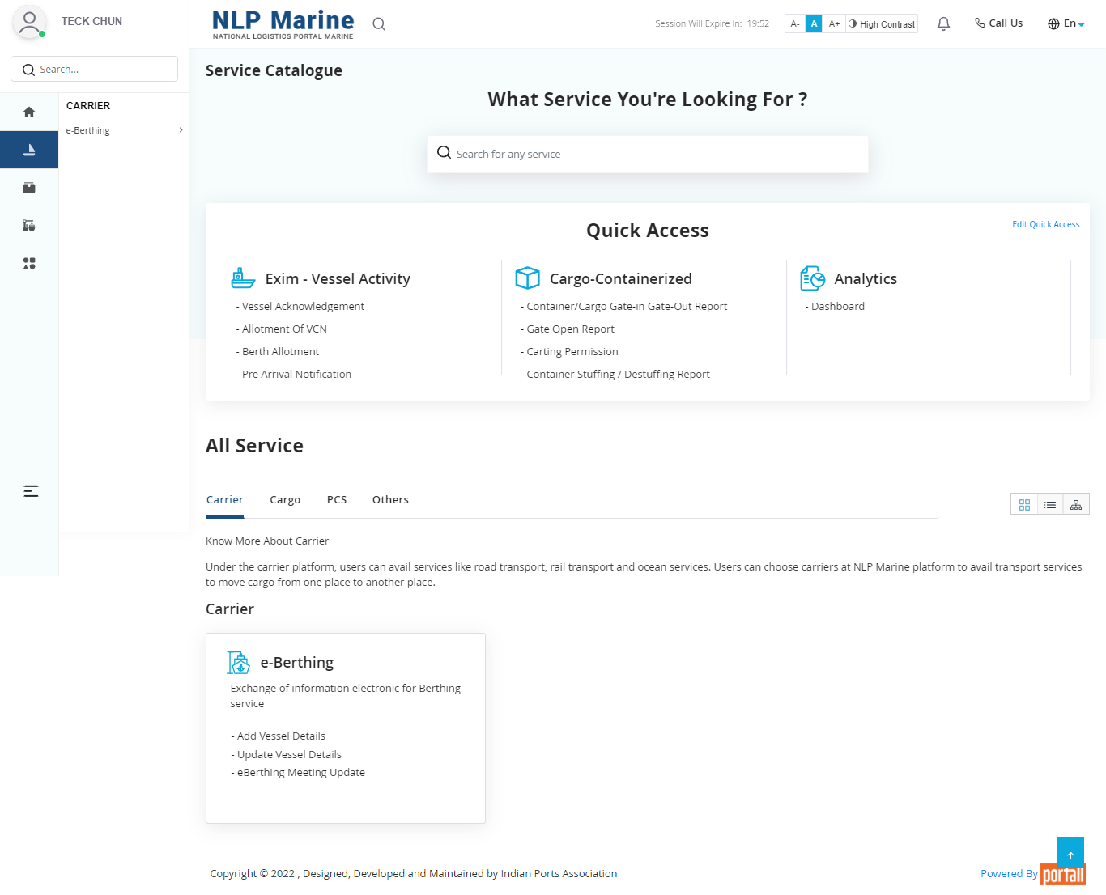

Step 3) Port user need to click carrier tab & and after that need to click e-Berthing.

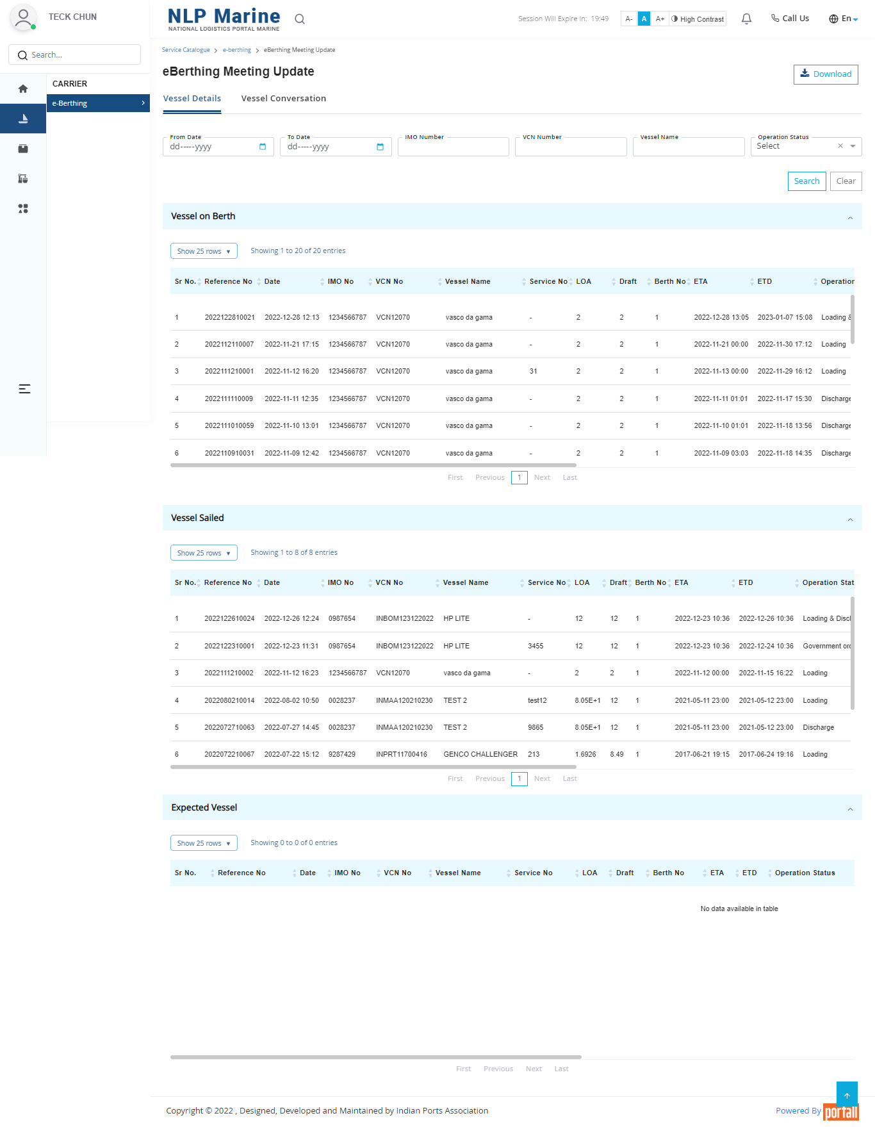

Step 4) Shipping Agent will select terminal & add vessel details ,cargo details & other mandatory details to list vessel on portal.

Step 4) This page - Vessel Details & Vessel Conversation - is accessible to both shipping agents and port users.

So, in the vessel detail tab, the shipping agent will add vessel details, and in the conversation chat option, both the shipping agent and the port agent will hold a chat meeting to discuss berthing preferences based on urgency.

This is only the User manual for the **E-Berthing module**. The goal of this document was to collect all the flow and information related to e-Berthing module specifically for NLP Marine User who want to opt e-Berthing meeting related services from NLP Marine.

Please refer to the **TRAINING & USER GUIDE** on the landing page for the rest of the Module/Flow User manuals, which are directly accessible from the NLP Marine portal landing page.

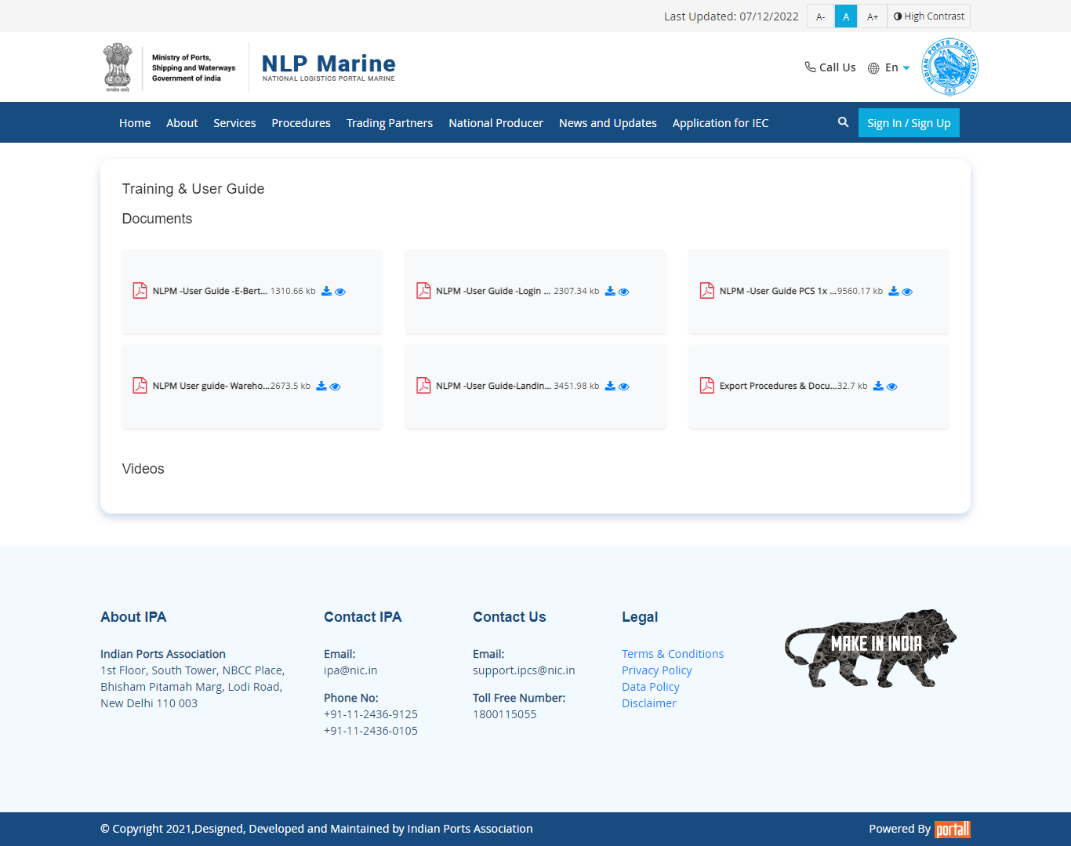

Please reach out to our Customer Support team if need any more assistance on NLP Marine.

**Email Id:** [**nlpsupport@portall.in**](mailto:nlpsupport@portall.in)

**Toll Free Number:** 1800115055

**Contact Detail:** +91-11-24369125, +91-11-2436-0105