**MakeMyTrip – Modified Logo & Where2Go Link Integration**

**User Story**

* The scope of this user story is to **make a new company logo**. The client also wants to **add a new link ("Where2Go")** after the logo.
* Please refer to the **modified logo in the mockup** and complete all the subtasks.

**Acceptance Criteria:**

1. Upon clicking on the **‘Where2Go’** link, the system should **navigate to the Where2Go-by-MakeMyTrip page**.
2. The **Where2Go-by-MakeMyTrip page** should open in a **new window/tab**.
3. The **tab title** should display:  
   "Where2Go by Makemytrip | Explore Destination | Plan your trip"

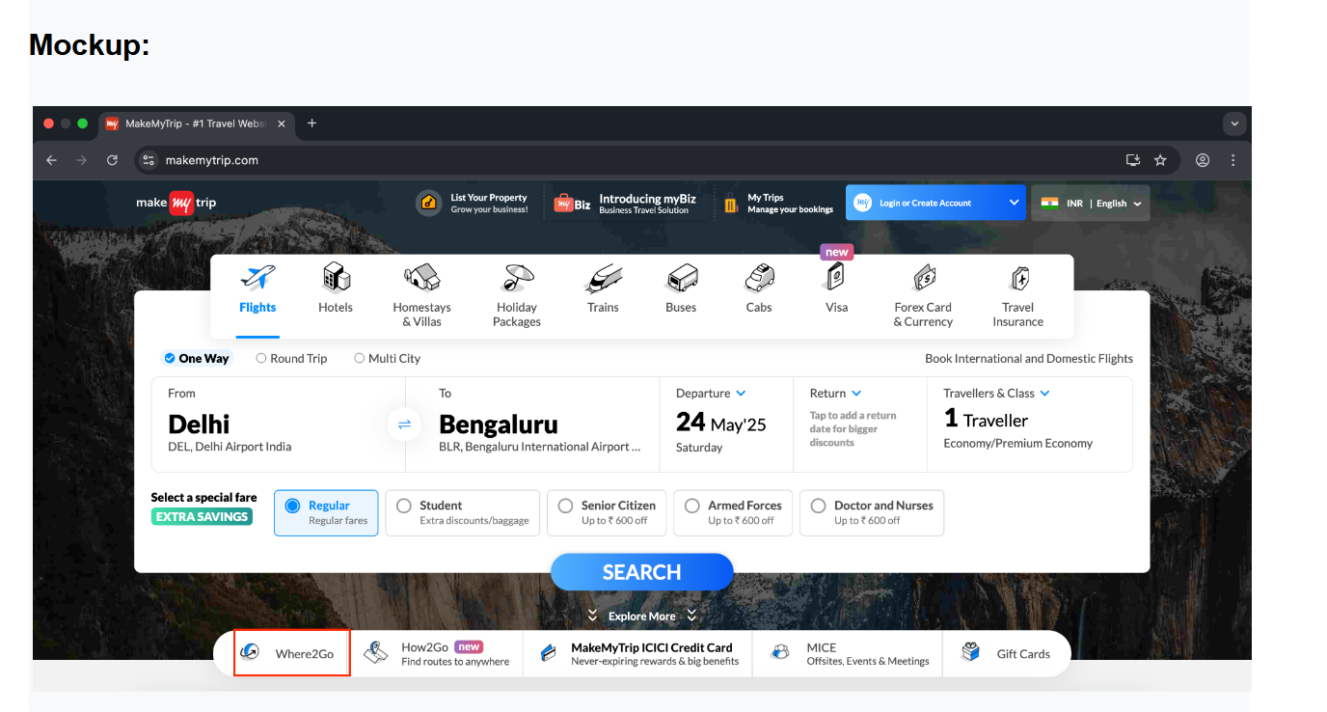

**Subtasks:**

**1. Write the Test Scenario and Test Cases**

Based on the acceptance criteria, create test scenarios and cases for the newly implemented functionality.

**2. Report a Bug Found During Testing**

While testing, you found a **bug**: When a user clicks on the **‘Explore the world’** link, the system throws an **"Unauthorized user"** error.Provide the following bug details:

* **Severity of the bug:**
* **Bug title:**
* **Steps to reproduce:**
* **Actual Result:**
* **Expected Result:**

