**Aurora - Now**

Weather Detection App

**Made By: Anagha Jain**

**Mentor: Mr Muddhit Baid**

**Program: Winter of Mentorship by UAcelt**

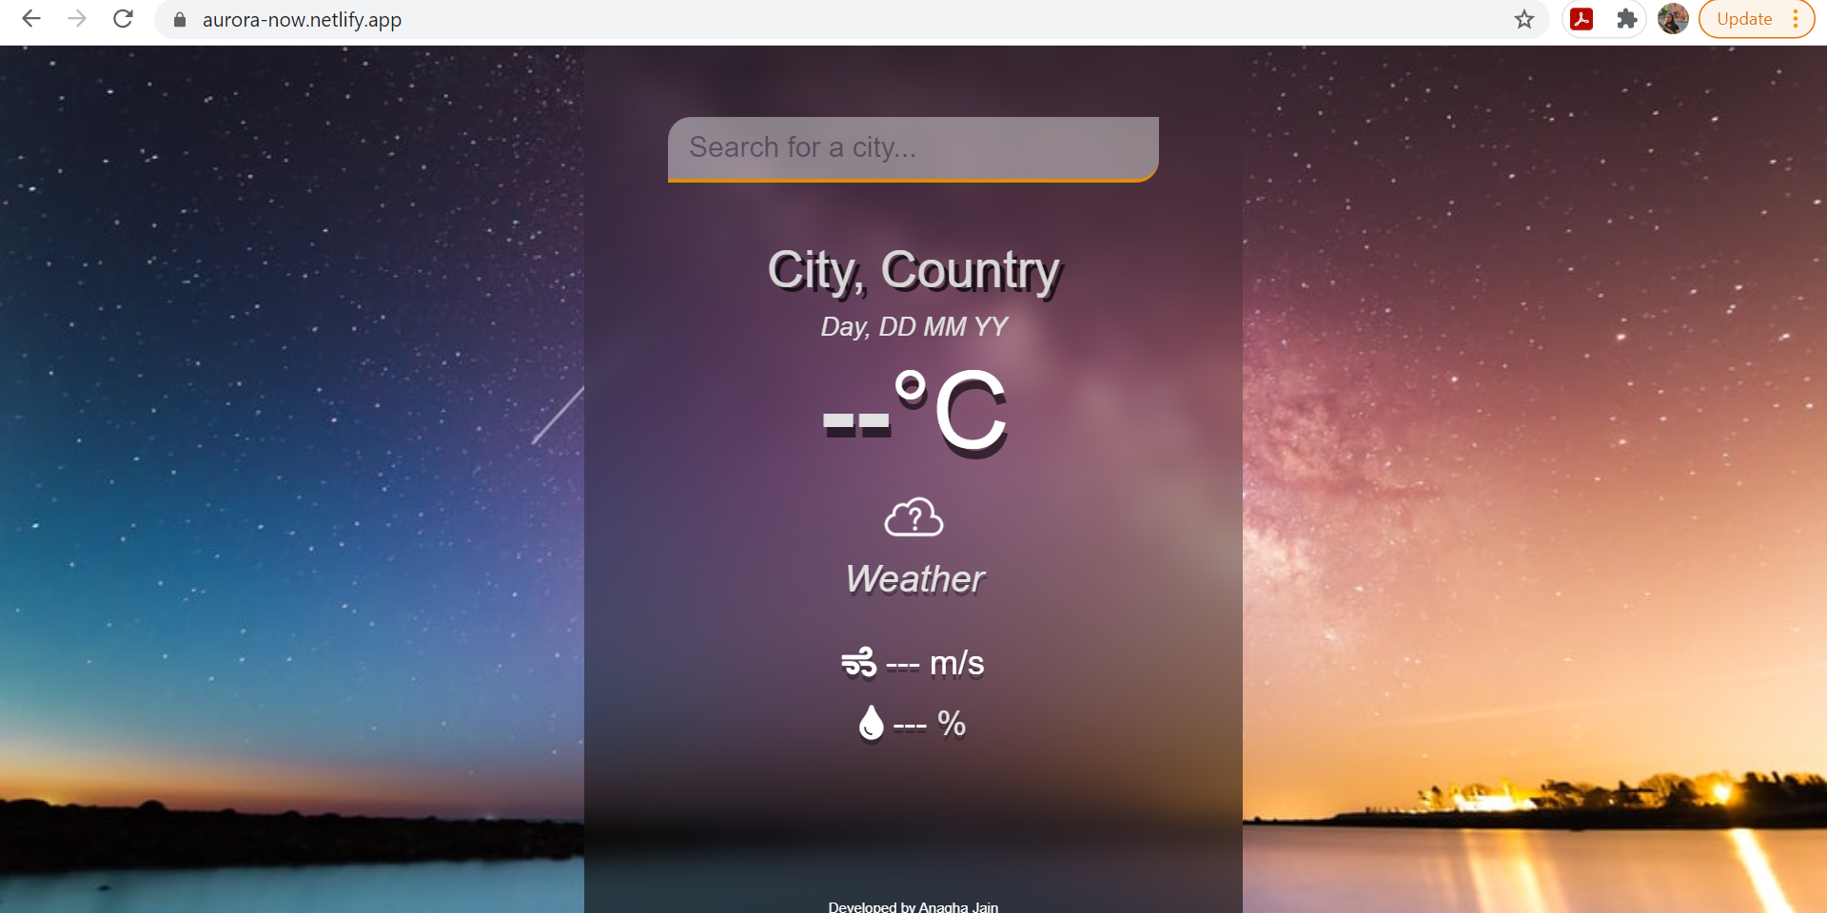

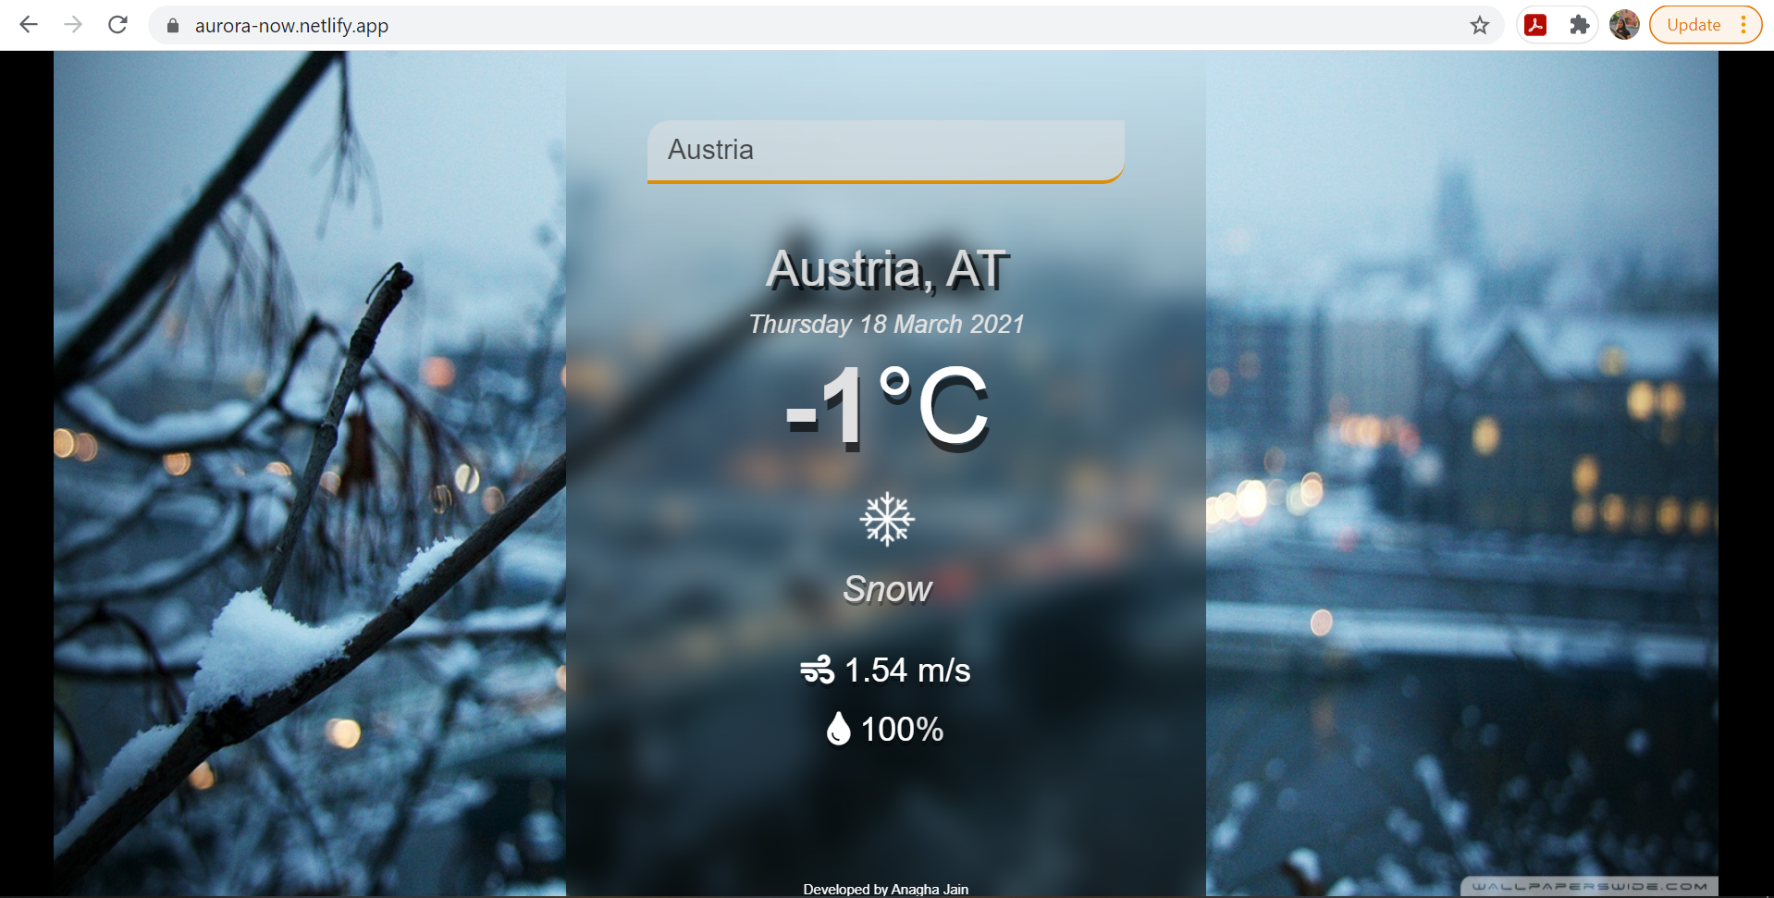

# Acknowledgements

I would like to thank my mentor, Mr Muddhit Baid. He was a great mentor throughout the duration of 8 weeks. He made sure all of us were up to date with our weekly tasks without any drop in our enthusiasm level. Our mentor’s constant support and promptness made the weather detection app a great success. I could ask my queries any time and he made sure it is solved at the earliest.

I would also like to extend my token of gratitude to the UAcelt team who came up with this mentorship program and gave me an opportunity to get my hands dirty in web development! I learnt a lot in this mentorship program and look forward for more programs from UAcelt in future.

Lastly, I thank my family for always supporting me and rooting on for me in this coding journey. They are the source of my success; may it be big or small.

# Summary

I was a part of the Weather Detection App team. In the program we were required to make a weather app using Web Development. The page used an API key which made the page responsive. On entering the name of a city or state, we could get live weather details such as temperature, kind of weather and the low/high of the place. My page also changed its background as per the weather conditions.

The 8 weeks mentorship program started in phases, we learnt Git and GitHub, HTML, CSS and JavaScript. The weather app was an implementation of our learnings.

In the app, there is a text box where the name of the city is to be searched and the page would provide the following by making use of the API calls:

* Day
* Date
* Temperature
* Weather
* Wind speed
* Humidity

My project also changed its background as per the weather conditions giving the user an interesting feel while searching.

I named my weather app – Aurora-Now, which means “dawn” or the “goddess of dawn” as this project was like the new beginning for me into the field of development. I implemented my WebD skills properly into a full-fledged project for the first time and it is just the beginning.

# Project Report

I made the Weather Detection App under the mentorship of Mr Muddhit Baid, mentor of the Weather Detection App. The name of my app is Aurora-Now. The word Aurora means “dawn, goddess of the dawn”. This program was the dawn of development for me, thus the name.

It was a program for beginners as well as seeking to make a web development project. I had some prior knowledge in Web Development but was not very confident while applying them. I struggled quite a bit and really wished for some hands-on practice and project implementation. This is where the Winter of Code by UAcelt really helped me and thus the name also.

* **1st Phase – 1st week** –

We learnt Git and GitHub. A Udacity course really helped me learn the basis of git and also provided cheat sheets for future reference. The Udacity course was great and a great help.

* **2nd Phase – 2nd, 3rd and 4th week**

Our mentor provided us with links and resources for learning HTML, CSS and JavaScript. Many resources and YouTube videos were shared which helped us make our foundation stronger in Web Development.

* **3rd Phase – 5th, 6th, 7th week**

We got videos on how to proceed with the project. The project called for calling of the API key and the application of the same. The API key were a little tricky for me and caused some confusion while coding as well. Our mentor helped us by conducting a session on the API keys and explaining how the calls work in our JavaScript file.

* **4rd Phase – 8th week**

By the 8th week, we had our projects ready but all of us were enthusiastic to implement our own unique touch and add some more functionalities. I tried to experiment with the background. In my project, the background changes as per the weather conditions mentioned on the screen. I wish to implement the usage of google location so that my main page doesn’t look blank when nothing is inputted. In this week we also deployed our site onto Netlify page and generated the site link. The links are mentioned further in the report.

In my app, there is a text box where the name of the city is to be searched and the page would provide the following by making use of the API calls:

* Day
* Date
* Temperature
* Weather
* Wind speed
* Humidity

We wrote the HTML file, giving the file the basic framework. The CSS provided the styles. I tried to learn new CSS commands and styling techniques. The JS file had all the functionalities of the app. The API calls were a part of the JS file. API was all new to me and I learnt immensely with the help of this project. To give my unique touch, I added some extra JS commands to my file which changed the background image as per the weather outputted. This can also be viewed on the first page of my report.

The entire journey was great and I learnt a lot. Our mentor conducted regular sessions for us so that we can present our progress and also solve our doubts. I struggled while coding in the JS file for a while. I made mistakes like adding extra spaces and wrong commas which resulted in catastrophe sometimes. Muddhit bhaiya was always really prompt when it came to solving our queries and debugging our code.

All in all, I had a great experience and I am looking forward for more such programs from UAcelt.

# Links

You can check the weather of any place NOW!!

Use this site link : <https://aurora-now.netlify.app/>

Do you want to see the framework behind these sites?? Check out my GitHub repository now! <https://github.com/AnaghaJain/WeatherDetectionApp.git>

You can connect with me on LinkedIn - <https://www.linkedin.com/in/anaghajain/>

# Conclusion

The project, weather detection App, was a project which implemented WebD. During the course of 8 weeks, we learnt Git and GitHub, WebD frameworks like HTML, CSS, JavaScript. Then during the 3rd phase of the course, we made the projects using the resources and with the aid of our mentor, Mr Muddhit Baid. We also gave the project our own special touches in the end by adding something different from the others. Mine had changing backgrounds. As per the weather conditions in the inputted city/state, the background of site changed. After the completion of our project, all the mentees deployed our projects using Netlify. The entire journey was great! I learnt a lot and had a lot of fun! I am looking forward to more sessions like these from UAcelt.

# Future Scope

I wish to make more changes to the project. Some being –

1. Wish to add the feature in which the google provides the live location and my app give the correct output as per that.
2. Add more flexboxes so that the page is more dynamic and compatible on all devices.
3. I would love to try to add more temperature feature on my app.

# References

These are some of the references provided to us and the references used by me.

1. <https://www.youtube.com/watch?v=n4dtwWgRueI&t=1295s>
2. <https://www.freecodecamp.org/learn/responsive-web-design/basic-html-and-html5/>
3. <https://youtu.be/iR5WIknxdkY>
4. <https://github.com/manifestinteractive/weather-underground-icons/tree/master/dist/icons>