Name: Anagha Jayaraj

Sem, Branch, Section: S5, CSE A

Roll no: 14

**ROUGH RECORD**

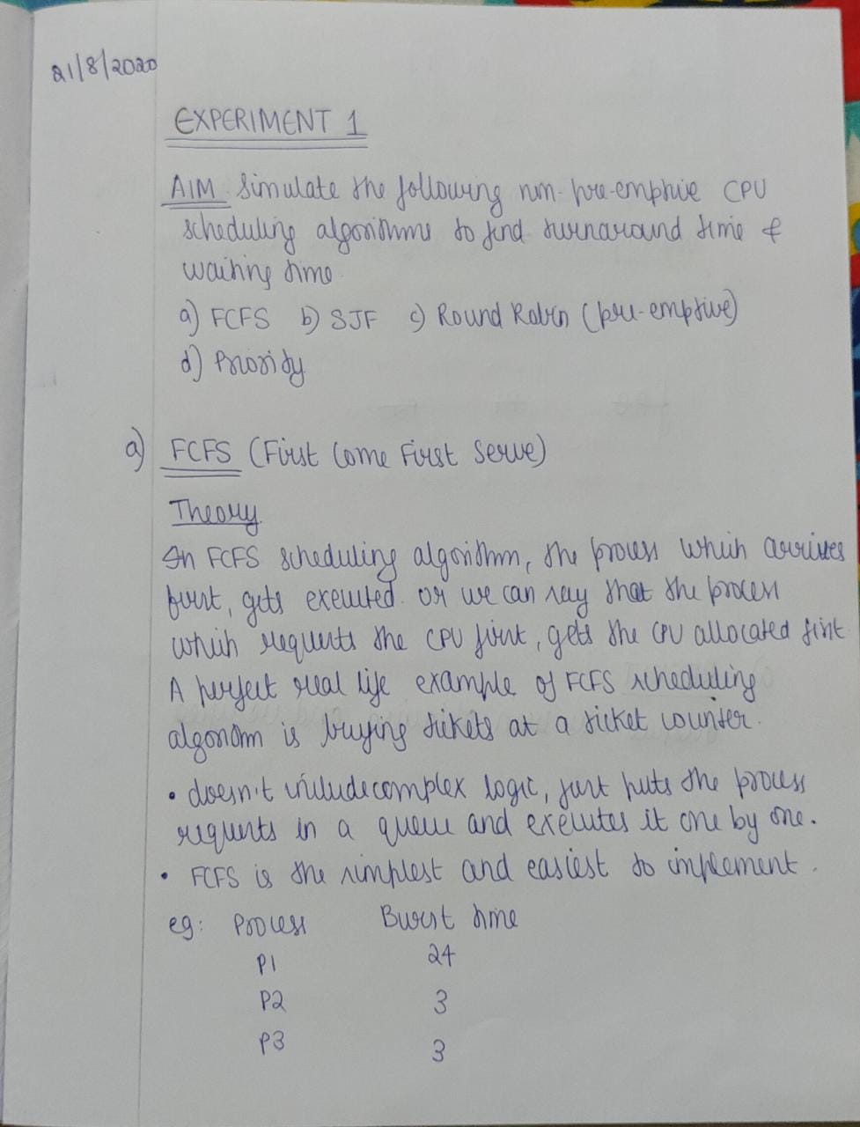

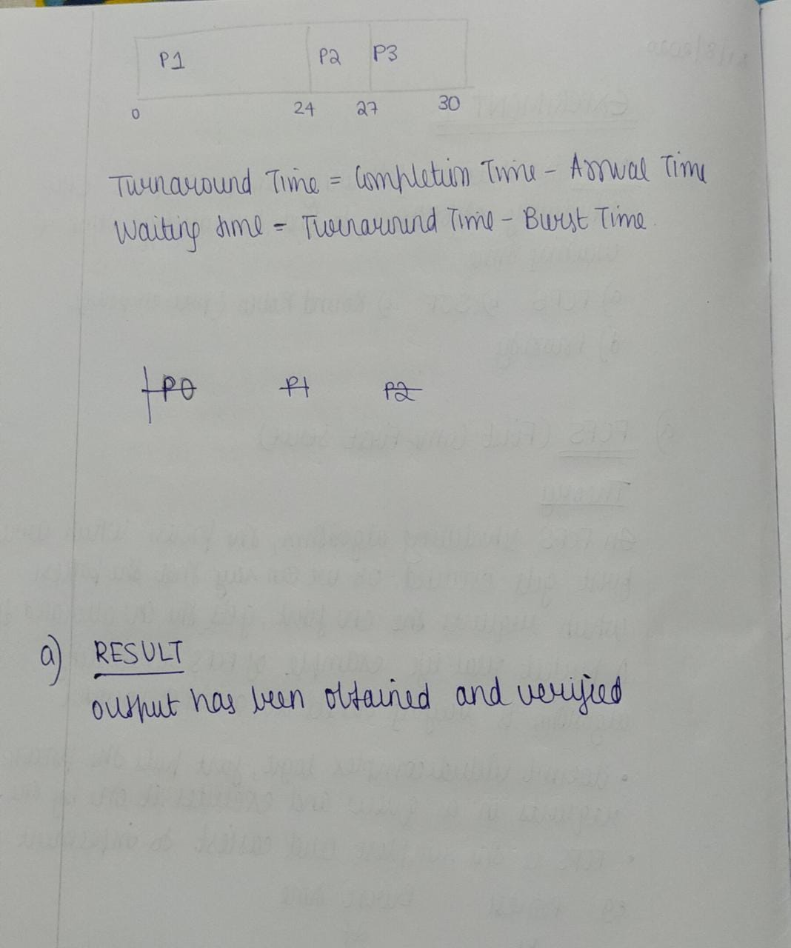

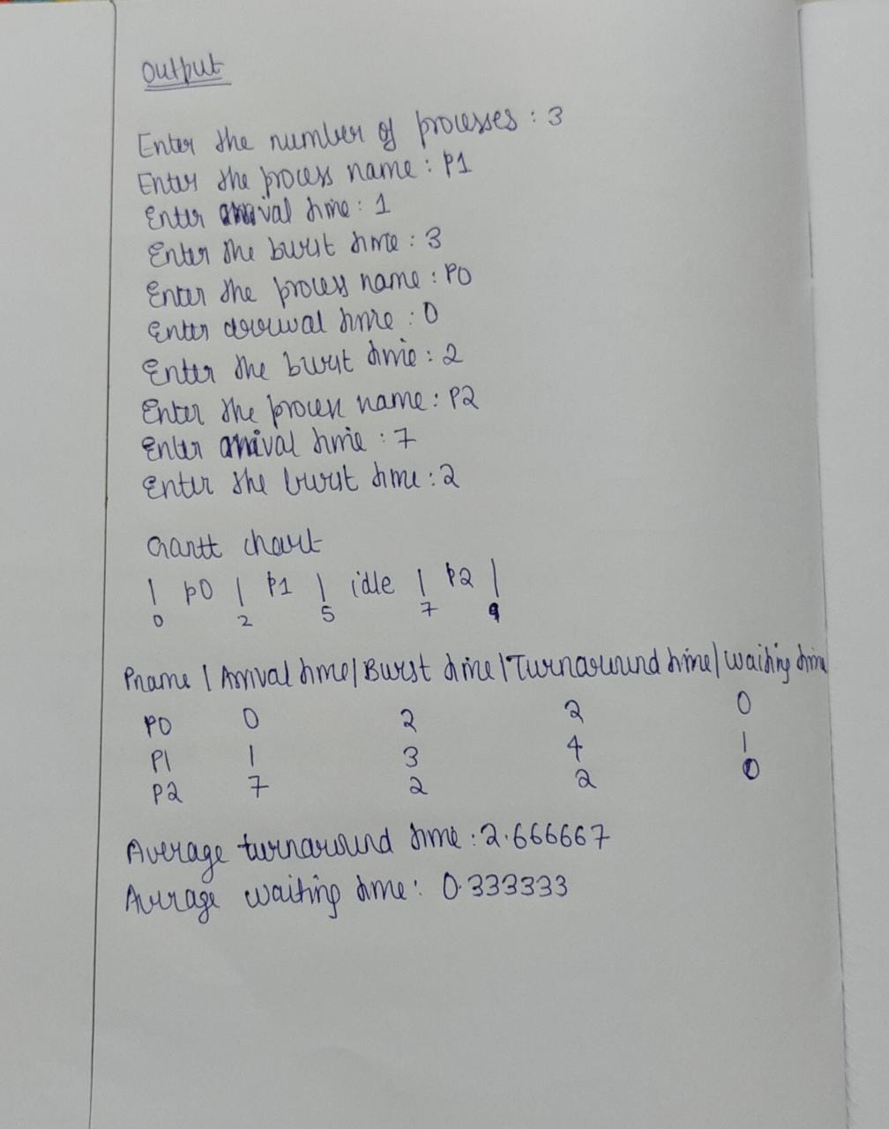

**PROGRAM CODE**

#include <stdio.h>

#include<string.h>

struct process{

char pname[50];

int at,bt,wt,tt,status;

}p[30];

struct gantt{

char pname[50];

int st,ct;

}g[30];

int main()

{

int n,i,j,k,temp,idle,count;

float avgwt=0.0,avgtt=0.0;

char tempname[30];

printf("Enter the number of processes: ");

scanf("%d", &n);

for(i=0;i<n;i++)

{

printf("Enter the process name: ");

scanf("%s",&p[i].pname);

printf("Enter arrival time: ");

scanf("%d",&p[i].at);

printf("Enter the burst time: ");

scanf("%d",&p[i].bt);

p[i].status=0;

}

count=n;

for (i = 0; i < n; ++i)

{

for (j = i + 1; j < n; ++j)

{

if (p[i].at > p[j].at)

{

temp = p[i].at;

p[i].at = p[j].at;

p[j].at = temp;

temp = p[i].bt;

p[i].bt = p[j].bt;

p[j].bt = temp;

strcpy(tempname,p[i].pname);

strcpy(p[i].pname,p[j].pname);

strcpy(p[j].pname, tempname);

}

}

}

for(i=0,j=0,k=-1;j<n;)

{

if((p[j].at<=i)&&(p[j].status==0))

{ k++;

idle=0;

strcpy(g[k].pname,p[j].pname);

g[k].st=i;

g[k].ct=i+p[j].bt;

p[j].tt = g[k].ct-p[j].at;

p[j].wt=p[j].tt-p[j].bt;

p[j].status=1;

i=g[k].ct;

j++;

}

else

{

if(idle==0)

{ k++;

strcpy(g[k].pname,"idle");

g[k].st=i;

i++; idle=1;

count++;g[k].ct=i;

}

else

{

g[k].ct=i+1;

//k++;

i++;

}

}

}

printf("\n\nGantt Chart \n");

for(i=0;i<count;i++)

{

printf("| %s ", g[i].pname);

}

printf("|\n");

printf("%d ", g[0].st);

for(i=0;i<count;i++)

{

printf("%d ", g[i].ct);

}

printf("\n\n");

printf("Pname|Arrival time|Burst time|Turnaround time|Waiting time \n ");

for(i=0;i<n;i++)

{

printf("%s ", p[i].pname);

printf("%d ", p[i].at);

printf("%d ", p[i].bt);

printf("%d ", p[i].tt);

printf("%d \n ", p[i].wt);

avgtt=avgtt+p[i].tt;

avgwt=avgwt+p[i].wt;

}

printf("\nAverage turnaround time: %f \n", avgtt/n);

printf("Average waiting time: %f\n\n ", avgwt/n);

return 0;

}

**OUTPUT**

