Name: Anagha Jayaraj

Sem, branch : S5, CSE A

Roll no: 14

SJF NON PRE-EMPTIVE

Rough Record

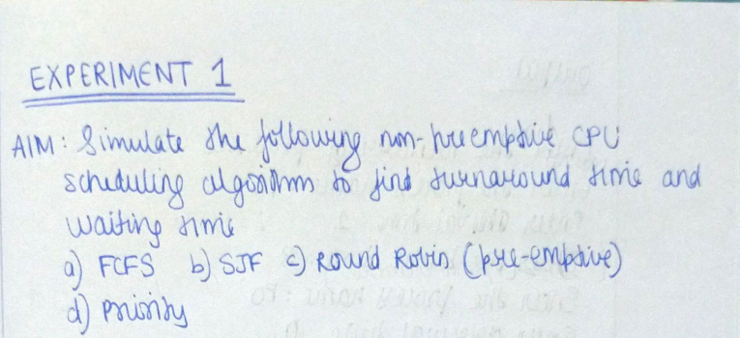

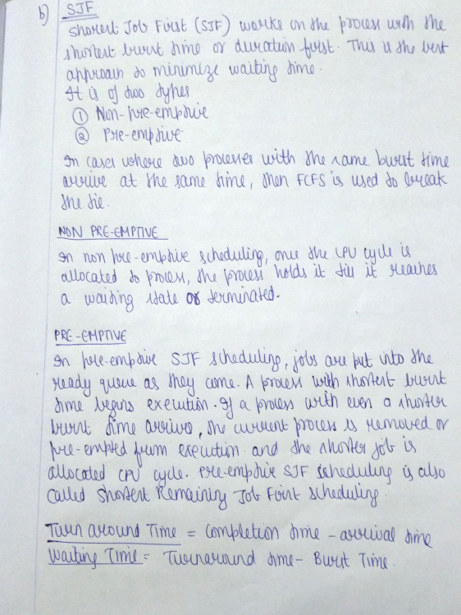

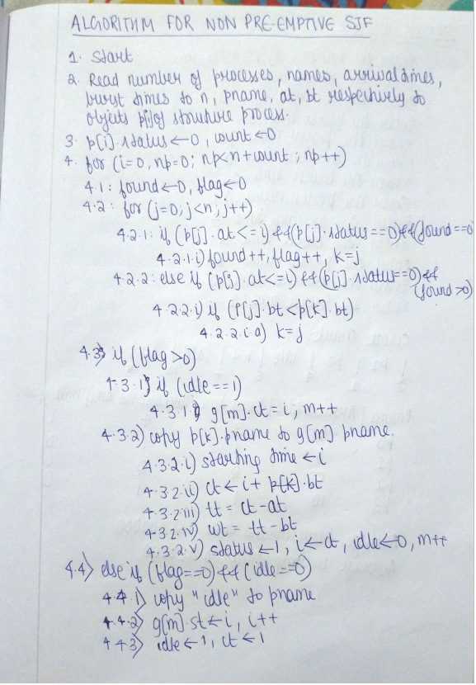

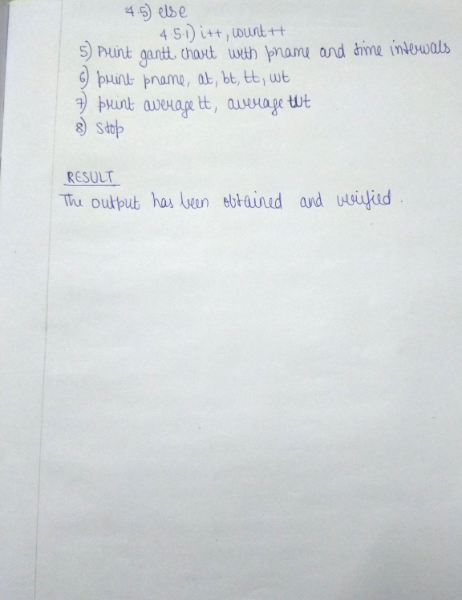

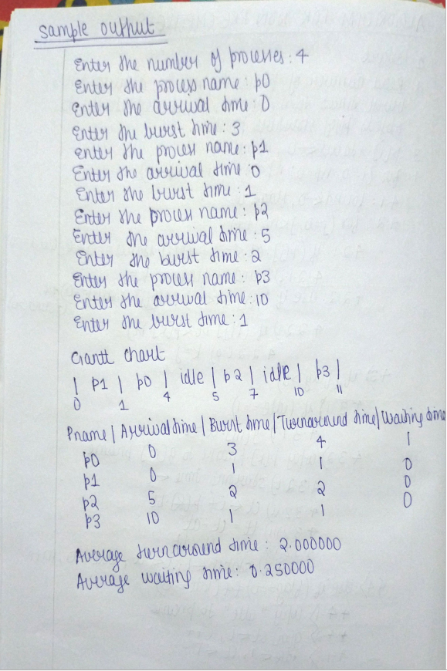

PROGRAM CODE

#include<string.h>

struct process{

char pname[50];

int at,bt,wt,tt,status;

}p[30];

struct gantt{

char pname[50];

int st,ct;

}g[30];

int main()

{

int n,m=0,i=0,j=0,k=0,idle=0,count=0,found=0,flag=0,np=0;

float avgwt=0.0,avgtt=0.0;

int loop;

printf("Enter the number of processes: ");

scanf("%d", &n);

for(i=0;i<n;i++)

{

printf("Enter the process name: ");

scanf("%s",&p[i].pname);

printf("Enter arrival time: ");

scanf("%d",&p[i].at);

printf("Enter the burst time: ");

scanf("%d",&p[i].bt);

p[i].status=0;

}

loop=n;

for(i=0,np=0;np<n+count;np++)

{

found=0;

flag=0;

for(j=0;j<n;j++)

{

if ((p[j].at<=i) && (p[j].status==0) && (found==0))

{

found++;

flag++;

k=j;

}

else if((p[j].at<=i)&&(p[j].status==0)&&(found>0))

{

if(p[j].bt<p[k].bt)

{

k=j;

}

}

}

if(flag>0)

{

if (idle==1)

{

g[m].ct=i;

m++;

}

strcpy(g[m].pname,p[k].pname);

g[m].st=i;

g[m].ct=i+p[k].bt;

p[k].tt = g[m].ct-p[k].at;

p[k].wt=p[k].tt-p[k].bt;

p[k].status=1;

i=g[m].ct;

idle=0;

//k++;

m++;

}

else if(flag==0 && idle==0)

{

strcpy(g[m].pname,"idle");

g[m].st=i;

i++; idle=1;

count++;g[m].ct=i;

loop++;

}

else {

//g[k].ct=i+1;

//k++;

i++; count++;

}

}

printf("\n\nGantt Chart \n");

for(i=0;i<loop;i++)

{

printf("| %s ", g[i].pname);

}

printf("|\n");

printf("%d ", g[0].st);

for(i=0;i<loop;i++)

{

printf("%d ", g[i].ct);

}

printf("\n\n");

printf("Pname|Arrival time|Burst time|Turnaround time|Waiting time \n ");

for(i=0;i<n;i++)

{

printf("%s ", p[i].pname);

printf("%d ", p[i].at);

printf("%d ", p[i].bt);

printf("%d ", p[i].tt);

printf("%d \n ", p[i].wt);

avgtt=avgtt+p[i].tt;

avgwt=avgwt+p[i].wt;

}

printf("\nAverage turnaround time: %f \n", avgtt/n);

printf("Average waiting time: %f\n\n ", avgwt/n);

return 0;

}

OUTPUT SCREENSHOT

