Malaria Deaths in Africa: 2000-2014

**Insight 1)**  Kenya has the highest death rate for Malaria in African countries.

**Observation :** I select the darkest area on the geographical data graph which is Kenya, that indicates average death in the region per day is **76.43** and average death per year is **27,896** which is highest then Africa average ratio. Whereas 2003 has recorded a highest number of deaths. After 2010 the death count has reduced till 2014 as recorded.

**Conclusion:** In the initial years people suffered from Malaria from 2011 the death rate reduced.

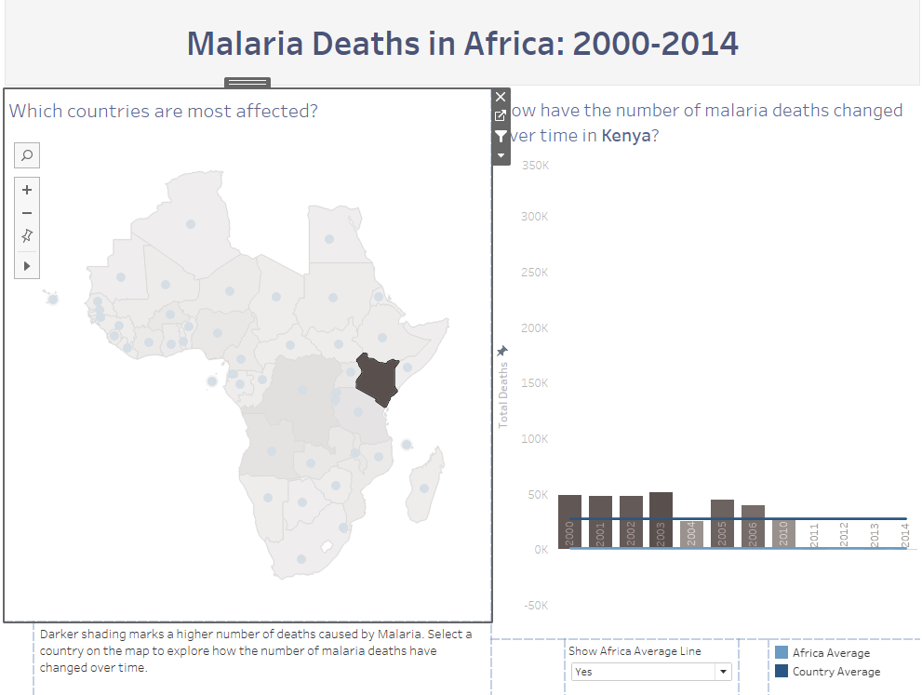

**Insight 2)** Death rate increasing every year in Democratic Republic of Congo

**Observation:**  I hover over the map and select this country in a map because it shows the increasing death rate.

Democratic Republic of Congo is one of the poorest countries in Africa. The country was in better shape from 2000 to 2003. From 2004 the death rate observed to be increasing every year, crossing the country average. The average death per year noted as of **15,203** with the average deaths per day is **41.65.**

**Conclusion:** Initial years the death rate was low and from 2004 it is increasing every year. The country is in need of more vaccine and Malaria prevention plan to work around.

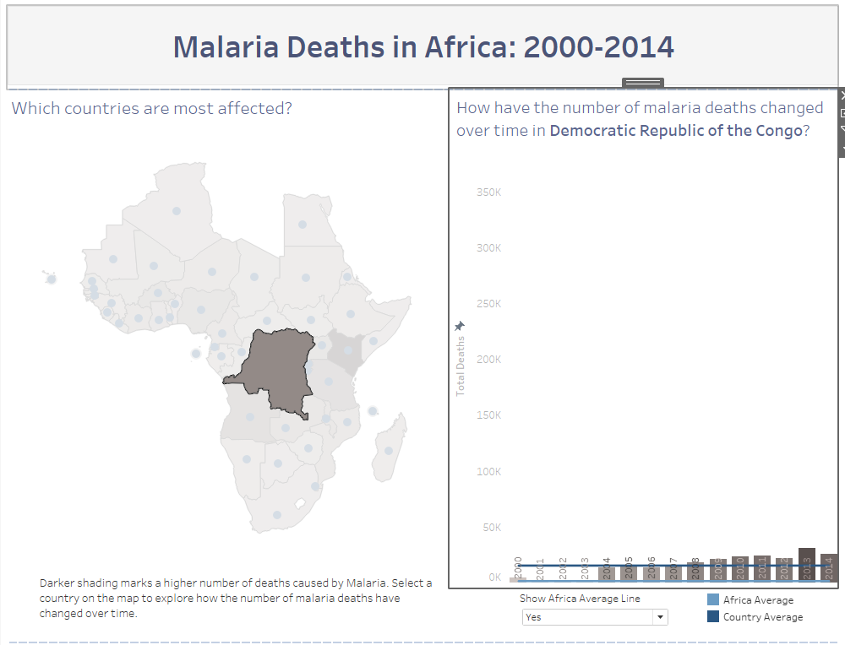

**Insight 3)** Algeria is least affected by Malaria.

**Observation:** I hover over the geographical map to find the lowest death rate per day and I select Algeria on the map.

Algeria is one of the country in Africa which has one death recorded in every year due to malaria. Which is surprising to believe with the other affected countries around.

**Conclusion:**  If the number to be believed then the country has Malaria vaccine or all the possible preventions to prevent Malaria.

