**AIM:**

To develop an interactive sales dashboard utilizing pivot tables, charts, timelines, and slicers is the aim of this activity. Users of this sales dashboard will be able to acquire insights into sales trends, product performance, and time-based variations by efficiently visualizing the sales statistics.

**INTRODUCTION:**

Source: [Kaggle](https://www.kaggle.com/)

Dataset: [Sales Data for Economic Data Analysis](https://www.kaggle.com/datasets/abhishekrp1517/sales-data-for-economic-data-analysis)

Overview of the Dataset:

(I have filtered out some unnecessary columns, such as (index, age, gender, etc.…)  and I have also included a new column named "Profit")

* The dataset comprises data on sales transactions, including information on the customer's country, and the goods sold.
* The dataset contains information on both the product's cost and the sales income, enabling estimates of profit and profit margins.
* The collection probably contains both descriptive and numerical information, needing different ways of analysis and visualization techniques.

**Column Descriptions:**

* Date: The date when the transaction took place is shown in this column. It might be used to monitor patterns over time or filter the data depending on particular days, months, or years.
* Country: This column displays the location of the transaction. It might be used to filter the data based on a particular nation or group of countries, or to analyse sales by country.
* Product: The products sold
* Quantity: The number of units of the product sold is shown in this column. It might be used to determine the overall income earned from a certain product or product category.
* Unit Cost: The cost to produce one unit of the product is shown in this column. It might be used to figure out profit margins.
* Unit Price: The price at which a single unit of the product was sold is shown in this column. It might be used to examine pricing tactics or to contrast the costs of various goods or product groups.
* Cost: This column represents the total cost of the products sold, which is calculated as the product of the quantity and the unit cost.

(Cost = Quantity x Unit Cost)

* Revenue: This column represents the total revenue generated by the sales, which is calculated as the product of the quantity and the unit price

(Revenue = Quantity x Unit Price)

* Profit: It is the amount of money left over after deducting all expenses from the revenue.

(Profit = Revenue – Cost)

Why choose this data set?

This dataset seems to offer an in-depth overview about sales transactions, with the ability to do different analyses, including those by product, customer, and region. With a dashboard, we can showcase the most important information in this dataset.

**PROCEDURE:**

1. PREPARING THE DATASET

Step 1: Gathering the appropriate dataset. In this case, a sales dataset from the internet, make sure that the data is well documented and clean.

Step 2: Filter out any unnecessary columns like index, gender, age etc...

[Column Heading (right click) > hide]

Step 3: Creating the profit column using the formula

[Profit = Revenue – Cost]

Step 4: Tabulate everything.

[Insert > Table] and ☑this table has headers

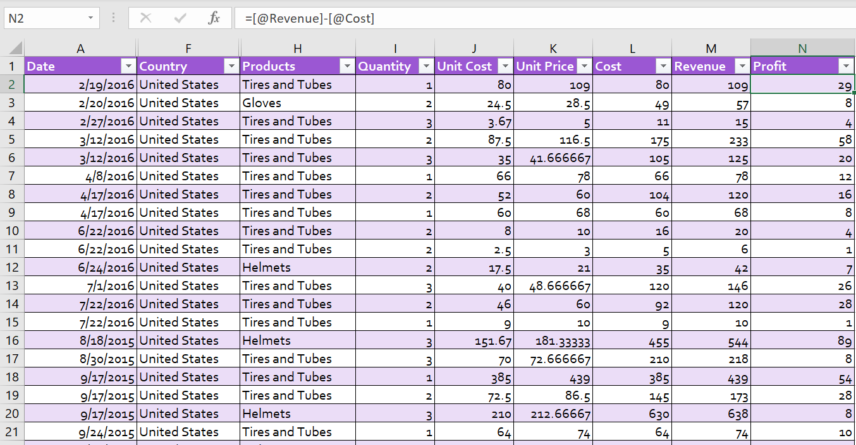

1. CREATING PIVOT TABLE SHEETS:

Step 1: Insert 3 pivot table sheets

[Select any table cell > Insert > Pivot tables] and ctrl + drag to create 2 more pivot table sheets.

1. PIVOT TABLE 1 (Profit by country and products):

Step 1: [PivotChart Analyze > Field List]

Step 2: In PivotTable Fields drag and place Country > Rows, Products > Columns and Profit>Values]

Step 3: Formatting all the values into currencies and removing the decimals.

Step 4: Sorting out the markets/countries. Right click on any cell in grand total and sort (largest to smallest)

Step 5: Similarly sort out all the products from largest to smallest profit.

Step 6: Creating a Pivot Chart [PivotChart Analyze > PivotChart > Stacked Column Chart]

Step 7: Add chart title, legend, axis titles and other chart elements as needed.

[Design > Chart layout > Add Chart element]

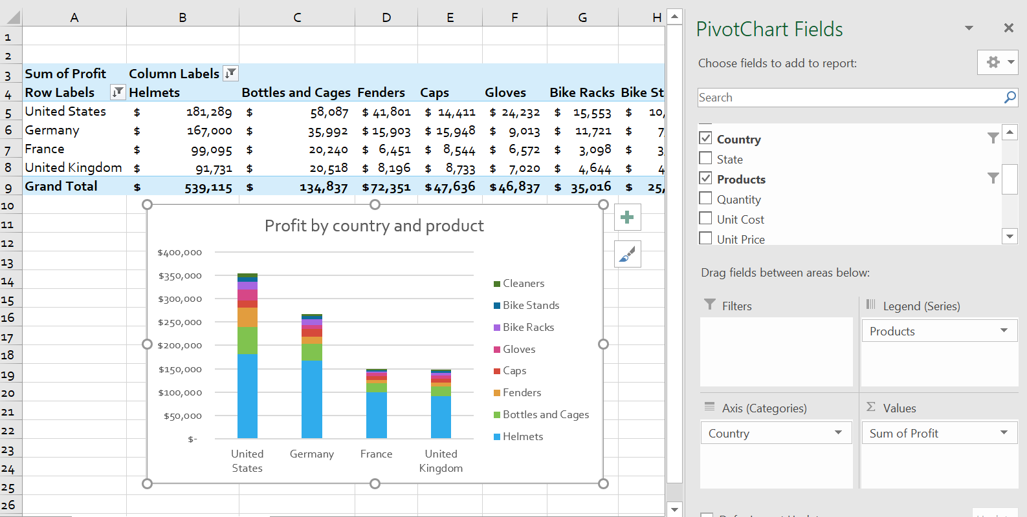

1. PIVOT TABLE 2 (Units sold each month):

Step 1: Open next pivot sheet [PivotChart Analyze > Field List]

Step 2: In PivotTable Fields drag and place Date > Rows and Quantity > Columns.

Step 3: Format the values by introducing commas and remove the decimal points.

Step 4: Creating a pivot chart. To represent data over time line charts, work the best.

[PivotChart Analyze > PivotChart >Line Chart with markers]

Step 5: Add chart title, legend, axis titles and other chart elements as needed.

[Design > Chart layout > Add Chart element]

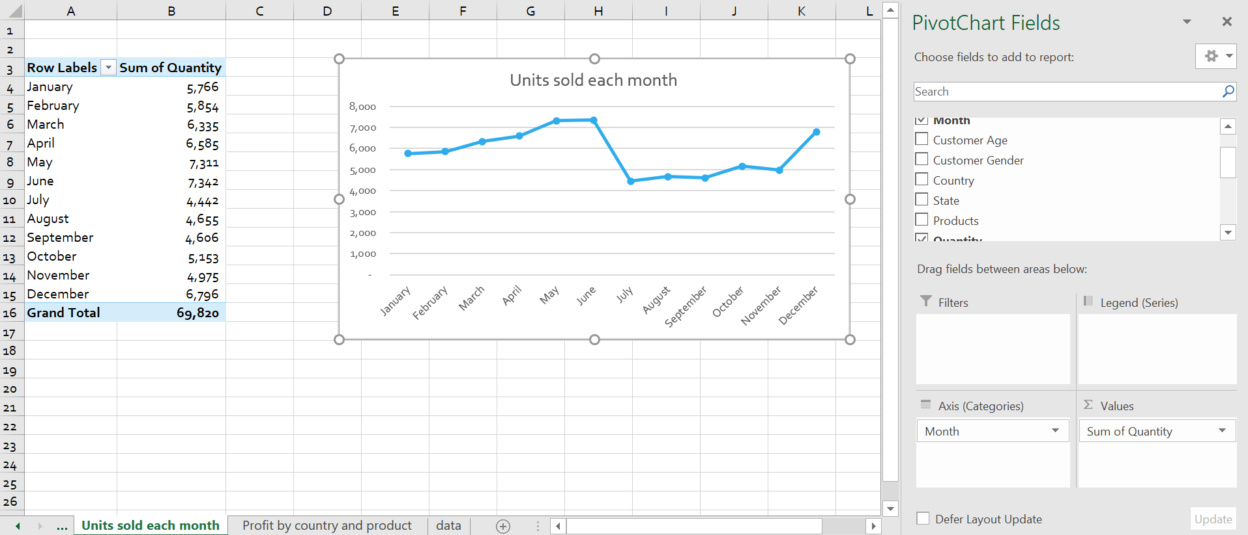

1. PIVOT TABLE 3 (Profit by Month):

Step 1: Follow the Step 1 as above and drag Months > Rows and Profit > Values.

Step 2: Set all the values to Currency and remove decimals.

Step 3: Creating a pivot chart [PivotChart Analyze > PivotChart >Line Chart with markers]

Step 4: Add chart title, legend, axis titles and other chart elements as needed.

[Design > Chart layout > Add Chart element]

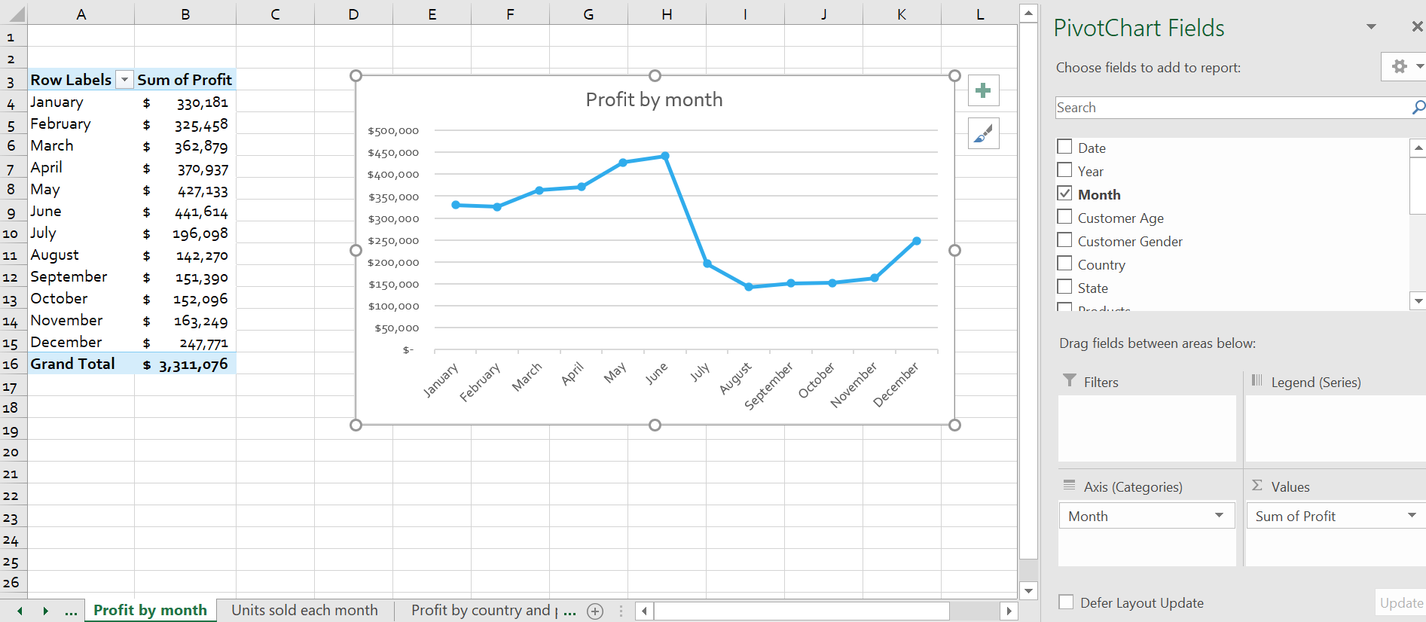

1. CREATING THE DASHBOARD:

Step 1: Add the logo and edit the sheet to create the appropriate dashboard.

Step 2: Copy & paste the 3 charts in it, adjust their dimensions and align them neatly in the dashboard.

Step 3: Adding the timeline:

[Select the column chart > PivotChart Analyze > Filter > Insert Timeline]

Step 4: Within the prompt ☑ ‘date’ and click on OK.

Step 5: Place the timeline neatly in the dashboard.

Step 6: Adding the slicers:

[Select the column chart > PivotChart Analyze > Filter > Insert Timeline]

Step 7: To filter data by country and product, within the prompt ☑ ‘country’ and ‘product’ and click on OK.

Step 8: Connecting slicers to all pivot charts to make the dashboard more interactive

[Right click on any slicer > Report Connections > ☑ all the pivot tables.

Do the same for the other slicer and timeline.

Step 9: Now when we click on the slicers, we can observe the changes in the charts.

1. ADJUSTING THE VIEW TO MAKE THE DASHBOARD LOOK LESS LIKE EXCEL

Step 1: [View > Show > Uncheck Gridlines, Headings and Formula Bar]

Step 2: Customize the theme or colors accordingly in Page layout > Themes

1. ADDING INTERACTIVE KEY FINANCIAL FIGURES TO THE DASHBOARD

Step 1: Dataset table > Pivot table > PivotTable Analyze > (Revenue, Quantity, Profit) > add it to Values

Step 2: Enter the newly found sum values in the dashboard by using ‘=’

Step 3: To make it interactive [PivotTable Analyze > Filter > Filter connections > ☑ everything.

**OUTPUT:**

Link for the dashboard: <https://1drv.ms/x/s!Aq7N_1DshPXkgmu9KFbQONkVqlNE>

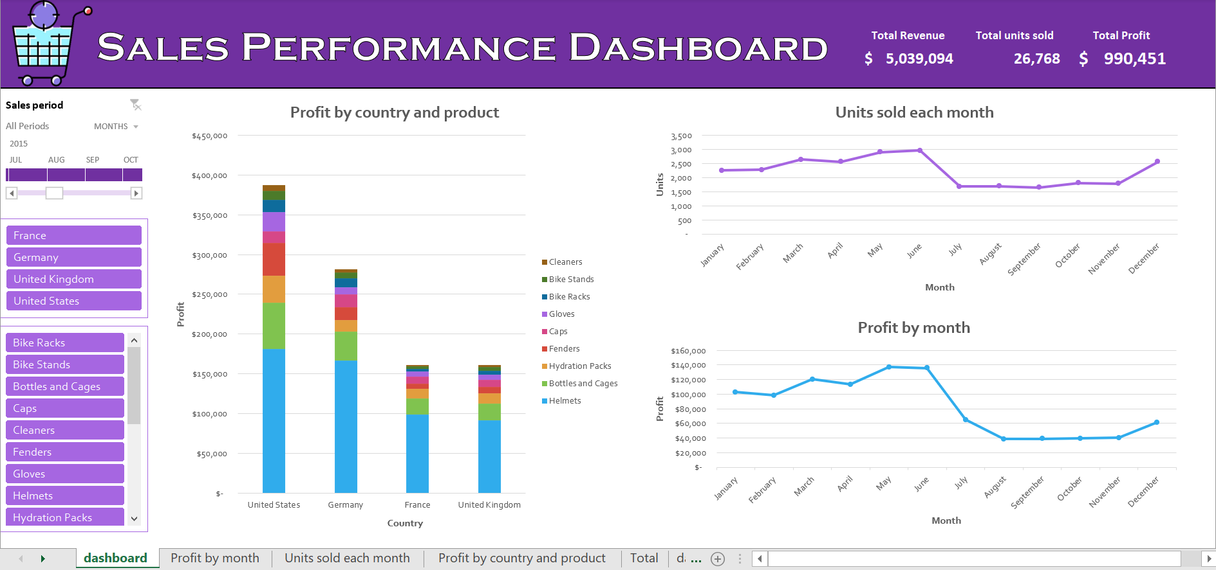

**CONCLUSION:**

Finally, we have created a dynamic and user-friendly interactive sales dashboard. This dashboard will allow users to easily dig into the sales statistics by utilizing pivot tables, charts, timelines, and slicers. The combination of these methods will give an efficient method of identifying critical sales trends and evaluating product performance.

**REFERENCES:**

[**https://www.kaggle.com/datasets/abhishekrp1517/sales-data-for-economic-data-analysis**](https://www.kaggle.com/datasets/abhishekrp1517/sales-data-for-economic-data-analysis)