**Project Name : Flipkart**

**Guided By :Aakash Handa Submitted By : Anagha P**

**TABLE OF CONTENT**

|  |  |  |
| --- | --- | --- |
| **S No** | **Content** | **Page No.** |
| 1 | Overview | 2 |
| 2 | Goal | 3 |
| 2.1 | Home page | 3 |
| 2.2 | Listing page | 4 |
| 2.3 | Detail page | 5 |
| 2.4 | Cart page | 6 |
| 2.5 | Login page | 7 |
| 2.6 | Payment section | 8 |
| 3 | Technologies used in Flipkart | 9 |

1. **Overview**

E-commerce means commercial transactions conducted electronically on the internet. E-commerce is revolutionizing the way we all shop in India.

**Flipkart** is an Indian e-commerce company .The company initially focused on online book sales before expanding into other product categories such as consumer electronics, fashion, home essentials, groceries, and lifestyle products.

1. **Goals**

Targets to fulfil for the completion of the projects.

1. **Home page**

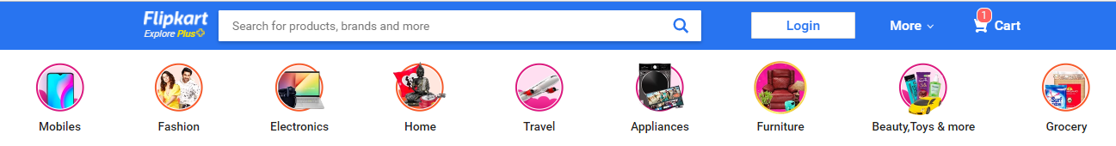

Home page consist of a navbar, content and a footer.Inside navbar provides the logo of flipkart,search option ,login button, more and cart.When a user enters the page they could directly search items using search bar or can directly click on the products mensioned in the content area.

If a user wishes to login to the page can visit the login button on navbar.Cart is like a wish list, saved items are stored here.

In the content section, available offers of the products are listed here.By clicking on it ,user can visit the various products with offers and can consume it too.

On footer section , provides the information about the company.

1. **Listing page**

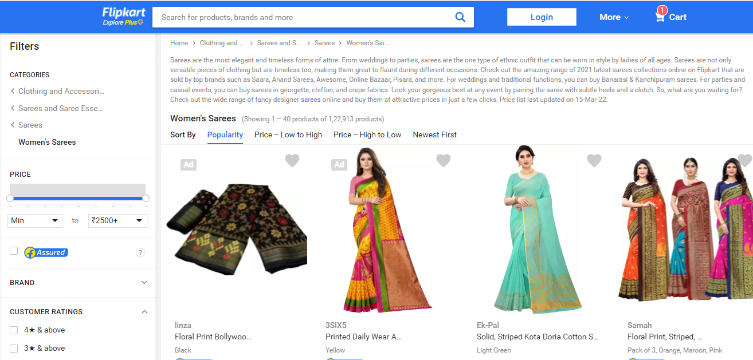

Listing page provide the list of the desired items .products can be categorised,viewed efficiently and can purchase without losing all available items and time based on the filtering feature. Items are filtered by

* Dress category
* Price
* Brand
* Customer rating
* Flipkart assurance

1. **Detail Page**

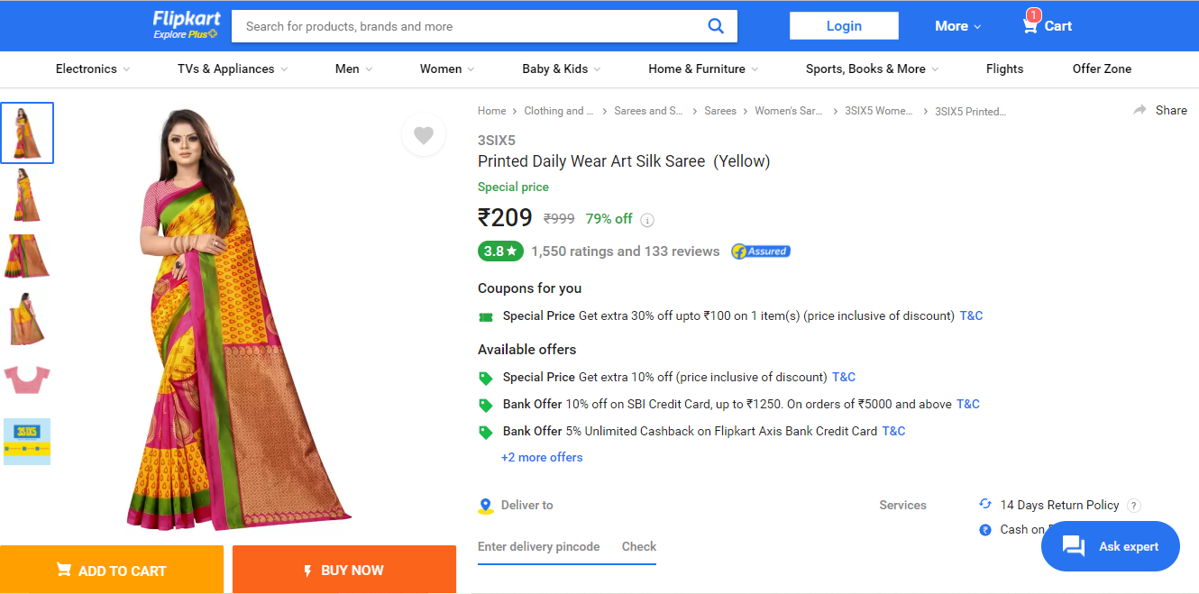

This page gives all the information regarding the item we want to buy.If the user wish to buy then he can go for by clicking buy now button or if he wish to add the item they selected can go for add to cart button .

User can even visit other products pages if necessary.

1. **Cart Page**

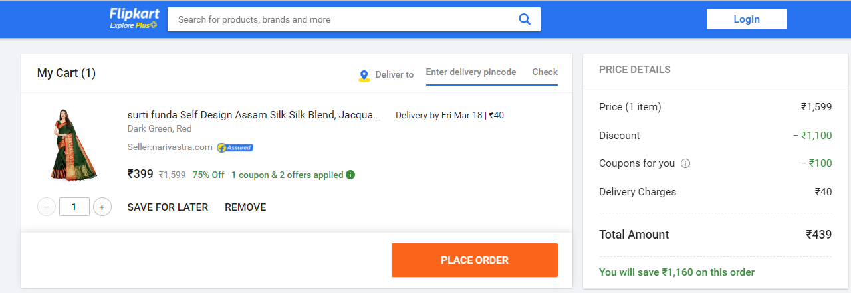

The saved products are listed here .We provide the information of product price, quantity of items needed ,can check whether we can place the order or not by mensioning the place pin code ,can remove the order also.

Product order can be placed by clicking the place order button.

1. **Login page**

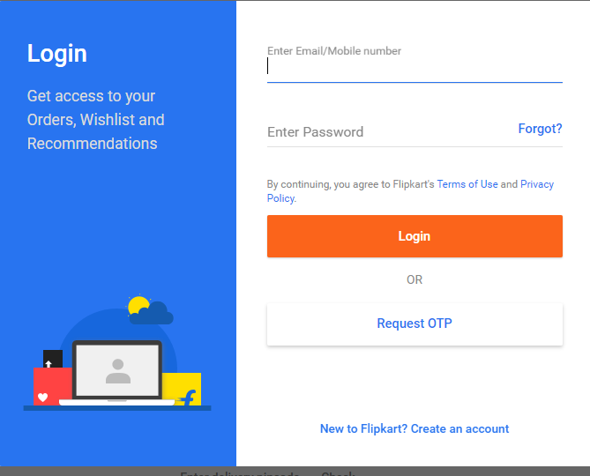

Before making payment user have to login the page by entering the email/mobile number and password.Then we can move to payment process.

1. **Payment section**

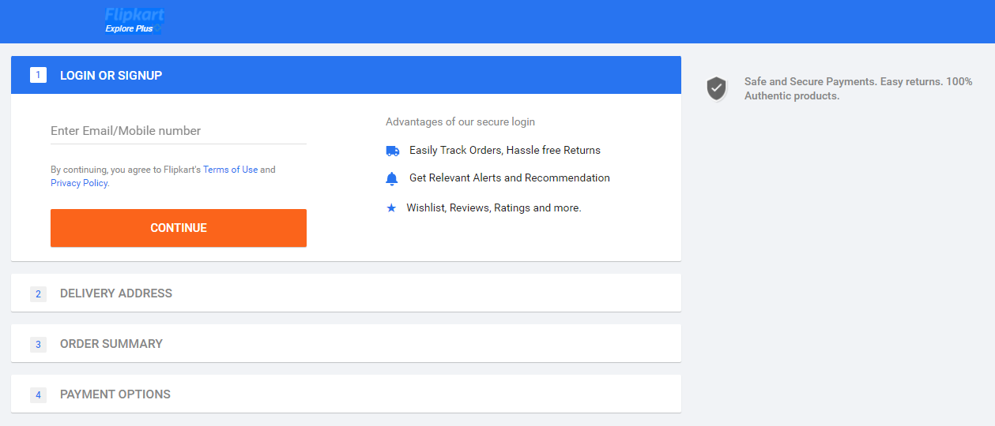

After the completion of payment process ,order is placed and will deliver the product on the mentioned date.

1. **Technologies used in Flipkart**

**Font**-**End:**

* HTML
* CSS
* Bootstrap
* React

**Dynamic:**

* Javascript

**Back-End:**

* Nodejs

**Database:**

* Mongodb

**Code compiler:**

* Visual Studio Code
* Git bash
* Git hub