SQL ASSIGNMENT

ANAGHA ARAVIND- 2437009

CODE 1: SELECT * FROM crime_scene_report LIMIT 5;

OUTPUT:

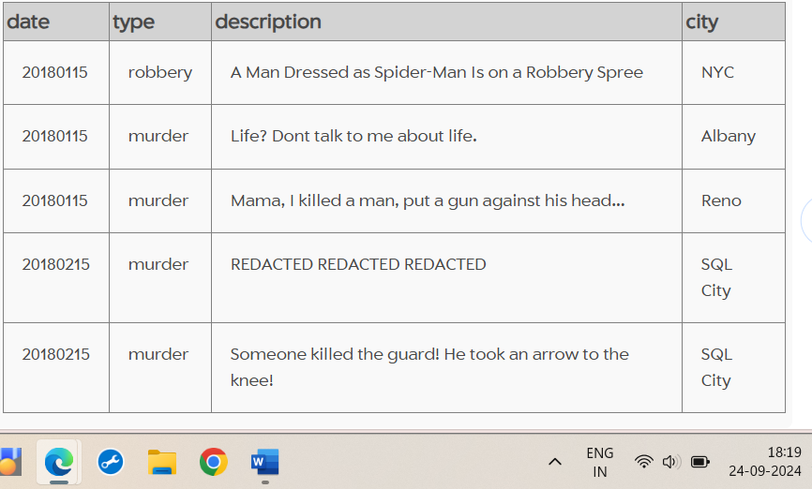

CODE 2: SELECT * FROM crime_scene_report WHERE type = "murder";

CODE 3: SELECT * FROM crime_scene_report WHERE type= "murder" AND date= 20180115 AND city ="SQL City" ;

OUTPUT 3:

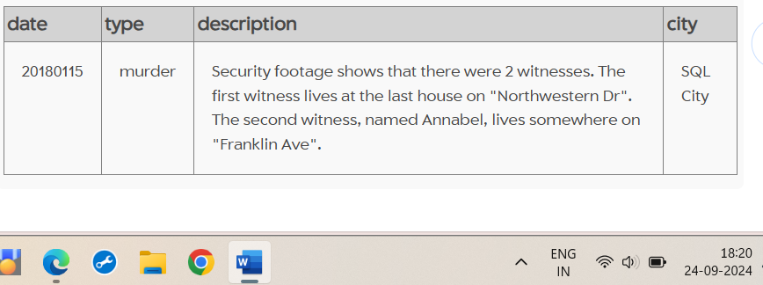

CODE 4: SELECT * FROM person LIMIT 5;

OUTPUT:

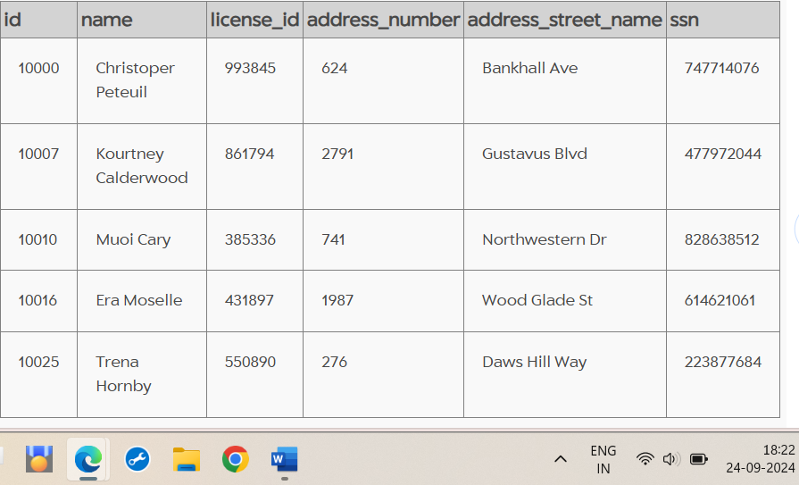

CODE 5: SELECT * FROM person WHERE address_street_name = "Northwestern Dr" ORDER BY address_number DESC;

OUTPUT:

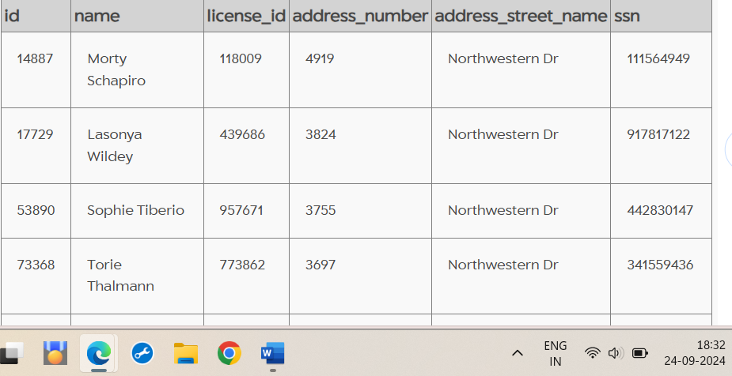

CODE 6: SELECT * FROM person WHERE name LIKE "%Annabel%" AND address_street_name = "Franklin Ave”;

OUTPUT:

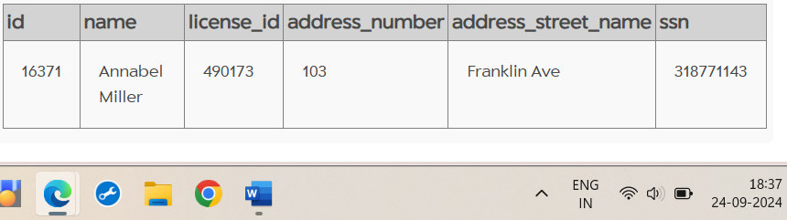

CODE 7: SELECT * FROM interview WHERE person_id IN ("14887", "16371");

OUTPUT:

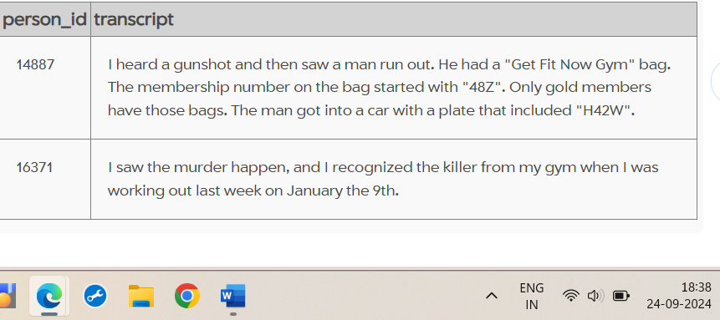

CODE 8: SELECT * FROM get_fit_now_check_in WHERE membership_id LIKE '48Z%' AND check_in_date = "20180109";

OUTPUT:

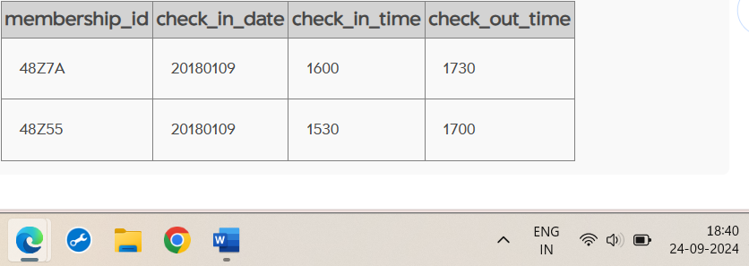

CODE 9: SELECT * FROM drivers_license WHERE gender = "male" AND plate_number LIKE '%H42W%';

OUTPUT: 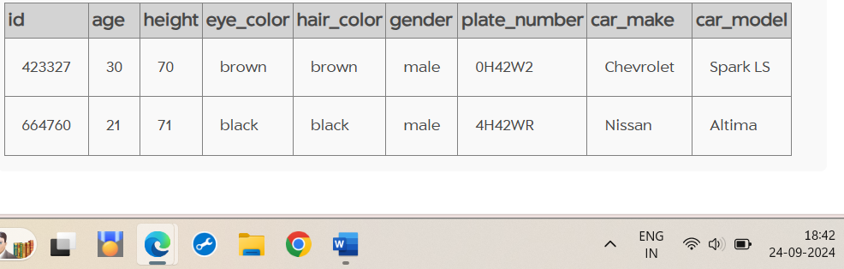

CODE 10: SELECT * FROM person WHERE license_id IN ("423327", "664760");

OUTPUT: 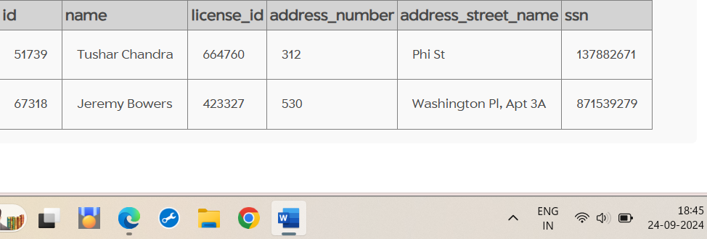

CODE 11: SELECT * FROM get_fit_now_member WHERE person_id IN ("51739", "67318");

OUTPUT: 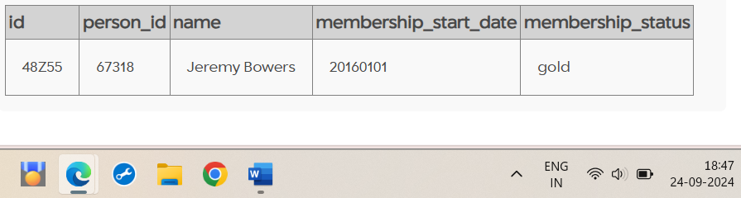

CODE 12: INSERT INTO solution VALUES (1, 'Jeremy Bowers'); SELECT value FROM solution;

OUTPUT: 