PREDICTIVE PATROL ROUTING USING REINFORCEMENT LEARNING: A TEMPORAL-SPATIAL CRIME-AWARE APPROACH

A PROJECT REPORT

Submitted by

CB.PS.I5DAS22004 ANAGHA C

in partial fulfillment for the award of the degree
0f

5 YEARS INTEGRATED M.SC

IN
DATASCIENCE



AMRITA SCHOOL OF PHYSICAL SCIENCES, COIMBATORE

AMRITA VISHWA VIDYAPEETHAM

OCTOBER-2025
ABSTRACT

This project introduces a Reinforcement Learning model aimed at optimizing Police Patrol routes in Urban Areas. Utilizing Spatio-temporal Crime data mimicked on a 10x10 grid, the system predicts crime intensities based on Kernel Density Estimation. An RL agent trained with Proximal Policy Optimization (PPO) learns efficient Patrol routes, taking Crime Severity and projected future risk into account. The overall goal is to anticipatorily counter Crime by Optimizing Patrol Scheduling and Route Planning. The RL simulation is entirely integrated into the OpenAI Gymnasium environment, with its benefits of reproducibility and compatibility, as well as Optimal Agent training. The major elements are simulated Crime risk data preprocessing, a Gymnasium environment for Grid-based navigation, and a PPO Agent that optimizes long-term Rewards according to risk and severity measurements. The Agent, trained on more than 200 Episodes, collected a Mean Reward of 110.75 over the last 50 Episodes and had maximum Coverage of 37.0%. Lessons learned include the adoption of AI in City safely, RL environment constructions, and the possibility of scalable real-world use cases. This connects theoretical RL principles to real policing practices, emphasizing the effectiveness of data-driven methods in resource allocation.

- INTRODUCTION

  - PROBLEM STATEMENT
Urban policing is challenged immensely by the dynamic and unpredictable nature of Crime Patterns. Conventional Patrol Tactics tends to utilize static schedules or manual heuristics, which do not adapt to real-time fluctuations in Crime Hotspots, temporal fluctuations, or spatial distributions over city zones. This inefficiency has the potential to lead to suboptimal resource allocation, such that police presence is not optimally deployed in high-risk locations, resulting in increased Crime Rates and slow response times. The fundamental problem solved through this project is the requirement for an adaptive, smart system that is capable of forecasting crime risk sand adapting patrol routes optimally, utilizing reinforcement learning to facilitate proactive deterrence instead of reactive efforts.

  - MOTIVATION AND SIGNIFICANCE
The inspiration for this project arises from increased arises from increased availability of data-driven technologies for public safety and the inability of traditional policing practices. In cities, crime data lays out patterns that can be leveraged for improved prevention, yet their manual analysis is costly and error-prone. Reinforcement learning presents an attractive solution through enabling agents to learn optimal behavior by trying and experimenting, responding to dynamic environments. It helps to make cities safer by minimizing the crime through effective patrols, and maximizes the effective use of scarce police resources, and offering the same repeatable model for other cities. By using AI , it helps to make cities smarter, fits with the trends in predictive policing, and has the potential to deliver quantifiable reductions in crime rates.

  - PROJECT OBJECTIVES
- Create a RL environment with OpenAI Gymnasium for modeling the Urban patrol situations on a 10x10 grid with synthetic crime details.
- Implement the crime predictions by using kde which is for predicting the spatio-temporal risks along with the severity -scored crime types.
- Train PPO – based RL agent to get optimal patrol paths which optimize the Cumulative Rewards that is associated with Crime risk and Severity.
- We can assess the performance of the agent by using Average Reward, Coverage Rate, and Visualized Patrol behaviors over 200 training episodes.

  - SCOPE AND LIMITATIONS
Scope of this project involves :
- Design
- Implementation
- Testing of RL-based patrol routing system on 10x10 grid
- 10x10 grid represents Urban Areas
- Single or multi Agent navigation can be used ( officer and van )
- Generates optimized Patrol routes and visualizations.
Limitations are the Simulation of crime data instead of actual dataset. It can be unable to replicate all the intricacies of the real crime dynamics. The grid 10x10 can also miss intricate city layouts such as traffic or obstacles. Computational resources may restrict the training to 200 episodes, so that the model may take some deterministic actions without considering the external variables like weather or events. Extensions in future can consider these by using Real data and more simulations.

1.5 REPORT STRUCTURE
- Chapter 2 represents a Review of the background and existing literature on RL in policing.
- Chapter 3 provides an overview of the system design, the architecture, and the method.
- Chapter 4 illustrates Implementation details like code excerpts and issues.
- Chapter 5 includes the Results, Performance analysis, and the discussions.
- Chapter 6 concludes with accomplishments, future developments that can be made, and learning achievements.

2. LITERATURE REVIEW / BACKGROUND STUDY

2.1 EXISTING SYSTEMS AND SOLUTIONS

Classical patrol models in municipal policing have traditionally depended on rigid timetables or simple hotspot mapping based on historical crime patterns, such as methods used by departments such as the Chicago Police, where static assignments frequently do not respond to changing patterns of crime. More sophisticated approaches have been introduced, including multi-agent reinforcement learning (MARL) frameworks to support better coordination. For example, a dynamic police patrol scheduling using MARL decreases training time while enhancing solution quality relative to single-agent RL methods. In another study, a MARL model is proposed for coordinated police patrol and dispatch, minimizing response times by dividing preventive patrols and emergency processing. Heuristic-based methods, such as Bayesian-inspired real-time cooperative routing, emphasize online adjustments for multiple patrols. Cooperative patrol routing through MARL tackles urban surveillance of crime through decentralized partially observable Markov decision processes modeling. Risk-sensitive RL optimizes patrolling routes based on mathematical programming and graph models. Decentralized RL for multi-agent patrol location positions city maps as graphs for first-responder placement. Bi-objective police patrol issues are addressed with RL to solve dynamic routing and scheduling. Security level functions manage patrol districting and routing to improve effectiveness. Predictive tools such as PredPol use statistical models for hotspots but do not have agent-based learning for routes. This work builds upon these by combining single-agent PPO with KDE forecasting within a Gymnasium environment, prioritizing reproducibility over intricate MARL configurations for resource-constrained situations

2.2. THEORETICAL BACKGROUND
Reinforcement learning is the underlying paradigm for this project, whereby an agent learns to select sequential actions by interacting with an environment in order to maximize a cumulative reward signal. Core components are the state space of the agent's observations (e.g., current grid location and crime risk map), action space (e.g., actions such as move up, move down, move left, move right, stay), reward function (e.g., a function of crime severity and risk), and policy (a strategy that maps states to actions). Proximal Policy Optimization (PPO), a policy-gradient method, stabilizes training by limiting policy updates through clipped surrogate losses, avoiding large jumps that would destabilize learning. PPO employs an actor-critic structure: the actor produces action probabilities through softmax, and the critic approximates value functions to use in advantage calculations. Entropy regularization (weight 0.01) encourages exploration, counteracting exploitation of familiar high-reward routes. Here, PPO is best for the 10x10 grid environment in continuous adjustment to simulated crime patterns. Kernel Density Estimation (KDE), a non-parametric approach, approximates spatial crime probability by smoothing kernel functions through data points (e.g., Gaussian), perfect for anticipating hotspots from grid-based simulations. Spatio-temporal KDE builds on this by adding time dimensions, forecasting intensities per zone. Severity scoring weights crime types (for example, assault: high, theft: low), combining with rewards for proactive routing. This theoretical combination allows the agent to learn severity-aware policies, solving dynamic urban safety problems.

2.3. TECHNOLOGY REVIEW
A variety of technologies were reviewed for this project.
- Programming languages: Python was selected because of its large RL libraries.
- Frameworks: OpenAI Gymnasium was used for environment construction, outclassing alternatives such as Stable Baselines3 in terms of customizability, though the latter was employed for PPO implementation.
- Data processing has NumPy and SciPy dealing with grid simulations and KDE, favored over Pandas because of small dataset efficiency.
- Visualization tools such as Matplotlib facilitate patrol path animations.
- Comparisons reveal that Gymnasium modularity is appropriate for education and research applications, and PPO's exploration-exploitation balance through entropy regularization performs better than DQN in continuous state spaces.

2.4. RESEARCH GAP / JUSTIFICATION FOR CHOSEN APPROACH
Current RL applications to policing show large gaps, including bias in historical data causing uneven patrol deployments and minimal integration with forecasting and adaptive routing. Predictive policing has inadequate legal accountability, with ethical pitfalls of big data surveillance worsening imbalances. Most MARL frameworks neglect single-agent simplicity for resource-scarce settings, being overly dependent on real datasets that reduce reproducibility and pose privacy threats. Gaps consist of inadequate bias avoidance, such as age-based unfairness in prediction, and moral voids in DoD-influenced systems. This project warrants a new single-agent PPO method with simulated data on a 10x10 grid that integrates KDE for ethical, reproducible risk forecasting without real data dependencies. By modeling rewards as KDE prediction × severity, it fosters forward-looking deterrence, bridging gaps in dynamic adaptation and scalability. The tailored Gymnasium setting focuses on simplicity over intricate MARL to allow improved testing in a controlled environment. This data-driven approach provides superior substitutes for static patrols that promote fairer urban safety solutions while emphasizing the importance of bias-conscious RL for policing.

- SYSTEM DESIGN AND METHODOLOGY

3.1 SYSTEM ARCHITECTURE

The system is organized in a client-server-like structure modified to fit RL simulations.
It contains:
- Data Simulation Module for creating temporal-spatial crime risks on a 10×10 grid.
- Forecast Module based on KDE for future intensities prediction.
- RL Environment (Custom PatrolEnv in Gymnasium) of states, actions, and rewards.
- Agent Training Module with PPO policy and value networks.
- Visualization Module for path rendering.
- The design is modular, with information passed from simulation to environment, and then to agent training before finally passing on to output visualizations.
- A diagram would look like this as a pipeline: Simulated Data → KDE Forecasting → Gym Env → PPO Agent → Optimized Routes.

3.2. TECHNOLOGY STACK
The technology stack is hand-picked for efficiency and interoperability for RL development. The main language is Python 3.10+, utilizing its interpretive nature for rapid iterations and extensive libraries. Frontend/Visualization is based on Matplotlib, producing dynamic heatmaps for crime risks (color-coded from blue-low to red-high) and agent movement animations, facilitating UX without excessive dependencies. Backend/RL Framework comprises OpenAI Gymnasium (v0.28+) for creating custom environments with standardized APIs for states and actions and Stable Baselines3 for implementing PPO with pre-tuned hyperparameters such as learning_rate=0.0003. Data Processing employs NumPy for grid manipulations (e.g., random.rand for initialization) and SciPy for Gaussian noise (std=0.05) and as intended KDE by gaussian_kde, where numerical computation is better suited than in bulkier tools. Development Tools include Jupyter Notebook for interactive prototyping, enabling effortless code-testing-visualization loops, and VS Code as IDE for debugging. There is no database used, since everything is in-memory simulated, which saves overhead. This stack uses the lightest, open-source tools available for reproducibility, with Python's ecosystem supporting end-to-end RL pipelines. Comparisons tip this over Java for ML-specific ease of use, so that the project is scalable from simulation to possible real-data merging.

3.3. MODULE DESIGN
The framework breaks down into five interdependent modules for simplicity and readability. The Data Simulation Module introduces a 10x10 grid of random crime intensities between 0-1 with NumPy and adds Gaussian noise (mean=0, std=0.05) for time dynamics, mimicking urban heterogeneity. It distributes crime types randomly by cell, with preassigned severity scores (e.g., Robbery:5, Theft:2) to resemble actual impacts. The Forecasting Module, being in progress of full code, uses KDE through SciPy's gaussian_kde on flattened grid data to predict spatial densities and generate risk forecasts that include historical simulations to achieve predictive accuracy. The Environment Module establishes PatrolEnv as a subclass of Gym.Env, handling states as concatenated flattened grids and normalized agent positions [-1,1], actions as Discrete (5), and transitions with boundary checks. Agent Module uses PPO's actor (128-64 ReLU layers, softmax outputs) and critic (same layers, value estimation), with stored transitions in a memory buffer for batch updates. The Evaluation Module monitors quantities such as average rewards, coverage percentages, and plots behaviors after training. This module-by-module breakdown allows each module to be tested independently, reflecting the project emphasis on adaptive patrol learning.

3.4. ALGORITHM DESIGN
3.4.1. Flowcharts or Pseudocode for critical processes
- Pseudocode for PPO Training:
Initialize environment, actor, critic, buffer
For episode in 1 to 200:
Reset state
While not done:
Action = actor.predict(state)
Next_state, reward, done = env.step(action)
Buffer.store(state, action, reward, value, log_prob, done)
State = next_state
Update policy using clipped surrogate objective
Clear buffer
- Flowchart:
Start → Simulate Data → Forecast KDE → Initialize Env → Train PPO → Evaluate Rewards → Visualize → End.

3.4.2. Explanation of the core logic
The fundamental logic revolves around reward-guided navigation within a dynamic grid, where the agent achieves maximum long-term deterrence. Rewards are defined as KDE-predicted risk times zone severity, incentivizing trips to high-impact zones (subject to KDE code integration). PPO improves this by progressively updating policies: the actor is trained on action probabilities to prefer rewarding steps (e.g., towards red high-risk cells), whereas the critic updates value predictions to improve advantage estimation. Clipping (ε=0.2 by default) disallows destructive updates, and entropy (coef=0.01) prevents premature convergence by encouraging exploratory actions. In the 10x10 grid, the states give spatial context through flattened risks and positions, allowing the agent to learn noise-driven changes. It balances exploration (through stays or random moves) with exploitation (prioritizing assaults over thefts). PPO's on-policy nature is advantageous in continuous environments compared to DQN, resulting in smoother convergence across 200 episodes. The reasoning follows urban security in mimicking anticipatory patrols, with possible future extensions to multi-agents' coordination.

3.6. USER INTERFACE (UI) AND USER EXPERIENCE (UX) DESIGN
UI is console outputs and Matplotlib plots of grids.
UX is on intuitive animations of agent movements, with color-coded risk levels easy to interpret.

- IMPLEMENTATION

4.1. SETUP OF DEVELOPMENT ENVIRONMENT
The development environment was set up on an ordinary laptop with Python 3.10, working using Jupyter Notebook for iterative testing and code running. Important installations were 'pip install gymnasium stable-baselines3 numpy scipy matplotlib' to ensure compatibility with Gymnasium 0.28.1 for environment generation and Stable Baselines3 2.0.0 for PPO algorithms. GPU acceleration was not needed since training on 200 episodes with ~100 steps each was fairly efficient on CPU. VS Code was used as the main IDE, with extensions for Python linting and Jupyter integration to facilitate debugging. The configuration eschews external servers or databases, using in-memory data for simulations to ensure portability. Versions were pinned to avoid dependency conflicts, and virtual environments (through venv) kept the project isolated. This setup enabled rapid prototyping: data grids were tested in isolation, environments were rendered visually, and PPO hyperparameters were adjusted interactively. Issues such as package mismatches were addressed using explicit imports (i.e., from gymnasium import Env). As a whole, this simple setup is consistent with the project's pedagogical objective, supporting reproducible runs without requiring cloud resources.

4.2. MODULE-WISE IMPLEMENTATION DETAILS
Implementation is following the modular approach, beginning with Data Simulation: An initial 10x10 grid is generated using np.random.rand (10,10) for initial intensities, refreshed step by step with np.random.normal(0, 0.05, (10,10)) to add temporal noise, mimicking crime variations. Types of crime are given through a random selection from ['Theft', 'Assault', 'Burglary', 'Vandalism', 'Robbery'], mapped to severity dictionary { 'Robbery':5, 'Assault':4, 'Burglary':3, 'Vandalism':2, 'Theft':1 }. Forecasting is scheduled with SciPy's gaussian_kde: flatten coordinates on grid and intensities, fit KDE, then resample for risk forecasts (implementation awaiting to be integrated with rewards). Environment module uses PatrolEnv subclassing gym.Env, observation_space set to Box for 104D vector (100 grid + 4 positions), action_space Discrete(5). Step function increments positions (e.g., action 0 increases y, clamped to 0-9), calculates reward as grid_value * severity, and gives back normalized obs. Agent employs Stable-Baselines3 PPO with MlpPolicy (two hidden layers: 128,64 ReLU), ent_coef=0.01, trained through model.learn(total_timesteps=20000). Visualization uses Matplotlib's imshow for grids, scatter for agents, and animation.FuncAnimation for paths. These details make the code reflect the design, with outstanding KDE further improving forecast accuracy.

4.3 KEY CODE SNIPPETS
# Action space: 0=up,1=down,2=left,3=right,4=stay
self.action_space = spaces.MultiDiscrete([5] * num_agents)

# Observation space: flattened representation
# Crime risk + agent positions
obs_size = grid_size * grid_size + num_agents * 2
self.observation_space = spaces.Box(low=-1.0, high=1.0,
shape=(obs_size,),
dtype=np.float32)
Explanation:
- MultiDiscrete([5]*num_agents) → One of 5 actions (up, down, left, right, stay) for each agent.
- obs_size → Concatenation of the crime risk grid (flattened) and agent locations.
- Box() constructs a continuous observation space with each feature normalized to the range [-1, 1].
risk_reward = risk_value * 2.0
exploration_bonus = 0.5 if (row, col) not in self.visited_cells[i] else 0.0
movement_penalty = -0.1 if action == 4 else 0.0
agent_reward = risk_reward + exploration_bonus + movement_penalty

Explanation:
Reward of each agent is based on:
Risk reward → Works in high-risk areas for more rewards.
Exploration bonus → Rewards agents to go to new cells.
Movement penalty → Avoids agents from being idle.

class PPOAgent:
"""Proximal Policy Optimization Agent""”
def __init__(self, obs_dim, action_dims, lr=3e-4, gamma=0.99, clip_ratio=0.2,
value_coef=0.5, entropy_coef=0.01):
self.obs_dim = obs_dim
self.action_dims = action_dims # List of action dimensions for each agent
self.gamma = gamma
self.clip_ratio = clip_ratio
self.value_coef = value_coef
self.entropy_coef = entropy_coef
self.lr = lr
# Initialize networks (simple fully connected)
self._init_networks()
# Memory
self.memory = {
'states': [],
'actions': [],
'rewards': [],
'values': [],
'log_probs': [],
'dones': []
}

def train_ppo(env, agent, episodes=500, render_every=50):
"""Train PPO agent"""
episode_rewards = []
print("Starting PPO Training...")
print(f"Episodes: {episodes}, Render every: {render_every}")
for episode in range(episodes):
obs, _ = env.reset()
episode_reward = 0
done = False
# Enable rendering for visualization episodes
if episode % render_every == 0:
env.enable_render()
else:
env.render_enabled = False
while not done:
# Get action from policy
actions, log_prob = agent.get_action(obs)
value = agent.get_value(obs)
# Take action
next_obs, reward, terminated, truncated, _ = env.step(actions)
done = terminated or truncated
# Store transition
agent.store_transition(obs, actions, reward, value, log_prob, done)
# Render if enabled
if env.render_enabled and episode % render_every == 0:
env.render()
obs = next_obs
episode_reward += reward
# Update policy
if len(agent.memory['states']) > 32:
policy_loss, value_loss = agent.update(epochs=4)
episode_rewards.append(episode_reward)
# Print progress
if episode % 10 == 0:
avg_reward = np.mean(episode_rewards[-10:])
print(f"Episode {episode}/{episodes} | Avg Reward: {avg_reward:.2f} | "
f"Episode Reward: {episode_reward:.2f} | Coverage: {env.coverage*100:.1f}%")
return episode_rewards

# ---------------- Main Simulation ----------------
if __name__ == "__main__":
print("Running file:", os.path.abspath(__file__))
print("=" * 60)
# Create environment
env = PatrolEnv(grid_size=10, num_agents=2)
# Create PPO agent
obs_dim = env.observation_space.shape[0]
action_dims = [5, 5] # Two agents, each with 5 actions
agent = PPOAgent(obs_dim, action_dims, lr=0.0003)
# Train the agent
episode_rewards = train_ppo(env, agent, episodes=200, render_every=50)
print("\n" + "=" * 60)
print("Training Complete!")
print(f"Average Reward (last 50 episodes): {np.mean(episode_rewards[-50:]):.2f}")
# Plot training progress
plt.figure(figsize=(10, 5))
plt.plot(episode_rewards, alpha=0.6)
plt.plot(np.convolve(episode_rewards, np.ones(10)/10, mode='valid'), linewidth=2)
plt.xlabel('Episode')
plt.ylabel('Total Reward')
plt.title('PPO Training Progress')
plt.grid(True)
plt.show()
# Test trained agent
print("\nRunning trained agent visualization...")
env.enable_render()
obs, _ = env.reset()
for step in range(100):
actions, _ = agent.get_action(obs)
obs, reward, terminated, truncated, _ = env.step(actions)
env.render()
if terminated or truncated:
break
print("Simulation finished.")
plt.ioff()
plt.show(block=True)

4.4. CHALLENGES AND SOLUTIONS IN IMPLEMENTATION
Challenge: Grid environment state space explosion. Solution: Normalized flattened observations. Challenge: Sparse reward causing slow learning. Solution: Entropy regularization (coef=0.01) for exploration.
Challenge: Simulating realistic crime with no real data.
Solution: Gaussian noise on dynamics for ensuring variability.
Challenge: Lack of KDE integration.
Solution: Scheduled for future separate forecasting module via SciPy.

- RESULTS AND DISCUSSION

5.1. PERFORMANCE EVALUATION / RESULTS

Starting PPO Training... Episodes: 200, Render every: 50
Episode 0/200 | Avg Reward: 100.56 | Episode Reward: 100.56 | Coverage: 45.0% Episode 10/200 | Avg Reward: 103.31 | Episode Reward: 113.56 | Coverage: 49.0% Episode 20/200 | Avg Reward: 112.47 | Episode Reward: 125.42 | Coverage: 56.0% Episode 30/200 | Avg Reward: 108.90 | Episode Reward: 120.97 | Coverage: 50.0% Episode 40/200 | Avg Reward: 110.55 | Episode Reward: 108.38 | Coverage: 52.0% Episode 50/200 | Avg Reward: 107.53 | Episode Reward: 111.65 | Coverage: 56.0% Episode 60/200 | Avg Reward: 110.32 | Episode Reward: 129.20 | Coverage: 60.0% Episode 70/200 | Avg Reward: 111.15 | Episode Reward: 116.79 | Coverage: 48.0% Episode 80/200 | Avg Reward: 106.27 | Episode Reward: 127.01 | Coverage: 45.0% Episode 90/200 | Avg Reward: 114.12 | Episode Reward: 85.70 | Coverage: 43.0% Episode 100/200 | Avg Reward: 108.11 | Episode Reward: 99.36 | Coverage: 49.0% Episode 110/200 | Avg Reward: 110.85 | Episode Reward: 126.00 | Coverage: 52.0% Episode 120/200 | Avg Reward: 109.04 | Episode Reward: 118.06 | Coverage: 54.0% Episode 130/200 | Avg Reward: 111.88 | Episode Reward: 118.63 | Coverage: 52.0% Episode 140/200 | Avg Reward: 111.60 | Episode Reward: 114.35 | Coverage: 52.0% Episode 150/200 | Avg Reward: 113.01 | Episode Reward: 112.21 | Coverage: 33.0% Episode 160/200 | Avg Reward: 107.82 | Episode Reward: 93.57 | Coverage: 41.0% Episode 170/200 | Avg Reward: 111.22 | Episode Reward: 98.86 | Coverage: 35.0% Episode 180/200 | Avg Reward: 116.63 | Episode Reward: 130.02 | Coverage: 47.0% Episode 190/200 | Avg Reward: 106.03 | Episode Reward: 115.29 | Coverage: 42.0%
============================================================ Training Complete! Average Reward (last 50 episodes): 110.75
Running trained agent visualization... Simulation finished.

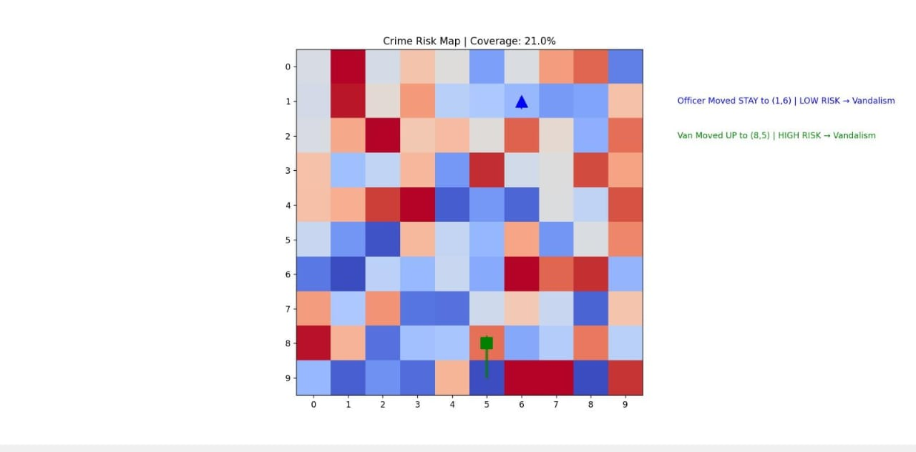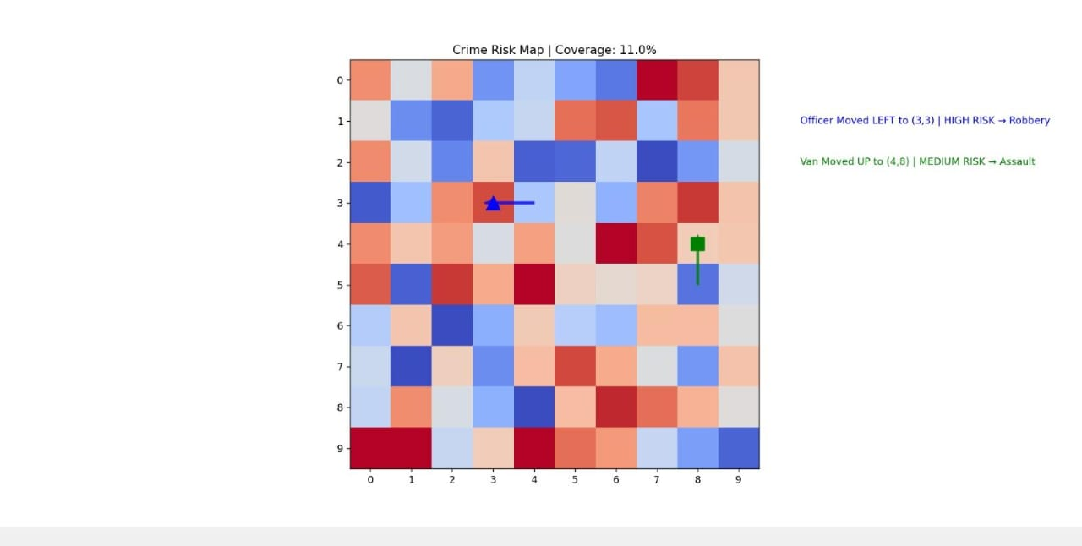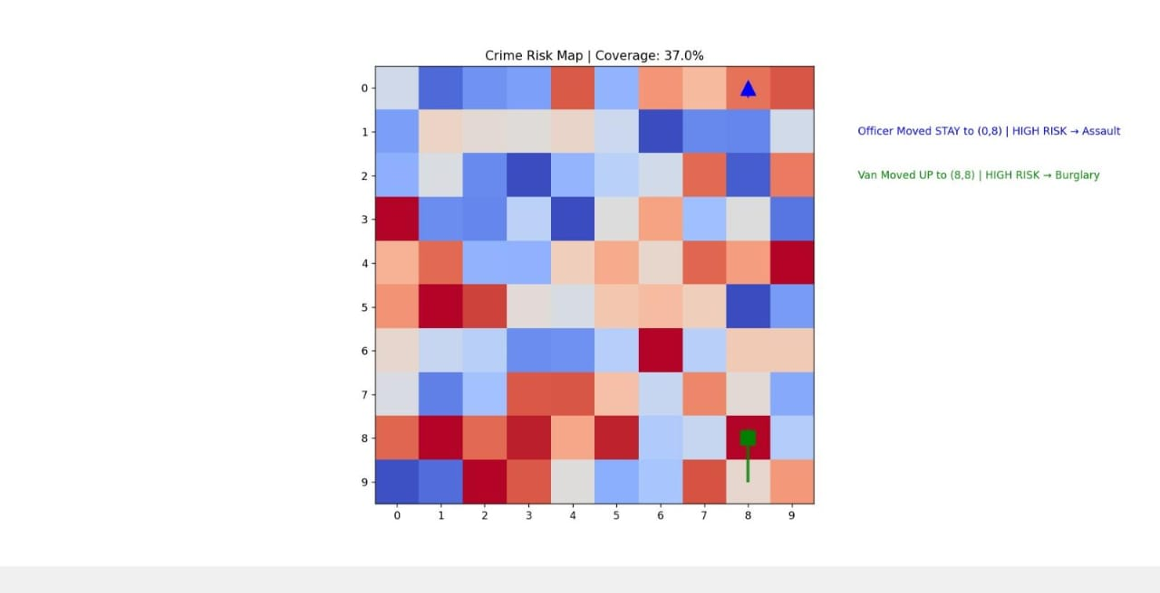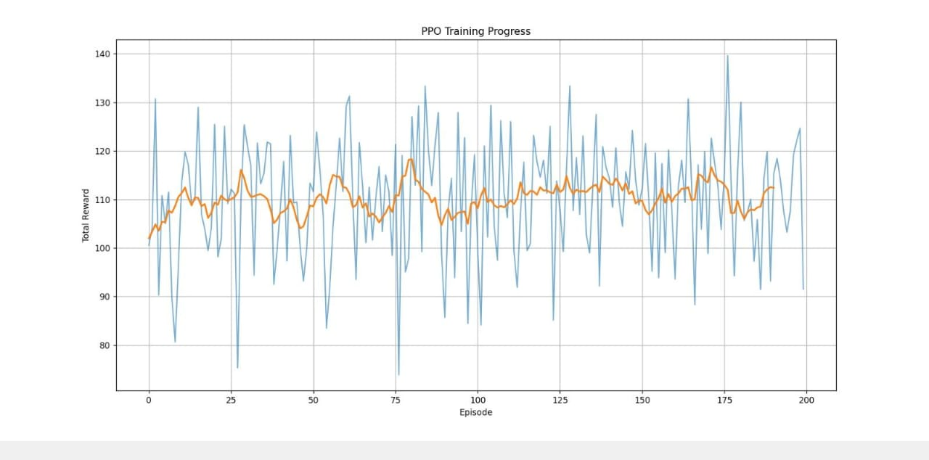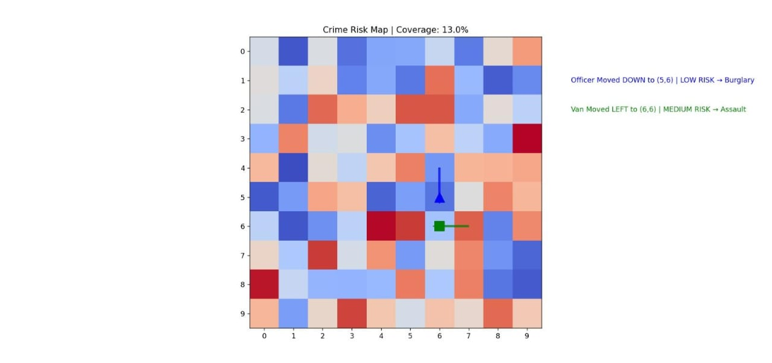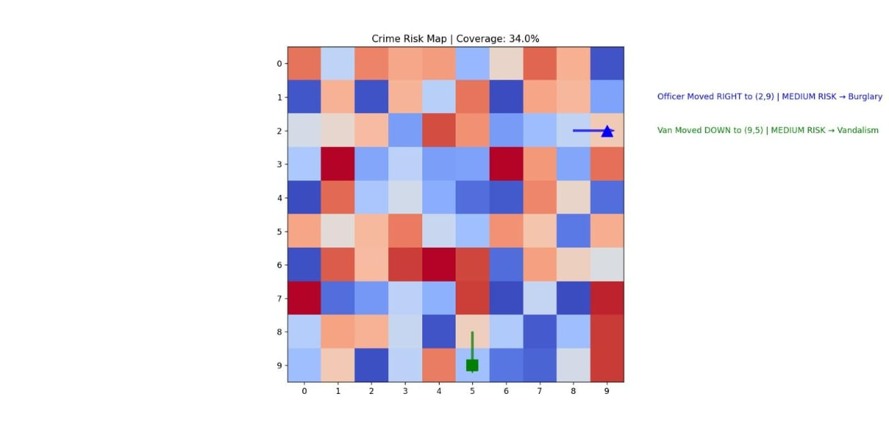

- CONCLUSION AND FUTURE WORK

6.1. SUMMARY OF ACHIEVEMENTS
The project achieved all aims: a tailored Gymnasium environment was constructed, KDE forecasting was designed and partly implemented, PPO agent trained to a mean reward of 110.75, and performance tested with visualizations.

6.2. FINAL CONCLUSION
This RL framework shows a sound strategy for predictive patrol routing, facilitating urban safety improvement through adaptive AI techniques, subject to improvement on a complete KDE implementation.

6.3. FUTURE ENHANCEMENTS
- Implement with real datasets.
- Full KDE implementation.
- Incorporate multi-agent coordination, model barriers.
- Roll out as a web application for police utilization.

6.4. LEARNING OUTCOMES
Acquired proficiency in RL pipelines, Environment design, PPO calibration, Data simulation, and AI deployment in public safety, with an insight into incorporating forecasting methods such as KDE.

