**LINUX COMMANDS**

Linux commands are Case-sensitive.

* **access** 🡪 check whether the calling program has access to the specified file
* **accton** 🡪 to turn on or turn off the process for accounting.
* **cat** 🡪 Reads from file and gives their content as output. Used to create, view, concentrates files
* **mv** 🡪 Used to move 1 or more files or directories from one place to another in file system like UNIX.
* **cp** 🡪 Used to copy files or group of files or directory
* **find** 🡪 Used to find files in directories and perform subsequent operations on them
* **grep** 🡪 Searches a file for a particular pattern of characters, and displays all lines that contain
* **Head** 🡪 Prints the top N number of data of the given input.
* **Tail** 🡪 Prints the last N number of data of the given input.
* **chmod** 🡪 Used to change the access nod of a file
* **chown** 🡪 Used to change the file owner or group
* **sudo** 🡪Used as a prefix of some command that only superuser are allowed

to run.

* **man**

man command_name **🡪** Gives completedetails about that particular command

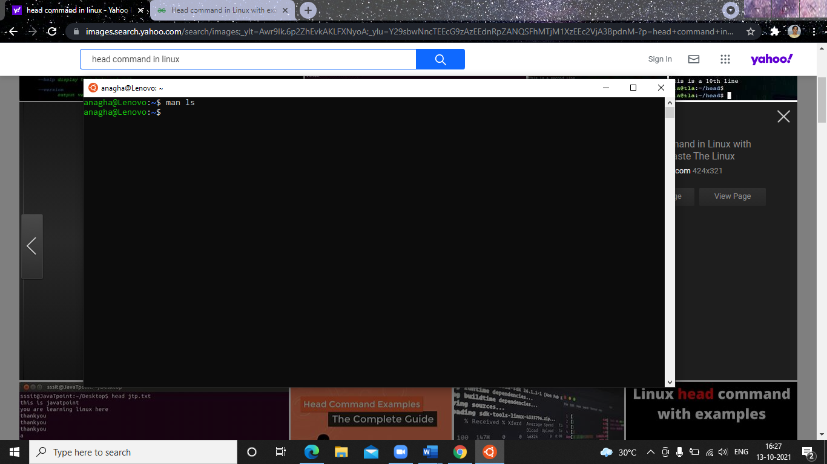

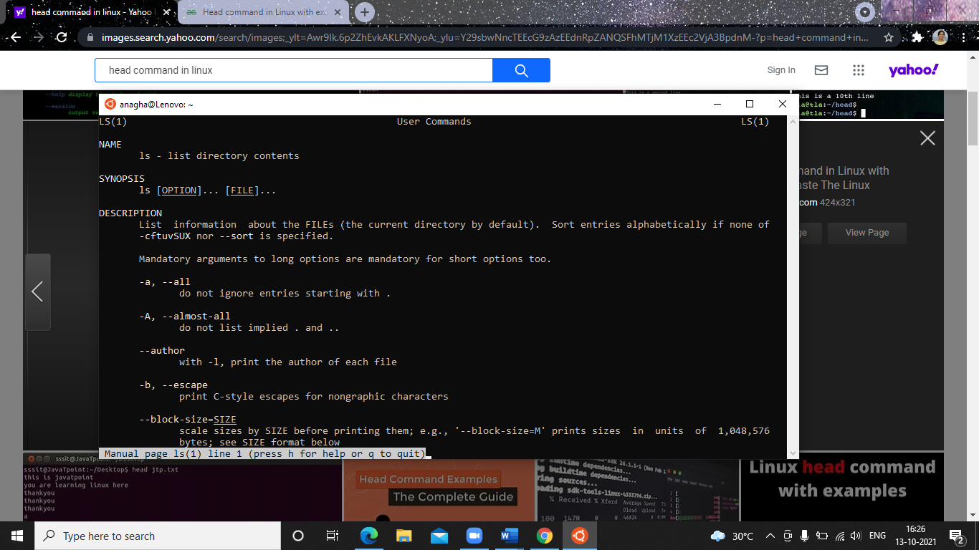

* **pwd**

It prints the path of the working directory, starting from the root

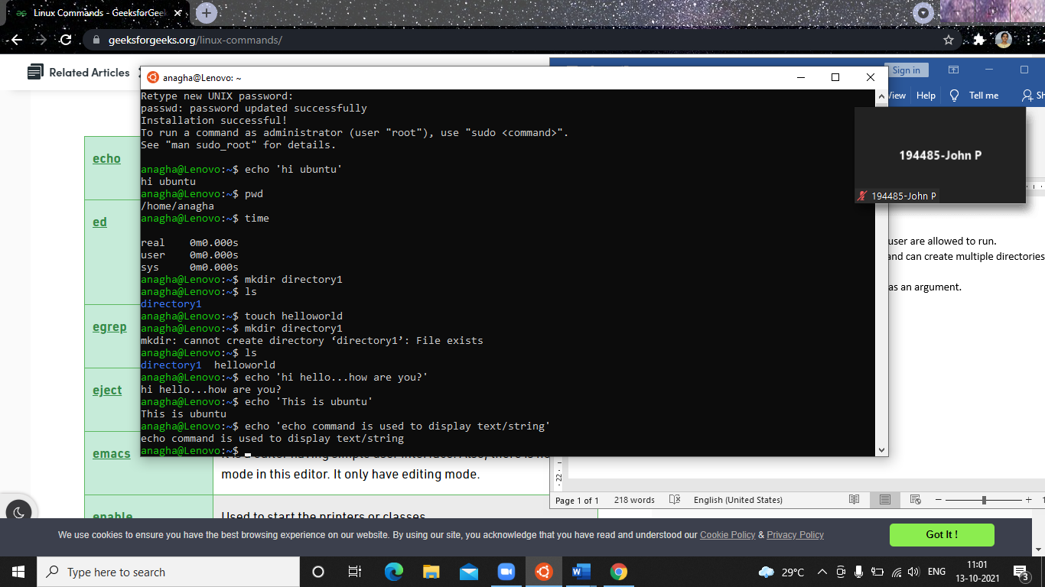

* **time**

Used to execute a command and prints a summary of real time, user CPU time and system CPU time spent by executing a command when it terminates



* **ls**

ls ~ 🡪 gives/jump all file present in system or all home directory

ls .. 🡪 give content or file present in parent directory

ls . 🡪 List files and folder in current directory

ls ~ 🡪 show u all content in home directory

ls -a 🡪 list all files and folder including hidden one

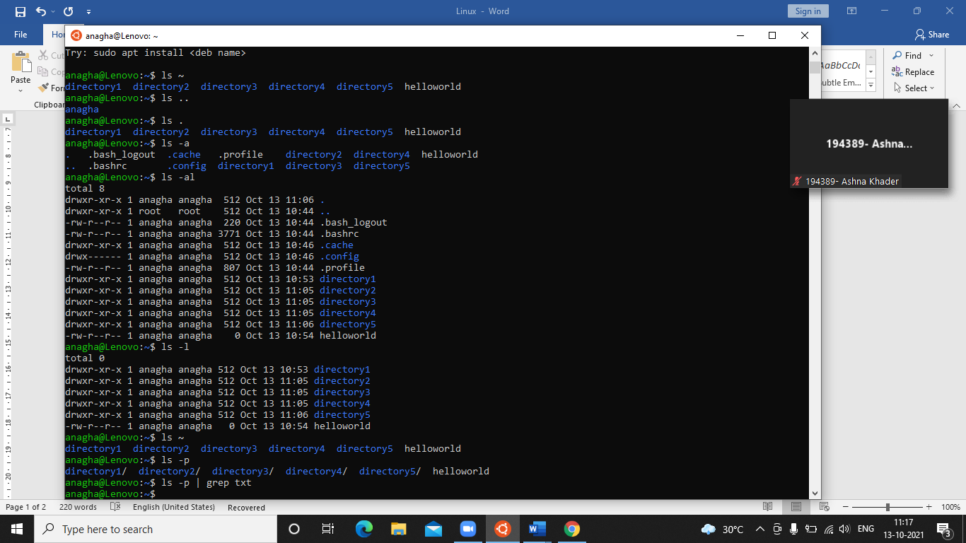

ls -al 🡪 list all files and folder including hidden one in long format

ls -l 🡪 list files and folder in long format

ls -p 🡪 give all files in current directory

ls -p | grep pdf 🡪 gives if any pdf file is present (write whatever type of file in place of pdf like txt n all)



* **mkdir**

Allows the user to create directories. This command can create multiple directories at once.

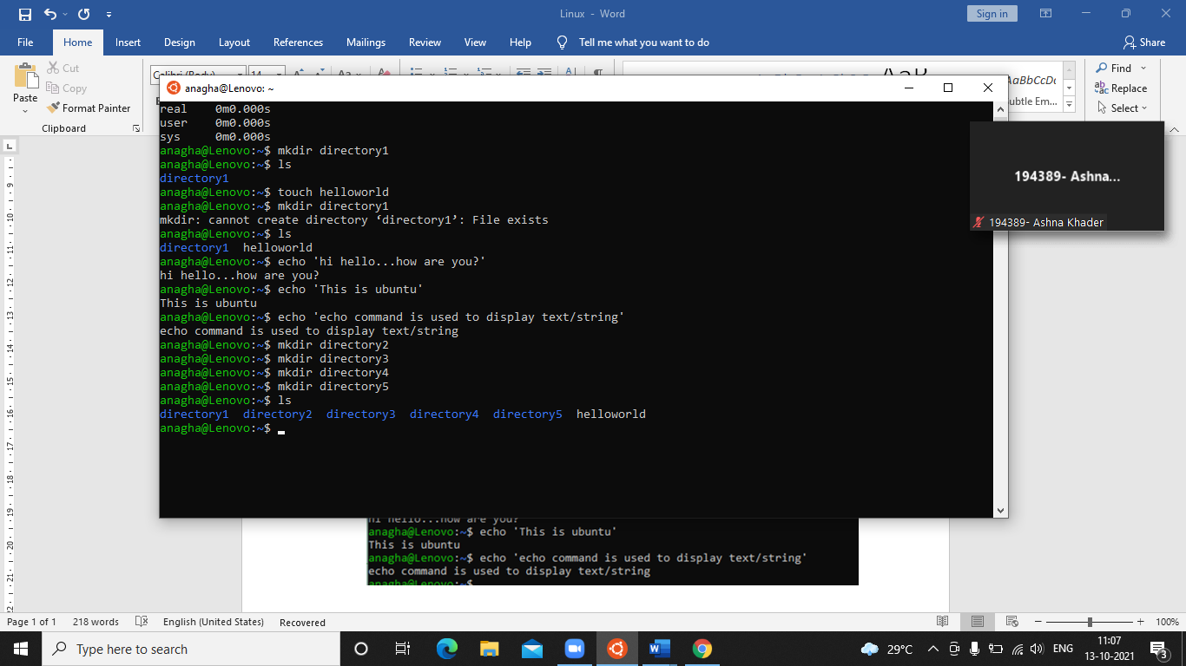

* **echo**

Used to display line of text/string that are passed as an argument.



* **cd**

cd directory_name/ 🡪 take u to that directory

cd .. 🡪 take u to one directory before

cd - 🡪 take u to previous working directory

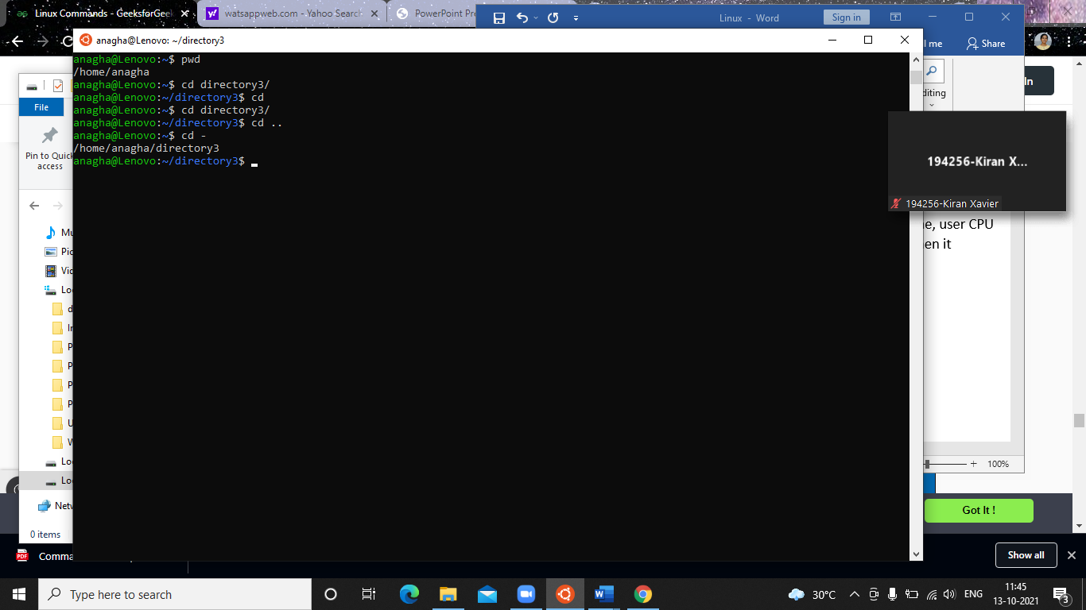

* **touch**

touch file_name 🡪 create empty file

cd /etc/ 🡪 take u to home directory directly

ls -t 🡪 gives highlight on last modified directory

ls -lt 🡪 give complete details about recent modified file plus other file present

touch file_name 🡪 create file name of file_name

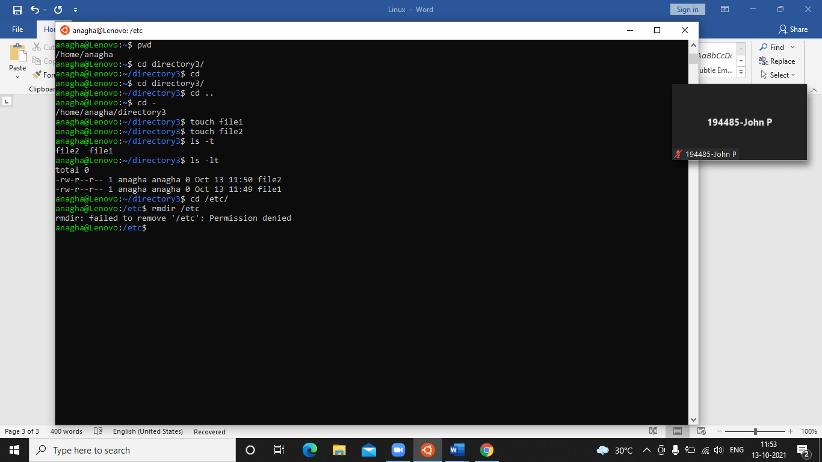

* **rm**

rm -r file_name 🡪 deletes that perticular file_name

rm -i file_name 🡪 ask user permission before deletion

rm -I file_name 🡪 dosnt ask user before deletion

