Am creeat un proiect de tip Model View Controller

Am adaugat Controllere(care contin partea de cod a proiectului)

-HomeController

-MovieTypeController

-MovieController

-TicketController

Am adaugat Views(care contine partea grafica de html)

-Home

-Movie

-MovieType

-Ticket

Am adaugat Modele(care mapeaza tabelele din baza de date)

-MovieModel

-MovieTypeModel

-TicketModel

Am adaugat in wwwroot fisier static (darkly.css)

Am creat modele cu proprietati:

-Microsoft.EntityFrameworkCore(permite aplicatiei sa foloseasca entity framework)

-Microsoft.EntityFrameworkCore.SqlServer(permite sa foloseasca sqlserver)

-Microsoft.EntityFrameworkCore.Tools(permite migrari)

Am modificat json(am adaugat connstring)

Am creat clasa de Context

Am configurat sql server in Program.cs

Am creat migrari: DatabaseInitialization si IdentityImplementation

Am creat metode si interfata grafica

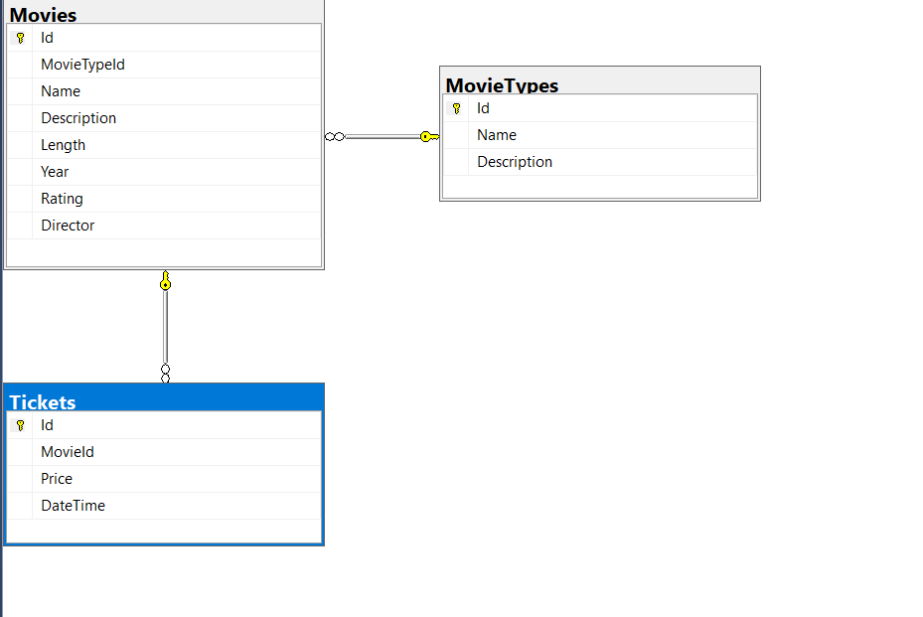Diagrama bazei de date RezervariBilete cu tabelele: Movies, MovieTypes si Tickets.

