Anahita ABEDINI

E-Commerce Operations &
Logistics Performance Analysis
Brazilian E-Commerce Public Dataset by Olist | Python • Pandas • NumPy • Matplotlib • Seaborn
Purpose
Evaluate commercial performance, logistics efficiency, delivery reliability, and customer impact in one management-oriented analytical pipeline. The notebook translates transactional data into operational priorities rather than stopping at descriptive statistics.

R$13.22M  Realized sales | 96,478  Delivered orders | 16.63%  Freight / sales | 8.11%  Late-delivery rate

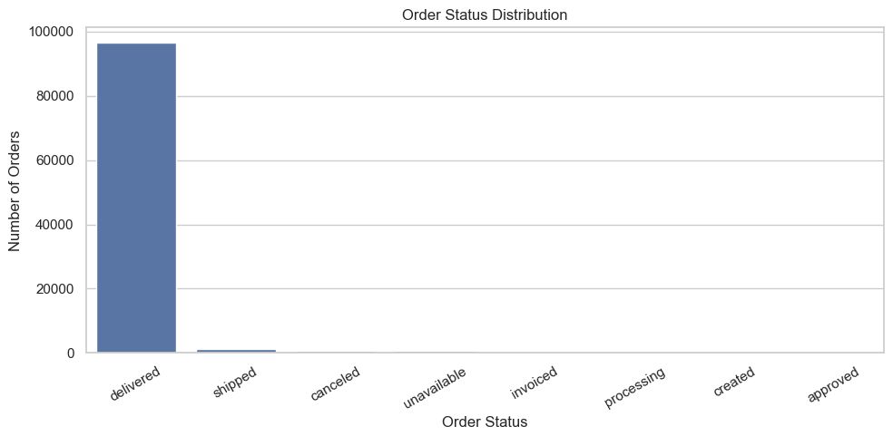
Figure 1. Order status distribution from the notebook. Delivered orders dominate the lifecycle.
Executive takeaway
The strongest improvement opportunity sits where commercial exposure and logistics risk overlap. High-priority categories account for 30.76% of realized sales but 40.85% of realized freight, while late deliveries are associated with a 1.73-point lower average review score.

FROM RAW TABLES TO MANAGEMENT METRICS

01. Data Foundation & Analytical Pipeline

The project loads nine CSV tables from a local data directory. The orders table provides the lifecycle timestamps; order items provide sales and freight; products and category translation add merchandise context; sellers add operational context; reviews are joined later for customer-experience analysis.
9  Source tables | 99,441  Orders table rows | 112,650  Order-item rows | 24  Final analytical columns

Core pipeline
1. Load & inspect | Discover CSVs, load them into a dictionary, review shapes/columns, missing values, and duplicates.
2. Standardize dates | Convert purchase, approval, carrier, customer-delivery, and estimated-delivery timestamps to datetime.
3. Build item-level model | Merge order_items → orders → products → sellers → category translation. This becomes the commercial/logistics dataset.
4. Engineer measures | Define sales_value = price, freight_cost = freight_value, and total_order_value = sales + freight.
5. Separate realized sales | Use delivered orders for realized KPIs, category performance, freight burden, and delivery analysis.
6. Add customer impact | Join delivered order performance with review scores and compare late versus on-time/early outcomes.

Data-quality checks that matter
• Missing delivery dates are retained as a completeness signal; they are expected for orders that were not successfully delivered.
• Product category labels are missing for a small portion of items, so category-level outputs exclude or group those records depending on the operation.
• The geolocation table contains 261,831 duplicate rows, but it is not used in the core item-level analytical merge shown in this notebook.
• There are 775 orders with no item records; 603 are unavailable and 164 are canceled. The notebook explicitly reconciles this before reporting sales KPIs.
Grain matters
Commercial and freight analysis is performed at order-item level, while delivery KPIs are deduplicated to order level so each order contributes once. This prevents multi-item orders from artificially inflating the late-delivery calculation.

SALES, VOLUME, AND REALIZED BUSINESS

02. Commercial Performance

The notebook first calculates gross activity across all order statuses, then narrows management reporting to delivered orders. This distinction keeps canceled, shipped, invoiced, and other unfinished transactions from being treated as fully realized sales.
R$13.59M  Gross item sales | R$13.22M  Realized sales | 97.28%  Sales realization | R$137.04  Realized AOV

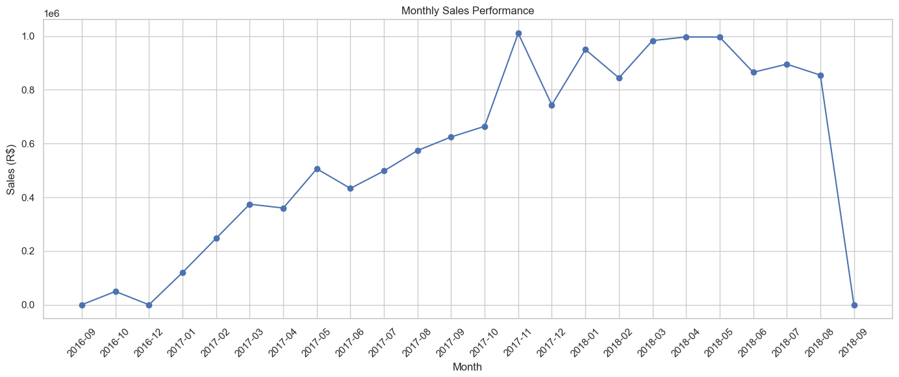  Figure 2. Monthly sales performance. | 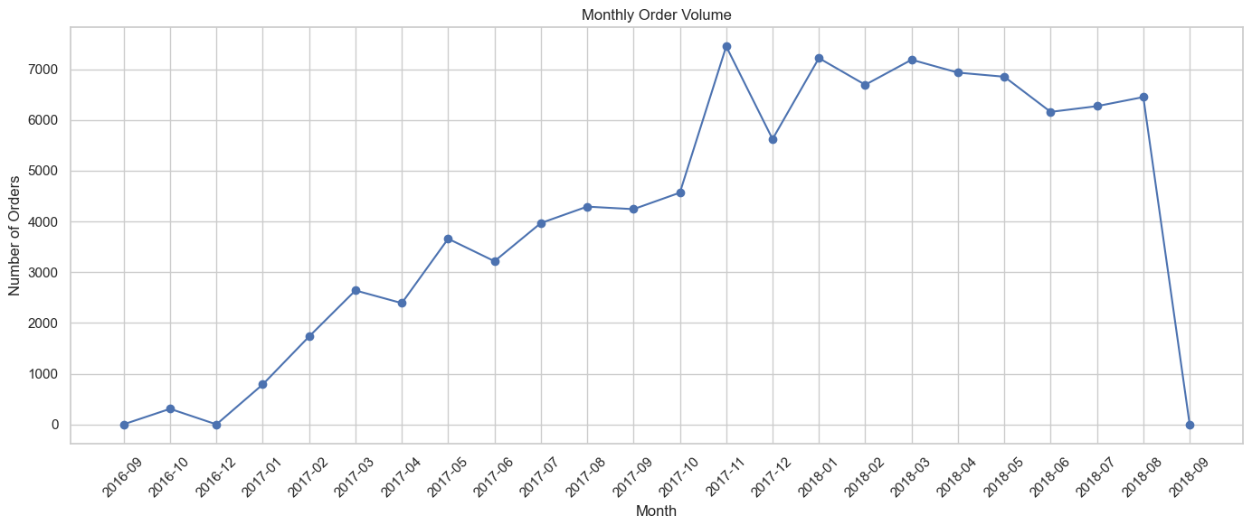  Figure 3. Monthly order volume.

How to interpret the trend
• Monthly sales and order volume rise materially through the main body of the dataset, showing that commercial growth is primarily accompanied by increased transaction volume.
• The notebook includes sparse observations at the edge of the date range; these should not be interpreted as normal operating months without additional period filtering.
• Average order value is calculated as sales divided by unique orders, so volume and ticket size can be evaluated separately.

Realized sales by status
Status | Orders | Sales (R$)
Delivered | 96,478 | 13,221,498
Shipped | 1,106 | 150,727
Canceled | 461 | 95,235
Invoiced | 312 | 61,526
Processing | 301 | 60,439
Management interpretation
The 97.28% sales-realization rate confirms that most gross transactional value is associated with delivered orders. Using delivered orders as the operating baseline produces a cleaner view of revenue exposure, freight burden, and customer service performance.

WHERE LOGISTICS COST IS CONCENTRATED

03. Freight Efficiency & Category Prioritization

Freight is evaluated as a percentage of sales rather than only as an absolute amount. This exposes categories whose logistics burden is high relative to the commercial value they generate.
R$2.20M  Realized freight | 16.63%  Realized freight / sales | 30.76%  Priority sales share | 40.85%  Priority freight share

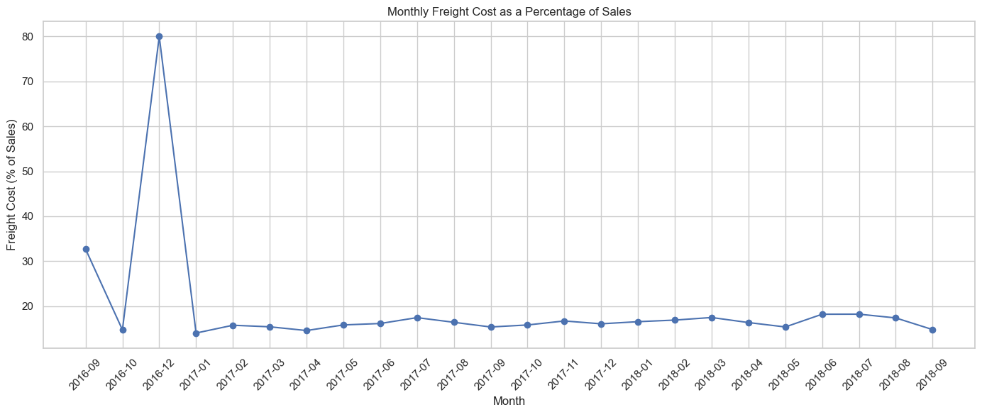  Figure 4. Monthly freight cost as % of sales. | 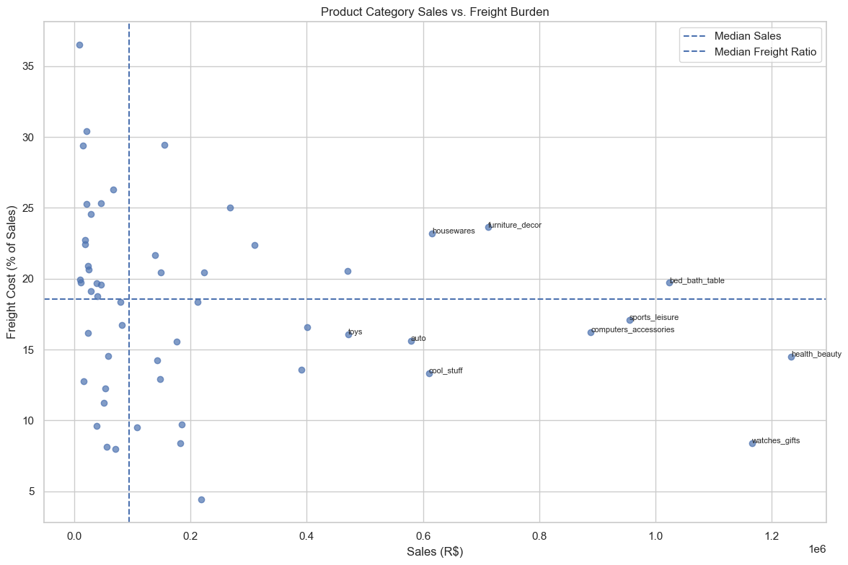  Figure 5. Category sales vs. freight burden.

Prioritization rule
Only categories with at least 100 delivered items are considered. The notebook compares each category with the median sales and median freight-to-sales ratio of that sufficiently large group. Categories above both thresholds are labeled High Priority.
Priority category | Sales (R$) | Freight ratio
bed_bath_table | 1,023,435 | 20%
furniture_decor | 711,928 | 24%
housewares | 615,629 | 23%
garden_tools | 470,495 | 21%
telephony | 309,860 | 22%
office_furniture | 268,154 | 25%
electronics | 155,044 | 29%
Freight over-index = 1.33×
High-priority categories generate 30.76% of realized sales but consume 40.85% of realized freight. That imbalance makes them a natural first queue for packaging, consolidation, carrier, and seller-level logistics investigation.

SERVICE PERFORMANCE MEETS CUSTOMER EXPERIENCE

04. Delivery Reliability & Customer Impact

Delivery performance is measured against the promised date. A positive delay value means the order arrived late; a negative value means it arrived before the estimate. The notebook then joins delivered orders to review scores to quantify the customer-experience gap.
−11.18 d  Average delay | −11.95 d  Median delay | 7,826  Late orders | 1.73 pts  Review-score gap

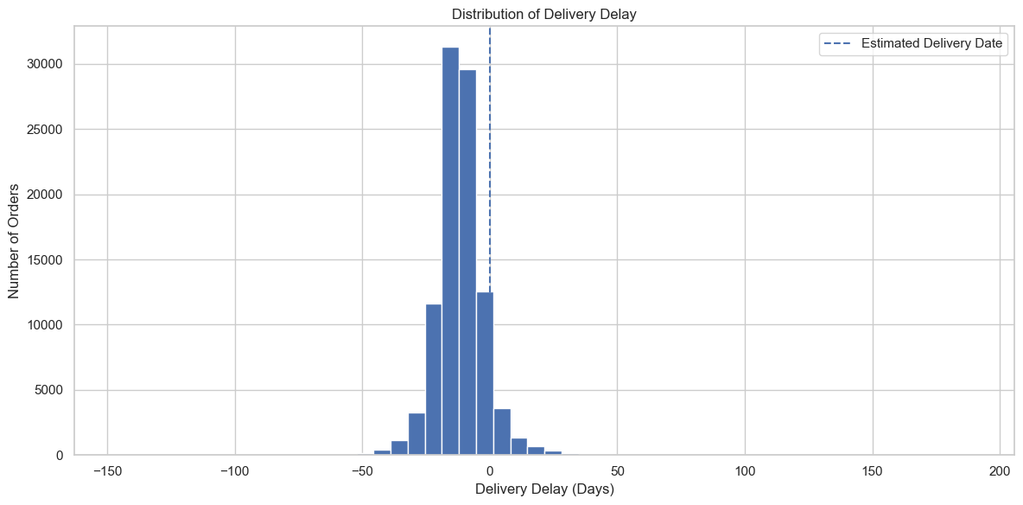
Figure 6. Distribution of delivery delay. Zero marks the estimated delivery date.

Customer satisfaction comparison
Delivery status | Reviewed orders | Average review
Late | 7,661 | 2.57 / 5
On Time / Early | 88,171 | 4.29 / 5
The difference is an association, not proof of causality. Still, the size of the gap makes delivery exceptions operationally important because poor service performance is strongly aligned with lower customer ratings in this dataset.

Categories with elevated late-delivery risk
Category | Delivered items | Late rate
audio | 362 | 12.71%
fashion_underwear_beach | 127 | 12.60%
christmas_supplies | 150 | 12.00%
books_technical | 263 | 11.03%
home_confort | 429 | 10.26%
electronics | 2,729 | 9.75%
office_furniture | 1,668 | 8.93%
Operational signal
The median order arrives about 12 days before the estimated date, suggesting substantial promise-date buffer overall, yet 8.11% of delivered orders are still late. That combination points to an opportunity to manage exceptions more precisely rather than treating all deliveries as equally risky.

PRACTICAL USER GUIDE

05. Using the Project & Acting on the Results

How to run and read the notebook
1 | Place the Olist CSV files in the project’s data directory. The notebook expects DATA_DIR = Path('../data').
2 | Run cells from top to bottom so the shared data dictionary, standardized dates, joins, and engineered measures are created in sequence.
3 | Use the gross KPI section for overall transactional activity, then use the delivered-order section for management reporting on realized performance.
4 | Use category_performance and priority_categories to locate categories with both commercial scale and freight burden.
5 | Use delivered_orders, delivery_reviews, and category_late_rate for service-level and customer-experience analysis.

Recommended management actions
Prioritize high-impact categories: Start with categories combining material sales and elevated freight burden, including bed & bath table, furniture décor, housewares, telephony, office furniture, and electronics.
Investigate freight drivers: Review packaging dimensions, shipment consolidation, carrier selection, and seller-specific logistics practices for priority categories.
Create an operating dashboard: Track late-delivery rate, freight-to-sales ratio, average/median delay, sales realization rate, and customer review score.
Protect at-risk customers: Use proactive communication and delivery-exception handling for orders likely to miss the promised date.
Avoid blanket cost cutting: Target the overlap between financial exposure and service risk instead of reducing freight indiscriminately.

Core analytical framework
Sales exposure → Logistics burden → Delivery performance → Customer impact → Management priority
The project’s main value is the linkage between commercial, logistics, and customer metrics. It turns several operational tables into one decision sequence, making it easier to decide where intervention is most likely to protect both cost efficiency and customer satisfaction.

Key limitations to keep in mind
• The review comparison is associative; it does not establish that delivery timing alone caused the review-score difference.
• Category prioritization depends on median thresholds and a 100-item minimum; alternative business rules may change the priority set.
• The notebook uses the available historical Olist data and does not include a forecasting model or causal optimization model.

