Customer Shopping Behavior Analysis
Project Report
Data Preparation (Python) • Data Analysis (SQL) • Visualization (Power BI)
July 2026

1. Executive Summary
This project analyzes a retail customer shopping behavior dataset of 3,900 transactions to help management understand what drives purchasing decisions, customer loyalty, and engagement across demographics, product categories, and shopping preferences. The workflow spans three stages: data cleaning and feature engineering in Python, structured querying and business-question analysis in SQL (PostgreSQL), and an interactive Power BI dashboard for stakeholder-facing visualization.
The analysis shows that Clothing and Accessories generate the majority of revenue, that the customer base is dominated by long-tenured “loyal” buyers rather than new customers, and that discounting is applied broadly (roughly 40% of transactions) without a strong link to higher review ratings. These findings translate into concrete recommendations for merchandising, retention, and promotional strategy, detailed in Section 6.

2. Problem Statement
A leading retail company wants to better understand its customers’ shopping behavior in order to improve sales, customer satisfaction, and long-term loyalty. Management has noticed changes in purchasing patterns across demographics, product categories, and sales channels, and is particularly interested in which factors — discounts, reviews, seasonality, or payment preferences — drive consumer decisions and repeat purchases.
Business question: “How can the company leverage consumer shopping data to identify trends, improve customer engagement, and optimize marketing and product strategies?”

3. Dataset Overview
The raw dataset contains 3,900 customer transaction records across 18 attributes, covering demographics, product details, pricing, engagement, and shopping preferences.
Attribute group | Fields | Notes
Customer | Customer ID, Age, Gender, Location | 1 row per transaction
Product | Item Purchased, Category, Size, Color | 4 categories, 25 items
Transaction | Purchase Amount (USD), Season, Payment Method | Range and seasonality vary
Engagement | Review Rating, Subscription Status, Previous Purchases | Rating had missing values
Promotions | Discount Applied, Promo Code Used | Fully duplicate fields (see §4.1)
Fulfilment | Shipping Type, Frequency of Purchases | 6 shipping types, 7 frequency bands
Note: the dataset does not include an explicit online-vs-offline sales channel field; “Shipping Type” and “Location” were used as the closest available proxies for channel-related behavior.

4. Methodology

4.1 Data Preparation & Modeling (Python)
Raw data was cleaned and transformed in Python (pandas) before loading into a relational database:
- Column standardization: column headers were lower-cased and spaces replaced with hyphens for consistent, query-safe naming (e.g. “Purchase Amount (USD)” → purchase-amount).
- Missing values: missing Review Rating values were imputed using the median rating within each product category, preserving category-level rating distributions rather than using a single global average.
- Feature engineering – purchase frequency: the categorical Frequency of Purchases field (e.g. “Weekly”, “Fortnightly”) was mapped to a numeric purchase-frequency-days field to make it usable in quantitative analysis.
- Feature engineering – age group: customers were split into four equal-sized age bands (young-adult, adult, middle-aged, senior) using quantile binning, enabling fair, balanced demographic comparisons instead of arbitrary fixed cutoffs.
- Redundant field removal: Discount Applied and Promo Code Used were found to be identical for every record, so Promo Code Used was dropped to avoid duplicated signal.
- Loading: the cleaned dataset was loaded into a PostgreSQL database (via SQLAlchemy) as a customer table for SQL-based analysis.

4.2 Data Analysis (SQL)
Ten analytical queries were written against the PostgreSQL customer table to answer specific business questions, including: revenue extraction, above-average discounted spenders, lowest-rated items, shipping-type preferences by item, subscriber value comparison, discount rates by item, customer loyalty segmentation, top-selling items per category (via window functions), high-frequency repeat buyers, and revenue by age group. Full query text is included in the project repository (sql.sql).

4.3 Visualization & Insights (Power BI)
A one-page interactive “Customer Behaviour Dashboard” was built in Power BI (c_b.pbix), connected to the cleaned customer table. It combines:
- KPI cards for number of customers, average purchase amount, and average review rating
- A donut chart of subscription status distribution
- Clustered column charts of revenue and order volume by product category
- Clustered bar charts of customer count and revenue by age group
- Slicers for filtering by category, season, and other attributes, enabling interactive stakeholder exploration

5. Key Findings

5.1 Revenue is concentrated in Clothing and Accessories
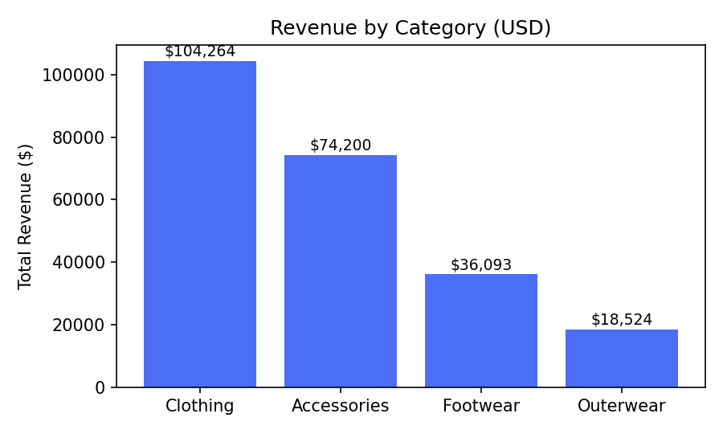
Figure 1. Total revenue by product category (USD).
Clothing ($104,264) and Accessories ($74,200) together account for roughly 82% of total revenue, while Outerwear contributes the least ($18,524). This mirrors order volume: Clothing (1,737 orders) and Accessories (1,240 orders) are also the most frequently purchased categories, confirming that revenue concentration is driven by purchase frequency rather than higher-priced items in those categories.

5.2 The customer base is dominated by loyal, repeat buyers
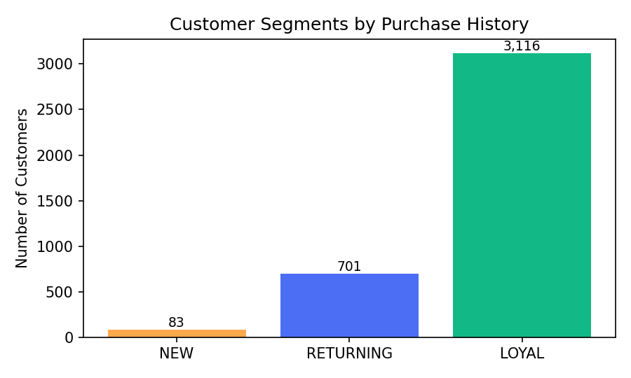
Figure 2. Customer segments by purchase history (NEW = 1 prior purchase, RETURNING = 2–10, LOYAL = 10+).
Of 3,900 customers, 3,116 (80%) are classified as LOYAL (more than 10 previous purchases), 701 (18%) are RETURNING, and only 83 (2%) are NEW. This is an unusually loyalty-heavy base, suggesting the company's challenge is less about retention of existing customers and more about acquisition — new customer inflow is comparatively small.

5.3 Subscribers spend about the same as non-subscribers
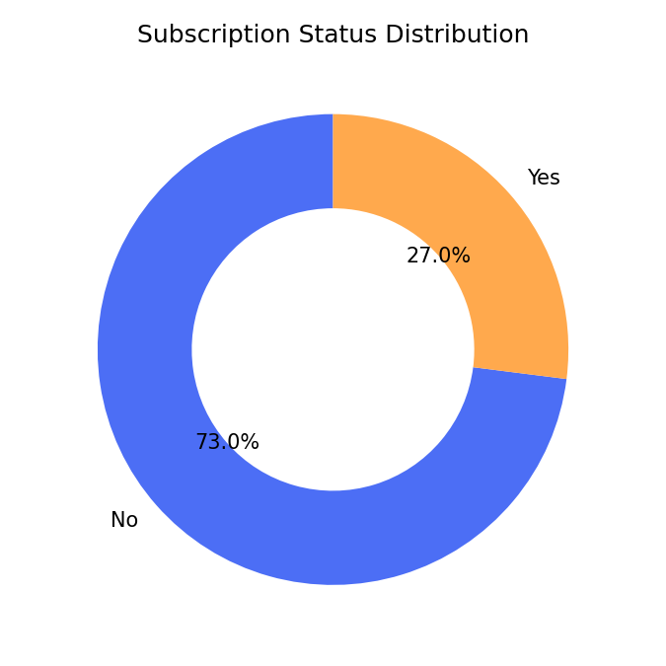
Figure 3. Subscription status distribution.
Subscription status | Customers | Avg. spend | Total revenue
No | 2,847 (73%) | $59.87 | $170,436
Yes | 1,053 (27%) | $59.49 | $62,645
Only 27% of customers are subscribed, and subscribers do not spend more per transaction than non-subscribers ($59.49 vs. $59.87). Subscription status appears to reflect a communication preference rather than a value-driving loyalty program, meaning it is currently underleveraged as a growth lever.

5.4 Discounting is broad but not clearly tied to satisfaction
Discounts were applied to roughly 40% of all transactions, with usage varying meaningfully by item — from 50% of Hat purchases down to 32.7% of Socks purchases. Notably, customers who spent above the dataset average while using a discount (839 customers, averaging $79.79 per transaction) still represent a meaningful high-value segment, showing discounts are being used effectively to drive larger baskets rather than only price-sensitive small purchases. However, the lowest-rated items overall (Shirt 3.62, Jeans 3.65, Blouse 3.68) are not the least-discounted items, indicating discount depth alone does not explain satisfaction gaps.

5.5 Revenue and engagement vary only modestly by age and season
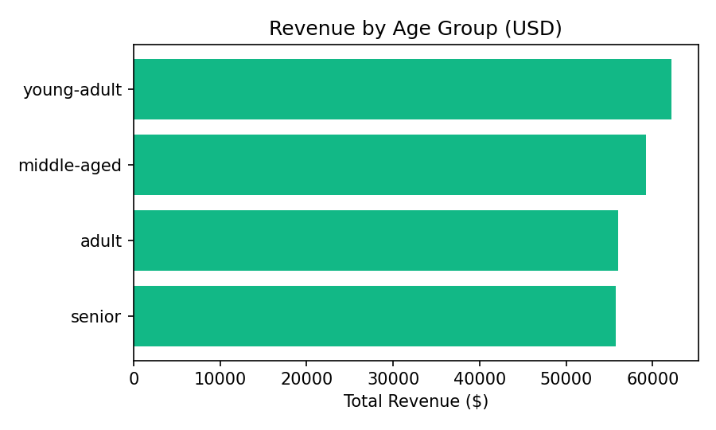
Figure 4. Total revenue by age group (USD).
Revenue is fairly evenly spread across age groups ($55,763–$62,143), with young-adults contributing slightly more despite all four groups having comparable customer counts (~950–1,030 each). Seasonally, Fall ($61.56 avg) and Winter ($60.36 avg) see marginally higher average spend than Spring and Summer, a modest but consistent pattern worth monitoring for seasonal campaign timing.

5.6 Payment method and shipping preferences are evenly distributed
No single payment method dominates: PayPal, Credit Card, Cash, Debit Card, Venmo, and Bank Transfer each account for roughly 15–17% of transactions. Similarly, discount usage is fairly consistent across all six shipping types (36–44%), meaning shipping choice is not a strong differentiator of discount-seeking behavior.

6. Business Recommendations
- Prioritize new-customer acquisition: with loyal customers making up 80% of the base but new customers only 2%, marketing spend should shift toward top-of-funnel acquisition channels rather than further retention incentives for an already-loyal base.
- Redesign the subscription program: since subscribers spend the same as non-subscribers, the subscription should be repositioned with tangible value (early access, subscriber-only discounts) to convert it into an actual loyalty and revenue driver rather than a passive opt-in.
- Protect margins on high-discount, low-margin categories: items like Hats, Sneakers, and Coats see discount rates near 50%; the company should test smaller discount depths on these items and measure the impact on conversion versus margin.
- Investigate low-rated core items: Shirts, Jeans, and Blouses — all high-volume Clothing items — have the lowest review ratings; targeted quality or fit reviews on these specific SKUs could lift both ratings and repeat purchase rates in the company's top revenue category.
- Lean into Fall/Winter seasonal spend: with average spend modestly higher in Fall and Winter, promotional calendars and inventory planning should weight these seasons more heavily.
- Capture true channel data going forward: since the dataset lacks an explicit online/offline field, the company should begin capturing channel at point of sale to enable direct online-vs-offline behavioral analysis in future iterations.

7. Conclusion
This project demonstrates an end-to-end analytics workflow — from raw data cleaning in Python, through structured business-question analysis in SQL, to an interactive Power BI dashboard — to answer the company's core question of how shopping data can inform marketing and product strategy. The clearest opportunities are in acquisition (rather than retention, given an already loyal base), subscription program redesign, and targeted attention to low-rated, high-volume Clothing items. All code, queries, and the dashboard file are included in the accompanying GitHub repository for reproducibility.

8. Appendix: Deliverables
Deliverable | File | Description
Data Preparation (Python) | python.txt / .ipynb | Cleaning, imputation, feature engineering, DB load
Data Analysis (SQL) | sql.sql | 10 business-question queries against PostgreSQL
Visualization (Power BI) | c_b.pbix | Interactive Customer Behaviour Dashboard
Report & Presentation | This document | Findings and recommendations
Source data | customer_shopping_behavior.csv | 3,900 transaction records, 18 fields

