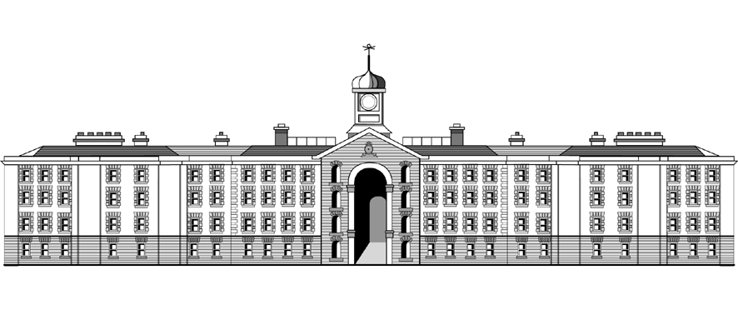

**Griffith College Dublin**

**COMPUTING ASSIGNMENT TITLE SHEET**

**Course:** B.Sc. in Computing (Level 7 and Level 8)

**Stage/Year:** I

**Module:** Computer Programming

**Semester:** I

**Assignment Number:** I

**Date of Title Issue:** 21/11/23

**Assignment Deadline: 7/01/24 23:59**

**Assignment Submission:** Submitted on Moodle

**Assignment Weighting: 10%**

## Assignment Title

|  |
| --- |
| Create a project called AssignmentOne_StudentNumber.  With StudentNumber being your student number i.e AssignmentOne_32323.  Add your Student Name and ID at the top of any files.  Create a new package with the name **griffith.**  Create a new class called **FruitMachine**    For this assignment you are to create a console game that emulates a fruit machine (<http://en.wikipedia.org/wiki/Slot_machine>). |
|  |