|  |  |  |  |  |  |  |
| --- | --- | --- | --- | --- | --- | --- |
| **Student name:** | **Hussaina Hussain** | | | | | |
| **Student number:** | **3136381** | | | | | |
| **Faculty:** | **Computing Science** | | | | | |
| **Course:** | **BSCH/BSCO/EXCH** | | | **Stage/year:** | **2** | |
| **Subject:** | **Software Development 2** | | | | | |
| **Study Mode:** | Full time |  |  | Part-time |  |  |
| **Lecturer Name:** | **Gemma Deery** | | | | | |
| **Assignment Title:** | **Worksheet 2** | | | | | |
| Date due: | **05/03/2025** | | |  | | |
| Date submitted: | **05/03/2025** | | |  | | |
| **Plagiarism disclaimer:**  *I understand that plagiarism is a serious offence and have read and understood the college policy on plagiarism. I also understand that I may receive a mark of zero if I have not identified and properly attributed sources which have been used, referred to, or have in any way influenced the preparation of this assignment, or if I have knowingly allowed others to plagiarise my work in this way.*  *I hereby certify that this assignment is my own work, based on my personal study and/or research, and that I have acknowledged all material and sources used in its preparation. I also certify that the assignment has not previously been submitted for assessment and that I have not copied in part or whole or otherwise plagiarised the work of anyone else, including other students.*  **Signed: Hussaina Hussain Date: 05/03/2025** | | | | | | |
| Please note: Students MUST retain a hard / soft copy of ALL assignments as well as a receipt issued and signed by a member of Faculty as proof of submission. | | | | | | |

**Repo Link:**

# Tasks:

# Task One:

## Part One:

* Creating the GitHub repository

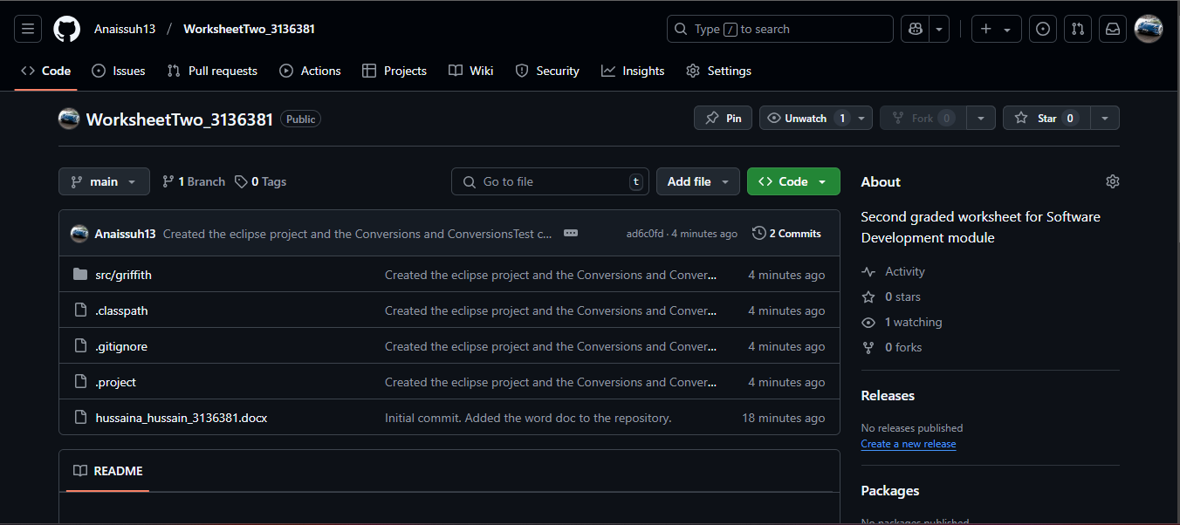

* Granting Access

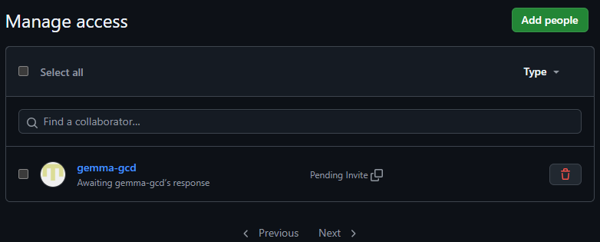

* Creating a new project in Eclipse along with the package and classes

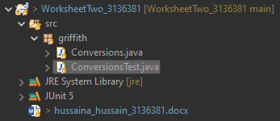

## Part Two:

* Adding the method stubs to the Conversions class

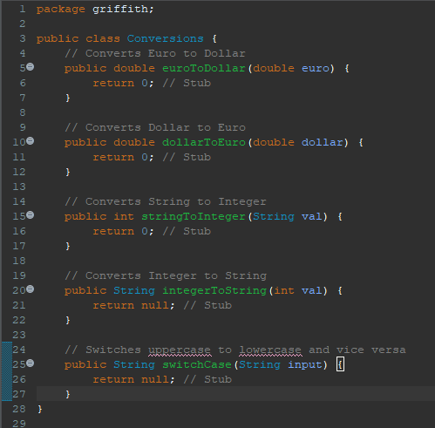

* Committing it to repository

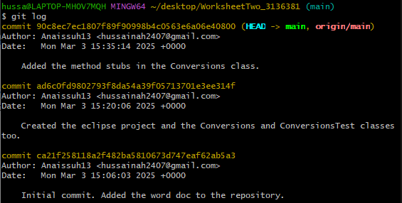

## Part Three:

* Adding unit tests for each method.

**euroToDollar**

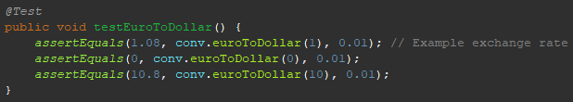

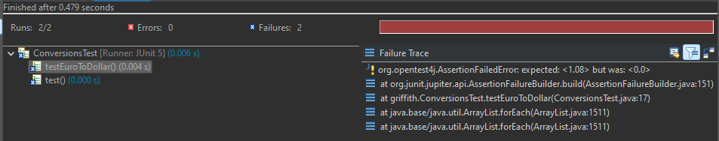

**dollarToEuro**

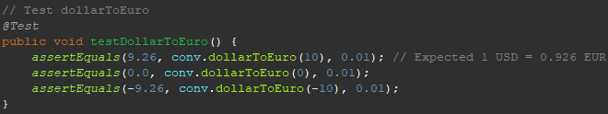

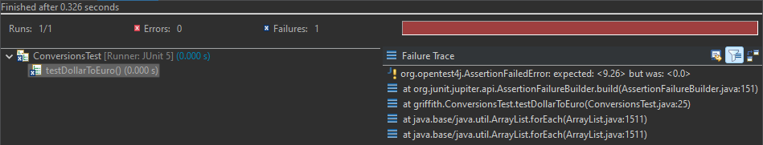

**stringToInteger**

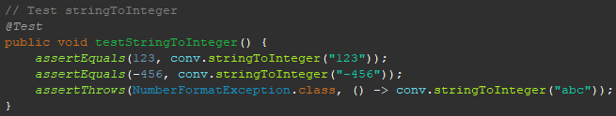

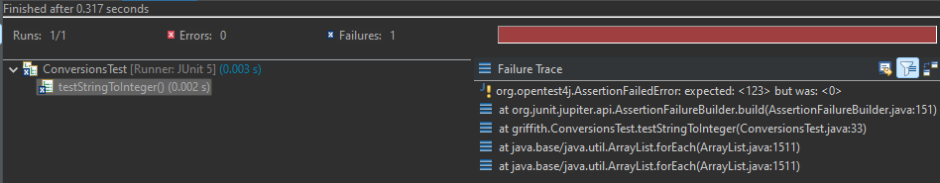

**integerToString**

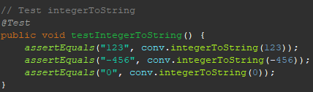

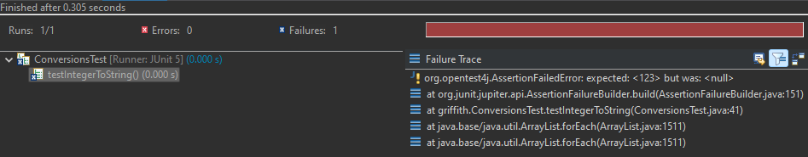

**switchCase**

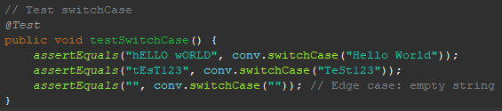

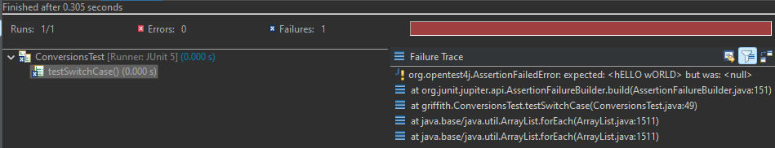

* Implementing the methods in Conversions.java and making sure the unit test passes before moving on.

**euroToDollar**

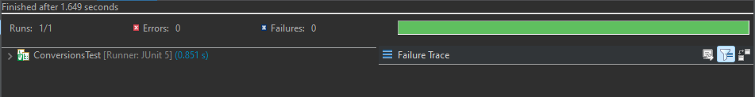

**dollarToEuro**

**stringToInteger**

**integerToString**

**switchCase**