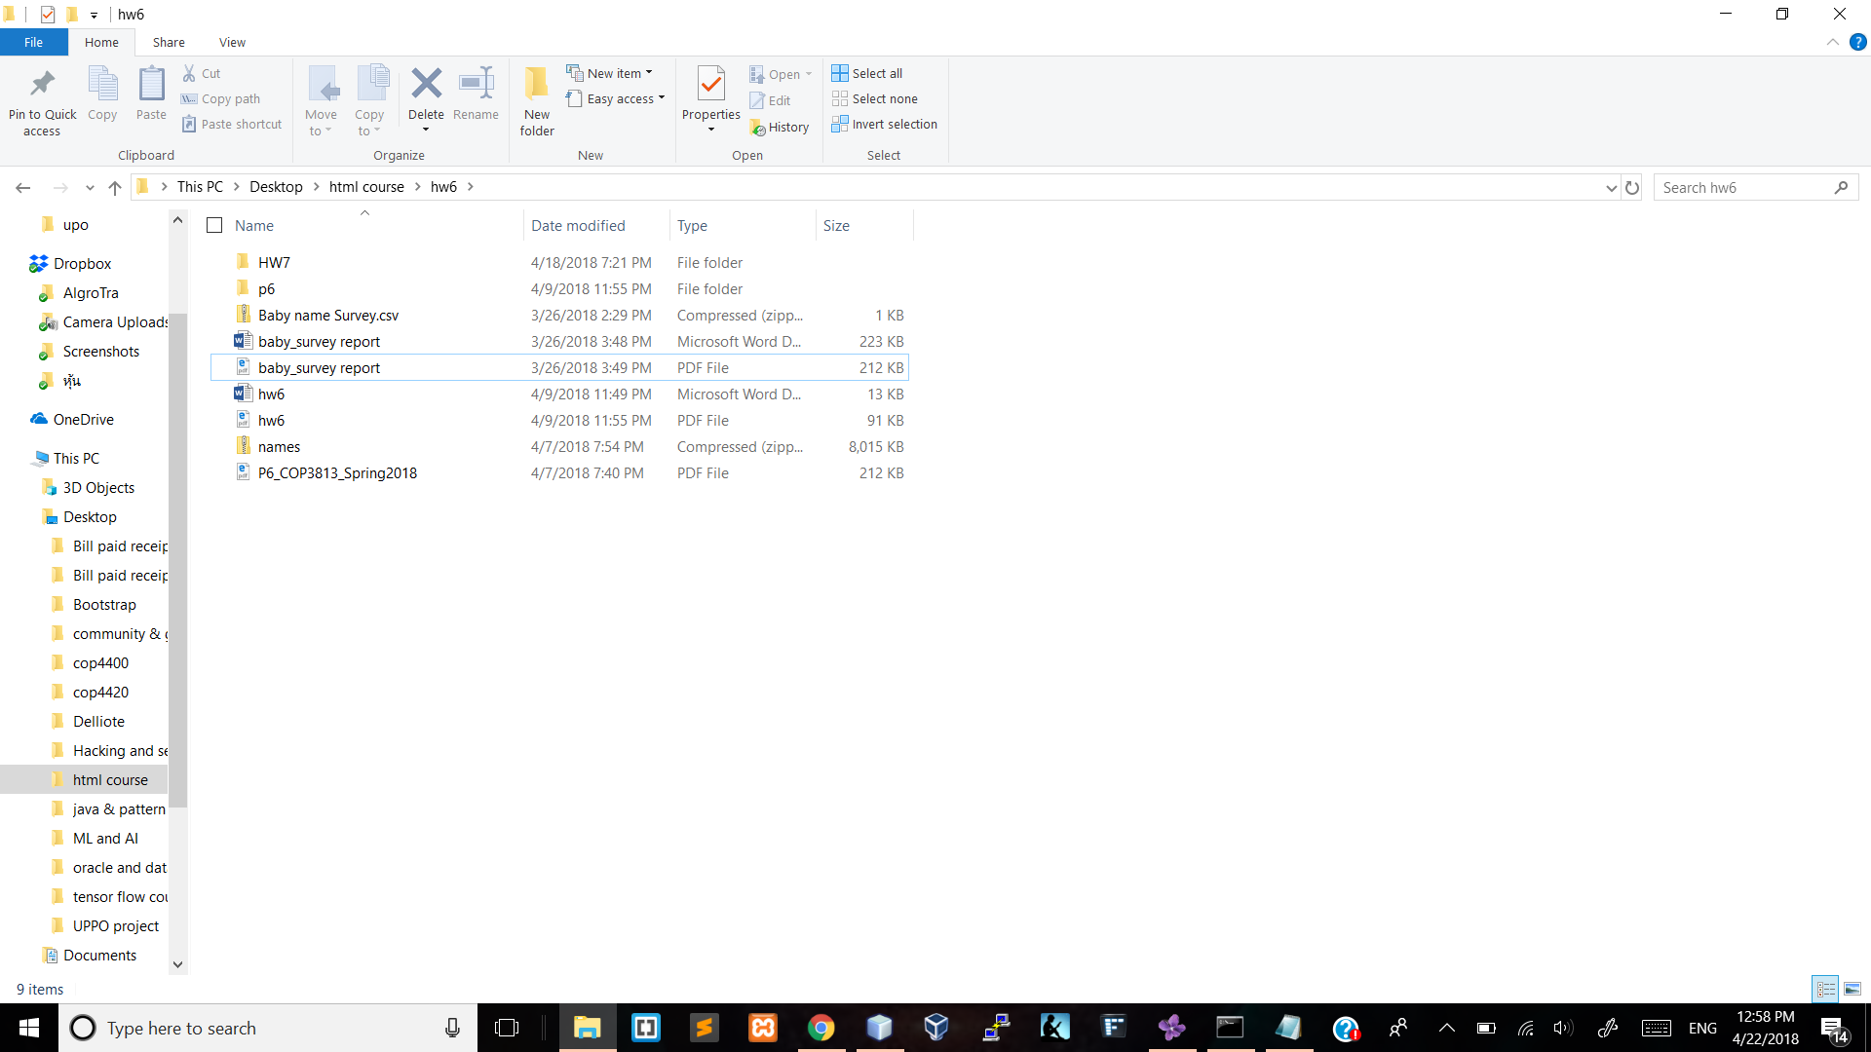

Last Edit date is 3/262018. This is a proof that I have not edit anything after the due date of the assignment.