1. Implement the following class hierarchy

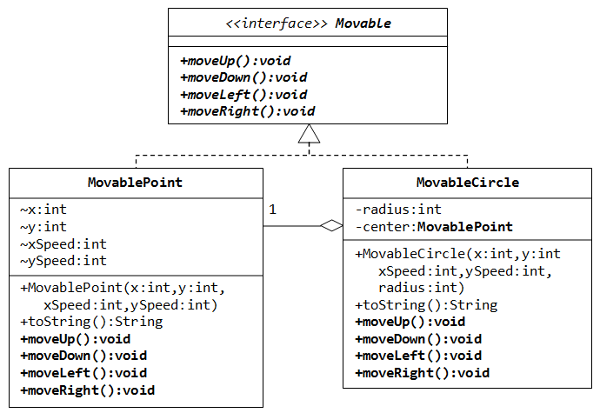

1. Model class heirarchy  
   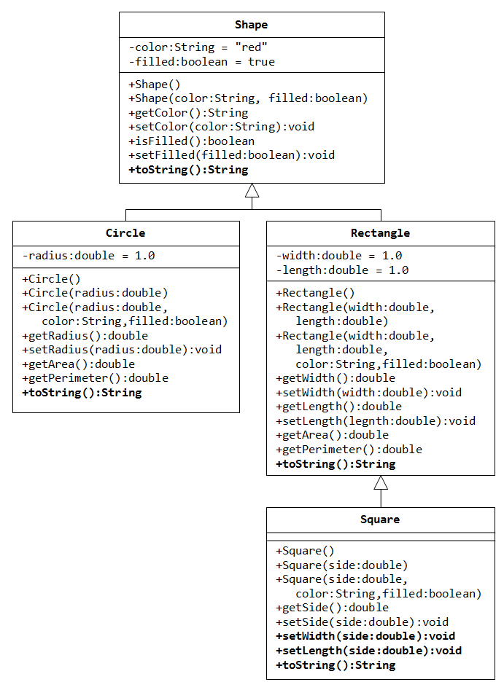
2. Create a student information system in Java. Use files.
3. Joe is preparing for programming contests and loves to debug his code when he gets compilation errors. Initially, the compiler displayed n compilation errors, each of them is represented as a positive integer. After some effort, Joe managed to fix some mistake and then another one mistake.However, despite the fact that Joe is sure that he corrected the two errors, he can not understand exactly what compilation errors disappeared — the compiler of the language which Joe uses shows errors in the new order every time! Joe is sure that unlike many other programming languages, compilation errors for his programming language do not depend on each other, that is, if you correct one error, the set of other error does not change.

Help Joe find out exactly which two errors he corrected.

Input

The first line of the input contains integer n (3 ≤ n ≤ 105) — the initial number of compilation errors.

The second line contains n space-separated integers a1, a2, ..., an (1 ≤ ai ≤ 109) — the errors the compiler displayed for the first time.

The third line contains n - 1 space-separated integers b1, b2, ..., bn - 1 — the errors displayed at the second compilation. It is guaranteed that the sequence in the third line contains all numbers of the second string except for exactly one.

The fourth line contains n - 2 space-separated integers с1, с2, ..., сn - 2 — the errors displayed at the third

except for exactly one.

Output

Print two numbers on a single line: the numbers of the compilation errors that disappeared after Joe made the first and the second correction, respectively.

Input:

5

1 5 8 123 7

123 7 5 1

5 1 7

Output:

8

123

Input:

6

1 4 3 3 5 7

3 7 5 4 3

4 3 7 5

Output:

1

3

1. The School №0 of the capital of Wonderland has n children studying in it. All the children in this school are gifted: some of them are good at programming, some are good at maths, others are good at PE (Physical Education). Hence, for each child we know value ti:

ti = 1, if the i-th child is good at programming,

ti  = 2, if the i-th child is good at maths,

ti  = 3, if the i-th child is good at PE

Each child happens to be good at exactly one of these three subjects.

The Team Scientific Decathlon Olympiad requires teams of three students. The school teachers decided that the teams will be composed of three children that are good at different subjects. That is, each team must have one mathematician, one programmer and one sportsman. Of course, each child can be a member of no more than one team.

What is the maximum number of teams that the school will be able to present at the Olympiad? How should the teams be formed for that?

Input

The first line contains integer n (1 ≤ n ≤ 5000) — the number of children in the school. The second line contains n integers t1, t2, ..., tn (1 ≤ ti ≤ 3), where ti describes the skill of the i-th child.

Output

Print the largest possible number of teams. If no teams can be compiled, print the only line with value w equal to 0.

Input:

7

1 3 1 3 2 1 2

Output:

2

Input:

4

2 1 1 2

Output: