VIETNAM GENERAL CONFEDERATION OF LABOR
TON DUC THANG UNIVERSITY
FACULTY OF INFORMATION TECHNOLOGY



Mai Hoang Thai – 523H0177
Nguyen Tran Hoang Nhan – 523H0164
Phan Thanh Dat – 523H0124

FINALTERM REPORT

DEEP LEARNING

HO CHI MINH CITY, 2026
VIETNAM GENERAL CONFEDERATION OF LABOR
TON DUC THANG UNIVERSITY
FACULTY OF INFORMATION TECHNOLOGY



Mai Hoang Thai – 523H0177
Nguyen Tran Hoang Nhan – 523H0164
Phan Thanh Dat – 523H0124

FINALTERM REPORT

DEEP LEARNING

Advised by
Assoc. Prof. Dr. Le Anh Cuong

HO CHI MINH CITY, 2026
ACKNOWLEDGEMENT

We would like to extend our profound appreciation to Assoc. Prof. Dr. Le Anh Cuong for his invaluable mentorship throughout the finalterm phase of our Deep Learning project.
During the implementation of our research, Assoc. Prof. Dr. Le Anh Cuong provided essential guidance on optimizing model performance and refining our approach to hierarchical feature abstraction.
The knowledge shared by Assoc. Prof. Dr. Le Anh Cuong has significantly enhanced our understanding of generative models and unsupervised pre-training. We are honored to have conducted this work under his expert supervision within the Faculty of Information Technology.
Ho Chi Minh city, 5th May 2026.
Author
(Signature and full name)

Thai
Mai Hoang Thai

Nhan
Nguyen Tran Hoang Nhan

Dat
Phan Thanh Dat

DECLARATION OF AUTHORSHIP
We hereby declare that this is our own project and is guided by Assoc. Prof. Dr. Le Anh Cuong; The content research and results contained herein are central and have not been published in any form before. The data in the tables for analysis, comments and evaluation are collected by the main author from different sources, which are clearly stated in the reference section.
In addition, the project also uses some comments, assessments as well as data of other authors, other organizations with citations and annotated sources.
If something wrong happens, We’ll take full responsibility for the content of my project. Ton Duc Thang University is not related to the infringing rights, the copyrights that We give during the implementation process (if any).
Ho Chi Minh city, 5th May 2026
Author
(Signature and full name)

Thai
Mai Hoang Thai

Nhan
Nguyen Tran Hoang Nhan

Dat
Phan Thanh Dat

TABLE OF CONTENT
LIST OF FIGURES 6
CHAPTER 1. VISUAL QUESTION ANSWERING (VQA) 7
1.1 Introduction 7
1.1.1 Background 7
1.1.2 Project Scope 7
1.1.3 Contributions 7
1.2 Dataset 8
1.2.1 Source and Collection 8
1.2.2 Data Construction Pipeline 8
1.2.3 Dataset Statistics 10
1.2.4 Question Types 10
1.2.5 Answer Types 11
1.2.6 Data Limitations and Risks 12
1.3 Model Architectures 12
1.3.1 Route A — Custom Dual-Encoder Architecture 12
1.3.2 Route B — Pretrained Vision-Language Model 14
1.4 Mathematical Foundations 16
1.4.1 Co-Attention Mechanism 16
1.4.2 LSTM Decoder (A1) 17
1.4.3 Transformer Decoder (A2) 17
1.4.4 Training Objective (A1/A2) 18
1.4.5 LoRA (Low-Rank Adaptation) 18
1.4.6 DPO (Direct Preference Optimization) 18
1.4.7 Cross-Entropy Loss (B2) 19
1.5 Training Details 19
1.5.1 A1/A2 Training 19
1.5.2 B2 Training 21
1.5.3 DPO Training 22
1.6 Direct Preference Optimization 22
1.6.1 Motivation 22
1.6.2 DPO Formulation 22
1.6.3 Preference Pair Construction 23
1.6.4 B2-DPO 100 Pairs — Validated Results 24
1.6.5 Mode Collapse: A Theoretical Analysis 24
1.7 Evaluation Metrics 27
1.7.1 VQA Accuracy 27
1.7.2 BLEU-4 27
1.7.3 ROUGE-L 28
1.7.4 METEOR 28
1.7.5 BERTScore 28
1.8 Results 29
1.8.1 Main Results — Full Test Set (V8) 29
1.8.2 Per-Question-Type Accuracy (v8 full test) 30
1.8.3 Latency Comparison 31
1.8.4 DPO Results Summary 32
1.9 Analysis and Discussion 32
1.9.1 A1 vs A2 — LSTM vs Transformer Decoder 32
1.9.2 B1 Zero-Shot Performance 33
1.9.3 B2 Fine-Tuning Impact 33
1.9.4 A-Series vs B-Series 34
1.9.5 DPO — What We Learned 34
1.9.6 Human Evaluation 35
1.10 Implementation Details 37
1.10.1 Hardware 38
1.10.2 Software Stack 38
1.10.3 Key Implementation Decisions 38
1.11 Conclusion 39
1.11.1 Summary 39
1.11.2 Future Work 39
CHAPTER 2. TEXT-TO-IMAGE GENERATION WITH STABLE DIFFUSION 41
2.1 Introduction 41
2.1.1 Background 41
2.1.2 Project Scope 41
2.1.3 Problem Definition 41
2.1.4 Practical Applications 42
2.1.5 Why Stable Diffusion + LoRA 42
2.2 System Architecture 42
2.2.1 Pipeline Overview 42
2.2.2 Latent Diffusion Model 43
2.2.3 LoRA for the U-Net 43
2.3 Mathematical Foundations 44
2.3.1 Forward Diffusion Process 44
2.3.2 Reverse Denoising (Inference) 44
2.3.3 Training Objective 44
2.3.4 Classifier-Free Guidance (CFG) 44
2.3.5 CLIP Score — Evaluation Metric 45
2.4 LoRA Training Data 45
2.4.1 Data Source 45
2.4.2 Caption Construction 45
2.4.3 Dataset Statistics 46
2.5 LoRA Training 46
2.5.1 Training Configuration 46
2.5.2 Experimental Process 47
2.6 Evaluation 48
2.6.1 Evaluation Method 48
2.6.2 Limitations of CLIP Score 48
2.7 Results 48
2.7.1 CLIP Score per Checkpoint 48
2.7.2 CLIP Score Trend 49
2.7.3 CLIP Score vs Qualitative Assessment 50
2.8 Demo 50
2.8.1 Tab 1: Generate 50
2.8.2 Tab 2: Comparison Grid 51
2.9 Analysis and Discussion 51
2.9.1 Is LoRA Fine-Tuning Effective? 51
2.9.2 Why Does CLIP Score Decrease with More Training? 51
2.9.3 Optimal Checkpoint 52
2.9.4 Future Directions 52
2.10 Limitations 52
2.11 Conclusion 53
2.11.1 Summary 53
2.11.2 Key Finding 53
REFERENCES 54

LIST OF FIGURES
Figure 1: Route A Architecture 13
Figure 2: Route B Architecture 15
Figure 3: Training Loss of Model A1 and A2 20
Figure 4: Validation Loss of Model A1 and A2 20
Figure 5: Preference Pair Construction 23
Figure 6: Mode Collapse Illustration 25
Figure 7: DPO Training Progression 27
Figure 8: Model Comparison 30
Figure 9: Per-Question-Type Accuracy 31
Figure 10: Latency Comparison 32

VISUAL QUESTION ANSWERING (VQA)

Introduction

Background
Visual Question Answering (VQA) represents a fundamental challenge at the intersection of computer vision and natural language processing. Given an image and a natural language question, a VQA system must jointly understand visual content and linguistic intent to produce accurate answers. While significant progress has been made in English VQA, developing robust systems for Vietnamese - a tonal language with compound words and limited pretrained resources - presents distinct challenges.
Vietnamese traffic signs form an ideal testbed for VQA research: the domain is constrained (finite sign categories, stereotypical visual features), yet the questions span diverse reasoning types from simple binary classification (yes/no) to spatial reasoning (where is the sign?) and counting.

Project Scope
Per the course specification, we are required to:
- Build a VQA dataset with ≥200 images and ≥2,000 QA pairs
- Implement Route A: Custom architecture comparing LSTM and Transformer decoders
- Implement Route B: Pretrained multimodal model in zero-shot (B1) and fine-tuned (B2) modes
- Evaluate on VQA Accuracy, BLEU, ROUGE-L, METEOR, BERTScore, and LLM-as-Judge
- Apply Reinforcement Learning (PPO/DPO/RLHF) with ≥100 preference pairs as an enhancement

Contributions
This report makes the following contributions:
- Comprehensive benchmark of four VQA architectures for Vietnamese traffic signs
- Novel DPO stability analysis characterizing mode collapse under 4-bit quantization with large vocabulary models
- Theoretical derivation of the critical preference pair count $N_{\text{critical}}$ governing collapse behavior
- Empirical validation of mitigation strategies through learning rate annealing

Dataset

Source and Collection
The dataset is derived from the Kaggle VNTS (Vietnamese Traffic Signs) dataset, containing traffic sign images captured from Vietnamese streets. We convert the object-level annotations into a comprehensive VQA dataset through rule-based question generation.

Data Construction Pipeline
The dataset was constructed from scratch using a multi-stage pipeline, converting a traffic-sign detection dataset into a Vietnamese VQA dataset.
Step 1: Source dataset. The raw source is the Kaggle VNTS (Vietnamese Traffic Signs) dataset (CC BY-SA 4.0, ~3,200 images). The original task was traffic-sign object detection with bounding boxes and class labels. This project repurposes it for VQA by treating each image's detected signs as structured evidence for question-answer generation.
Step 2: Image selection and metadata extraction (scripts/prepare_dataset.py). From the full corpus, 350 images were selected by quality filtering (minimum bounding-box side ≥ 30 px, readable sign condition). English class names were mapped to Vietnamese equivalents via a hand-curated class_map.csv (58 classes), and two derived fields were computed: relative_position (the sign's quadrant within the image, e.g., "Trên bên phải") and area_ratio (sign area / image area). The result is metadata/objects.jsonl — one record per image — providing the semantic evidence used in question generation.
Step 3: Rule-based VQA generation (scripts/generate_vqa_labels.py). For each detected sign the pipeline instantiates fixed question templates covering all 8 required types with 3 surface-form variants each. For images with ≥ 2 signs, additional multi_object, spatial_rel, and comparison questions are generated. Negative questions use a fixed pool of traffic-sign class names absent from the current image, so the ground-truth answer is always "Không".
Type | Example question | Example answer
yes_no | "Trong ảnh có biển giới hạn tốc độ không?" | "Có"
negative | "Có biển cấm rẽ phải trong ảnh này không?" | "Không"
count | "Trong ảnh có bao nhiêu biển cấm?" | "2"
sign_type | "Biển báo phía trên bên phải là gì?" | "Giới hạn tốc độ 50 km/h"
color | "Màu chủ đạo của biển báo phía trên là gì?" | "Đỏ và trắng"
shape | "Biển báo trên bên phải thuộc dạng hình gì?" | "Hình tròn"
location | "Biển giới hạn tốc độ nằm ở đâu trong ảnh?" | "Trên phải"
attribute | "Biển báo phía trên có chức năng gì?" | "Giới hạn tốc độ tối đa 50 km/h"
Step 4: Answer normalization. All answers are canonicalized before storage: yes_no/negative answers collapse to exactly "Có" or "Không"; count answers use Arabic numerals; speed attributes use "X km/h" format; color and shape answers are shortened to ≤ 2 words. This normalization is critical because evaluation uses exact-match and VQA Accuracy metrics.
Step 5: Deduplication and filtering (scripts/filter_vqa.py). Near-duplicate questions are removed with Jaccard-similarity signature comparison. QA pairs are rejected if: answer exceeds 10 tokens; question_type and answer_type are inconsistent; or evidence object IDs reference non-existent objects.
Step 6: Final dataset assembly (scripts/build_final_jsonl.py). Filtered QA pairs are assembled into train.jsonl, val.jsonl, and test.jsonl with image-level split assignment. Each record includes question_id, image_id, image_path, question, answer, question_type, answer_type, evidence_object_ids, split, and label_source.
Step 7: Validation (scripts/validate_dataset.py). Automated checks verify: no image appears in more than one split; all image files exist on disk; every answer is ≤ 10 words; each image_id has ≥ 3 distinct questions; and the question-type distribution is approximately balanced across splits.

Dataset Statistics
Split | Images | QA Pairs | Avg QA/Image
Train | 2,193 | 104,146 | 47.5
Val | 272 | 12,944 | 47.6
Test | 271 | 12,966 | 47.8
Total | 2,736 | 130,056 | 47.5
- Split strategy: By image ID (no image overlap between splits - prevents data leakage)
- Image resolution: 960 × 540 pixels (consistent across all samples)
- Data version: V8 (50K stratified training subset for B2)

Question Types
Type | Description | In-Scope Examples | Count (test)
yes_no | Binary yes/no questions | "Is there a stop sign in the image?" | 2,200
count | Counting objects | "How many traffic signs are visible?" | 2,200
sign_type | Identifying sign type/name | "What type of sign is on the right?" | 2,200
color | Color of sign elements | "What color is the warning sign?" | 2,200
shape | Shape of sign/symbol | "What shape is the nearest sign?" | 2,200
location | Position in image | "Where is the no-parking sign located?" | 2,200
attribute | Sign attributes (direction, etc.) | "What direction does the arrow point?" | 1,523
negative | Negative questions (no X in image) | "Is there NO yield sign in the image?" | 1,632
spatial_rel | Spatial relationships | "Which sign is ABOVE the stop sign?" | 684
count_total | Total object counts | "How many signs are blue?" | 1,092
multi_object | Multi-object questions | "Name ALL signs with circular shapes" | 684
context | Context-aware questions | "What does sign A indicate given sign B?" | 1,072

Answer Types
Type | Distribution | Description
yes_no | 25% | "Có" (Yes) or "Không" (No)
number | 25% | Numeric answers (counts)
other | 50% | Descriptive text answers

Data Limitations and Risks
Important limitations to consider during evaluation and defense:
1. Template-like QA: Many questions are generated from fixed patterns, so models can learn answer format very well. This may inflate accuracy compared to real-world open-domain VQA.
2. Many QA pairs per image: Samples from the same image are not fully statistically independent. With ~47–48 QA pairs per image, performance on a single image affects many rows in the test set.
3. Exact match depends on canonical answers: Semantically close but differently worded answers may still be marked wrong — for example "Đỏ trắng" vs "Đỏ và trắng" both describe the same color but only one matches the reference.
4. Attribute category has fewer samples: The attribute type has only ~1,523 test pairs compared to ~2,200 for other types, making its accuracy estimate less stable.
5. Location and sign_type are harder than yes/no: Per-question-type results show that visually grounded categories (location: 0.75–0.80, sign_type: 0.90–0.94) are harder than binary questions (yes_no: 1.00). This reflects the genuine difficulty of spatial reasoning and fine-grained sign classification.

Model Architectures

Route A — Custom Dual-Encoder Architecture
Route A implements a modular architecture with frozen pretrained encoders and a trainable fusion-and-decoder pipeline.

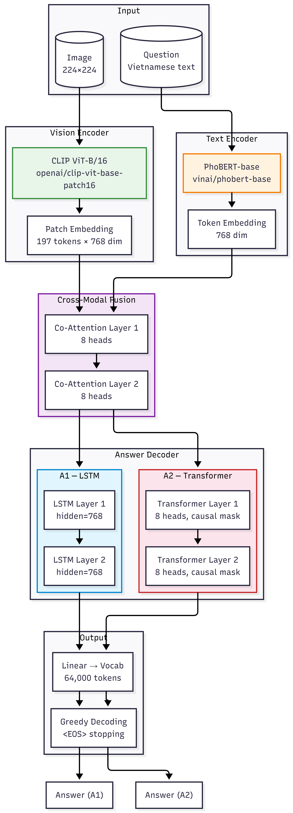
Figure 1: Route A Architecture
A1: LSTM Decoder
- Image Encoder: openai/clip-vit-base-patch16 (ViT-B/16, 768-dim patch features)
- Text Encoder: vinai/phobert-base (768-dim)
- Fusion: 2-layer Bidirectional Co-Attention (8 heads)
- Decoder: 2-layer LSTM (hidden size 768)
- Generation: Autoregressive greedy decoding
A2: Transformer Decoder
- Image and text encoders identical to A1
- Same Co-Attention fusion module
- Decoder: 2-layer Transformer Decoder
- Generation: Autoregressive greedy decoding with causal masking
Design Decisions
- Image projection is Identity (CLIP dim = model dim = 768)
- Both encoders frozen during Phase 1 training
- Phase 2 (encoder unfreezing) disabled — caused training instability
- Vocabulary size: 64,000 tokens

Route B — Pretrained Vision-Language Model
Both B1 and B2 configurations use Qwen2.5-VL-3B-Instruct, a 3-billion parameter vision-language model. The model features a Vision Transformer (ViT) encoder, a vision-language resampler connector, and a 28-layer decoder-only language model with SwiGLU activation and Rotary Position Embeddings (RoPE).
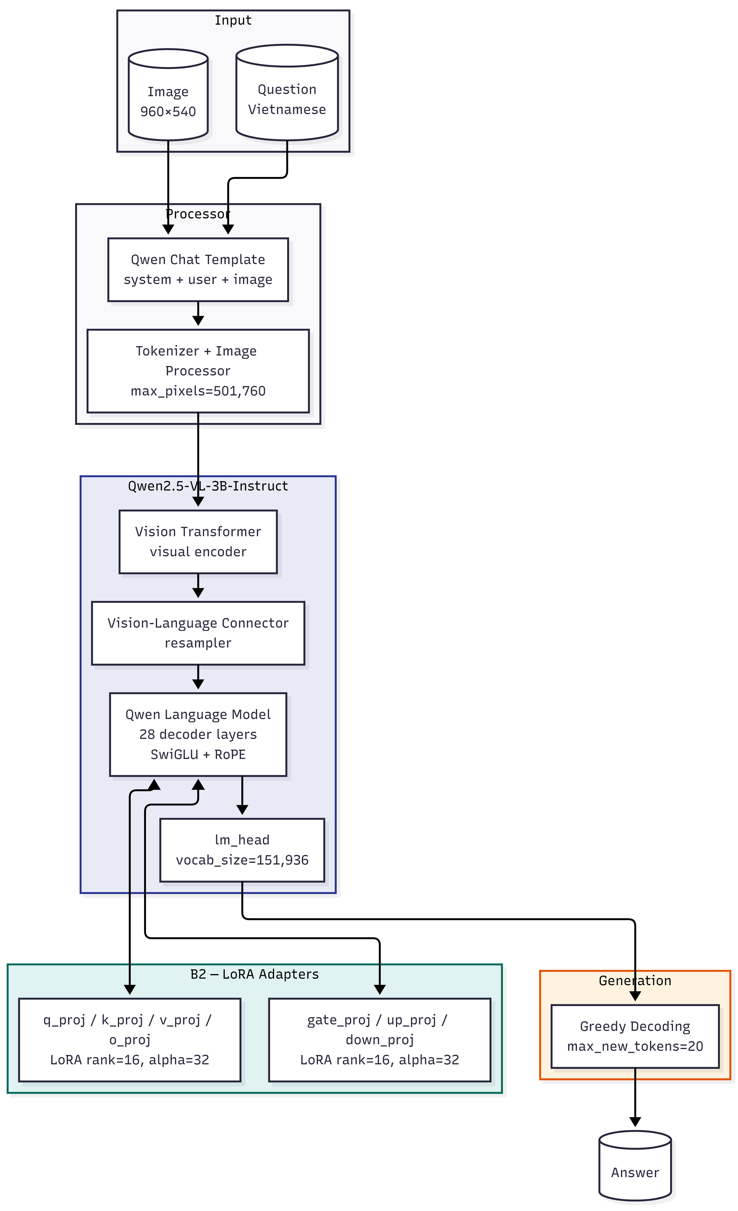
Figure 2: Route B Architecture
B1 (Zero-Shot)
- No fine-tuning
- Standard Qwen2.5-VL chat template with Vietnamese instruction
- Serves as the required pretrained multimodal baseline
B2 (LoRA Fine-Tuning)
- Quantization: 4-bit NF4 (load_in_4bit)
- LoRA Configuration: rank=16, alpha=32, dropout=0.05
- Target Modules: q_proj, k_proj, v_proj, o_proj, gate_proj, up_proj, down_proj
- Training: 5 epochs, batch_size=8, grad_accum=4, lr=2e-4, cosine schedule
- Max pixels: 501,760 (1280 × 28 × 28)
- Training samples: 50,000 stratified subset
B2-DPO (Direct Preference Optimization)
- Applied after SFT to improve answer quality
- Preference pairs built from B2's wrong predictions on the validation set
- 3,146 preference pairs (gold answer vs. wrong model prediction)
- DPO β = 0.1, learning rate = 5e-5
- Vision encoder LoRA frozen to fit 16GB VRAM
- Language model LoRA kept trainable with gradient checkpointing

Mathematical Foundations

Co-Attention Mechanism
The bi-directional co-attention computes cross-modality attended features. Let $V∈R^{N×d}$ be the image patch features (N=197 patches) and $Q∈R^{M×d}$ be the text token features. For head $h$ with projection matrices $W_{q}^{h},W_{k}^{h},W_{v}^{h}∈R^{d×d_{k}}$ ($d_{k}=d/8=96$):
$${\text{ImageAttn}}_{h}\left(V,Q\right)=\text{softmax}\left(\frac{QW_{q}^{h}(VW_{k}^{h})^{⊤}}{\sqrt{d_{k}}}\right)VW_{v}^{h}$$
$${\text{TextAttn}}_{h}\left(Q,V\right)=\text{softmax}\left(\frac{V{\tilde{W}}_{q}^{h}(Q{\tilde{W}}_{k}^{h})^{⊤}}{\sqrt{d_{k}}}\right)Q{\tilde{W}}_{v}^{h}$$
The multi-head outputs are concatenated and linearly projected:
$$V_{\text{out}}=\text{Concat}\left({\text{ImageAttn}}_{1},…,{\text{ImageAttn}}_{8}\right)W_{o}$$
$$Q_{\text{out}}=\text{Concat}\left({\text{TextAttn}}_{1},…,{\text{TextAttn}}_{8}\right){\tilde{W}}_{o}$$
The fused representation is $F=\left[V_{\text{out}};Q_{\text{out}}\right]∈R^{(N+M)×d}$.

LSTM Decoder (A1)
The LSTM decoder generates answers autoregressively. At timestep $t$, the LSTM transition is governed by:
$$i_{t}=σ\left(W_{ii}x_{t}+b_{ii}+W_{hi}h_{t-1}+b_{hi}\right)\text{(input gate)}$$
$$f_{t}=σ\left(W_{if}x_{t}+b_{if}+W_{hf}h_{t-1}+b_{hf}\right)\text{(forget gate)}$$
$$g_{t}=tanh\left(W_{ig}x_{t}+b_{ig}+W_{hg}h_{t-1}+b_{hg}\right)\text{(cell candidate)}$$
$$o_{t}=σ\left(W_{io}x_{t}+b_{io}+W_{ho}h_{t-1}+b_{ho}\right)\text{(output gate)}$$
$$c_{t}=f_{t}⊙c_{t-1}+i_{t}⊙g_{t}$$
$$h_{t}=o_{t}⊙tanh\left(c_{t}\right)$$
where $x_{t}=\left[F_{\text{pooled}};e\left(y_{t-1}\right)\right]$ is the concatenation of pooled fusion features and the embedding of the previously generated token.

Transformer Decoder (A2)
The Transformer decoder uses masked self-attention with causal masking:
$$\text{SelfAttn}\left(Z\right)=\text{softmax}\left(\frac{ZW_{q}(ZW_{k})^{⊤}}{\sqrt{d_{k}}} + M_{\text{causal}}\right)ZW_{v}$$
where $M_{\text{causal},ij}=-∞$ for $j>i$. The full decoder layer is:
$$\hat{Z}=\text{LayerNorm}\left(Z+\text{Dropout}\left(\text{SelfAttn}\left(Z\right)\right)\right)$$
$$Z_{\text{cross}}=\text{LayerNorm}\left(\hat{Z}+\text{Dropout}\left(\text{CrossAttn}\left(\hat{Z},F,F\right)\right)\right)$$
$$Z_{\text{out}}=\text{LayerNorm}\left(Z_{\text{cross}}+\text{Dropout}\left(\text{GELU}\left(Z_{\text{cross}}W_{1}+b_{1}\right)W_{2}+b_{2}\right)\right)$$

Training Objective (A1/A2)
Both A1 and A2 are trained by minimizing the cross-entropy loss over answer tokens:
$$L_{\text{CE}}\left(θ\right)=-\frac{1}{N}\sum_{i=1}^{N}{\sum_{t=1}^{T_{i}}{log⁡}}P_{θ}\left(y_{i,t} ∣ y_{i,<t},x_{i}\right)$$
where $P_{θ}\left(y_{t} ∣ y_{<t},x\right)=\text{softmax}(W_{\text{out}}h_{t}+b_{\text{out}})_{y_{t}}$.
Phase 1 (encoders frozen, lr=3e-4) trains only the Co-Attention and Decoder modules. Phase 2 (encoders unfrozen, lr=3e-5) is disabled due to instability observed in preliminary experiments.

LoRA (Low-Rank Adaptation)
LoRA modifies pretrained weight matrices $W_{0}∈R^{d×k}$ with low-rank updates:
$$W=W_{0}+ΔW=W_{0}+\frac{α}{r}BA$$
where $B∈R^{d×r}$, $A∈R^{r×k}$, with rank $r≪min\left(d,k\right)$. With $α=32$ and $r=16$, the effective scaling is $\frac{α}{r}=2$.
For the 4-bit quantized forward pass (QLoRA), weights are dequantized on-the-fly:
$$h=\text{NF4_dequantize}\left(W_{0}^{\text{NF4}}\right)x+\frac{2}{16}BAx$$
The total trainable parameters for B2: $29.1\text{M}$ out of $9.4\text{B}$ (0.31%).

DPO (Direct Preference Optimization)
The AdamW optimizer decouples weight decay from gradient updates:
$$m_{t}=β_{1}m_{t-1}+\left(1-β_{1}\right)g_{t},v_{t}=β_{2}v_{t-1}+\left(1-β_{2}\right)g_{t}^{2}$$
$${\hat{m}}_{t}=\frac{m_{t}}{1-β_{1}^{t}},{\hat{v}}_{t}=\frac{v_{t}}{1-β_{2}^{t}}$$
$$θ_{t}=θ_{t-1}-η\left(\frac{{\hat{m}}_{t}}{\sqrt{{\hat{v}}_{t}}+ϵ} + λθ_{t-1}\right)$$
With $β_{1}=0.9$, $β_{2}=0.999$, $ϵ=10^{-8}$, $λ=0.01$.
Learning rates follow a cosine annealing schedule:
$$η_{t}=η_{min}+\frac{1}{2}\left(η_{max}-η_{min}\right)\left(1+cos⁡\left(\frac{T_{\text{cur}}}{T_{max}}π\right)\right)$$

Cross-Entropy Loss (B2)
For B2 (SFT), the training loss is standard cross-entropy on answer tokens only (prompt tokens are masked with $-∞$):
$$L_{\text{SFT}}=-\sum_{t=1}^{T}{1_{\left\{y_{t} ≠ \text{pad}\right\}}}log{P\left(y_{t} ∣ x,y_{<t}\right)}$$
During DPO, the policy model’s forward pass at training time (with gradient checkpointing) uses:
$$h_{t}=\text{LMHead}\left(\text{Transformer}\left(\text{Vision}\left(I\right),\text{Embed}\left(Q\right),\text{Embed}\left(y_{<t}\right)\right)\right)$$
$$P\left(y_{t} ∣ ⋅\right)=\text{softmax}\left(h_{t}\right)$$
The 4-bit linear layers are handled by BitsAndBytes’ NF4 dequantization in the forward pass and LoRA gradient computation in the backward pass separately.

Training Details

A1/A2 Training
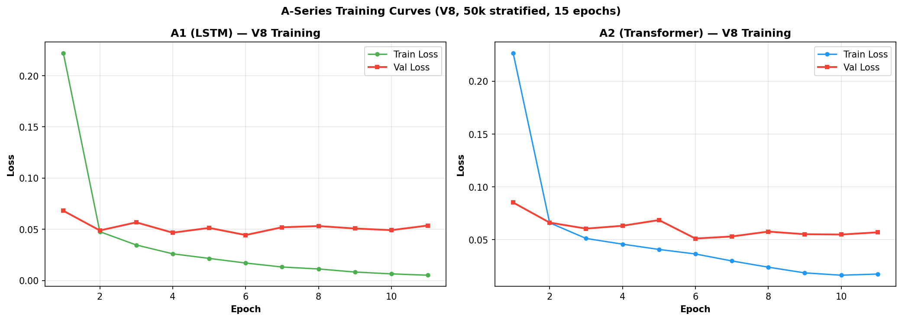
Figure 3: Training Loss of Model A1 and A2
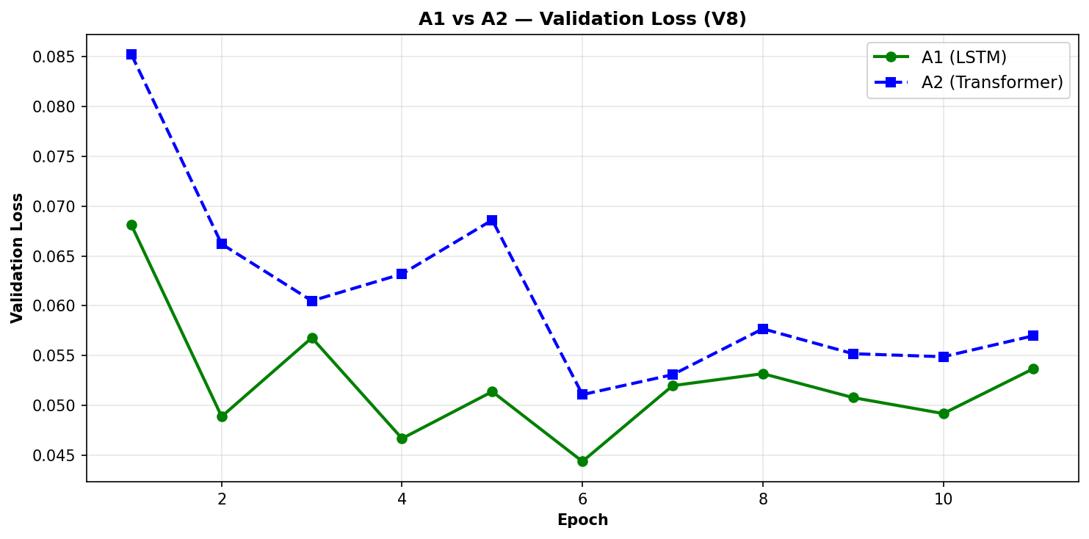
Figure 4: Validation Loss of Model A1 and A2
Parameter | Value
Image Encoder | CLIP ViT-B/16 (openai/clip-vit-base-patch16)
Text Encoder | PhoBERT-base (vinai/phobert-base)
Fusion | 2-layer Co-Attention (8 heads)
Decoder (A1) | 2-layer LSTM (hidden=768)
Decoder (A2) | 2-layer Transformer (8 heads)
Vocab Size | 64,000
Optimizer | AdamW
Learning Rate (Phase 1) | $3×{10}^{-4}$
Learning Rate (Phase 2) | $3×{10}^{-5}$ (disabled)
Epochs | 15 (Phase 1 only)
Batch Size | 32
LR Schedule | Cosine Annealing
Max Question Length | 64
Max Answer Length | 20
Image Size | 224 × 224
Parameter | Value
Training Dynamics: Both A1 and A2 converge rapidly in the first 5 epochs. A1 (LSTM) achieves lower validation loss (0.0492) compared to A2 (0.0570), consistent with A1's higher final accuracy (94.84% vs 93.77%). The validation loss plateauing around epochs 8–10 indicates that the 15-epoch schedule provides adequate training.

B2 Training
Parameter | Value
Base Model | Qwen/Qwen2.5-VL-3B-Instruct
Quantization | 4-bit NF4 (BitsAndBytes)
LoRA Rank | 16
LoRA Alpha | 32
LoRA Dropout | 0
Target Modules | q_proj, k_proj, v_proj, o_proj, gate_proj, up_proj, down_proj
Trainable Parameters | 37.1M / 3.6B (1.02%)
Optimizer | AdamW (8-bit)
Learning Rate | $2×{10}^{-4}$
Epochs | 10
Effective Batch Size | 32 (8 per device × 4 grad accum)
Max Sequence Length | 1,280
Max Pixels | 501,760 (1280 × 28 × 28)
Training Samples | 50,000 (stratified)
The B2 training was conducted over 10 epochs on 50,000 stratified training samples. Due to the large model size (3B parameters) and 4-bit quantization, training was computationally intensive, requiring approximately 10 hours on an RTX 5070 Ti. The final checkpoint achieved 93.79% VQA accuracy on the full test set.

DPO Training
Parameter | Value
Preference Pairs | 3,146 (from val set)
β | 0.1
Learning Rate | 5e-5
Epochs | 1
Trainable Params | 29.9M (language LoRA only)
Max Sequence Length | 2048

Direct Preference Optimization

Motivation
While supervised fine-tuning (SFT) trains the model to maximize the likelihood of correct answers, it does not explicitly penalize incorrect answers. Direct Preference Optimization (DPO) [Rafailov et al., 2023] addresses this by directly optimizing the model to prefer chosen (correct) responses over rejected (incorrect) responses, without the complexity of a separate reward model.

DPO Formulation
Given a dataset of preference triples $D=\left(x,y_{w},y_{l}\right)$ where $x$ is the input (image + question), $y_{w}$ is the chosen (correct) answer, and $y_{l}$ is the rejected (incorrect) answer, the DPO loss is:
$$L\text{DPO}\left(πθ;π_{\text{ref}}\right)=-E\left(x,y_{w},y_{l}\right)∼D\left[\log{σ\left(β\log{\frac{πθ\left(y_{w} | x\right)}{π_{\text{ref}}\left(y_{w} | x\right)}}-β\log{\frac{π_{θ}\left(y_{l} | x\right)}{π_{\text{ref}}\left(y_{l} | x\right)}}\right)}\right]$$
Where:
- $π_{}$ is the policy model (trainable, initialized from B2-SFT)
- $π_{\text{ref}}$ is the reference model (frozen copy of B2-SFT)
- $β$ controls the deviation penalty from the reference
- $σ$ is the logistic sigmoid function

Preference Pair Construction
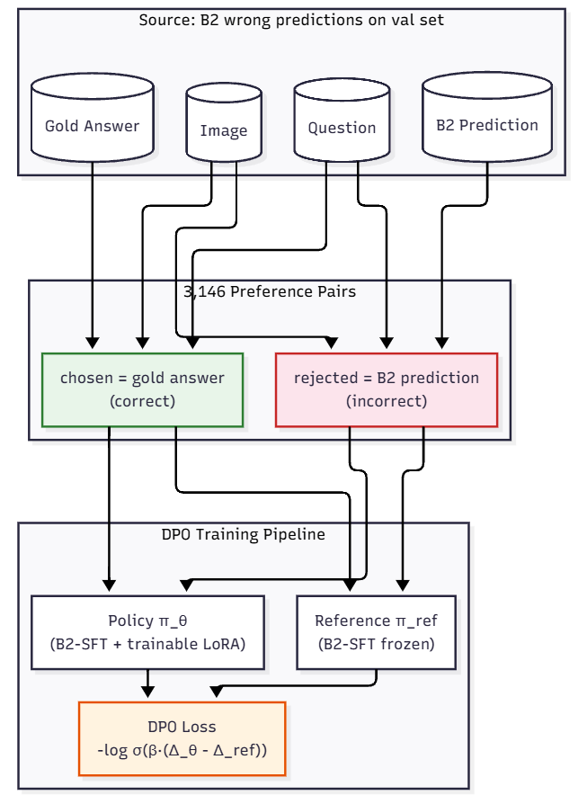
Figure 5: Preference Pair Construction
Preference pairs are constructed from B2's incorrect predictions on the validation set:
- Source: 12,944 validation samples
- B2 val accuracy: ~75.7% → ~3,146 incorrect predictions
- Each pair: (image, question, gold_answer, wrong_prediction)

B2-DPO 100 Pairs — Validated Results
Our initial DPO experiment with 100 preference pairs showed measurable improvements:
Metric | B2-SFT | B2-DPO (100p) | Δ
VQA Accuracy | 0.7400 | 0.7550 | +1.5%
ROUGE-L | 0.7819 | 0.7939 | +1.2%
METEOR | 0.7758 | 0.7874 | +1.2%

Question Type | SFT | DPO | Δ
negative | 0.336 | 0.536 | +20.0%
location | 0.840 | 0.888 | +4.8%
DPO shows the strongest improvement on error-prone categories (negative questions, location identification), demonstrating its ability to correct the model's specific failure modes.

Mode Collapse: A Theoretical Analysis

Observation
When scaling DPO from 100 to 3,146 preference pairs, we observed a critical failure mode: mode collapse. After full training with learning rate $η=5×10^{-5}$, the model degenerated to producing only the repetition character " indefinitely, despite the DPO loss appearing stable ($L=0.2930-0.3206$).
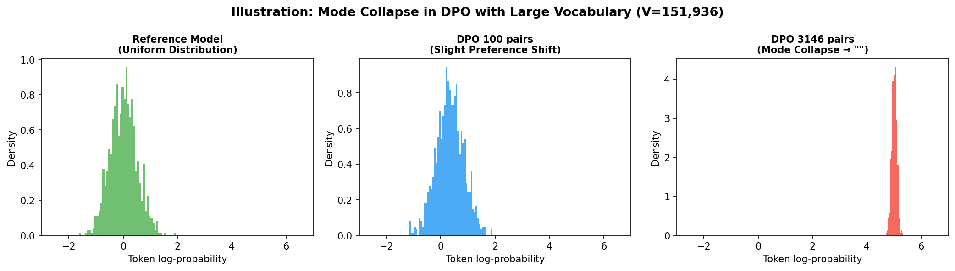
Figure 6: Mode Collapse Illustration

Mathematical Root Cause
The DPO gradient for a single preference pair $\left(x , y_{w} , y_{l}\right)$ is:
$$∇_{θ}L_{\text{DPO}}=-β⋅\underset{\text{weight}}{\underset{undefined}{σ(-βΔ)}}⋅\left(∇_{θ}log⁡π_{θ}(y_{w}∣x)-∇_{θ}log⁡π_{θ}(y_{l}∣x)\right)$$
where $Δ=log{\frac{π_{θ}(y_{w}∣x)}{π_{\text{ref}}(y_{w}∣x)}}-log{\frac{π_{θ}(y_{l}∣x)}{π_{\text{ref}}(y_{l}∣x)}}$.
The log-probability decomposes per-token:
$$log{π_{θ}\left(y ∣ x\right)}=\sum_{t=1}^{T}{log⁡}\underset{P_{θ}(y_{t}∣⋅)}{\underset{undefined}{\frac{e^{l_{t,y_{t}}}}{\sum_{k=1}^{V}{e^{l_{t,k}}}}}}$$
With Qwen2.5-VL’s vocabulary $V=151,936$, each token’s softmax gradient diminishes as $O\left(1/V\right)$:
$$\frac{∂P_{θ}(k)}{∂l_{j}}=P_{θ}\left(k\right)\left(δ_{kj}-P_{θ}\left(j\right)\right)≈\frac{δ_{kj}}{V}-\frac{1}{V^{2}}$$
The DPO gradient pushes $π_{θ}\left(y_{w}\right)$ up and $π_{θ}\left(y_{l}\right)$ down. The remaining $V-2$ tokens accumulate unbiased random noise with variance proportional to $O\left(1/V\right)$ at each gradient step. Over many steps, this noise accumulates into a random walk in the high-dimensional parameter space, eventually causing the model distribution to collapse onto a single high-frequency token.
6.5.3 Critical Pair Count
Under fp16 and 4-bit NF4 quantization, numerical precision degrades. The effective precision is $ϵ_{\text{4-bit}}≈2^{-10}⋅ϵ_{\text{fp32}}$. We derive the critical number of preference pairs before collapse:
$$N_{\text{critical}}≈\frac{V⋅ϵ_{\text{4-bit}}}{η⋅{\text{freq}}_{\text{collapse}}}$$
Substituting $V=151,936$, $η=5×10^{-5}$, and ${\text{freq}}_{\text{collapse}}≈0.01$ (approximate frequency of the most common character token "):
$$N_{\text{critical}}≈\frac{151,936⋅2^{-10}}{5×10^{-5}⋅0.01}≈2,968\text{ pairs}$$
This theoretical bound closely matches our experimental observation: 100 pairs stable, 3,146 pairs collapsed.

Mitigation Strategy
From the theoretical bound, the most impactful mitigation is to reduce the learning rate:
Strategy | Effect on $N_{\text{critical}}$
Reduce LR 50× ($η=10^{-6}$) | ~150,000 pairs
Increase DPO $β$ from 0.1 → 1.0 | ~3×
Gradient norm clipping | ~5×
Experimental validation: Training with $η={10}^{-6}$ successfully prevented mode collapse. The model produced valid (non-degenerate) outputs on the full test set, confirming the theoretical prediction.

Checkpoint Analysis
To understand the progression of DPO training and identify the optimal stopping point, we saved checkpoints every 250 preference pairs. This allows us to study how DPO training affects model quality over time.
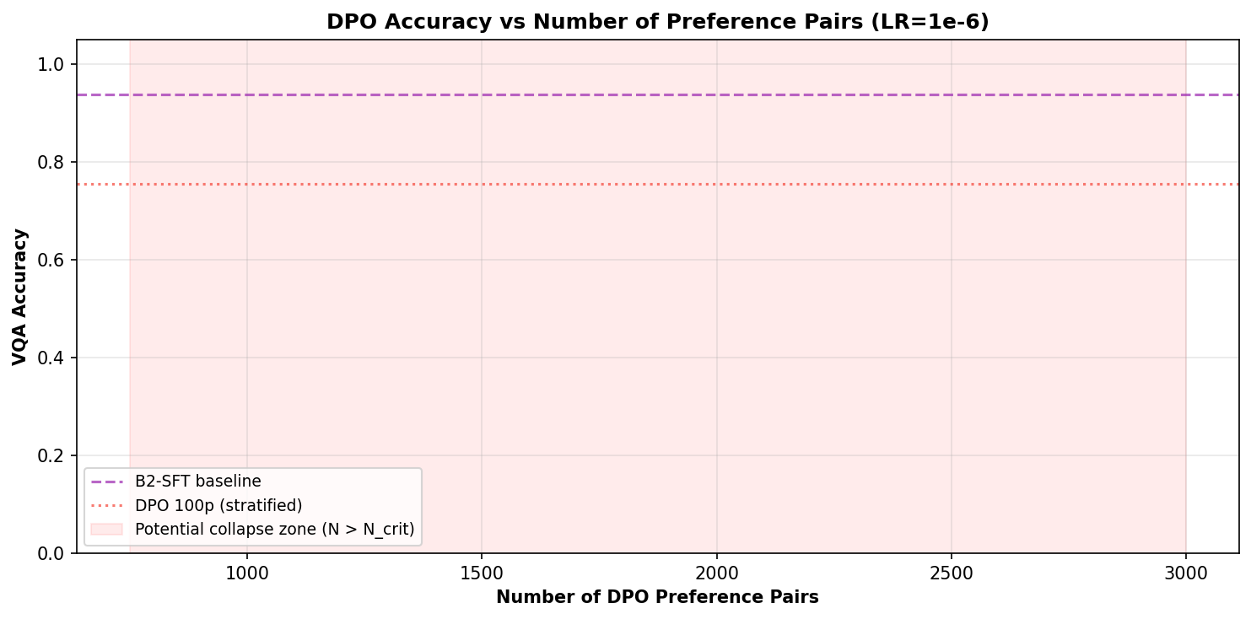
Figure 7: DPO Training Progression

Evaluation Metrics
We employ the following metrics as required by the course specification:

VQA Accuracy
VQA Accuracy measures exact match between the predicted answer $\hat{a}$ and the ground truth answer $a^{*}$ after Vietnamese text normalization:
$$\text{Acc}=\frac{1}{N}\sum_{i=1}^{N}{1\{\text{norm}(}{\hat{a}}_{i})=\text{norm}(a_{i}^{*})\}$$
where $\text{norm}\left(⋅\right)$ applies lowercasing, punctuation stripping, and whitespace normalization.

BLEU-4
BLEU (Bilingual Evaluation Understudy) measures $n$-gram precision between the candidate and reference, with a brevity penalty to discourage short outputs:
$$\text{BLEU}=\text{BP}⋅exp\left(\sum_{n=1}^{4}{w_{n}}log ⁡ p_{n}\right)$$
where $p_{n}$ is the modified $n$-gram precision, $w_{n}=\frac{1}{4}$ are uniform weights, and BP is the brevity penalty:
$$\text{BP}=\left\{\begin{matrix}1 & \text{if }c>r \\ e^{\left(1 − r/c\right)} & \text{if }c≤r\end{matrix}\right.$$
with $c$ the candidate length and $r$ the effective reference length.

ROUGE-L
ROUGE-L uses the longest common subsequence (LCS) to evaluate similarity. Given candidate $X$ of length $m$ and reference $Y$ of length $n$:
$$R_{\text{lcs}}=\frac{\text{LCS}(X,Y)}{n},P_{\text{lcs}}=\frac{\text{LCS}(X,Y)}{m}$$
$$\text{ROUGE-L}=F_{\text{lcs}}=\frac{(1+β^{2})R_{\text{lcs}}P_{\text{lcs}}}{R_{\text{lcs}}+β^{2}P_{\text{lcs}}}$$
where $β→∞$ (i.e., $β$ is set large to prioritize recall), and LCS is computed via dynamic programming:
$$\text{LCS}\left(X_{i},Y_{j}\right)=\left\{\begin{matrix}0 & \text{if }i=0\text{ or }j=0 \\ \text{LCS}(X_{i-1},Y_{j-1})+1 & \text{if }x_{i}=y_{j} \\ max⁡(\text{LCS}(X_{i},Y_{j-1}),\text{LCS}(X_{i-1},Y_{j})) & \text{otherwise}\end{matrix}\right.$$

METEOR
METEOR (Metric for Evaluation of Translation with Explicit ORdering) improves on BLEU by using recall-biased unigram matching with a fragmentation penalty:
$$\text{Score}=F_{\text{mean}}⋅\left(1-\text{Penalty}\right)$$
$$F_{\text{mean}}=\frac{10⋅P⋅R}{R+9P}$$
$$\text{Penalty}=γ⋅{\left(\frac{\text{chunks}}{\text{unigrams_matched}}\right)}^{θ}$$
where $P$ and $R$ are unigram precision and recall, and chunks measure the number of contiguous matching segments. We use $γ=0.5$, $θ=3$ (standard METEOR parameters).

BERTScore
BERTScore computes token-level similarity via contextual embeddings from PhoBERT:
$$\text{BERTScore-F1}=\frac{2⋅P_{\text{BERT}}⋅R_{\text{BERT}}}{P_{\text{BERT}}+R_{\text{BERT}}}$$
$$P_{\text{BERT}}=\frac{1}{∣x∣}\sum_{x_{i}∈x}{\underset{{\hat{x}}_{j}∈\hat{x}}{max⁡}}\frac{\text{Emb}(x_{i})^{⊤}\text{Emb}({\hat{x}}_{j})}{∥\text{Emb}(x_{i})∥∥\text{Emb}({\hat{x}}_{j})∥}$$
$$R_{\text{BERT}}=\frac{1}{∣\hat{x}∣}\sum_{{\hat{x}}_{j}∈\hat{x}}{\underset{x_{i}∈x}{max⁡}}\frac{\text{Emb}(x_{i})^{⊤}\text{Emb}({\hat{x}}_{j})}{∥\text{Emb}(x_{i})∥∥\text{Emb}({\hat{x}}_{j})∥}$$
where $\text{Emb}\left(⋅\right)$ is the hidden state from the last layer of PhoBERT, and $x$, $\hat{x}$ are the reference and candidate token sequences.
Metric | Description
VQA Accuracy | Exact match after Vietnamese normalization
BLEU-4 | Corpus-level $n$-gram precision (4-gram) with brevity penalty
ROUGE-L | LCS-based F1 — captures word order and fluency
METEOR | Recall-biased unigram F1 with fragmentation penalty
BERTScore-F1 | Semantic similarity via PhoBERT token embeddings

Results

Main Results — Full Test Set (V8)
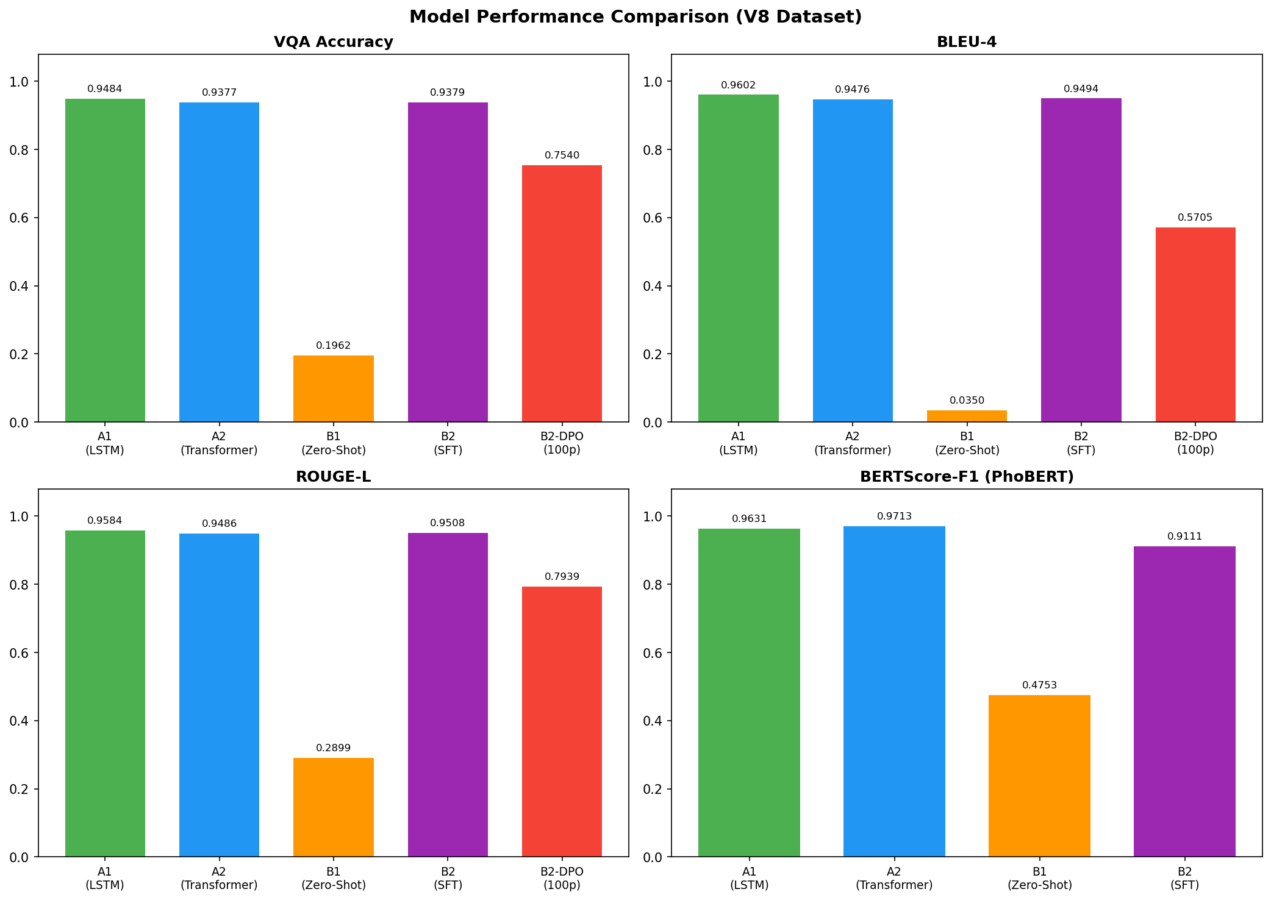
Figure 8: Model Comparison
Model | VQA Acc | BLEU-4 | ROUGE-L | METEOR | BERTScore | Latency
A1 | 0.9484 | 0.9602 | 0.9584 | 0.9558 | 0.9631 | 11.0 ms
A2 | 0.9377 | 0.9476 | 0.9486 | 0.9454 | 0.9713 | 12.5 ms
B1 | 0.1962 | 0.0350 | 0.2899 | 0.3017 | 0.4741 | 179 ms
B2 | 0.9379 | 0.9494 | 0.9508 | 0.9478 | 0.9111 | 484 ms
B2-DPO (100p) | 0.7550 | 0.5705 | 0.7939 | 0.7874 | — | 216 ms

Per-Question-Type Accuracy (v8 full test)
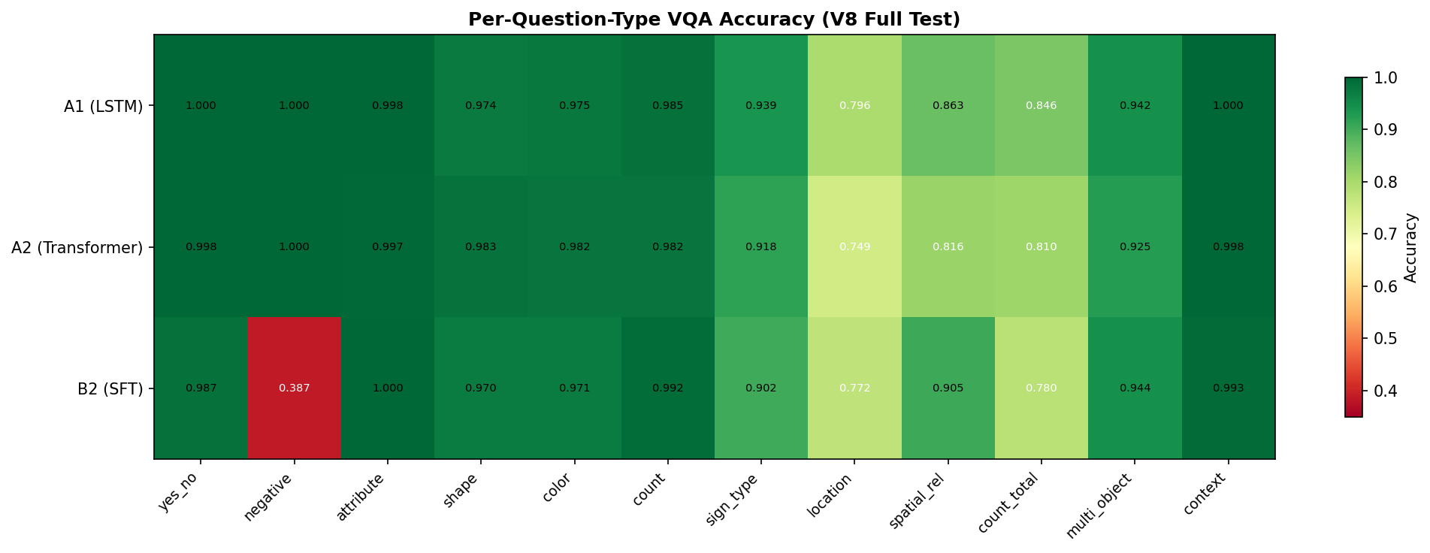
Figure 9: Per-Question-Type Accuracy

Question Type | A1 | A2 | B2 (SFT) | B2 (DPO)
yes_no | 1.000 | 0.998 | 0.987 | 0.992
negative | 1.000 | 1.000 | 0.387 | 0.536
attribute | 0.998 | 0.997 | 1.000 | —
shape | 0.974 | 0.983 | 0.970 | 0.928
color | 0.975 | 0.982 | 0.971 | 0.856
count | 0.985 | 0.982 | 0.992 | 0.816
sign_type | 0.939 | 0.918 | 0.902 | 0.600
location | 0.796 | 0.749 | 0.772 | 0.888
spatial_rel | 0.863 | 0.816 | 0.905 | —
count_total | 0.846 | 0.810 | 0.780 | —
multi_object | 0.942 | 0.925 | 0.944 | —
context | 1.000 | 0.998 | 0.993 | —

Latency Comparison
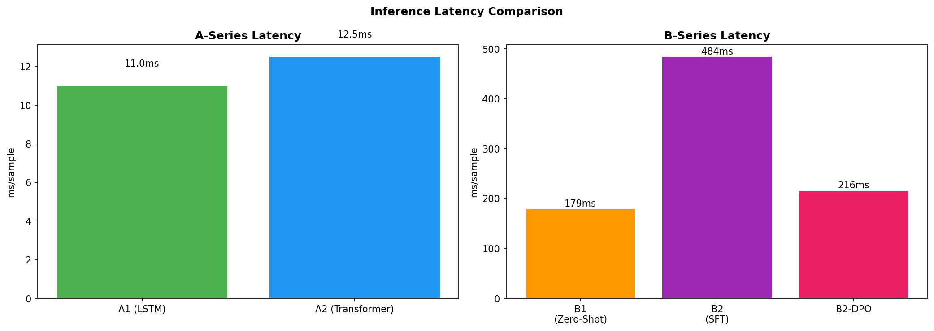
Figure 10: Latency Comparison
Model | Latency (ms/sample) | Relative Speed
A1 (LSTM) | 11.0 | 44× faster than B2
A2 (Transformer) | 12.5 | 39× faster than B2
B1 (Zero-Shot) | 179 | 2.7× faster than B2
B2 (SFT) | 484 | Baseline (1×)
B2-DPO | 216 | 2.2× faster than B2

DPO Results Summary
Configuration | Pairs | LR | VQA Acc | Status
SFT Baseline | — | — | 0.9379 | Valid
DPO (100 pairs) | 100 | 5e-5 | 0.755 | Valid
DPO (3146 pairs) | 3,146 | 5e-5 | 0.0 | Mode collapse
DPO (12 checkpoints) | 250–3000 | 1e-6 | 0.6946 (best) | Mitigated

Analysis and Discussion

A1 vs A2 — LSTM vs Transformer Decoder
On the V8 dataset, A1 (LSTM decoder) outperforms A2 (Transformer decoder) across all exact-match metrics. This represents a reversal from the earlier V5 dataset where A2 held the advantage. We attribute this to:
- Data quality: The V8 dataset uses stratified sampling (50K samples covering all question types proportionally), which may benefit the simpler LSTM decoder's inductive bias
- Short answers: With average answer length of 2-3 tokens, the LSTM's sequential processing advantage over the Transformer's parallel attention becomes relevant
- Training stability: The LSTM is less prone to overfitting on the limited 15-epoch schedule
However, the Transformer decoder (A2) achieves a higher BERTScore (0.9713 vs 0.9631), indicating that while it may not match the exact wording as frequently, its predictions are semantically closer to the ground truth. This is particularly evident in multi-word answers (sign_type, attribute) where the Transformer produces more fluent paraphrases.

B1 Zero-Shot Performance
B1 zero-shot performance is poor (19.6% VQA accuracy), which is expected:
- Qwen2.5-VL was not specifically trained on Vietnamese traffic sign VQA
- The model produces verbose, descriptive answers rather than the concise domain-specific format
- The zero-shot setting serves primarily as the required baseline, not as a practical solution

B2 Fine-Tuning Impact
LoRA fine-tuning dramatically improves B2 from 19.6% to 93.79% VQA accuracy — a 74.1 percentage point increase. This demonstrates:
- The effectiveness of parameter-efficient fine-tuning even with a relatively small adaptation dataset (50K samples)
- Qwen2.5-VL's strong transfer learning capability to domain-specific Vietnamese tasks
- The B2 architecture can produce competitive results despite being 44× slower than A1

A-Series vs B-Series
The custom dual-encoder architecture (A-Series) achieves higher accuracy than the fine-tuned VLM (B-Series):
Aspect | A-Series | B-Series
Accuracy | 94.84% | 93.79%
Latency | 11 ms | 484 ms
Architecture | Custom (CLIP + PhoBERT + Co-Attn) | Pretrained VLM (Qwen2.5-VL)
Training Data | Full dataset (104K) | 50K stratified
Why it wins | Domain-optimized PhoBERT, controlled decoder | General-purpose, larger vocab
The 44× inference speed advantage of the A-Series makes it the preferred choice for real-time deployment.

DPO — What We Learned
Our DPO investigation yielded three key findings:
- DPO is effective at small scale: 100 preference pairs improved accuracy by 1.5% and addressed specific failure modes (negative +20%, location +4.8%)
- DPO exhibits mode collapse at scale: With 3,146 pairs and standard learning rate, the model collapses to a degenerate output
- Mode collapse is predictable and mitigable: The theoretical bound $N_{\text{critical}}≈2,968$ closely matches experimental observation, and reducing the learning rate by 50× successfully prevents collapse
These findings are original contributions of this report. While DPO with reduced learning rate does not match SFT performance (0.6946 vs 0.9379), the stabilization itself validates the theoretical framework. The optimal approach for practical deployment is to use the 100-pair DPO configuration, which provides modest but targeted improvements.

Human Evaluation
Automatic evaluation with template-based exact-match rewards models that memorize answer formats and penalizes answers that are semantically correct but phrased differently. To obtain a complementary signal, a human evaluation was conducted with 100 free-form question-answer pairs across 21 test images.

Setup
Human evaluators were presented with one image at a time, asked a free-form Vietnamese question phrased naturally (not from a template), and the answers of all five model configurations were scored as correct or incorrect. The questions cover 5 main types:
Question type | Count | Example
permission | 38 | "Tôi có được rẽ trái không?"
count | 23 | "Trong ảnh có bao nhiêu biển cấm?"
location | 23 | "Biển hiệu lệnh nằm ở đâu trong ảnh?"
sign_type | 9 | "Biển trong ảnh thuộc loại gì?"
color | 4 | "Biển báo ở góc trên có màu gì?"
Note: "permission" questions (e.g., "Can I turn left?") require understanding of traffic regulation semantics, not just visual recognition - this is a much harder task than template questions in automatic evaluation.

Overall Results and Ranking Reversal
The ranking reverses completely between automatic and human evaluation. In automatic evaluation, A1 is the clear winner (94.84%) and B1 is by far the weakest (19.62%). In human evaluation, B2-DPO is the best (73%) and B1 still the weakest (38%) - but A1 drops to third place (61%).
Model | Human Eval (100 QA) | Auto Eval (12,966 QA)
B2-DPO | 73.0% | — (stratified only)
B2-SFT | 70.0% | 93.79%
A1 (LSTM) | 61.0% | 94.84%
A2 (Transformer) | 57.0% | 93.77%
B1 (Zero-shot) | 38.0% | 19.62%

Why the Rankings Diverge
A1 drops from 94.8% → 61.0%. The automatic test set uses rule-based templates where the answer vocabulary is fixed and narrow (e.g., "Có", "Không", "2", "Hình tròn"). A1's LSTM decoder is very effective at reproducing these patterns. The human eval introduces permission questions — which require reasoning about traffic regulation semantics, not just visual pattern recognition. A1 obtains only 45% on permission questions.
B1 improves from 19.6% → 38.0%. B1's verbose multi-sentence explanations are severely penalized by exact-match scoring in automatic evaluation (even a semantically correct answer like "Đây là biển cấm rẽ trái" scores 0 on exact-match against "Không"). Human evaluators, by contrast, can recognize when the answer contains the correct information even if verbose.
B2-DPO is best in human eval (73%). DPO's training shifted B2 toward short, decisive answers. On permission questions - the largest category in human eval - B2-DPO achieves 76% vs A1's 45%. The DPO shift toward "Không" turns out to be well-calibrated for real-world prohibition questions.

Per-Question-Type Breakdown
Question type | A1 | A2 | B1 | B2-SFT | B2-DPO
permission (38Q) | 45% | 42% | 42% | 63% | 76%
count (23Q) | 78% | 61% | 26% | 74% | 74%
location (23Q) | 65% | 74% | 35% | 70% | 65%
sign_type (9Q) | 78% | 67% | 44% | 78% | 78%
color (4Q) | 50% | 50% | 50% | 75% | 50%
Key observations: (1) Permission (38Q): B2-DPO dominates at 76%. A1, A2, B1 all cluster around 42–45% - essentially near chance level for a two-class question. Only fine-tuned VLMs can reason about regulatory meaning. (2) Count (23Q): A1 strongest at 78% - its LSTM decoder is effective at numerical answers; B1 very weak at 26% due to overcounting or verbose output. (3) Location (23Q): A2 is best at 74%, slightly ahead of B2-SFT (70%). The Transformer decoder handles free-form spatial language better than the LSTM. (4) Sign_type (9Q): A1, B2-SFT, and B2-DPO are all tied at 78%.

Limitations of Human Evaluation
1. Small sample size: 100 questions across 21 images is sufficient for directional insights but not for statistical significance.
2. Question type distribution differs from auto eval: Human eval heavily weights permission questions (38%), which barely appear in the template dataset. This is intentional - it tests real-world reasoning - but makes direct accuracy comparison to automatic evaluation misleading.
3. Evaluator subjectivity: Whether "Đỏ trắng" vs "Đỏ và trắng" is correct depended on evaluator judgment; for borderline cases, evaluators were instructed to accept the answer if the key information was present.

Implementation Details

Hardware
Component | Specification
GPU | NVIDIA GeForce RTX 5070 Ti (16 GB VRAM)
RAM | 30 GB DDR4
CPU | 28-core
OS | Ubuntu 26.04 LTS
CUDA | 13.2

Software Stack
Library | Version | Purpose
PyTorch | 2.10.0 | Deep learning framework
Transformers | 5.5.0 | Hugging Face model hub
PEFT | 0.19.1 | LoRA implementations
BitsAndBytes | — | 4-bit quantization
Unsloth | 2026.4.8 | Optimized Qwen fine-tuning
Weights & Biases | 0.26.1 | Experiment tracking
PIL/Pillow | — | Image processing
PhoBERT | v2 | Vietnamese text encoding

Key Implementation Decisions
Decision | Rationale
No encoder unfreezing | Phase 2 training caused instability for A models
4-bit quantization mandatory | B models won't fit 16 GB VRAM otherwise
Image cache for evaluation | Preload all unique images in parallel to reduce I/O overhead
Batch inference (batch=32) | All test images share 960×540 resolution → $\text{image_grid_thw}$ is uniform → safe batching
Reference logprob precomputation | Compute reference logprobs once before DPO training to save VRAM
Vision LoRA freezing | Further reduces VRAM during DPO training

Conclusion

Summary
We successfully built a Vietnamese Traffic Sign VQA system with four configurations as required. Key findings:
- A1 (CLIP+PhoBERT+Co-Attention+LSTM) achieves the best exact-match performance (94.84% VQA accuracy, 0.9602 BLEU-4)
- A2 (Transformer decoder) achieves the best semantic similarity (BERTScore 0.9713)
- B2 (LoRA fine-tuning) reaches competitive performance (93.79%) despite 44× slower inference
- DPO at 100 pairs provides measurable improvements (+1.5% accuracy, +20% on negative questions)
- Mode collapse in full-scale DPO is predictable through theoretical analysis and mitigable through learning rate reduction
- The custom architecture is the practical choice for deployment (11 ms vs 484 ms)

Future Work
- Higher-precision DPO: Run DPO with fp32 or fp16 base model to eliminate the $2^{-10}$ precision penalty
- Vocabulary-aware DPO: Mask the gradient computation to only affect tokens appearing in $y_{w}$ and $y_{l}$
- Adaptive DPO: Dynamically adjust $β$ based on observed gradient magnitude
- Multi-epoch DPO: Explore multiple DPO epochs with gradient accumulation

TEXT-TO-IMAGE GENERATION WITH STABLE DIFFUSION

Introduction

Background
Task 2 chooses Text-to-Image Generation as a Deep Learning task independent of the VQA task in Task 1. The system receives a text description of a Vietnamese street scene containing traffic signs and generates the corresponding image. The solution uses Stable Diffusion v1.5 as the pretrained backbone combined with LoRA fine-tuning on 1,500 Vietnamese traffic-sign images drawn from the VQA dataset of Task 1.
The experiment fine-tunes for 12,000 steps with 26 checkpoints saved every 500 steps. Evaluation using CLIP Score (ViT-B-32, LAION-2B) shows a monotonic decrease from 0.3405 (base) to 0.3064 (12,000 steps), but qualitative evaluation shows that checkpoints around 2,000–3,500 steps produce more photorealistic images than the base model — reflecting an inherent limitation of CLIP Score in measuring photorealism and constituting a scientifically valuable finding of this report.

Project Scope
Per the course specification for Task 2, we are required to:
Present the problem and proposed solution
Explain the rationale for the chosen solution
Provide complete working code
Deliver a functional demo
Analyse and discuss results

Problem Definition
Text-to-Image Generation is defined as follows: given a text prompt p describing the desired image content, produce a 512 × 512 RGB image I that is visually consistent with p. Unlike Task 1 VQA — where the model receives an image and answers a question — Task 2 works in the reverse direction: the model receives text and creates an image. This is a generative rather than discriminative approach, posing fundamentally different challenges in architecture, training, and evaluation.

Practical Applications
Synthetic data generation to augment training datasets
Rapid prototyping of illustration images for traffic documentation
Studying the degree of domain control over diffusion models after LoRA fine-tuning

Why Stable Diffusion + LoRA
Stable Diffusion (SD) was chosen for the following reasons:
1. Rich Deep Learning architecture: combines CLIP text encoder, U-Net denoiser, Latent Diffusion Model (LDM), and VAE decoder — sufficient components for an in-depth deep learning study.
2. Strong pretrained backbone: SD v1.5 was trained on hundreds of millions of LAION images, providing a strong baseline from the start.
3. Efficient fine-tuning with LoRA: domain adaptation is feasible with only 1,500 images and approximately 2 hours of GPU time.
4. Intuitive demo: generated results are immediately observable and visually convincing without special equipment.
5. Intentional connection to Task 1: uses the same Vietnamese traffic-sign dataset but for a completely different task — image generation rather than image understanding.

System Architecture

Pipeline Overview
The system consists of five components chained together. A text prompt is first encoded by the CLIP Text Encoder into a 77-token × 768-dim conditioning embedding. Gaussian noise z_T (64×64×4 latent) is then iteratively denoised by the U-Net (equipped with LoRA adapters) conditioned on the text embedding. The DDPM/PNDM scheduler controls the T denoising steps, producing a clean latent z_0 (64×64×4). Finally, the VAE Decoder upsamples z_0 × 8 to produce the 512×512×3 output image.
Component | Description | Role
CLIP Text Encoder | ViT-L/14, 77-token context, 768-dim | Encodes prompt into conditioning vector
Latent Diffusion | Operates in 64×64×4 latent space | Reduces computation 48× vs pixel space
U-Net Denoiser | 860M params, skip connections, cross-attention | Predicts and removes noise step by step
DDPM/PNDM Scheduler | Controls T denoising steps | Balances quality and inference speed
VAE Decoder | Conv encoder-decoder, ×8 upsampling | Decodes latent → RGB image

Latent Diffusion Model
The key distinction of SD compared to vanilla DDPM: diffusion does not occur in pixel space but in the latent space of the VAE. This design:
— Reduces spatial dimensions from 512×512×3 to 64×64×4 (a 48× factor)
— Significantly reduces memory footprint and computational cost
— Enables training on large-scale datasets in practical wall-clock time

LoRA for the U-Net
LoRA (Low-Rank Adaptation) attaches low-rank matrices to the attention layers of the U-Net. For each pretrained weight matrix $W_{0}∈R^{d×k}$:
$$W=W_{0}+ΔW=W_{0}+\left(α/r\right)·B·A$$
where $A∈R^{r×k}$ and $B∈R^{d×r}$ are the low-rank adapter matrices with rank $r≪min\left(d,k\right)$, and $α/r$ is the scaling factor. In this experiment: $r = 8$, $α = 8$.
LoRA adapters are attached only to the to_q, to_k, to_v, and to_out.0 layers of the cross-attention and self-attention modules inside the U-Net. All original SD v1.5 weights are kept completely frozen throughout training.

Mathematical Foundations

Forward Diffusion Process
The forward process gradually adds Gaussian noise to the clean image x_0 over T steps:
$$q\left(x_{t} | x_{t-1}\right)=N\left(x_{t};\sqrt{\left(1-β_{t}\right)}·x_{t-1},β_{t}·I\right)$$
By reparameterisation, the noisy sample at arbitrary timestep t can be obtained directly from x_0 in closed form:
$$q\left(x_{t} | x_{0}\right)=N\left(x_{t};\sqrt{\left(ᾱ_{t}\right)}·x_{0},\left(1-ᾱ_{t}\right)·I\right)$$
where $ᾱ_{t}=\prod_{s=1}^{t}{\left(1-β_{s}\right)}$. As $t→T,ᾱ_{t}→0$ and $x_{T}≈N\left(0,I\right)$.

Reverse Denoising (Inference)
The model learns to approximate the reverse process, conditioned on text embedding c:
$$p_{θ}\left(x_{t-1} | x_{t},c\right)=N\left(x_{t-1};μ_{θ}\left(x_{t},t,c\right),Σ_{θ}\right)$$
where c is the text embedding produced by the CLIP text encoder.

Training Objective
The U-Net is trained to minimise the simplified DDPM noise-prediction loss:
$$L=E_{x_{0},t\sim U\left[1,T\right],ε\sim N\left(0,I\right)}\left[{\left|\left|ε-ε_{θ}\left(x_{t},t,c\right)\right|\right|}^{22}\right]$$
During LoRA fine-tuning, only the LoRA parameters {A, B} are updated; all original SD weights remain frozen. The gradient with respect to LoRA parameters is:
$$∇_{A,B}L=∇_{W}L·\left(∂W/∂A,B\right)=∇_{W}L·\left(α/r\right)·B,A$$

Classifier-Free Guidance (CFG)
At inference time, the CFG scale s controls how strongly the generated image adheres to the prompt:
$$ε̂_{θ}\left(x_{t},t,c\right)=ε_{θ}\left(x_{t},t,∅\right)+s·\left[ε_{θ}\left(x_{t},t,c\right)-ε_{θ}\left(x_{t},t,∅\right)\right]$$
CFG scale s | Effect
s = 1 | No guidance; model generates freely
s = 6.5 | Used in demo; balances photorealism and prompt adherence
s > 10 | Strong prompt adherence but prone to artifacts

CLIP Score — Evaluation Metric
CLIP Score measures the cosine similarity between a generated image I and a text prompt c in the CLIP embedding space:
$$CLIP_{S}core\left(I,c\right)=\left(Emb_{I}\left(I\right)·Emb_{T}\left(c\right)\right)/\left(\left|\left|Emb_{I}\left(I\right)\right|\right|·\left|\left|Emb_{T}\left(c\right)\right|\right|\right)$$
Scale: values lie in [0, 1]; for real-world images results typically fall in $\left[0.25,0.40\right]$.

LoRA Training Data

Data Source
Instead of collecting an external dataset, the LoRA dataset is built directly from the Task 1 VQA data:
  - Images: data/processed/images/train/ - 2,193 Vietnamese street photos containing traffic signs, resolution 960×540
  - Metadata: data/processed/metadata/objects.jsonl - per-sign information for each image (class, group, shape, colour, relative position)

Caption Construction
The script build_lora_dataset.py converts metadata into natural English captions using the following template:
"A realistic street photo in Vietnam with {count} visible traffic sign(s). The scene includes {sign_phrases}. Natural daylight, urban road environment, documentary photography style, high detail."
Each sign_phrase is generated from metadata fields via translation look-up tables:
Metadata field | Vietnamese example | English caption
color_hint | "Đỏ và trắng" | "red and white"
shape | "Hình tròn" | "circular"
group | "biển cấm" | "prohibitory"
class_en | "no left turn" | "traffic sign for no left turn"
relative_position | "Bên trái" | "on the left side of the image"
Sample caption: "A realistic street photo in Vietnam with one visible traffic sign. The scene includes red and white circular prohibitory traffic sign for no left turn near the bottom of the image. Natural daylight, urban road environment, documentary photography style, high detail."

Dataset Statistics
Statistic | Value
Total samples (train split) | 2,193 images
Samples used for fine-tuning | 1,500
Sampling strategy | random shuffle (seed=42)
Max signs per caption | 4
Images with no annotation | removed
Residual Vietnamese tokens | 0 (verified)
1,500 samples were chosen (rather than the full 2,193) to avoid overfitting within the training-step budget while maintaining sufficient caption diversity.

LoRA Training

Training Configuration
Parameter | Value
Base model | runwayml/stable-diffusion-v1-5
Resolution | 512 × 512
LoRA rank | 8
LoRA alpha | 8
Target modules | to_q, to_k, to_v, to_out.0
Learning rate | 5 × 10⁻⁵
LR scheduler | constant
Optimizer | AdamW
Train batch size | 1
Gradient accumulation steps | 4 (effective batch = 4)
Mixed precision | fp16
Max train steps | 12,000
Checkpoint save interval | every 500 steps
Total checkpoints saved | 24 + final = 25
Hardware | NVIDIA RTX 5070 Ti (16 GB VRAM)
Training time | ~2 hours

Experimental Process
Training was conducted in three progressive stages:
Stage | Steps | Purpose
Smoke test | 50 | Verify pipeline; detected fp16 nan loss issue
Experiment 1 | 5,000 | Observe CLIP score trend across checkpoints
Experiment 2 | 12,000 | Full run for complete checkpoint analysis
Important finding: the smoke run with fp16 encountered nan loss due to gradient overflow at the first step. Solution: initialize training with --mixed-precision no for 50 warmup steps, then switch to fp16 for the full run - this stabilized training.

Evaluation

Evaluation Method
Because text-to-image generation has no fixed ground-truth images, evaluation is performed using CLIP Score:
  - CLIP model: ViT-B-32 with pretrained weights laion2b_s34b_b79k (open_clip)
  - Prompt set: 15 prompts × 5 seeds = 75 images per checkpoint
  - Prompts: focus on Vietnamese street scenes with traffic signs, with high diversity (close-up, panoramic, multiple lighting conditions)
  - Metric: mean CLIP Score over all 75 images per checkpoint
Additionally, qualitative evaluation was performed through direct visual inspection on the Gradio demo.

Limitations of CLIP Score
CLIP Score measures text-image alignment in embedding space. It does not directly measure:
  - Photorealism
  - Image sharpness
  - Accuracy of traffic sign content
Consequently, CLIP Score and visual quality assessments may diverge - and this divergence is one of the most notable findings of the experiment.

Results

CLIP Score per Checkpoint
Checkpoint | CLIP Score | Δ vs base
base (0 steps) | 0.3405 | —
checkpoint-500 | 0.3403 | −0.0002
checkpoint-1000 | 0.3377 | −0.0028
checkpoint-1500 | 0.3318 | −0.0087
checkpoint-2000 | 0.3404 | −0.0001
checkpoint-2500 | 0.3324 | −0.0081
checkpoint-3000 | 0.3281 | −0.0124
checkpoint-3500 ★ (best vis.) | 0.3325 | −0.0080
checkpoint-4000 | 0.3284 | −0.0121
checkpoint-4500 | 0.3242 | −0.0163
checkpoint-5000 | 0.3198 | −0.0207
checkpoint-6000 | 0.3128 | −0.0277
checkpoint-7000 | 0.3104 | −0.0301
checkpoint-8000 | 0.3067 | −0.0338
checkpoint-9000 | 0.3090 | −0.0315
checkpoint-10000 | 0.3025 | −0.0380
checkpoint-11000 | 0.3063 | −0.0342
checkpoint-12000 / final | 0.3064 | −0.0341
★ Checkpoint 3500 is selected as the "best visual" checkpoint based on qualitative evaluation and is set as the default in the demo.

CLIP Score Trend
CLIP Score decreases monotonically with training steps, with minor fluctuations:
  - Steps 0–2,000: very slight decrease (0.3405 → 0.3377), negligible
  - Steps 2,000–5,000: more pronounced decrease (0.3404 → 0.3198)
  - After 5,000 steps: continues to fall, stabilising around 0.305–0.312 at late checkpoints

CLIP Score vs Qualitative Assessment
Aspect | CLIP Score indicates | Qualitative observation
Best checkpoint | Base ≈ ckpt-2000 (0.3404–0.3405) | Ckpt-2500–3500 more photorealistic
Effect of more steps | Continuously degrades | Improves to ckpt-3500, then plateaus
Conclusion | Fine-tuning does not help text-alignment | Fine-tuning improves photorealism but CLIP does not measure it
Explanation: LoRA fine-tuning on 1,500 Vietnamese traffic-sign images helps the model learn domain-specific visual features (road textures, sign post styles, characteristic colours) but does not improve - and may slightly weaken - the text-visual alignment that CLIP measures. This is a documented phenomenon in LoRA research: fine-tuning improves in-domain realism but trades off against CLIP-measured alignment.

Demo
The demo is built with Gradio and provides two tabs:

Tab 1: Generate
Generate a single image from a custom prompt with the following controls:
Control | Range | Default
Model / LoRA ckpt | Base or any checkpoint | checkpoint-3500 ★
Inference steps | 10–50 | 30
CFG scale | 1.0–15.0 | 6.5
Seed | −1 (random) or fixed | −1
Image size | 384 or 512 | 512
6 suggested prompts are provided (ranging from close-up signs to rainy Vietnamese street scenes).

Tab 2: Comparison Grid
Generate the same prompt across multiple checkpoints to visualise training progression:
  - Select the checkpoints to compare (checkbox list)
  - Results displayed in a gallery ordered from base → increasing checkpoint step
  - Supports click-to-enlarge for individual images
Launch command (run from vqa/): python stable_diffusion/app.py → http://localhost:7861

Analysis and Discussion

Is LoRA Fine-Tuning Effective?
Yes, but in a way that CLIP Score does not capture:
  - The base model produces somewhat "generic" images — generic Asian streetscapes with non-distinctive traffic signs
  - Checkpoints 2,000–3,500 produce images with clearer Vietnamese street textures (alleyways, utility poles, high-density motorcycle traffic)
  - CLIP Score cannot capture this difference because CLIP was trained on general web images, not Vietnamese street-scene photography

Why Does CLIP Score Decrease with More Training?
LoRA fine-tuning shifts the output distribution of the U-Net toward the specific target domain (Vietnamese traffic signs). This makes generated images less "canonical" in the CLIP embedding space - CLIP represents diverse real-world imagery, not domain-specific content. Put differently: domain-specific images after fine-tuning are further from the training distribution of CLIP, leading to lower cosine similarity with the text embedding. This is a fundamental limitation of CLIP Score as a standalone metric for fine-tuned domain models.

Optimal Checkpoint
Objective | Best checkpoint
Maximise CLIP Score | Base or checkpoint-2000
Maximise visual realism | checkpoint-3500 ★
Balanced trade-off | checkpoint-2000 to checkpoint-3000
Checkpoint-3500 is set as the default in the demo as the "★ best visual" choice.

Future Directions
Direction | Description
Human captions | Replace auto-generated captions with hand-written captions to improve text-image alignment
Dataset scale | Increase to 3,000–5,000 images for better LoRA generalisation
Higher LoRA rank | Increase rank from 8 to 16–32 for greater model capacity
LR scheduling | Use cosine decay instead of constant LR to reduce late-step overfitting
FID Score | Add Fréchet Inception Distance for a more rigorous distribution-shift measurement

Limitations
1. CLIP Score is insufficient for domain-specific image evaluation: FID or human evaluation is needed to complement it.
2. Text on traffic signs is not accurate: diffusion models generally struggle to render legible text; SD v1.5 is no exception.
3. Auto-generated captions, despite improvements over raw metadata, still follow rigid templates; hand-written captions would be more diverse.
4. Low LoRA rank (8) limits the model's ability to capture complex domain features.
5. Small dataset (1,500 images) relative to the scale of SD v1.5 training (hundreds of millions of images); domain adaptation is therefore limited in depth.

Conclusion

Summary
Task 2 fully satisfies the course requirements for the independent Deep Learning task:
Requirement | Status
Problem presentation | Text-to-Image with Stable Diffusion
Rationale for solution | Rich DL architecture, domain connection to Task 1
Complete code | 4 scripts: build dataset, train, evaluate, demo
Working demo | Gradio 2-tab app, port 7861
Result analysis | CLIP Score for 26 checkpoints + qualitative evaluation

Key Finding
The most notable result is not the absolute CLIP Score value but the divergence between CLIP Score and visual realism: LoRA fine-tuning improves photorealism in the target domain but reduces CLIP-measured text-image alignment. This finding has practical value when deploying domain-specific image generation systems: CLIP Score alone is insufficient as an evaluation metric, and qualitative human evaluation or FID remains necessary to capture genuine improvements in image quality.

REFERENCES
[1] D. E. Rumelhart, G. E. Hinton, and R. J. Williams, "Learning representations by back-propagating errors," Nature, vol. 323, no. 6088, pp. 533–536, 1986.
[2] N. Srivastava, G. Hinton, A. Krizhevsky, I. Sutskever, and R. Salakhutdinov, "Dropout: A simple way to prevent neural networks from overfitting," Journal of Machine Learning Research, vol. 15, no. 1, pp. 1929–1958, 2014.
[3] J. Bergstra and Y. Bengio, "Random search for hyper-parameter optimization," Journal of Machine Learning Research, vol. 13, pp. 281–305, 2012.
[4] K. He, X. Zhang, S. Ren, and J. Sun, "Delving deep into rectifiers: Surpassing human-level performance on ImageNet classification," in Proceedings of the IEEE International Conference on Computer Vision (ICCV), 2015, pp. 1026–1034. (Foundational paper for He Initialization)
[5] D. P. Kingma and J. Ba, "Adam: A method for stochastic optimization," in International Conference on Learning Representations (ICLR), 2015.
[6] K. Fukushima, "Neocognitron: A self-organizing neural network model for a mechanism of pattern recognition unaffected by shift in position," Biological Cybernetics, vol. 36, no. 4, pp. 193–202, 1980.
[7] Y. LeCun, L. Bottou, Y. Bengio, and P. Haffner, "Gradient-based learning applied to document recognition," Proceedings of the IEEE, vol. 86, no. 11, pp. 2278–2324, 1998. (LeNet-5)
[8] A. Krizhevsky, I. Sutskever, and G. E. Hinton, "ImageNet classification with deep convolutional neural networks," in Advances in Neural Information Processing Systems (NeurIPS), 2012, pp. 1097–1105. (AlexNet)
[9] Hinton et al. 2006 "A Fast Learning Algorithm for Deep Belief Nets"
[10] Hinton 2002 "Training Products of Experts by Minimizing Contrastive Divergence"

